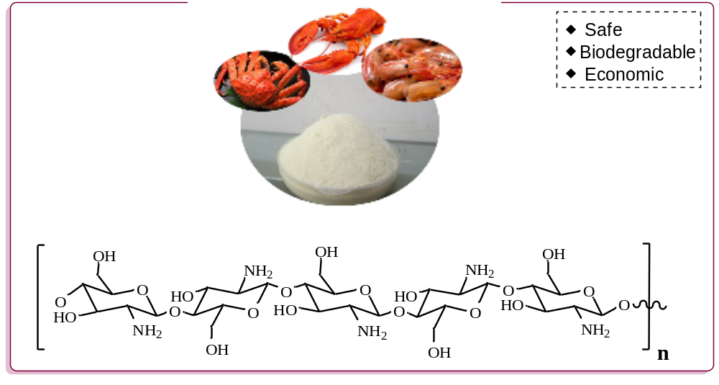
Scheme 1 Chemical structure of chitosan.

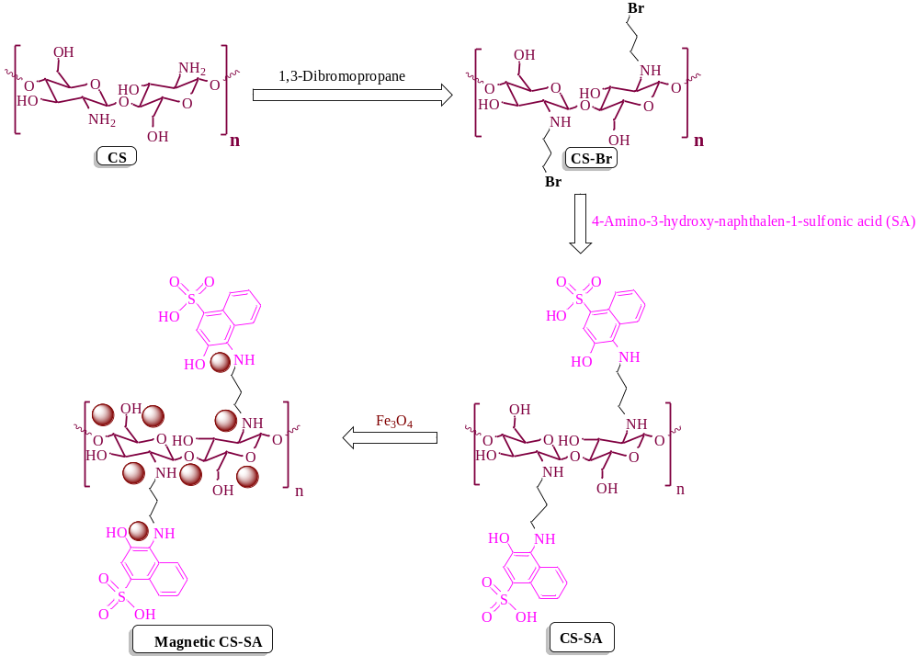
Scheme 2 Synthesis steps for the preparation of magnetic-CS-SA nanocomposite.

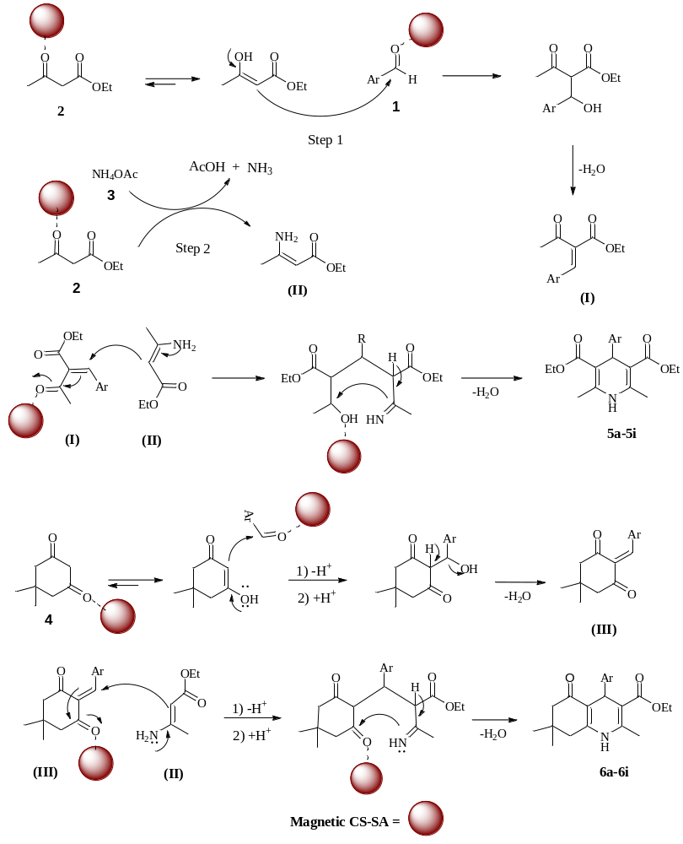
Scheme 3 Probable mechanism for the formation of 1,4-DHPs and polyhidroquinolines using magnetic-CS-SA

