Supporting Information

Acidic magnetic chitosan nanocamposite: a reusable and efficient nanocatalyst for the synthesis of 1,4-DHPs and polyhydroquinolines
Maryam Shahsavari, Mohammad Piltan*
ª Department of Chemistry, Sanandaj Branch, Islamic Azad University, Sanandaj, Iran mohammadpiltan@yahoo.com

Content
Materials and methods | 1
Spectral data for some selected products | 2-3
¹H and ¹³C NMR of selected products | 4-10
Hot filtration analysis (Figure S1) | 11

Materials and methods
All the chemicals, solvents, and reagents were obtained from Aldrich and Merck and used without any purification. Shimadzu IRPrestige-21 spectrophotometer was applied for recording FT-IR spectra based on KBr pellets. Melting points of products were recorded with Barnstead Electrothermal IA9200 apparatus and mentioned without rectification. The Bruker DRX-301 Avance spectrometer (¹H NMR: 301 MHz and ¹³C NMR 76 MHz) was used to record the ¹H and ¹³ C NMR in DMSO-d₆ or CDCl₃ as a solvent. The PANalytical X’Pert Pro diffractometer with Cu radiation source (λ = 1.54050 Å) was applied to analyse the crystalline structure of the nanocomposite. The magnetic properties of Fe₃O₄-CS-SA nanocomposite was evaluated at room temperature by vibrating sample magnetometer (VSM, BHV-55, Riken, Japan). The structure and morphology of the magnetic-CS-SA were investigated by FESEM, MIRA III, TESCAN, Czech Republic, which is equipped with an energy scattered X-ray detector (EDS) to detect chemical elements in the structure of the nanocatalyst. The thermal stability of the nanocomposite was evaluated using SDT Q600 V20.9 Build 20 apparatus in the air atmosphere at 25-800 ° C.
Spectral data for selected 1,4-DHPs and polyhydroquinoline compounds
Diethyl 2,6-dimethyl-4-phenyl-1,4-dihydropyridine-3,5-dicarboxylate: ¹H NMR (DMSO-d6, 301 MHz,): δ_{H} (ppm): 7.15-7.17 (m, 5H), 4.89 (s, 1H), 4.01 (q, ³J= 7.2, 4H), 2.29 (s, 6H), 1.15 (t, ³J= 7.1 Hz, 6H). ¹³ C NMR (DMSO-d₆, 76 MHz): δ_{C} (ppm): 167.71, 148.55, 145.89, 128.30, 128.05, 126.32, 102.54, 59.52, 43.04, 18.51, 14.62.
Diethyl 4-(4-methoxyphenyl)-2,6-dimethyl-1,4-dihydropyridine-3,5-dicarboxylate: ¹H NMR (DMSO-d6, 301 MHz): δ: 8.80 (s, 1H), 7.07 (d, ³J= 8.5 Hz, 2H), 6.78 (d, ³J= 8.5 Hz, 2H), 4.81 (s, 1H), 4.01-3.69 (m, 4H), 2.27 (s, 6H), 1.15 (t, ³J= 6.7 Hz, 6H). ¹³C NMR (DMSO-d₆, 76 MHz): δ: 167.70, 158.09, 145.55, 140.99, 128.98, 113.79, 102.90, 59.53, 54.94, 38.41, 18.52, 14.57.
Diethyl 4-(4-chlorophenyl)-2,6-dimethyl-1,4-dihydropyridine-3,5-dicarboxylate: ¹H NMR (DMSO-d6, 301 MHz): δ: 8.88 (s, 1H), 7.28 (d, ³J= 8.5 Hz, 2H), 7.18 (d, ³J= 8.5 Hz, 2H), 4.87 (s, 1H), 4.13-3.82 (m, 4H), 2.29 (s, 6H), 1.14 (t, ³J= 6.7 Hz, 6H). ¹³ C NMR (DMSO-d₆, 76 MHz): δ: 167.05, 147.60, 146.11, 130.62, 129.99, 128.26, 101.88, 59.53, 39.70, 18.52, 14.60.
Ethyl 4-(4-methoxyphenyl)-2,7,7-trimethyl-5-oxo-1,4,5,6,7,8-hexahydroquinoline-3-carboxylate: ¹H NMR (DMSO-d6, 301 MHz): δ: 9.04 (s, 1H), 7.08 (d, ³J= 8.3 Hz, 2H), 6.76 (d, ³J= 8.3 Hz, 2H), 4.82 (s, 1H), 3.99 (q, ³J= 7.1 Hz, 2H), 3.68 (s, 3H), 2.64-1.93 (m, 7H), 1.16 (t, ³J= 7.0 Hz, 3H), 1.02 (s, 3H), 0.87 (s, 3H). ¹³C NMR (DMSO-d₆, 76 MHz): δ: 194.85, 167.41, 157.76, 149.83, 145.11, 140.96, 128.88, 113.54, 110.49, 104.54, 59.46, 55.30, 50.91, 35.41, 32.78, 29.48, 26.83, 18.87, 14.64.
Ethyl 4-(4-chlorophenyl)-2,7,7-trimethyl-5-oxo-1,4,5,6,7,8-hexahydroquinoline-3-carboxylate: ¹H NMR (DMSO-d6, 301 MHz): δ: 9.14 (s, 1H), 7.26 (d, ³J= 8.5 Hz, 2H), 7.18 (d, , ³J= 8.5 Hz, 2H), 4.86 (s, 1H), 3.98 (q, ³J= 7.1 Hz, 2H), 2.52-1.94 (m, 7H), 1.13 (t, ³J= 7.1 Hz, 3H), 1.02 (s, 3H), 0.85 (s, 3H). ¹³C NMR (DMSO-d₆, 76 MHz): δ: 194.89, 167.39, 150.20, 146.92, 145.91, 130.67, 129.69, 128.05, 110.14, 103.89, 59.59, 50.63, 36.07, 32.79, 29.51, 26.82, 18.88, 14.60.
Ethyl 2,7,7-trimethyl-4-(4-nitrophenyl)-5-oxo-1,4,5,6,7,8-hexahydroquinoline-3-carboxylate: ¹H NMR (DMSO-d6, 301 MHz): δ: 9.26 (s, 1H), 8.11 (d, ³J= 8.7 Hz, 2H), 7.44 (d, ³J= 8.7 Hz, 2H), 4.99 (s, 1H), 3.98 (q, ³J= 7.1 Hz, 2H), 2.54-1.87 (m, 7H), 1.12 (t, ³J= 7.1 Hz, 3H), 1.02 (s, 3H), 0.83 (s, 3H). ¹³ C NMR (DMSO-d₆, 76 MHz): δ: 194.88, 166.71, 155.48, 150.20, 146.91, 145.91, 129.32, 123.75, 106.51, 103.25, 59.50, 50.28, 37.11, 32.43, 29.78, 27.11, 18.83, 14.55.
Ethyl 2,7,7-trimethyl-5-oxo-4-(thiophen-2-yl)-1,4,5,6,7,8-hexahydroquinoline-3-carboxylate: ¹H NMR (DMSO-d6, 301 MHz): δ: 9.29 (s, 1H), 7.23 (d, ³J= 5 Hz, 1H), 6.89-6.87 (m, 1H), 6.71 (d, ³J= 7.0 Hz, 1H), 5.23 (s, 1H), 4.13 (q, ³J=7.0 Hz, 2H), 2.63-2.16 (m, 7H), 1.25 (t, ³J= 7.1 Hz, 3H), 1.11 (s, 3H), 1.02 (s, 3H). ¹³ C NMR (DMSO-d₆, 76 MHz): δ: 194.51, 167.42, 151.84, 150.48, 145.55, 127.05, 123.76, 123.07, 110.14, 103.24, 59.86, 50.94, 32.45, 31.07, 29.73, 27.12, 18.87, 14.94.

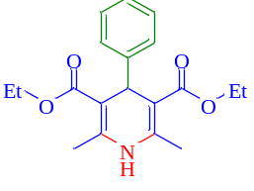
¹H NMR of diethyl 2,6-dimethyl-4-phenyl-1,4-dihydropyridine-3,5-dicarboxylate
¹³C NMR of diethyl 2,6-dimethyl-4-phenyl-1,4-dihydropyridine-3,5-dicarboxylate

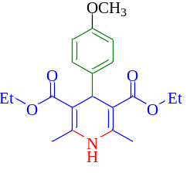
¹H NMR of diethyl 4-(4-methoxyphenyl)-2,6-dimethyl-1,4-dihydropyridine-3,5-dicarboxylate

¹³C NMR of diethyl 4-(4-methoxyphenyl)-2,6-dimethyl-1,4-dihydropyridine-3,5-dicarboxylate

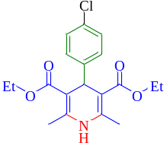
¹H NMR of diethyl 4-(4-chlorophenyl)-2,6-dimethyl-1,4-dihydropyridine-3,5-dicarboxylate
¹³C NMR of diethyl 4-(4-chlorophenyl)-2,6-dimethyl-1,4-dihydropyridine-3,5-dicarboxylate
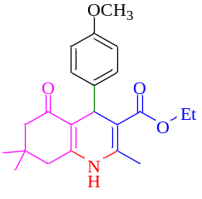
¹H NMR ethyl 4-(4-methoxyphenyl)-2,7,7-trimethyl-5-oxo-1,4,5,6,7,8-hexahydroquinoline-3-carboxylate

¹³C NMR ethyl 4-(4-methoxyphenyl)-2,7,7-trimethyl-5-oxo-1,4,5,6,7,8-hexahydroquinoline-3-carboxylate
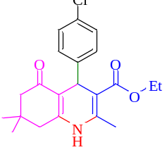
¹H NMR of ethyl 4-(4-chlorophenyl)-2,7,7-trimethyl-5-oxo-1,4,5,6,7,8-hexahydroquinoline-3-carboxylate
¹³C NMR of ethyl 4-(4-chlorophenyl)-2,7,7-trimethyl-5-oxo-1,4,5,6,7,8-hexahydroquinoline-3-carboxylate

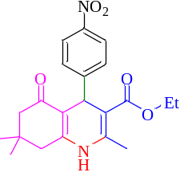
¹H NMR of ethyl 2,7,7-trimethyl-4-(4-nitrophenyl)-5-oxo-1,4,5,6,7,8-hexahydroquinoline-3-carboxylate
¹³C NMR of ethyl 2,7,7-trimethyl-4-(4-nitrophenyl)-5-oxo-1,4,5,6,7,8-hexahydroquinoline-3-carboxylate

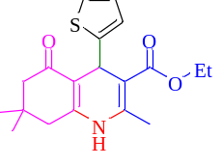
¹H NMR of ethyl 2,7,7-trimethyl-5-oxo-4-(thiophen-2-yl)-1,4,5,6,7,8-hexahydroquinoline-3-carboxylate

¹³C NMR of ethyl 2,7,7-trimethyl-5-oxo-4-(thiophen-2-yl)-1,4,5,6,7,8-hexahydroquinoline-3-carboxylate

Hot filtration test

Figure S1

