npj Climate and Atmospheric Science

Supporting Information for
Bimodality in Simulated Precipitation Frequency Distributions and Its Relationship with Convective Parameterizations

Ahn, Min-Seop¹*, Paul A. Ullrich^{1,2}, Jiwoo Lee¹*, Peter J. Gleckler¹, Hsi-Yen Ma¹, Christopher R. Terai¹, Peter A. Bogenschutz¹, and Ana C. Ordonez¹

¹Lawrence Livermore National Laboratory, Livermore, CA, USA
²Department of Land, Air and Water Resources, University of California, Davis, CA, USA

Contents of this file

Tables S1 to S3
Figures S1 to S3

Table S1. List of CMIP5 and CMIP6 models with their horizontal resolution and default convection scheme. The number in parentheses next to the model name indicates the number of realizations used for each model. Note that the horizontal resolution information is obtained from the number of grids, and it may vary slightly if the grid interval is not linear.

Institute | CMIP5 |  |  | CMIP6
Institute | Model | Horizontal resolution [lon x lat °] | Default deep convection scheme | Model | Horizontal resolution [lon x lat °] | Default deep convection scheme
CSIRO/BOM, Australia | ACCESS1-0 (1) | 1.875 x 1.241 | Gregory and Rowntree (1990) | ACCESS-CM2 (7) | 1.875 x 1.25 | Gregory and Rowntree (1990)
CSIRO/BOM, Australia | ACCESS1-3 (2) | 1.875 x 1.241 | Gregory and Rowntree (1990) | ACCESS-ESM1-5 (10) | 1.875 x 1.241 | Gregory and Rowntree (1990)
BCC, China | BCC-CSM1-1 (1) | 1.875 x 1.241 | Zhang and McFarlane (1995) | BCC-CSM2-MR (3) | 1.125 x 1.125 | Zhang and McFarlane (1995)
BCC, China | BCC-CSM1-1-M (1) | 1.125 x 1.125 | Zhang and McFarlane (1995) | BCC-CSM2-MR (3) | 1.125 x 1.125 | Zhang and McFarlane (1995)
BNU, China | BNU-ESM (1) | 2.812 x 2.812 | Zhang and McFarlane (1995) | N/A
CCCma, Canada | N/A |  |  | CanESM5 (7) | 2.812 x 2.812 | Zhang and McFarlane (1995)
NCAR, USA | CCSM4 (6) | 1.25 x 0.938 | Zhang and McFarlane (1995) | CESM2 (10) | 1.25 x 0.938 | Zhang and McFarlane (1995)
 |  |  |  | CESM2-FV2 (3) | 2.5 x 1.875 | Zhang and McFarlane (1995)
 |  |  |  | CESM2-WACCM (3) | 1.25 x 0.938 | Zhang and McFarlane (1995)
CMCC, Italy | CMCC-CM (3) | 0.75 x 0.75 | Tiedtke (1989) | CMCC-CM2-HR4 (1) | 1.25 x 0.938 | Zhang and McFarlane (1995)
 |  |  |  | CMCC-CM2-SR5 (1) | 1.25 x 0.938 | Zhang and McFarlane (1995)
CNRM-CERFACS, France | N/A |  |  | CNRM-CM6-1 (1) | 1.406 x 1.406 | Piriou et al. (2018)
CNRM-CERFACS, France |  |  |  | CNRM-CM6-1-HR (1) | 0.5 x 0.5 | Piriou et al. (2018)
CNRM-CERFACS, France |  |  |  | CNRM-ESM2-1 (1) | 1.406 x 1.406 | Piriou et al. (2018)
CSIRO-QCCCE, Australia | CSIRO-Mk3-6-0 (1) | 1.875 x 1.875 | Gregory and Rowntree (1990) | N/A
DOE, USA | N/A |  |  | E3SM-1-0 (3) | 1.0 x 1.0 | Zhang and McFarlane (1995)
EC-Earth-Consortium, European Community | EC-Earth (1) | 1.125 x 1.125 | Tiedtke (1989) | EC-Earth3 (6) | 0.703 x 0.703 | Tiedtke (1989)
 |  |  |  | EC-Earth3-AerChem (1) | 0.703 x 0.703 | Tiedtke (1989)
 |  |  |  | EC-Earth3-CC (5) | 0.703 x 0.703 | Tiedtke (1989)
 |  |  |  | EC-Earth3-Veg (2) | 0.703 x 0.703 | Tiedtke (1989)
 |  |  |  | EC-Earth3-Veg-LR (1) | 1.125 x 1.125 | Tiedtke (1989)
IAP-CAS/THU, China | FGOALS-g2 (1) | 2.812 x 3.0 | Zhang and McFarlane (1995) | N/A
IAP-CAS/THU, China | FGOALS-s2 (1) | 2.812 x 1.667 | Tiedtke (1989)
NOAA GFDL, USA | GFDL-CM3 (5) | 2.5 x 2.0 | Donner et al. (2001) | GFDL-CM4 (1) | 1.0 x 1.0 | Zhao et al. (2018)
NOAA GFDL, USA | GFDL-HIRAM-C180 (2) | 0.625 x 0.5 | Bretherton et al. (2004) | GFDL-CM4 (1) | 1.0 x 1.0 | Zhao et al. (2018)
NOAA GFDL, USA | GFDL-HIRAM-C360 (1) | 0.312 x 0.25 | Bretherton et al. (2004) | GFDL-CM4 (1) | 1.0 x 1.0 | Zhao et al. (2018)
﻿MOHC, UK | HadGEM2-A (1) | 1.875 x 1.241 | Gregory and Rowntree (1990) | HadGEM3-GC31-LL (5) | 1.875 x 1.25 | Gregory and Rowntree (1990)
 |  |  |  | HadGEM3-GC31-MM (4) | 0.833 x 0.556 | Gregory and Rowntree (1990)
 |  |  |  | UKESM1-0-LL (1) | 1.875 x 1.25 | Gregory and Rowntree (1990)
IITM, India | N/A |  |  | IITM-ESM (1) | 1.875 x 1.915 | Arakawa and Schubert (1974)
INM, Russia | INMCM4 (1) | 2.0 x 1.5 | Betts (1986) | N/A
IPSL, France | IPSL-CM5A-LR (6) | 3.75 x 1.875 | Emanuel (1991) | IPSL-CM6A-LR (22) | 2.5 x 1.259 | Emanuel (1991)
IPSL, France | IPSL-CM5A-MR (3) | 2.5 x 1.259 | Emanuel (1991) | IPSL-CM6A-LR (22) | 2.5 x 1.259 | Emanuel (1991)
IPSL, France | IPSL-CM5B-LR (1) | 3.75 x 1.875 | Grandpeix and Lafore (2010) | IPSL-CM6A-LR (22) | 2.5 x 1.259 | Emanuel (1991)
MIROC, Japan | MIROC5 (2) | 1.406 x 1.406 | Chikira and Sugiyama (2010) | MIROC6 (10) | 1.406 x 1.406 | Chikira and Sugiyama (2010)
 |  |  |  | MIROC-ES2L (3) | 2.812 x 2.812 | Chikira and Sugiyama (2010)
MPI-M, Germany | MPI-ESM-MR (3) | 1.875 x 1.875 | Tiedtke (1989) | N/A
MRI, Japan | MRI-AGCM3-2H (1) | 0.562 x 0.562 | Yoshimura et al. (2015) | MRI-ESM2-0 (3) | 1.125 x 1.125 | Yoshimura et al. (2015)
MRI, Japan | MRI-AGCM3-2S (1) | 0.188 x 0.188 | Yoshimura et al. (2015) | MRI-ESM2-0 (3) | 1.125 x 1.125 | Yoshimura et al. (2015)
MRI, Japan | MRI-CGCM3 (1) | 1.125 x 1.125 | Yoshimura et al. (2015) | MRI-ESM2-0 (3) | 1.125 x 1.125 | Yoshimura et al. (2015)
NCC, Norway | N/A |  |  | NorESM2-LM (2) | 2.5 x 1.875 | Zhang and McFarlane (1995)
SNU, Korea | N/A |  |  | SAM0-UNICON (1) | 1.25 x 0.938 | Park (2014)
AS-RCEC, Taiwan | N/A |  |  | TaiESM1 (1) | 1.25 x 0.938 | Zhang and McFarlane (1995)

Table S2. List of DYAMOND model simulations with their horizontal resolution and convective parameterization.

Institute | Model | Horizontal resolution | Convective parameterization
Météo-France, France | ARPEGE-NH | 2.5 km | None
NOAA GFDL, USA | FV3 | 3.25 km | Shallow
MPI-M/DWD/DKRZ, Germany | ICON | 2.5 km | None
ECMWF, UK | IFS | 4 km | Shallow
ECMWF, UK | IFS | 9 km | Full
NCAR, USA | MPAS | 3.75 km | Full
NCAR, USA | MPAS | 7.5 km | Full
JAMSTEC, Japan | NICAM | 3.5 km | None
JAMSTEC, Japan | NICAM | 7 km | None
SBU, USA | SAM | 4 km | None
NCAS, UK | UM | 5 km | Shallow

Table S3. List of satellite-based and reanalysis products with their data source, coverage, resolution, and reference.

Product | Data source | Coverage |  | Resolution |  | Reference
Product | Data source | Domain | Period | Horizontal | Frequency | Reference
IMERG | NASA Integrated Multi-satellitE Retrievals for GPM version 6 final run product | Global, while beyond 60°NS is incomplete | 2000.6-present | 0.1° | 30 minutes | Huffman et al. (2020)
TRMM | NASA Tropical Rainfall Measuring Mission Multi-satellite Precipitation Analysis 3B42 version 7 product | 50°S-50°N | 1998.1-2019.12 | 0.25° | 3 hours | Huffman et al. (2007)
CMORPH | NOAA Bias-corrected Climate Prediction Center Morphing technique product | 60°S-60°N | 1998.1-present | 0.073° | 30 minutes | Xie et al. (2017)
GPCP | NASA Global Precipitation Climatology Project 1DD version 1.3 | Global, while beyond 40°NS is incomplete | 1996.10-present | 1° | 1 day | Huffman et al. (2001)
PERSIANN | UC-IRVINE/CHRS Precipitation Estimation from Remotely Sensed Information using Artificial Neural Networks-Climate Data Record | 60°S-60°N | 1983.1-present | 0.25° | 1 day | Ashouri et al. (2015)
ERA5 | ECMWF Integrated Forecasting System Cy41r2 | Global | 1950.1-present | 0.25° | 1 hour | Hersbach et al. (2020)
ERA-Interim | ECMWF Integrated Forecasting System Cy31r2 | Global | 1979.1-2019.08 | 0.75° | 6 hours | Dee et al. (2011)
MERRA2 | NASA GEOS atmospheric data assimilation system version 5.12.4 | Global | 1980.1–present | 0.5°x0.63° | 1 hour | Gelaro et al. (2017)
MERRA | NASA GEOS atmospheric data assimilation system version 5.2.0 | Global | 1979.1-2016.02 | 0.5°x0.66° | 1 day | Rienecker et al. (2011)
CFSR | NCEP Climate Forecast System Reanalysis (CFSR and CFSv2) | Global | 1979.1-present | 0.5° | 6 hours | Saha et al. (2010, 2014)
JRA-55 | JMA operational data assimilation system version TL319 | Global | 1958.1-present | 1.25° | 3 hours | Kobayashi  et al. (2015)

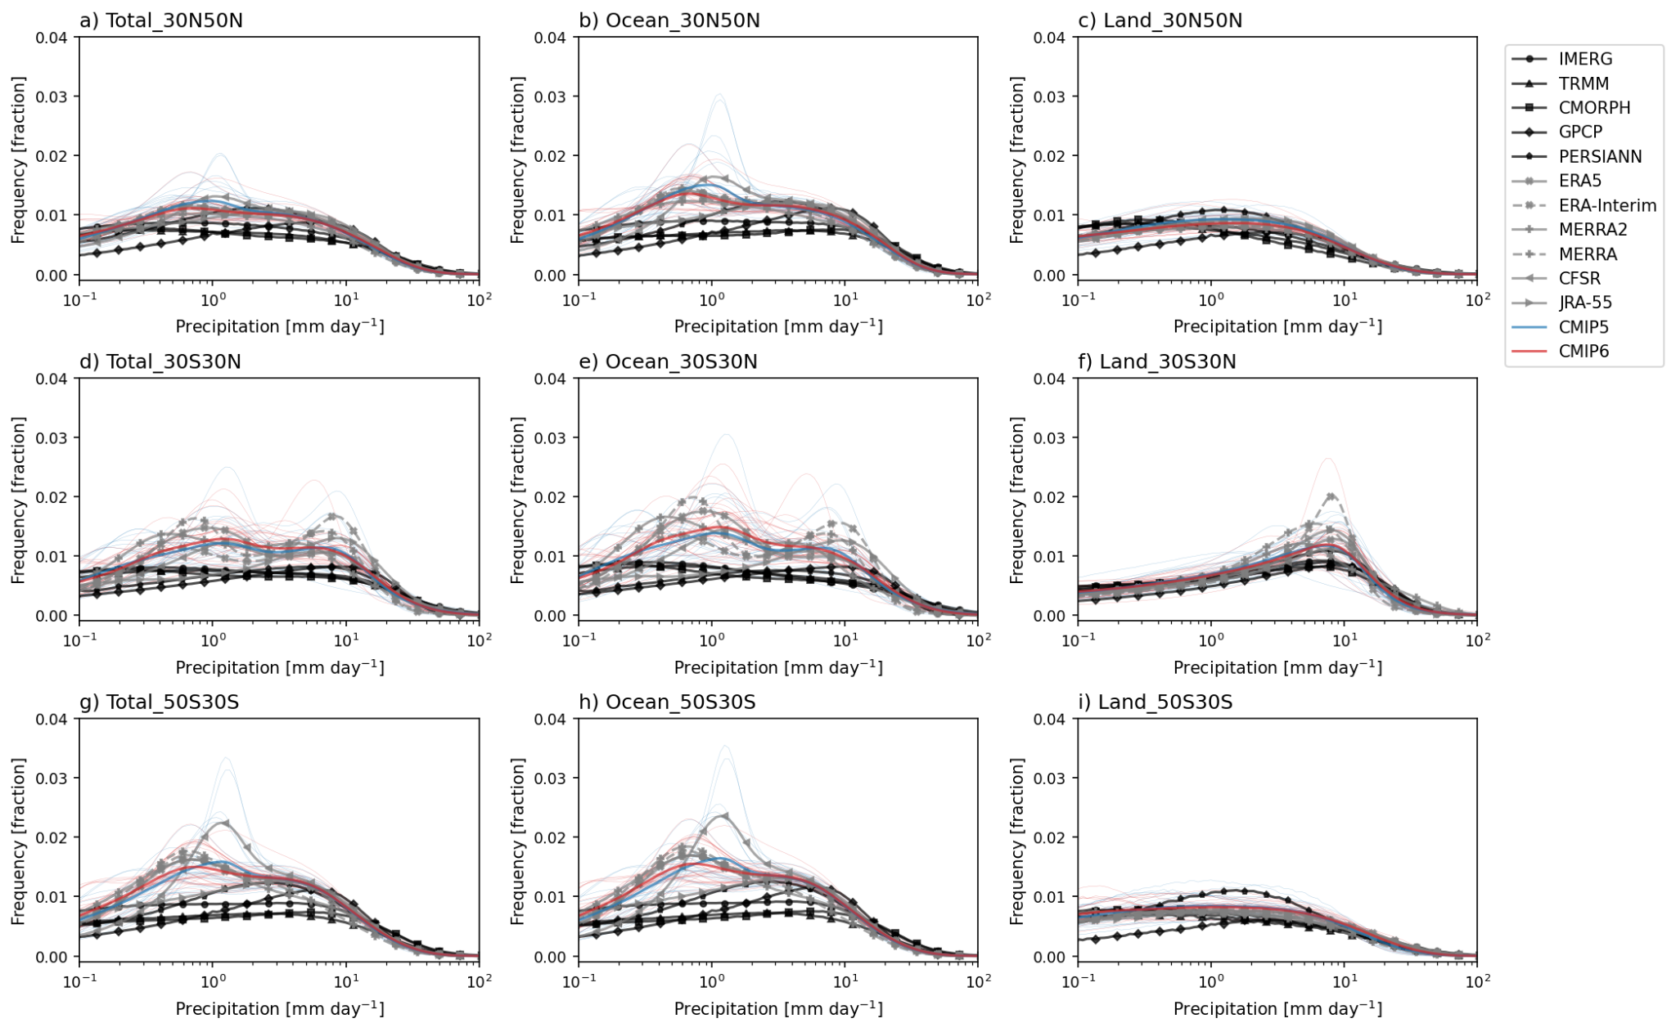

Figure S1. Frequency distributions of total precipitation for satellite-based products (black), reanalysis products (gray), CMIP5 (blue), and CMIP6 (red) models over a)-c) Northern Hemisphere extratropics (30°N-50°N), d)-f) Tropics (30°S-30°N), and g)-i) Southern Hemisphere extratropics (50°S-30°S). Land and ocean regions are separated by different columns. Thin and thick lines indicate each model and multi-model mean, respectively.

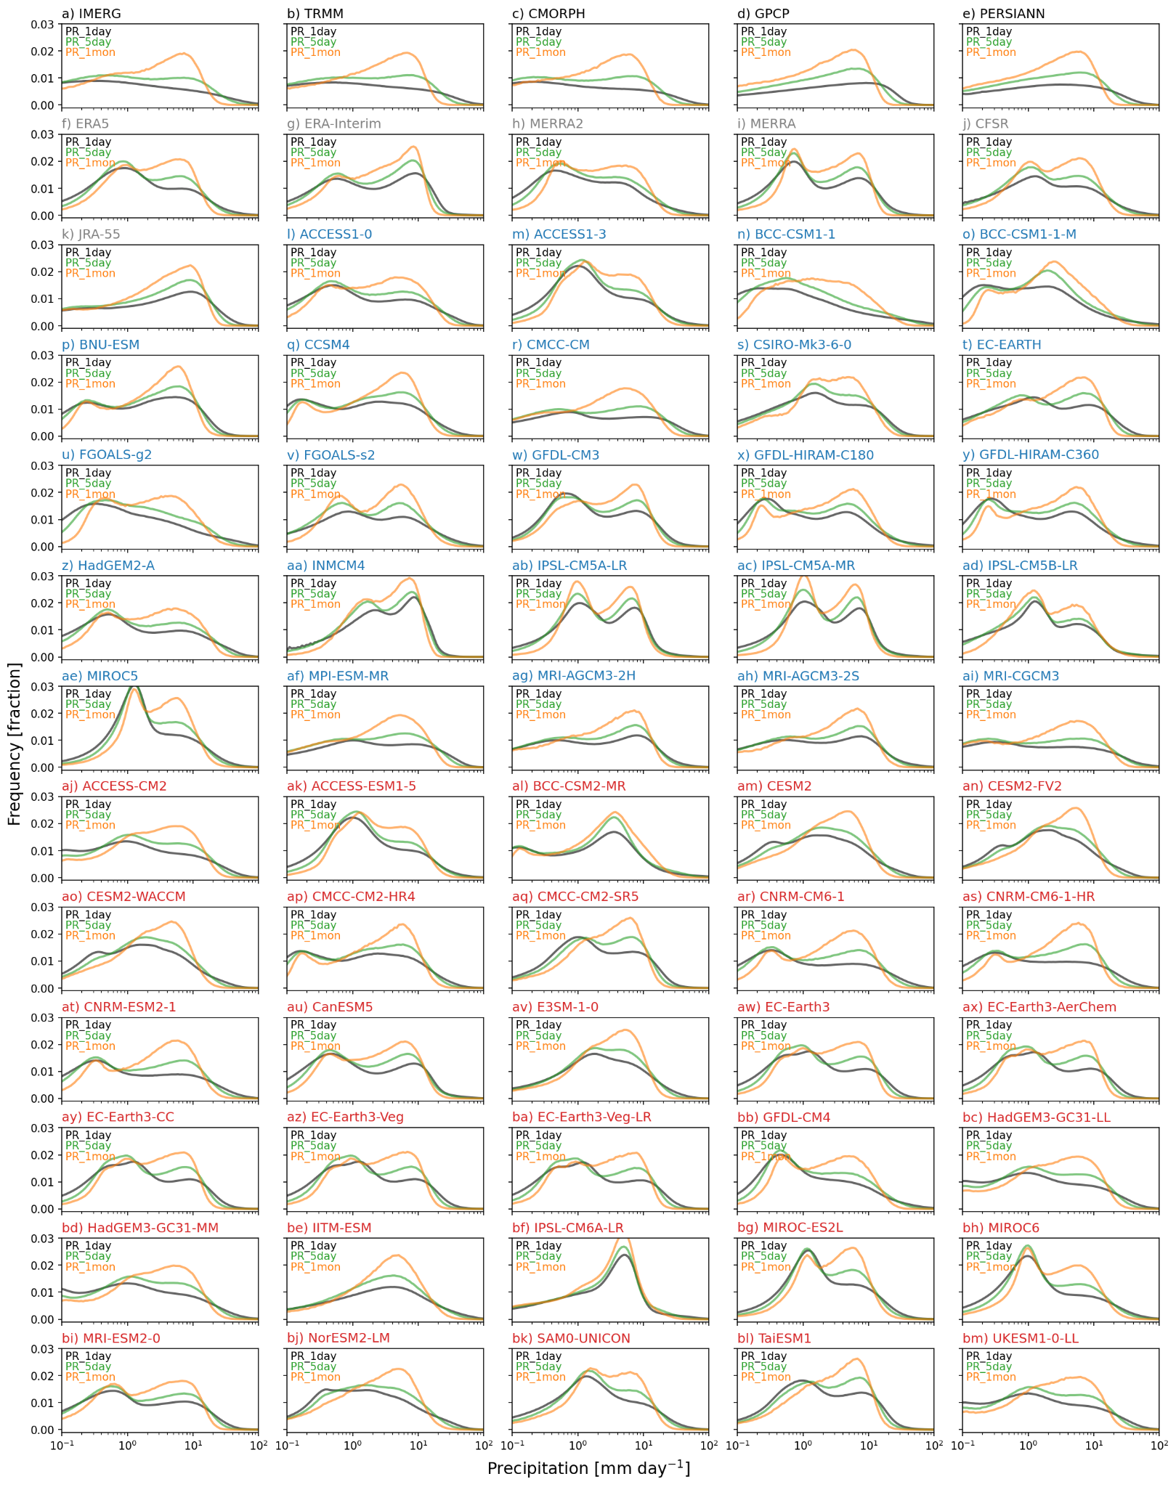

Figure S2. As in Fig. 1, but showing the frequency distributions of 1-day (black), 5-day (green), and 1-month (orange) averaged total precipitation.
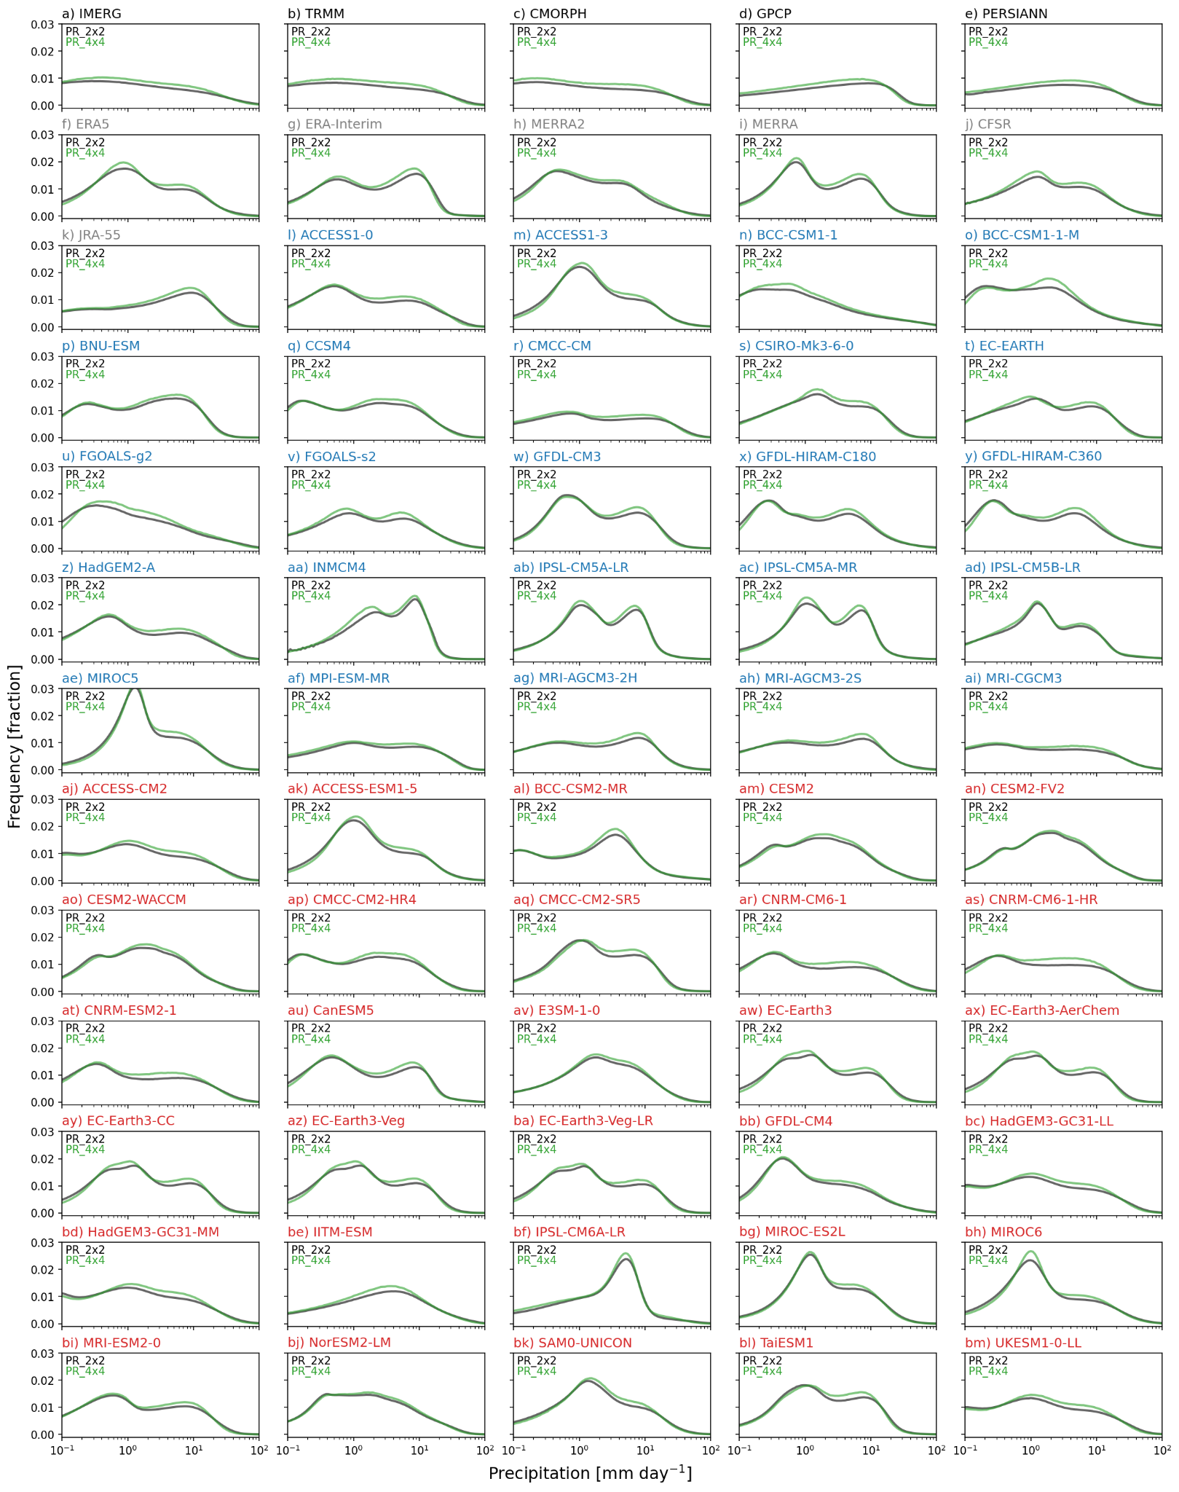

Figure S3. As in Fig. 1, but showing the frequency distributions of total precipitation regridded to 2x2 (black) and 4x4 (green) degrees.

