Supplementary Materials

S1. Further methodological details

S1.1 Picture description instructions
At the start of the experiment, a picture (showing a visibly happy man) had to be described by the participants (“In one complete sentence, describe what could have happened before this picture was taken. You can write anything you like; there is no right or wrong answer: leave it to your imagination!”) in order to test whether participants follow the written instructions.

S1.2 Instructions for thought probes
“Throughout the task, try to stay focused on the task. However, you may find that your mind may wander, which is a perfectly natural phenomenon. We will interrupt the task a few times and ask three questions about it each time, whether you were concentrating on the task at hand or on something else. To answer these questions, use the mouse!
First, we ask you to what extent you focused on the task before the question appeared. Here, the answer options are on a 4-point scale from "1: Not at all" to "4: Completely". A response of "1: Not at all" means that your thoughts are completely diverted (e.g. to your friends, weekend plans, etc.). A "4: Completely" answer means that you were only thinking about the task at hand (where the dog's head appears, and which key to press as soon as possible).
The second question asks whether, if you were not focused on the task, you thought about specifically about something, or if you thought about nothing at all. Here, the answer options are on a 4-point scale ranging from "1: I was thinking about nothing" to "4: I was thinking about something in particular". A response of "1: I was thinking about nothing" means that your mind wandered, but you weren't thinking about anything it's as if your mind was completely blank. The answer "4: I was thinking about something in particular" means that you were thinking about something (e.g. a book, recent events, the task is too easy, you are hungry, it is uncomfortable to sit to do the task, etc.).
The third question refers to whether your focus of attention (either on the task or elsewhere) was intentional or spontaneous. Here, the response options are on a 4-point scale from '1: I was completely spontaneous" to "4: I was completely deliberate" A response of "1 - I was completely spontaneous " means that your attention did not require any effort. If you were focusing on the task at hand, it happened automatically, it was not difficult to focus. If you were distracted, this happened even though you wanted to focus on the task at hand. The answer "4: I was completely spontaneous " means that you consciously directed your attention somewhere. If you were focusing on the task at hand, it was conscious, you were deliberately focusing on the task. If your mind was wandering, it was because you made a conscious decision to focus on something else. (e.g., the weekend). This can happen when you are bored during the task. It is important to stress that there is no right or wrong answer to these questions, and that your answers will not have any consequences. Please answer the questions completely honestly!”

S1.3 Quiz questions
The following quiz questions were presented to the participants following the instructions (see above “Instructions for thought probes”). To demonstrate this part, see Gorilla Open Materials Platform in Data Availability Statement).

1. When doing the task, I thought of a film I saw yesterday:
- I was completely focused on the task
- Not focused on the task at all

2. If, while doing the task, I was thinking about my dinner tonight, I was:
- Completely focused on the task
- Not focused on the task at all

3. If, while doing the task, I was focused on where the dog's head would appear, I was:
- I focused completely on the task
- I did not focus on the task at all

4. If I was focused on the noise in the room while doing the task, I was:
- Focused completely on the task
- Not focused on the task at all

5. If I was concentrating on which key to press while doing the task, then:
- I focused completely on the task
- I did not focus on the task at all

6. If, while doing the task, I was thinking about how easy it was or how difficult the task is, then:
- I focused completely on the task
- I did not focus on the task at all

7. If, while doing the task, I did not focus on the task but I was thinking about the task, then:
- I was thinking specifically about something
- I was not thinking about anything

8. If, while doing the task, I tried to focus on the task, but my thoughts wandered, then:
- It was intentional
- It was completely spontaneous

S2. Full results of the linear mixed models

Terms | b | SE b | 95% CI | t | df | p
(Intercept) | 369.9649 | 3.7344 | 362.5782 – 377.3516 | 99.0686 | 132.7746 | <.001
Triplet Type [High] | -4.1420 | 0.3464 | -4.8210 – -3.4630 | -11.9582 | 6360.9445 | <.001
MW [MW] | -1.2387 | 0.5511 | -2.3316 – -0.1458 | -2.2476 | 104.0192 | .027
Block | -12.1142 | 1.3267 | -14.7372 – -9.4912 | -9.1308 | 140.3710 | <.001
Triplet Type [High] × MW [MW] | -0.4860 | 0.3464 | -1.1650 – 0.1930 | -1.4031 | 6360.9445 | .161
Triplet Type [High] × Block | -0.8094 | 0.3527 | -1.5008 – -0.1179 | -2.2947 | 6360.9445 | .022
MW [MW] × Block | -1.7023 | 0.4345 | -2.5541 – -0.8506 | -3.9182 | 4507.9176 | <.001
Triplet Type [High] × MW [MW] × Block | 0.7287 | 0.3527 | 0.0373 – 1.4202 | 2.0660 | 6360.9445 | .039
Random Effects
σ² | 650.18
τ₀₀ _{Subject} | 1861.04
τ₁₁ _{Subject.re1.MW2} | 13.65
τ₁₁ _{Subject.re1.Block2} | 218.51
ρ₀₁ | 0.02
 | -0.41
ICC | 0.74
N _{Subject} | 135
Observations | 6750
Marginal R² / Conditional R² | 0.058 / 0.756
Table S1. Results of the linear mixed model, predicting block-wise median RTs. The marginal R-squared considers only the variance of the fixed effects, while the conditional R-squared takes both the fixed and random effects into account (based on Nakagawa, Johnson, & Schielzeth, 2017). Degrees of freedom are based on Satterthwaite’s approximation. Significant terms are highlighted in bold. Terms in brackets indicate the level of the factor that is contrasted against the reference level.

Terms | b | SE b | 95% CI | t | df | p
(Intercept) | 0.9038 | 0.0035 | 0.8970 – 0.9107 | 260.9599 | 123.5330 | <.001
Triplet Type [High] | 0.0133 | 0.0009 | 0.0115 – 0.0151 | 14.4059 | 6355.2126 | <.001
MW [MW] | -0.0166 | 0.0019 | -0.0203 – -0.0129 | -8.8908 | 110.9225 | <.001
Block | -0.0127 | 0.0017 | -0.0159 – -0.0094 | -7.6511 | 159.4352 | <.001
Triplet Type [High] × MW [MW] | 0.0024 | 0.0009 | 0.0006 – 0.0042 | 2.6080 | 6355.2126 | .009
Triplet Type [High] × Block | 0.0031 | 0.0009 | 0.0013 – 0.0050 | 3.3137 | 6355.2126 | .001
MW [MW] × Block | -0.0063 | 0.0011 | -0.0085 – -0.0042 | -5.7478 | 3239.2628 | <.001
Triplet Type [High] × MW [MW] × Block | 0.0005 | 0.0009 | -0.0014 – 0.0023 | 0.5115 | 6355.2126 | .609
Random Effects
σ² | <0.0001
τ₀₀ _{Subject} | <0.0001
τ₁₁ _{Subject.re1.MW2} | <0.0001
τ₁₁ _{Subject.re1.Block2} | <0.0001
ρ₀₁ | 0.34
 | 0.66
ICC | 0.24
N _{Subject} | 135
Observations | 6750
Marginal R² / Conditional R² | 0.091 / 0.306
Table S2. Results of the linear mixed model, predicting block-wise mean accuracy. The marginal R-squared considers only the variance of the fixed effects, while the conditional R-squared takes both the fixed and random effects into account (based on Nakagawa, Johnson, & Schielzeth, 2017). Degrees of freedom are based on Satterthwaite’s approximation. Significant terms are highlighted in bold. Terms in brackets indicate the level of the factor that is contrasted against the reference level.

Terms | b | SE b | 95% CI | t | df | p
(Intercept) | 0.1935 | 0.0027 | 0.1882 – 0.1988 | 71.8985 | 140.0027 | <.001
Triplet Type [High] | 0.0063 | 0.0008 | 0.0048 – 0.0078 | 8.0731 | 6472.9768 | <.001
MW [MW] | 0.0052 | 0.0009 | 0.0033 – 0.0070 | 5.5560 | 6714.1219 | <.001
Block | 0.0001 | 0.0002 | -0.0003 – 0.0005 | 0.4297 | 155.2504 | .668
Triplet Type [High] x MW [MW] | 0.0009 | 0.0008 | -0.0006 – 0.0024 | 1.1346 | 6472.9768 | .257
Triplet [MW] x Block | 0.0001 | 0.0001 | -0.0001 – 0.0003 | 0.7266 | 6473.1007 | .467
MW [MW] x Block | 0.0007 | 0.0001 | 0.0004 – 0.0009 | 5.0948 | 5341.3056 | <.001
Triplet Type [High]  x MW [MW]) x Block | 0.0001 | 0.0001 | -0.0001 – 0.0003 | 0.8795 | 6473.1007 | .379
Random Effects
σ² | <0.0001
τ₀₀ _{Subject} | <0.0001
τ₁₁ _{Subject.Block2} | <0.0001
ρ₀₁ _{Subject} | 0.34
ICC | 0.26
N _{Subject} | 135
Observations | 6749
Marginal R² / Conditional R² | 0.019 / 0.269
Table S3. Results of the linear mixed model, predicting block-wise coefficient of variation. The marginal R-squared considers only the variance of the fixed effects, while the conditional R-squared takes both the fixed and random effects into account (based on Nakagawa, Johnson, & Schielzeth, 2017). Degrees of freedom are based on Satterthwaite’s approximation. Significant terms are highlighted in bold. Terms in brackets indicate the level of the factor that is contrasted against the reference level.

Terms | b | SE b | 95% CI | t | df | p
(Intercept) | 368.9254 | 3.5139 | 361.9760 – 375.8748 | 104.9907 | 135.0118 | <.001
ACC | 1.8687 | 0.0713 | 1.7290 – 2.0085 | 26.2168 | 3186.6094 | <.001
Block | -1.3708 | 0.1759 | -1.7188 – -1.0229 | -7.7918 | 133.9127 | <.001
ACC x Block | 0.0609 | 0.0082 | 0.0448 – 0.0771 | 7.4060 | 3241.9055 | <.001
Random Effects
σ² | 379.29
τ₀₀ _{Subject} | 1651.17
τ₁₁ _{Subject.Block2} | 3.87
ρ₀₁ _{Subject} | -0.48
ICC | 0.83
N _{Subject} | 135
Observations | 3375
Marginal R² / Conditional R² | 0.136 / 0.853
Table S4. Results of the first linear mixed model of the SAT, predicting block-wise RT. The marginal R-squared considers only the variance of the fixed effects, while the conditional R-squared takes both the fixed and random effects into account (based on Nakagawa, Johnson, & Schielzeth, 2017). Degrees of freedom are based on Satterthwaite’s approximation. Significant terms are highlighted in bold. Terms in brackets indicate the level of the factor that is contrasted against the reference level.

Terms | b | SE b | 95% CI | t | df | p
(Intercept) | -0.0901 | 0.0274 | -0.1437 – -0.0364 | -3.2931 | 3280.1498 | .001
MW [MW] | -0.2453 | 0.0277 | -0.2996 – -0.1910 | -8.8519 | 3353.6804 | <.001
Block | -0.0904 | 0.0056 | -0.1015 – -0.0793 | -16.0848 | 168.2678 | <.001
MW [MW] x Block | -0.0071 | 0.0042 | -0.0153 – 0.0012 | -1.6839 | 2700.9673 | .092
Random Effects
σ² | 2.01
τ₀₀ _{Subject} | <0.0001
τ₁₁ _{Subject.Block2} | <0.0001
ρ₀₁ _{Subject} | -0.17
ICC | 0.05
N _{Subject} | 135
Observations | 3375
Marginal R² / Conditional R² | 0.190 / 0.234
Table S5. Results of the second linear mixed model of the SAT, predicting block-wise speed/accuracy bias. The marginal R-squared considers only the variance of the fixed effects, while the conditional R-squared takes both the fixed and random effects into account (based on Nakagawa, Johnson, & Schielzeth, 2017). Degrees of freedom are based on Satterthwaite’s approximation. Significant terms are highlighted in bold. Terms in brackets indicate the level of the factor that is contrasted against the reference level.

S3. Further preregistered analyses

S3.1 Did statistical learning occur and how did it evolve during the task?
Please note that this analysis is similar to the analysis presented in the main text; however, here, larger time chunks (of 5 blocks) are considered, and that response to the probes is omitted. We present it separately as preregistered for transparency. Median RT and accuracy values were calculated separately for high- and low-probability triplets. To determine if statistical learning occurred during the task and evaluate its progression, median RT/mean ACC values were submitted to two separate repeated measures ANOVA with within-subject factor of Time (Block 1-5 vs. Block 6-10 vs. Block 11-15 vs. Block 16-20 vs. Block 21-25) and Triplet Type (high vs. low-probability triplet) as within subject-factors. Results are presented in Table S6. Results confirmed an occurrence of statistical learning (main effect of Triplet Type), an overall speed-up on the task (main effect of Time), and a change in statistical learning as the task went on (Time by Triplet Type interaction).

Table S6. Full results of the ANOVA for RT data of the ASRT task
Effect | df | F-value | p-value
Time | 1.54, 206.92 | 53.05*** | < .001
Triplet Type | 1, 134 | 210.26*** | < .001
Time × Triplet Type | 3.69, 494.87 | 10.97*** | < .001

Significance codes: *** < .001, ** < .01, * < .05, + < .10
The same analysis was run for the accuracy scores. Results are presented in Table S7. Results confirmed an occurrence of statistical learning (main effect of Triplet Type), an overall drop of accuracy over the course of the task (main effect of Time) and a change in statistical learning as the task went on (Time by Triplet Type interaction).

Table S7. Full results of the ANOVA for accuracy data of the ASRT task
Effect | df | F-value | p-value
Time | 2.43, 325.20 | 22.32*** | < .001
Triplet Type | 1, 134 | 205.15*** | < .001
Time × Triplet Type | 3.85, 515.81 | 6.51*** | < .001

Significance codes: *** < .001, ** < .01, * < .05, + < .10

S3.2 How did MW change over the course of the task?
To determine how MW changed over the course of the task, mean on-task vs. off-task values were submitted to a repeated measures ANOVA with within-subject factor of Time (Block 1-5 vs. Block 6-10 vs. Block 11-15 vs. Block 16-20 vs. Block 21-25). The main effect of Time was significant, F(3.33, 446.47) = 31.75, p < .001, η_{p}² = .068. Post-hoc contrasts revealed increasing MW (i.e., lower average score) over the course of the task (Block 1-5 and Block 6-10 significantly higher, Block 16-20 and Block 21-25 significantly lower than the grand mean) (Fig. S1).
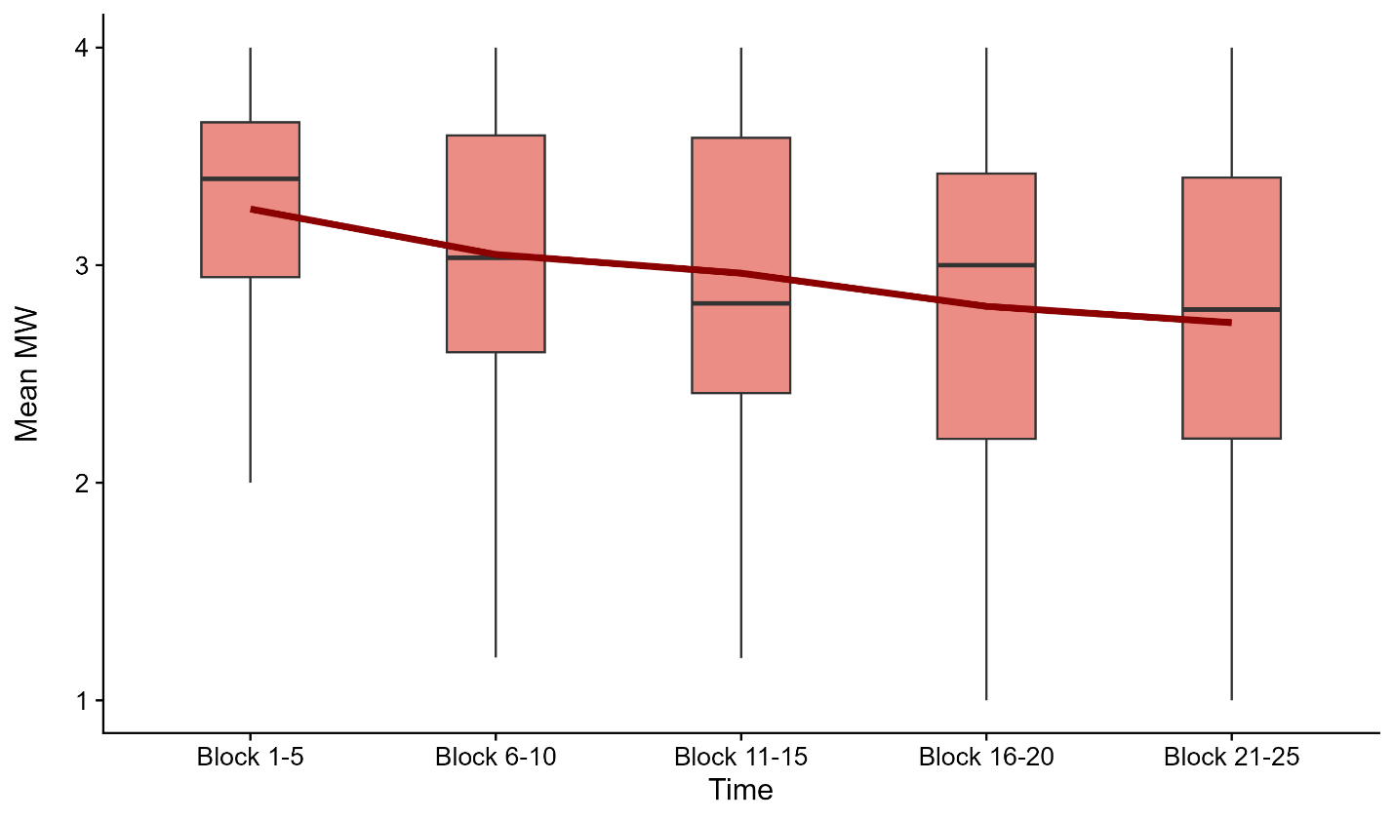
Fig. S1. The development of mean MW scores. The x-axis indicates the blocks of the task, and the y-axis the mean MW score (smaller value indicates more MW). The red line indicates the mean of the data. The lower and upper hinges correspond to the first and third quartiles (the 25th and 75th percentiles), whiskers show 1.5 × IQR, horizontal notches show the median. For clarity, outlier values (outside the 1.5 × IQR) are not shown. MW increased over the course of the task (i.e., smaller means as the task progressed).

S3.3 Is there a linear relationship between the amount of state and trait MW and statistical learning?
We ran correlations between the statistical learning scores and the MW thought probe averages and the Mind Wandering Questionnaire (MWQ) scores (Mrazek, Phillips, Franklin, Broadway, & Schooler, 2013). Higher values on the MWQ indicate stronger MW-trait, while smaller Thought Probes Average indicate more MW during the ASRT task. Correlations coefficients are shown in Fig. S2. Statistical learning scores measured by RT or accuracy do not correlate significantly with averaged MW scores (all ps > .381).
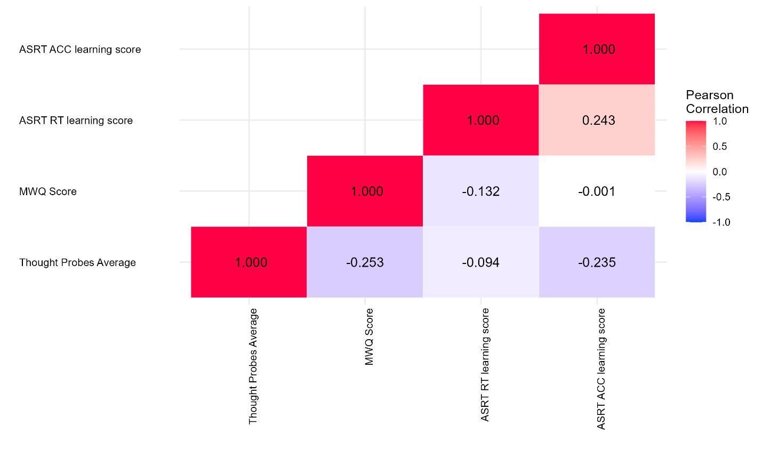
Figure S2. Pearsons’s correlation coefficients of state (Thought Probes Average) and trait MW scores (MWQ Score) and statistical learning scores measured by RT and accuracy. The strength of the correlation was indicated by different colors. However, none of the correlations were found to be significant.

S3.4 How does predisposition to MW influence learning?
To assess the effect of the overall amount of MW on learning, we run a mixed three-way repeated measures ANOVA with Time (Time 1-5) and Triplet Type (high- vs. low-probability) as a within-subject factors and MW Proneness (less MW vs. more MW) as a between-subjects factor on RTs and accuracy with the aov_ez function from the afex R package. Results on RTs are presented in Table S8 and visualized in Fig. S3A. Overall, participants who reported more MW were faster [main effect of MW Proneness: F(1, 133) = 4, p = .048, η_{p}² = .029]. No interactions of other factors with MW Proneness were significant (all p > .072), indicating that the effect of overall MW did not change as the task progressed (Table S8).

Table S8. Results of the ANOVA for RT data comparing groups of participants by MW Proneness
Effect | df | F-value | p-value
MW Proneness | 1, 133 | 4* | .048
Time | 1.55, 206.24 | 53.74*** | < .001
Triplet Type | 1, 133 | 210.99*** | < .001
MW Proneness × Time | 1.55, 206.24 | 2.36 | .110
MW Proneness × Triplet Type | 1, 133 | 1.63 | .201
Time × Triplet Type | 3.71, 492.90 | 11.12*** | < .001
MW Proneness × Time × Triplet Type | 3.71, 492.90 | 2.21 | .072
Significance codes: *** < .001, ** < .01, * < .05, + < .10

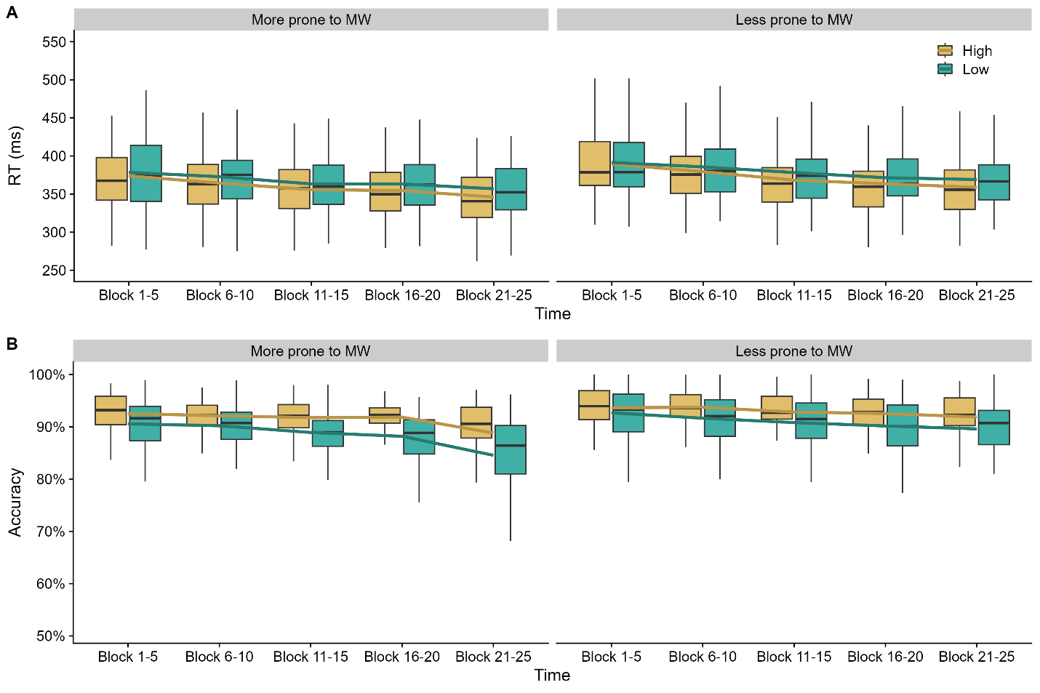
Fig. S3. RT (A) and accuracy (B) for high- and low-probability triplets separately by MW Proneness. The y-axes indicate RT/accuracy, and the x-axes the blocks of the task. Yellow boxes indicate data for high-probability triplets and turqouise boxes that of for low-probability triplets. The lower and upper hinges correspond to the first and third quartiles (the 25th and 75th percentiles), whiskers show 1.5 × IQR, horizontal notches show the median. For clarity, outlier values (outside the 1.5 × IQR) are not shown. The difference between the two lines indicate statistical learning.

We run the same analysis as described above with accuracy data. Results are presented in Table S9 and visualized in Fig. S3B. The group with more overall MW was less accurate throughout the task [main effect of MW Proneness: F(1, 133) = 10.611, p = .001, η_{p}² = .074]. The interaction between MW Proneness and Time indicates that the trajectory of accuracy change differs between the two groups: there is a sharper decline in accuracy for the more MW group towards the end of the task [Time 5 differ (p < .001) from every other timepoint in MW group, while Time 5 differs only from Time 1 (p = .001 and Time 2 in p = .02]. The interaction between MW Proneness and Triplet Type indicates that statistical learning is higher for participants that engaged in more MW during the task, F(1, 133) = 8.807, p = .004, η_{p}² = .062. The three-way interaction between MW Proneness, Time, and Triplet Type was non-significant, F(3.86, 513.56) = 1.853, p = .120, η_{p}² = .014], indicating that the effect of of MW Proneness did not change as the task progressed (Table S9).

Table S9. Results of the ANOVA for accuracy data comparing groups of participants by MW Proneness
Effect | df | F-value | p-value
MW Proneness | 1, 133 | 10.61** | .001
Time | 2.48, 330.49 | 22.66*** | < .001
Triplet Type | 1, 133 | 216.44*** | < .001
MW Proneness × Time | 2.48, 330.49 | 3.77* | .016
MW Proneness × Triplet Type | 1, 133 | 8.81** | .004
Time × Triplet Type | 3.86, 513.56 | 6.52*** | < .001
MW Proneness × Time × Triplet Type | 3.86, 513.56 | 1.85 | .120
Significance codes: *** < .001, ** < .01, * < .05, + < .10

S4. Further non-preregistered analysis

S4.1. What was the impact of overall MW on learning?
To be consistent with the analysis in the main text, the preregistered between-subject ANOVA analysis was repeated with linear mixed models. Here, we wondered how the predisposition to MW (i.e., the mean score of the thought probes) across participants influences learning processes. To determine if overall MW affects learning, linear mixed models were fitted on data over blocks with the same outcome variables (median RT and mean accuracy). Block (Block 1-25), Triplet Type (high- vs. low-probability), MW Proneness (more vs. less prone to MW; determined by median split of the mean values of thought probes) as well as their interactions served as fixed effects in the models. The final model for RT data achieved convergence using participants as random intercepts and by-participants random slopes for Blocks for accuracy data.
With respect to RTs, the main effects of Triplet Type and Block, as well as the interaction between Triplet Type and Block can be interpreted similarly as in the previous models. The main effect of MW Proneness indicated that those who were more prone to mind wander were faster on the task (b = -7.584, 95% CI [-14.910, -0.258], t₍₁₃₃₎ = -2.048, p = .043, more MW: 363 ms, 95% CI = [352, 373]; less MW: 378 ms, 95% CI = [368, 388]). The interaction between Block and MW Proneness factors indicates that the slowing effect of more MW increased over time (b = 1.422, 95% CI = [0.714 – 2.130], t₍₆₆₀₉₎ = -3.938, p < .001). The two-way interaction between Triplet Type and MW Proneness, as well as the three-way interaction with Block was not significant (Table S10).

Terms | b | SE b | 95% CI | t | df | p
(Intercept) | 370.3809 | 3.7039 | 363.0547 – 377.7071 | 99.9971 | 133.0000 | <.001
Triplet Type [High] | -3.8402 | 0.3611 | -4.5480 – -3.1324 | -10.6357 | 6609.0000 | <.001
MW Proneness [More prone] | -7.5838 | 3.7039 | -14.9100 – -0.2576 | -2.0475 | 133.0000 | .043
Block | -11.5104 | 0.3611 | -12.2183 – -10.8025 | -31.8764 | 6609.0000 | <.001
Triplet Type [High] × MW Proneness [More prone] | -0.4154 | 0.3611 | -1.1232 – 0.2924 | -1.1504 | 6609.0000 | .250
Triplet Type [High] × Block | -1.1988 | 0.3611 | -1.9066 – -0.4909 | -3.3199 | 6609.0000 | .001
MW Proneness [More prone] × Block | 1.4220 | 0.3611 | 0.7141 – 2.1298 | 3.9379 | 6609.0000 | <.001
Triplet Type [High] × MW Proneness [More prone] × Block | 0.5209 | 0.3611 | -0.1870 – 1.2288 | 1.4425 | 6609.0000 | 0.149
Random Effects
σ² | 879.95
τ₀₀ _{Subject} | 1834.36
ICC | 0.68
N _{Subject} | 135
Observations | 6750
Marginal R² / Conditional R² | 0.071 / 0.699
Table S10. Results of the linear mixed model, predicting block-wise median RTs. The marginal R-squared considers only the variance of the fixed effects, while the conditional R-squared takes both the fixed and random effects into account (based on Nakagawa, Johnson, & Schielzeth, 2017). Degrees of freedom are based on Satterthwaite’s approximation. Significant terms are highlighted in bold.

We run the same analysis as described above with accuracy data. The main effects of Triplet Type and Block can be interpreted similarly as in the previous models. The main effect of MW Proneness indicated that those who were more prone to mind wander was less accurate (b = -0.010, 95% CI = [-0.016, -0.004], t_{(133.025)} = -3.286, p = .001, more MW: 89.9%, 95% CI = [89.1%, 90.8%]; less MW, 95% CI = [91.1, 92.8]). The interaction between Triplet Type and MW Proneness indicates that participants who were more prone to mind wander in general showed higher difference between high- and low-probability triplets, i.e., better statistical learning (b = 0.002, 95% CI = [0.001, 0.004], t_{(6476.001)} = 2.943, p = .003, more MW: 3%, less MW: 1.9%). The interaction between Block and MW Proneness factors indicated that in MW periods, participants who were more prone to mind wander were less accurate towards the end of the task (b = -0.004, 95% CI = [-0.007, -0.0001], t_{(132.979)} = -2.047, p = .043). However, the three-way interaction between MW, Triplet Type, and Block was not significant (Table S11).

Terms | b | SE b | 95% CI | t | df | p
(Intercept) | 0.9093 | 0.0031 | 0.9033 – 0.9154 | 296.4125 | 133.0249 | <.001
Triplet Type [High] | 0.0124 | 0.0009 | 0.0107 – 0.0141 | 14.4819 | 6476.0007 | <.001
MW Proneness [More prone] | -0.0101 | 0.0031 | -0.0161 – -0.0040 | -3.2856 | 133.0249 | .001
Block | -0.0122 | 0.0017 | -0.0157 – -0.0088 | -7.0211 | 132.9792 | <.001
Triplet Type [High] × MW Proneness [More prone] | 0.0025 | 0.0009 | 0.0008 – 0.0042 | 2.9435 | 6476.0007 | .003
Triplet Type [High] × Block | 0.0033 | 0.0009 | 0.0016 – 0.0049 | 3.7942 | 6476.0007 | <.001
MW Proneness [More prone] × Block | -0.0036 | 0.0017 | -0.0070 – -0.0001 | -2.0473 | 132.9792 | .043
Triplet Type [High] × MW Proneness [More prone] × Block | 0.0012 | 0.0009 | -0.0005 – 0.0029 | 1.3756 | 6476.0007 | .169
Random Effects
σ² | 0.00
τ₀₀ _{Subject} | 0.00
τ₁₁ _{Subject.re1.Block} | 0.00
ρ₀₁ _{Subject} | 0.40
ICC | 0.19
N _{Subject} | 135
Observations | 6750
Marginal R² / Conditional R² | 0.067 / 0.245
Table S11. Results of the linear mixed model, predicting block-wise mean accuracy. The marginal R-squared considers only the variance of the fixed effects, while the conditional R-squared takes both the fixed and random effects into account (based on Nakagawa, Johnson, & Schielzeth, 2017). Degrees of freedom are based on Satterthwaite’s approximation. Significant terms are highlighted in bold.

S4.2 How did mind blanking affect learning?
Mind blanking (MB) is a special manifestation of attentional lapses during cognitive tasks, after which participants do not have conscious access to the content of their stream of thought (Ward & Wegner, 2013). MB has been associated with a cognitive profile and neural mechanisms that are distinct from MW with reportable content, pointing at the differential contribution of these two mental states to off-line memory consolidation (Andrillon, Burns, Mackay, Windt, & Tsuchiya, 2021). Furthermore, MB has increased prevalence in individuals with attention-deficit/hyperactivity disorder (ADHD; Van den Driessche et al., 2017), and children with ADHD also show atypical learning in the ASRT task (Barnes, Howard, Howard, Kenealy, & Vaidya, 2010). Therefore, we hypothesized that the effects of task-unrelated thoughts on statistical learning in the ASRT task would be more prominent during episodes of MB than preceding MW reports with reportable content.
Overall, 117 of the 135 participants showed periods of MW, i.e., responded 1-2 on Q1 (see “Thought probes”). Thus, results from the second (mind blanking vs. MW) and third (spontaneous vs. deliberate focus) questions of the thought probes could be analyzed for these participants. Fig. S4 provides descriptive data about the amount of mind blanking (MB) throughout the task. Among the blocks where participants reported MW, 46.01% of them were reported as mind-blanking (MB) blocks. From the 117 participants, 21 reported MW only, but no MB at all, whereas 11 reported only MB, but no MW with reportable content.

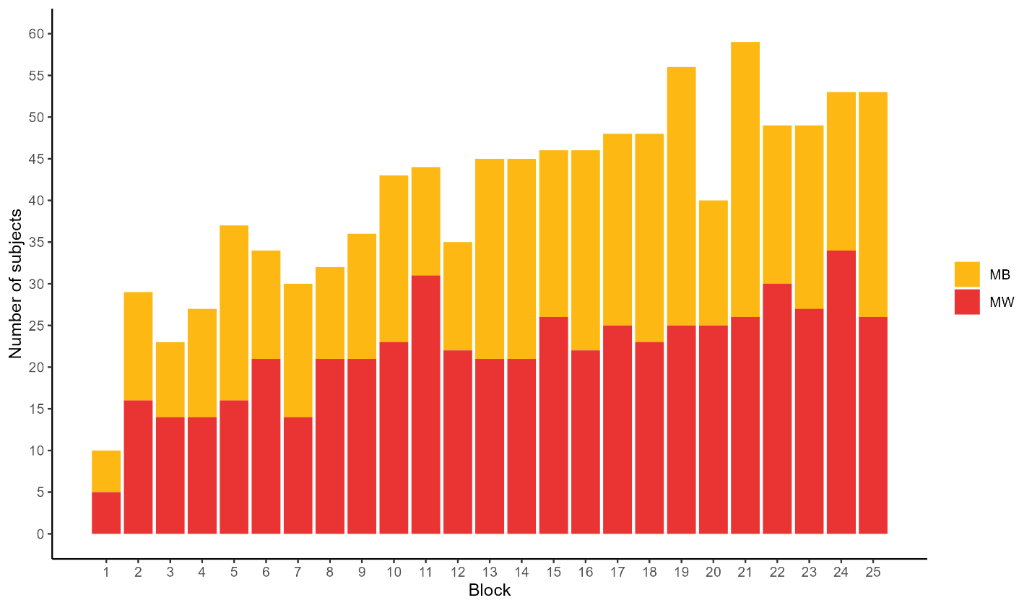
Fig. S4. The number of MB and MW periods in the blocks where participants reported MW. In the graph, the x-axis represents the different blocks of the task, while the y-axis displays the number of participants who responded 1-2 of the first question of the thought probes. The stacked barplots are color-coded to show the distribution of participants who reported different mental states. Specifically, the yellow segments of the bars represent the number of participants who reported being MB, while the red segments indicate the number of participants who reported MW.

Linear mixed models with the same parameters as for the on-task/off-task questions were fitted on the data of the other two thought probe questions. However, here, only those blocks were considered where MW (response 1 or 2) was indicated at the first question. Responses 1-2 were considered as mind blanking (MB) periods, and responses 3-4 as MW periods. Final models achieved convergence using random intercept for participants with by-participant correlated slopes for the Block factor.
The results of RT data can be found in Table S12. The main effect of Triplet Type and Block can be interpreted similarly to the analysis presented in the main text. The main effect of MB indicated faster RTs during mind blanking periods (b = -2.407, 95% CI = [-4.093, -0.720], t_{(1974.894)} = -2.799, p = .005, MB: 360 ms, 95% CI = [353, 368]; MW: 365 ms, 95% CI = [357, 372]) (Fig. S5). No other main effects or interactions were significant, indicating a lack of difference in statistical learning between MB and MW periods (Table S12).

Terms | b | SE b | 95% CI | t | df | p
(Intercept) | 359.5941 | 3.6520 | 352.3615 – 366.8266 | 98.4653 | 117.0004 | <.001
Triplet Type [High] | -4.6673 | 0.6647 | -5.9710 – -3.3636 | -7.0216 | 1806.1603 | <.001
MB [MB] | -2.4065 | 0.8599 | -4.0929 – -0.7202 | -2.7987 | 1975.4104 | .005
Block | -11.7127 | 1.6073 | -14.9064 – -8.5191 | -7.2872 | 89.0828 | .001
Triplet Type [High] × MB [MB] | -0.2727 | 0.6647 | -1.5763 – 1.0310 | -0.4102 | 1806.1603 | .682
Triplet Type [High] × Block | -0.0861 | 0.6656 | -1.3915 – 1.2194 | -0.1293 | 1806.1603 | .897
MB [MB] × Block | -0.3843 | 0.8415 | -2.0347 – 1.2660 | -0.4568 | 1835.1440 | .648
Triplet Type [High] × MB [MB] × Block | -0.1465 | 0.6656 | -1.4519 – 1.1589 | -0.2201 | 1806.1603 | .826
Random Effects
σ² | 892.85
τ₀₀ _{Subject} | 1444.01
τ₁₁ _{Subject.re1.block} | 190.12
ρ₀₁ | -0.14
ICC | 0.62
N _{Subject} | 117
Observations | 2034
Marginal R² / Conditional R² | 0.066 / 0.643
Table S12. Results of the linear mixed model, predicting block-wise median RTs. The marginal R-squared considers only the variance of the fixed effects, while the conditional R-squared takes both the fixed and random effects into account (based on Nakagawa, Johnson, & Schielzeth, 2017). Degrees of freedom are based on Satterthwaite’s approximation. Significant terms are highlighted in bold.

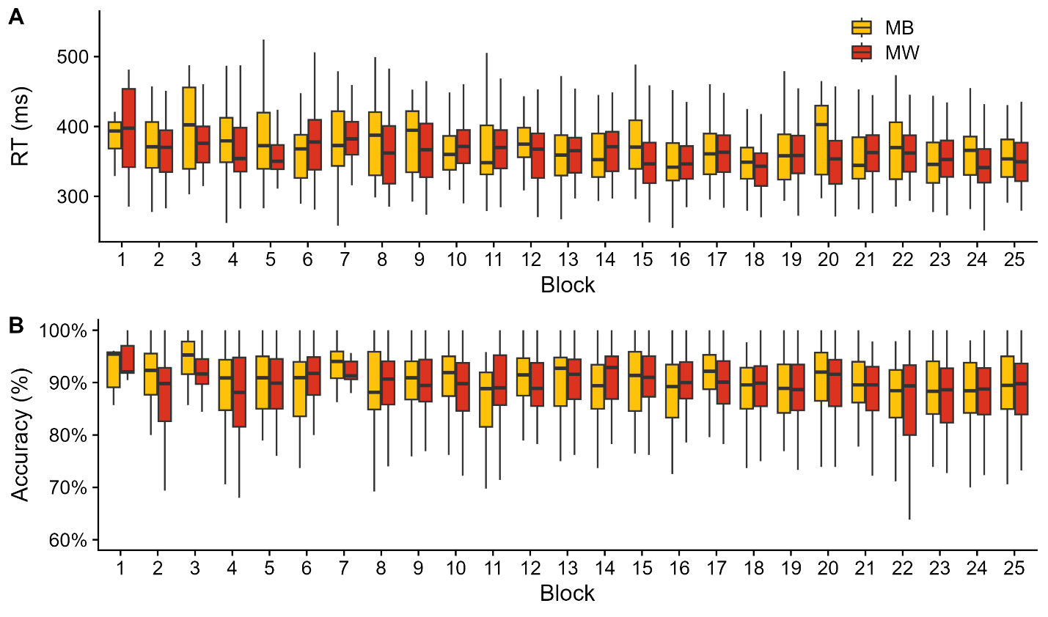
Fig. S5. RT (A) and accuracy (B) over the course of the task by MB/MW periods. The y-axes indicate RT/accuracy, and the x-axes indicate the blocks of the task. Red boxplots sign individual data of the MW, and yellow boxplots the mind blanking periods. The lower and upper hinges correspond to the first and third quartiles (the 25th and 75th percentiles), whiskers show 1.5 × IQR, and horizontal notches show the median. Outlier values (outside the 1.5 × IQR) are not shown for clarity.

The results of the accuracy data are presented in Table S13. The main effect of Triplet Type and Block can be interpreted similarly to the analysis presented in the main text. No other main effects or interactions were significant.
Terms | b | SE b | 95% CI | t | df | p
(Intercept) | 0.8793 | 0.0050 | 0.8695 – 0.8892 | 176.5834 | 104.2693 | <.001
Triplet Type [High] | 0.0164 | 0.0019 | 0.0127 – 0.0201 | 8.7228 | 1804.2592 | <.001
MB [MB] | -0.0054 | 0.0023 | -0.0100 – -0.0009 | -2.3504 | 1933.5081 | .019
Block | -0.0178 | 0.0043 | -0.0263 – -0.0093 | -4.1543 | 89.2985 | <.001
Triplet Type [High] × MB [MB] | -0.0027 | 0.0019 | -0.0063 – 0.0010 | -1.4109 | 1804.2592 | .158
Triplet Type [High] × Block | 0.0032 | 0.0019 | -0.0005 – 0.0069 | 1.6891 | 1804.2592 | .091
MB [MB] × Block | -0.0026 | 0.0023 | -0.0071 – 0.0019 | -1.1293 | 1592.9244 | .259
Triplet Type [High] × MB [MB] × Block | -0.0026 | 0.0019 | -0.0062 – 0.0011 | -1.3537 | 1804.2592 | .176
Random Effects
σ² | 0.01
τ₀₀ _{Subject} | 0.00
τ₁₁ _{Subject.re1.block} | 0.00
ρ₀₁ | 0.72
ICC | 0.23
N _{Subject} | 117
Observations | 2034
Marginal R² / Conditional R² | 0.065 / 0.284
Table S13. Results of the linear mixed model, predicting block-wise mean accuracy. The marginal R-squared considers only the variance of the fixed effects, while the conditional R-squared takes both the fixed and random effects into account (based on Nakagawa, Johnson, & Schielzeth, 2017). Degrees of freedom are based on Satterthwaite’s approximation. Significant terms are highlighted in bold.

As some participants did not report both MW and MW periods, we performed a more selective analysis by including data from only those participants, who reported experiencing both types of off-task states (N=85). This analysis did not reveal any significant main effects or interactions related to the MB/MW factor with regards to both response time and accuracy (analysis codes are provided for these analyses too).
Overall, we did not find evidence that MB influences visuomotor performance or statistical learning differently than conventional MW episodes with reportable content. While our primary analysis found MB to be associated with faster responses, which is in contrast with a recent report showing that during MB, participants become rather more sluggish (Andrillon et al., 2021), our subsequent analysis with a smaller sample size, but including only participants reporting both forms of off-task periods, did not confirm this. Therefore, we conclude that whether one’s mind wanders with or without reportable content does not influence learning profiles in the ASRT task.

S4.3 How did the spontaneous vs. deliberate focus orientation affect learning?
MW is a heterogeneous mental phenomenon regulated via both automatic and deliberate constraints (Christoff, Irving, Fox, Spreng, & Andrews-Hanna, 2016). Along these lines, an important distinction between different manifestations of MW is whether it occurs spontaneously or intentionally (Seli, Risko, Smilek, & Schacter, 2016). Spontaneous MW seems to be more detrimental to cognitive performance than deliberately initiated MW (Robison & Unsworth, 2018), and is also more characteristic of individuals with ADHD traits (Seli, Smallwood, Cheyne, & Smilek, 2015). Based on these observations, we hypothesized that the intentionality of task-unrelated thoughts might play a role in how MW episodes influence visuomotor performance and the extraction of statistical relationships between task-stimuli in the ASRT task.
Again, only those blocks were considered in the analysis where MW (response 1 or 2) was indicated at the first question. Responses 1-2 were considered as spontaneous periods, and responses 3-4 as deliberate periods. Fig. S6 provides descriptive data about the amount of spontaneous and deliberate focus periods throughout the task. Among the blocks where participants reported MW, 23.80% of them were reported as deliberate blocks. Out of 117 participants, 34 did not report deliberate, only spontaneous MW, while 8 reported only deliberate but no spontaneous MW.

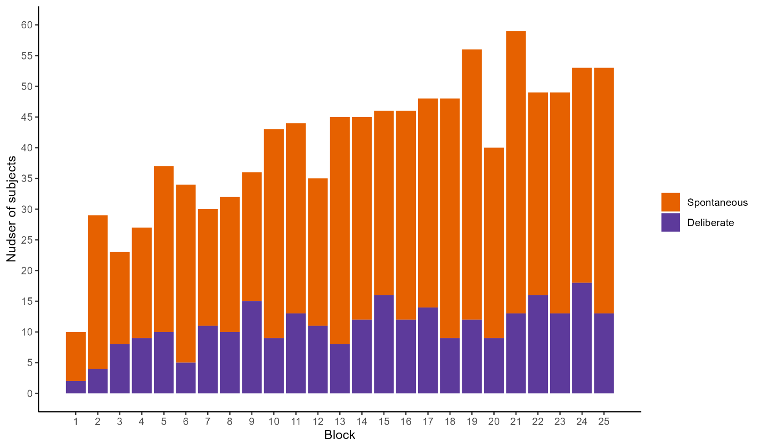
Fig. S6. The number of spontaneous and deliberate focus periods in the blocks where participants reported MW. In the graph, the x-axis represents the different blocks of the task, while the y-axis displays the number of participants who responded 1-2 of the first question of the thought probes. The stacked barplots are color-coded to show the distribution of participants who reported different mental states. Specifically, the orange segments of the bars represent the number of participants who reported having spontaneous focus, while the purple segments indicate the number of participants who reported having deliberate focus.

Final model for RT and accuracy data achieved convergence using participants as random intercepts with by-participant uncorrelated slopes for the Block and Focus (spontaneous vs. deliberate) factors. Reaction time results can be found in Table S14. The main effect of Triplet Type and Block can be interpreted similarly to the analysis presented in the main text. There was an interaction between Focus and Block, indicating faster RTs on spontaneous focus periods as the task progressed (b = 2.367, 95% CI = [0.385, 4.349], t_{(1304.360)} = 2.343, p = .019). No other main effects or interactions were significant, indicating a lack of difference in statistical learning between spontaneous and deliberate focus periods (Table S14).

Terms | b | SE b | 95% CI | t | df | p
(Intercept) | 360.0281 | 3.7164 | 352.6659 – 367.3904 | 96.8751 | 113.9221 | <.001
Triplet Type [High] | -4.5527 | 0.7264 | -5.9774 – -3.1279 | -6.2672 | 1730.6120 | <.001
Focus [Spontaneous] | -1.1948 | 1.5540 | -4.2917 – 1.9022 | -0.7688 | 73.1361 | .444
Block | -12.4844 | 1.6718 | -15.7987 – -9.1701 | -7.4678 | 106.2639 | <.001
Triplet Type [High] × Focus [Spontaneous] | -0.2050 | 0.7264 | -1.6297 – 1.2198 | -0.2822 | 1730.6120 | .778
Triplet Type [High] × Block | -0.2144 | 0.7283 | -1.6429 – 1.2141 | -0.2944 | 1730.6120 | .769
Focus [Spontaneous] × Block | 2.3667 | 1.0103 | 0.3847 – 4.3487 | 2.3426 | 1304.3614 | .019
Triplet Type [High] × Focus [Spontaneous] × Block | 0.2964 | 0.7283 | -1.1321 – 1.7249 | 0.4069 | 1730.6120 | .684
Random Effects
σ² | 841.14
τ₀₀ _{Subject} | 1435.71
τ₁₁ _{Subject.re1.Focus} | 111.90
τ₁₁ _{Subject.re1.} | 187.02
ρ₀₁ | 0.00
 | -0.15
ICC | 0.63
N _{Subject} | 117
Observations | 2034
Marginal R² / Conditional R² | 0.064 / 0.654
Table S14. Results of the linear mixed model, predicting block-wise median RTs. The marginal R-squared considers only the variance of the fixed effects, while the conditional R-squared takes both the fixed and random effects into account (based on Nakagawa, Johnson, & Schielzeth, 2017). Degrees of freedom are based on Satterthwaite’s approximation. Significant terms are highlighted in bold.

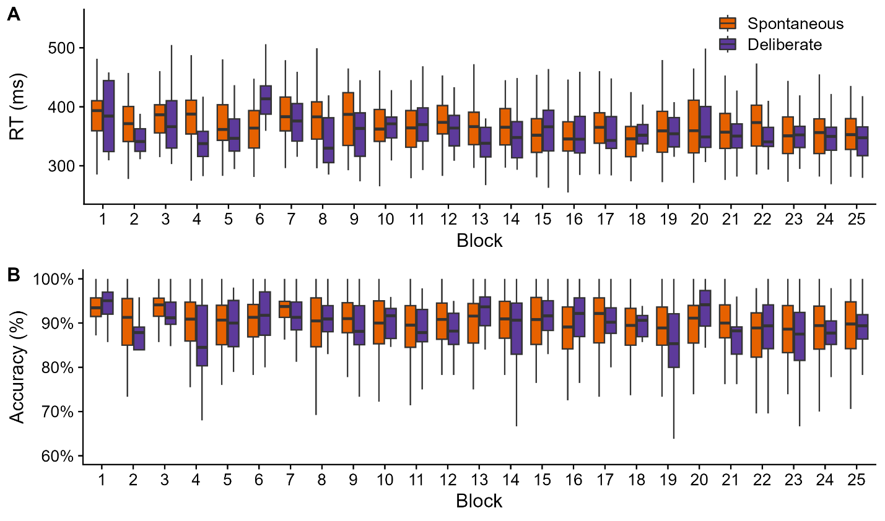
Fig. S7. RT (A) and accuracy (B) over the course of the task by spontaneous/deliberate focus periods. The y-axes indicate RT/accuracy, and the x-axes indicate blocks of the task. Orange boxplots indicate individual data of the spontaneous focus periods and purple boxplots the deliberate focus periods. The lower and upper hinges correspond to the first and third quartiles (the 25th and 75th percentiles), whiskers show 1.5 × IQR, horizontal notches show the median. Outlier values (outside the 1.5 × IQR) are not shown for clarity.

The final model for accuracy data achieved convergence using the by-participant intercept with by-participant correlated slopes for the Block and Focus factors. Results can be found in Table S15. The main effect of Triplet Type and Block can be interpreted similarly to the analysis presented in the main text. No other main effects or interactions were significant (Table S15).

Terms | b | SE b | 95% CI | t | df | p
(Intercept) | 0.8780 | 0.0052 | 0.8676 – 0.8884 | 167.8929 | 90.9508 | <.001
Triplet Type [High] | 0.0172 | 0.0021 | 0.0131 – 0.0213 | 8.2599 | 1753.2022 | <.001
Focus [Spontaneous] | 0.0040 | 0.0037 | -0.0034 – 0.0113 | 1.0772 | 81.2521 | .285
Block | -0.0176 | 0.0044 | -0.0263 – -0.0089 | -4.0096 | 109.4091 | <.001
Triplet Type [High] × Focus [Spontaneous] | -0.0013 | 0.0021 | -0.0054 – 0.0028 | -0.6152 | 1753.2022 | .539
Triplet Type [High] × Block | 0.0040 | 0.0021 | -0.0000 – 0.0081 | 1.9376 | 1753.2022 | .053
MB [MB] × Block | -0.0006 | 0.0027 | -0.0058 – 0.0046 | -0.2194 | 1064.3449 | .826
Triplet Type [High] × Focus [Spontaneous] × Block | -0.0014 | 0.0021 | -0.0055 – 0.0027 | -0.6690 | 1753.2022 | .504
Random Effects
σ² | 0.01
τ₀₀ _{Subject} | 0.00
τ₁₁ _{Subject.re1.Focus} | 0.00
τ₁₁ _{Subject.re1.Block} | 0.00
ρ₀₁ | -0.10
 | 0.75
ICC | 0.24
N _{Subject} | 117
Observations | 2034
Marginal R² / Conditional R² | 0.064 / 0.285
Table S15. Results of the linear mixed model, predicting block-wise mean accuracy. The marginal R-squared considers only the variance of the fixed effects, while the conditional R-squared takes both the fixed and random effects into account (based on Nakagawa, Johnson, & Schielzeth, 2017). Degrees of freedom are based on Satterthwaite’s approximation. Significant terms are highlighted in bold.

As some participants did not report on both deliberate and non-deliberate periods, we conducted a more focused analysis by restricting the sample to only those who reported both types (N = 75). In this analysis, we did not observe any significant main effects or interactions involving the Focus factor (analysis codes are provided for these analyses too).
In light of these results, we could not provide any evidence for the role of intentionality in the effect of MW on statistical learning. Based on the competition framework that places emphasis on the antagonistic relationship between cognitive control and statistical learning (Daw, Niv, & Dayan, 2005; Poldrack et al., 2001), we assume that the relative depletion of executive resources during MW fostered statistical learning (see Discussion in the main text). The context-regulation hypothesis of MW states that our cognitive resources are dynamically allocated to either the task at hand or to MW, depending on several factors such as goal pertinence, current concerns, or working memory capacity (McVay & Kane, 2012; Smallwood & Andrews-Hanna, 2013). In this view, the current finding suggests that the beneficial effect of MW on statistical learning occurs regardless of how and why cognitive control is compromised, i.e., whether it is initiated deliberately by our participants via wandering away from the task, or if it happens spontaneously, despite their efforts to maintain task-focus.

S.4.4. Is there evidence for a SAT in learning scores?
While the presence of SAT across various cognitive tasks is well-established in the literature, and was also confirmed in the current dataset, we asked if a similar trade-off would characterize the two measures of implicit statistical learning, accuracy and RT. In particular, we noted that learning scores for on-task periods were more homogeneous across the sample for both measures than those calculated for MW, with some participants showing extremely high or low learning scores (Fig. 4C-D). This raises the possibility that learning scores during MW for accuracy and RT would show a negative correlation; that is, participants would either benefit from MW by responding more accurately to high-probability trials at the expense of their corresponding RTs, or vice versa. To investigate this question, we used RT learning scores as the outcome variable in a linear mixed model including Block (Block 1-25), MW (MW vs. on-task periods) and accuracy learning scores as well as their interaction as fixed effects in the model, and random intercepts and slopes for Block for each participant.
The model resulted in a statistically significant main effect of Block, indicating that participants' RT learning scores generally increased with Time (b = 0.23, 95% CI = [0.09, 0.37], t_{(192.727)} = 3.258, p = .001). The main effect of MW also approached statistical significance, indicating somewhat higher RT learning scores for MW, than on-task periods (b = 0.92, 95% CI = [-0.01, 1.86], t_{(2148.096)} = 1.933, p = .053, statistical learning scores in MW periods: 9.17 ms, 95% CI = [7.49, 10.86]; on-task periods: 7.33 ms, 95% CI = [6.16, 8.49]). There was also a statistically significant interaction between Block and MW (b = -0.20, 95% CI = [-0.33, -0.07], t_{(1675.334)} = -3.053, p = .002). Post hoc estimated marginal trends revealed that whereas the slope of Block was positive for on-task periods (b = 0.431, 95% CI = [0.287, 0.574]), it was not significantly different from 0 for MW periods (b = 0.027, 95% CI = [-0.199, 0.254]). Neither the main effect of accuracy, nor any of its interaction terms with other variables was statistically significant. Thus, there is no evidence that a speed/accuracy trade-off also exists in learning scores, either during MW or on-task periods, and no further analysis with MW was carried out. Full model results are reported in Table S16.

Terms | b | SE b | 95% CI | t | df | p
(Intercept) | 8.2522 | 0.5596 | 7.1477 – 9.3567 | 14.7462 | 173.8169 | <.001
ACC | -0.0218 | 0.0550 | -0.1297 – 0.0862 | -0.3952 | 3360.4880 | .693
Block | 0.2289 | 0.0703 | 0.0904 – 0.3675 | 3.2585 | 192.7272 | .001
MW [MW] | 0.9223 | 0.4772 | -0.0134 – 1.8581 | 1.9329 | 2148.0964 | .053
ACC × Block | -0.0046 | 0.0078 | -0.0199 – 0.0107 | -0.5929 | 3317.6133 | .553
ACC × MW [MW] | 0.0652 | 0.0548 | -0.0423 – 0.1727 | 1.1893 | 3335.6456 | .234
Block × MW [MW] | -0.2017 | 0.0661 | -0.3312 – -0.0721 | -3.0528 | 1675.3335 | .002
ACC × Block × MW [MW] | -0.0005 | 0.0078 | -0.0158 – 0.0147 | -0.0698 | 3347.3481 | .944
Random Effects
σ² | 541.47
τ₀₀ _{Subject} | 14.38
τ₁₁ _{Subject.Block2} | 0.12
ρ₀₁ _{Subject} | -0.43
ICC | 0.04
N _{Subject} | 135
Observations | 3375
Marginal R² / Conditional R² | 0.010 / 0.047
Table S16. Results of the linear mixed model of the SAT in learning scores, predicting block-wise RT learning scores. The marginal R-squared considers only the variance of the fixed effects, while the conditional R-squared takes both the fixed and random effects into account (based on Nakagawa, Johnson, & Schielzeth, 2017). Degrees of freedom are based on Satterthwaite’s approximation. Significant terms are highlighted in bold. Terms in brackets indicate the level of the factor that is contrasted against the reference level.

References
Andrillon, T., Burns, A., Mackay, T., Windt, J., & Tsuchiya, N. (2021). Predicting lapses of attention with sleep-like slow waves. Nature Communications, 12(1), 1–12. https://doi.org/10.1038/s41467-021-23890-7
Barnes, K. A., Howard, J. H., Howard, D. V., Kenealy, L., & Vaidya, C. J. (2010). Two forms of implicit learning in childhood ADHD. Developmental Neuropsychology, 35(5), 494–505. https://doi.org/10.1080/87565641.2010.494750
Christoff, K., Irving, Z. C., Fox, K. C. R., Spreng, R. N., & Andrews-Hanna, J. R. (2016). Mind-wandering as spontaneous thought: A dynamic framework. Nature Reviews Neuroscience, 17(11), 718–731. https://doi.org/10.1038/nrn.2016.113
Daw, N. D., Niv, Y., & Dayan, P. (2005). Uncertainty-based competition between prefrontal and dorsolateral striatal systems for behavioral control. Nature Neuroscience, 8(12), 1704–1711. https://doi.org/10.1038/nn1560
McVay, J. C., & Kane, M. J. (2012). Drifting from slow to “D’oh!”: Working memory capacity and mind wandering predict extreme reaction times and executive control errors. Journal of Experimental Psychology: Learning Memory and Cognition, 38(3), 525–549. https://doi.org/10.1037/a0025896
Mrazek, M. D., Phillips, D. T., Franklin, M. S., Broadway, J. M., & Schooler, J. W. (2013). Young and restless: validation of the Mind-Wandering Questionnaire (MWQ) reveals disruptive impact of mind-wandering for youth. Frontiers in Psychology, 4, 560. https://doi.org/10.3389/FPSYG.2013.00560
Nakagawa, S., Johnson, P. C. D., & Schielzeth, H. (2017). The coefficient of determination R2 and intra-class correlation coefficient from generalized linear mixed-effects models revisited and expanded. Journal of The Royal Society Interface, 14(134). https://doi.org/10.1098/RSIF.2017.0213
Poldrack, R. A., Clark, J., Paré-Blagoev, E. J., Shohamy, D., Creso Moyano, J., Myers, C., & Gluck, M. A. (2001). Interactive memory systems in the human brain. Nature, 414(6863), 546–550. https://doi.org/10.1038/35107080
Robison, M. K., & Unsworth, N. (2018). Cognitive and contextual correlates of spontaneous and deliberate mind-wandering. Journal of Experimental Psychology: Learning Memory and Cognition, 44(1), 85–98. https://doi.org/10.1037/xlm0000444
Seli, P., Risko, E. F., Smilek, D., & Schacter, D. L. (2016). Mind-wandering with and without intention. Trends in Cognitive Sciences, Vol. 20, pp. 605–617. https://doi.org/10.1016/j.tics.2016.05.010
Seli, P., Smallwood, J., Cheyne, J. A., & Smilek, D. (2015). On the relation of mind wandering and ADHD symptomatology. Psychonomic Bulletin and Review, 22(3), 629–636. https://doi.org/10.3758/s13423-014-0793-0
Smallwood, J., & Andrews-Hanna, J. (2013). Not all minds that wander are lost: The importance of a balanced perspective on the mind-wandering state. Frontiers in Psychology, 4(AUG), 441. https://doi.org/10.3389/fpsyg.2013.00441
Van den Driessche, C., Bastian, M., Peyre, H., Stordeur, C., Acquaviva, É., Bahadori, S., … Sackur, J. (2017). Attentional lapses in Attention-Deficit/Hyperactivity Disorder: Blank rather than wandering thoughts. Psychological Science, 28(10), 1375–1386. https://doi.org/10.1177/0956797617708234
Ward, A. F., & Wegner, D. M. (2013). Mind-blanking: When the mind goes away. Frontiers in Psychology, 4(SEP), 650. https://doi.org/10.3389/fpsyg.2013.00650

