Supplementary Material

Magnetic Measurements and Microscopy
In order to verify the generality of the weak areas observed, another magnet with similar composition and processing has been observed. Magnetization curves of both samples and the reference are compared in Fig. S1. The initial curves show the expected pinning type behavior, with B5 having a higher initial susceptibility. Remanent polarization is almost the same but the demagnetization behavior shows some differences: The polarization of B4 undergoes a drop at demagnetizing fields as low as 0.3 T and then is undergoing slower demagnetization with increasing demagnetizing fields, being accelerated at about 1.1 T before getting quickly demagnetized when surpassing 2.0 T. For sample B5 however, the step-like drop at low fields is almost not present but the accelerated demagnetization with increasing fields above 1.0 T is more pronounced. Moreover, the quick demagnetization is starting at lower fields. For the reference sample both, the delay of the initial curve as well as the continuous demagnetization exceed the behavior of the current samples.

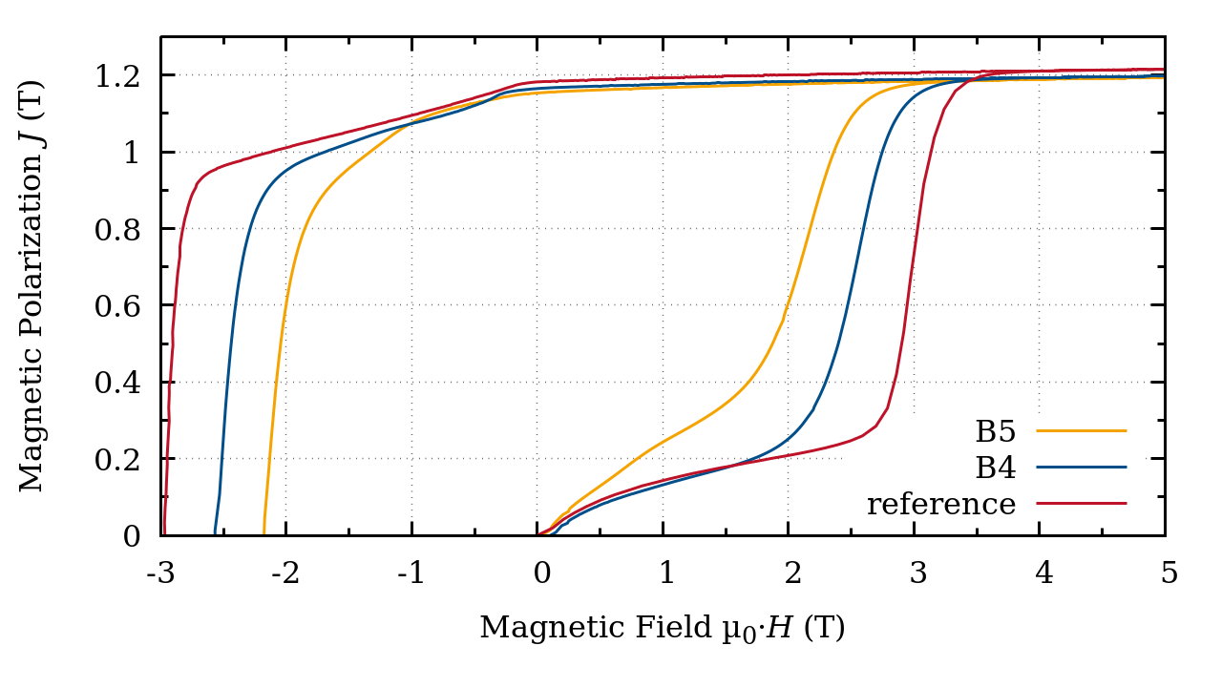
Fig. S1: Initial curve and demagnetization of the samples B5, B4 and the reference sample after applying a field of 14 T. All samples show a pinning-like initial magnetization curve with significantly higher initial susceptibility and weaker pinning in the case of B5. At demagnetizing fields as small as 0.3 T a shoulder appears for the sample B4, lowering its BH_{max}. Contrary to the reference sample, both B5 and B4 show a two-step demagnetization with increased susceptibilities in demagnetizing fields larger than approximately 1.0 T.

A glimpse at Fig. S2 also reveals a difference in grain size: B4 has an average grain size of 74 µm, whereas the grain size in B5 is 200 µm (cp. Tab. S2). In contrast to the overaged microstructure of B5, there are no additional Zr-rich precipitates in B4, either. Overall B4 is rather underaged.
The difference at low demagnetizing fields may be attributed to the effect of the grain boundaries. B4 has a significantly larger grain boundary volume as compared to B5, thus the magnetic polarization is effected by the magnetic reversal of the grain boundary regions, that takes place at low fields.
Despite the different microscopic morphology, B4 shows the same kind of low coercivity regions. These again may be identified in the thermally demagnetized state, both via SEM and Kerr microscopy as depicted in the top row of Fig. S2. When saturating and afterwards demagnetizing the sample, these regions again act as weak spots showing magnetization reversal before any other area is affected (cp. Fig. S2c).

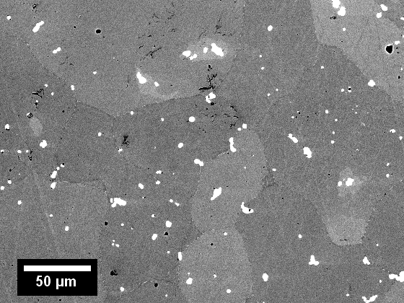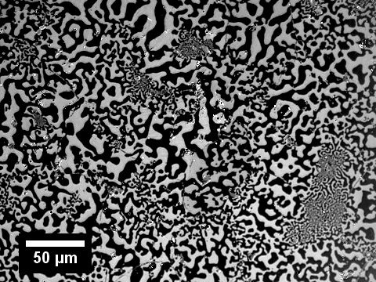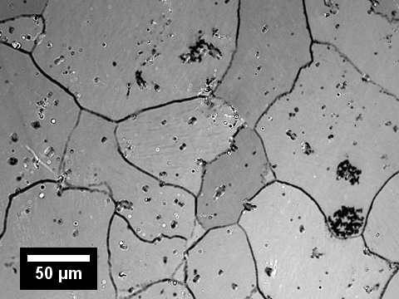
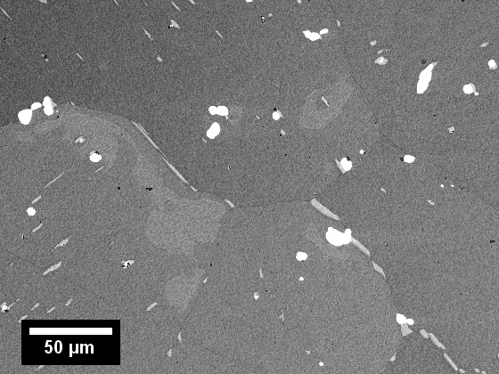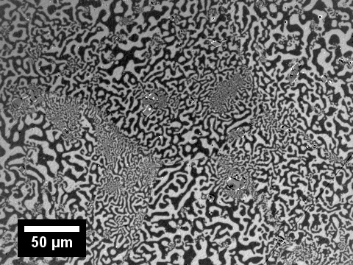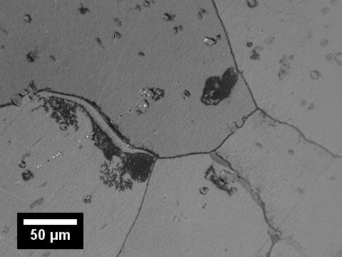
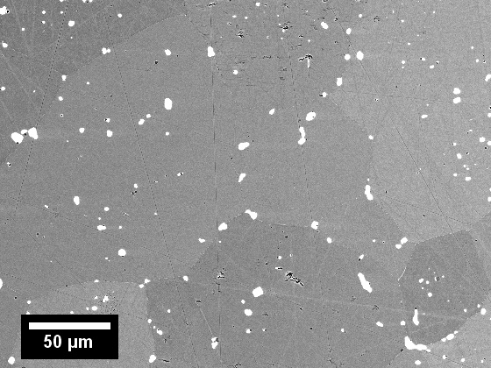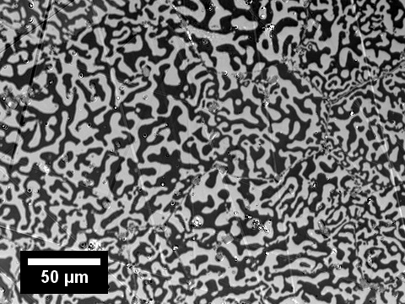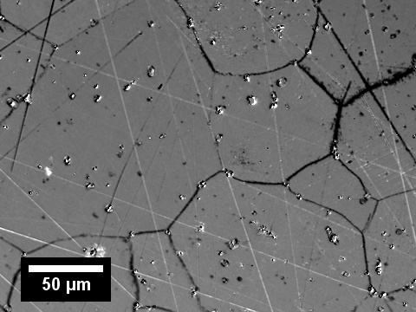
Fig. S2: SEM images using BSE ((a), (d) and (g)) and Kerr microscopy images of the thermally demagnetized state ((b), (e) and (h)) and after applying an external field of 0.8 T ((c), (f) and (i)) to the saturated samples B4 (top row), B5 (middle) and the reference (bottom row) respectively. The same sample regions are shown for SEM and Kerr microscopy.

Tab. S1: Average grain size d_{g} and average cell size d_{c} for both samples in the regular and distorted areas respectively.
sample | grain size  d_{g} / µm | area | cell size  d_{c} / nm
B4 | 74 | high H_{c} | 199(70)
B4 | 74 | low H_{c} | 169(76)
B5 | 200 | high H_{c} | 272(62)
B5 | 200 | low H_{c} | 238(31)

A more detailed view via HR-SEM (Fig. S3) reveals smaller cell sizes in the low coercivity regions of B5. The interface of a low and a high coercivity region show continuous magnetic domains and the difference in domain size in MFM (Fig. S5).

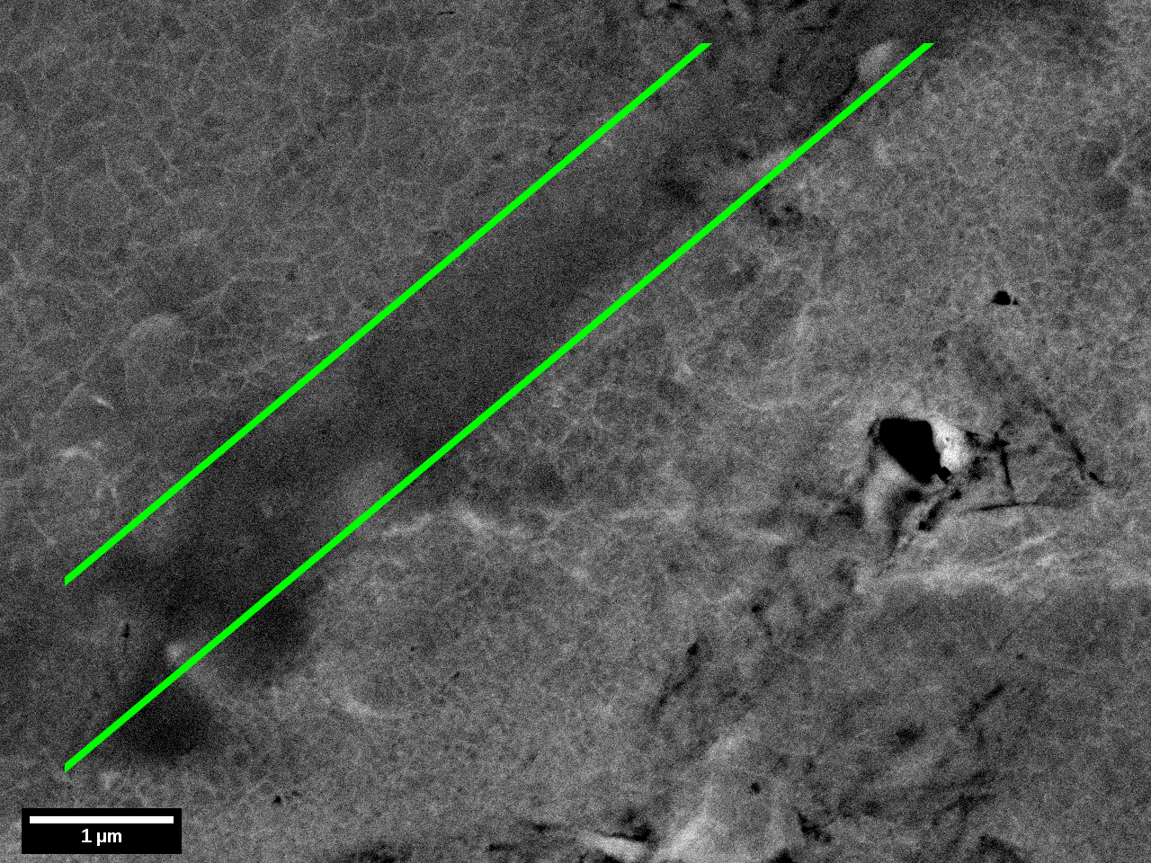
Fig. S3: HR-SEM image of a regular region on the left side of the grain boundary (marked by green lines) and a distorted region on the right. A finer cell structure is visible in the distorted region. The surface is perpendicular to the c-axis of the 2:17 phase.

Table S2: Composition, phase fraction and thicknesses of the respective phases determined from APT data in the high- and low-H_{c} regions in sample B5. The thickness of the 2:17 phases (in italics) was determined from TEM images instead.
Region | Phase | Volume Fraction  v / % | Thickness  d / nm | Composition x / at%
 |  |  |  | Sm | Co | Fe | Cu | Zr
high H_{c} | 2:17 | 78.0±1.6 | 272±62 | 11.0±0.1 | 59.3±0.2 | 27.2±0.1 | 2.1±0.2 | 0.4±0.1
high H_{c} | 1:5 | 6.7±0.5 | 11.7±1.5 | 14.3±0.3 | 48.4±1.0 | 16.5±1.1 | 20.3±1.8 | 0.4±0.1
high H_{c} | Z | 15.2±1.1 | 11.7±4.6 | 10.2±0.8 | 62.0±1.9 | 15.4±1.5 | 3.9±0.7 | 8.5±1.3
high H_{c} | total | – |  | 11.3±0.1 | 58.1±0.2 | 24.7±0.2 | 4.5±0.1 | 1.3±0.1
low H_{c} | 2:17 | 65.1±2.8 | 238±31 | 11.0±0.1 | 59.2±0.1 | 27.7±0.1 | 1.6±0.1 | 0.4±0.1
low H_{c} | 1:5 | 14.8±0.9 | 11.0±2.7 | 15.0±0.4 | 52.3±0.6 | 17.0±0.9 | 15.3±1.1 | 0.4±0.1
low H_{c} | Z | 20.1±1.9 | 10.8±2.8 | 11.7±0.5 | 60.7±0.7 | 16.4±1.1 | 3.8±0.4 | 7.4±1.2
low H_{c} | total | – |  | 12.3±0.2 | 57.4±0.2 | 22.9±0.5 | 5.8±0.4 | 1.5±0.2

Tab. S3: Average concentrations of the elements in the high and low coercivity regions in both samples, B4 and B5, determined by SEM-EDX from six points each. For B5 also values derived from APT scans are given in the two bottom rows for comparison.
sample | area | Samarium  x_{Sm} / wt% | Iron  x_{Fe} / wt% | Cobalt  x_{Co} / wt% | Copper  x_{Cu} / wt% | Zirconium  x_{Zr} / wt%
B4 (EDX) | high H_{c} | 11.8(13) | 24.2(10) | 57.9(10) | 4.6(29) | 1.5(39)
B4 (EDX) | low H_{c} | 12.6(12) | 22.9(10) | 57.5(10) | 5.5(26) | 1.5(39)
B5 (EDX) | high H_{c} | 11.9(13) | 24.3(10) | 57.6(10) | 4.7(29) | 1.5(38)
B5 (EDX) | low H_{c} | 12.6(13) | 23.0(10) | 57.4(10) | 5.4(26) | 1.6(40)
B5 (EDX) | precipitate | 13.3(12) | 15.3(11) | 58.2(10) | 6.3(25) | 6.9(23)
B5 (APT) | high H_{c} | 11.3(1) | 24.7(2) | 58.1(1) | 4.5(1) | 1.3(1)
B5 (APT) | low H_{c} | 12.3(2) | 22.9(5) | 57.4(1) | 5.8(4) | 1.5(2)

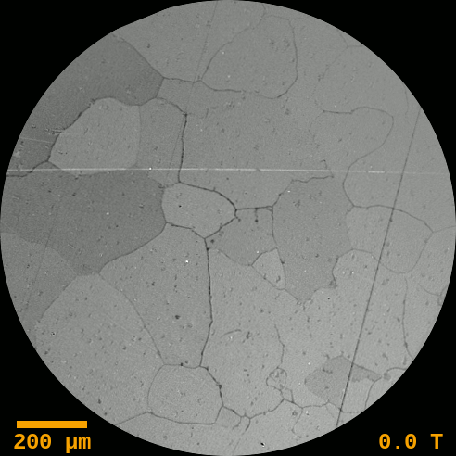
Fig. S4: Animated Kerr image series of demagnetization. The strength of the external field pulse before observation is given in the bottom right.

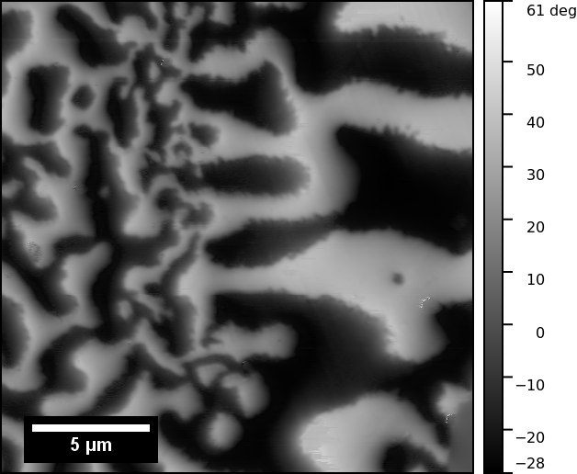
Fig. S5: MFM image of an interface between a low coercivity region (left) and a high coercivity region (right).

Transmission Electron Microscopy
Phase identification for HAADF-STEM was carried out with the help of theoretical structures as shown with the respective overlays in Fig. S6.
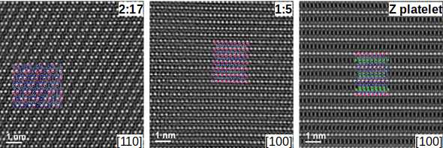
Fig. S6: Atomic stacking of 2:17 R, 1:5, and Z-platelet phases that are used to characterize phases in nanostructures shown in Fig. 2. Images of theoretical structure of phases are superimposed on HAADF images. Pink (Sm), blue (Co), green (Zr).

In order to show the geometrical presence of 2:17 R’ phase in the nanostructure, a representative HRTEM image (Fig. S7a) of high coercivity area is given. Using the fast Fourier transformation of the image (Fig. S7b), and masking only the reflections that belong to 2:17 R’ (purple dashed-circled reflections), the positions where this phase is present are shown (Fig. S7c). As can be seen, 2:17 R’ exist compatibly to the matrix of 2:17 R phase.

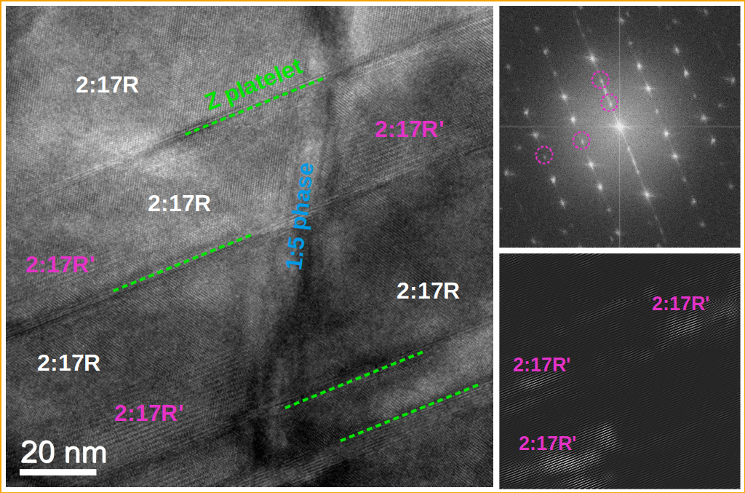
(a)
(b)
(c)
Fig. S7: (a) HRTEM image from the high coercivity area showing the presence of 2:17 R’ phase in the nanostructure. (b) is FFT image of a, and (c) is inverse FFT image of b, filtering only reflections of 2:17 R’ phase.

Magnetic imaging
The infocus image in Fig. S8a shows an approximately 1 µm wide region between the high-H_{c} and low-H_{c} grain, which possess a different microstructure than the that in the core grains. The defocus Fresnel image of the same region (Fig. 4b) shows characteristic zig-zag-shaped magnetic domain walls in high- and low-H_{c} regions and a more linear domain wall in the grain boundary region. Based on the domain wall location, the in-plane magnetic field directions are indicated using arrows in Fig. S8 (b). The domain wall imaging in these regions do not show notable differences that can be attributed to the observed high and low coercivity. Figure S8c shows a Fresnel image recorded from a control TEM specimen that was prepared to confirm the domain wall observations in the grain boundary region and extract information on its magnetic properties. The convergent (white) domain wall contrast runs mostly as straight line with small kinks that suggest presence of pinning sites in this region. Note that the grain boundary region lacks the characteristic lamellar structure that is clearly visible in the high and low-Hc grains. The marked rectangular area in Fig. S8c was further investigated using off-axis electron holography. Figure S8d shows the in-plane magnetic induction map generated from the total electron optical phase shift. The contour lines and colours indicate the in-plane magnetic field strength and direction. It can be observed that the domain wall runs straight in the grain boundary region and contains kinks once it enters to the high-H_{c} regions, possible pinned at the 1:5 phase boundaries. The 180º domain wall segment in the grain boundary region allows to measure the domain wall width, as shown in Fig. 4e, using the differential of the recorded phase shift using a fitting function of the form y=y₀-atanh((x-x₀)/w), where y₀, a, x₀ and w are constants obtained from the fit. The domain wall width 𝛿 is defined as 𝛿=πw and is measured to be as 24 ± 4 nm, which is larger than typical domain width in SmCo₅ which is 2.6 nm based on the literature.
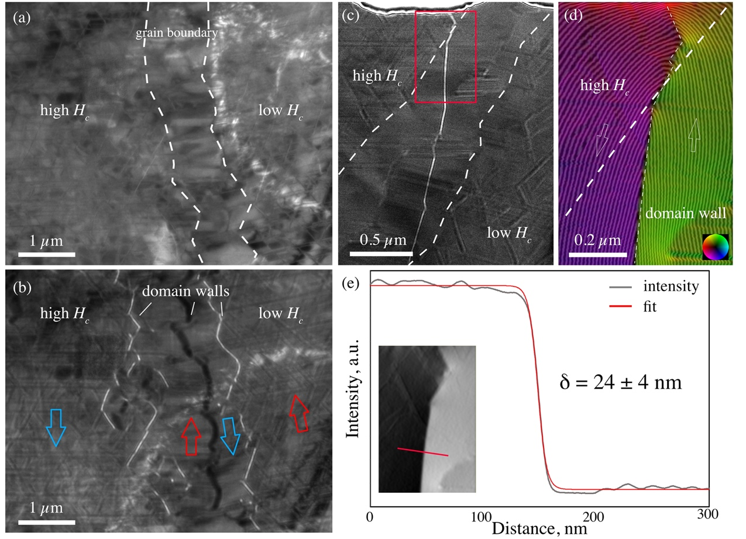
Fig. S8: Magnetic imaging of domain walls with TEM. (a) Infocus and (b) defocus Fresnel images of the high and low-H_{c} grains enclosed by the grain boundary region. Dashed lines in (a) mark the boundary between the grain boundary region and the high- and low-H_{c} grains. The black and white contrast lines in (b) are the magnetic domain walls. The arrows mark the possible in-plane magnetic field directions between the domains. The defocus value was 0.25 mm. (c) Fresnel image of a control specimen showing a magnetic domain wall in the grain boundary region. (d) Magnetic induction map of the marked area in (c). The contour lines and colour indicate the magnetic field strength and direction at in-plane. The contour spacing is 2π/6 rad. (e) Magnetic domain wall width measurement using the (inset) phase shift differential across the 180º domain wall segment. The domain wall width 𝛿 is determined is determined to be 24 ± 4 nm.
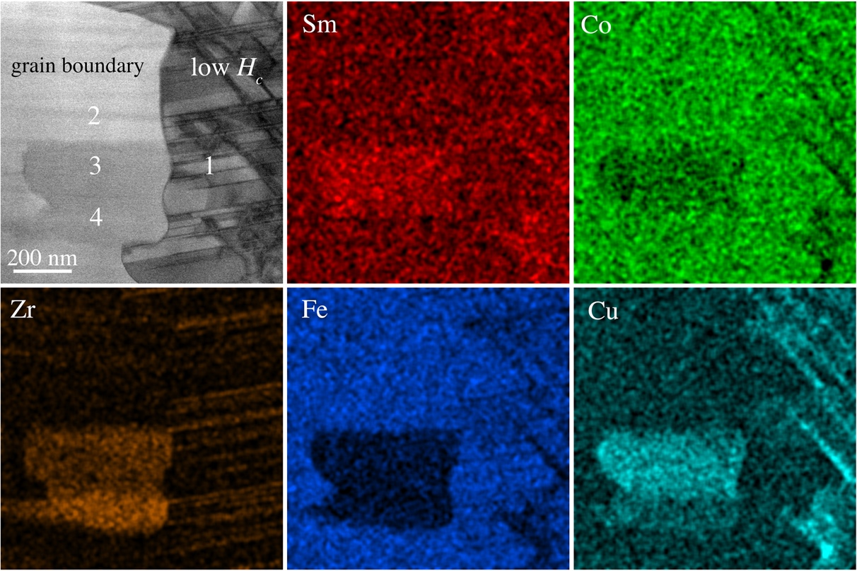
Fig. S9: BF STEM image and the corresponding elemental maps of the grain boundary and low coercivity regions. Note that lack of the 1:5 Sm-Co cells in the grain boundary region.
Table 2: Chemical compositions in atomic % measured by EDX of regions marked in the STEM BF image in Fig. S8.
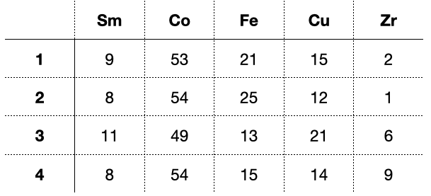

Micromagnetic Simulation

Micromagnetic simulations were carried out by using the open-source GPU-accelerated finite-difference (FD) program Mumax3 [Vansteenkiste2014]. We consider the free energy of the magnetic system as
F = F_{ex} + F_{ani} + F_{dm} + F_{ext} (S1)
which is the sum of the exchange energy F_{ex}, the magnetocrystalline anisotropy energy F_{ani}, the magnetostatic (demagnetizing) energy F_{dm}, and the Zeeman energy F_{ext}. Taking the uniaxial anisotropy for all magnetic phases, the free energy of the system with the domain volume Ω and an applied external field H_{ext} can be written as
$F\left(M,H_{\text{ext}}\right)=\int_{Ω}{\left[\frac{A}{M_{\text{s}}^{2}}{\left(∇⋅M\right)}^{2}-\frac{K_{1}}{M_{\text{s}}^{2}}{\left(u⋅M\right)}^{2}-μ_{0}\left(\frac{1}{2}H_{\text{dm}}⋅M+H_{\text{ext}}⋅M\right)\right]dV},$ (S2)
where u is the uniaxial vector and set to be identical to the magnetocrystalline easy axis c for all coherent phases. H_{dm} is the demagnetizing field. The exchange parameter A, 1st order uniaxial anisotropy constant K₁, and saturation magnetization M_{s} are phase-dependent parameters as listed in Tab. 2, taken from Ref. [Katter1996]. The domain wall energy is also calculated as $σ_{\text{dw}}=4\sqrt{AK_{1}}$. The varying parameters of Sm(Co_{1-x}Cu_{x})₅ phases versus the copper fraction x are explicitly presented in Fig. S10a according to [Lectard1994]. The magnetization M is then calculated for every increased external field by small increments from
$\frac{δF}{δM}=0$, (S4)
where the conjugate gradient (CG) solver is used.
Parameterized nanostructures in a 512x512x4 nm³ domain were generated to recapitulate the spatial characteristics of the underlying phases of the samples in this work, as shown in the Fig. S10b. To recapture the domain behaviours in the micromagnetic simulations without artificial effects related to mesh, the FD cell size is chosen as 1 nm, which is smaller than the magnetocrystalline exchange length, i.e., $l_{\text{ex}}=π\sqrt{A/{K_{1}}}$ , as also shown in the Tab. 3. A grain boundary layer with thickness of 2 nm (as shown in Fig. S8b), where magnetocrystalline isotropy is assumed (i.e., K₁ = 0), was also introduced to emulate the effects of the grain boundary in reducing the nucleation field to the system [Yi2016]. The periodic boundary condition (BC) is applied on the two boundaries perpendicular to the z direction, while the Neumann BC is applied on other boundaries [Vansteenkiste2014].

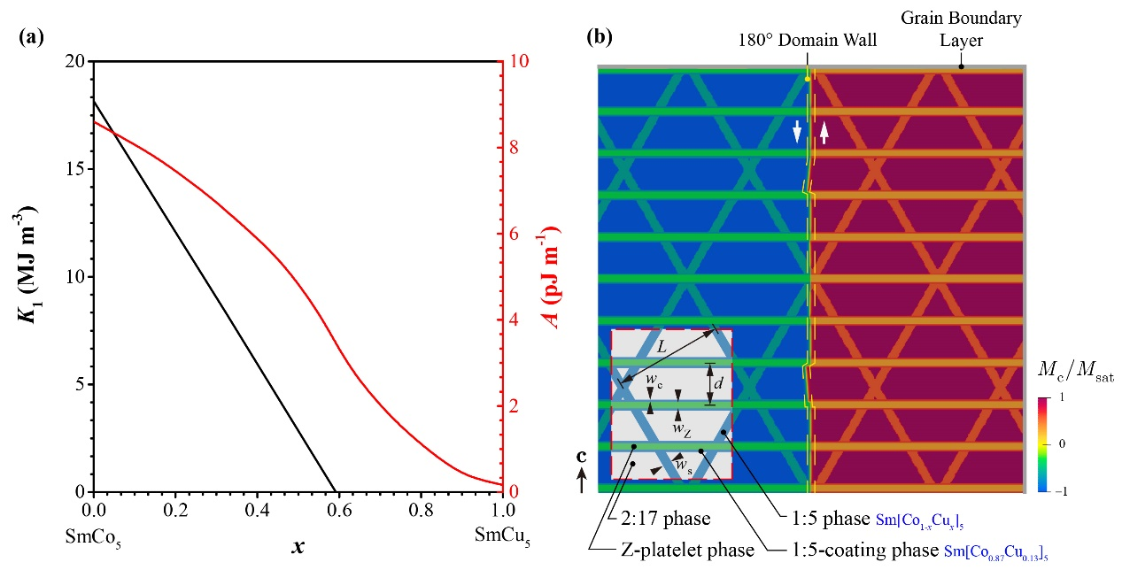
Fig. S10: (a) Dependence of uniaxial anisotropy constant K₁ and exchange constant A from the Cu content x in Sm(Co_{1-x}Cu_{x})₅ [Lectard1994]. (b) Schematic of the parameterized nanostructure with the 180° domain wall along the easy axis c (taking two-domain IC as an example). An external magnetic field parallel to the c-axis is applied to simulate the reversal behaviour of the nanostructure.

As detailed in Fig S11, four structural parameters are defined: cell size L, distance in between Z-platelets d, thickness of the 1:5 cell wall phase w_{s}, and thickness of the Z-platelet phase w_{Z} describing the cellular nanostructure in Sm₂(CoFeCuZr)₁₇ magnets following Ref. [16], we introduce the parameter w_{c} indicating the thickness of the 1:5-coating phase on the Z-platelet phase. Two Cu concentrations $x_{Cu}^{\left(s\right)}$ and $x_{Cu}^{\left(c\right)}$ are independently considered for the 1:5 cell boundary phase and the 1:5 coating phase, respectively.
Three initial conditions (IC) were studied in the micromagnetic simulation. The two-domain IC with zero overall magnetization was set for the initial magnetizing curve, while nucleated and saturated ICs were chosen for the demagnetization curves. In the nucleated IC, the fully magnetized nanostructure is in contact with a thin boundary layer with reversed magnetization, emulating an existing nucleation of the reversed domain. The domain wall propagation thereby becomes the main process during the demagnetization process, and structural pinning from the nanostructure should have a remarkable effect. On the other hand, demagnetization from the saturated IC ideally forms the other edge case where no nucleus appears in the domain and the whole domain is reversed under a strong applied field. In this sense, the experimentally measured coercive field is expected to lie between the ones from the nucleated and saturated IC, denoted as the lower-bound (μ₀H_{c,L}) and upper-bound coercive field (μ₀H_{c,U}), respectively.
To single out the influence of each characteristic, Fig. S12a-c sequentially present the simulated initial magnetization and the demagnetization curves on varying w_{Z}, L and x_{Cu}^{(s)}, each for lof and high-H_{c} cases, with and without 1:5-cover layers on top of the Z-platelet phase. The existence of the 1:5-coating generally increases the coercivity (both μ₀H_{c,L} and μ₀H_{c,U}) of the nanostructure with fixed w_{Z}, L and x_{Cu}^{(s)}. Without 1:5-coating phase, varying parameters do not show a distinctive influence on the coercivity. In contrast, the existence of the 1:5-coating phase amplified the influences of modifying w_{Z} and x_{Cu}^{(s)} on H_{c,L}, implying enhanced pinning effects to the domain wall propagation from these two characteristics. However, a beneficial effect on the coercivity by smaller cells may not be concluded from our set of parameters and only the initial magnetization curve hints on a stronger pinning effect. Remarkably, with 1:5-coating, μ₀H_{c,L} increases from 0.8 to 1.6 T when rising x_{Cu}^{(s)} from 18.8 to 28.0 at%. A rather small increase of μ₀H_{c,L} from 0.6 to 0.8 T was achieved when rising w_{Z} from 4 to 16 nm.
To briefly sum up, the existence of 1:5-coating and increased x_{Cu}^{(s)} is the phenomenological reason for the high coercivity of the nanostructure. Increased w_{Z} also may contribute to enhanced coercivity, but varying L has no evident effect within the scope of this work. Fig. S12d presents the combined effects using the proposed two nanostructures, providing good agreement with the experimental observations. By comparing the initial magnetization and the demagnetization curve with nucleated IC of both structures, the high coercivity nanostructure presents a more significant pinning effect on the propagation of domain walls by showing larger increments between consecutive de-pinning steps, resulting in an increased μ₀H_{c,L}. Meanwhile, it has a relatively higher critical field for the total reversal of the saturated domain, i.e. an increased μ₀H_{c,U}.

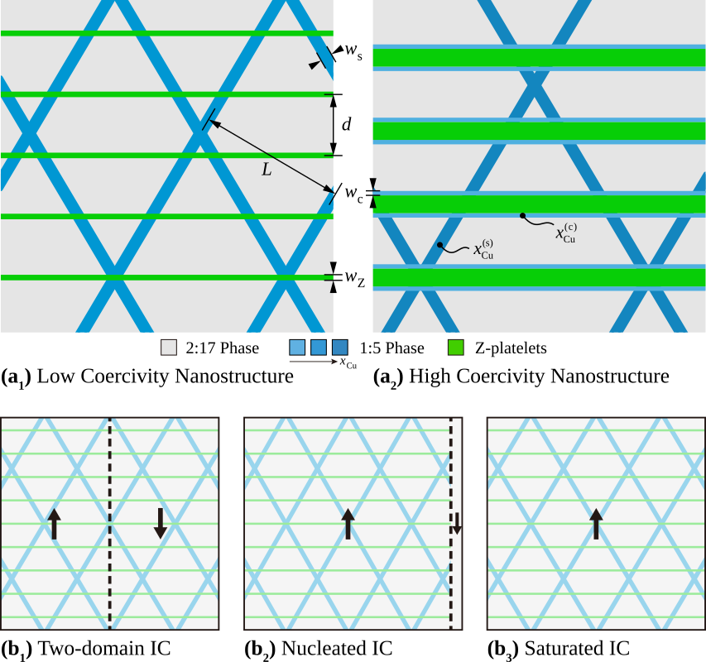
Fig. S11: Proposed nanostructures in the (a₁) low coercivity and (a₂) high coercivity regions according to APT and TEM micro- and nanoscale findings. Parameters corresponding to the structural and compositional characteristics of the nanostructure are also denoted. Three different initial conditions (IC) are used for the simulation: the initial magnetization process is modelled with (b1) two-domain IC and the demagnetization process with both (b₂) nucleated IC and (b₃) saturated IC.

Table S4: Micromagnetic parameters of the phases used for the simulation [16,29]. Please refer to the supplementary material for details.
Composition | Cu concentration  (at%) | A  (pJ m⁻¹) | K₁  (MJ m⁻³) | M_{s}  (kA m⁻¹) | l_{ex}  (nm) | σ_{dw}  (mJ m⁻²)
Sm₂(CoFeCuZr)₁₇ | – | 19.6 | 3.9 | 987.7 | 7.0 | 35.0
Zr₂Sm(CoFeCu)₉ | – | 0.7 | 1.4 | 310.4 | 2.2 | 4.0
Sm(CoFeCuZr)₅ | 0.0 | 8.6 | 18.3 | 810.8 | 2.2 | 50.2
Sm(CoFeCuZr)₅ | 13.0 | 7.8 | 13.7 | 654.4 | 2.4 | 41.3
Sm(CoFeCuZr)₅ | 18.8 | 7.3 | 11.3 | 580.7 | 2.5 | 36.3
Sm(CoFeCuZr)₅ | 28.0 | 6.4 | 7.8 | 442.3 | 2.8 | 28.3

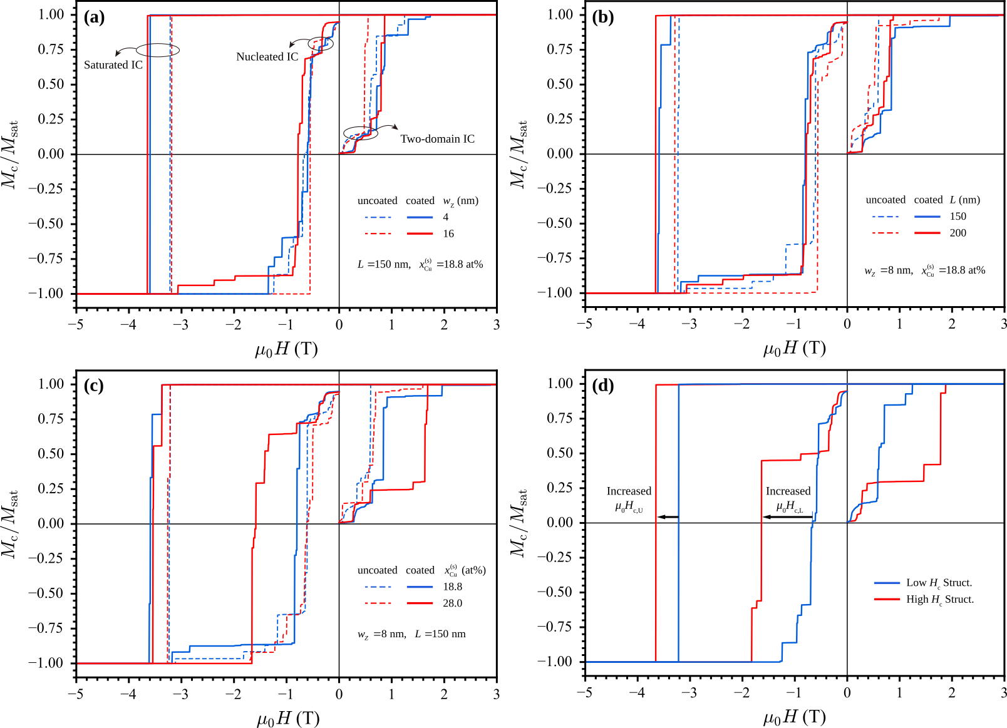
Fig. S12: Simulated initial magnetization and demagnetization curves for three different initial conditions (IC): the parameterized nanostructures each for the 1:5-coated and 1:5-uncoated case (a) varying w_{Z} (b) varying L, (c) varying x_{Cu}^{(s)}. (d) For the proposed high and low coercivity nanostructures also denoting the lower-bound (µ₀H_{c,L}) and upper-bound coercive field (µ₀H_{c,U}).

