Molecular characterization and expression profiling of two flavohemoglobin genes play essential roles in dissolved oxygen and NO stress in Saitozyma podzolica zwy2-3
Qingzhuoma Yang¹, Yulu Ran¹, Shengtao Guo¹, Fazhi Li¹, Dongyou Xiang¹, Yu Cao¹, Dairong Qiao¹, Hui Xu^{1,} * and Yi Cao^{1,} *
¹ Microbiology and Metabolic Engineering key laboratory of Sichuan Province, College of Life Science, Sichuan University, Chengdu, Sichuan 610065, China
* Correspondence: Hui Xu. Email address: xuhui_scu@scu.edu.cn; Yi Cao. Email address: geneium@scu.edu.cn.

Supplementary Table S1. Strains and plasmids used in this study.
 | Description | Reference or source
Strains
Zwy 2-3 | Saitozyma podzolica zwy2-3 | This study
E. coli DH5α | TreliefTtMm 5α Chemically Competent Cell | TsingKe
E. coli BL21 (DE3) | Expression Chemically Competent Cell | TsingKe
AGL-1 | Agrobacterium tumefaciens Chemically Competent Cell | Biomed
Y187 | GAL4 system for Yeast one‑hybrid Chemically Competent Cell | WeidiBio
Plasmids
pET28a | E. coli expression vector (Kan, T7 promoter) | This study
pET28a-Fhb1 | pET28a carrying gene Fhb1 from S. podzolica Zwy2-3 fused with His tag in N-terminus | This study
pET28a-Fhb2 | pET28a carrying gene Fhb2 from S. podzolica Zwy2-3 fused with His tag in N-terminus | This study
pRFHU2 | The vector was used for One-Step construction of vectors for targeted gene replacement in filamentous fungi | This study
pRFHU2-eGFP | GFP labelling of filamentous fungi by Agrobacterium tumefaciens mediated transformation | This study
pRFHU2-lb1-rb1 | pRFHU2 carrying the upstream and downstream homologous arms of gene gFhb1 from S. podzolica Zwy2-3 | This study
pRFHU2-lb2-rb2 | pRFHU2 carrying the upstream and downstream homologous arms of gene gFhb2 from S. podzolica Zwy2-3 | This study
pRFHU2-eGFP-fhb1 | pRFHU2-eGFP carrying gene cFhb1 from S. podzolica Zwy2-3 | This study
pRFHU2-eGFP-fhb2 | pRFHU2-eGFP carrying gene cFhb2 from S. podzolica Zwy2-3 | This study
pHIS | Yeast one‑hybrid bait vector | This study
pHIS-pFhb1 | pHIS carrying promoter of the gene Fhb1 from S. podzolica Zwy2-3 | This study
pHIS-pFhb2 | pHIS carrying promoter of the gene Fhb2 from S. podzolica Zwy2-3 | This study
pGADT7-Rec2 | Yeast one‑hybrid receptor vector | This study
pGADT7-Rec2-Asg1 | pGADT7-Rec2 carrying gene cAsg1 from S. podzolica Zwy2-3 | This study

Supplementary Table S2. Primers used in this study.
Name | Sequence (5′-3′) | Description
Fhb1_F | ATGGCCATCGAGATCCCC | Amplification of the spFhb1 gene
Fhb1_R | CGGAGAGATCGAGATGGTGTAG | Amplification of the spFhb1 gene
Fhb2_F | ATGTCGCTTTCGTTGCCTGC | Amplification of the spFhb2 gene
Fhb2_R | GGAAAAGTCAGCCAAGGCGTGA | Amplification of the spFhb2 gene
Fhb1-lb_F | AAGCAGAAGGAGCTCGTG | Upstream fragment of spFhb1 gene
Fhb1-lb_R | CGGCTCGAGGTAGAAGCT | Upstream fragment of spFhb1 gene
Fhb1-rb_F | GGCATGGTCTCCAACACC | Downstream fragment of spFhb1 gene
Fhb1-rb_R | ATATTGTCGTTCGCCACGC | Downstream fragment of spFhb1 gene
Fhb2-lb_F | CTTGGCGCTCGCATTCTC | Upstream fragment of spFhb2 gene
Fhb2-lb_R | AAGAAGAGAACATCTACCATGA | Upstream fragment of spFhb2 gene
Fhb2-rb_F | AACGACAAGTACCTCCGC | Downstream fragment of spFhb2 gene
Fhb2-rb_R | TTGAAGTCGATGGGTGTGCC | Downstream fragment of spFhb2 gene
P1_F | cttttctcttaggtttacccg | Vector upstream homologous arm verification
P2_R | taatgcaggagtcgcataag | Vector upstream homologous arm verification
P3_F | cccaaaaagtgctccttcaa | Vector downstream homologous arm verification
P4_R | tgtgctgcaaggcgattaa | Vector downstream homologous arm verification
Y1_F | cttcatcgcagcttgactaaca | Verification of pRFHU2-eGFP
Y2_R | acacgctgaacttgtggc | Verification of pRFHU2-eGFP
pHIS_F | GCCAGTGAATTGTAATACG | Verification of pHIS
pHIS_R | TAATGCCAGGAATTTCTAG | Verification of pHIS
pGADT7_F | TAATACGACTCACTATAGGG | Verification of pGADT7-Rec2
pGADT7_R | GATGCACAGTTGAAGTGAAC | Verification of pGADT7-Rec2
pET28a_F | CAAGACCCGTTTAGAGGC | Verification of pET28a
pET28a_R | TGACTGGTGGACAGCAAAT | Verification of pET28a
pFhb1_F | TGAGGCAGAGGTCGTAGGGG | The promoter of the spFhb1 gene
pFhb1_R | TACACGGAGACAACTGGCAGAGT | The promoter of the spFhb1 gene
pFhb2_F | CGAGCCACTACCACGAAGATG | The promoter of the spFhb1 gene
pFhb2_R | GGCTCGGTGTTTTCTCCAGC | The promoter of the spFhb1 gene
Asg1_F | ATGACCATGTCCGACCGG | Amplification of the spAsg1 gene
Asg1_R | AGCGGCCAGTGAATTGGTAA | Amplification of the spAsg1 gene
18S_F | CATTAGTATTCCGTTGCTAGAGGTG | 18S of qPCR
18S_R | CGATCCCTAGTCGGCATAGTTTA | 18S of qPCR
G3PDH_F | GATGAGCCCACCACGAAGG | Glycerol 3 phosphate dehydrogenase of qPCR
G3PDH_R | GCCAAGGGAGGAAGAAGATGA | Glycerol 3 phosphate dehydrogenase of qPCR
ZWF1_F | GGAGGGCGTGCCTTTCAT | Glucose 6 phosphate dehydrogenase of qPCR
ZWF1_R | ACCGGGTAGCTTCGAGTTCA | Glucose 6 phosphate dehydrogenase of qPCR
PYC1_F | CGGTGGTGGTCGTGGTAT | Pyruvate carboxylase of qPCR
PYC1_R | CAGTTGCCCTCTGCGTCA | Pyruvate carboxylase of qPCR
ME_F | CGAGTTCGCAGGCAAGGT | Malate synthase of qPCR
ME_R | CCTGACGACACGCATACCAC | Malate synthase of qPCR
FAS_F | TACTTCTCCGACTTTGCCTCG | Fatty acid synthetase 1 of qPCR
FAS_R | CGCTGGTTGAACGCCTCA | Fatty acid synthetase 1 of qPCR
ACS_F | CGCCGTGAGCATCTACCTTC | Acetyl CoA synthetase of qPCR
ACS_R | TCGCTCGTGATGAGCACTTT | Acetyl CoA synthetase of qPCR
ACC_F | TTTAGCCACAACGAGTTTACCG | Acetyl CoA carboxylase of qPCR
ACC_R | CGCCTGATGCCCTTTCC | Acetyl CoA carboxylase of qPCR
ICL_F | AGCTCCTGGTACGAAGAAGTG | Isocitrate lyase 1 of qPCR
ICL_R | GTCCCGAGGGTCGATGTT | Isocitrate lyase 1 of qPCR
qFhb1_F | TCACCACTTTCAGGATCGCC | SpFhb1 of qPCR
qFhb1_R | TCGACCCATACCCTCACAGT | SpFhb1 of qPCR
qFhb2_F | CCGAGGAAGTAGATGTCGGC | SpFhb2 of qPCR
qFhb2_R | ACCGTCTACGAGACCAAGGA | SpFhb2 of qPCR
qAsg1_F | CGGCATACAGAGTCACGACA | SpAsg1 of qPCR
qAsg1_R | AAGCACAGCCAAGGAGGAT | SpAsg1 of qPCR

Supplementary Table S3. Detailed sequence descriptions of the 10 Fhb genes.
Species | Nucleotide  Accession Number | Full length  (bp) | ORF  (bp) | 5'-UTR  (bp) | 3'-UTR  (bp) | Protein  Accession Number | Predicted  protein  (aa) | Molecular  Weight  (kDa) | Theoretical  pI | Signal  peptide | Transmembrane
Saitozyma podzolica | RSCD01000018.1 | 1480 | 1305 | 0 | 0 | RSH87147.1 | 434 | 47.4 | 6.19 | NO | NO
Saitozyma podzolica | RSCD01000002.1 | 1350 | 1350 | 0 | 0 | RSH94666.1 | 449 | 49.7 | 7.11 | NO | NO
Aspergillus tubingensis | XM_035495526 | 1371 | 1371 | 0 | 0 | XP_035351419.1 | 456 | 50.7 | 7.35 | NO | NO
Fusarium tonkinense | FJ874761 | 1617 | 1251 | 88 | 278 | ACP18865.1 | 416 | 45.8 | 5.61 | NO | NO
Neurospora crassa | NCU02096 | 1440 | 1440 | 0 | 0 | EAA34752.3 | 480 | 54.5 | 9.07 | NO | NO
Ophiocordyceps sinensis | OCS_02673 | 1281 | 1281 | 0 | 0 | EQL01616.1 | 426 | 46.8 | 6.16 | NO | NO
Pochonia chlamydosporia | XM_018288421 | 1263 | 1263 | 0 | 0 | XP_018137831.1 | 420 | 46.0 | 6.08 | NO | NO
Purpureocillium lilacinum | XM_018328596 | 1257 | 1257 | 0 | 0 | XP_018172816.1 | 418 | 45.9 | 5.46 | NO | NO
Pyricularia oryzae | MGG_00198 | 1824 | 1344 | 149 | 331 | EHA49335.1 | 447 | 42.9 | 6.3 | NO | NO
Sclerotinia borealis | SBOR_8645 | 1248 | 1248 | 0 | 0 | ESZ90982.1 | 415 | 49.9 | 9.31 | NO | NO
Trichoderma guizhouense | A0O28_0080480 | 1265 | 1265 | 0 | 0 | OPB41330.1 | 412 | 46.2 | 6.21 | NO | NO
Trichoderma reesei | TRIREDRAFT_76722 | 1320 | 1320 | 0 | 0 | EGR49938.1 | 439 | 50.0 | 6.94 | NO | NO

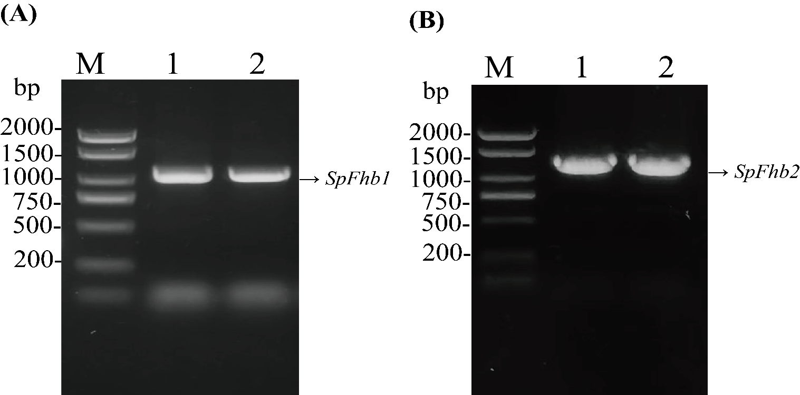
Supplementary Fig. S1 PCR amplification of SpFhb1 and SpFhb2. The full length of SpFhb1 (A) and SpFhb2(B) was 1305 bp and 1350 bp, respectively.

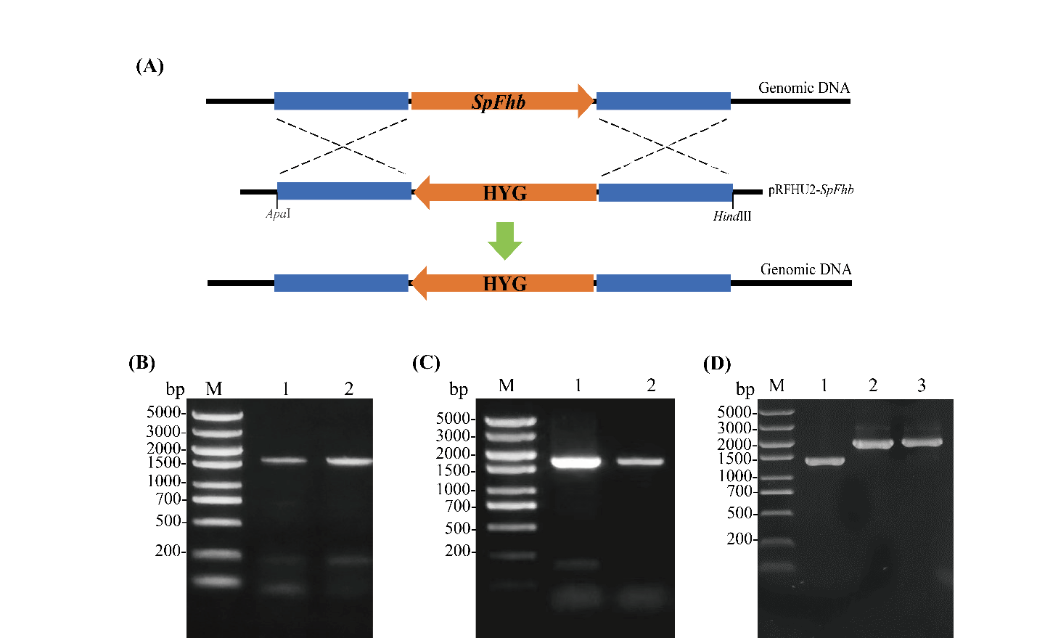
Supplementary Fig. S2 PCR analysis and confirmation of SpFhb gene deletion and overexpression in S. podzolica zwy2-3. (A) Schematic presentation of the region showing integration of upstream and downstream region of the SpFhb gene with hygromycin cassette in pRFHU2. Confirmation of SpFhb1 (B) and SpFhb2 (C) knockout in in S. podzolica zwy2-3 by amplifying the SpFhb gene specific primers. (D) Confirmation of vgb (lane 1), SpFhb1 (lane 2) and SpFhb2 (lane 3) overexpression in S. podzolica zwy2-3 by amplifying specific primers.

