Supplemental Information
Functional and structural analysis of a catabolite control protein C that responds to citrate
Wei Liu ^{1,2†}, Jinli Chen ^{3†}, Liming Jin ^{1,2}, Zi-Yong Liu ⁴, Ming Lu ⁴, Ge Jiang ⁵, Qing Yang ³, Chunshan Quan ^{1,2*}, Ki Hyun Nam ^{6*}, and Yongbin Xu ^{1,2*}

¹ Department of Bioengineering, College of Life Science, Dalian Minzu University, Dalian 116600, Liaoning, China
² Key Laboratory of Biotechnology and Bioresources Utilization of Ministry of Education, College of Life Science, Dalian Minzu University, China
³ School of Life Science and Biotechnology, Dalian University of Technology, No. 2 Linggong Road, Dalian 116024, Liaoning, China
⁴ Shandong Provincial Key Laboratory of Energy Genetics, key Laboratory of Biofuel, Qingdao Institute of Bioenergy and Bioprocess Technology, Chinese Academy of Sciences, Qingdao 266101, Shandong, China
⁵ School of Life Science and Biotechnology, Dalian University, Dalian 116622, Liaoning, China
⁶ Department of Life Science, Pohang University of Science and Technology, 35398 Pohang, Republic of Korea
*Corresponding author: Tel. (+86) 411 8765 6045; Fax. (+86) 411 8765 6219; E-mail: yongbinxu@dlnu.edu.cn (Y. Xu). Tel. (+82) 10 5208 5730; E-mail: structures@ postech.ac.kr (K. H. Nam). Tel. (+86) 411 8765 6219; E-mail: mikyeken@dlnu.edu.cn (C. Quan).
† Both authors contributed equally to this work.

Supplementary Figure 1. Dimer interface of LTTRs family.
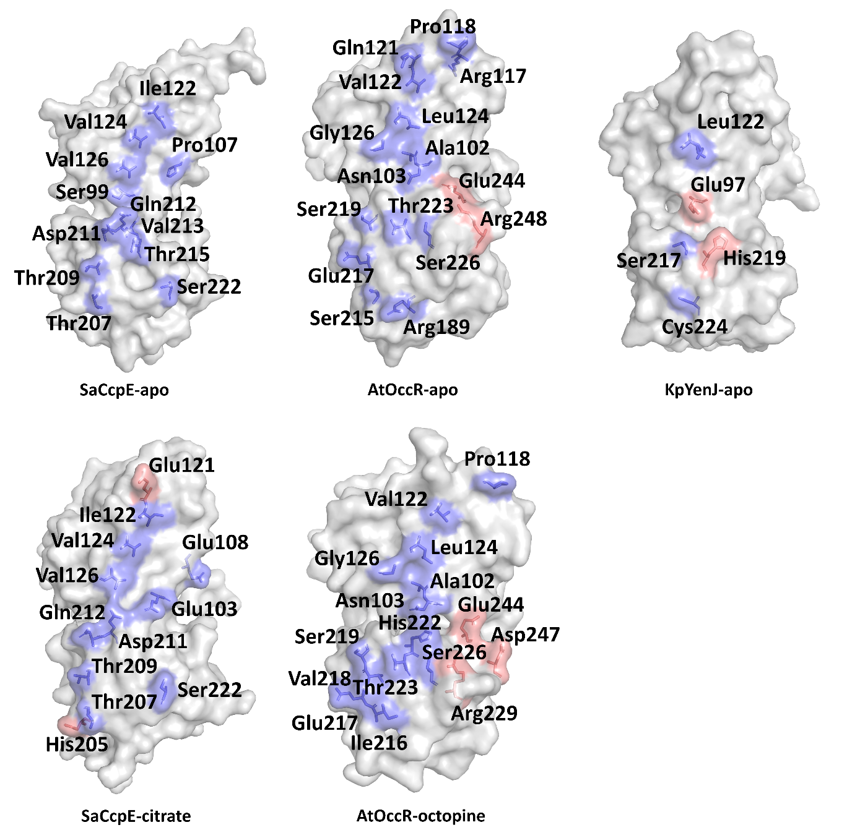
Blue shows hydrogen-bond interaction and red shows salt bridges.

Supplementary Table S1. Oligonucleotide sequences used for EMSA analysis.
citB-P | TGATAAGACGATCTTATTGTATTTAATAAAAACATTGATATTTACTTATGTATGAT
citB-PI | TGATAAGACGATCTTATTGT
citB-PII | TGATATTTACTTATGTATGAT

Supplementary Table S2. Crystallography data and refinement statistics
Data sets BaCcpC-IBD
Beamline | Beamline 7A at PLS
Resolution range (Å) | 29.71 (2.37-2.30)
Space group | C121
Total /unique reflections | 55744/4795
a, b, c (Å) | 140.96, 105.53, 106.19
R_{sym} (%) | 8 (3.1)
Completeness (%) | 96.46 (83.04)
Multiplicity | 5.3 (2.6)
Average I/σ(I) | 36.2
Model refinement
^{b}R_{factor} / R_{free} (%) | 20.75 (34.77)/ 26.70 (41.22) 16.47(18.81)/22.53(26.03)
No. of protein atoms | 7976
No. of water molecule | 153
Average B factor (Å²) | 62.00
R.m.s.d (Bond) | 0.008
R.m.s.d (Angles) | 0.94
Ramachandran plot(%)

plot(%

)
PLOTPLOTPreferred (%)
Favored regions | 95.53
Allowed regions | 4.16
Disalowed regions | 0.31
PDB code | 7DMW
ªValues in the parentheses refers to the highest resolution shell.
^{b}∑hkl│Fo-Fc│/ ∑hkl│Fo│ for all data with Fo > 2σ(Fo), excluding data used to calculate R_{free}.
§R_{free}= ∑hkl│Fo-Fc│/∑hkl│Fo│ for all data with Fo >2σ (Fo) that were excluded from refinement.

