Supplemental figure 1. Significant time-varying predictors of e-cigarette harm perception among US young adults (18-24 years): longitudinal analysis of the Population Assessment of Tobacco and Health Study, 2013-2018.
C1: Combustible smoke-free home rules C2: Non-combustible smoke-free home rules
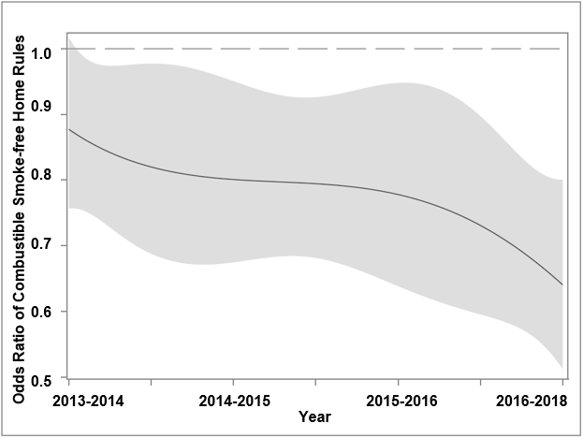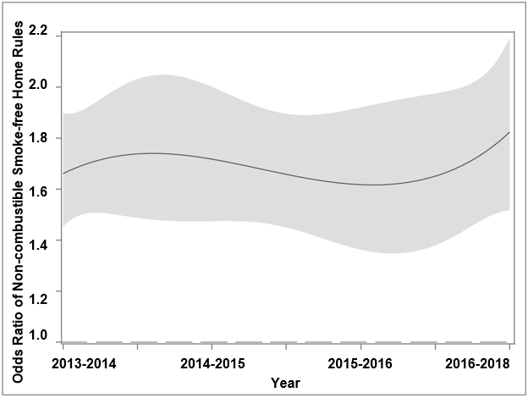
C3: Environmental/Peer influence C4: Tobacco-related Attitudes
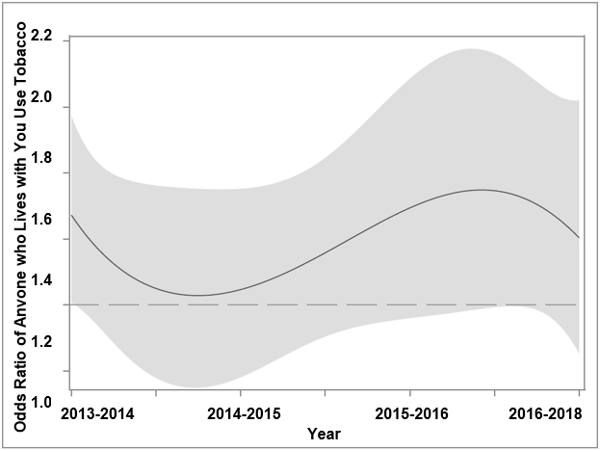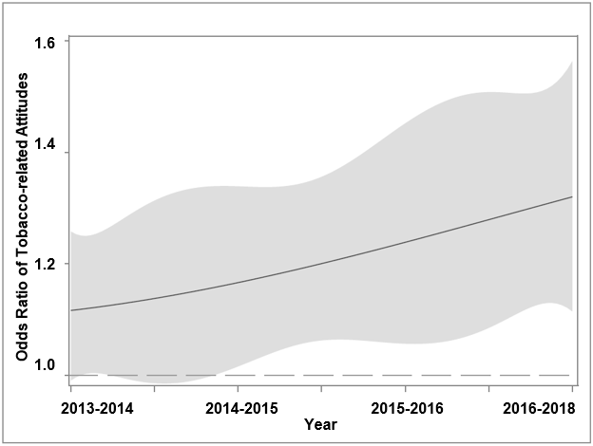
C5: Current cigarette use C6: Current e-cigarette use
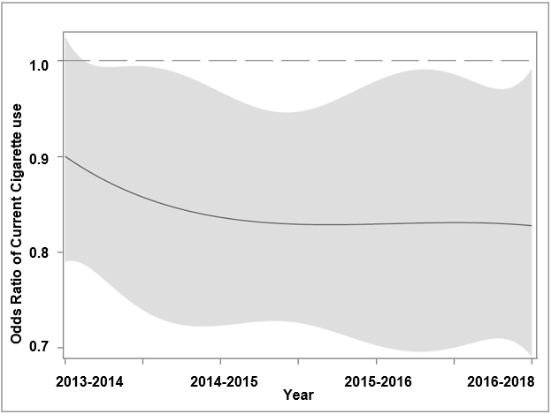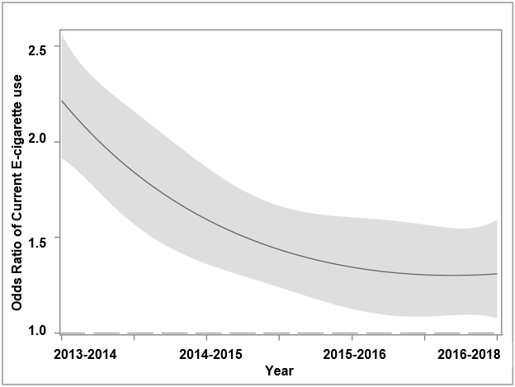
C7: Ever other tobacco product use C8: Physical health
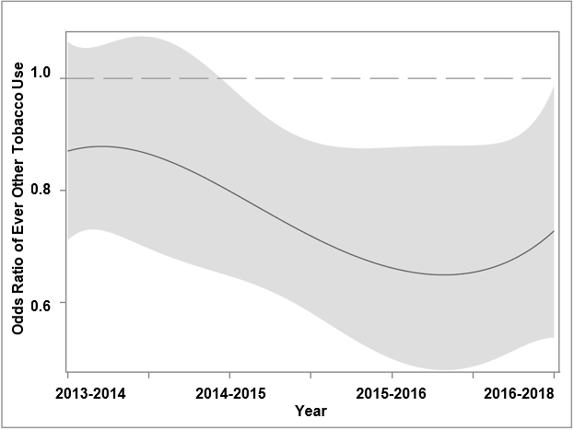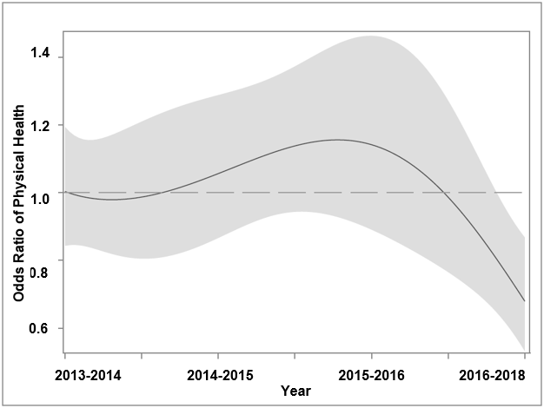
C9: Ever alcohol use C10: Mental health
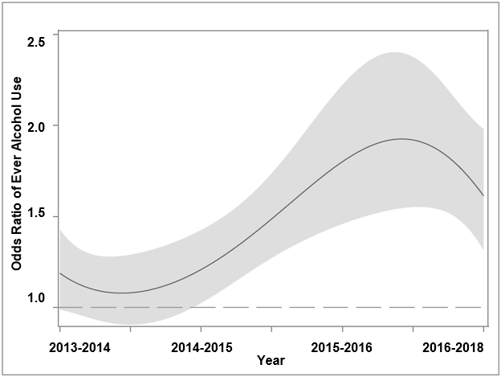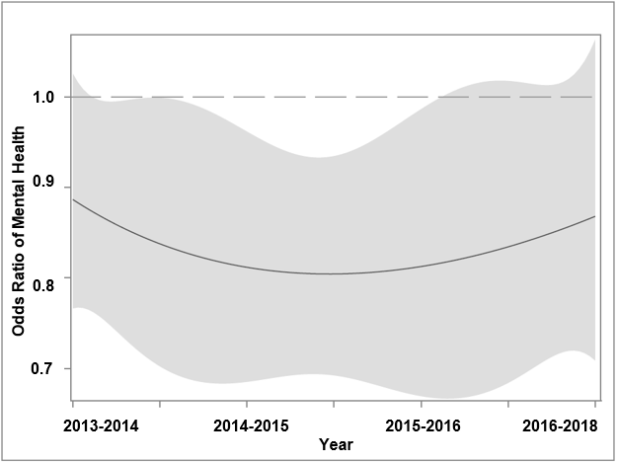
C11: Ever drug use C12: Health warning exposure
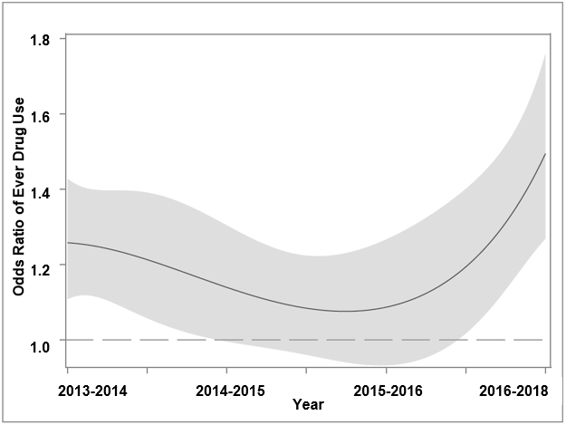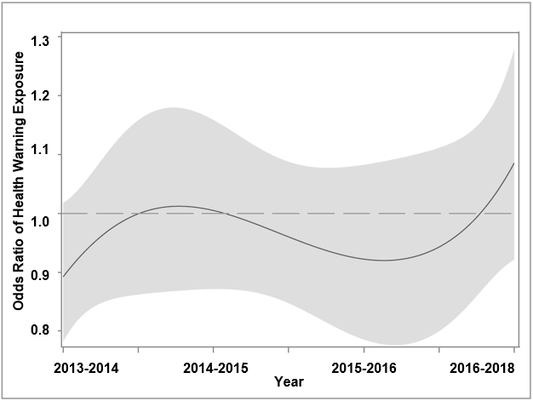
C13: High school education C14: College education
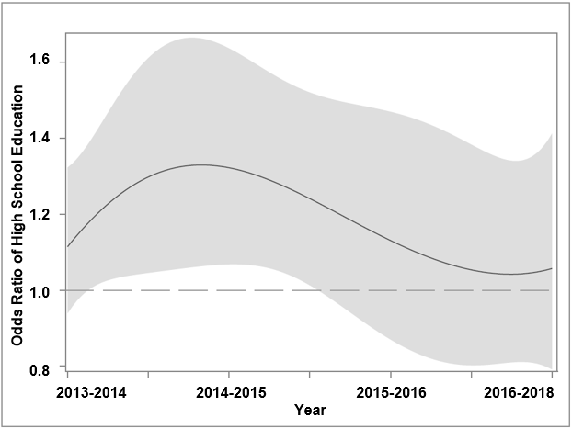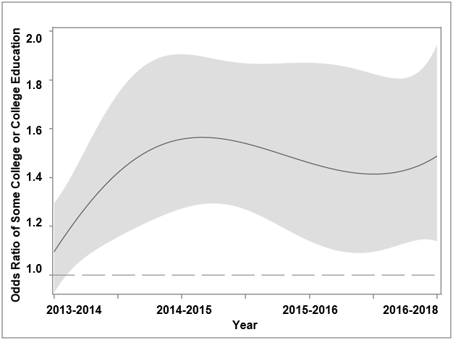
C15: Advanced degree education
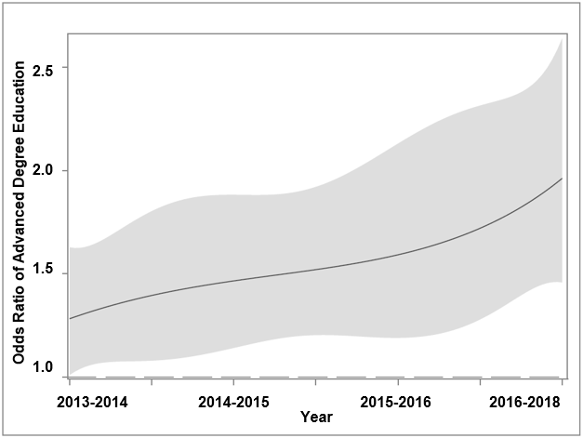
†Time-variant predictors were assessed from all four waves.
NOTE: These are graphical summaries of intercept functions (odds ratios with confidence intervals), representing a time-varying level of predictors of relative harm perceptions of e-cigarettes. The central solid line indicates the point estimate of the odds ratio, and the gray ribbon with dashed borders shows the 95% confidence interval. The horizontal dotted line shows the odds ratio of 1 (no predictive validity).

