1a. In-hospital mortality
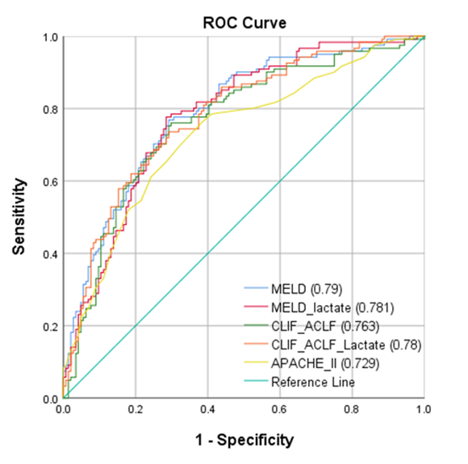
1b. Six-month mortality
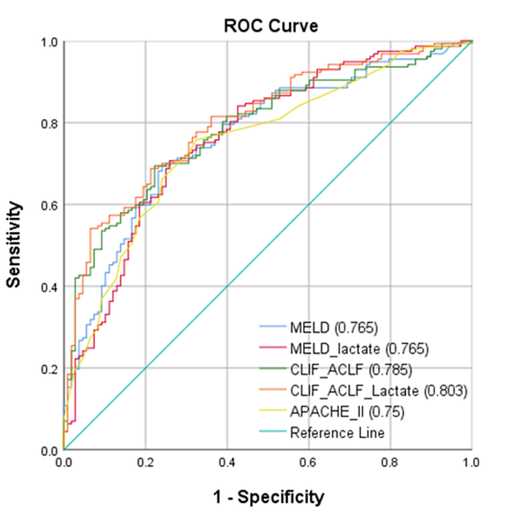
1c. One-year mortality
Supplementary Figure 1. Comparison of the five prognostic scores predicting short-term mortality by AUROC analysis (a) in-hospital mortality (b) six-month mortality (c)one-year mortality

2a. in-hospital mortality
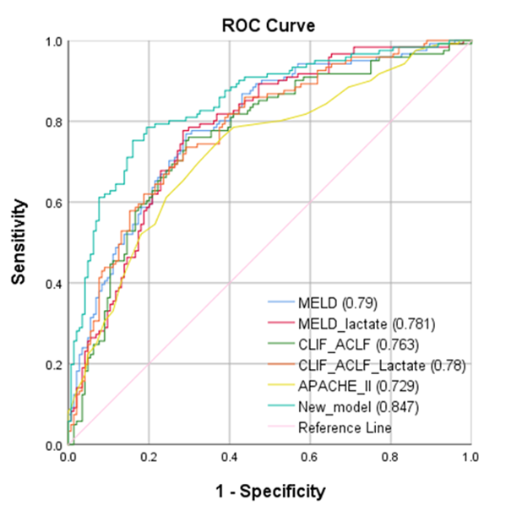
2b. six-month mortality
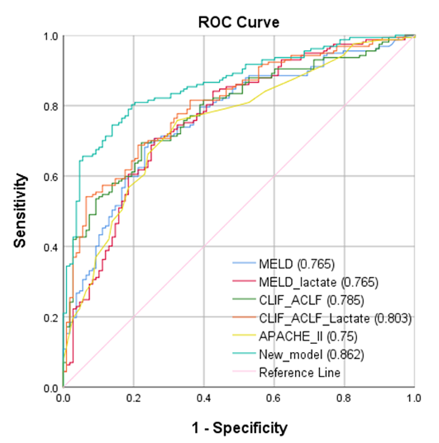
2c. one-year mortality

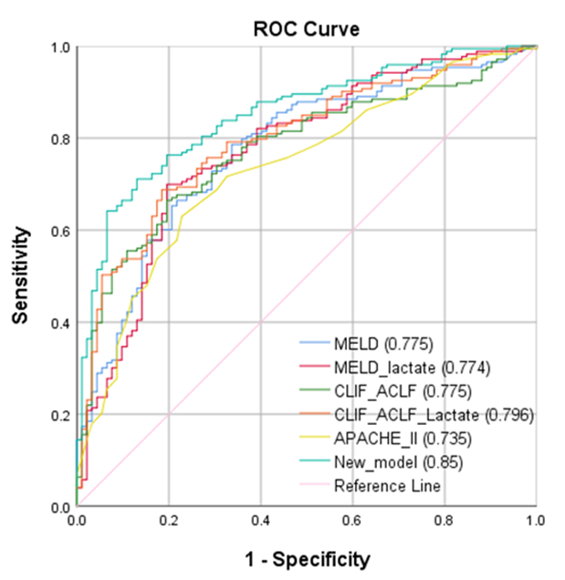
Supplementary Figure 2. Comparison of the new model and the five prognostic scores predicting short-term mortality by AUROC analysis (a)in-hospital mortality (b)six-month mortality(c)one-year mortality

