.

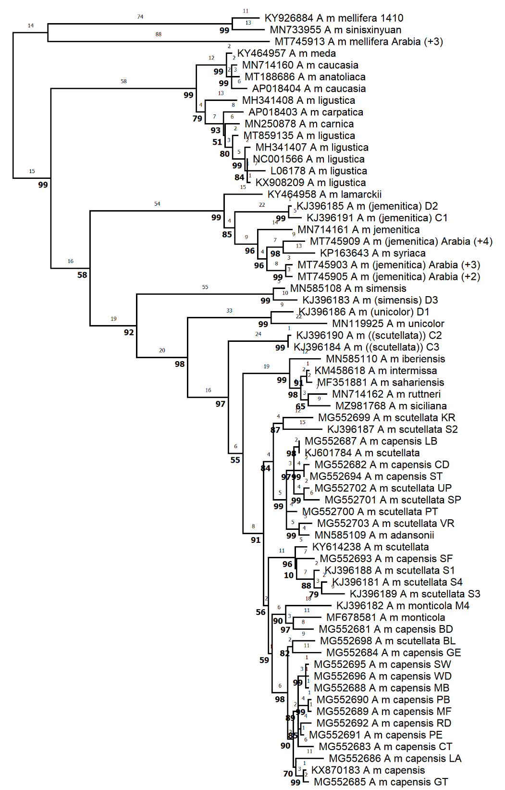
Supplementary Figure S1 – Maximum Parsimony analysis of phylogenetic relationships among 78 individual A. mellifera. Individuals are the 66 included in Figure 3, identified by GenBank accession numbers, plus 12 individual Arabian bees identical to those shown.
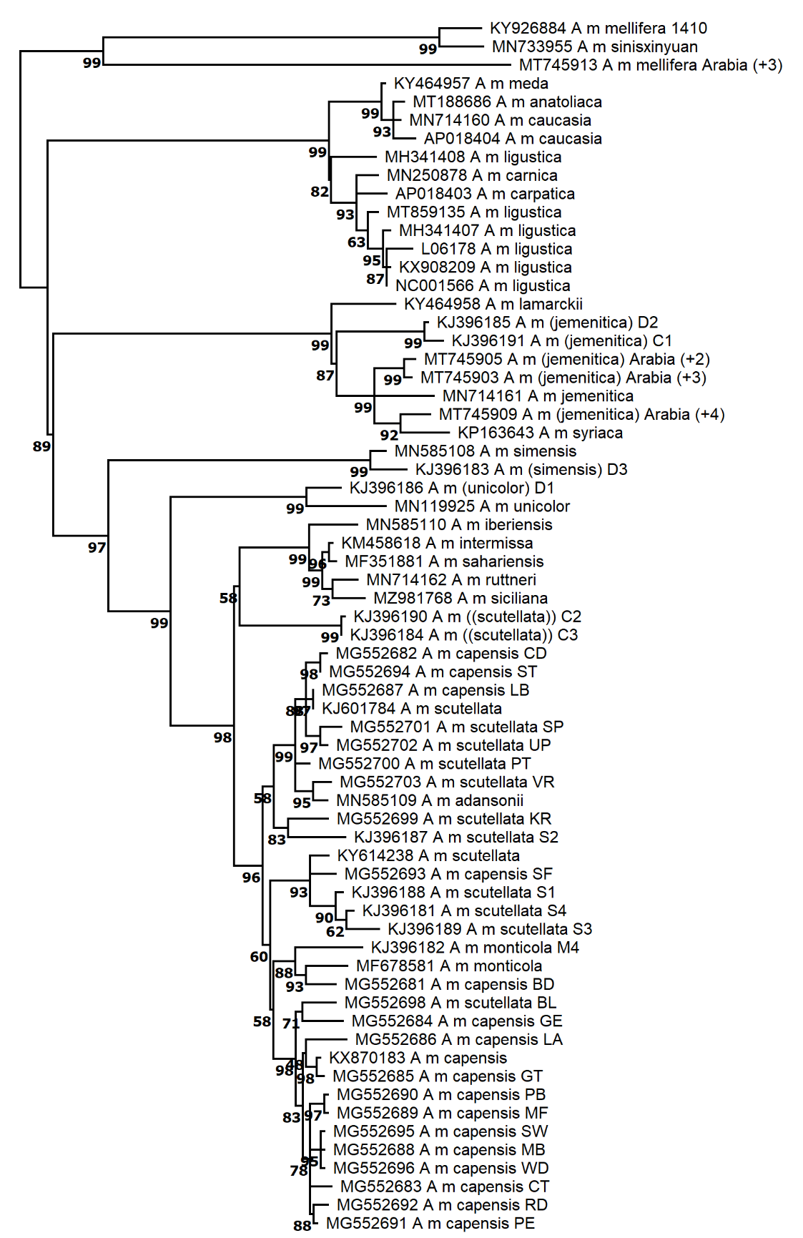
Supplementary Figure S2 – Maximum Likelihood analysis, as in Supplementary Figure S1.

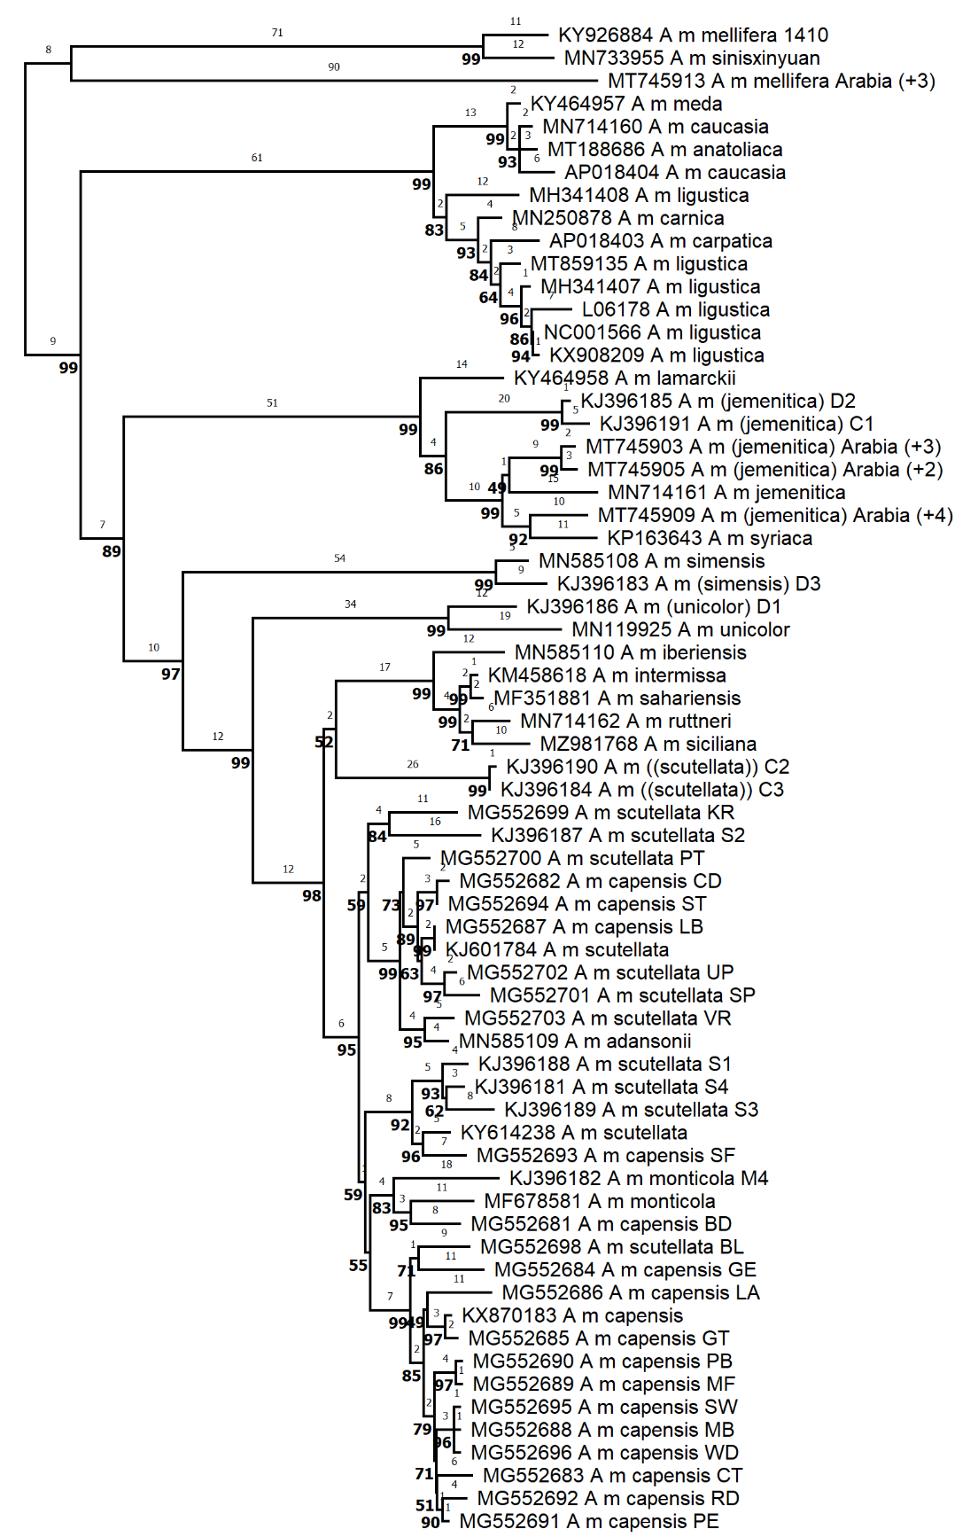
Supplementary Figure S3 – Neighbor-Joining analysis, as in Supplementary Figure S1.

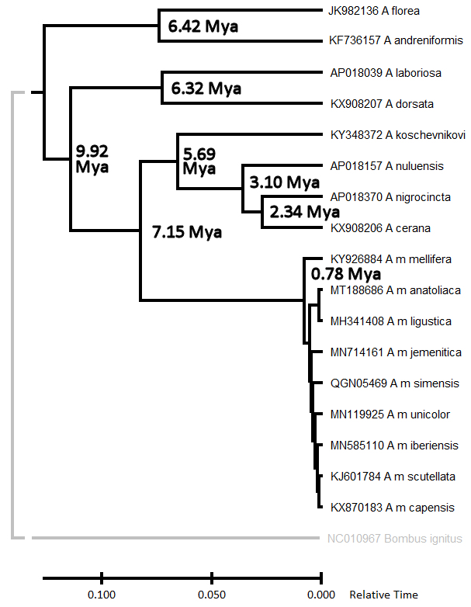
Supplementary Figure S4 - An mtDNA-based molecular clock for species of Apis. Divergence times are calculated as in Figure 7, with Bombus as outgroup (cf. Figure 2).

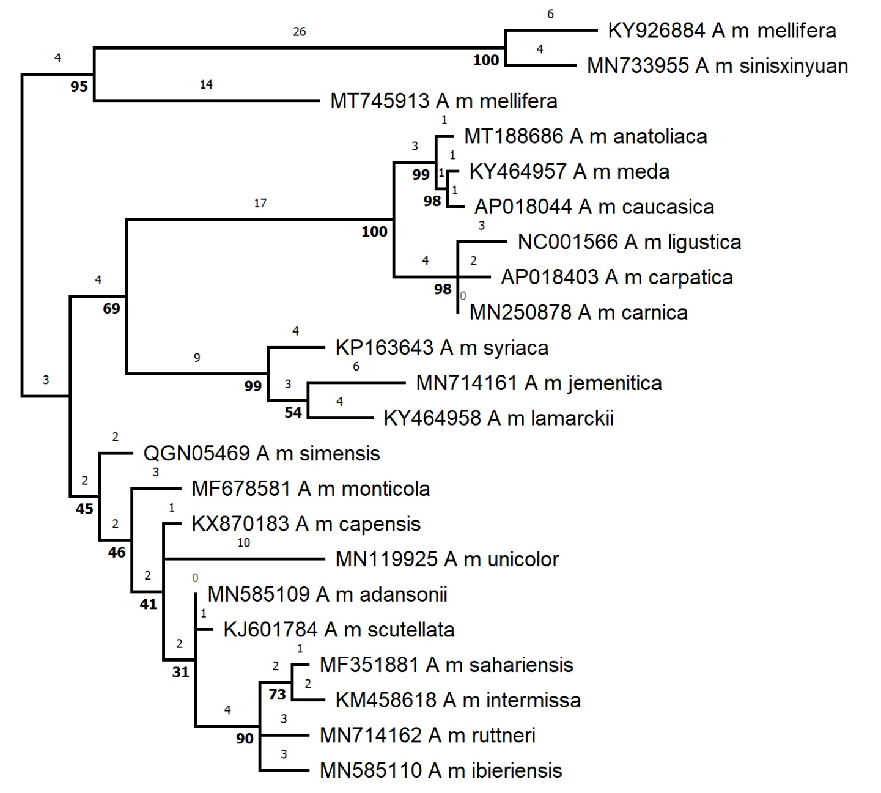
Supplementary Figure S5 - Maximum Parsimony analysis of 125 amino acid variants across representatives of 22 subspecies of A. mellifera. Numbers above each branch are the inferred numbers of amino acid substitutions; numbers below each node are the support among 3,000 bootstrap replications. Note that support for most nodes among African subspecies are < 50%.

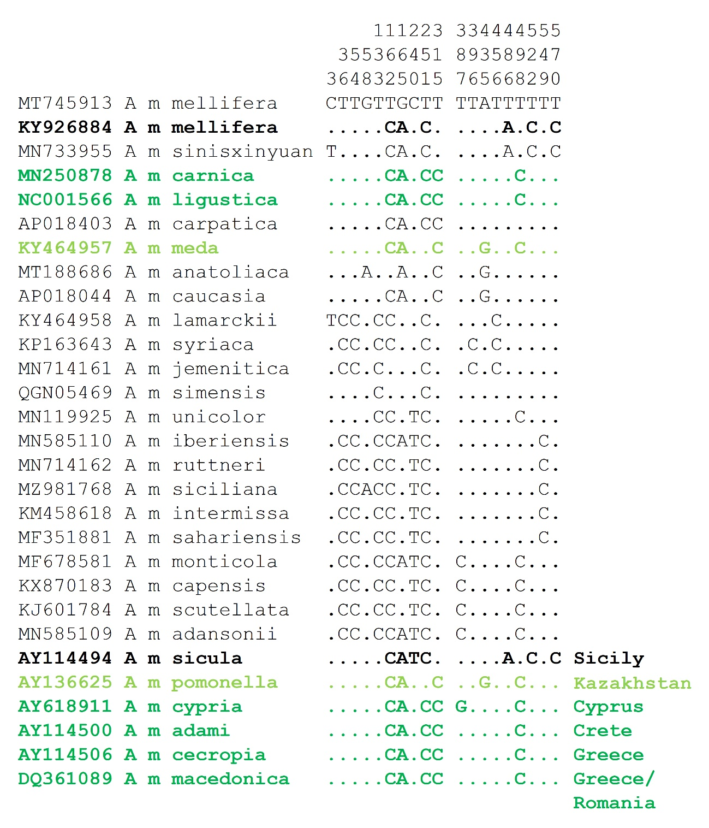
Supplementary Figure S6 – Phylogenetically Informative Sites in the 5’-most 574 bases of the ND2 coding region for 29 subspecies of A. mellifera. The last six sequences are in addition to those analyzed in the main MS. Sequences in dark green are shared with the SE Europe clade, in light green with the Asia Minor clade, and in black with the reference A. m. mellifera sequence. Positions are numbered from #1 in the 11,006 Coding Region alignment.

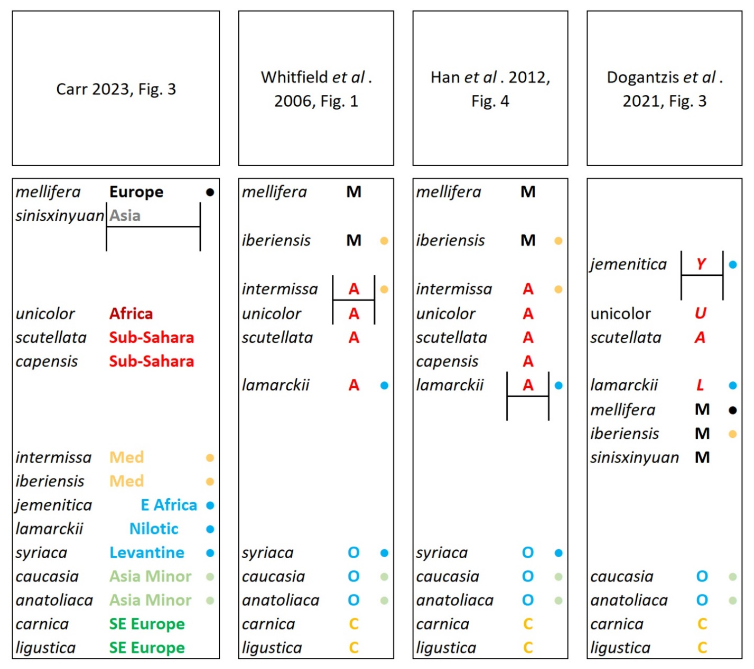
Supplementary Figure S7 – Schematic comparison of mtDNA genome phylogeny versus nucDNA phylogenies of A. mellifera. Order of taxa is based on a linearized ordering of MAOC as in Whitfield et al. (2006)⁴: placement of the root is indicated by |---| between the basal-most clades. MtDNA color codes as in Figure 3; nucDNA color codes for Mellifera, African, Oriental [Asian], and Continental [European] clusters as in the referenced MSS^{4,25,7}. Disparities of placement of taxa as inferred from mtDNA versus nucDNA data are indicated by color-coded ●’s, referenced to Figure 3: see Text. A. m. ruttneri (not shown) is in the Mediterranean mtDNA clade and the O nucDNA cluster¹⁹.

