Supplementary Material

Randomized Controlled Trial of Individualized Arousal-Biofeedback for children and adolescents with Disruptive Behavior Disorders (DBD)

Pascal-M Aggensteiner¹, Boris Böttinger¹, Sarah Baumeister¹, Sarah Hohmann¹, Stefan Heintz¹, Anna Kaiser¹, Alexander Häge¹, Julia Werhahn^{2,3}, Christoph Hofstetter^{2,3}, Susanne Walitza^{2,3}, Barbara Franke^{4,5}, Jan Buitelaar^{4,5}, Tobias Banaschewski¹, Daniel Brandeis^{1,2,3*} & Nathalie E Holz*^{1,4,5,6}

MOAS scoring: The MOAS, like the OAS (Yudofsky et al., 1986) on which it is based, is designed to measure four types of aggression (verbal, against objects, against self, against others) by severity and frequency, with each type having a rating of zero when the type of aggression was absent, and four levels of severity adding a measure of frequency (f) to each behavior that occurred during the observation period, being 0 = absent, 1 = less than 10 incidents, and 2 = 10 or more incidents. Further, each level of severity had a different weight, being A=0, B=2, C=4 and D=8. The overall aggression score (V) was calculated as V = fA+fB+fC+fD.

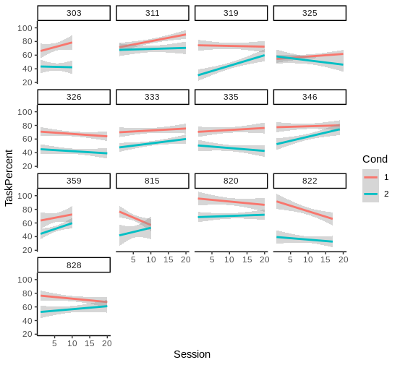
Figure S1 - SCL-BF Individual performance
Mean performance (% correct trials) for each participant. Cond 1= Down-regulation; 2= Up-regulation

Figure S2 - SCL-BF Performance (offline preprocessed SCL Data)
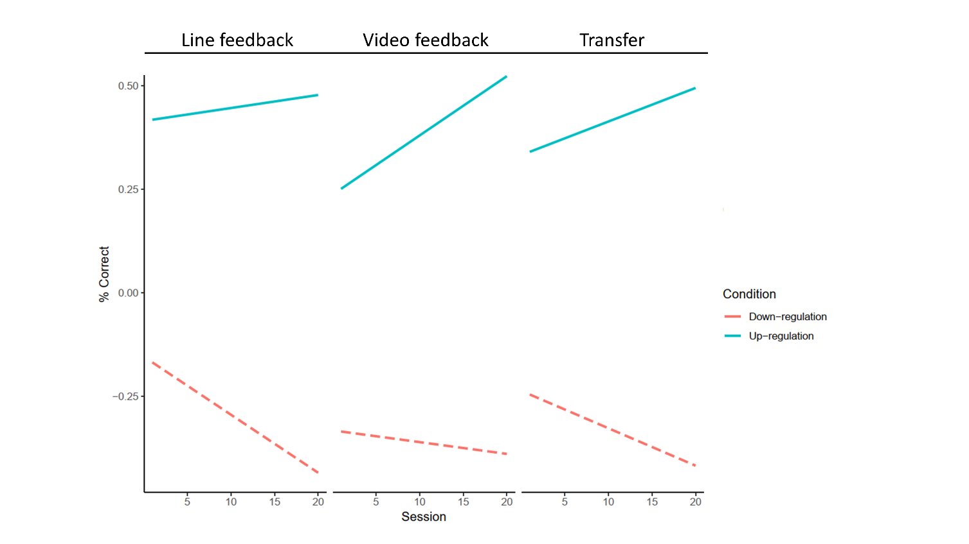
Mean performance (offline preprocessed SCL Data) for each participant. Each trial consisted of a baseline (10 sec), which was the threshold to up or down - regulate SCL. Each trial lasted 40 sec.
Task mean (µS) reflects the mean of baseline minus up or down-regulation for each trial

 | Task
Predictors | Estimates | CI | p
(Intercept) | -0.15 | -0.38 – -0.03 | 0.128
Session | -0.01 | -0.02 – 0.00 | 0.123
Run [2] vs Run [1] | -0.18 | -0.19 – 0.05 | 0.139
Run [3] vs Run [1] | -0.08 | -0.15 – 0.09 | 0.495
Cond [Up] vs Cond [Down] | 0.57 | 0.37 – 0.76 | <0.001
Session * Cond [Up] | 0.02 | -0.00 – 0.03 | 0.051
Session * Run [2] | 0.01 | -0.01 – 0.03 | 0.298
Session * Run [3] | 0.00 | -0.02- 0.03 | 0.644

Table S1 – Mixed model with offline preprocessed SCL Data (micro Siemens)

