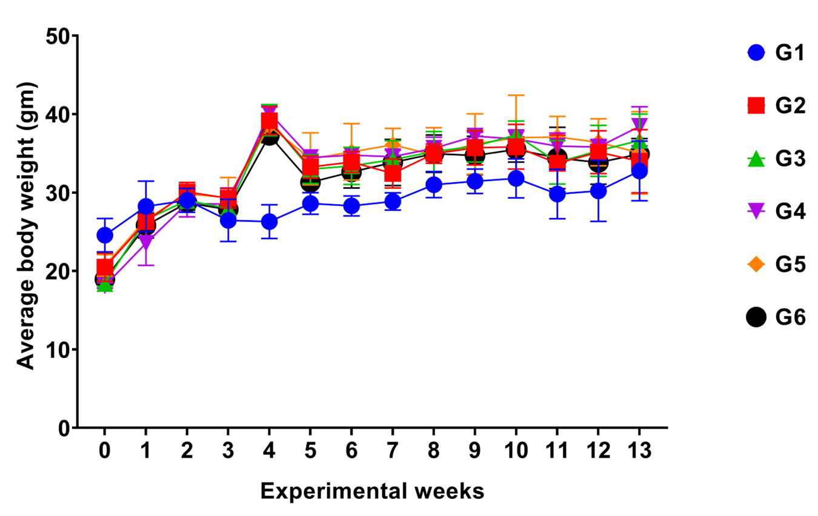
Supplementary Fig 1: Growth curves of mice in different groups during experimental weeks.

Supplementary Table 1: Means of the Initial, Final Body, Absolute and Relative Organ Weights and Weight
Gains

Groups  (Treatment) | G1  (Control -ve) | G2  (Ure+ BHT) | G3  (Ure+ BHT+ Etract) | G4  (Ure+ BHT+ Avastin) | G5  (Ure+BHT+ Encapsule) | G6  (Ure+ BHT+ Encap+  Avastin)
Mice initial No. | 12 | 29 | 28 | 28 | 27 | 28
Mice final No. | 10 | 17 | 15 | 19 | 13 | 10
Initial b.wt.(gm) | 24.5±2.1 | 20.5±1.7 * | 18.4±0.3 *, ** | 18.1±0.3 *, ** | 20.7±1.3 * | 18.9±0.6 *, **
Final b.wt.(gm) | 32.7±3.8 | 33.9±4.0 | 36.6±3.3 *, ** | 38.4±2.4 *, ** | 35.1±5.2 *, ** | 34.9±1.9 *, **
Weight gain (gm) | 8.19±0.06 | 13.5±0.1 * | 18.2±0.2 *, ** | 20.3±0.3 *, ** | 14.3±0.2 *, ** | 15.9±0.3 *, **
Lung wt. (gm) | 0.29±0.027 (1.03) | 0.35±0.07¹ (0.98)² | 0.37±0.08 (1.03) | 0.33±0.04 (0.87) | 0.39±0.12 (1.1) | 0.4±0.16 (1.12)
Liver wt. (gm) | 1.99±0.5 (7.1) | 1.92±0.5 (5.2) * | 1.94±0.53 (5.1) * | 1.9±0.41 (5.2) * | 1.88±0.33 (5.2) * | 1.88±0.44 (5.3) *
Left Kidney wt. (gm) | 0.23±0.06 (0.8) | 0.26±0.06  (0.7) * | 0.28±0.1  (0.7) *, ** | 0.27±0.046  (0.7) * | 0.29±0.03  (0.8) * | 0.26±0.05  (0.7) **
Right Kidney wt. (gm) | 0.24±0.08 (0.8) | 0.26±0.61  (0.7) * | 0.27±0.08  (0.7) *, ** | 0.26±0.06  (0.6) * | 0.29±0.03  (0.8) * | 0.28±0.06  (0.7) **
Spleen wt (gm) | 0.27±0.08 (0.96) | 0.18±0.07  (0.5) * | 0.27±0.11 (0.75) *, ** | 0.27±0.13  (0.7) *, ** | 0.32±0.16 (0.9) ^{b} | 0.25±0.1  (0.7) *, **
Testes wt (gm) | 0.24±0.05 (0.86) | 0.26±0.05 (0.72) * | 0.28±0.04 (0.77) * | 0.27±0.02  (0.71) * | 0.27±0.03 (0.78) * | 0.34± 0.04  (0.96) **
1: values of absolute organ wts. (means ± S. D.); 2: values in parenthesis are relative organ wts: Ratio of organs wts/ body wt. (%); a: significant versus G1 at P< 0.05; **: significant vs G2 at P< 0.05.

Supplementary Fig 2: The Log curves of qRT-PCR melting, raw, and quantitation data in Cycling A. Green for mRNA expressions of HRAS (A-C), MAPK (D-F), and Bcl2 (G-I) in animal lung cancer mouse.

Supplementary Fig 3: The Log curves of qRT-PCR melting, raw, and quantitation data in Cycling A. Green for mRNA expressions of Bax (J-L), P21 (M-O), and B-actin housekeeping gene (P-R) in animal lung cancer mouse.

