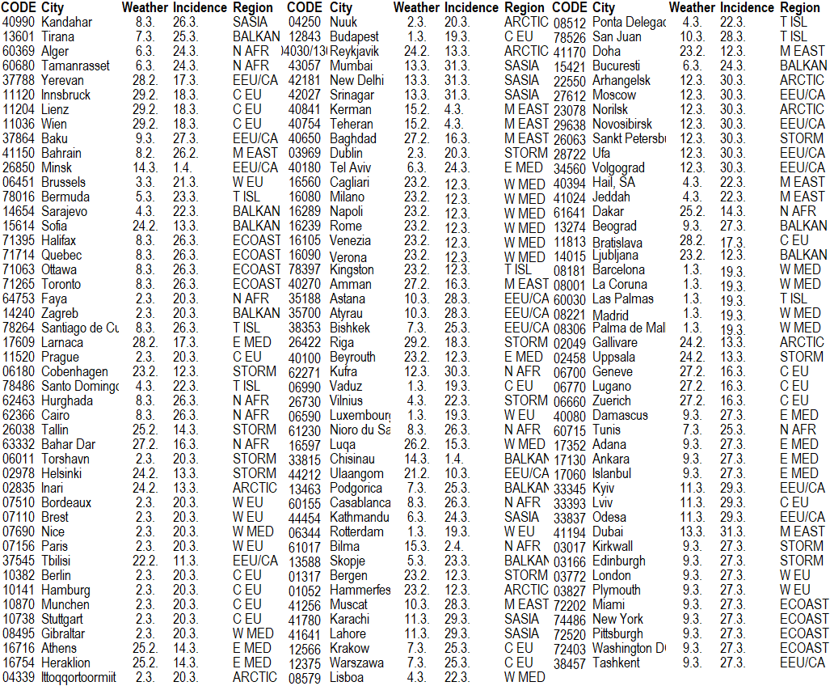
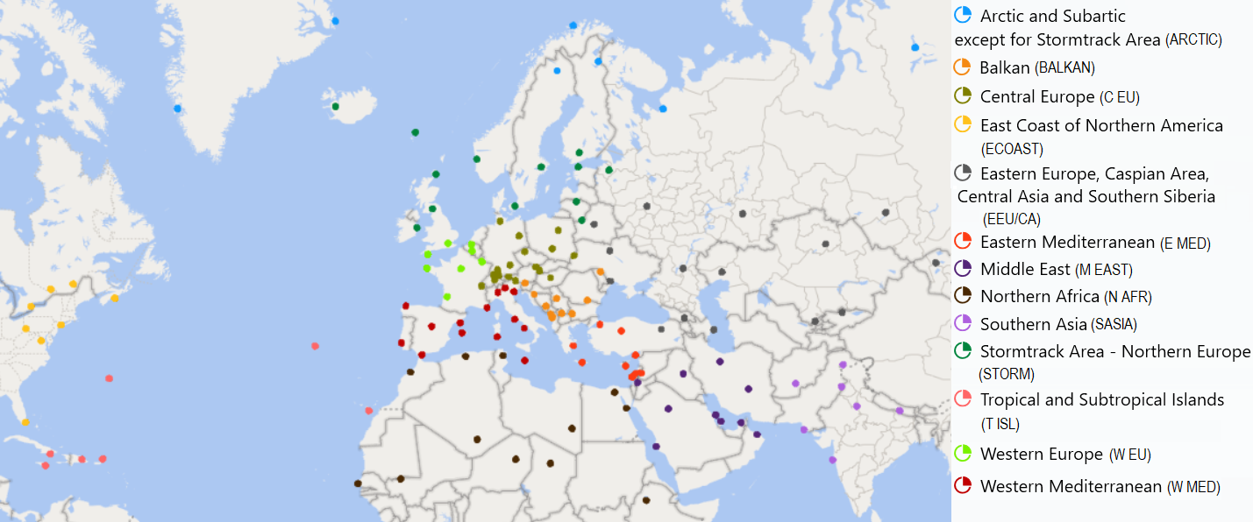

Fig. and Table 1: Up: List of 137 cities (representative meteorological stations) with their WMO CODE, date of the first day of meteo data (Weather) and incidence data (Incidence) entering to the computations and main region (Region) of cities; Down: Map of used stations (cities) within 13 main regions

Table 2: Spearman correlation ranks between daily means of 8 meteorological elements (average temperature (° C), TX – maximum temperature (° C), TN – minimum temperature (° C), RR – 24-hours precipitation (mm), PP – air pressure (Hpa), WW – average daily wind speed (km/h), SS – sunshine duration (h) and snow cover (cm)) and daily incidence of SARS-COV-2 for 3 incubation time periods (1st 0-9 day/NAO-; 2nd 5-14 day/NAO neutral; 3rd 10-19 day/NAO+) and circulation phases in 137 cities. Crossed cells – significant at level 0.10.
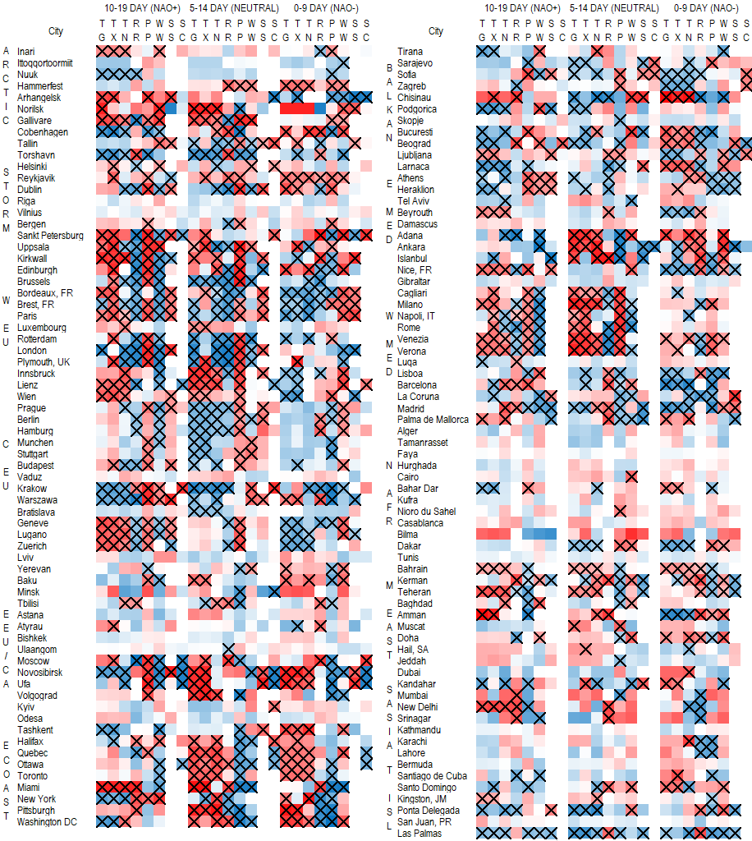

Table 3: Correlation matrixes (Spearman correlation rank) between impacts of 8 meteorological elements on the incidence of SARS-COV-2 every with each other. This output is computed for 13 partial regions and for all 137 stations (All set), separately and 3 incubate time periods (such in Fig. 3). Statistically significant responses at level 0.10 are in frames.

