Supplementary Information for
Programmable terahertz metamaterials with non-volatile memory

Benwen Chen¹, Jingbo Wu^{1*}, Weili Li¹, Caihong Zhang¹, Qiang Xue², Yaojia Chi², Qiye Wen², Biaobing Jin^{1*}, Jian Chen¹ and Peiheng Wu¹

¹Research Institute of Superconductor Electronics (RISE), School of Electronic Science and Engineering, Nanjing University, Nanjing 210023, China
²State Key Laboratory of Electronic Thin Films and Integrated Devices, University of Electronic Science and Technology of China, Chengdu 610054, China
Correspondence should be addressed to Jingbo Wu (jbwu@nju.edu.cn), and Biaobing Jin (bbjin@nju.edu.cn)

Supplementary Note 1. Electromagnetic simulation the VO₂-integrated device
As discussed in the main text, the working bands of the device are mainly determined by the absorption frequency conditions of Salisbury screen. In Fig. S1a, we set up an equivalent circuit model of the device based on the transmission line theory. In the top layer, the VO₂ patches are in connection with the bow-tie antennas. It is equivalent to an impedance of Z_{s} which short-circuits the transmission line. The ground layer of continuous gold film blocks all of the incident THz waves. Therefore, the impedance at Interface I (Z_{I}) is 0. The impedance at the Interface II (Z_{II}) and III (Z_{III}) are
$Z_{II}=jη_{2}\tan{(β_{2}d)}$, (S1-1)
$Z_{III}=\frac{Z_{II}Z_{s}}{Z_{II}+Z_{s}}$, (S1-2)
where $η_{2}$ and $d$ is the wave impedance and the thickness of the Al₂O₃ substrate, β₂ is the wave vector of the THz wave propagating in the substrate and $β_{2}=\sqrt{ε_{r} }2πf/c$, where ε_{r} is the dielectric constant of the substrate, f and c are the frequency and the speed of the THz wave in vacuum, respectively. The reflection coefficient (Г) referred to the Interface III can be expressed as
$Γ=\frac{Z_{III}-Z_{0}}{Z_{III}+Z_{0}},$ (S1-3)
where Z₀ is the wave impedance of free space. In the resonant condition, β₂d in the Eq. (S1-1) equals to (2m-1)π/2 (where m=1,2,3…). In that case, Z_{II} approaches infinity, and Eq. (S1-2) can be simplified as Z_{III}=Z_{s}. It means Г mainly depends on the Z_{s}. To meet the condition: β₂d=(2m-1)π/2, the following condition is required:
$f=\left(2m-1\right)\frac{c}{4d\sqrt{ε_{r}}}, m=1,2,3,…$ (S1-4)
In our device, ε_{r} is 9.4 for the c-cut Al₂O₃ substrate, and d = 150 μm. In our design, the frequency band of 0.42-0.48 THz is corresponding to the second-order resonance. When m equals 2, the calculated resonance frequency is 0.489 THz, slightly different from the actual working band. The shift of resonance frequency is mainly because the substrate thickness and the reactance of the VO₂ patch in the active layer deviate from the designed values. Based on the Salisbury screen theory, Г is sensitive to the resistance of the top metallic layer. As the conductivity of VO₂ patches changes with temperature, there is a remarkable change of Г.
Furthermore, the absorption coefficient at f = 0.479 THz was studied by simulating the power loss density (PLD) in the top metallic layer. Figure S1b shows the two-dimensional distribution of PLD for three different conductivities of VO₂ film. In Fig. S1b, the maximum PLD appears around the VO₂ patches, indicating that the VO₂ patches absorb most THz energy. Besides that, the PLD goes up with increasing VO₂ conductivities. It shows an agreement with the theoretical analysis. 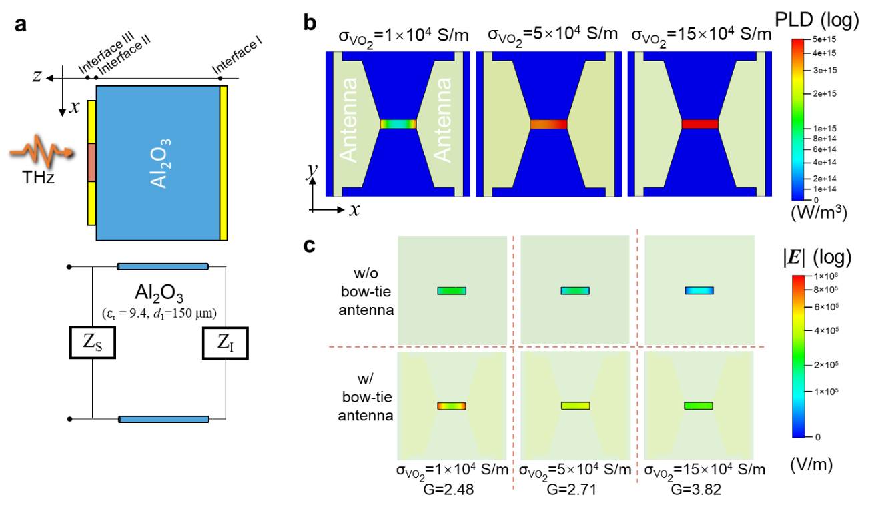
Fig. S1. Circuit model and electromagnetic simulation of a unit cell. (a) Schematic cross-section view of the unit cell (top) and its equivalent circuit model based on the transmission line theory (bottom). (b) Simulated PLD distribution in the top metallic layer for different VO₂ conductivity of 1×10⁴ S/m, 5×10⁴ S/m and 15 × 10⁴ S/m at 0.479 THz. In the simulation, The Floquet boundary condition is used. The conductivity of the gold film is 4.56×10⁷ S/m [S1]. (c) Two-dimensional THz electric field distribution for the VO₂ patches with and without bow-tie antennas, respectively. The calculated G based on the simulation results is displayed at the bottom of the corresponding figure.

Next, we studied the role that the bow-tie antenna plays in the interaction between the THz wave and VO₂ patches. We simulated the electrical field distribution for the VO₂ patches with or without the bow-tie antennas. As shown in Fig. S1c, there is a noticeable THz electric field enhancement when the antenna is integrated into the top metallic structures. To evaluate its contribution to THz electric field enhancement, we introduced an averaged enhancement factor (G),
$G=\frac{\int_{l,w/}^{ }{|E|}dx}{\int_{l,w/o}^{ }{|E|}dx}$. (S1-5)
where $E$ is the total electric field along the horizontal centre line of the VO₂ patches with a length of $l$. The calculated G are listed below the corresponding figure. It shows that the averaged electric field for the devices with bow-tie antennas is over 2.4 times compared with the devices without bow-tie antennas.

Supplementary Note 2. Optimisation of the layout of the device.
The structure of the feed network is crucial for thermal isolation in pixelated devices. In our device, the resistance of electrical leads connecting the electrodes with VO₂ patches. The quantity of heat generated from the electric wires could result in the thermal crosstalk. To minimise the resistance of electric leads, we increase their width and shorten the distance between electrodes and VO₂ patches.
The resistance of a pixel is a significant factor in thermal management. As shown in Fig. 2b of the main article, a pixel is composed of 10×10 unit cells. The total resistance can be varied by adjusting the series and parallel connection between different unit cells. To obtain a practical value of resistance, we need to consider the following factors. When VO₂ goes into the metallic state, there is a significant drop in the resistance of VO₂ patches. There will be an excessive quantity of heat if we choose the voltage bias. On the contrary, the high resistance of VO₂ patches in the insulating state requires a high voltage as the bias to trigger the IMT.
The series or parallel connection between different unit cells determines the resistance of pixel (R_{p}). When all unit cells are connected in series, R_{p} equals 100R_{u}, where R_{u} is the resistance of a unit cell. In that case, a relatively high excitation voltage is required to trigger the IMT of VO₂ patches. On the contrary, if every unit cell is in parallel, R_{p} = R_{u}/100. When VO₂ goes into the metallic state, R_{p} is remarkably lower than the resistance of the electric leads. Consequently, most electric power is dissipated in the electrical wires rather than in the VO₂ patches.
After the experimental verification, the optimised design of the electric connection between different VO₂ patches is shown in Fig. S2b. A pixel is divided into five identical blocks which are in series connection. Correspondingly, R_{p} = 5R_{block}, where R_{block} is the resistance of a block. For a block consisting of two columns of unit cells, five unit cells in parallel constitute a supercell. The two supercells in the same column are in series, while the two columns in the same block are in parallel. In that case, R_{p} = 5R_{block} = R_{u}. The electric bias is controlled at a reasonable value through the optimization of the feed network and the connection between unit cells. The thermal generation in the electric wires is greatly suppressed.
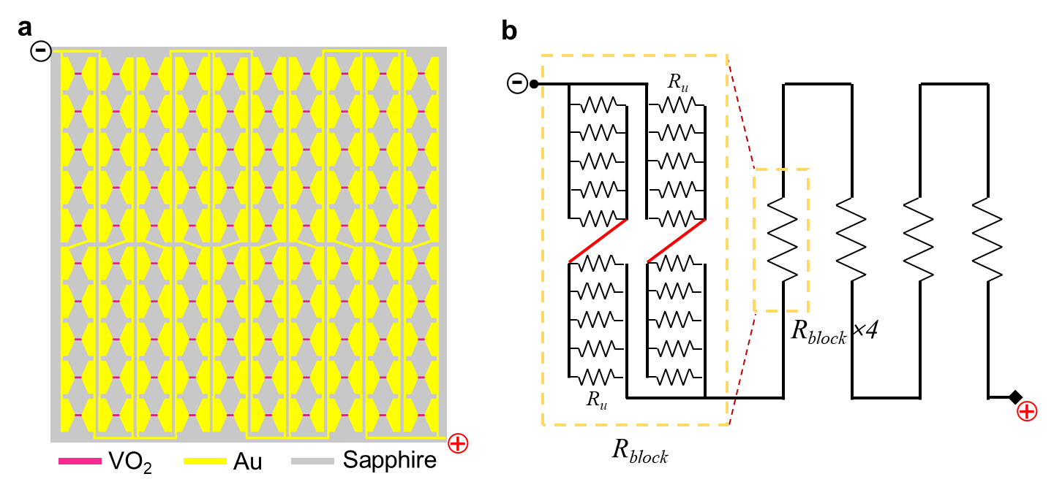
Fig. S2 Pixel resistance. (a) The schematic of a pixel in the device. (b) The equivalent resistance model of a pixel.

Supplementary Note 3. Temperature calibration of the thermal camera
Firstly, we used a thermal camera to take photos of the sample when the temperature was biased at 55 °C (below T_{c}) and 69 °C (above T_{c}). The greyscales of the images were corresponding to the radiation intensity in the infrared region (8–14 μm). Then, we adjusted the infrared emissivity in the software of the thermal camera so that the obtained temperature in the sample region is equal to the bias temperature. After that, we got the infrared emissivity in the area of the whole sample at 55°C (E_{T=55°C} (x, y)) and 69 °C (E_{T=69°C} (x, y)). There is a significant difference in the emissivity when the sample is in the insulating and metallic state. In the following, the sample temperature was biased at 55°C. The electric stimuli triggered the phase change of each pixel. Then, we assumed the sample temperature was still at 55°C and adjusted the emissivity in the software to keep the sample temperature at this value. In that case, the obtained infrared emissivity (E’_{T=55°C}(x, y)) is different from E_{T=55°C}(x, y) at the positions where the pixels were triggered. A line scan of the difference in emissivity (Δ = E’_{T=55°C} (x, y) - E_{T=55°C} (x, y)) along the blue dashed line in the inset is shown in Fig. S3. The triggered pixels have a higher Δ than those which was not activated. To distinguish whether the pixel is switched on or not, we set a threshold value (Δ_{th}). Here we chose Δ_{th} = 0.3 to minimise the noise. If Δ > Δ_{th}, the pixel has been triggered to the metallic state. The emissivity around these pixels was set to be the emissivity at 69 °C. If Δ < Δ_{th}, the phase change does not occur in these pixels. The emissivity around them was kept to be the value at 55°C. Based on this method, the temperature distribution was obtained.
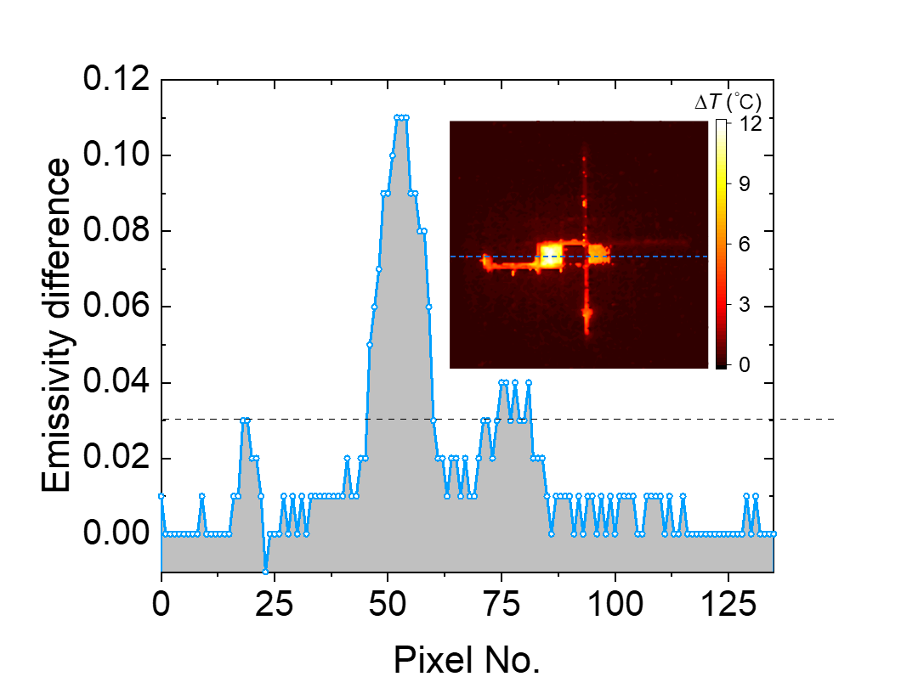
Fig. S3. Line scan of the emissivity difference along the blue dash line shown in the inset. The inset is a copy of Fig. 3d in the main text.

Supplementary Note 4. Thermal diffusion model of the VO₂ device
We established a simplified thermal model to analyse the thermal effect inducted by the ohmic loss of VO₂ patches. In this model, the heat conduction through the interfaces of VO₂ patches and bow-tie antenna is neglected. We considered the thermal generation from the ohmic loss of VO₂ patches and the thermal conduction from the VO₂ patches to air, substrate and stage. The thermodynamic equation can be written as follows:
$C_{V}\frac{dT_{V}}{dt}+G_{1}\left(T_{V}-T_{a}\right)+G_{2}\left(T_{V}-T_{s}\right)=P_{in}$, (S4-1)
where C_{V} and T_{V} are the heat capacity and the temperature of the VO₂ patches, respectively; G₁ and G₂ are the thermal conductance at air/VO₂ and substrate/VO₂ interfaces; T_{a} and T_{s} are the temperatures of air and substrate. P_{in} is the power that triggers the phase change of VO₂ patches in a pixel. The items of G₁(T_{v} - T_{a}) and G₂(T_{v} - T_{s}) are the heat transfer from the VO₂ patches to the air and the substrate, respectively. To describe T_{s}, we established a heat transfer equation by assuming that the four side faces of the sapphire substrate are thermally isolated:
$C_{s}\frac{dT_{s}}{dt}-G_{2}\left(T_{V}-T_{s}\right)+G_{eff}(T_{s}-T_{stage})=0$, (S4-2)
where C_{s}, G_{eff}, and T_{stage} are the heat capacity of the substrate, thermal conductance at the substrate/stage interface, and the stage temperature, respectively. At the substrate/stage interface, a thin intermediate layer of liquid metal was inset into it to optimise the heat conduction between the sapphire substrate and the stage. In this simplified model, the heat capacity of the intermediate layer is neglected since its volume is tiny, and G_{eff} is raised accordingly.
When the temperature of the VO₂ patches is maintained at T_{c} and T_{s} goes into a steady state, C_{s}dT_{s}/dt = 0, we can deduce that:
$T_{s}=\frac{G_{2}T_{c}+G_{eff}T_{stage}}{G_{2}+G_{eff}}=T_{stage}+\frac{G_{2}(T_{c}-T_{stage})}{G_{2}+G_{eff}}$. (S4-3)
Based on the above equation, when T_{c} is higher than T_{stage}, T_{s} decreases with the increase of G_{eff}. It indicates that we can use an intermediate layer with a high thermal conductivity to reduce T_{s} and suppress thermal crosstalk among neighbouring pixels. Hence, a layer of thermal conductive eutectic alloys with a thermal conductivity of up to 73 W/(m·K) was used in our experiment. With the thermally conductive adhesive, the heat transfer from the substrate to the stage is much faster. When the external stimulus is switched off, the VO₂ could recover to the initial steady state quickly. In previous studies, the recovery time is the main bottleneck that affects the switching speed of the VO₂ modulator [2]. In our work, we significantly shortened the switching time. The modulation speed can reach up to 1 kHz, as shown in Fig. 3 of the main article.

Supplementary Note 5. Thermal crosstalk between adjacent pixels
To characterize the thermal crosstalk suppression, we used a voltage pulse with an amplitude of 50 V (the compliance current is set to be 200 mA) and a duration time of 200 ms to trigger the IMT of the total 64 pixels one by one. The distribution of temperature differences (assuming an emissivity of 1) was recorded with a thermal camera. When the voltage pulse is applied to a pixel to trigger the phase change of VO₂, the consumed power is approximately 1 W. As shown in the video (see supplementary movie 1), the zone around the excited pixel is light up, and the other regions is still dark. It indicates that the thermal crosstalk is significantly suppressed.

Supplementary Note 6. Characterization of the focused THz beam using a quasi-optical system
The quasi-optical system was used to measure the generated THz patterns from the pixelated devices. We characterized the profile of the focused THz beam used in the quasi-optical system. As shown in Fig. S4a, the THz wave generated by a THz source (AMC 336, VDI Inc.) was collimated and focused by two off-axis parabolic mirrors (OAP). The THz detector (WR2.2ZBD, VDI Inc.) with the xy-positioning stage was placed on the focal plane to scan the two-dimensional intensity distribution of the focused THz beam. The obtained image is shown in Fig. S4b, in which the intensity is normalised by the maximum. The intensity distribution along the horizontal centre line and the vertical centre line of the 2D distribution are plotted in Fig. S4c. We could obtain the full width at half maxima (FWHM) of the focused beam. The FWHMs in the two directions are both approximately 2.76 mm.
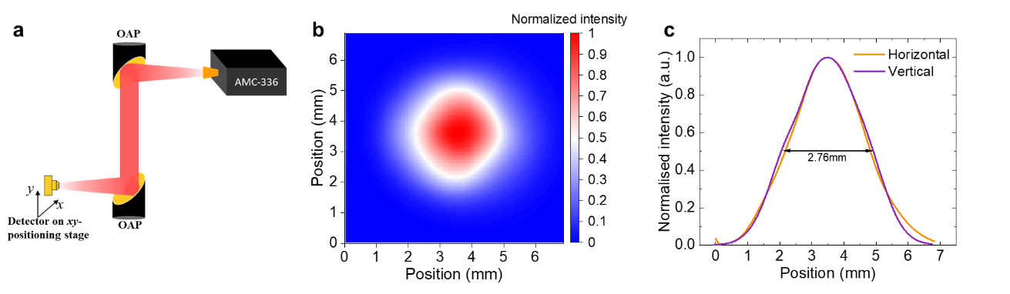
Fig. S4. Characterization of the focused THz beam (a) Sketch of the quasi-optical setup for measuring the THz beam profile. (b) Normalised two-dimensional intensity distribution at the frequency of 0.479 THz. (c) The normalised intensity distribution of focused THz beam along the horizontal and vertical centre lines.

Supplementary Note 7. Experimental setup for characterizing the THz spatial light modulation (SLM)
As each pixel could be controlled independently, the device can work as a THz SLM. Different THz spatial patterns could be generated from the reflected THz wave. Using the experimental setup shown in Fig. S5, we measured the spatial profiles of the THz wave with the raster scanning method. Here a 340–500 GHz amplifier/ multiplier chain modules (AMC-336, VDI Inc.) combined with a microwave signal generator (E8257D PSG, Keysight) was used as the THz source. For the control circuit of the device, the DC signals output from IO ports of FPGA (Spartan-6, Xilinx Inc.) were amplified by 64-channel amplifiers. In our experiment, the pixels were triggered by a DC voltage with the amplitude of 26 V to be lit up. By implanting the codes into FPGA, we could control the state of each pixel individually and apply different coding sequences to generate the designed THz patterns. The device was placed in the focal plane of OAP #2 so that the THz spot was focused onto the device with a full width at half maxima (FWHM) of ~2.76 mm at 0.479 THz. The THz wave reflected by the device was received by a zero-biased detector (WR2.2ZBD, VDI Inc.). The readout signals from the receiver were sent to a lock-in amplifier to recover the unmodulated signal. A computer acquired the data for processing. By controlling the movement of the XY positioning stage step by step, the spatial map generated by the sample was measured. For the measurement of the modulation speed of the device, the temperature of the thermal stage was set at 55 ℃. The THz spot was focused onto a pixel, and it was applied with a square-wave current signal generated by a current source (Keithley 6221). The readout signal of the THz detector was acquired by a lock-in amplifier (MFLI, Zurich Instrument) to recover the modulated signal.
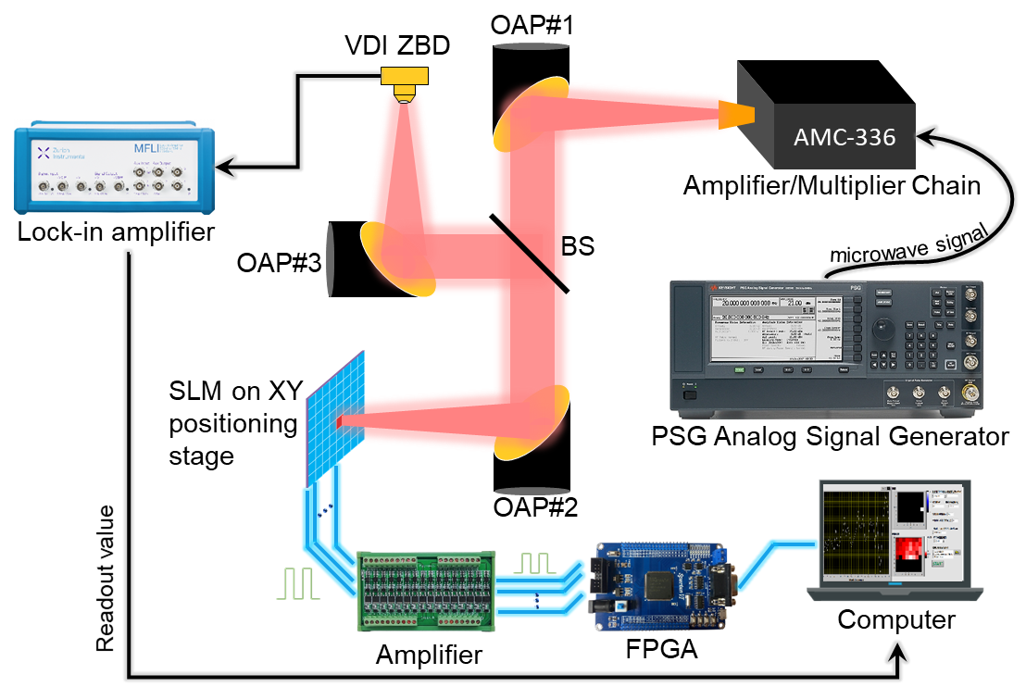
Fig. S5. Schematic of the quasi-optical setup for raster-scanning. OAP: off-axis parabolic mirror; BS: beam splitter; ZBD: zero-bias detector.

Supplementary Reference
[S1] W. C. Chen et al., "Single-layer terahertz metamaterials with bulk optical constants," Physical Review B, vol. 85, no. 3, p. 035112, 01/17/ 2012.
[S2] D. Li et al., "Joule Heating-Induced Metal-Insulator Transition in Epitaxial VO2/TiO2 Devices," ACS Appl Mater Interfaces, vol. 8, no. 20, pp. 12908-14, May 25 2016.

