Supporting Information
Construction of nanoparticle array membranes by tumour metastasis-inspired self-seeded phase inversion for microplastic wastewater treatment

Contents
1. Fabrication, characterization, and analysis of a polyvinylidene fluoride nanoparticle array membrane (PVDF-NP-A) via self-seeded phase inversion (SSPI).
1.1. Explanation of PVDF crystal seeds uniformly distributed in PVDF-S membrane.
2. Parameters of PVDF-NP-A membranes.
3. Separation performances of the PVDF-NPs-A membranes.
3.1. Calculation method

1. Fabrication, characterization, and analysis of a polyvinylidene fluoride nanoparticle array membrane (PVDF-NP-A) via self-seeded phase inversion (SSPI).

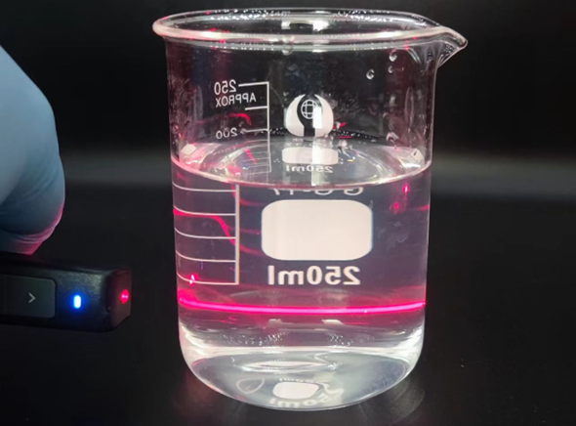
Figure S1. Tyndall effect in the PVDF NPs dispersion

Figure S2. Size/concentration distribution of the PVDF NPs dispersion tested by a NP tracking analyzer (The adding volume of the PVDF solution to the water are 0.5, 1, and 2 mL)

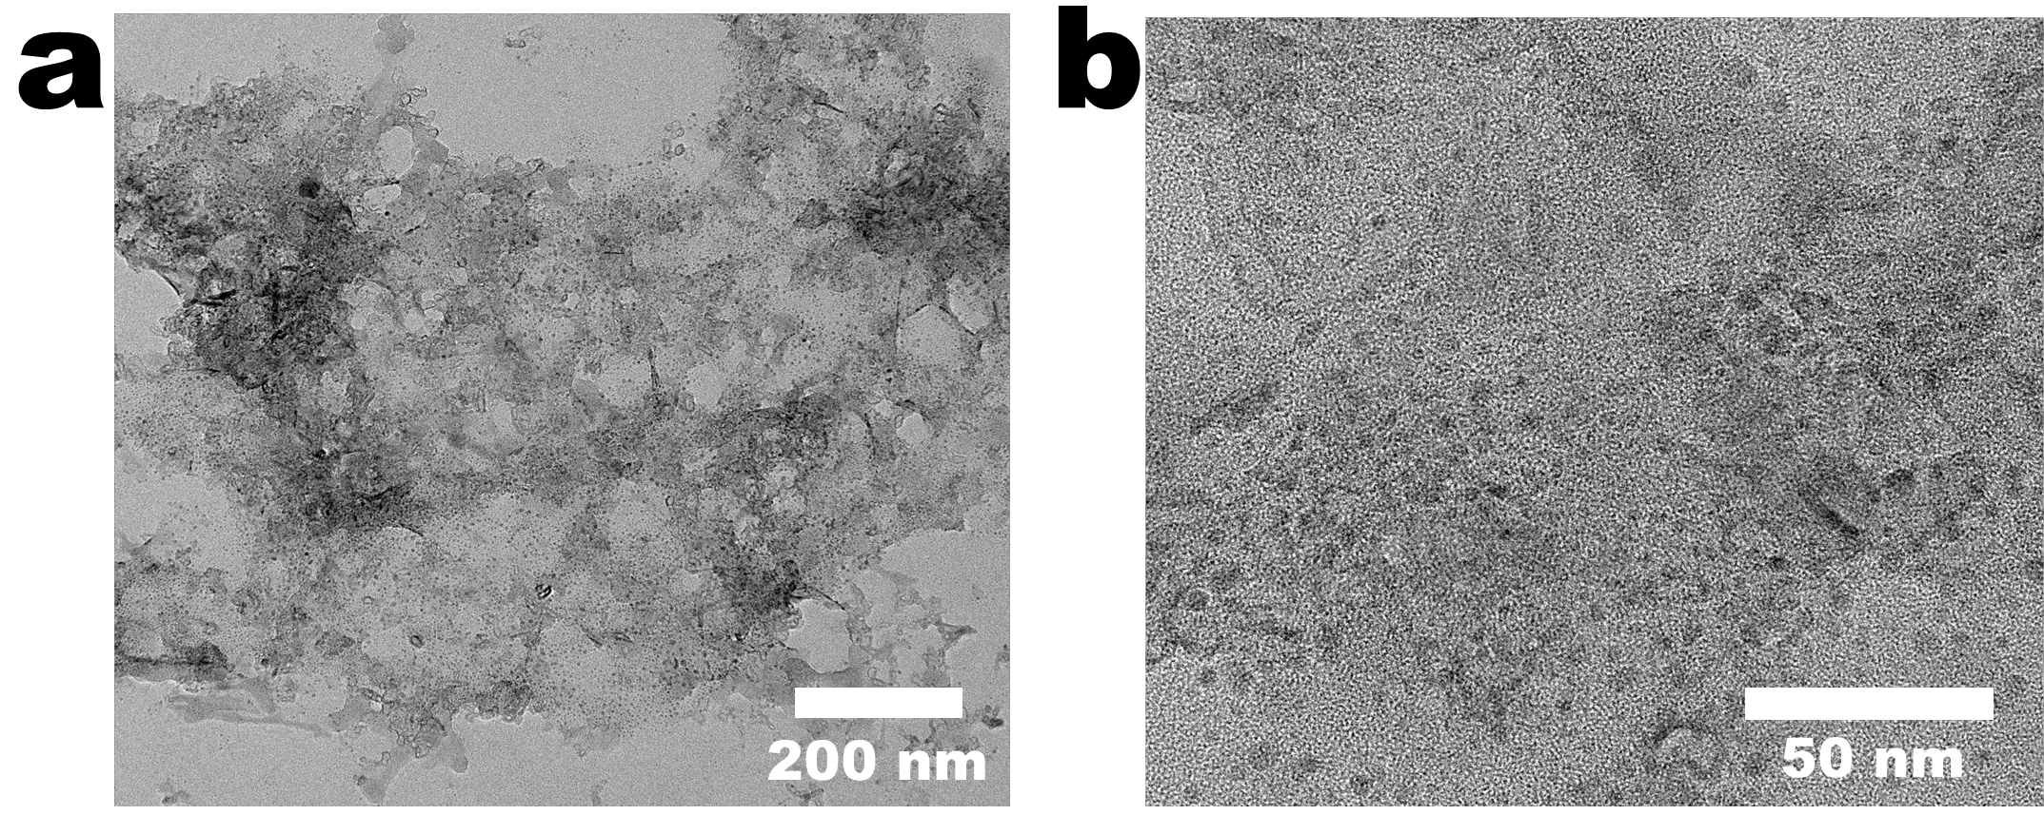
Figure S3. STEM image of the PVDF-S20 membrane

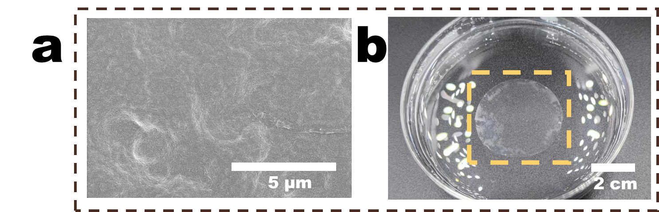
Figure S4. (a) SEM image of PVDF-S5 membrane; (b) Digital image of the PVDF-S5 membrane

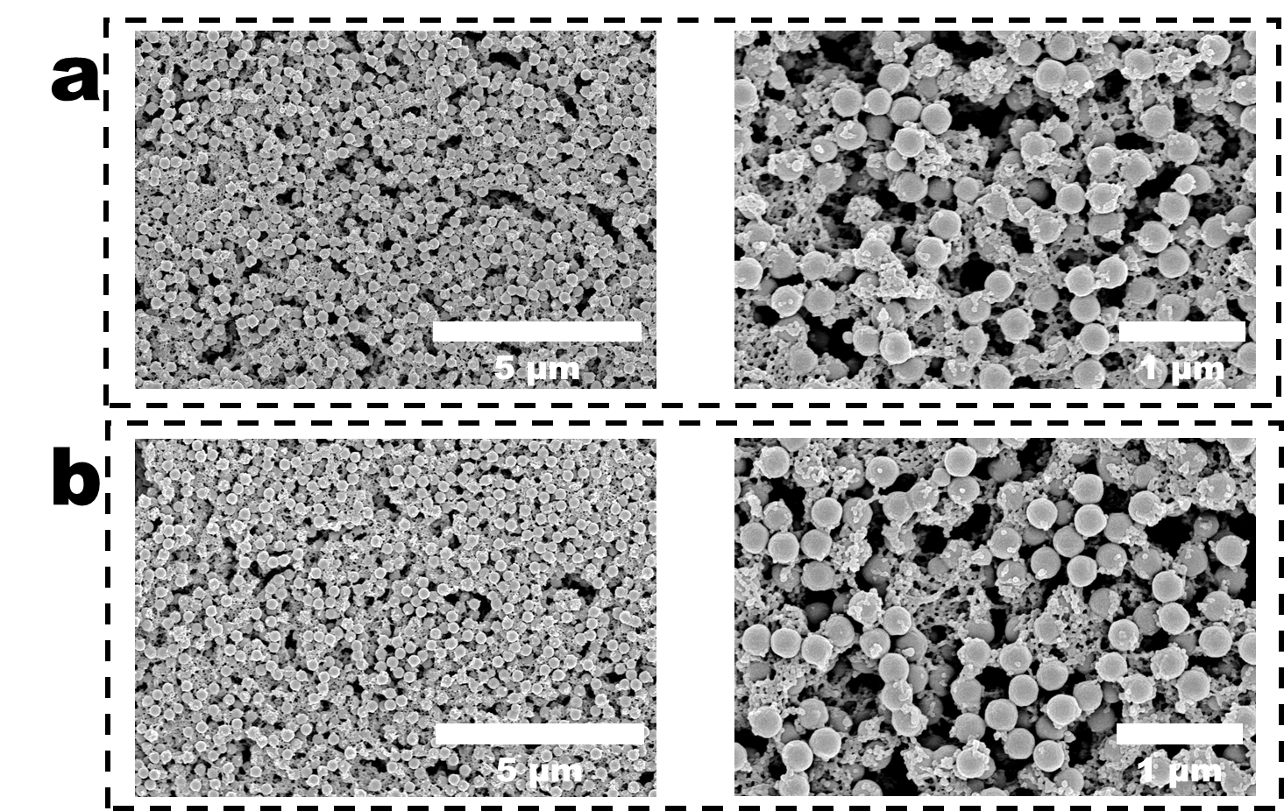
Figure S5. SEM images of PVDF-NPs10 membrane (a) and PVDF-NPs20 membrane (b)

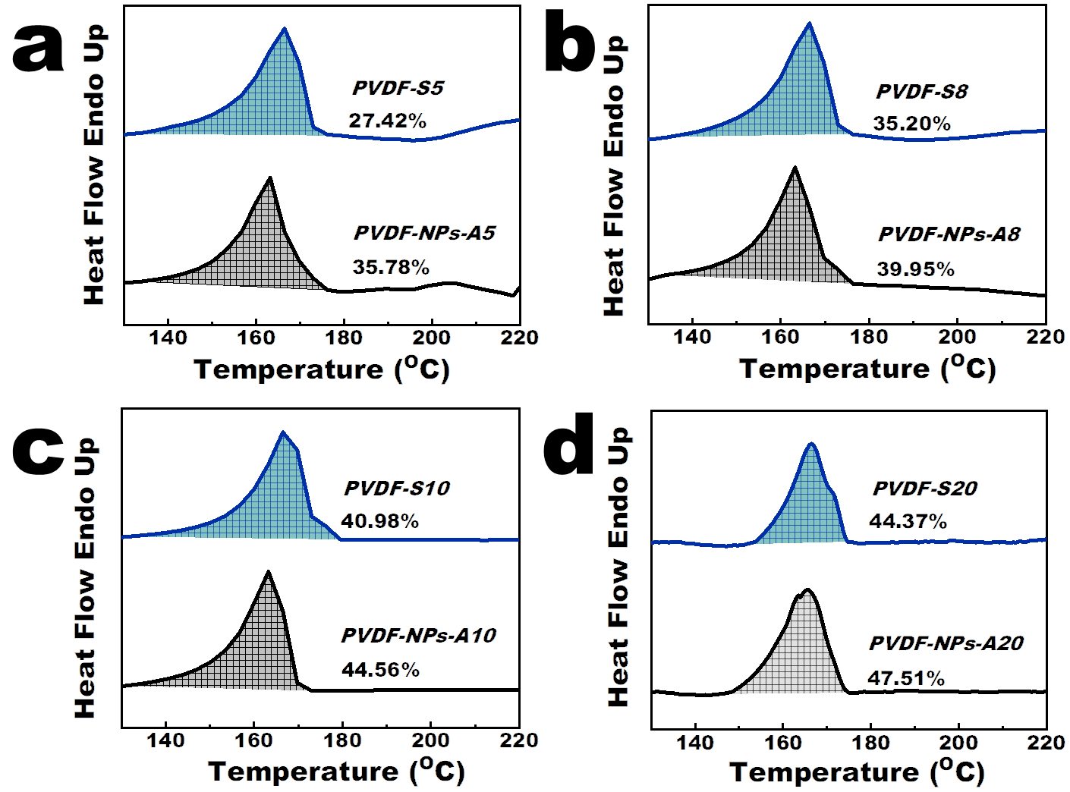
Figure S6. DSC thermograms of PVDF-S and PVDF-NPs-A membranes

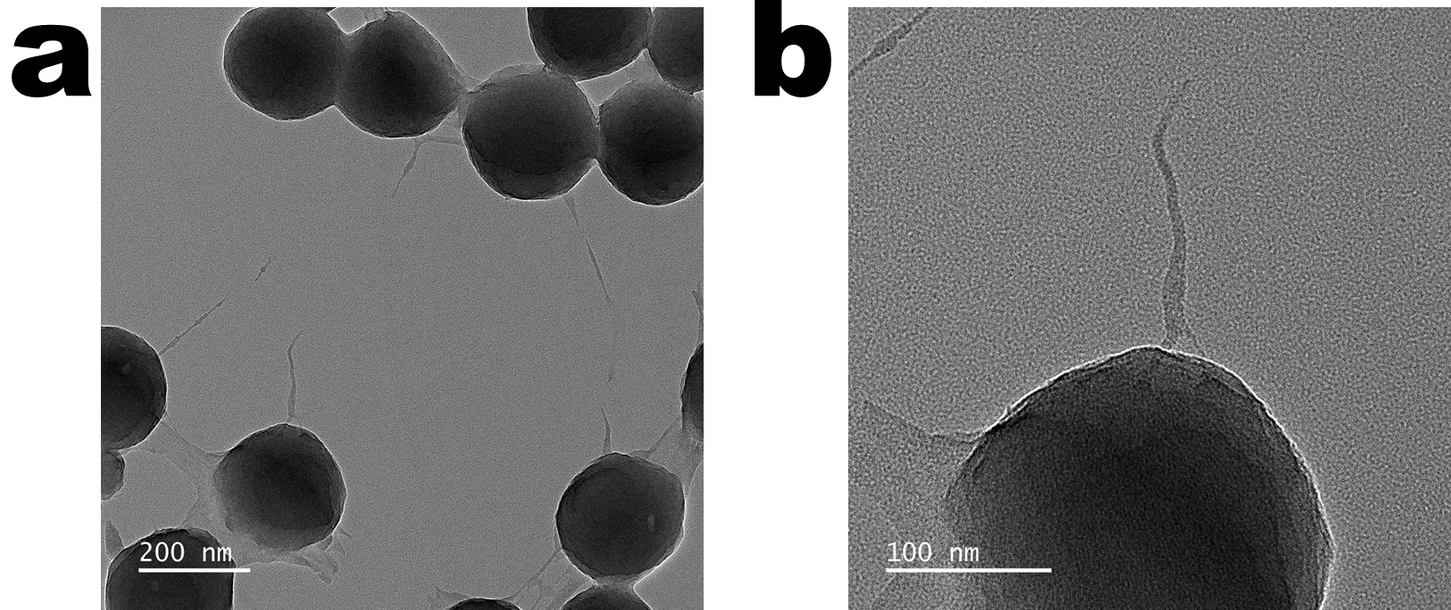
Figure S7. PVDF polymer draw and form threads in poor phase.

1.1. Explanation of PVDF crystal seeds uniformly distributed in PVDF-S membrane.

Due to concentration differences, DMF undergoes diffusion during the filtration process, and the diffusion process is driven by the chemical potential gradient, which generates a driving force for DMF transfer. Therefore, the direction of the force is isotropic, allowing DMF to be transferred in all directions within the membrane with equal probability, ultimately leading to even distribution. Additionally, as the pressure was homogeneous throughout the membrane during filtration, the force that drives DMF into the membrane was homogeneous in a single direction. Due to the simultaneous occurrence of diffusion and pressure-driven mechanisms, the resulting force can be expressed as¹：

$p_{t}=∆p+∆π=-\frac{RTln\left(1-\frac{J∆x}{DKc}\right)}{V}>∆p$ (S1)

$D=\frac{kT}{6πμr}$ (S2)
In the equation, $p_{t}$ represents the pressure that drives the transfer of DMF, ∆p represents the vacuum pressure, ∆π represents the osmotic pressure generated during the diffusion process, R is the ideal gas constant, T is temperature, J is the permeation flux of DMF, ∆x is the membrane thickness, D is the diffusion coefficient of DMF, K is the distribution coefficient, c is the molar concentration of DMF in the membrane, k is the Boltzmann constant, μ is the viscosity of DMF, and r is the radius of DMF molecules. It can be seen that during the diffusion process of DMF, a driving force greater than the vacuum pressure (0.95 bar) can be generated in the membrane to drive DMF transfer. The transfer of DMF can also cause migration of polymer segments and crystal types inside the viscous PVDF-S membrane (with a viscosity of 874 Pa·s).
This study uses COMSOL Multiphysics to simulate the transfer path of DMF inside the membrane. Specifically, the Convection-Diffusion Equation and Navier-Stokes Equation were used for description:
$\frac{∂c}{∂t}+∇\left(-D∇c+uc\right)=α$ (S3)

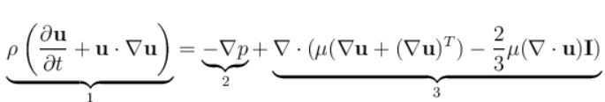 (S4)
In the equation, $u=\left(u_{x}, u_{y}, u_{z}\right)$ represents the mass transfer rate of DMF in different directions, t is the time, α is called the reaction term, ρ is the density of DMF, and $∇p=\left(p_{x}, p_{y}, p_{z}\right)$ represents the pressure applied to DMF in different directions. In Equation (S4), the different terms correspond to inertial forces (1), pressure forces (2), and viscous forces (3). By providing the diffusion rate of DMF (1.54*10⁻⁹ m²·s⁻¹), vacuum pressure, and the viscosity of the PVDF-S membrane, the diffusion pathway of DMF within the membrane can be simulated. As shown in Figure 2j and Figure S8, DMF diffuses uniformly in all directions within the PVDF-S membrane, leading to a uniformly distributed DMF in the membrane. As a result, the chemical-potential gradient of DMF diffusion, and pressure propels crystal seeds to move, ultimately leading them to be uniformly distributed within the membrane.

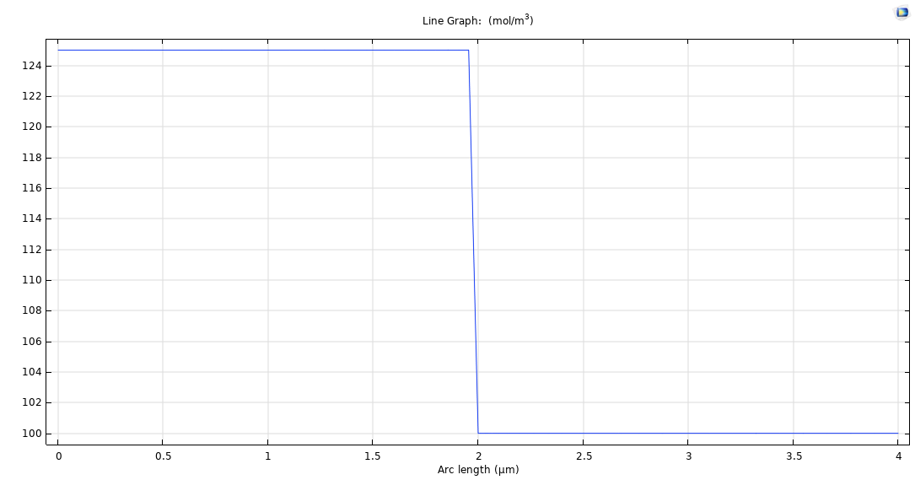
Figure S8. Variation of DMF concentration with Arc length.

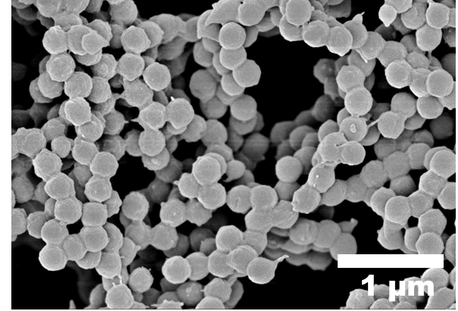
Figure S9. SEM image of PVDF-NPs-PI5 membrane

2. Parameters of PVDF-NP-A membranes.

Table S1. Parameters of the PVDF-NPs-A membranes
Membrane | Mean pore size  (nm) | Thickness  (μm) | Porosity  (%)
PVDF-NPs-A5 | 523±11 | ~1.94 | 87.06
PVDF-NPs-A8 | 517±7 | ~3.75 | 72.38
PVDF-NPs-A10 | 500±10 | ~5.41 | 46.08
PVDF-NPs-A20 | 491±9 | ~11.33 | 38.42

3. Separation performances of the PVDF-NPs-A membranes.

3.1. Calculation method

According to the Hagen-Poiseuille equation (Equation 1), the membrane flux J is directly related to the membrane thickness, porosity, and pore size. Since the Hagen-Poiseuille equation assumes the channels within the membrane to be vertical cylinders and neglects the resistive effects of the tortuosity of the internal channels, a tortuosity parameter η is introduced into the Hagen-Poiseuille equation as:
$J=επ{r_{p}}^{2}∆P/8ημL$ (S4)
Where η is the tortuosity of the membrane. The tortuosity parameter is calculated based on the experimental flux of the PVDF-NPs-A5 membrane and is then used in combination with the data from Table S1 to calculate the theoretical fluxes for other PVDF-NPs-A membranes. Since the tortuosity parameter of all membranes is assumed to be the same as that of the PVDF-NPs-A5 membrane in the calculation process, the calculated theoretical fluxes for all membranes are assumed to be the same as the tortuosity of the PVDF-NPs-A5 membrane. Therefore, by comparing the calculated results with the experimental flux of the membranes, the effect of the pore tortuosity on membrane flux can be intuitively reflected by the deviation between the experimental and theoretical data.

Table S2. Performance comparison of Current PVDF-based Separation Membranes
Membrane | Flux  (L·m⁻²·h⁻¹) | Pressure  (bar) | Rejection  (%) | Reference
PVDF-NPs-A5  (This work) | 2924.67 ± 28 | 0.5 | MP (500nm): 92.10±1.9 | /
PVDF  （Synder® filtration） | 32 ± 4 | 0.5 | MP (10±7μm): 100 | 2
PVDF -LiCl | 305.56 | 0.2 | O/W: 100 | 3
PVDF-PC | 3420 | 1.0 | O/W: 100 | 4
PVDF-MWCNT | 2137 | 1.0 | BSA: 98 | 5
PVDF- Fe₃O₄@TiO₂ | 1752 | 1.0 | TOC:67.17 | 6
PVDF-CA | 1600 | 1.0 | γ-globulin: 89 | 7
PVDF-g-PEGMA  (DMF) | 1068 | 1.0 | / | 8
PVDF-g-PEGMA  (DMAc) | 928.62 | 1.0 | Sodium alginate: 82.9 | 9
PVDF-PTFE | 869 | 1.0 | / | 10
PVDF-GO-CNC | 800 | 1.0 | / | 11
PVDF-PE-b-PEG | 420 | 1.0 | / | 12
PVDF-GO | 253 | 1.0 | / | 13

Figure S10. Linear relationship between the adding volume of the PVDF solution and membrane thicknesses.

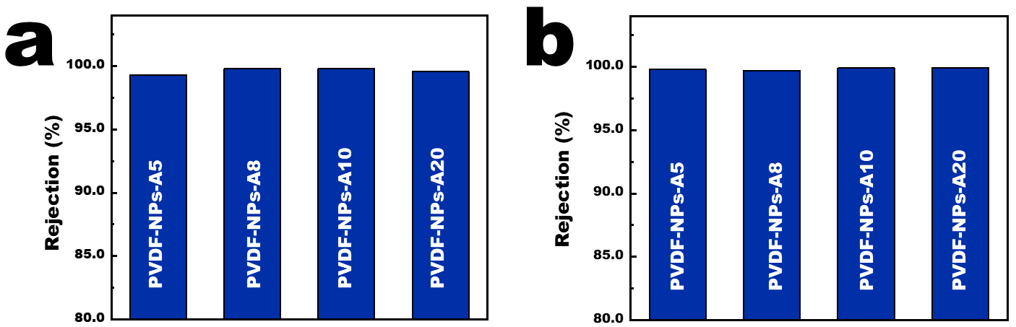
Figure S11. The rejection rates of polystyrene microspheres for the PVDF-NPs-A membranes. The particle size is 700 nm (a) and 1000 nm (b)

References

(1) Wilmans J. G., Baker R. W., The solution-diffusion model: a review, J. Membr. Sci., 1995, 107(1-2):1-21.
(2) C. Hachemi, M. O. Enfrin, A. Rashed, V. Jegatheesan, P. D. Hodgson, D. L. Callahan, J. Lee, L. F. Dumée, The impact of PET microplastic fibres on PVDF ultrafiltration performance – A short-term assessment of MP fouling in simple and complex matrices, Chemosphere 2023, 310, 136891.
(3) N.I.M. Nawi, N.R. Sait, M.R. Bilad, N. Shamsuddin, J. Jaafar, N.A.H. Nordin, T. Narkkun, K. Faungnawakil, D. F. Mohshim, Mohshim, Polyvinylidene fluoride membrane via vapour induced phase separation for oil/water emulsion filtration, Polymer 2021, 13, 427 (Basel).
(4) Z. Guo, Y. Yang, S. Xiang, X. Du, Z. Cui, B. He, H. Wang, J. Li, T. Jiang, Preparation of PVDF membrane based on “In-situ Template-TIPS” technology and the investigation on membrane formation mechanism, microstructure regulation and permeability, J. Membr. Sci. 2021, 620, 118839.
(5) H.M. Park, H. Oh, K.Y. Jee, Y.T. Lee, Synthesis of PVDF/MWCNT nanocomplex microfiltration membrane via atom transfer radical addition (ATRA) with enhanced fouling performance, Sep Purif Technol 2020, 246, 116860.
(6) J. Sun, S. Li, Z. Ran, Y. Xiang, Preparation of Fe3O4@TiO2 blended PVDF membrane by magnetic coagulation bath and its permeability and pollution resistance, J. Mater. Res. Technol. 2020, 9, 4951.
(7) R.L. Thankamony, X. Li, X. Fan, G. Sheng, X. Wang, S. Sun, X. Zhang, Z. Lai, Preparation of highly porous polymer membranes with hierarchical porous structures via spinodal decomposition of mixed solvents with UCST phase behavior, ACS Appl. Mater. Interface, 2018, 10, 44041.
(8) W. Shuai, L. Tong, C. Chen, B. Liu, J.C. Crittenden, PVDF ultrafiltration membranes of controlled performance via blending PVDF-g-PEGMA copolymer synthesized under different reaction times, Front. Environ. Sci. Eng. 2018, 12, 1.
(9) Q. Wu, A. Tiraferri, T. Li, W. Xie, H. Chang, Y. Bai, B. Liu, Superwettable PVDF/PVDF-g-PEGMA ultrafiltration membranes, ACS Omega 2020, 5, 23450.
(10) J. Zhao, J.Y. Chong, L. Shi, R. Wang, PTFE-assisted immobilization of Pluronic F127 in PVDF hollow fiber membranes with enhanced hydrophilicity through nonsolvent-thermally induced phase separation method, J. Membr. Sci. 2021, 620, 118914.
(11) J.L. Lv, G.Q. Zhang, H.M. Zhang, F.L. Yang, Graphene oxide-cellulose nanocrystal (GO-CNC) composite functionalized PVDF membrane with improved antifouling performance in MBR: behavior and mechanism, Chem. Eng. J. 2018, 352, 765.
(12) C. Gandhimathi, S. Sundarrajan, T. Matsuura, D.K. Srinivasan, H. Wei, D. Xuecheng, S. Ramakrishna, Fabrication and characterization of high flux poly(vinylidene fluoride) electrospun nanofibrous membrane using amphiphilic polyethylene-block-poly(ethylene glycol) copolymer, J. Appl. Polyml. Sci. 2020, 138, e50296.
(13) T.T.V. Tran, S.R. Kumar, C.H. Nguyen, J.W. Lee, H.A. Tsai, C.H. Hsieh, S. J. Lue, High-permeability graphene oxide and poly(vinyl pyrrolidone) blended poly(vinylidene fluoride) membranes: roles of additives and their cumulative effects, J. Membr. Sci. 2021, 619, 118733.

