Table S1. Cell quality control overview results.
Sample | cells | UMI | UMI/cells | Mitochondrial UMI ratio | Sample saturation
HSR | 14672 | 31313450 | 2134.23 | 0.4% | 65.8%
LSR | 11753 | 34092212 | 2900.72 | 0.46% | 52.7%

Table S2. Statistical table of cell subpopulation classification results.
Cluster | Cells number | Median Genes per Cell | Median UMI Counts per Cell
0 | 4074 | 825 | 1090
1 | 2647 | 1596 | 3090
2 | 2510 | 1749.5 | 3696.5
3 | 2168 | 1803 | 3794
4 | 1658 | 922 | 1330.5
5 | 1534 | 1139 | 1866
6 | 1494 | 1313 | 2373.5
7 | 1204 | 725 | 882.5
8 | 1108 | 767 | 953
9 | 954 | 840 | 1226.5
10 | 931 | 925 | 1344
11 | 827 | 751 | 1041
12 | 789 | 1813 | 3913
13 | 695 | 1713 | 3491
14 | 687 | 1352 | 2442
15 | 605 | 712 | 863
16 | 534 | 1651.5 | 3249.5
17 | 487 | 690 | 836
18 | 407 | 572 | 677
19 | 238 | 1353 | 2531.5
20 | 208 | 655 | 815.5
21 | 201 | 902 | 1322
22 | 201 | 2055 | 4571
23 | 147 | 1646 | 3274
24 | 59 | 935 | 1236
25 | 58 | 1111 | 1766

Table S3. Hub genes ranked by five CytoHubba methods in GABAergic neurons. Bold gene symbols were the overlapped genes in the top 20 by five ranking methods.

Category | Rank methods in CytoHubba
Category | MNC | EPC | Closeness | Degree | MCC
1 | YWHAH | SMG1 | SMG1 | SMG1 | SMG1
2 | ACTB | YWHAH | YWHAH | CCT7 | ACTB
3 | TUBB2B | ACTB | ACTB | YWHAH | YWHAH
4 | CCT7 | TUBB2B | TUBB2B | ACTB | RPS6KA2
5 | HSPA5 | HSPA5 | HSPA5 | TUBB2B | HIPK2
6 | RPS6KA2 | RPS6KA2 | RPS6KA2 | HSPA5 | MARK1
7 | RASL11B | RASL11B | RASL11B | RPS6KA2 | RASL11B
8 | ARF1 | ARF1 | ARF1 | RASL11B | ARF1
9 | ERBB4 | ERBB4 | ERBB4 | ARF1 | MAP3K3
10 | RASD2 | RASD2 | RAB11A | ERBB4 | PRKCD
11 | RAB11A | RAB11A | RASD2 | RAB11A | RAB11A
12 | ENSGALG00000016808 | ENSGALG00000016808 | PPP2CA | RASD2 | RASD2
13 | PPP2CA | PPP2CA | ENSGALG00000016808 | PPP2CA | EPHA4
14 | ENSGALG00000006292 | ENSGALG00000006292 | ENSGALG00000006292 | ENSGALG00000016808 | PPP2CA
15 | RHOB | RHOB | RHOB | RHOB | PRKCE
16 | ATP2A3 | CDK14 | ATP2A3 | ATP2A3 | EPHA7
17 | CDK14 | ENO1 | CDK14 | CDK14 | RHOB
18 | ENO1 | HSPD1 | ENO1 | ENO1 | CDK14
19 | HSPD1 | PRKAR2B | HSPD1 | HSPD1 | PRKAR2B
20 | MRAS | MRAS | MRAS | MRAS | MRAS

Table S4 Hub genes ranked by five CytoHubba methods in glutaminergic neurons. Bold gene symbols were the overlapped genes in the top 20 by five ranking methods.

Category | Rank methods in CytoHubba
Category | MNC | EPC | Closeness | Degree | MCC
1 | RPS6KA6 | RPS6KA6 | RPS6KA6 | RPS6KA6 | LRRK1
2 | LRRK1 | RASD2 | LRRK1 | LRRK1 | CDK14
3 | CDK14 | LRRK1 | CDK14 | CDK14 | SIK3
4 | RAP2A | CDK14 | RHOB | RHOB | PAK1
5 | RHOB | RAP2A | LRRK2 | LRRK2 | RAP2A
6 | LRRK2 | RHOB | RHOBTB1 | RHOBTB1 | ARF4
7 | RHOBTB1 | LRRK2 | UBQLN1 | UBQLN1 | RHOB
8 | UBQLN1 | RHOBTB1 | SGK1 | SGK1 | LRRK2
9 | SGK1 | RASL11B | PKN2 | PKN2 | RHOBTB1
10 | PKN2 | UBQLN1 | AKT1 | AKT1 | SGK1
11 | AKT1 | SGK1 | HSPA5 | HSPA5 | PKN2
12 | HSPA5 | ACTB | FLT4 | FLT4 | AKT1
13 | FLT4 | MRAS | EPHA7 | EPHA7 | FLT4
14 | EPHA7 | PKN2 | EPHA5 | EPHA5 | EPHA7
15 | EPHA5 | AKT1 | ARF1 | ARF1 | ARF1
16 | ARF1 | FLT4 | YES1 | YES1 | RASL11A
17 | YES1 | RASL11A | ENSGALG00000016808 | ENSGALG00000016808 | YES1
18 | ENSGALG00000016808 | YES1 | PRKCD | PRKCD | PAK5
19 | PRKCD | STK32C | RAB11A | RAB11A | MAP2K5
20 | RRAS | RRAS | RRAS | RRAS | PRKCD

Table S5. Gene Primer List.

Gene | Forward primer | Reverse primer
SKG1 | TGGACTGGTGGTGCCTTGGAG | CATTTCTGCCGTGTTTCTGCTGTAG
YES1 | ACGGGTCAGACTCCAGCCAAG | GATGCTCCTCCAAAGGGTGTCATTC
CDK14 | CCCTAGCTCTCCTACAAGTCCCAAG | CCTTCAGTGCCACCAGCTTTCC
RHOB | GACGAGTTCCCCGAGGTTTA | CGTGTCTGGGTAGGAGAGAG
LRKK1 | TGGCTGTGTTCTTACTGCGGAATG | CCTGGTAGCGGGCTGGTCTC
PKN2 | CCTGTGATAAGCCCTCTTGAACTCC | GTGCCTTTCTGTCGGTAACCTTCC
AKT1 | ACTCACGGCATCCATTCTTAACAGC | AACTCCCCTCCGTTAGCATACTCC
FLT4 | GTTCAACTCTGGTGTCCGCTTCC | GGTCCTGCTGGCTGACATTGTG
YMHAH | AACAGTGTTGTGGAAGCCTCAGAAG | GAGTGCCAGCCCAAGCCTAATTG
PPP2CA | CATGAAAGCAGGCAGATCACACAAG | CCAAGGCGGTTAGAGGAAGGTAATC
RPS6KA2 | TGCATTTCAGACAGAGGGGA | GTGGAGGTGGTCTAAAGCCA

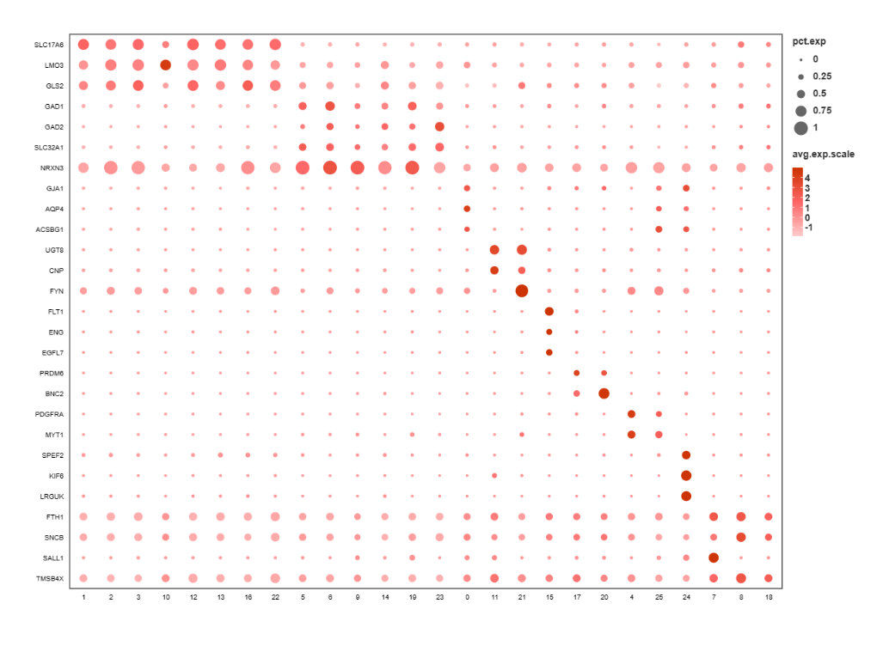
Figure S1. Bubble plots showing the expression of cell type-specific gene markers in different cell clusters.

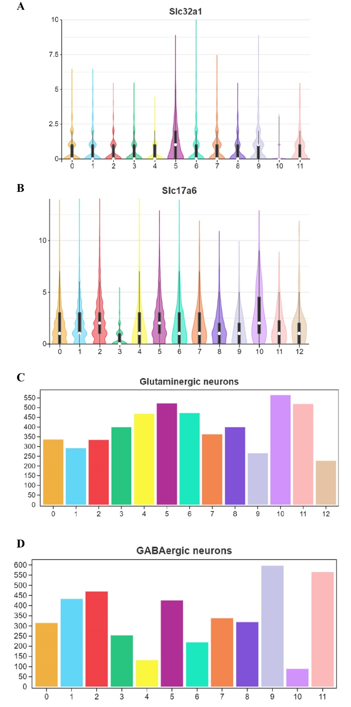
Figure S2.
- Violin plots showing the distribution of SLC32A1 in different subclusters of GABAergic neurons.
- Violin plots showing the distribution of SLC17A6 in different subclusters of glutamatergic neurons.
- The number of genes upregulated in each subpopulation of cells in glutamatergic neurons.
- The number of genes upregulated in each subpopulation of cells in GABAergic neurons.

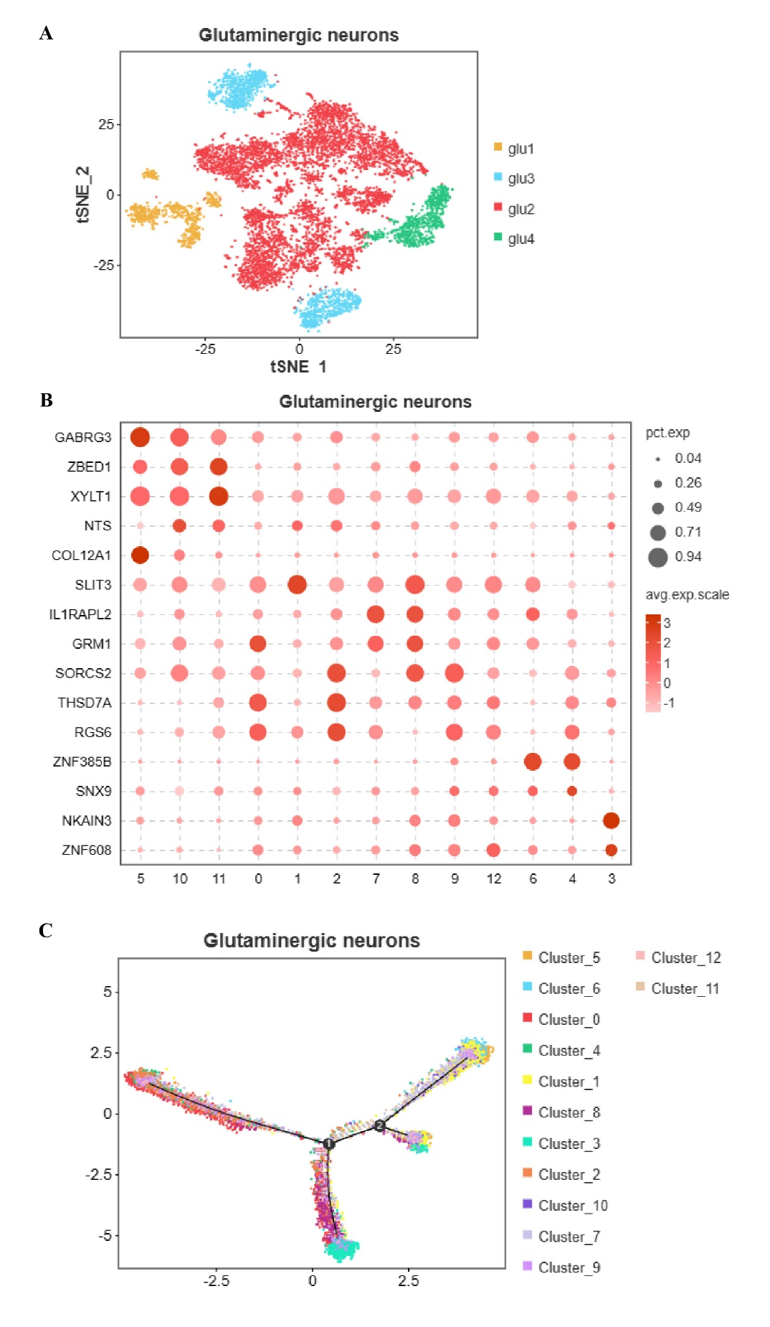
Figure S3. Molecular taxonomy of glutaminergic neurons in chicken amygdala.
(A)The t-SNE map showed that glutaminergic neurons in the amygdala could be further divided into 3 clusters, glu.1, glu.2, glu.3, glu.4 respectively.
(B)Bubble plots showing the expression of cell type-specific gene markers in different cell clusters.
(C)Pseudo-temporal trajectory maps of 13 subclusters of glutaminergic neurons.
(D)Pseudo time showing the possible trajectory of glutaminergic neurons depended on biomarkers.

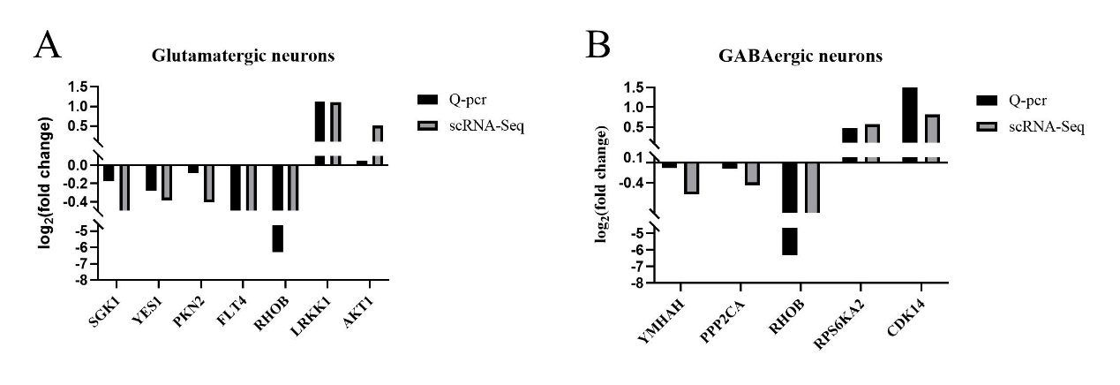
Figure S4. Fluorescent quantitative PCR to verify the accuracy of sequencing data.
- Validation of genes in glutamatergic neurons.
- Validation of genes in GABAergic neurons.

