An unprecedented photocatalytic architecture for benchmarking hydrogen production from methanol
Jinglin Li¹⁺, Bowen Sheng²⁺, Yiqing Chen³⁺, Jiajia Yang², Ping Wang², Yixin Li¹, Tianqi Yu¹, Hu Pan¹, Jun Song³*, Lei Zhu¹, Xinqiang Wang^{2,4,5}*, Tao Ma⁶, Baowen Zhou¹*.
- Key Laboratory for Power Machinery and Engineering of Ministry of Education, Research Center for Renewable Synthetic Fuel, School of Mechanical Engineering, Shanghai Jiao Tong University, 800 Dongchuan Road, Shanghai 200240, China.
- State Key Laboratory of Artificial Microstructure and Mesoscopic Physics, School of Physics, Nano-Optoelectronics Frontier Center of Ministry of Education (NFC-MOE), Peking University, Beijing 10087, China.
- Department of Mining and Materials Engineering, McGill University, 3610 University Street, Montreal, QC H3A0C9, Canada
- Peking University Yangtze Delta Institute of Optoelectronics, Nantong, Jiangsu 226010, China
- Collaborative Innovation Center of Quantum Matter, School of Physics, Peking University, Beijing 100871, China.
- Michigan Center for Materials and Characterization, University of Michigan, 2800 Plymouth Rd, Ann Arbor, MI 48109, USA.

* Corresponding authors Email: jun.song2@mcgill.ca; wangshi@pku.edu.cn; zhoubw@sjtu.edu.cn
+ These authors contributed equally to this work.

Table S1│Catalytic activity of various catalysts for MeOH reforming to hydrogen in recent years.
Catalysts | Light source | Activity (mol·g_{cat}⁻¹·h⁻¹) | TOF (h⁻¹) | Durability (h) | TON | Ref.
NiCo/GaN NWs | 300 W Xe lamp | 19.1 | 46460 | 600 | 1.6×10⁷ | This work
ZnCu Alloy | AM 1.5G | 0.328 | - | 4 | - | ¹⁰
Pt/CN | 450 W Xe lamp | 3.3 | - | 38 | 4.7×10⁵ | ¹¹
NiO_{x}/TiO₂ | 300 W Xe lamp | 0.032 | - | 30 | - | ¹²
Sr₂MgSi₂O₇:Eu²⁺, Dy³⁺ | 500 W mercury lamp | 0.014 | - | 10 | - | ¹³

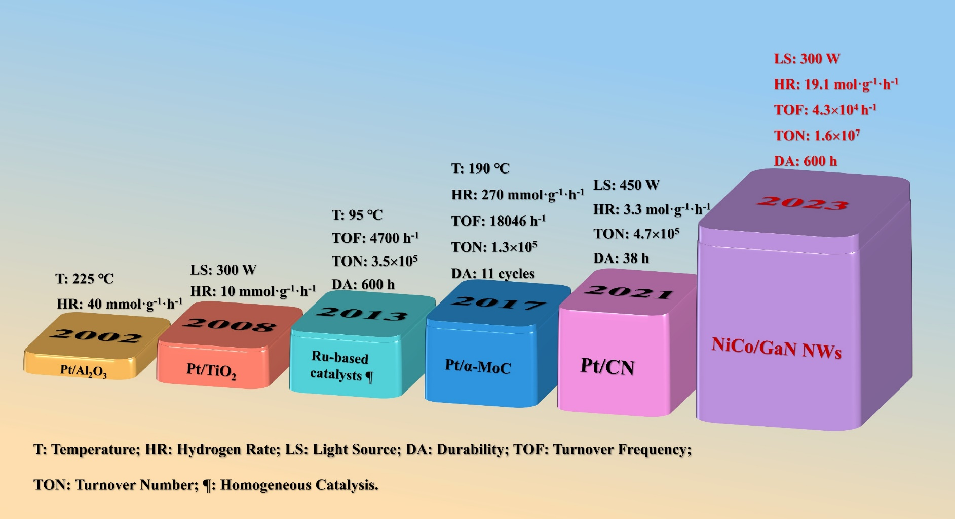
Fig. S1. Benchmarking progress of on-site hydrogen production from methanol by various approaches including photocatalysis and thermo-catalysis.

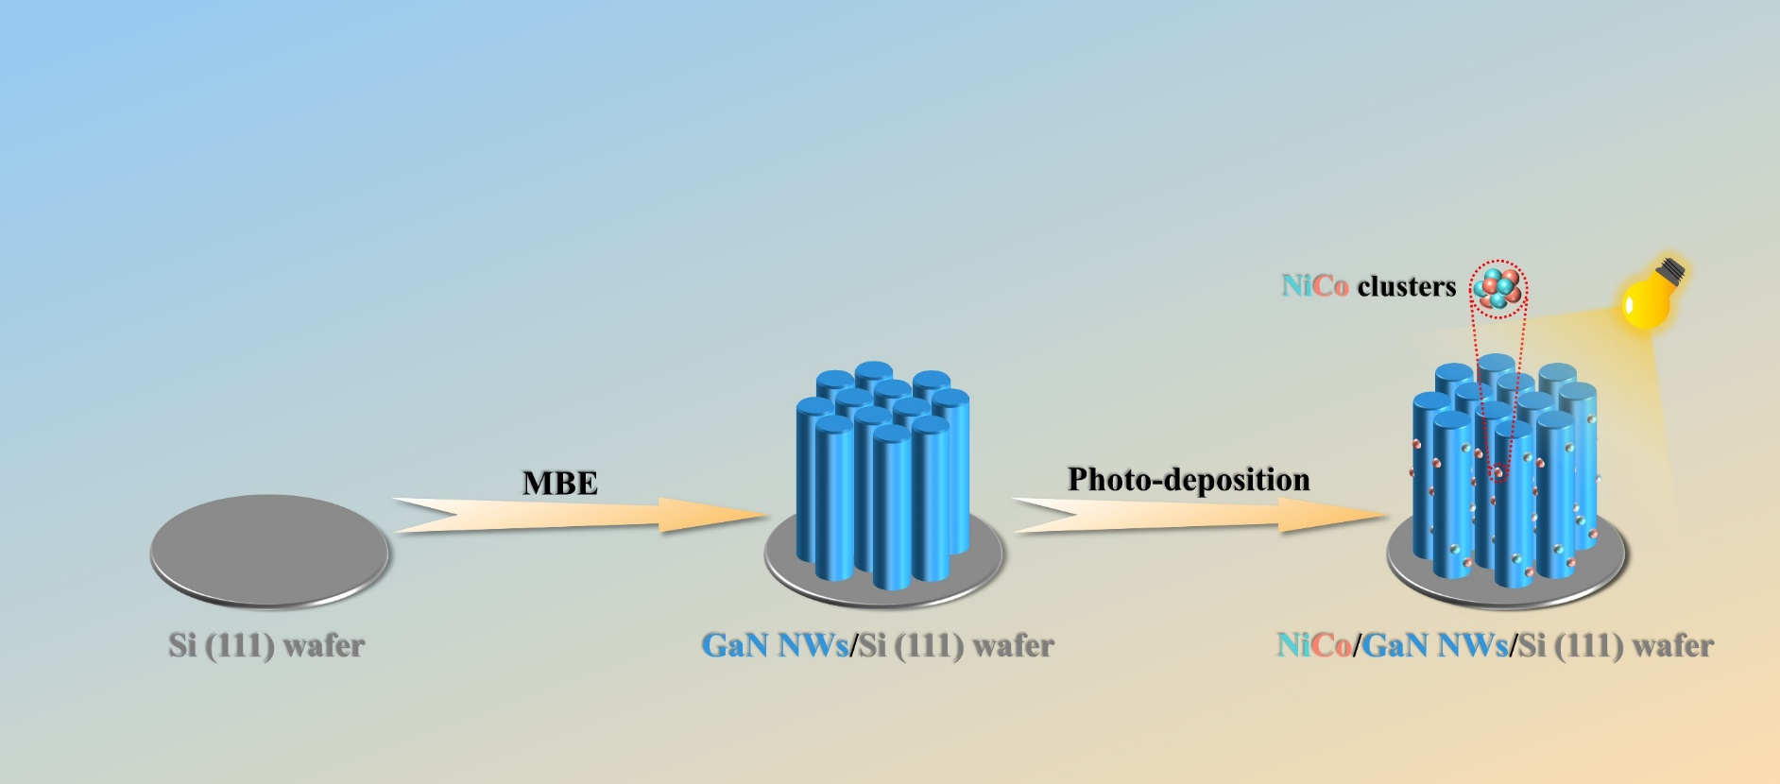
Fig. S2. Schematic diagram for the decoration of NiCo nanoclusters onto GaN NWs by combining plasma-assisted MBE with photo-deposition.

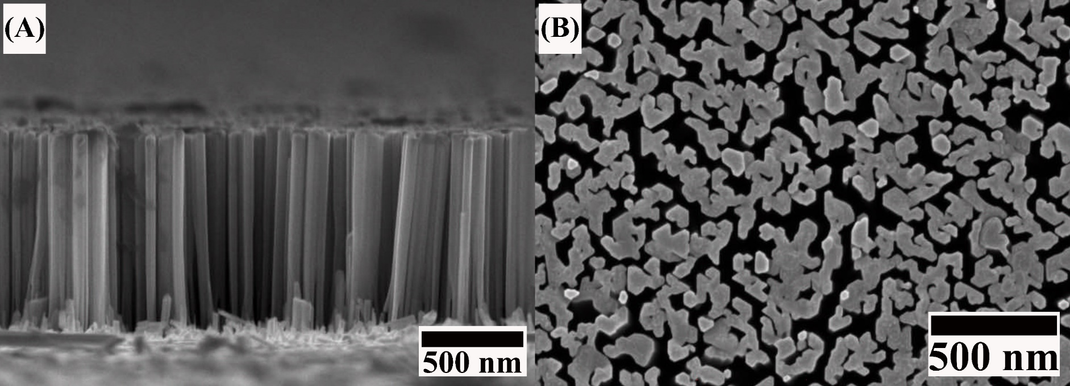
Fig. S3. SEM images of GaN NWs/Si vertically assigned onto Si wafer. (A) Side view. (B) Top view.

Fig. S4. XRD patterns of Si wafer, GaN NWs/Si, and NiCo/GaN NWs supported by Si wafer, respectively.

Fig. S5. XPS survey of NiCo/GaN NWs supported by Si substrate.

Fig. S6. Influence of content of NiCo on H₂ evolution rate over NiCo- decorated GaN NWs.

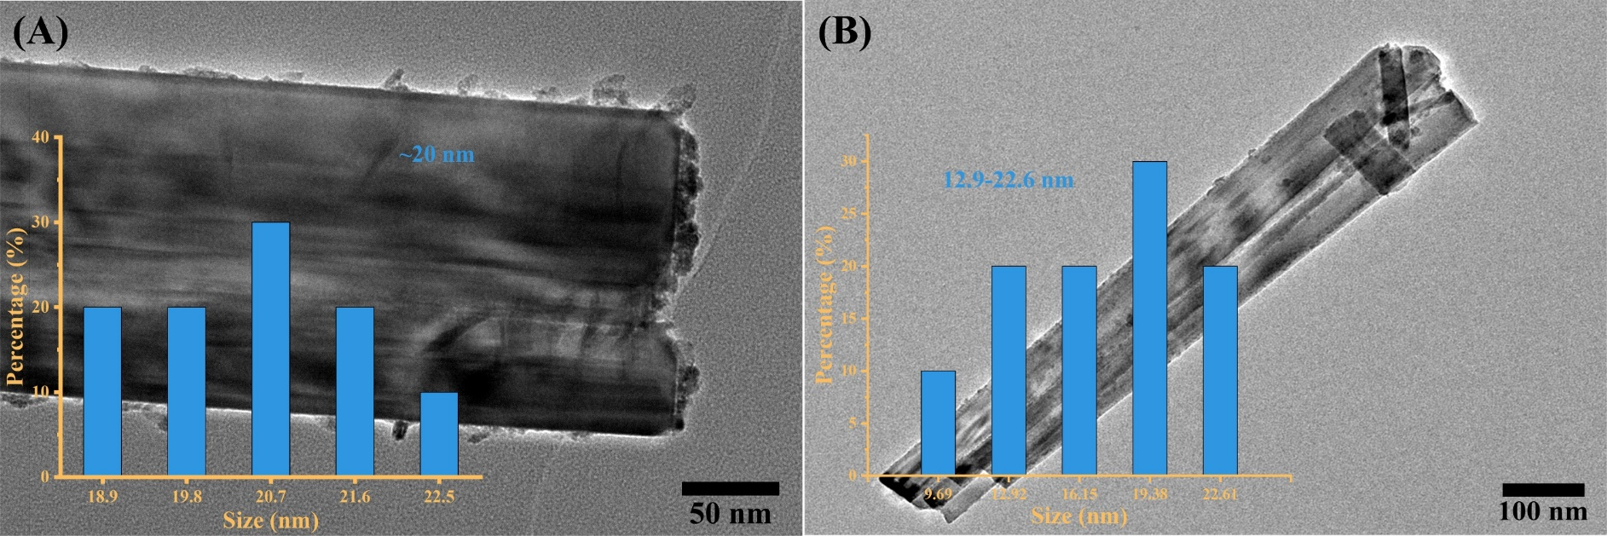
Fig. S7. TEM images and diameters distribution (inset) of NiCo supported by GaN NWs with (A) 5 μL and 30 μL NiCo precursor.

Fig. S8. H₂ evolution rate over NiCo-decorated GaN NWs supported by Si and NiCo-decorated Si wafer.

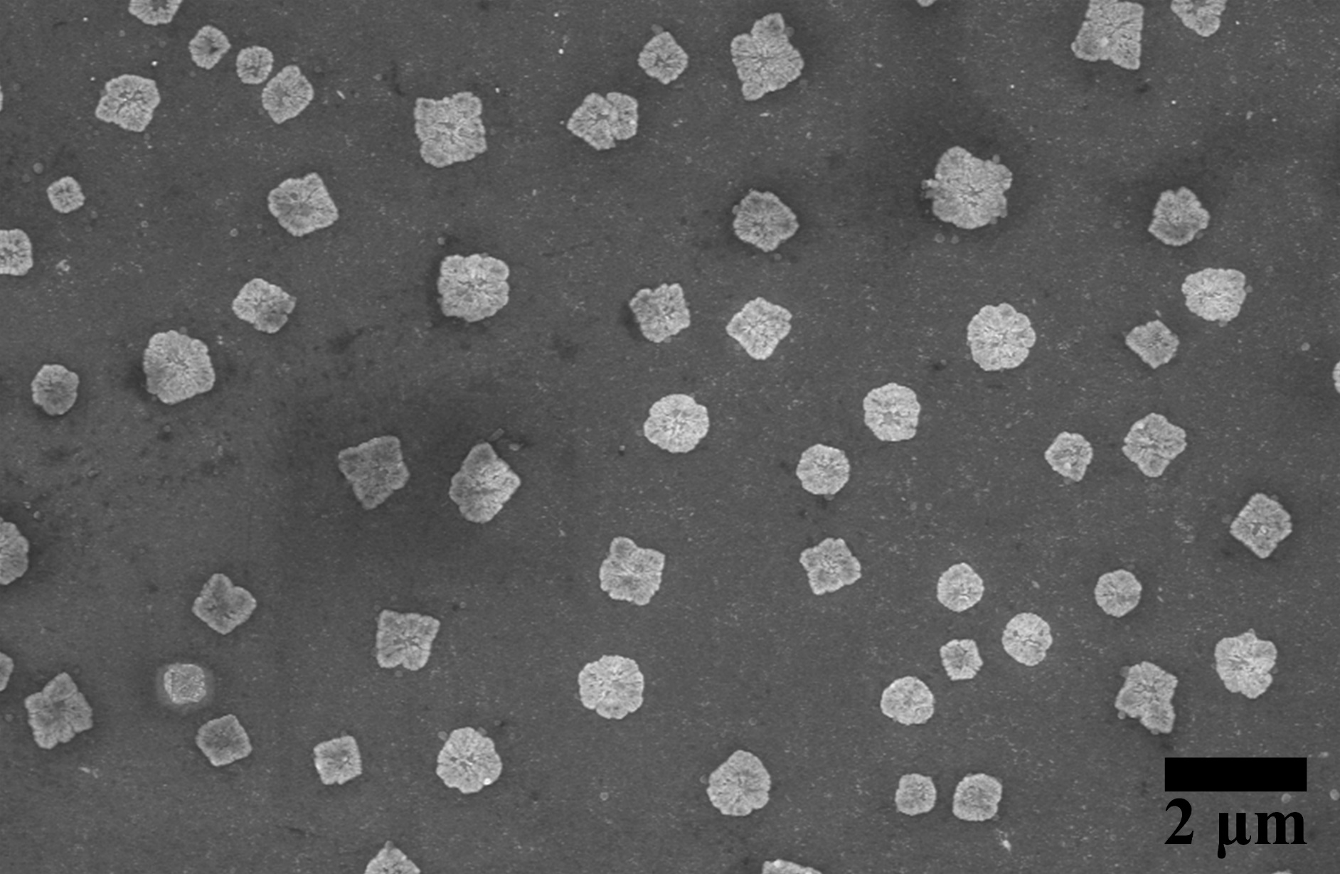
Fig. S9. SEM image of NiCo/Si.

Fig. S10. Influence of the methanol concentration in aqueous solution on H₂ evolution rate.

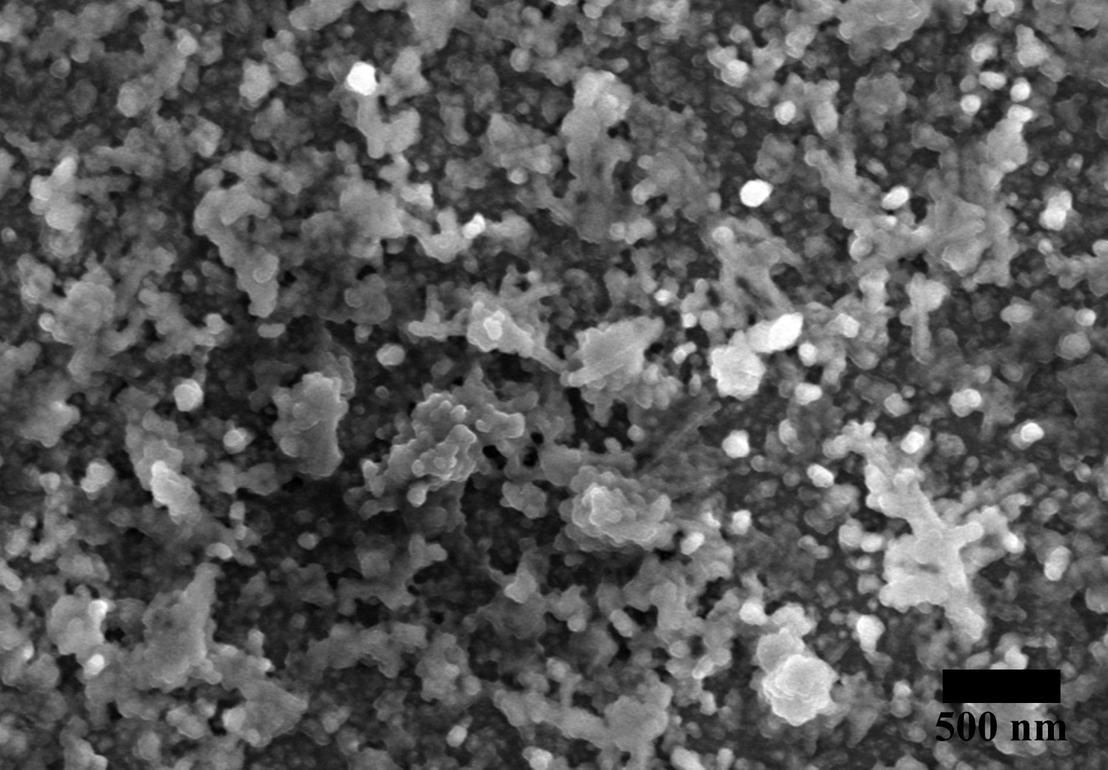
Fig. S11. SEM image of NiCo/GaN NWs after 600 h of durability testing.

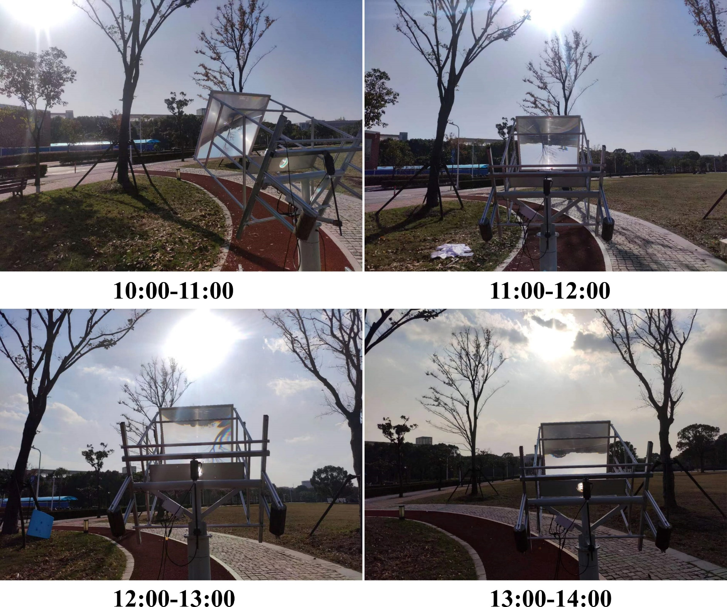
Fig. S12. The photos of the outdoor testing setup equipped with NiCo/GaN NWs supported by silicon wafer at varied testing times recorded at Shanghai Jiao Tong University, Shanghai, P. R. China.

Fig. S13. H₂ evolution rate over NiCo/GaN NWs without the catalyst under light or with the catalyst under dark, respectively.

Fig. S14. In situ EPR spectra of hydrogen production from methanol over NiCo/GaN NWs under a light intensity of 3 W·cm⁻².

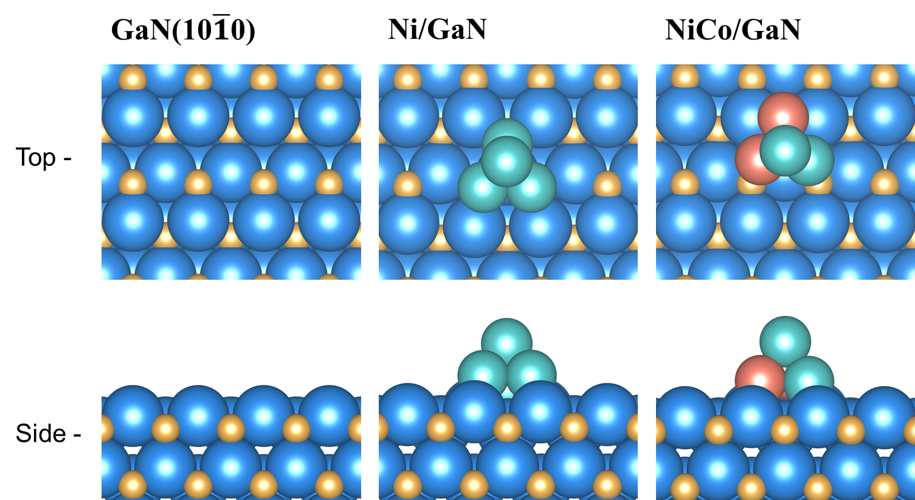
Fig. S15. The top and side views of structural models of GaN (10$\overline{1}$0), Ni/GaN and NiCo/GaN respectively. Ga, blue; N, yellow; Ni, cyan; and Co, orange.

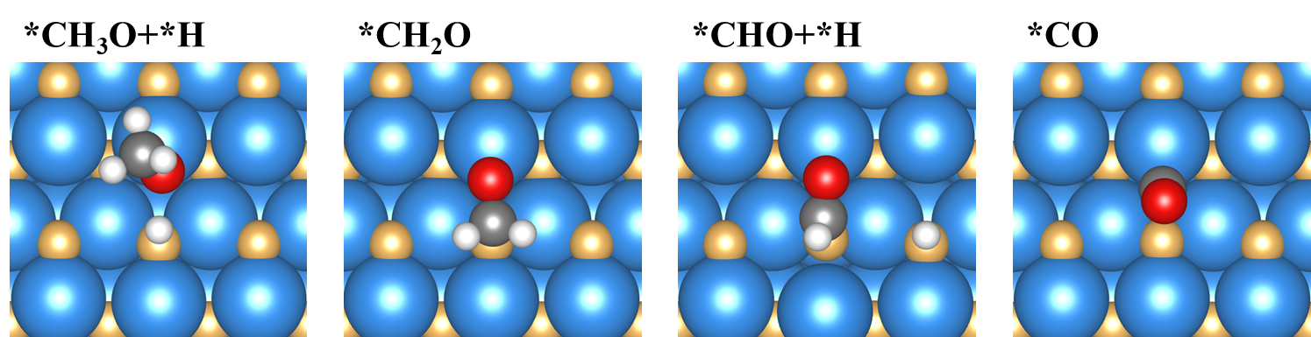
Fig. S16. Optimized adsorption configurations for each reaction intermediates of methanol reforming reaction on GaN (10$\overline{1}$0). Ga, blue; N, yellow; C, grey; O, red; and H, white.

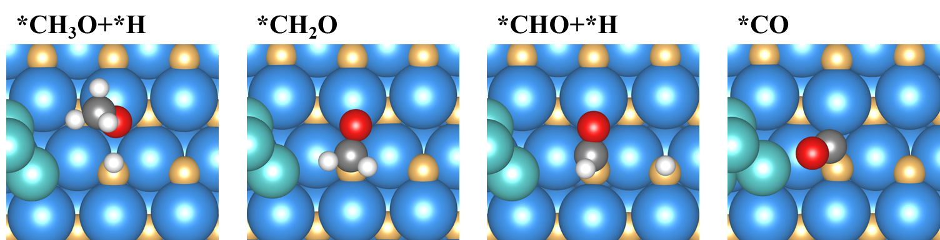
Fig. S17. Optimized adsorption configurations for each reaction intermediates of methanol reforming reaction on Ni/GaN. Ga, blue; N, yellow; Ni, cyan; C, grey; O, red; and H, white.

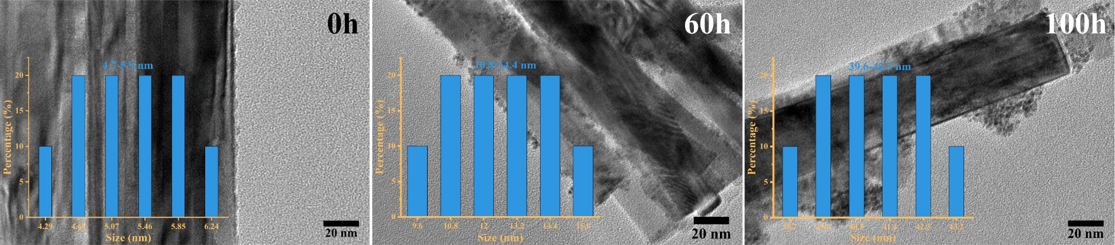
Fig. S18. TEM images and clusters diameters distribution plots of Ni/GaN NWs with various calcinating time (0, 60, and 120 h) at 480 ℃.

Fig. S19. The coking rate curve is calculated according to Fig. 4C.

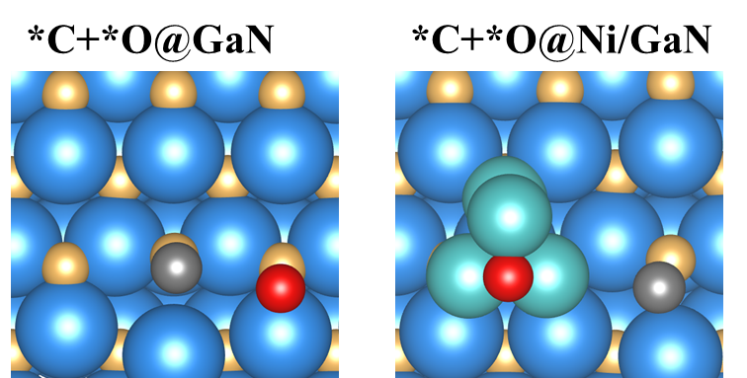
Fig. S20. Optimized adsorption configurations for coke formation on GaN (10$\overline{1}$0) and Ni/GaN. Ga, blue; N, yellow; Ni, cyan; C, grey; and O, red.

References
1 Kresse, G. & Joubert, D. From ultrasoft pseudopotentials to the projector augmented-wave method. Phys. Rev. B 59, 1758-1775 (1999).
2 Kresse, G. & Furthmüller, J. Efficient iterative schemes for ab initio total-energy calculations using a plane-wave basis set. Phys. Rev. B 54, 11169-11186 (1996).
3 Blöchl, P. E. Projector augmented-wave method. Phys. Rev. B 50, 17953-17979 (1994).
4 Perdew, J. P., Burke, K. & Ernzerhof, M. Generalized Gradient Approximation Made Simple. Phys. Rev. Lett. 77, 3865-3868 (1996).
5 Perdew, J. P. et al. Atoms, molecules, solids, and surfaces: Applications of the generalized gradient approximation for exchange and correlation. Phys. Rev. B 46, 6671-6687 (1992).
6 Grimme, S., Antony, J., Ehrlich, S. & Krieg, H. A consistent and accurate ab initio parametrization of density functional dispersion correction (DFT-D) for the 94 elements H-Pu. J. Chem. Phys. 132, 154104 (2010).
7 Grimme, S., Ehrlich, S. & Goerigk, L. Effect of the damping function in dispersion corrected density functional theory. J Comput Chem 32, 1456-1465 (2011).
8 Monkhorst, H. J. & Pack, J. D. Special points for Brillouin-zone integrations. Phys. Rev. B 13, 5188 (1976).
9 Nørskov, J. K. et al. Origin of the Overpotential for Oxygen Reduction at a Fuel-Cell Cathode. J. Phys. Chem. B 108, 17886-17892 (2004).
10 Luo, S. et al. Triggering Water and Methanol Activation for Solar-Driven H₂ Production: Interplay of Dual Active Sites over Plasmonic ZnCu Alloy. J. Am. Chem. Soc. 143, 12145-12153 (2021).
11 Wang, Y., Yao, E. P., Wu, L., Feldmann, J. & Stolarczyk, J. K. A Multi-Layer Device for Light-Triggered Hydrogen Production from Alkaline Methanol. Angew. Chem. Int. Ed. 60, 26694-26701 (2021).
12 Fang, S., Sun, Z. & Hu, Y. H. Insights into the thermo-photo catalytic production of hydrogen from water on a low-cost NiO_{x}-loaded TiO₂ catalyst. ACS Catal. 9, 5047-5056 (2019).
13 Cui, G. et al. Round‐the‐clock photocatalytic hydrogen production with high efficiency by a long‐afterglow material. Angew. Chem. Int. Ed. 58, 1340-1344 (2019).

