Figures

Supplementary Figure 1: Calibration Plot for Selected Model in the Main MSK Cohort

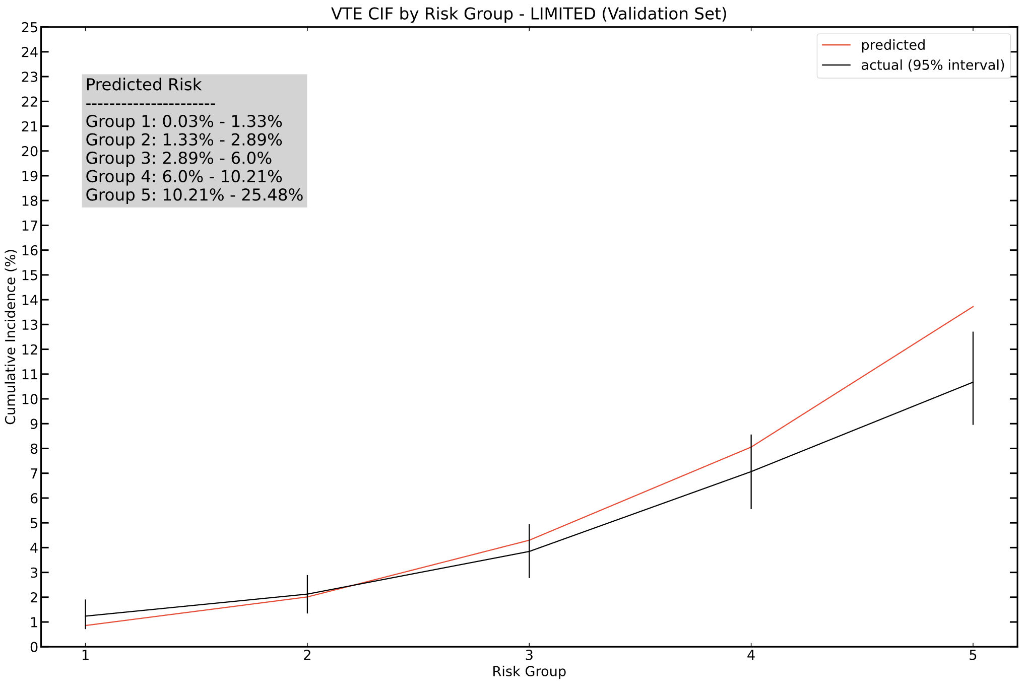
Calibration plot generated using the selected DeepHit model featuring a limited set of covariates, fitted on the main MSK cohort training set and evaluated on the corresponding validation set. Patients grouped by 180-day VTE risk interval based on model prediction and using quantile cutoff points, shown in the red line. Observed risk of VTE with 95% confidence intervals determined using the Aalen-Johansen estimator for each predicted risk interval, plotted in black.

Supplementary Figure 2: Calibration Plots for the MSK External Cohort Validation Set

A
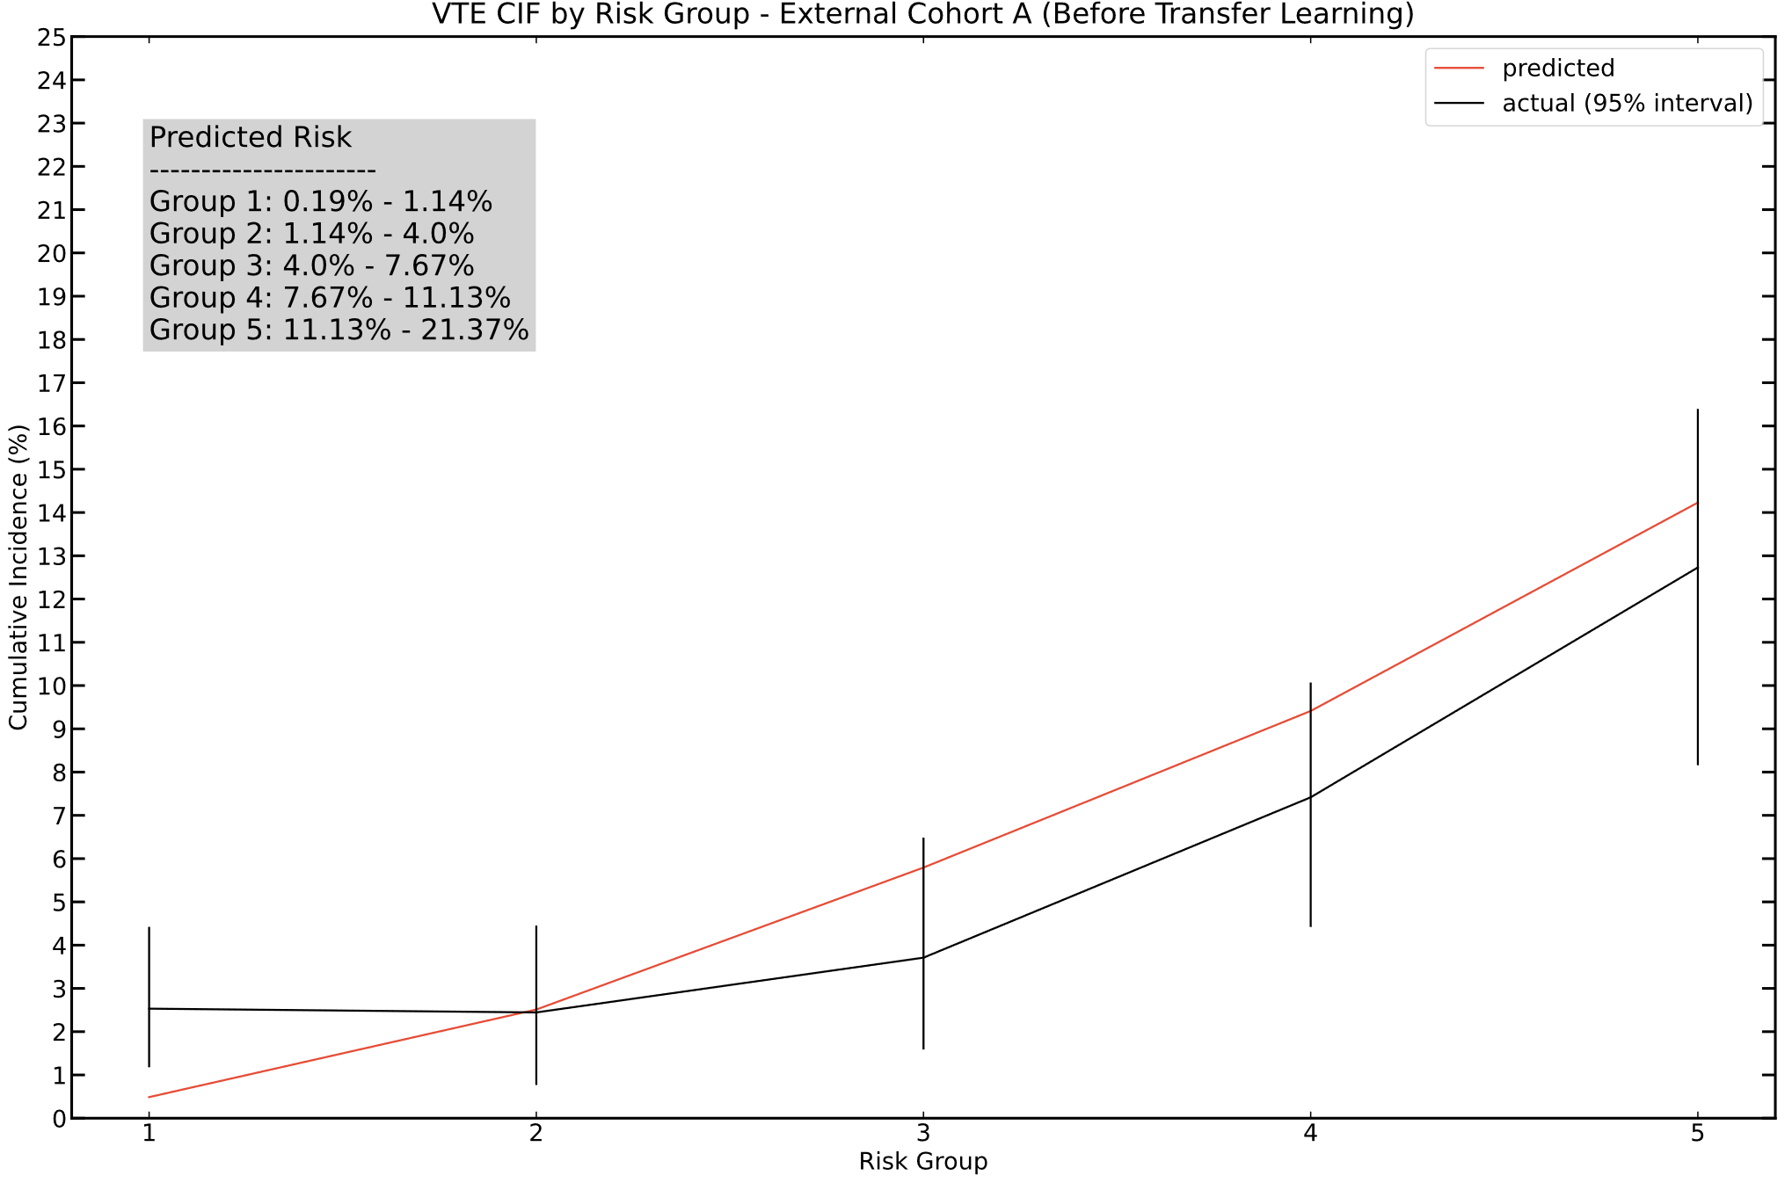

B
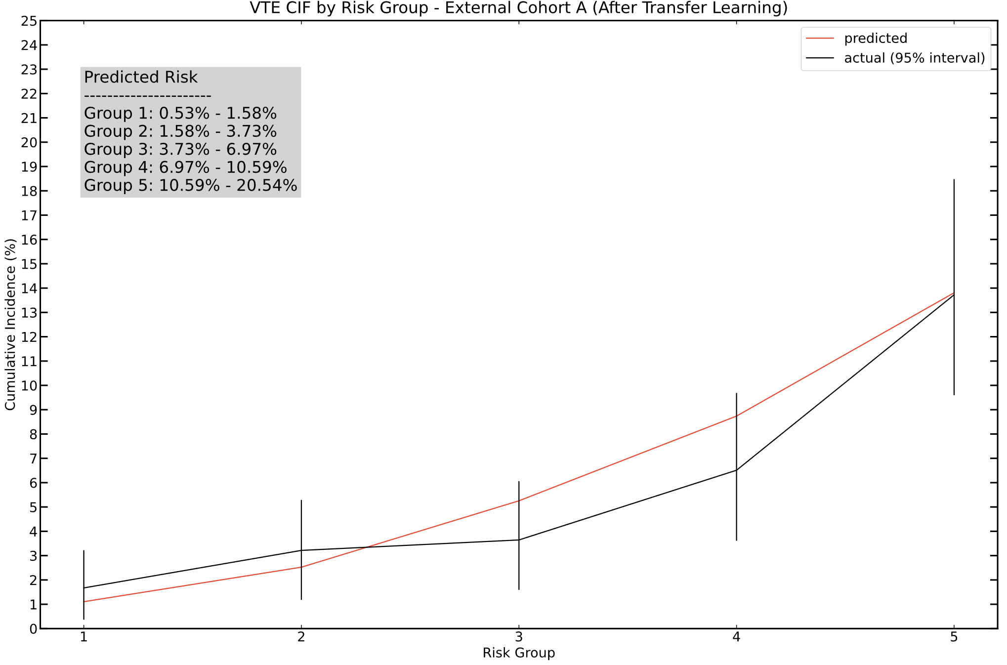

Supplementary Figure 2 (continued)

C
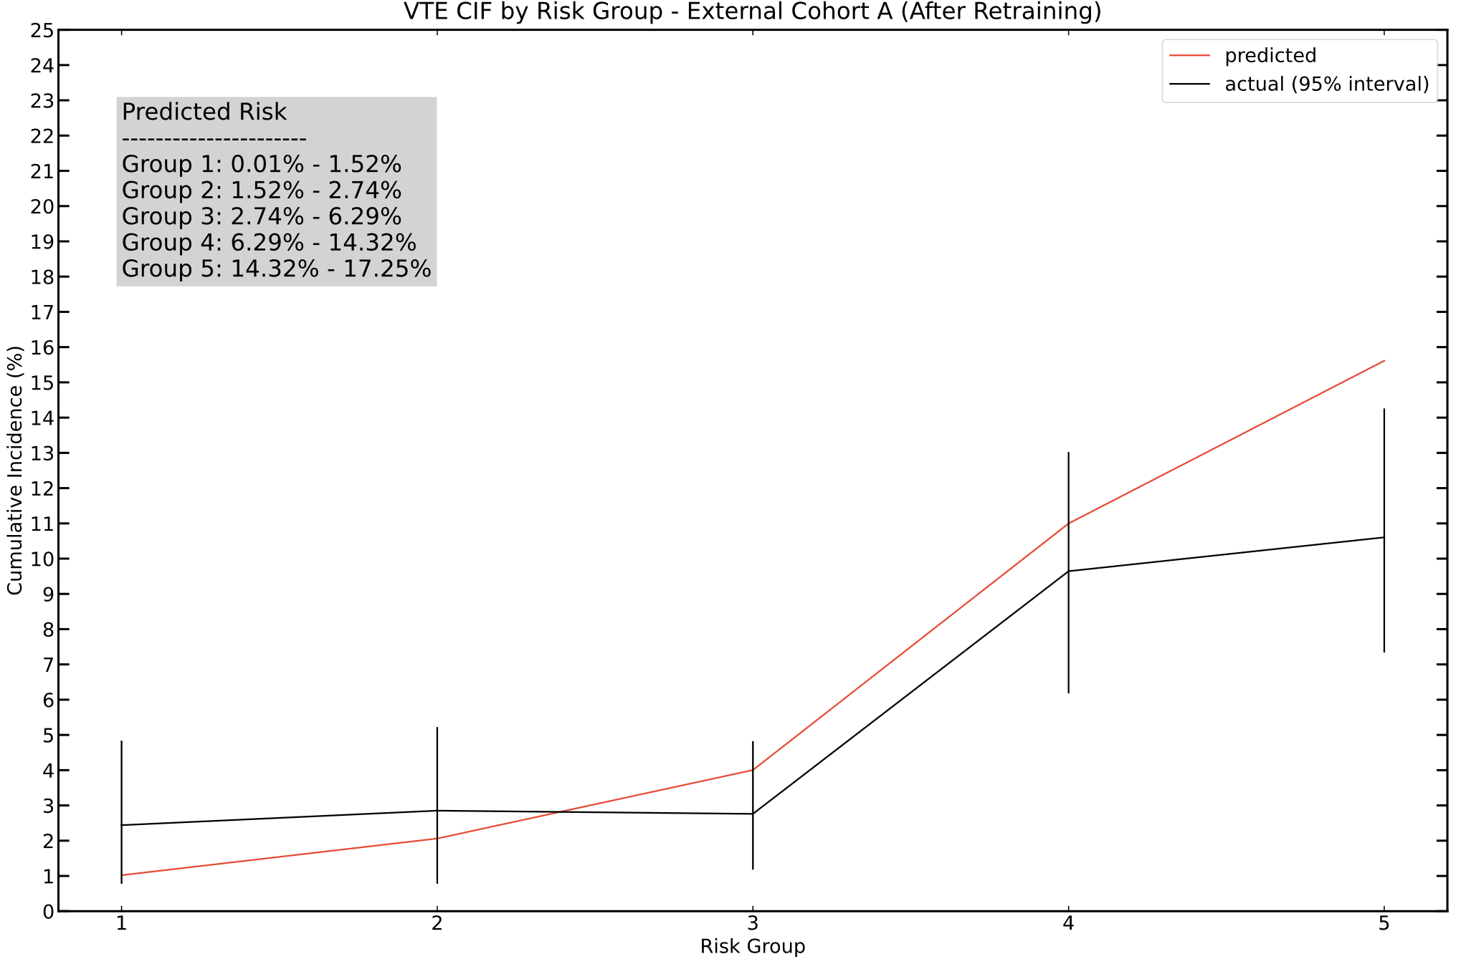
Calibration plots generated using the secondary DeepHit model A fitted on the main MSK cohort training set and evaluated on the MSK external cohort, before (A) and after (B) model updating on the dedicated transfer learning set. Calibration of the model trained de novo on the external MSK cohort transfer learning set shown in (C). Patients grouped by 180-day VTE risk interval based on model prediction and using quantile cutoff points, shown in the red line. Observed risk of VTE with 95% confidence intervals determined using the Aalen-Johansen estimator for each predicted risk interval, plotted in black.

Supplementary Figure 3: Calibration Plot for the ONCOTHROMB Cohort

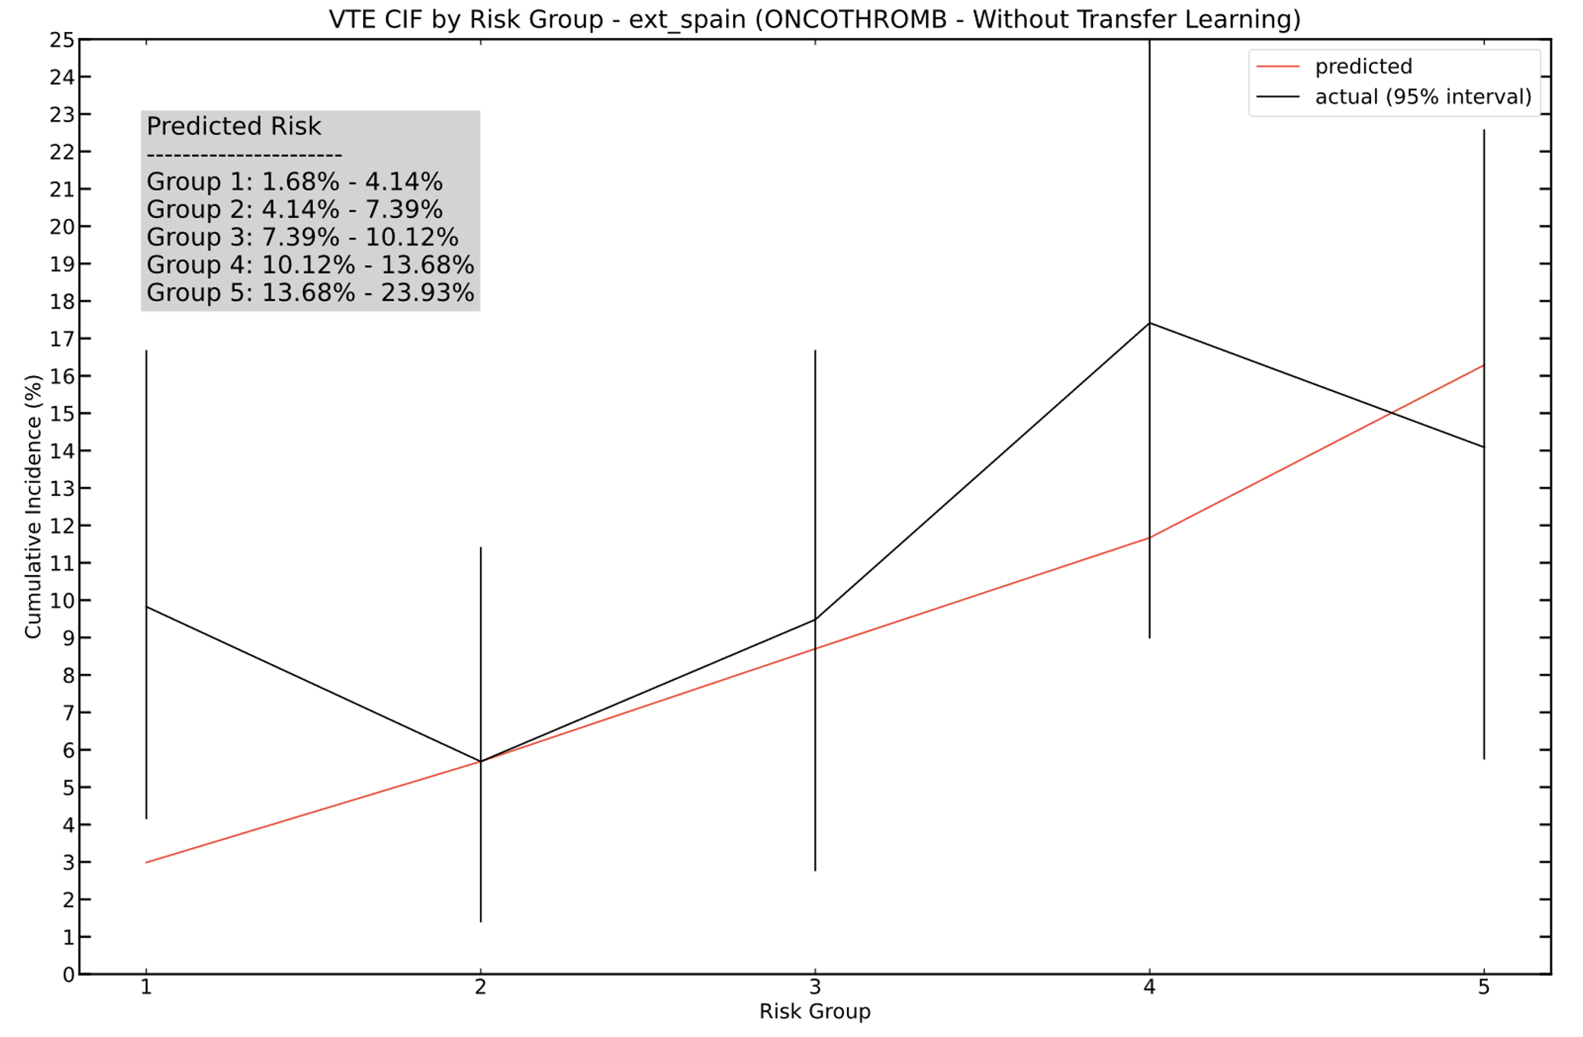

Calibration plot generated using the secondary DeepHit model B fitted on the main MSK cohort training set and evaluated on the ONCOTHROMB cohort. Patients grouped by 180-day VTE risk interval based on model prediction and using quantile cutoff points, shown in the red line. Observed risk of VTE with 95% confidence intervals determined using the Aalen-Johansen estimator for each predicted risk interval, plotted in black.

Tables

Supplementary Table 1: Tokens used by CEDARS to detect sentences with a potential venous thromboembolic event*

Token Combination | Endpoint
clot | thromboembolism
deep vein thrombosis | deep vein thrombosis
deep venous thrombosis | deep vein thrombosis
dvt | deep vein thrombosis
emboli | thromboembolism
embolism | thromboembolism
embolus | thromboembolism
pe | pulmonary embolism
phlebitis | thromboembolism
pulmonary emboli | pulmonary embolism
pulmonary embolism | pulmonary embolism
pulmonary embolus | pulmonary embolism
thrombi | thromboembolism
thromboembolic | thromboembolism
thromboembolism | thromboembolism
thrombophlebitis | venous thromboembolism
thrombose | thromboembolism
thrombosis | thromboembolism
thrombotic | thromboembolism
thrombus | thromboembolism
vte | venous thromboembolism

*Sentences reviewed by an adjudicator before final classification; see cedars.io for detailed methods of the latest software package version.

Supplementary Table 2: TRIPOD Checklist

Section/topic | Item | Development or validation? | Checklist item Page | Comment
Title and abstract
Title | 1 | D;V | Identify the study as developing and/or validating a multivariable prediction model, the target population, and the outcome to be predicted | complete
Abstract | 2 | D;V | Provide a summary of objectives, study design, setting, participants, sample size, predictors, outcome, statistical analysis, results, and conclusions. | complete
Introduction
Background and objectives | 3a | D;V | Explain the medical context (including whether diagnostic or prognostic) and rationale for developing or validating the multivariable prediction model, including references to existing models. | complete
 | 3b | D;V | Specify the objectives, including whether the study describes the development or validation of the model, or both. | complete
Methods
Source of data | 4a | D;V | Describe the study design or source of data (e.g., randomized trial, cohort, or registry data), separately for the development and validation data sets, if applicable. | complete
 | 4b | D;V | Specify the key study dates, including start of accrual; end of accrual; and, if applicable, end of follow-up. | complete
Participants | 5a | D;V | Specify key elements of the study setting (e.g., primary care, secondary care, general population) including number and location of centres. | complete
 | 5b | D;V | Describe eligibility criteria for participants. | complete
 | 5c | D;V | Give details of treatments received, if relevant. | complete
Outcome | 6a | D;V | Clearly define the outcome that is predicted by the prediction model, including how and when assessed. | complete
 | 6b | D;V | Report any actions to blind assessment of the outcome to be predicted. | complete
Predictors | 7a | D;V | Clearly define all predictors used in developing the multivariable prediction model, including how and when they were measured. | complete
 | 7b | D;V | Report any actions to blind assessment of predictors for the outcome and other predictors. | complete
Sample size | 8 | D;V | Explain how the study size was arrived at. | complete
Missing data | 9 | D;V | Describe how missing data were handled (e.g., complete-case analysis, single imputation, multiple imputation) with details of any imputation method. | complete
Statistical analysis methods | 10a | D | Describe how predictors were handled in the analyses. | complete
 | 10b | D | Specify type of model, all model-building procedures (including any predictor selection), and method for internal validation. | complete
 | 10c | V | For validation, describe how the predictions were calculated. | complete
 | 10d | D;V | Specify all measures used to assess model performance and, if relevant, to compare multiple models. | complete
 | 10e | V | Describe any model updating (e.g., recalibration) arising from the validation, if done. | complete
Risk groups | 11 | D;V | Provide details on how risk groups were created, if done. | complete
Development vs. validation | 12 | V | For validation, identify any differences from the development data in setting, eligibility criteria, outcome, and predictors. | complete
Results
Participants | 13a | D;V | Describe the flow of participants through the study, including the number of participants with and without the outcome and, if applicable, a summary of the follow-up time. A diagram may be helpful. | complete
 | 13b | D;V | Describe the characteristics of the participants (basic demographics, clinical features, available predictors), including the number of participants with missing data for predictors and outcome. | complete
 | 13c | V | For validation, show a comparison with the development data of the distribution of important variables (demographics, predictors and outcome). | complete
Model development | 14a | D | Specify the number of participants and outcome events in each analysis. | complete
 | 14b | D | If done, report the unadjusted association between each candidate predictor and outcome. | not performed, re: not pertinent for deep learning
Model specification | 15a | D | Present the full prediction model to allow predictions for individuals (i.e., all regression coefficients, and model intercept or baseline survival at a given time point). | available upon request
 | 15b | D | Explain how to use the prediction model. | complete
Model performance | 16 | D;V | Report performance measures (with CIs) for the prediction model. | complete
Model updating | 17 | V | If done, report the results from any model updating (i.e., model specification, model performance). | complete
Discussion
Limitations | 18 | D;V | Discuss any limitations of the study (such as nonrepresentative sample, few events per predictor, missing data). | complete
Interpretation | 19a | V | For validation, discuss the results with reference to performance in the development data, and any other validation data. | complete
 | 19b | D;V | Give an overall interpretation of the results, considering objectives, limitations, results from similar studies, and other relevant evidence. | complete
Implications | 20 | D,V | Discuss the potential clinical use of the model and implications for future research. | complete
Other information
Supplementary information | 21 | D;V | Provide information about the availability of supplementary resources, such as study protocol, Web calculator, and data sets. | complete
Funding | 22 | D;V | Give the source of funding and the role of the funders for the present study. | complete

Supplementary Table 3: Cross-Validation Results for VTE on the Training Set of the Main MSK Cohort

Model Type | Fine-Gray |  | Random Survival Forests |  | DeepHit
 | Mean  C-index* | 95% CI | Mean  C-index* | 95% CI | Mean  C-index* | 95% CI
Feature Set
BASIC_BINARIZED | 0.68 | (0.66, 0.70) | 0.68 | (0.65, 0.70) | 0.69 | (0.66, 0.70)
BASIC_CHEMO | 0.71 | (0.68, 0.74) | 0.72 | (0.69, 0.75) | 0.73 | (0.70, 0.75)
BASIC_GENETIC | 0.68 | (0.66, 0.71) | 0.68 | (0.65, 0.71) | 0.69 | (0.66, 0.73)
CANCER_TYPE_ONLY | 0.58 | (0.54, 0.61) | 0.57 | (0.54, 0.61) | 0.58 | (0.55, 0.60)
EXTENSIVE | 0.71 | (0.69, 0.74) | 0.73 | (0.70, 0.76) | 0.74 | (0.71, 0.76)
EXTENSIVE_MOD | 0.71 | (0.68, 0.73) | 0.73 | (0.69, 0.75) | 0.73 | (0.70, 0.75)
GENETIC_CANCER_TYPE | 0.64 | (0.61, 0.67) | 0.64 | (0.61, 0.67) | 0.65 | (0.63, 0.68)
GENETIC_ONLY | 0.66 | (0.63, 0.69) | 0.66 | (0.63, 0.71) | 0.67 | (0.64, 0.70)
LIMITED | 0.71 | (0.69, 0.74) | 0.72 | (0.70, 0.75) | 0.73 | (0.70, 0.75)
NO_LABS | 0.68 | (0.66, 0.71) | 0.70 | (0.67, 0.72) | 0.70 | (0.68, 0.73)
SIMPLE | 0.68 | (0.66, 0.72) | 0.69 | (0.66, 0.72) | 0.70 | (0.68, 0.72)

*Time-dependent C-index¹

Supplementary Table 4: DeepHit Model Results for VTE on the Validation Set of the Main MSK Cohort

Feature Set | C-index* | 95% CI
BASIC_BINARIZED | 0.68 | (0.65, 0.71)
BASIC_CHEMO | 0.71 | (0.68, 0.73)
BASIC_GENETIC | 0.69 | (0.66, 0.72)
CANCER_TYPE_ONLY | 0.60 | (0.57, 0.62)
EXTENSIVE | 0.73 | (0.70, 0.75)
EXTENSIVE_MOD | 0.71 | (0.68, 0.73)
GENETIC_CANCER_TYPE | 0.64 | (0.61, 0.67)
GENETIC_ONLY | 0.67 | (0.64, 0.70)
LIMITED | 0.72 | (0.70, 0.74)
NO_LABS | 0.69 | (0.66, 0.72)
SIMPLE | 0.68 | (0.66, 0.71)

*Time-dependent C-index¹

Supplementary Table 5: Secondary DeepHit Model Results on the Validation Set of the Main MSK Cohort

Model | Features | C-index | 95% CI
Secondary Model A | age, sex, cancer type, time from cancer diagnosis, CHEMO, BASIC_LAB, ADDITIONAL_LAB | 0.71 | (0.69, 0.74)
Secondary Model B | age, sex, cancer type, metastatic disease, time from cancer diagnosis, had_chemo†, BASIC_LAB, total bilirubin, alkaline phosphatase, creatinine | 0.72 | (0.69, 0.74)

*Time-dependent C-index¹
†Denotes recent (<28 days) or planned administration of chemo; TRUE for all individuals in the ONCOTHROMB cohort

Text

Random Audit Results:

200 individuals were randomly selected in the cohort at large, for whom 28 cancer-associated VTE episodes had been previously recorded in the reference dataset. Hematology and anticoagulation clinic notes were examined for all 200 patients; no missed cancer-associated VTE episode was found. All 28 previously entered VTE episodes were examined for accuracy by reviewing pertinent clinical notes and radiology records. Two errors were found. In one case the data was correct as recorded initially based on information available, but additional notes entered later were uncovered during the audit which indicated timing was wrong and the VTE event was older than previously thought and not cancer-associated. In the second case, the cancer-associated VTE episode was found to have actually occurred 5 months before the date entered in the reference dataset.

Sensitivity: 100%
Specificity: 99%

Choice of Machine Learning Algorithms:

Several reliable ML classification algorithms exist; however, the choice was made early on to use VTE time-to-event as the main endpoint of interest. We felt that predicting the cumulative incidence function (CIF) of VTE would be more useful than a unique probability at 6 months, since it would allow the end user to effectively decide the time horizon they want to apply. Also, a set of event times contains more information than a limited assessment at an arbitrary cutoff, so intuitively we felt the model might be more accurate this way. Lastly, there was no computational cost to use a time-to-event endpoint in this use case, as opposed to a clinical prediction rule for which such an approach would be impractical.
One limitation of using a dataset spanning several years of observation is the oftentimes large number of individuals who may die before being censored. This is especially true for patients with cancer, even more so for the MSK-IMPACT™ cohort in which most participants have metastatic disease and an expected short life expectancy. Patient death is a competing risk since its occurrence will preclude the incidence of the primary event of interest (VTE). Conventional approaches, such as the semi-parametric standard Cox proportional hazard (CPH) model or the cause-specific hazard (CSH) model would not be appropriate for this use case because they do not account for the competing risk of death in the estimation process. CPH ignores competing events completely whereas the CSH model treats them as censoring. Counting competing events as censoring results in an upward biased estimation of risk for the primary event. In this regard, the bias associated with Kaplan-Meier estimates of VTE risk in patients with cancer and a high mortality rate has been discussed previously.² The remedy for this problem is to perform an adjustment for the competing risk of death. Several algorithms can be used for this purpose. We decided to use Fine-Gray regression as a simple, basic baseline approach, along with Random Survival Forests (RSF) and deep learning for survival analysis as implemented by the DeepHit algorithm, based on the extent of published experience with these methods for competing risks.
The Fine-Gray regression approach extends the CPH model by directly estimating the effect of each covariate on the CIF.^{3,4} The RSF model for competing risks is a modification of the non-competing RSF model from Ishwaran et al which is built using Breiman’s Random Forest model framework.⁵ RSF is a highly adaptive non-linear model which does not rely on pre-specification of the higher-order interaction variables and is not restricted by the proportional hazards assumption. DeepHit, first described by Lee et al, allows the relationship between the covariates and risk estimate to change over time.^{6,7} To handle competing risks, this approach uses a common neural subnet and risk-specific subnets.

Computing Environment, Statistical Packages and Main Functions:

R version 4.0.5, running on CentOS Linux 7 (Core)
Python version 3.8.13, running on Ubuntu 20.04.1 (LTS) GCC 7.5.0

Fine-Gray Model

Fine-Gray regression was implemented via the FGR function from the “riskRegression” package in R, which is a wrapper for the crr function from the R cmprsk package.

Random Survival Forests (RSF)

We implemented RSF model using the R “randomForestSRC” package.

Deep Survival Learning (DeepHit)

We implemented the DeepHit algorithm in Pytorch by modifying the model from Kvamme et al⁷, including ensembles with bootstrap aggregation to reduce variance in the model predictions. Two corresponding distinct output layers were used in the model, corresponding to cancer-associated VTE and death.

Imputation and Standardization

We used the IterativeImputer function implemented in Python for building an imputing model on the training dataset which was then used to impute both the traininig and the validation dataset. Continuous predictors used for the DeepHit model were standardized to zero mean and unit variance using the StandardScaler function in Python to ensure stable training of the deep model.

Hyperparameter Tuning

For the RSF model, the optimal values for three hyperparameters (ntree, mtry and nodesize) were determined using an exhaustive grid search algorithm. The optimal combination maximized Antolini C-Index separately for each of the 11 covariate sets. Given the size of the training dataset, we decided to fix ntree to 500 and created a two-dimensional grid using 10 values (2 to 20 with step size of 2) of mtry and 40 values (2 to 80 with step size of 2) of nodesize. For the DeepHit model, the “hyperopt” package in Python was used to determine the optimal combination of the 10 hyperparameters. The search space for the hyperopt algorithm was defined by creating profiles for each of the 10 hyperparameters using distribution of their possible values. The objective function for the tree-structured Parzen optimization algorithm in the “hyperopt” package was defined to maximize the Antolini C-index.

Feature Inspection

To compute SHAP values for our models, we used KernelExplainer and the “shap_values” method from the SHAP library in Python.

Covariates Used in the Models:

Model features were grouped by elementary subsets, the latter were combined to form the 11 final sets.

Elementary subsets:

BASIC = age, sex, cancer type (bladder, breast, colorectal, esophagogastric, gynecological, head and neck, hepatobiliary, high-grade glioma, low-grade glioma, lung, melanoma, pancreatic adenocarcinoma, prostate adenocarcinoma, renal, soft tissue sarcoma or other), metastatic disease (present or absent), time from tumor sampling, time from cancer diagnosis

BASIC_MOD = age, sex, cancer type, metastatic disease, time from tumor sampling

CHEMO = time elapsed since last systemic treatment (capped at 28 days), one value for each agent type (alkylating, antibiotic, antimetabolite, antimitotic, cyclin-dependent kinase inhibitor, epidermal growth factor receptor inhibitor, immune, multikinase inhibitor, PARP (poly ADP-ribose polymerase) inhibitor, platin, SERM (selective estrogen receptor modulator), VEGF (vascular endothelial growth factor) inhibitor or other); if systemic therapy was prescribed before cohort entry but not started yet, covariate value set to zero.

CHEMO_BINARIZED = chemotherapy administered in the last month or not

GENETIC = tumor mutation burden score, presence or absence of somatic genetic alteration for any of the genes with alteration frequency ≥ 1.5%. Gene list as follows:

AKT1, APC, ARID1A, ARID1B, ATM, ATRX, BAP1, BCOR, BRAF, BRCA2, CCND1, CCNE1, CDH1, CDK4, CDKN2A, CDKN2B, CREBBP, CTCF, CTNNB1, EGFR, ERBB2, ERG, FAT1, FBXW7, FGF19, FGFR1, FOXA1, GATA3, IDH1, KDM6A, KIT, KRAS, MAP3K1, MCL1, MDM2, MLL2, MLL3, MYC, NF1, NRAS, PAK1, PBRM1, PIK3CA, PIK3R1, PTEN, RB1, RBM10, RNF43, SETD2, SMAD4, SMARCA4, SOX9, STK11, TERT, TP53

BASIC_LAB = albumin, hemoglobin

ADDITIONAL_LAB = sodium, potassium, chloride, calcium, carbon dioxide, glucose, urea, creatinine, total protein, AST (aspartate transaminase), ALT (alanine transaminase), total bilirubin, alkaline phosphatase

Final sets:

BASIC_BINARIZED = BASIC_MOD, CHEMO_BINARIZED
BASIC_CHEMO = BASIC_MOD, CHEMO, BASIC_LAB
BASIC_GENETIC = BASIC, CHEMO_BINARIZED, GENETIC
CANCER_TYPE_ONLY = cancer type
EXTENSIVE = BASIC, CHEMO, GENETIC, BASIC_LAB, ADDITIONAL_LAB
EXTENSIVE_MOD = BASIC, CHEMO, GENETIC, BASIC_LAB
GENETIC_CANCER_TYPE = cancer_type, GENETIC
GENETIC_ONLY = BASIC, GENETIC
LIMITED = BASIC, CHEMO, BASIC_LAB, ADDITIONAL_LAB
NO_LABS = BASIC, CHEMO, GENETIC
SIMPLE = BASIC, CHEMO

References

1. Antolini, L., Boracchi, P. & Biganzoli, E. A time-dependent discrimination index for survival data. Stat Med 24, 3927-3944 (2005).
2. Ay, C., Posch, F., Kaider, A., Zielinski, C. & Pabinger, I. Estimating risk of venous thromboembolism in patients with cancer in the presence of competing mortality. J Thromb Haemost 13, 390-397 (2015).
3. Stensrud, M.J. & Hernan, M.A. Why Test for Proportional Hazards? JAMA 323, 1401-1402 (2020).
4. Schemper, M., Wakounig, S. & Heinze, G. The estimation of average hazard ratios by weighted Cox regression. Stat Med 28, 2473-2489 (2009).
5. Ishwaran, H. & Kogalur, U.B. Fast Unified Random Forests for Survival, Regression, and Classification (RF-SRC). (2022).
6. Lee, C., Zame, W.R., Yoon, J. & van der Schaar, M. DeepHit: A Deep Learning Approach to Survival Analysis with Competing Risks. in The Thirty-Second AAAI Conference on Artificial Intelligence (AAAI-18) (Association for the Advancement of Artificial Intelligence, New Orleans, Louisiana, 2018).
7. Kvamme, H., Borgan, O. & Scheel, I. Time-to-Event Prediction with Neural Networks and Cox Regression. J Mach Learn Res 20(2019).

