Supporting Information
Long-term Electrically Stable Silver Nanowire Composite Transparent Electrode under High Current Density
Kaiqing Wang¹, Yunxia Jin^{1, 2}, and Fei Xiao¹
¹ Department of Materials Science, Fudan University 220 Handan Road, Shanghai 200433, People’s Republic of China
² Institute for Health Innovation & Technology, National University of Singapore, 14 Medical Drive 117599, Singapore

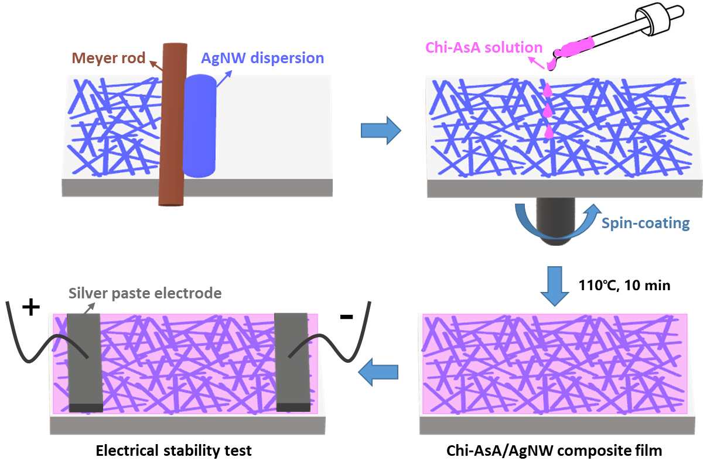
Fig. S1 Schematic illustration of the fabrication process of Chi-AsA/AgNW composite film for electrical stability test.

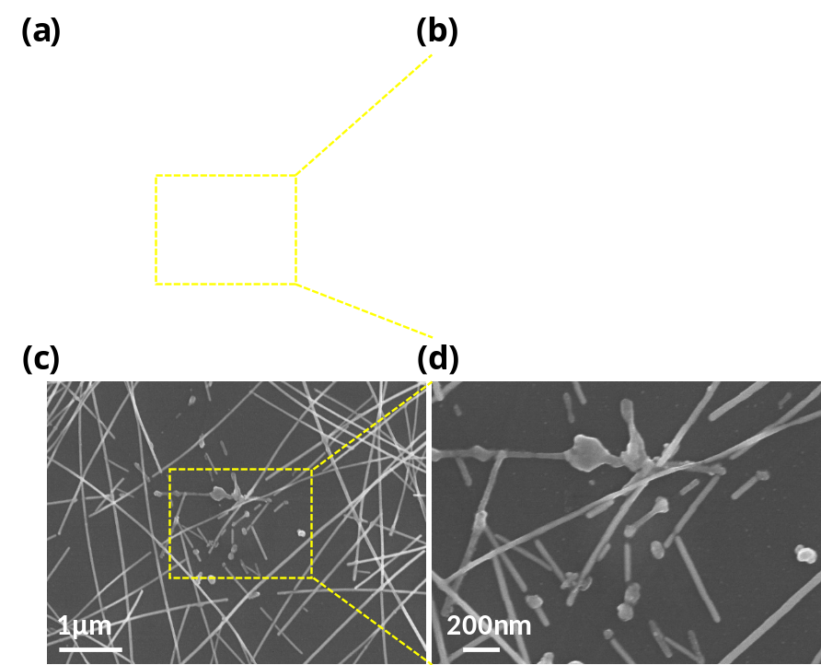
Fig. S2 SEM images demonstrating hot spots of the Chi-AsA/AgNW composite film (a, b) and pristine AgNW film (c, d) failed at 200 mA cm⁻¹ current.

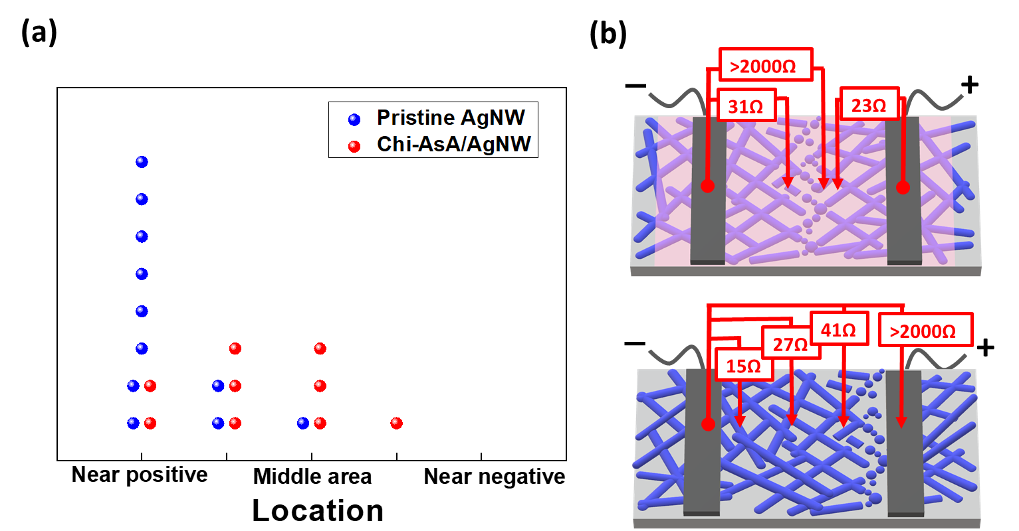
Fig. S3 (a) Location distribution of the wave break in the pristine AgNW films and Chi-AsA/AgNW films (8~15 Ω) failed at 200 mA cm⁻¹ current. (b-c) Schematic diagram of conductivity inspection for the Chi-AsA/AgNW films and pristine AgNW films.
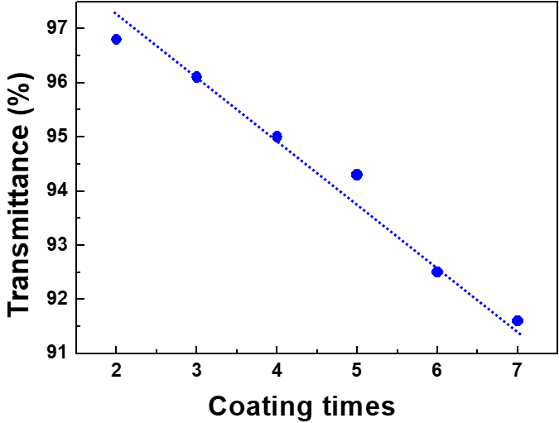
Fig. S4 The transmittance of the composite films as a function of coating times.

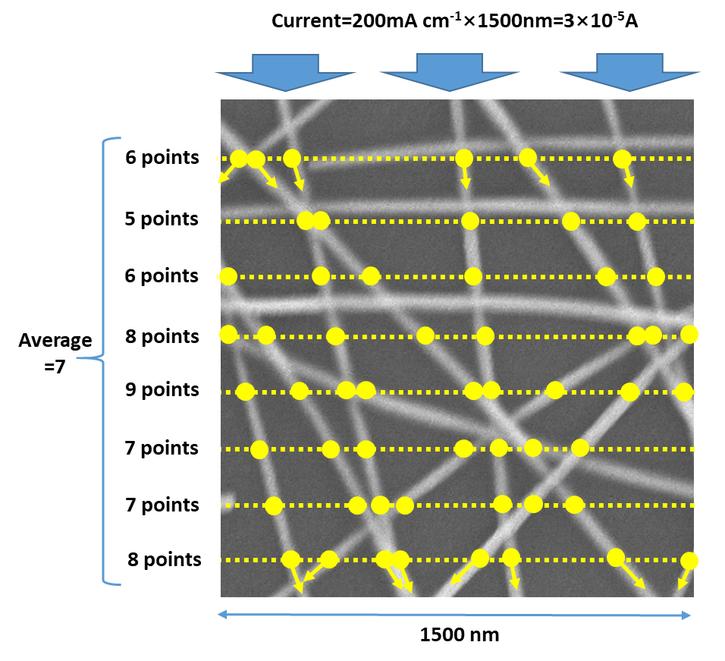
Fig. S5 Schematic of the calculation of the current density in single AgNW. The total current is calculated by multiplying the current density by width: 200 mA cm⁻¹×1500 nm = 3×10⁻⁵ A. The cross-sectional area of the all AgNWs on the path perpendicular to current is calculated by multiplying the average number of AgNWs on the line by the cross-sectional area of single AgNW: 7×π×(15 nm)² = 4.95×10⁻¹¹ cm². The current density (J) in single AgNW is calculated by dividing the current by total cross-sectional area: J = 3×10⁻⁵ A ÷ 4.95×10⁻¹¹ cm² = 6.1×10⁵ A cm⁻².
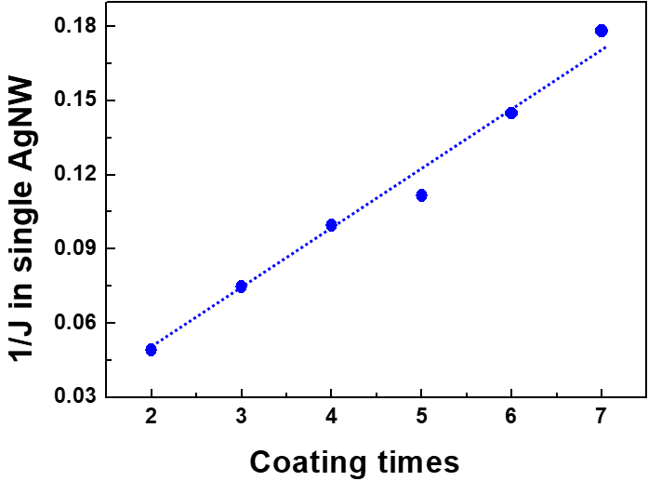
Fig. S6 The reciprocal of the current density in single AgNW as a function of coating times for different networks at 200 mA cm⁻¹ current.

