“Microwave-Assisted, Solvent Free, One Pot Synthesis of Novel Bioactive Imidazolyl -Pyrazole derivatives catalysed by Mesolite type Natural Zeolite”
Sandip S. Dhotreª, Ganesh T. Pawar^{b}, Rajendra P. Pawar^{c}, Sayujjata R. Vaidyaª∗

ªDepartment of Chemistry, Vivekanand Arts, Sardar Dalipsingh Commerce and Science College, Aurangabad-431001.
^{b}University Department of Basic and Applied Science (Chemistry) MGM University Aurangabad-431001.
^{c}Department of Chemistry, Shivchhatrapati college, Aurangabad-431005.

Supplementary data: -

IR Data: 1(A)

1(a)

1(b)

1(c)

1(d)
1(e)

¹H-NMR data
1(a) 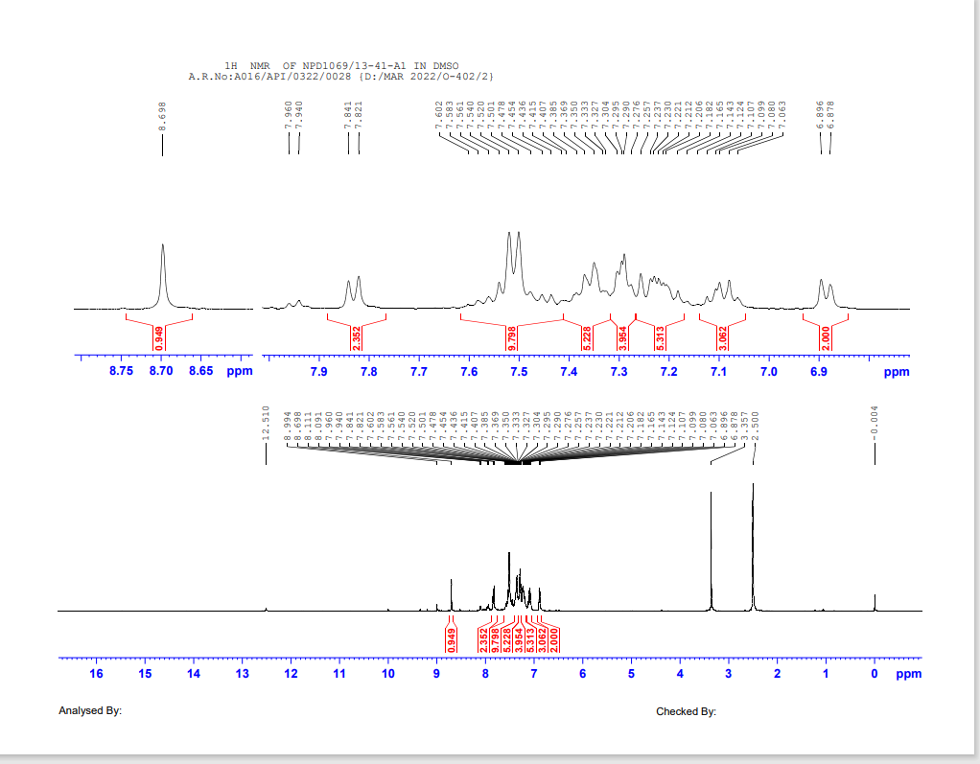

Mass Spectrometry:
1(a)

1(b)

1©

1(d)

1(e)

*Corresponding author: Dr. Sayujjata R. Vaidya, Professor, Department of Chemistry, Vivekanand Arts, Sardar Dalipsingh Commerce and Science College, Aurangabad-431001.profsrvaidya@gmail.com

