Supplementary Information
Hexavalent chromium detoxification by haloalkaliphilic Nesterenkonia sp strain NRC-Y immobilized in different matrices

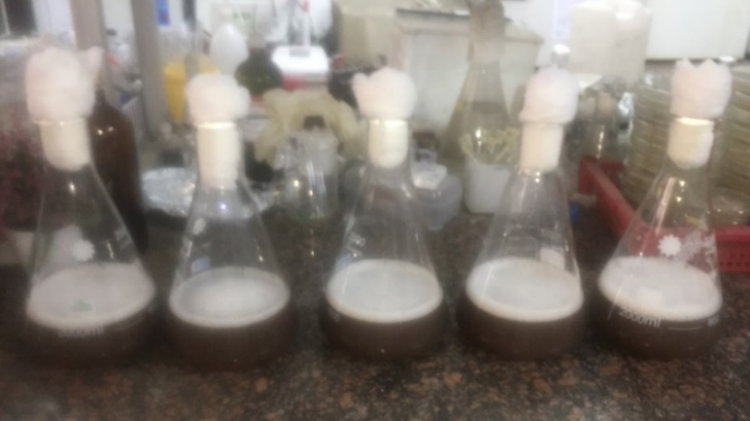
Figure S1: Large scale preparation of partially purified chromate reductase of Nesterenkonia sp strain NRC-Y.

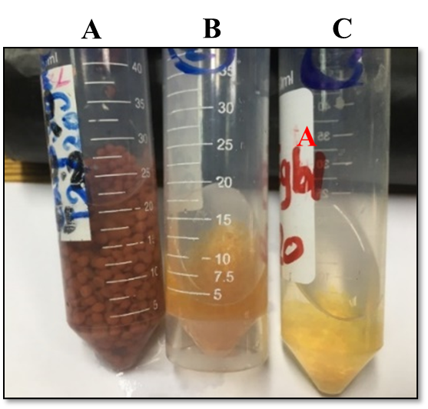
Figure S2: Immobilization of Nesterenkonia sp NRC-Y partially purified chromate reductase by covalent binding on three different carriers including carrageenan-calcium pectinate (Car-CPT) (A), soy protein isolate (SPI) activated Car (B), and egg-white protein (EWP) activated gellan gum (GG) beads (C).

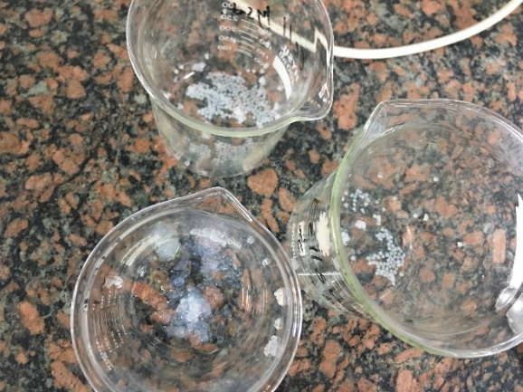 A 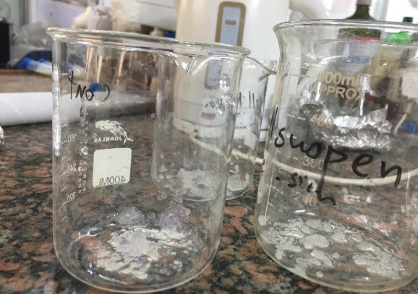
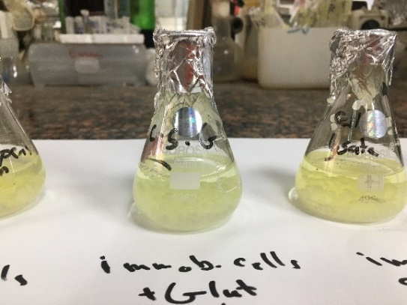 B 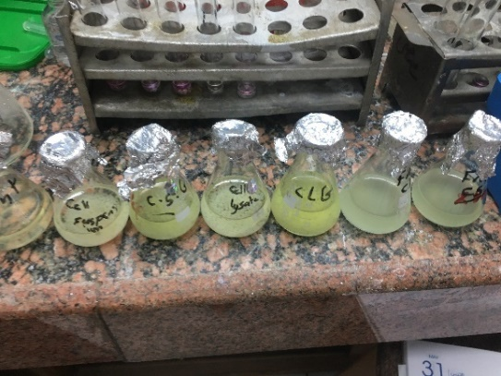
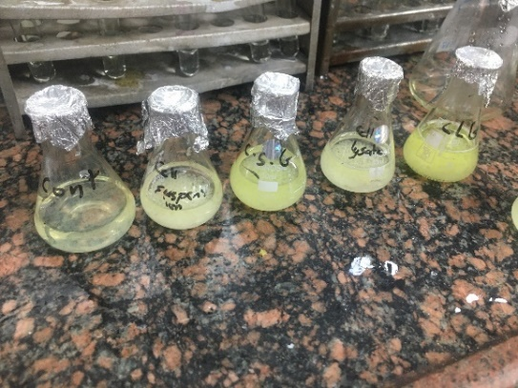 C 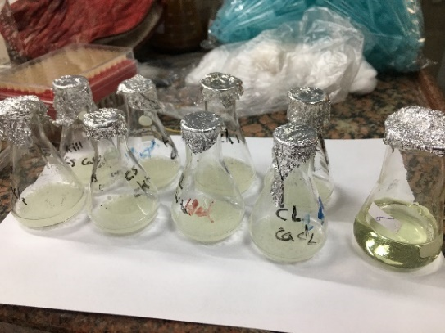
Figure S3: Immobilization whole cell and chromate reductase enzyme of Nesterenkonia sp NRC-Y in alginate-PVA-chitosan composite. A: Preparation of immobilized cell and chromate reductase enzyme in alginate-PVA-chitosan composite beads; B: Assay of the Cr(VI) reduction activity of the immobilized systems; and C: The reaction mixture after 20 h, showing the reduction of Cr(VI) in comparison to the substrate control.

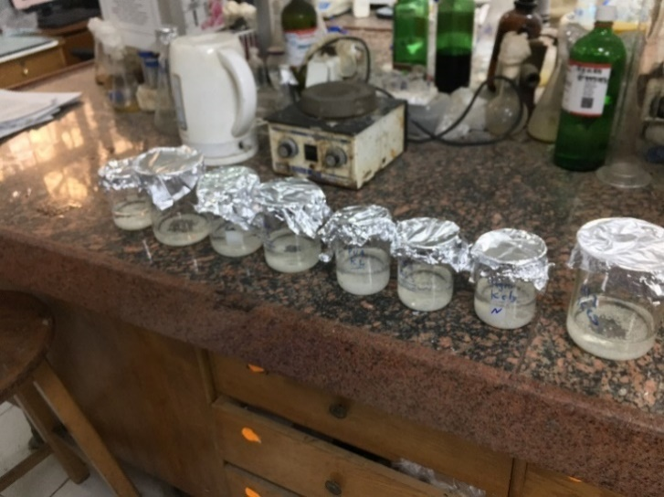 A 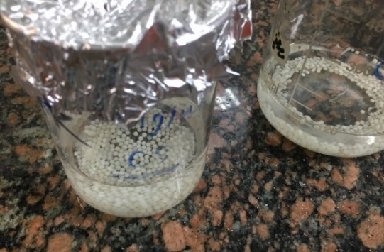
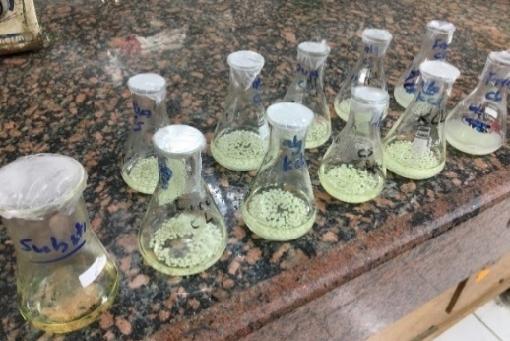B-C 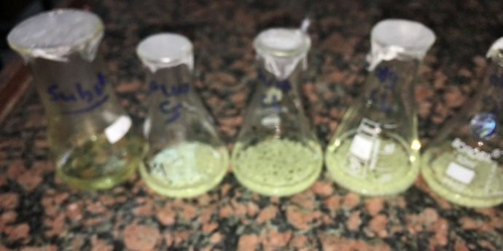
Figure S4: Immobilization of whole cell and chromate reductase of Nesterenkonia sp NRC-Y in alginate and alginate-PVA beads. A: Preparation of immobilized cell/enzyme in alginate and alginate-PVA beads; B: Assay of reduction activity of the immobilized systems; and C: The reaction mixture after 20 h, showing the reduction of Cr(VI) in comparison with the substrate control.

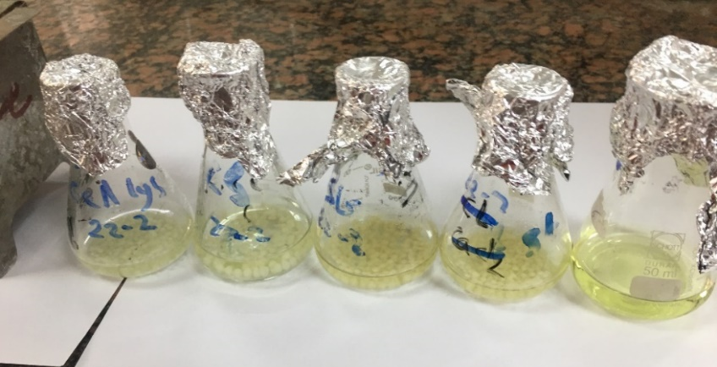
Figure S5: Immobilization of whole cells and chromate reductase enzyme of Nesterenkonia sp NRC-Y in amidated pectin beads.

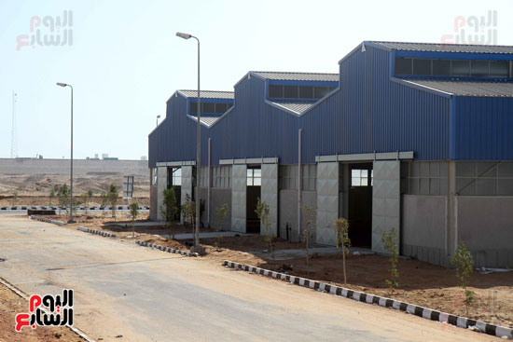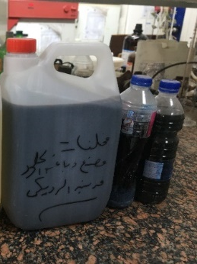
Figure S6: Industrial effluent waste samples collected from different leather tanning factories in El-Robieky City for Leather Industries, located in Badr City, Egypt).

