1. Material and Methods
1.1 Model Description: Weather Research and Forecasting model (WRF)
The Weather Research and Forecasting (WRF) model (Skamarock et al., 2008), developed by the National Centre for Atmospheric Research, is a community of Eulerian non-hydrostatic equations solvers that have a range of applications including forecasting, weather prediction, regional climate modelling, and atmospheric chemistry (Skamarock et al., 2008, 2019). The model has diverse features such as mass-based and hybrid sigma-pressure vertical coordinates, Arakawa-C grid staggering, 2nd to 6th-order advection options, Sub-grid scale turbulence formulation, and full Coriolis terms. WRF provides various options for parameterization, including microphysics, cumulus parametrization, surface physics, planetary boundary layer physics, and atmospheric longwave and shortwave radiation. From WRF V4.3 the multilayer Building Effect Parameterization (BEP), and BEP with Building Energy Model (BEP+BEM) UCMs are added to the Yonsei University (YSU) planetary boundary layer parameterization (Hendricks et al., 2020). Further, while the preceding versions of WRF accounted only for three urban classes in the land use (Low density residential, high-density residential and Industrial or commercial), the versions after WRF V4.3 now allow the incorporation of the LCZ scheme (Zonato & Chen, 2021) when a flag is added into the “& physics” section of the namelist.input files: use wudapt_lcz =1.

1.2 Description of Urban Canopy Models
In order to improve the ability of the WRF model to capture fine-scale urban processes and better representation of surface air energy interactions in urban areas (Chen et al., 2004), a number of urban parametrization schemes have been implemented. The Simple Layer Urban Canopy Model (SLAB) is a straightforward urban canopy model that assumes all urban processes are occurring below the lowest model vertical level. It estimates fluxes of heat and momentum based on the Monin-Obukov Similarity Theory (MOST) regardless of the urban structure. The SLUCM (Kusaka & Kimura, 2001) includes street canyons to represent urban geometry, shading, and radiative reflection by buildings. It also includes a multilayer heat equation for roof, wall, and road surface temperatures (Chen et al., 2011). Unlike SLAB, it takes into account the heterogeneity of urban landscapes and urban green infrastructure. The BEP (Martilli et al., 2002) is a 3D structure model that distributes the exchanges of heat, moisture, momentum, and turbulent kinetic energy within the urban structure. BEP+BEM, developed by Martilli et al., (2002), is a highly sophisticated multilayer scheme that estimates anthropogenic heat generated by air conditioning systems and heat exchange between the interior of a building and the atmosphere.
Bassett et al., (2020) experimented with the WRF-SLUCM driven by the Urban Canopy Parameters (UCPs) of Jackson et al., (2010)and found it to produce reliable results over Lagos in terms of UHI assessment. Building on this study, the proposed research seeks to assess the performance of SLAB, BEP, and BEP+BEM models driven with the UCPs of the Local Climate Zone (LCZ) scheme to determine the best model for heat stress analysis in the tropical humid city of Lagos.

1.3 Model Configuration
WRF version 4.4 was used for this study. WRF model has been used in several quasi-operational as well as process-based assessments of extreme temperature, UHI and heat stress investigations over the tropics (e.g Bhati & Mohan, 2016; Kedia et al., 2021; Khan & Chatterjee, 2016; Bassett et al., 2020). The domain is configured with 4 interacting nested domains set at 27km, 9km, 3km and 1km (grid ratio 1:3:3:3), similar to Bassett et al., (2020). All domains comprised of 35 vertical levels from the surface to 50hpa to capture the boundary layer processes. The master domain covers a large region of West Africa and extends over the Atlantic Ocean, which is the main source of wind and moisture for monsoon activities over the region; domain 2 covered Nigeria and domain 3 covered the city of Lagos at a much finer resolution and timestep.
The physical parameterisation schemes were derived from the optimal combination of schemes used in previous studies (e.g Bassett et al., 2020; Niyogi et al., 2020; Gbode et al., 2019) over a tropical savanna climate. The cloud microphysics is used from WSM 6-class graupel scheme (Lim & Hong, 2010), Surface Layer is parameterised using Monin-Obukhov Similarity scheme (Monin and Obukhov 1954), Land Surface Model considered in the study is the Noah Land-Surface Model (Liu et al., 2006). Boundary layer parameterization is from Bougeault and Lacarrère scheme (Bougeault & Lacarrere, 1989), long wave radiation model used is rapid radiative transfer model (RRTM: Mlawer et al., 1997), and for short wave radiation Dudhia’s scheme (Dudhia, 1989) is selected.
The model was run for 31 days for a typical pre monsoon period in March 2020. March generally is usually associated with a high degree of heat stress in southern Nigeria (Balogun et al., 2010) due to the influence of moisture-laden warm maritime air. The annual time series of mean daily air temperature is shown in (Fig. S1).
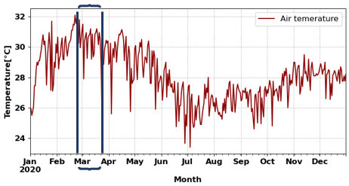
Fig. S1: Annual time series of air temperature for 2020
1.3 Model Inputs
The WRF initial and boundary conditions were obtained from the fifth generation of the European Center for Medium-Range Weather Forecasting (ECMWF) reanalysis ERA5 data set. For outer domains, the default MODIS IGBP 21- land cover category data was used. However, for the innermost domain (d04), we implement the high-resolution LCZ map (Fig. S2) for the urban Land use (LU) category. The LCZ map of Lagos representative of year 2020 was generated using the LCZ generator (Demuzere et al., 2021). The LCZ generator is an online web interface that accepts training areas file processed the map and produces a high-quality Gaussian-filtered map at 100m spatial resolution. The LCZ map in Fig. S2 displays the 17 classes with 10 urban and 7 natural classes. For Lagos Urban area, the dominant LCZs include LCZs 6, 3, 9 and 7 covering 54%, 25%, 22%, 13% of the urban area respectively.
To incorporate the LCZ map into WRF Preprocessing System (WPS), we made use of the WUDAPT to WRF python tool (w2w: Demuzere et al., 2021). The urban pixels corresponding to MODIS IGBP 21 urban land use categories (LU-index 13) were replaced with 10 distinct LCZ urban classes (Fig. S2). For details of the conversion processes see Demuzere et al., (2021).
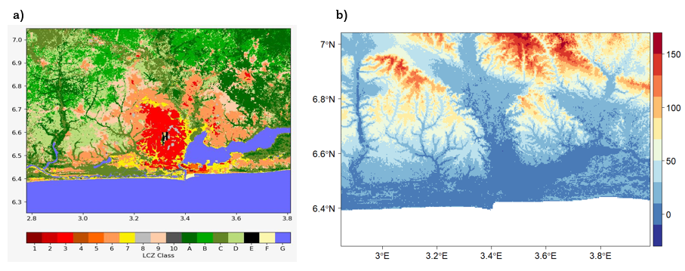
Fig. S2- a) High resolution (100m) LCZ map of Lagos Nigeria representative of year 2020 and b) high resolution (90m) SRTM topography data
As part of the model set up, we also implemented Shuttle Radar Topography Mission (SRTM: Slater et al., 2006) in WPS. SRTM was delivered onboard the Space Shuttle Endeavour during an eleven-day mission in February 2000 to create global most complete high-resolution (~90m) topographic database.

1.4 Anthropogenic Heat
To have a more realistic representation of the anthropogenic heat (Q_{F}) generated in Lagos, we ran a simple standalone Surface Urban energy and water balance Scheme using Python (SuPy: Grimmond, 2020; Sun & Grimmond, 2019). The model was driven with LCZ UCPs and forced with ERA5 surface meteorology at 500m spatial resolution and population data from Grid 3 (https://grid3.gov.ng/). SUEWS calculates Q_{F} based on heating and cooling degree days and population density (Järvi et al., 2011). The resulting values of anthropogenic heat per grid cell were aggregated by each LCZ and used in the UCMs model.

1.5 SUEWS Model Run
Surface Urban Energy and water balance scheme was used to simulate the anthropogenic heat for each LCZ as input to the Urban Canopy Model (UCM). The LCZ map of Lagos provides the land cover characteristics. In addition, SUEWS needs population data to estimate the anthropogenic heat (Q_{F)}. These were obtained from the Geo-Referenced Infrastructure and Demographic Data for Development (GRID³ ; WorldPop., 2020). This was used to calculate the population density per grid in pp/hectare for each grid using the zonal statistics tool in QGIS. Hourly meteorological data for a single location (Lagos Airport; 3.321E, 6.581N) from ERA5 were used. SUEWS was run in SuPy mode (SUEWS in Python) at 5 minutes time-step for the month of March 2020. The model output was subsequently averaged to hourly and for each LCZs.

1.6 Heat stress Analysis
A comparison of heat Indices, Humidex vs WBGT
The Wet-Bulb Globe Temperature, WBGT (Yaglou & Minard, 1957) on the other hand is widely considered as the most frequently used heat stress index due to its straightforward physical interpretation and its derivation from a broader range of environmental factors such as air temperature, humidity, wind, and solar radiation.
WBGT is formulated as a linear combination of the natural wet-bulb temperature, $T_{w}$, black globe temperature$, T_{g}$ and air temperature,$T_{2}$:
$WBGT = {0.7T}_{w}+ {0.2T}_{g }+ {0.1T}_{ 2 (4)}$
Where $T_{w}$ is estimated from relative humidity and air temperature using Stull’s equation (Stull, 2011) and $T_{g}$ measures the combined effect of radiant heat $L_{w}$, air temperature $T_{2}$, and wind speed $ws$.
$T_{g}$= $T_{2}{+ 0.017L}_{w}-0.0208ws (5)$
Obviously, WBGT will seem to be a better representation of human comfort than Humidex since it would account for the effect of four environmental factors than Humidex’s two. However, recent studies (e.g Budd, 2008; Havenith & Fiala, 2016; Kong & Huber, 2022) have shown that WBGT responds poorly to humidity and wind speed and consequently underestimates the heat stress under restricted evaporation in a prevailing highly humid environment. In this regard, it is possible that the humidity and wind patterns might not be well accounted for in a complex coastal city like Lagos using WBGT. Nevertheless, we compared the 2 indices and found a good linear relation between them as shown in Fig. S3 (R² = ~0.7).

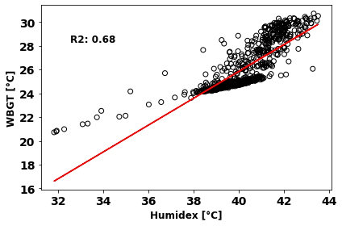
Fig.S3- Scatter plot showing the linear relation between WBGT and Humidex (^{O}C)
2. Result and Discussion
2.1 Model evaluations
2.1.1 Air Temperature Evaluation
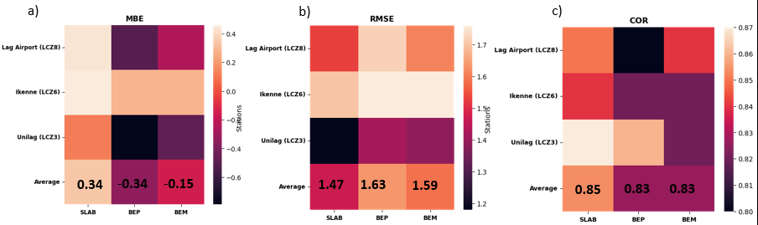
Fig.S4- Heat maps showing a) the MBE B) RMSE and c) the correlation coefficients of predicted T₂ (ºC) and observations over the selected stations.
Relative Humidity
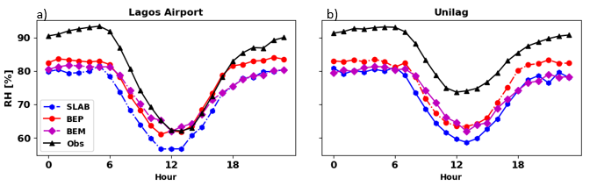
Fig.S5- Mean diurnal pattern of observed and simulated relative humidity (RH) over Lagos Airport and Unilag

2.1.2 Wind Speed
The wind pattern is shown in Fig. S6 corresponding to Ikenne (LCZ 6), Lagos Airport (LCZ8) and Unilag (LCZ 3). Overestimation of the diurnal pattern of wind speed is observed in Ikenne by all the models. The overestimation is most pronounced in the SLAB model, followed by BEP and least in BEP+BEM model. In Lagos Airport, we noted a general underestimation of wind speed, particularly during the day. Additionally, we noted that BEP model was able to capture the low wind speed at nighttime than SLAB and BEP+BEM model. In Unilag location, the diurnal pattern of wind speed by BEP model seems to be closest to observations, whereas the overestimations of the diurnal wind pattern is observed in the SLAB model and underestimations by the BEP+BEM. Despite the similarities in the physical configurations of BEP and BEP+BEM model, we found a general low wind speed in diurnal pattern of wind speed predicted by BEP+BEM . This might be related to the addition of a drag coefficient in the latest version of WRF(V>4.3: Zonato & Chen, 2021). The drag coefficient influences momentum sinks caused by vertically oriented surfaces (buildings and vegetation) as well as turbulent kinetic energy generated by buildings (Martilli et al., 2002). The drag from horizontal surfaces is however based on the MOST. In previous versions, drag coefficients were constant, however in WRFV4.3, this was modified to depend on the building plan area ratio, since the ratio affects the overall drag in simulations using Reynolds-averaged Navier-Stokes equations (Santiago & Martilli, 2010 ; Gutiérrez et al., 2015). The low wind speed predictions by BEP+BEM has also been noted by (Hendricks & Knievel, 2022) over Houston.

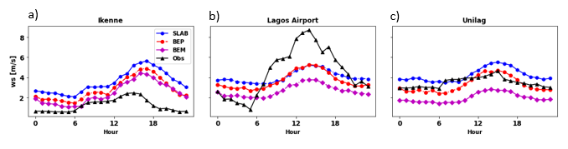
Fig. S6- Comparison of mean diurnal pattern of 10m air at the 3 locations
The error metrics evaluation between observed and modelled wind speed for each location and aggregates indicated a general overestimation in all the models with largest MBE occurring in the SLAB model (MBE=1.63), this is followed by BEP model (MBE=0.97m/s). However, BEP+BEM predicted wind speed closer to 0m/s (MBE= 0.05m/s). Likewise, BEP+BEM presents the lowest RMSE (RMSE =2.19m/s), followed by BEP (RMSE = 2.6m/s) and the highest error is noted with the SLAB model (RMSE = 3.1m/s). The correlation between the observed and predicted wind speeds is generally low with a correlation coefficient of 0.32, 0.36 and 0.35 for SLAB, BEP and BEP+BEM models respectively. The heat map for the evaluation metrics for the three stations is shown in Fig. S7. Although with a grid resolution of 1 km, we might expect the WRF model to perform better in simulating wind speed, as noted by Solbakken et al., (2021). However, the low correlation values observed between the model output and observations may be related to the model's land-use specification at each location. For instance, at Lagos Airport, the model grid with a resolution of 1 km is classified as LCZ 8, which represents large low-rise buildings. In reality, the meteorological site is located on grass with the closest low-rise buildings at least 100m away.
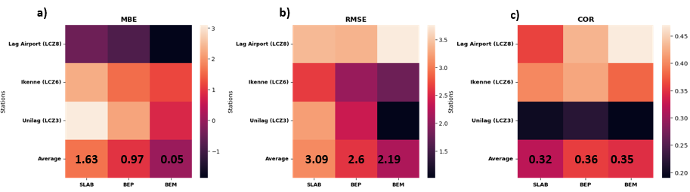
Fig. S7- Heat maps showing a) the MBE B) RMSE and c) the correlation coefficients of predicted wind speeds and observations over selected stations.
2.1.3 Wind Direction and Wind speed frequency
Fig. S8-S10 illustrates the comparison of modelled and observed wind directions and wind speed frequency. Over Ikenne (LCZ6) location. The prevalent wind direction is southwesterlies, which the models did well in replicating. However, BEP+BEM model shows much more variability in the wind direction than SLAB and BEP model. The wind speed histogram shows a general overestimation of the wind speed. Low wind speed frequency were underestimated (0-1m/s) by all the models, 1% by SLAB, 4% by BEP however BEP+BEM shows an improved performance with 14%. Wind speeds between 1 -2mls were well captured by BEP and BEP+BEM. 35% of the observed wind speed are between 1-2m/s, BEP predicted 34%, and BEP+BEM predicted 33% whereas the SLAB model predicted just 17%. It is evident that the model successfully captured the dominant sectors in the direction, indicating that the direction sectors that were not accurately simulated by the model have little significance.

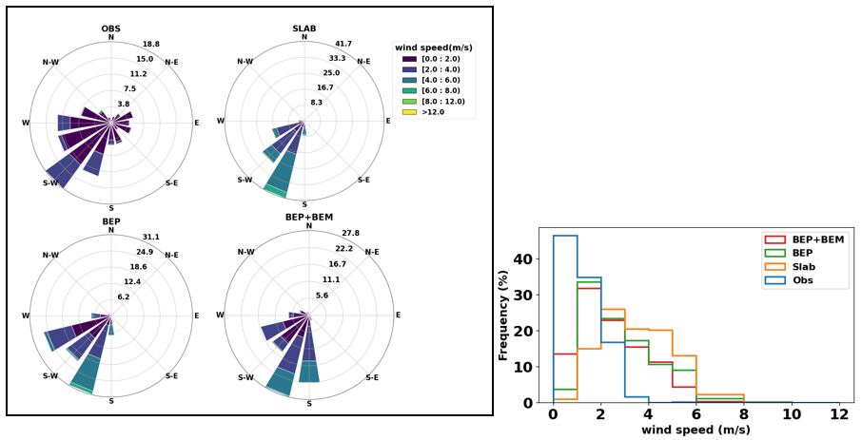
Fig. S8- a) wind rose and b) wind speed histogram depicting the wind speed frequencies in Ikenne location
Over Lagos airport, because this is an airport weather station, wind speed less than 3m/s which is classified as 0(calm). For comparison, modelled wind speed less than 3m/s were also classified as calm. The prevalent wind direction from observation is southwesterlies, which the models did well in replicating. However, BEP+BEM model shows much more variability in the wind direction than SLAB and BEP model. The wind speed histogram shows a general overestimation of the wind speed. Low wind speeds frequency were underestimated (0-1m/s) by all the models, 1% by SLAB, 4% by BEP however BEP+BEM shows an improved performance with 14%. Wind speeds between 1 -2mls were well captured by BEP and BEP+BEM. 35% of the observed wind speed are between 1-2m/s, BEP predicted 34%, and BEP+BEM predicted 33% whereas the SLAB model predicted just 17%. It is evident that the model successfully captured the dominant sectors in the direction, indicating that the direction sectors that were not accurately simulated by the model have little significance.

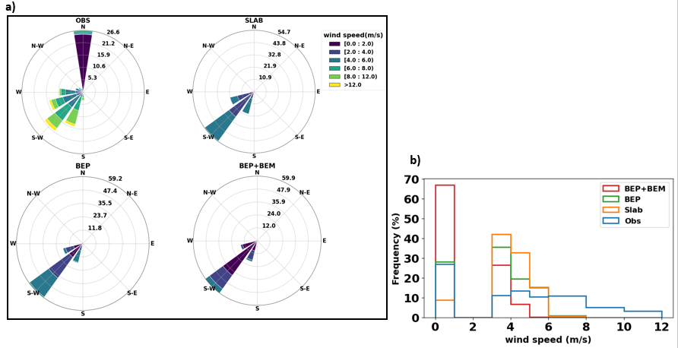
Fig. S9 a) Wind rose and b) wind speed histogram depicting the wind speed frequencies in Lagos airport location.
However, in Unilag location where north-westerly winds predominate, the 3 models failed to reproduce the wind directions as they all predicted southwesterlies. This again might be due to mismatch between the actual description of the measurement site and the grid description. Moreover, BEP+BEM did well in capturing the wind speed frequencies than BEP and SLAB. We noted that majority of the wind speed are between 1-2m/s (90%). BEP+BEM predicted the highest percentage within this range. As low wind speeds were observed in the location for (90%). BEP+BEM predicted the highest percentage within this range with a frequency of 50% followed by BEP (5%) and SLAB with 1%.

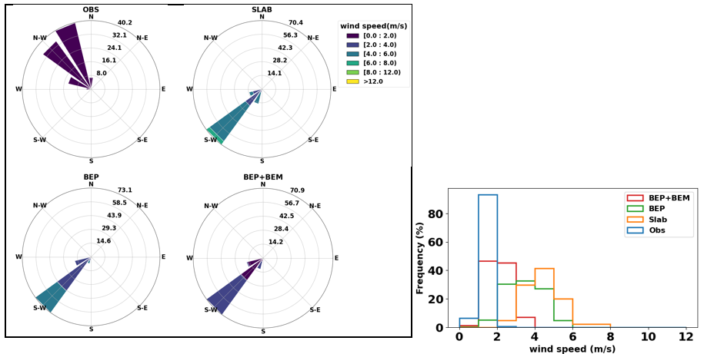
Fig. S10- a) wind rose and b) wind speed histogram depicting the wind speed frequencies over Unilag location

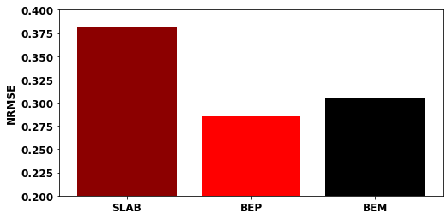
Fig. S11 Bar chart illustrating the normalised root mean square error for air temperature, wind speed and relative humidity.
Reference
Balogun, A. A., Balogun, I. A., Adeyewa, Z. D., Balogun, A. A., Balogun, I. A., & Adeyewa, Z. D. (2010). Comparisons of urban and rural heat stress conditions in a hot–humid tropical city. 9716. https://doi.org/10.3402/gha.v3i0.5614
Bassett, R., Young, P. J., Blair, G. S., Samreen, F., & Simm, W. (2020a). The megacity lagos and three decades of urban heat island growth. Journal of Applied Meteorology and Climatology, 59(12), 2041–2055. https://doi.org/10.1175/JAMC-D-20-0059.1
Bassett, R., Young, P. J., Blair, G. S., Samreen, F., & Simm, W. (2020b). The megacity lagos and three decades of urban heat island growth. Journal of Applied Meteorology and Climatology, 59(12), 2041–2055. https://doi.org/10.1175/JAMC-D-20-0059.1
Bhati, S., & Mohan, M. (2016). WRF model evaluation for the urban heat island assessment under varying land use/land cover and reference site conditions. Theoretical and Applied Climatology, 126(1–2), 385–400. https://doi.org/10.1007/s00704-015-1589-5
Chen, F., Kusaka, H., Tewari, M., Bao, J. W., & Hirakuchi, H. (2004). Utilizing the coupled WRF/LSM/urban modeling system with detailed urban classification to simulate the urban heat island phenomena over the Greater Houston area. 5th Symposium on the Urban Environment, 431–437.
Chen, Fei, Kusaka, H., Bornstein, R., Ching, J., Grimmond, C. S. B., Grossman-Clarke, S., Loridan, T., Manning, K. W., Martilli, A., Miao, S., Sailor, D., Salamanca, F. P., Taha, H., Tewari, M., Wang, X., Wyszogrodzki, A. A., & Zhang, C. (2011). The integrated WRF/urban modelling system: Development, evaluation, and applications to urban environmental problems. International Journal of Climatology, 31(2), 273–288. https://doi.org/10.1002/joc.2158
Demuzere, M., Kittner, J., & Bechtel, B. (2021). LCZ Generator: A Web Application to Create Local Climate Zone Maps. Frontiers in Environmental Science, 9, 637455. https://doi.org/10.3389/fenvs.2021.637455
Demuzere, M., Sida, J., Huang, F., Zhan, W., Bechtel, B., Liu, Z., Demuzere, M., Huang, Y., Xu, Y., Quan, J., Xia, W., Ma, L., Hong, F., Jiang, L., Lai, J., Wang, C., Kong, F., Du, H., Miao, S., … Zhang, X. (2021). Mapping Local Climate Zones: A Bibliometric Meta-Analysis and Systematic Review. 1–106. https://doi.org/10.31219/osf.io/c2bez
Dudhia, J. (1989). Numerical Study of Converction Observed during the Winter Monsson Experiment Using a Mesoscale Two- Dimensional Model. Journal of the Atmospheric Sciences.
Gbode, I. E., Dudhia, J., Ogunjobi, K. O., & Ajayi, V. O. (2019). Sensitivity of different physics schemes in the WRF model during a West African monsoon regime. Theoretical and Applied Climatology, 136(1–2), 733–751. https://doi.org/10.1007/s00704-018-2538-x
Grimmond, P. S. (2020). SuPy Documentation.
Havenith, G., & Fiala, D. (2016). Thermal indices and thermophysiological modeling for heat stress. Comprehensive Physiology, 6(1), 255–302. https://doi.org/10.1002/cphy.c140051
Hendricks, E. A., & Knievel, J. C. (2022). Evaluation of Urban Canopy Models against Near-Surface Measurements in Houston during a Strong Frontal Passage. Atmosphere, 13(10). https://doi.org/10.3390/atmos13101548
Hendricks, E. A., Knievel, J. C., & Wang, Y. (2020). Addition of multilayer urban canopy models to a nonlocal planetary boundary layer parameterization and evaluation using ideal and real cases. Journal of Applied Meteorology and Climatology, 59(8), 1369–1392. https://doi.org/10.1175/JAMC-D-19-0142.1
HIROYUKI KUSAKA YOKIHIRO KIKEGAWA and FUJIO, H. K., & Kimura. (2001). A SIMPLE SINGLE-LAYER URBAN CANOPY MODEL FOR{$}\backslash{\$}rATMOSPHERICMODELS: COMPARISONWITH MULTI-LAYER AND{$}\backslash{\$}rSLAB MODELS. Boundary-Layer Meteorology, 101(ii), 329–358.
Jackson, T. L., Feddema, J. J., Oleson, K. W., Bonan, G. B., & Bauer, J. T. (2010). Parameterization of urban characteristics for global climate modeling. Annals of the Association of American Geographers, 100(4), 848–865. https://doi.org/10.1080/00045608.2010.497328
Järvi, L., Grimmond, C. S. B., & Christen, A. (2011). The Surface Urban Energy and Water Balance Scheme (SUEWS): Evaluation in Los Angeles and Vancouver. Journal of Hydrology, 411(3–4), 219–237. https://doi.org/10.1016/j.jhydrol.2011.10.001
Kedia, S., Bhakare, S. P., Dwivedi, A. K., Islam, S., & Kaginalkar, A. (2021). Estimates of change in surface meteorology and urban heat island over northwest India: Impact of urbanization. Urban Climate, 36. https://doi.org/10.1016/j.uclim.2021.100782
Khan, A., & Chatterjee, S. (2016). Numerical simulation of urban heat island intensity under urban–suburban surface and reference site in Kolkata, India. Modeling Earth Systems and Environment, 2(2). https://doi.org/10.1007/s40808-016-0119-5
Kong, Q., & Huber, M. (2022). Explicit Calculations of Wet-Bulb Globe Temperature Compared With Approximations and Why It Matters for Labor Productivity. Earth’s Future, 10(3). https://doi.org/10.1029/2021EF002334
Lim, K. S. S., & Hong, S. Y. (2010). Development of an effective double-moment cloud microphysics scheme with prognostic cloud condensation nuclei (CCN) for weather and climate models. Monthly Weather Review, 138(5), 1587–1612. https://doi.org/10.1175/2009MWR2968.1
Martilli, A., Clappier, A., & Rotach, M. W. (2002). An urban surface exchange parameterisation for mesoscale models. Boundary-Layer Meteorology, 104(2), 261–304. https://doi.org/10.1023/A:1016099921195
Mlawer, E. J., Taubman, S. J., Brown, P. D., Iacono, M. J., & Clough, S. A. (1997). Radiative transfer for inhomogeneous atmospheres: RRTM, a validated correlated-k model for the longwave. Journal of Geophysical Research Atmospheres, 102(14), 16663–16682. https://doi.org/10.1029/97jd00237
Niyogi, D., Osuri, K. K., Busireddy, N. K. R., & Nadimpalli, R. (2020). Timing of rainfall occurrence altered by urban sprawl. Urban Climate, 33(June 2019), 100643. https://doi.org/10.1016/j.uclim.2020.100643
Note: Files available at https://wopr.worldpop.org may be slightly different than the files available from the DOI links in the citations above. See the section “Version History” below for more information. (2020). July 2019, 1–9.
Santiago, J. L., & Martilli, A. (2010). A Dynamic Urban Canopy Parameterization for Mesoscale Models Based on Computational Fluid Dynamics Reynolds-Averaged Navier-Stokes Microscale Simulations. Boundary-Layer Meteorology, 137(3), 417–439. https://doi.org/10.1007/s10546-010-9538-4
Skamarock, W. C., Klemp, J. B., Dudhia, J. B., Gill, D. O., Barker, D. M., Duda, M. G., Huang, X.-Y., Wang, W., & Powers, J. G. (2008). A description of the Advanced Research WRF Version 3, NCAR Technical Note TN-475+STR. Technical Report, June, 113.
Skamarock, W. C., Klemp, J. B., Dudhia, J., Gill, D. O., Zhiquan, L., Berner, J., Wang, W., Powers, J. G., Duda, M. G., Barker, D. M., & Huang, X.-Y. (2019). A Description of the Advanced Research WRF Model Version 4. NCAR Technical Note NCAR/TN-475+STR, 145. http://library.ucar.edu/research/publish-technote
Slater, J. A., Garvey, G., Johnston, C., Haase, J., Heady, B., Kroenung, G., & Little, J. (2006). The SRTM Data “ Finishing ” Process and Products. 72(3), 237–247.
Solbakken, K., Birkelund, Y., & Samuelsen, E. M. (2021). Evaluation of surface wind using WRF in complex terrain: Atmospheric input data and grid spacing. Environmental Modelling and Software, 145(September), 105182. https://doi.org/10.1016/j.envsoft.2021.105182
Stull, R. (2011). Wet-bulb temperature from relative humidity and air temperature. Journal of Applied Meteorology and Climatology, 50(11), 2267–2269. https://doi.org/10.1175/JAMC-D-11-0143.1
Sun, T., & Grimmond, S. (2019). A Python-enhanced urban land surface model SuPy (SUEWS in Python, v2019.2): Development, deployment and demonstration. Geoscientific Model Development, 12(7), 2781–2795. https://doi.org/10.5194/gmd-12-2781-2019
Zonato, A., & Chen, F. (2021). Updates of WRF-urban in WRF 4.3: Local Climate Zones, Mitigation Strategies, building materials permeability and new buildings drag coefficient. http://www.wudapt.org/wp-content/uploads/2016/05/

