There is market potential for circular farming food in Europe due to consumers’ willingness to purchase and pay a premium for circular-labeled food

Contents

Supplementary Results 3
Socio-demographic characteristics of the samples 3
Consumers’ environmental attitudes 3
Summary statistics of the demand for quantities of circular sliced pork, milk, and sliced bread demanded in six countries 4
Correlation between consumers’ environmental attitude, opinions about the impact of farming systems on the environment, and opinions about the environmental sustainability of dietary patterns 4
Supplementary Tables 5
Supplementary Table 1 Price of sliced pork loin, milk, and bread in each case study from OECE (€) 5
Supplementary Table 2 Socio-demographic characteristics of the samples 7
Supplementary Table 3 PCA for environmental attitudes 9
Supplementary Table 4 Demand for aggregate quantities of sliced pork loin from circular, organic, and conventional farming desired at different prices 11
Supplementary Table 5 Demand for aggregate quantities of milk from circular, organic, and conventional farming desired at different prices 12
Supplementary Table 6 Demand for aggregate quantities of sliced bread from circular, organic, and conventional farming desired at different prices 13
Supplementary Table 7 Summary statistics of the demand for quantities of circular sliced pork in six EU countries 14
Supplementary Table 8 Summary statistics of the demand for quantities of circular milk in six EU countries 15
Supplementary Table 9 Summary statistics of the demand for quantities of circular bread in six EU countries 16
Supplementary Table 10 NB regression of circular products in Spain 17
Supplementary Table 11 NB regression of circular products in Poland 18
Supplementary Table 12 NB regression of circular products in Italy 19
Supplementary Table 13 NB regression of circular products in Hungary 20
Supplementary Table 14 NB regression of circular products in Croatia 21
Supplementary Table 15 NB regression of circular products in Belgium 22
Supplementary Table 16 Correlation between consumers’ environmental attitude, opinions about the impact of farming systems on the environment, and opinions about the environmental sustainability of dietary patterns 23
Supplementary Figures 24
Supplementary Figure 1 An example of milk in the OECE and definitions of various farming systems for milk 24
Supplementary Figure 2 An example of sliced bread in the OECE and definitions of various farming systems for bread 25
Supplementary Figure 3 Geographical location of the study area of this research 26
Supplementary Figure 4 PCA results of environmental attitudes. 27
Full Questionnaire 28

Supplementary Results

Socio-demographic characteristics of the samples
The socio-demographic characteristics of the samples are displayed in Supplementary Table 2. The proportion of men and women was acceptable in accordance with the population distribution of each country. Nevertheless, in Poland, the proportion of females was slightly higher (59.52%). The age distribution was similar in most countries. However, a smaller proportion of people aged 35-44 in Croatia was found. The majority of respondents in all countries had completed secondary and university education and were full-time employees. In terms of stated financial situation, consumers in all countries considered it to be a little higher than the average (i.e., >5 points on a 10-point Likert scale), which could be described as a regular financial situation. Regarding the frequency with which monthly income covered household expenditure, all countries had higher percentages in the “always” and “very often” categories, and lower percentages in the “rarely” and “never” categories. In Italy and Hungary, the proportion of the “always” category was much higher than that of other categories. These results reveal that in all countries the majority of respondents’ income could cover their expenditures.

Consumers’ environmental attitudes
By applying Principal Component Analysis (PCA), we observed two clear dimensions in all countries (see Supplementary Table 3 and Supplementary Figure 4). The Kaiser Meyer Olkin test (KMO>0.75) indicated good fit and applicability of this method for the set of analyzed variables in each country. Moreover, the accumulated explained variance of the 2 principal components was higher than 55% in each country (Supplementary Table 3). The total variance explained by the first and second dimensions for each country was within the acceptable range of the NEP scale, thus confirming its suitability in describing environmental attitudes.

Summary statistics of the demand for quantities of circular sliced pork, milk, and sliced bread demanded in six countries
The summary statistics of the demand for quantities of circular sliced pork, milk, and sliced bread in six countries are displayed in Supplementary Tables 7 to 9, which were based on the results of individual consumers who indicated that they would buy at least one unit of the product, regardless of the farming system.

Correlation between consumers’ environmental attitude, opinions about the impact of farming systems on the environment, and opinions about the environmental sustainability of dietary patterns
Results from Supplementary Table 16 reveal that ecocentric consumers in all countries were positively correlated with vegetarian, vegan and flexitarian diets, and negatively correlated with non-restricted diets. Ecocentric consumers perceived the chosen diets of vegetarian, vegan, and flexitarian to be more environmentally sustainable, while non-restricted diets were perceived as being less sustainable. Ecocentric people were more likely to have sustainable diets (i.e., vegetarianism, veganism and flexitarianism), possibly because they perceived meat and dairy to be less environmentally sustainable. As a result, they were less likely to buy more circular pork and milk, and were more likely to achieve sustainability by having a more sustainable diet. Results also show that there was a positive correlation between ecocentric consumers and organic and circular farming and a negative correlation with conventional farming in five countries.

Supplementary Tables

Supplementary Table 1 Price of sliced pork loin, milk, and bread in each case study from OECE (€)
Product |  | Pork: Sliced pork loin packs (500g each)
Farming systems | Purchase Situation | Spain (€) | Poland (€) | Italy (€) |  | Hungary (€) |  | Croatia (€) |  | Belgium (€)
Circular | 1 | 2.50 | 1.97 | 2.80 |  | 2.93 |  | 3.09 |  | 4.50
Circular | 2 | 3.50 | 2.41 | 3.40 |  | 3.13 |  | 3.55 |  | 5.50
Circular | 3 | 4.50 | 2.85 | 4.20 |  | 3.32 |  | 4.02 |  | 6.50
Circular | 4 | 5.50 | 3.29 | 5.00 |  | 3.52 |  | 4.48 |  | 7.50
Circular | 5 | 6.50 | 3.73 | 5.80 |  | 3.72 |  | 4.95 |  | 8.50
Conventional | 1 | 4.50 | 2.85 | 4.20 |  | 3.32 |  | 4.02 |  | 6.50
Conventional | 2 | 4.50 | 2.85 | 4.20 |  | 3.32 |  | 4.02 |  | 6.50
Conventional | 3 | 4.50 | 2.85 | 4.20 |  | 3.32 |  | 4.02 |  | 6.50
Conventional | 4 | 4.50 | 2.85 | 4.20 |  | 3.32 |  | 4.02 |  | 6.50
Conventional | 5 | 4.50 | 2.85 | 4.20 |  | 3.32 |  | 4.02 |  | 6.50
Organic | 1 | 10.50 | 6.69 | 11.00 |  | 6.31 |  | 7.04 |  | 15.00
Organic | 2 | 10.50 | 6.69 | 11.00 |  | 6.31 |  | 7.04 |  | 15.00
Organic | 3 | 10.50 | 6.69 | 11.00 |  | 6.31 |  | 7.04 |  | 15.00
Organic | 4 | 10.50 | 6.69 | 11.00 |  | 6.31 |  | 7.04 |  | 15.00
Organic | 5 | 10.50 | 6.69 | 11.00 |  | 6.31 |  | 7.04 |  | 15.00
Product |  | Milk: Milk packs (1 liter/pack)
Farming systems | Purchase Situation | Spain | Poland | Italy |  | Hungary |  | Croatia |  | Belgium
Circular | 1 | 0.55 | 0.43 | 0.85 |  | 0.66 |  | 0.42 |  | 0.75
Circular | 2 | 0.65 | 0.47 | 0.95 |  | 0.76 |  | 0.58 |  | 0.85
Circular | 3 | 0.75 | 0.54 | 1.05 |  | 0.86 |  | 0.74 |  | 0.95
Circular | 4 | 0.85 | 0.60 | 1.15 |  | 0.96 |  | 0.9 |  | 1.05
Circular | 5 | 0.95 | 0.67 | 1.25 |  | 1.06 |  | 1.06 |  | 1.15
Conventional | 1 | 0.75 | 0.54 | 1.05 |  | 0.86 |  | 0.74 |  | 0.95
Conventional | 2 | 0.75 | 0.54 | 1.05 |  | 0.86 |  | 0.74 |  | 0.95
Conventional | 3 | 0.75 | 0.54 | 1.05 |  | 0.86 |  | 0.74 |  | 0.95
Conventional | 4 | 0.75 | 0.54 | 1.05 |  | 0.86 |  | 0.74 |  | 0.95
Conventional | 5 | 0.75 | 0.54 | 1.05 |  | 0.86 |  | 0.74 |  | 0.95
Organic | 1 | 1.35 | 1.86 | 1.65 |  | 1.46 |  | 1.79 |  | 1.55
Organic | 2 | 1.35 | 1.86 | 1.65 |  | 1.46 |  | 1.79 |  | 1.55
Organic | 3 | 1.35 | 1.86 | 1.65 |  | 1.46 |  | 1.79 |  | 1.55
Organic | 4 | 1.35 | 1.86 | 1.65 |  | 1.46 |  | 1.79 |  | 1.55
Organic | 5 | 1.35 | 1.86 | 1.65 |  | 1.46 |  | 1.79 |  | 1.55
Product |  | Bread: Sliced bread packs (450g each)
Farming systems | Purchase Situation | Spain | Poland |  | Italy |  | Hungary |  | Croatia |  | Belgium
Circular | 1 | 0.70 | 0.71 |  | 0.75 |  | 0.86 |  | 0.86 |  | 1.35
Circular | 2 | 0.90 | 1.04 |  | 0.85 |  | 0.96 |  | 1.07 |  | 1.45
Circular | 3 | 1.10 | 1.37 |  | 0.95 |  | 1.06 |  | 1.29 |  | 1.55
Circular | 4 | 1.30 | 1.70 |  | 1.05 |  | 1.16 |  | 1.50 |  | 1.65
Circular | 5 | 1.50 | 2.03 |  | 1.15 |  | 1.26 |  | 1.72 |  | 1.75
Conventional | 1 | 1.10 | 1.37 |  | 0.95 |  | 1.06 |  | 1.29 |  | 1.55
Conventional | 2 | 1.10 | 1.37 |  | 0.95 |  | 1.06 |  | 1.29 |  | 1.55
Conventional | 3 | 1.10 | 1.37 |  | 0.95 |  | 1.06 |  | 1.29 |  | 1.55
Conventional | 4 | 1.10 | 1.37 |  | 0.95 |  | 1.06 |  | 1.29 |  | 1.55
Conventional | 5 | 1.10 | 1.37 |  | 0.95 |  | 1.06 |  | 1.29 |  | 1.55
Organic | 1 | 3.25 | 3.56 |  | 1.70 |  | 1.67 |  | 2.52 |  | 2.40
Organic | 2 | 3.25 | 3.56 |  | 1.70 |  | 1.67 |  | 2.52 |  | 2.40
Organic | 3 | 3.25 | 3.56 |  | 1.70 |  | 1.67 |  | 2.52 |  | 2.40
Organic | 4 | 3.25 | 3.56 |  | 1.70 |  | 1.67 |  | 2.52 |  | 2.40
Organic | 5 | 3.25 | 3.56 |  | 1.70 |  | 1.67 |  | 2.52 |  | 2.40

Supplementary Table 2 Socio-demographic characteristics of the samples
Country |  | Spain | Poland | Italy | Hungary | Croatia | Belgium
Sample Size (n) |  | 1050 | 1040 | 755 | 988 | 506 | 950
 |  | Percentage (%)
Gender | Male | 49.52 | 40.48 | 47.15 | 48.79 | 54.74 | 51.37
Gender | Female | 50.48 | 59.52 | 52.85 | 51.21 | 45.26 | 48.63
Age (years) | 18-24 | 9.43 | 21.44 | 10.99 | 10.02 | 21.34 | 10.32
Age (years) | 25-34 | 15.62 | 24.62 | 21.46 | 15.38 | 28.26 | 19.05
Age (years) | 35-44 | 21.52 | 13.17 | 17.75 | 21.56 | 8.50 | 18.95
Age (years) | 45-54 | 21.81 | 19.52 | 15.10 | 21.86 | 23.91 | 20.42
Age (years) | 55 or older | 31.62 | 21.25 | 34.70 | 31.18 | 17.99 | 31.26
Education level | Not completed elementary studies | 1.81 | 0.87 | 0.53 | 4.08 | 0.40 | 2.85
Education level | Elementary studies | 7.33 | 2.79 | 5.83 | 16.44 | 1.79 | 5.91
Education level | Secondary studies | 45.62 | 50.38 | 51.13 | 42.62 | 55.34 | 44.20
Education level | University studies | 45.24 | 45.96 | 42.51 | 36.86 | 42.47 | 47.04
Employment status | Student | 4.95 | 9.23 | 8.21 | 4.79 | 11.46 | 5.27
Employment status | Self-employed/Business owner (full time) | 8.95 | 9.33 | 16.56 | 8.13 | 9.29 | 6.75
Employment status | Employee (full time) | 51.24 | 56.83 | 40.00 | 55.73 | 51.38 | 52.32
Employment status | Homemaker | 5.81 | 5.96 | 3.97 | 5.31 | 3.75 | 4.54
Employment status | On sick leave | 0.19 | 1.63 | 0.26 | 0.63 | 2.77 | 1.90
Employment status | Unemployed | 11.62 | 4.04 | 9.54 | 7.19 | 11.26 | 4.75
Employment status | Retired | 8.48 | 8.17 | 13.11 | 12.29 | 6.72 | 13.61
Employment status | Unable to work | 2.86 | 1.31 | 0.66 | 1.67 | 0.99 | 5.59
Monthly income covers their household expenditure | Always | 39.14 | 36.73 | 52.45 | 44.66 | 28.66 | 29.32
Monthly income covers their household expenditure | Very Often | 28.10 | 31.15 | 25.43 | 24.13 | 29.25 | 29.22
Monthly income covers their household expenditure | Sometimes | 23.62 | 22.21 | 16.82 | 19.15 | 24.90 | 29.96
Monthly income covers their household expenditure | Rarely | 7.04 | 7.12 | 4.11 | 6.77 | 13.24 | 8.65
Monthly income covers their household expenditure | Never | 2.10 | 2.79 | 1.19 | 5.29 | 3.95 | 2.85
 | Scale | Mean (SD)
Stated current financial situation | 10-point Likert scale (1=very difficult, 10=very good) | 5.70 (2.02) | 5.83 (2.04) | 5.86 (1.95) | 5.43 (2.15) | 5.64 (2.19) | 5.85 (2.09)

Supplementary Table 3 PCA for environmental attitudes
 | Spain |  | Croatia |  | Hungary |  | Italy |  | Poland |  | Belgium
 | Component |  | Component |  | Component |  | Component |  | Component |  | Component
 | 1 | 2 | 1 | 2 | 1 | 2 | 1 | 2 | 1 | 2 | 1 | 2
Item 1. The balance of nature is strong enough to deal with the impact caused by economic development | -0.165 | 0.744 | -0.252 | 0.672 | -0.305 | 0.662 | -0.297 | 0.696 | -0.137 | 0.728 | -0.243 | 0.724
Item 2. Over time, humans can learn how nature works to be able to control it | 0.095 | 0.781 | 0.139 | 0.730 | 0.106 | 0.844 | 0.062 | 0.800 | 0.205 | 0.760 | 0.183 | 0.723
Item 3. Human ingenuity will ensure that we do not make the earth an uninhabitable place | 0.074 | 0.776 | 0.067 | 0.737 | 0.215 | 0.787 | 0.083 | 0.786 | 0.149 | 0.686 | 0.074 | 0.772
Item 4. Humans have the right to modify the environment to adapt it to their needs | -0.236 | 0.703 | -0.396 | 0.586 | -0.380 | 0.563 | -0.377 | 0.660 | -0.229 | 0.668 | -0.244 | 0.711
Item 5. Plants and animals have as much right to exist as humans | 0.805 | -0.045 | 0.748 | -0.056 | 0.754 | -0.033 | 0.740 | -0.043 | 0.782 | -0.003 | 0.741 | -0.029
Item 6. The balance of nature is very delicate and easily alterable | 0.847 | 0.056 | 0.776 | -0.008 | 0.830 | -0.029 | 0.818 | -0.093 | 0.663 | 0.100 | 0.662 | 0.006
Item 7. If things continue as they are, we will soon face a major ecological catastrophe | 0.815 | -0.081 | 0.777 | -0.115 | 0.827 | -0.142 | 0.807 | -0.142 | 0.822 | -0.137 | 0.770 | -0.198
Item 8. Despite our special abilities, humans are still dependent on the laws of nature | 0.801 | 0.020 | 0.714 | -0.020 | 0.841 | 0.058 | 0.809 | -0.045 | 0.810 | 0.008 | 0.765 | 0.025
Explained variance by component (%) | 36.60 | 26.42 | 31.49 | 23.61 | 36.80 | 26.42 | 34.55 | 27.63 | 31.48 | 25.68 | 32.17 | 24.23
Total explained variance | 63.02% |  | 55.10% |  | 63.22% |  | 62.18% |  | 57.16% |  | 56.40%
(KMO) Kaiser-Meyer-Olkin Test | 0.794 |  | 0.777 |  | 0.778 |  | 0.812 |  | 0.758 |  | 0.753
Bartlett Test Chi-square | 2656.45 |  | 816.35 |  | 2655.82 |  | 1835.27 |  | 1923.62 |  | 1642.43
p-value | <0.001 |  | <0.001 |  | <0.001 |  | <0.001 |  | <0.001 |  | <0.001

Supplementary Table 4 Demand for aggregate quantities of sliced pork loin from circular, organic, and conventional farming desired at different prices
Sliced Pork loin
Spain (n=1050) |  |  |  |  |  |  | Poland (n=1040)
Circular |  | Organic |  | Conventional |  |  | Circular |  | Organic |  | Conventional
Price | Quantity | Price | Quantity | Price | Quantity |  | Price | Quantity | Price | Quantity | Price | Quantity
2.50 | 1760 | 10.50 | 904 | 4.50 | 1382 |  | 1.97 | 1639 | 6.69 | 1011 | 2.85 | 1228
3.50 | 1698 | 10.50 | 910 | 4.50 | 1335 |  | 2.41 | 1578 | 6.69 | 1039 | 2.85 | 1282
4.50 | 1587 | 10.50 | 898 | 4.50 | 1430 |  | 2.85 | 1446 | 6.69 | 981 | 2.85 | 1376
5.50 | 1277 | 10.50 | 900 | 4.50 | 1520 |  | 3.29 | 1243 | 6.69 | 1022 | 2.85 | 1413
6.50 | 1123 | 10.50 | 916 | 4.50 | 1681 |  | 3.73 | 1074 | 6.69 | 1028 | 2.85 | 1518
Italy (n=755) |  |  |  |  |  |  | Hungary (n=988)
Circular |  | Organic |  | Conventional |  |  | Circular |  | Organic |  | Conventional
Price | Quantity | Price | Quantity | Price | Quantity |  | Price | Quantity | Price | Quantity | Price | Quantity
2.80 | 1035 | 11.00 | 516 | 4.20 | 565 |  | 2.93 | 1624 | 6.31 | 495 | 3.32 | 1335
3.40 | 992 | 11.00 | 530 | 4.20 | 588 |  | 3.13 | 1594 | 6.31 | 520 | 3.32 | 1380
4.20 | 947 | 11.00 | 507 | 4.20 | 612 |  | 3.32 | 1580 | 6.31 | 561 | 3.32 | 1473
5.00 | 808 | 11.00 | 516 | 4.20 | 684 |  | 3.52 | 1295 | 6.31 | 523 | 3.32 | 1644
5.80 | 713 | 11.00 | 521 | 4.20 | 690 |  | 3.72 | 1084 | 6.31 | 531 | 3.32 | 1799
Croatia (n=506) |  |  |  |  |  |  | Belgium (n=950)
Circular |  | Organic |  | Conventional |  |  | Circular |  | Organic |  | Conventional
Price | Quantity | Price | Quantity | Price | Quantity |  | Price | Quantity | Price | Quantity | Price | Quantity
3.09 | 882 | 7.04 | 502 | 4.02 | 627 |  | 4.50 | 1094 | 15.00 | 512 | 6.50 | 878
3.55 | 857 | 7.04 | 497 | 4.02 | 623 |  | 5.50 | 1060 | 15.00 | 494 | 6.50 | 906
4.02 | 748 | 7.04 | 543 | 4.02 | 665 |  | 6.50 | 1007 | 15.00 | 511 | 6.50 | 954
4.48 | 602 | 7.04 | 530 | 4.02 | 760 |  | 7.50 | 807 | 15.00 | 517 | 6.50 | 1067
4.95 | 524 | 7.04 | 558 | 4.02 | 833 |  | 8.50 | 724 | 15.00 | 531 | 6.50 | 1135
Note: All prices are in Euros.

Supplementary Table 5 Demand for aggregate quantities of milk from circular, organic, and conventional farming desired at different prices
Milk
Spain (n=1050) |  |  |  |  |  |  | Poland (n=1040)
Circular |  | Organic |  | Conventional |  |  | Circular |  | Organic |  | Conventional
Price | Quantity | Price | Quantity | Price | Quantity |  | Price | Quantity | Price | Quantity | Price | Quantity
0.55 | 2772 | 1.35 | 1325 | 0.75 | 2145 |  | 0.43 | 2369 | 1.86 | 1137 | 0.54 | 1862
0.65 | 2623 | 1.35 | 1380 | 0.75 | 2177 |  | 0.47 | 2163 | 1.86 | 1158 | 0.54 | 1941
0.75 | 2445 | 1.35 | 1359 | 0.75 | 2353 |  | 0.54 | 2026 | 1.86 | 1194 | 0.54 | 1998
0.85 | 1925 | 1.35 | 1426 | 0.75 | 2698 |  | 0.60 | 1618 | 1.86 | 1253 | 0.54 | 2163
0.95 | 1644 | 1.35 | 1452 | 0.75 | 2834 |  | 0.67 | 1432 | 1.86 | 1256 | 0.54 | 2304
Italy (n=755) |  |  |  |  |  |  | Hungary (n=988)
Circular |  | Organic |  | Conventional |  |  | Circular |  | Organic |  | Conventional
Price | Quantity | Price | Quantity | Price | Quantity |  | Price | Quantity | Price | Quantity | Price | Quantity
0.85 | 1235 | 1.65 | 591 | 1.05 | 682 |  | 0.66 | 2340 | 1.46 | 383 | 0.86 | 1192
0.95 | 1175 | 1.65 | 622 | 1.05 | 714 |  | 0.76 | 2243 | 1.46 | 402 | 0.86 | 1207
1.05 | 1065 | 1.65 | 629 | 1.05 | 753 |  | 0.86 | 1829 | 1.46 | 381 | 0.86 | 1503
1.15 | 866 | 1.65 | 618 | 1.05 | 859 |  | 0.96 | 1101 | 1.46 | 393 | 0.86 | 2056
1.25 | 753 | 1.65 | 638 | 1.05 | 940 |  | 1.06 | 886 | 1.46 | 449 | 0.86 | 2244
Croatia (n=506) |  |  |  |  |  |  | Belgium (n=950)
Circular |  | Organic |  | Conventional |  |  | Circular |  | Organic |  | Conventional
Price | Quantity | Price | Quantity | Price | Quantity |  | Price | Quantity | Price | Quantity | Price | Quantity
0.42 | 1753 | 1.79 | 696 | 0.74 | 944 |  | 0.75 | 1877 | 1.55 | 811 | 0.95 | 1396
0.58 | 1559 | 1.79 | 720 | 0.74 | 1076 |  | 0.85 | 1794 | 1.55 | 819 | 0.95 | 1417
0.74 | 1238 | 1.79 | 718 | 0.74 | 1178 |  | 0.95 | 1700 | 1.55 | 884 | 0.95 | 1550
0.90 | 829 | 1.79 | 716 | 0.74 | 1447 |  | 1.05 | 1330 | 1.55 | 909 | 0.95 | 1727
1.06 | 698 | 1.79 | 841 | 0.74 | 1641 |  | 1.15 | 1107 | 1.55 | 929 | 0.95 | 1901
Note: All prices are in Euros.

Supplementary Table 6 Demand for aggregate quantities of sliced bread from circular, organic, and conventional farming desired at different prices
Sliced bread
Spain (n=1050) |  |  |  |  |  |  | Poland (n=1040)
Circular |  | Organic |  | Conventional |  |  | Circular |  | Organic |  | Conventional
Price | Quantity | Price | Quantity | Price | Quantity |  | Price | Quantity | Price | Quantity | Price | Quantity
0.70 | 1483 | 3.25 | 691 | 1.10 | 1114 |  | 0.71 | 1591 | 3.56 | 698 | 1.37 | 963
0.90 | 1472 | 3.25 | 718 | 1.10 | 1164 |  | 1.04 | 1427 | 3.56 | 708 | 1.37 | 1053
1.10 | 1287 | 3.25 | 750 | 1.10 | 1279 |  | 1.37 | 1173 | 3.56 | 741 | 1.37 | 1177
1.30 | 1101 | 3.25 | 750 | 1.10 | 1392 |  | 1.70 | 938 | 3.56 | 718 | 1.37 | 1287
1.50 | 1008 | 3.25 | 755 | 1.10 | 1447 |  | 2.03 | 841 | 3.56 | 777 | 1.37 | 1414
Italy (n=755) |  |  |  |  |  |  | Hungary (n=988)
Circular |  | Organic |  | Conventional |  |  | Circular |  | Organic |  | Conventional
Price | Quantity | Price | Quantity | Price | Quantity |  | Price | Quantity | Price | Quantity | Price | Quantity
0.75 | 827 | 1.70 | 449 | 0.95 | 512 |  | 0.86 | 1111 | 1.67 | 257 | 1.06 | 758
0.85 | 806 | 1.70 | 464 | 0.95 | 544 |  | 0.96 | 1077 | 1.67 | 242 | 1.06 | 736
0.95 | 761 | 1.70 | 509 | 0.95 | 569 |  | 1.06 | 989 | 1.67 | 265 | 1.06 | 871
1.05 | 619 | 1.70 | 479 | 0.95 | 602 |  | 1.16 | 562 | 1.67 | 274 | 1.06 | 1118
1.15 | 588 | 1.70 | 482 | 0.95 | 637 |  | 1.26 | 492 | 1.67 | 288 | 1.06 | 1185
Croatia (n=506) |  |  |  |  |  |  | Belgium (n=950)
Circular |  | Organic |  | Conventional |  |  | Circular |  | Organic |  | Conventional
Price | Quantity | Price | Quantity | Price | Quantity |  | Price | Quantity | Price | Quantity | Price | Quantity
0.86 | 576 | 2.52 | 331 | 1.29 | 430 |  | 1.35 | 933 | 2.40 | 916 | 1.55 | 1267
1.07 | 525 | 2.52 | 290 | 1.29 | 451 |  | 1.45 | 919 | 2.40 | 485 | 1.55 | 806
1.29 | 484 | 2.52 | 335 | 1.29 | 491 |  | 1.55 | 867 | 2.40 | 509 | 1.55 | 930
1.50 | 362 | 2.52 | 316 | 1.29 | 591 |  | 1.65 | 698 | 2.40 | 493 | 1.55 | 997
1.72 | 351 | 2.52 | 331 | 1.29 | 633 |  | 1.75 | 626 | 2.40 | 502 | 1.55 | 1090
Note: All prices are in Euros.

Supplementary Table 7 Summary statistics of the demand for quantities of circular sliced pork in six EU countries
Circular sliced pork
Spain (n=1050) |  |  |  |  | Poland (n=1040) |  |  |  |  | Italy (n=755)
Price (€) | Median (unit) | Mean  (unit) | SD (unit) |  | Price (€) | Median (unit) | Mean  (unit) | SD (unit) |  | Price (€) | Median (unit) | Mean  (unit) | SD (unit)
2.50 | 1 | 1.77 | 1.76 |  | 1.97 | 1 | 1.78 | 1.78 |  | 2.80 | 1 | 1.57 | 1.60
3.50 | 1 | 1.71 | 1.75 |  | 2.41 | 1 | 1.72 | 1.76 |  | 3.40 | 1 | 1.50 | 1.44
4.50 | 1 | 1.59 | 1.74 |  | 2.85 | 1 | 1.57 | 1.71 |  | 4.20 | 1 | 1.43 | 1.48
5.50 | 1 | 1.28 | 1.60 |  | 3.29 | 1 | 1.35 | 1.70 |  | 5.00 | 1 | 1.22 | 1.33
6.50 | 1 | 1.13 | 1.62 |  | 3.73 | 1 | 1.17 | 1.72 |  | 5.80 | 1 | 1.08 | 1.29
Hungary (n=988) |  |  |  |  | Croatia (n=506) |  |  |  |  | Belgium (n=950)
Price (€) | Median (unit) | Mean  (unit) | SD (unit) |  | Price (€) | Median (unit) | Mean  (unit) | SD (unit) |  | Price (€) | Median (unit) | Mean  (unit) | SD (unit)
2.93 | 1 | 1.87 | 2.25 |  | 3.09 | 2 | 1.93 | 1.96 |  | 4.50 | 1 | 1.40 | 1.64
3.13 | 1 | 1.84 | 2.18 |  | 3.55 | 2 | 1.88 | 1.88 |  | 5.50 | 1 | 1.36 | 1.58
3.32 | 1 | 1.82 | 2.13 |  | 4.02 | 1 | 1.64 | 1.80 |  | 6.50 | 1 | 1.29 | 1.52
3.52 | 1 | 1.49 | 1.95 |  | 4.48 | 1 | 1.32 | 1.58 |  | 7.50 | 1 | 1.04 | 1.35
3.72 | 1 | 1.25 | 1.89 |  | 4.95 | 1 | 1.15 | 1.61 |  | 8.50 | 0 | 0.93 | 1.41

Supplementary Table 8 Summary statistics of the demand for quantities of circular milk in six EU countries
Circular milk
Spain (n=1050) |  |  |  |  | Poland (n=1040) |  |  |  |  | Italy (n=755)
Price (€) | Median (liter) | Mean  (liter) | SD (liter) |  | Price (€) | Median (liter) | Mean  (liter) | SD (liter) |  | Price (€) | Median (liter) | Mean  (liter) | SD (liter)
0.55 | 2 | 3.02 | 4.03 |  | 0.43 | 2 | 2.49 | 3.01 |  | 0.85 | 1 | 2.08 | 2.72
0.65 | 2 | 2.85 | 3.81 |  | 0.47 | 1 | 2.28 | 2.74 |  | 0.95 | 1 | 1.98 | 2.59
0.75 | 1 | 2.66 | 3.79 |  | 0.54 | 1 | 2.13 | 2.66 |  | 1.05 | 1 | 1.79 | 2.22
0.85 | 1 | 2.09 | 3.30 |  | 0.60 | 1 | 1.70 | 2.37 |  | 1.15 | 1 | 1.46 | 1.99
0.95 | 1 | 1.79 | 2.96 |  | 0.67 | 1 | 1.51 | 2.31 |  | 1.25 | 1 | 1.27 | 1.88
Hungary (n=988) |  |  |  |  | Croatia (n=506) |  |  |  |  | Belgium (n=950)
Price (€) | Median (liter) | Mean  (liter) | SD (liter) |  | Price (€) | Median (liter) | Mean  (liter) | SD (liter) |  | Price (€) | Median (liter) | Mean  (liter) | SD (liter)
0.66 | 1 | 2.91 | 4.45 |  | 0.42 | 2 | 3.72 | 4.76 |  | 0.75 | 1 | 2.44 | 3.57
0.76 | 1 | 2.79 | 4.31 |  | 0.58 | 2 | 3.31 | 4.23 |  | 0.85 | 1 | 2.33 | 3.44
0.86 | 1 | 2.28 | 3.71 |  | 0.74 | 1 | 2.63 | 3.58 |  | 0.95 | 1 | 2.21 | 3.37
0.96 | 0 | 1.37 | 2.76 |  | 0.90 | 1 | 1.76 | 2.64 |  | 1.05 | 1 | 1.73 | 3.19
1.06 | 0 | 1.10 | 2.45 |  | 1.06 | 0 | 1.48 | 2.73 |  | 1.15 | 0 | 1.44 | 2.71

Supplementary Table 9 Summary statistics of the demand for quantities of circular bread in six EU countries
Circular bread
Spain (n=1050) |  |  |  |  | Poland (n=1040) |  |  |  |  | Italy (n=755)
Price (€) | Median (pack) | Mean  (pack) | SD (pack) |  | Price (€) | Median (pack) | Mean  (pack) | SD (pack) |  | Price (€) | Median (pack) | Mean  (pack) | SD (pack)
0.70 | 1 | 1.74 | 1.84 |  | 0.71 | 1 | 1.80 | 1.86 |  | 0.75 | 1 | 1.61 | 1.57
0.90 | 1 | 1.73 | 1.85 |  | 1.04 | 1 | 1.62 | 1.75 |  | 0.85 | 1 | 1.57 | 1.52
1.10 | 1 | 1.51 | 1.67 |  | 1.37 | 1 | 1.33 | 1.65 |  | 0.95 | 1 | 1.48 | 1.45
1.30 | 1 | 1.30 | 1.73 |  | 1.70 | 1 | 1.06 | 1.60 |  | 1.05 | 1 | 1.20 | 1.37
1.50 | 1 | 1.19 | 1.69 |  | 2.03 | 0 | 0.95 | 1.67 |  | 1.15 | 1 | 1.14 | 1.39
Hungary (n=988) |  |  |  |  | Croatia (n=506) |  |  |  |  | Belgium (n=950)
Price (€) | Median (pack) | Mean  (pack) | SD (pack) |  | Price (€) | Median (pack) | Mean  (pack) | SD (pack) |  | Price (€) | Median (pack) | Mean  (pack) | SD (pack)
0.86 | 1 | 1.58 | 2.04 |  | 0.86 | 1 | 1.83 | 2.02 |  | 1.35 | 1 | 1.29 | 1.69
0.96 | 1 | 1.53 | 2.03 |  | 1.07 | 1 | 1.67 | 1.92 |  | 1.45 | 1 | 1.27 | 1.60
1.06 | 1 | 1.41 | 1.88 |  | 1.29 | 1 | 1.54 | 1.94 |  | 1.55 | 1 | 1.20 | 1.58
1.16 | 0 | 0.80 | 1.48 |  | 1.50 | 0 | 1.15 | 1.77 |  | 1.65 | 1 | 0.96 | 1.47
1.26 | 0 | 0.70 | 1.35 |  | 1.72 | 0 | 1.12 | 1.95 |  | 1.75 | 0 | 0.86 | 1.46

Supplementary Table 10 NB regression of circular products in Spain
 | Circular pork quantity | Circular milk quantity | Circular bread quantity
Variables | Coefficient (IRRª) | Coefficient (IRR) | Coefficient (IRR)
Gender (vs male)
Female | -0.125*** (0.883) | -0.119*** (0.888) | -0.162*** (0.851)
Age (vs 18-24 years)
45-54 years | -0.574*** (0.563) | -0.310*** (0.734) | -0.713*** (0.490)
>55 years | -0.669*** (0.512) | -0.359*** (0.699) | -0.812*** (0.444)
Employment (vs student)
Business owner | 0.183** (1.201) | 0.190 (1.209) | 0.128 (1.136)
On sick leave | 0.277 (1.320) | 0.117 (1.124) | 0.875** (2.400)
Education (vs university studies)
Elementary studies | -0.118* (0.889) | -0.119 (0.888) | 0.073 (1.076)
Secondary studies | -0.032 (0.968) | -0.127*** (0.881) | -0.135*** (0.873)
Income covers expenditure (vs always)
Sometimes | 0.083 (1.086) | -0.244* (0.783) | -0.291** (0.747)
Stated finance^{b} | 0.001 (1.000) | 0.021** (1.021) | 0.027*** (1.027)
Environmental attitude^{c}
Ecocentric consumers | 0.051*** (1.052) | 0.162*** (1.176) | 0.032* (1.033)
Anthropocentric consumers | 0.002 (1.002) | -0.103*** (0.902) | 0.027 (1.028)
Price
Circular pork price | -0.121*** (0.886)
Circular milk price |  | -1.383*** (0.251)
Circular bread price |  |  | -0.563*** (0.569)
_cons | 1.215*** | 1.910*** | 1.310***
alpha^{d} | 0.400 | 1.195 | 0.420
p-value | <0.001 | <0.001 | <0.001
N | 4980 | 4595 | 4250
ª IRR: incidence-rate ratios.
^{b} Stated financial situation was measured using a 10-point Likert scale (1=very difficult, 10=very good).
^{c} The reduced New Ecological Paradigm (NEP) scale was used to measure this variable. Principal component analysis (PCA) was adopted. Ecocentric consumers and anthropocentric consumers were extracted.
^{d} Alpha was the estimated value of the dispersion parameter. If the dispersion parameter is equal to zero, the model reduces to the simpler Poisson model. If the dispersion parameter α is significantly greater than zero, the data are over-dispersed, and it is better to use a negative binomial model than a Poisson model. All α values were greater than zero. Therefore, the NB model fitted the data better than the Poisson model.
* p<0.1, ** p<0.05, *** p<0.01

Supplementary Table 11 NB regression of circular products in Poland
 | Circular pork quantity | Circular milk quantity | Circular bread quantity
Variables | Coefficient (IRR) | Coefficient (IRR) | Coefficient (IRR)
Gender (vs male)
Female | -0.219*** (0.804) | -0.281*** (0.755) | -0.175*** (0.839)
Age (vs 18-24 years)
45-54 years | -0.039 (0.962) | -0.227*** (0.797) | -0.396*** (0.673)
>55 years | -0.171*** (0.842) | -0.465*** (0.628) | -0.224*** (0.799)
Employment (vs student)
Business owner | 0.100 (1.105) | 0.420*** (1.522) | 0.361*** (1.435)
Retired | -0.632*** (0.531) | -0.233** (0.792) | -0.193* (0.824)
Income covers expenditure (vs always)
Never | -0.070 (0.932) | 0.044 (1.045) | -0.311*** (0.733)
Stated finance | 0.024*** (1.025) | 0.023** (1.023) | 0.044*** (1.045)
Environmental attitude
Ecocentric consumers | -0.033* (0.967) | -0.003 (0.997) | -0.167*** (0.847)
Anthropocentric consumers | 0.091*** (1.095) | 0.034** (1.035) | 0.090*** (1.094)
Price
Circular pork price | -0.057*** (0.945)
Circular milk price |  | -0.489*** (0.613)
Circular bread price |  |  | -0.122*** (0.885)
_cons | 1.261*** | 2.096*** | 1.033***
alpha | 0.493 | 0.769 | 0.582
p-value | <0.001 | <0.001 | <0.001
N | 4600 | 4750 | 4410
* p<0.1, ** p<0.05, *** p<0.01

Supplementary Table 12 NB regression of circular products in Italy
 | Circular pork quantity | Circular milk quantity | Circular bread quantity
Variables | Coefficient (IRR) | Coefficient (IRR) | Coefficient (IRR)
Gender (vs male)
Female | -0.143*** (0.867) | -0.315*** (0.729) | -0.161*** (0.851)
Age (vs 18-24 years)
45-54 years | -0.149** (0.862) | -0.289*** (0.749) | -0.046 (0.955)
>55 years | -0.477*** (0.621) | -0.253*** (0.776) | -0.298*** (0.743)
Employment (vs student)
Retired | -0.182* (0.834) | -0.289** (0.749) | -0.509*** (0.601)
Education (vs university studies)
Elementary studies | -0.128 (0.880) | -0.385*** (0.680) | -0.139 (0.870)
Secondary studies | 0.015 (1.016) | -0.186*** (0.831) | 0.013 (1.013)
Income covers expenditure (vs always)
Rarely | -0.025 (0.975) | -0.143*** (0.867) | -0.037 (0.964)
Never | -0.494*** (0.610) | -0.399*** (0.671) | -0.025 (0.975)
Environmental attitude
Ecocentric consumers | -0.005 (0.995) | -0.020 (0.980) | -0.041** (0.960)
Anthropocentric consumers | 0.040** (1.040) | 0.022 (1.023) | 0.007 (1.007)
Price
Circular pork price | -0.126*** (0.882)
Circular milk price |  | -1.273*** (0.280)
Circular bread price |  |  | -0.953*** (0.385)
_cons | 1.402*** | 2.560*** | 1.631***
alpha | 0.212 | 0.692 | 0.213
p-value | <0.001 | <0.001 | <0.001
N | 3285 | 2960 | 2565
* p<0.1, ** p<0.05, *** p<0.01

Supplementary Table 13 NB regression of circular products in Hungary
 | Circular pork quantity | Circular milk quantity | Circular bread quantity
Variables | Coefficient (IRR) | Coefficient (IRR) | Coefficient (IRR)
Gender (vs male)
Female | -0.147*** (0.863) | -0.081 (0.922) | -0.117** (0.889)
Age (vs 18-24 years)
45-54 years | -0.253*** (0.777) | -0.092 (0.912) | 0.012 (1.012)
>55 years | -0.293*** (0.746) | -0.290** (0.748) | -0.049 (0.952)
Employment (vs student)
Business owner | 0.251** (1.285) | -0.031 (0.970) | 0.445*** (1.560)
Employee (full time) | 0.284*** (1.328) | 0.317** (1.372) | 0.251* (1.286)
Education (vs university studies)
Elementary studies | -0.372*** (0.690) | -0.304*** (0.738) | -0.417*** (0.659)
Secondary studies | -0.201*** (0.818) | -0.237*** (0.789) | -0.095* (0.909)
Income covers expenditure (vs always)
Rarely | 0.077* (1.080) | -0.202*** (0.817) | 0.036 (1.037)
Never | 0.018 (1.018) | -0.545*** (0.580) | -0.291*** (0.747)
Stated finance | 0.014 (1.015) | 0.019 (1.019) | 0.033*** (1.033)
Environmental attitude
Ecocentric consumers | 0.116*** (1.123) | 0.071*** (1.073) | 0.045* (1.046)
Anthropocentric consumers | -0.016 (0.984) | -0.043* (0.957) | -0.066*** (0.936)
Price
Circular pork price | -0.520*** (0.594)
Circular milk price |  | -2.630*** (0.072)
Circular bread price |  |  | -2.230*** (0.108)
_cons | 2.274*** | 3.008*** | 2.269***
alpha | 0.638 | 1.412 | 0.760
p-value | <0.001 | <0.001 | <0.001
N | 3965 | 3730 | 3270
* p<0.1, ** p<0.05, *** p<0.01

Supplementary Table 14 NB regression of circular products in Croatia
 | Circular pork quantity | Circular milk quantity | Circular bread quantity
Variables | Coefficient (IRR) | Coefficient (IRR) | Coefficient (IRR)
Age (vs 18-24 years)
45-54 years | -0.326*** (0.722) | -0.214** (0.807) | -0.568*** (0.567)
>55 years | -0.491*** (0.612) | -0.341*** (0.711) | -0.453*** (0.636)
Employment (vs student)
Business owner | 0.375*** (1.455) | 0.158 (1.171) | 0.255* (1.291)
Employee (full time) | 0.223** (1.250) | 0.280** (1.323) | 0.275** (1.317)
Education (vs university studies)
Elementary studies | -0.473** (0.623) | -0.821*** (0.440) | -0.268 (0.765)
Income covers expenditure (vs always)
Rarely | -0.075 (0.928) | -0.255*** (0.775) | 0.012 (1.013)
Never | -0.168** (0.846) | -0.116 (0.891) | 0.121 (1.129)
Stated finance | 0.024** (1.024) | 0.008 (1.008) | 0.011 (1.011)
Environmental attitude
Ecocentric consumers | -0.066*** (0.936) | -0.137*** (0.872) | -0.180*** (0.835)
Anthropocentric consumers | 0.057** (1.058) | 0.080*** (1.083) | 0.042 (1.043)
Price
Circular pork price | -0.309*** (0.734)
Circular milk price |  | -1.741*** (0.175)
Circular bread price |  |  | -0.718*** (0.488)
_cons | 1.657*** | 2.265*** | 1.419***
alpha | 0.506 | 1.357 | 0.709
p-value | <0.001 | <0.001 | <0.001
N | 2280 | 2355 | 1570
* p<0.1, ** p<0.05, *** p<0.01

Supplementary Table 15 NB regression of circular products in Belgium
 | Circular pork quantity | Circular milk quantity | Circular bread quantity
Variables | Coefficient (IRR) | Coefficient (IRR) | Coefficient (IRR)
Gender (vs male)
Female | -0.213*** (0.808) | -0.347*** (0.707) | -0.183*** (0.832)
Age (vs 18-24 years)
45-54 years | -0.550*** (0.577) | -0.560*** (0.571) | -0.708*** (0.493)
>55 years | -0.671*** (0.511) | -0.729*** (0.482) | -0.820*** (0.440)
Employment (vs student)
Business owner | 0.726*** (2.067) | 0.419*** (1.520) | 0.340*** (1.404)
Employee (full time) | 0.599*** (1.820) | 0.585*** (1.795) | 0.243** (1.276)
Education (vs university studies)
Elementary studies | 0.053 (1.055) | -0.399*** (0.671) | -0.120 (0.887)
Secondary studies | -0.070* (0.932) | -0.090* (0.914) | -0.198*** (0.820)
Income covers expenditure (vs always)
Rarely | 0.062 (1.064) | -0.205*** (0.815) | 0.068 (1.070)
Never | -0.281*** (0.755) | -0.311*** (0.733) | -0.085 (0.919)
Stated finance | -0.023** (0.977) | -0.058*** (0.944) | -0.002 (0.998)
Environmental attitude
Ecocentric consumers | 0.068*** (1.071) | 0.177*** (1.194) | 0.080*** (1.084)
Anthropocentric consumers | 0.003 (1.003) | -0.006 (0.994) | 0.012 (1.012)
Price
Circular pork price | -0.109*** (0.897)
Circular milk price |  | -1.409*** (0.244)
Circular bread price |  |  | -1.087*** (0.337)
_cons | 1.038*** | 2.587*** | 2.109***
alpha | 0.418 | 1.494 | 0.570
p-value | <0.001 | <0.001 | <0.001
N | 3895 | 3850 | 3620
* p<0.1, ** p<0.05, *** p<0.01

Supplementary Table 16 Correlation between consumers’ environmental attitude, opinions about the impact of farming systems on the environment, and opinions about the environmental sustainability of dietary patterns
 |  |  | Spain
 | Conventional | Organic | Circular | Vegetarian | Vegan | Flexitarian | Non-restricted diets
Ecocentric | -0.101** | 0.431** | 0.275** | 0.275** | 0.314** | 0.306** | -0.193**
Anthropocentric | 0.390** | 0.041 | 0.087** | 0.063* | 0.023 | 0.083** | 0.309**
 |  |  | Poland
Ecocentric | -0.063* | 0.363** | 0.196** | 0.304** | 0.295** | 0.307** | -0.188**
Anthropocentric | 0.311** | -0.036 | 0.104** | -0.004 | -0.055 | -0.013 | 0.344**
 |  |  | Italy
Ecocentric | -0.174** | 0.316** | -0.170** | 0.279** | 0.286** | 0.335** | -0.336**
Anthropocentric | 0.333** | 0.060 | 0.019 | 0.057 | -0.019 | 0.082* | 0.348**
 |  |  | Hungary
Ecocentric | -0.088** | 0.329** | 0.344** | 0.188** | 0.212** | 0.245** | -0.110**
Anthropocentric | 0.220** | 0.146** | 0.037** | 0.115** | 0.072** | 0.126** | 0.196**
 |  |  | Croatia
Ecocentric | -0.087** | 0.338** | 0.161** | 0.179** | 0.159** | 0.252** | -0.184**
Anthropocentric | 0.261** | -0.092** | 0.017 | 0.037 | -0.026 | -0.029 | 0.244**
 |  |  | Belgium
Ecocentric | -0.198** | 0.325** | 0.281** | 0.309** | 0.323** | 0.281** | -0.241**
Anthropocentric | 0.301** | 0.048** | 0.033* | 0.030* | -0.037* | 0.078** | 0.387**
* p<0.05, ** p<0.01

Supplementary Figures

Supplementary Figure 1 An example of milk in the OECE and definitions of various farming systems for milk. a, Definitions of various farming systems for milk that respondents were presented with before making choices in OECEs. b, An example of milk in the OECE.

Supplementary Figure 2 An example of sliced bread in the OECE and definitions of various farming systems for bread. a, Definitions of various farming systems for bread that respondents were presented with before making choices in OECEs. b, An example of sliced bread in the OECE.

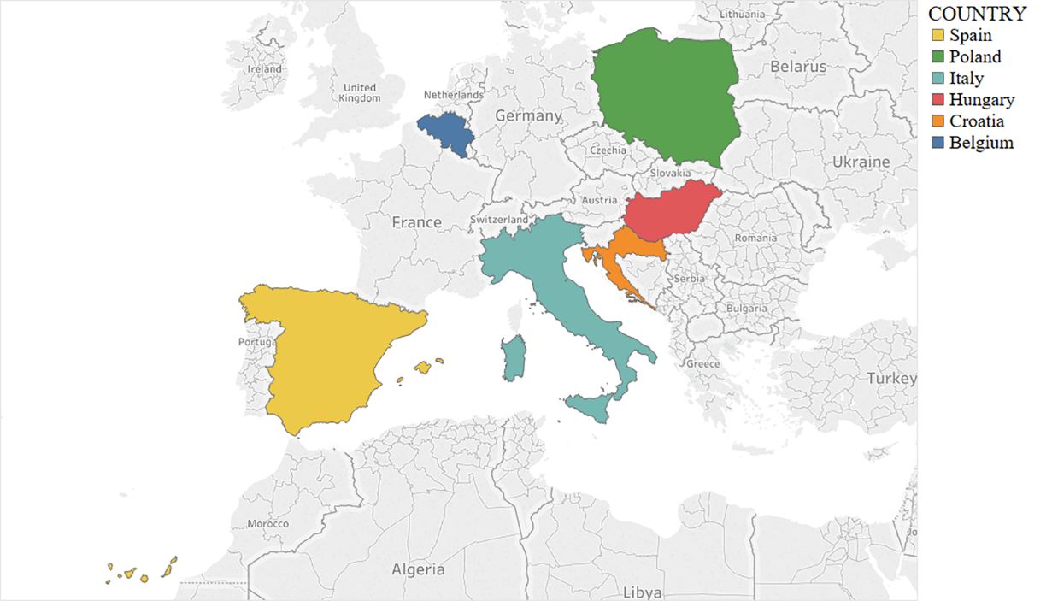

Supplementary Figure 3 Geographical location of the study area of this research

Supplementary Figure 4 PCA results of environmental attitudes. I1-I8: Item 1 to Item 8.

Full Questionnaire

(The questionnaire was conducted in the format of an online survey. Here we show an example of a questionnaire that was conducted in Italy and has been translated from the original Italian into English.)

Q1.1
Our project is working on innovative solutions at farm level, by applying the principles of the circular economy to agriculture. Accordingly, these farming systems include several technologies, solutions, and practices that improve the current cycle of Carbon, Nitrogen, Phosphorus, energy, and water. It focuses on the more efficient use of nutrients to improve animal feeding, to reduce residues and emissions, and to recover and reuse nutrients from biowaste.

Survey Objective:
The objective of this survey is to analyze consumers’ demand and willingness to pay a premium for pork, milk, and bread products obtained from sustainable circular systems.
Duration: The questionnaire will take approximately 15 minutes to complete.
Conditions:
The RESULTS of this SURVEY have the character of PUBLIC RESEARCH and all information collected will be treated CONFIDENTIALLY and strictly ANONYMOUSLY. Responses will NEVER be provided to third parties. Please note that if you CANNOT or DO NOT WANT to proceed, you MAY stop. Remember that you can exit the questionnaire without completing it and return to it at any time at the point where you left off. Your privacy and data protection in the survey is in line with GDPR regulation (2016/679 EC) including the right to access your data, to rectify them, to erase them, to restrict the processing, to data portability, and to object to processing.
Do you want to participate?
- I agree to participate
- I refuse to participate

Section 1 Socio-demographic Information

Q1.2 What is your gender?
- Male
- Female

Q1.3 What is your age?
- 18-24 years
- 25-34 years
- 35-44 years
- 45-54 years
- More than 55 years

Q1.4 How would you describe your current financial situation?

10
Very good
1
Very difficult
5

Q1.5 Does the level of your monthly income cover your household expenditure?
- Always
- Very Often
- Sometimes
- Rarely
- Never

Q1.6 What is your education level?
- Not completed elementary studies
- Elementary studies
- Secondary studies
- University studies

Q1.7 What is your current employment status?
- Student
- Self-employed/Business owner (full time)
- Employee (full time)
- Homemaker
- On sick leave
- Unemployed
- Retired
- Unable to work
- Others__________________________________________________

Q1.8 Who is mainly responsible for your household food shopping?
- Exclusively me
- Mostly me
- I and someone else
- Mostly someone else
- Exclusively someone else

Section 2 Open-ended Choice Experiments in 3 Cases

Case 1: Pork Loin

Q2.1 Do you eat pork?
- Yes
- No

Q2.2 Do you purchase pork?
- Yes
- No

OPEN-ENDED CHOICE EXPERIMENT PORK LOIN

Below you are presented with definitions of different farming systems and the definition of pork from circular farming. The pork loins are obtained from different production systems: Conventional farming, Organic farming, and Circular farming.
Conventional Farming. Livestock is housed, generally under constantly-controlled temperature, light, and humidity conditions. Livestock is mainly fed on feed and fodder. It uses high-performance breeds in meat production adapted to market demand and produces homogeneous products (cut, size, and volume) that satisfy large-scale marketing needs. It is governed by a general livestock regulation that regulates its operation in matters of food, hygiene, production and bans the use of growth hormones. The use of antibiotics in livestock farms is monitored and supervised. The use of drugs for disease control must be authorized and administered through veterinary prescription and must follow the principles of good veterinary practice.
Organic Farming. Livestock is raised following strict criteria of living conditions, medical treatment, and animal welfare. Livestock is fed with organic certificate fodder. GMO feedstuff cannot be used, and animals exceptionally can be treated with antibiotics. However, there is a longer quarantine for the products (meat) after treatment. Animals must have permanent access to outdoors and the space should maintain a low density of animals. The regulations place emphasis on improving animal welfare throughout their life span, controlling their transport and slaughter conditions.
Circular Farming. Animal husbandry produces not only meat, milk, and eggs but also manure, urine, heat, ammonia, methane, and CO2 which, if emitted uncontrolled, may lead to negative environmental impacts. These materials are often not used optimally and are by some farmers regarded as waste. As an alternative, in circular farming, livestock is raised under conventional farming conditions, but with the inclusion of the principles of the circular economy. Accordingly, these farming systems include several technologies, solutions, and farming practices to improve the recycling of Carbon, Nitrogen, Phosphorus, energy, and water by focusing on the use of nutrients more efficiently, improving animal feeding, reducing residues and emissions, and recovering and reusing nutrients from biowaste. In the case of pig farming, pig slurry and manure are treated to produce bio-energy (biogas) and bio-based fertilizers using a combination of techniques.

Q2.3
Below we present 5 purchase situations. On each occasion, THE SAME 3 types of sliced pork loin packs (500g each) are presented at different prices. HOWEVER, the price level of the organic and conventional loin remains FIXED (average market price) in all the purchase situations, while the price of the loin from circular farming MAY VARY across the purchase situations.
At the following given prices, HOW MANY units/packs (of 500g) from EACH LOIN TYPE would you buy in each purchase situation? (from 0 to 10 units/packs)

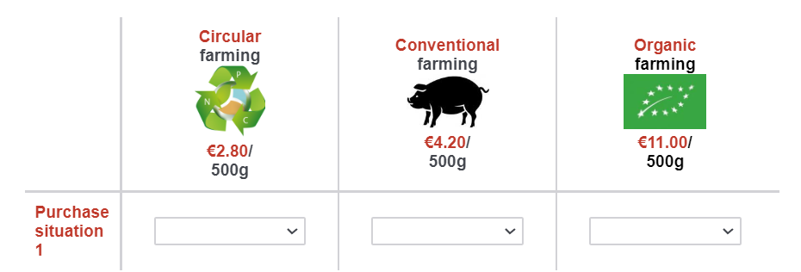

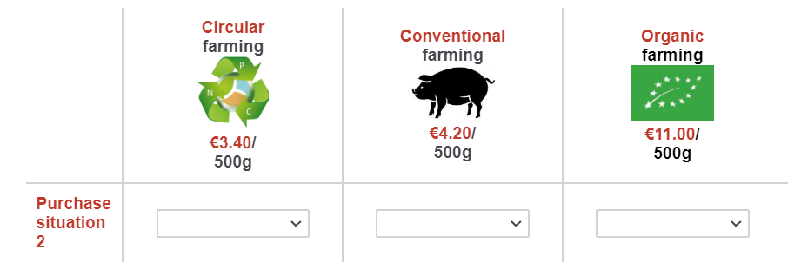
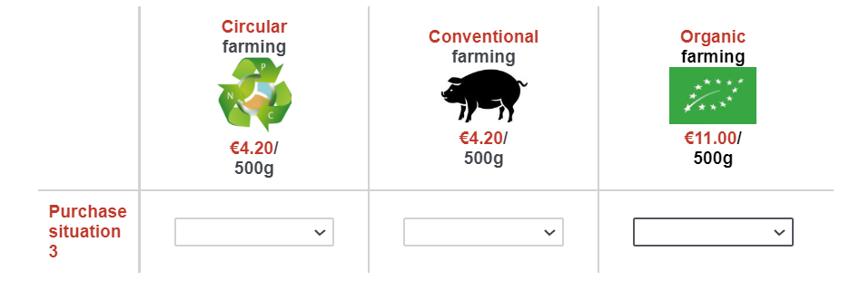
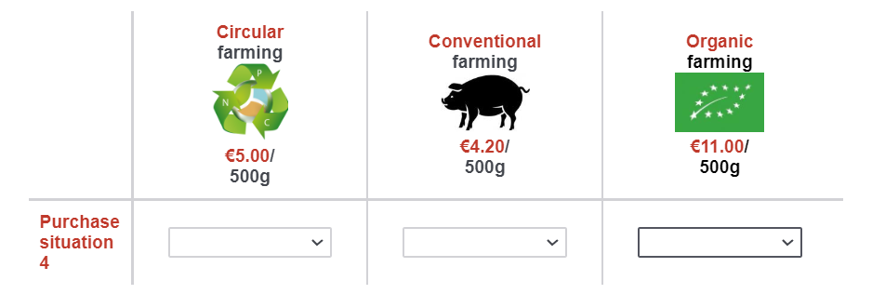
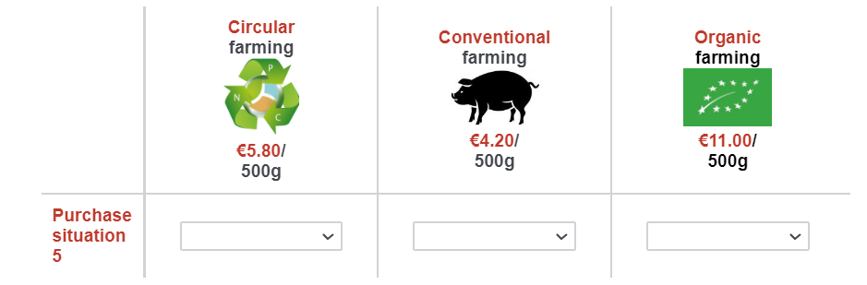

Case 2: Milk

Q2.4 Do you drink cows’ milk (any type)?
- Yes
- No

Q2.5 Do you purchase cows’ milk (any type)?
- Yes
- No

OPEN-ENDED CHOICE EXPERIMENT MILK
Below you are presented with definitions of the different farming systems and the definition of milk from circular farming. The MILK is obtained from different production systems: Conventional farming, Organic farming, and Circular farming.
Conventional Farming. Livestock is housed, generally under constantly-controlled temperature, light, and humidity conditions. Livestock is mainly fed on feed and fodder. It is governed by a general livestock regulation that regulates its operation in matters of food, hygiene, production and bans the use of growth hormones. The use of antibiotics in livestock farms is monitored and supervised. The use of drugs for disease control must be authorized and administered through veterinary prescription and must follow the principles of good veterinary practice.
Organic Farming. Livestock is raised following strict criteria of living conditions, medical treatment, and animal welfare. Cattle are usually pastured outdoors during the day and kept in stables at night or during calving. GMO feedstuff cannot be used, and animals exceptionally can be treated with antibiotics. However, there is a longer quarantine for the products (milk, meat) after treatment. Animals must have permanent access to outdoors and the space should maintain a low density of animals. The regulations place emphasis on improving animal welfare throughout their life span, controlling their transport and slaughter conditions.
Circular Farming. Animal husbandry produces not only meat, milk, and eggs but also manure, urine, heat, ammonia, methane, and CO2, which if emitted uncontrolled may lead to negative environmental impacts. These materials are often not used optimally and are by some farmers regarded as waste. As an alternative, in circular farming, livestock is raised under conventional farming conditions, but with the inclusion of the principles of the circular economy. Accordingly, these farming systems include several technologies, solutions, and farming practices to improve the recycling of Carbon, Nitrogen, Phosphors, energy, and water by focusing on the use of nutrients more efficiently, improve animal feeding, reduce residues and emissions, recover and reuse nutrients from biowaste. In the case of cattle farming, the dairy farm uses wastewater to produce Algae as a new source of protein (animal feeding) and the milk industry uses dairy processing residues to produce fertilizer and build soil fertility.

Q2.6
Below we present 5 purchase situations. On each occasion, THE SAME 3 types of Milk packs (1 liter/pack) are presented at different prices. HOWEVER, the price level of the organic and conventional milk remains FIXED (average market price) in all the purchase situations, and the price of the milk from circular farming MAY VARY across the purchase situations.
Considering that the milks presented in the following purchase situations are the same that you usually purchase, at the following given prices, HOW MANY liters from the different production systems would you buy in each one-time purchase occasion? (from 0 to 24 liters/packs)
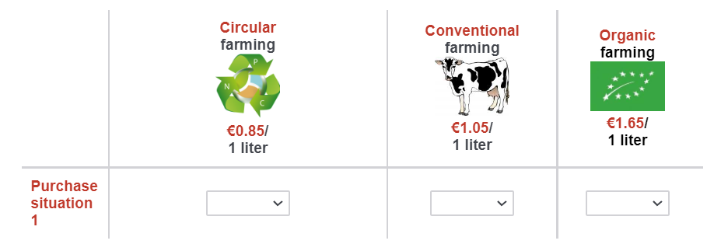
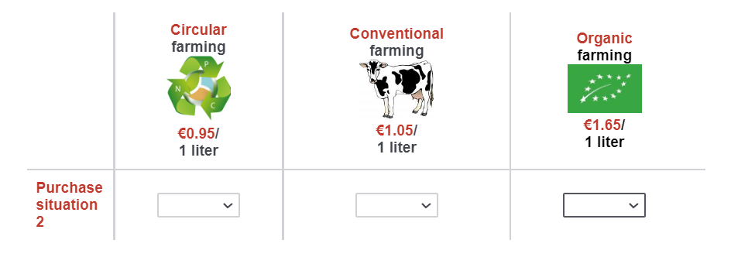
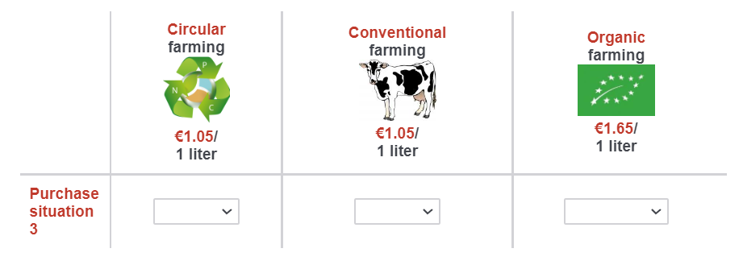
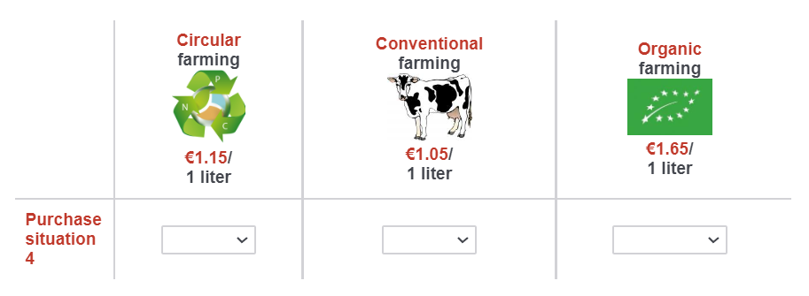
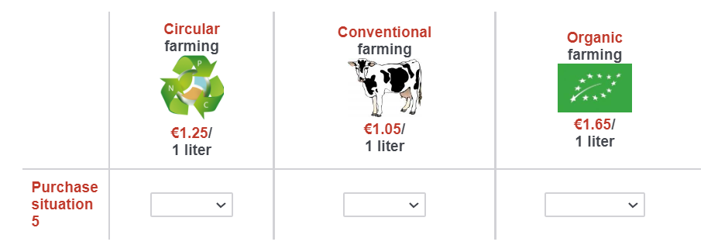

Case 3: Sliced Bread

Q2.7 Do you consume sliced bread?
- Yes
- No

Q2.8 Do you purchase sliced bread?
- Yes
- No

OPEN-ENDED CHOICE EXPERIMENT SLICED BREAD
Below you are presented with definitions of the different farming systems and the definition of bread from circular farming. The SLICED BREAD packs are produced with wheat flour obtained from different production systems: Conventional farming, Organic farming, and Circular farming.
Conventional Farming. The bread-quality wheat used for flour to produce the bread are improved varieties obtained from traditional breeding methods, excluding biotechnology (GMO). These varieties have higher yields, greater pest and disease resistance, and larger seeds. It is a type of variety adapted to market demand and produces a homogeneous crop (e.g., grain protein-content) and flour quality (e.g., bread-volume index) that satisfy large-scale marketing needs. The use of synthetic phytosanitary treatments (pesticides) and chemical fertilizers are allowed.
Organic Farming. The cultivation of organic bread-wheat requires the application of specific certified organic practices and production rules. The use of genetically-modified organisms (GMO) and seed radiation (for removal of seed-borne diseases and pests) are strictly prohibited. The use of synthetic phytosanitary treatments (pesticides) and chemical fertilizers are banned or severely limited; however, the use of organic fertilisers (e.g., manures) approved for organic farming is permitted, though only within certain application limits. Preventive methods for insect and disease control are allowed, including crop rotation, and the use of resistant and genetically-improved varieties with traditional breeding methods.
Circular Farming. Production of bread-wheat here consists of using the agricultural biomass (e.g., animal manure, crop residues) and processing waste and by-products of the food industry as renewable resources. Recycling, reusing, and reducing losses to the environment are three key factors for circular agriculture. This farming system is considered multifunctional by producing both food, feed and different organic residues that can be used as fodder for livestock, bio-based fertilisers or as a source of bio-energy. In the case of bread, cereals are cultivated using crop management systems that increase soil fertility and organic matter content by adopting crop rotations, cover crops and no-tillage practices, and the crops are fertilized with recycled, bio-based fertilizers.

Q2.9
Below we present 5 purchase situations. On each occasion, THE SAME 3 types of Sliced Bread packs (450g each) are presented at different prices. HOWEVER, the price level of the organic and conventional Sliced Bread packs remains FIXED (average market price) in all the purchase situations and the price of the Sliced Bread packs from circular farming MAY VARY across the purchase situations.
At the following given prices, how many units/packs from EACH BREAD TYPE would you buy in each purchase situation? (from 0 to 10 units/packs)

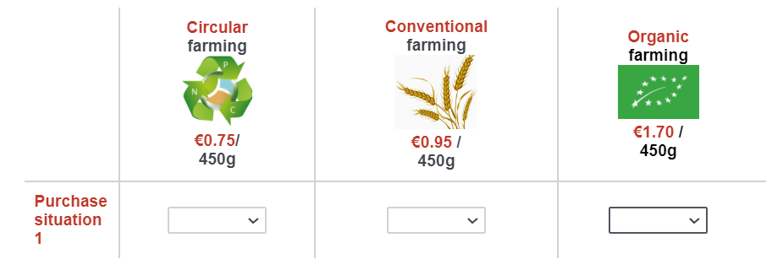
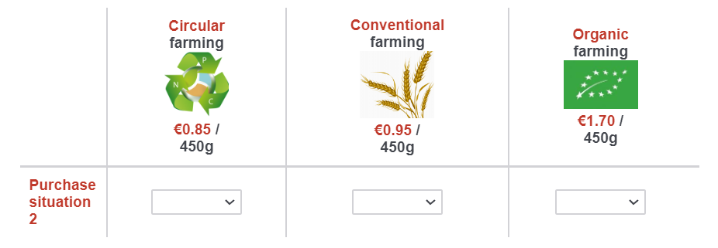
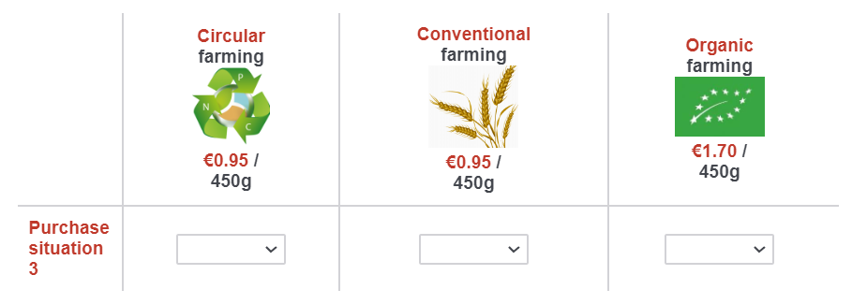
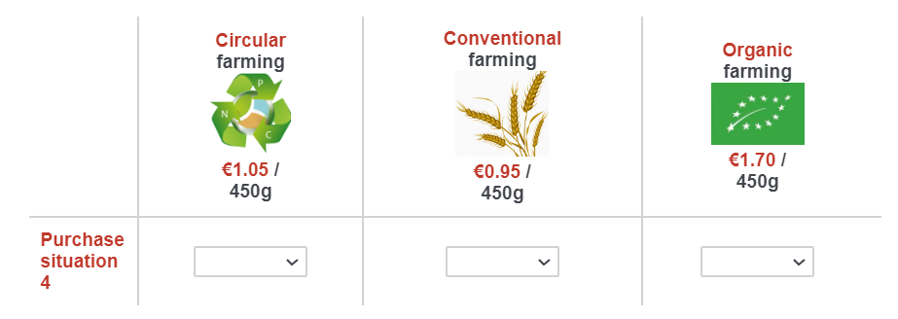
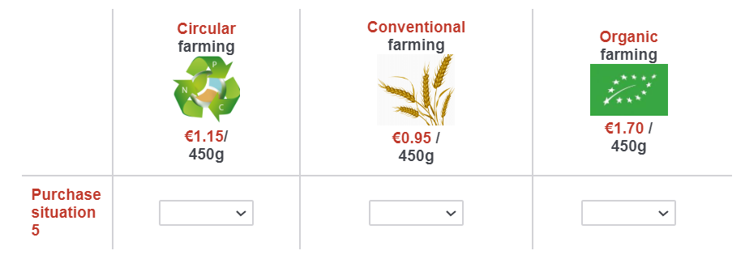

Section 3 Environmental Attitudes

Q3.1 How much do you agree or disagree with the following statements?

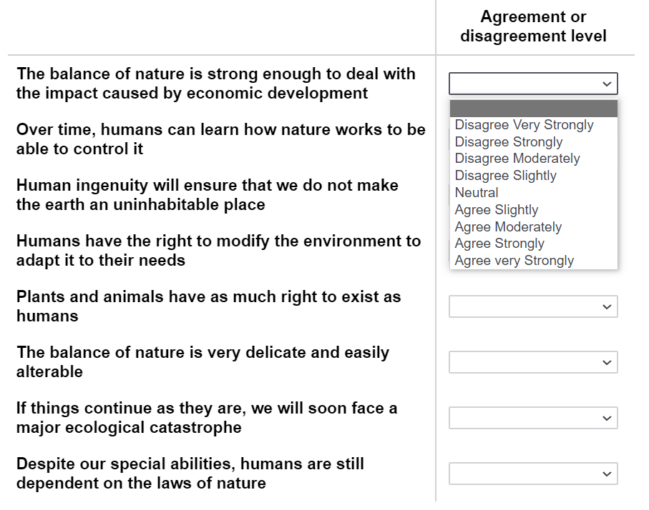

Section 4 Opinions on the Sustainability of Different Production Systems and Dietary Patterns

Q4.1 In your opinion, what impact do the following farming systems have on the environment?

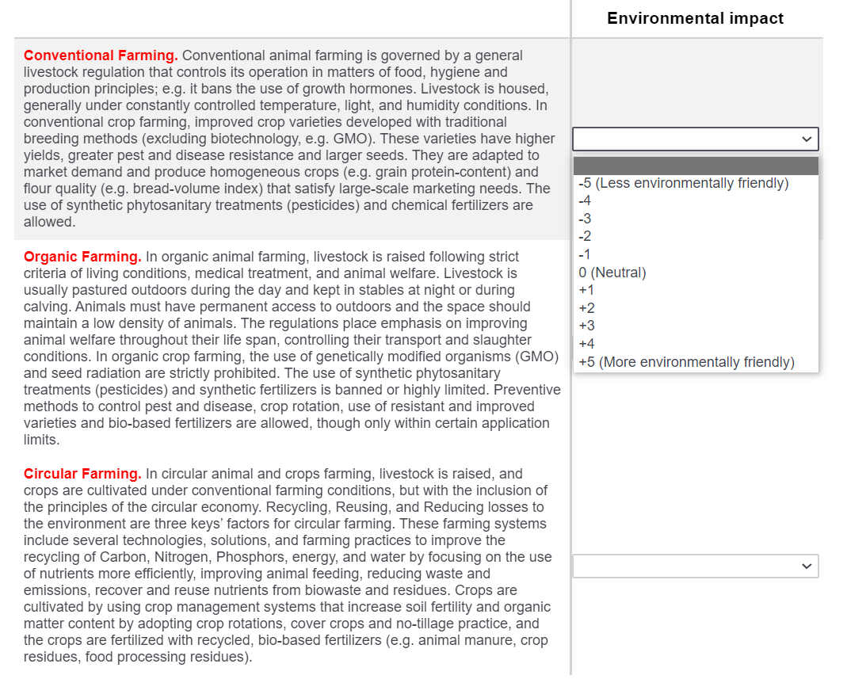

Q4.2 In your opinion, based on your understanding of what Environmental Sustainability means, what level of environmental sustainability do the following dietary patterns have?

Vegetarian (It consists of not consuming meat or fish. The basis of this diet is vegetables, legumes, fruits, cereals, seeds, and nuts. It also includes the consumption of animal products such as dairy (yogurt, milk, cheese) |  | 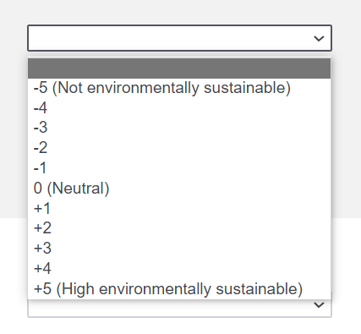
Vegan (It consists of not consuming any food of animal origin, such as meat, fish, eggs, or dairy)
Flexitarian (It consists of increasing the consumption of vegetables and fruits, and reducing the consumption of animal meats)
Non-restricted diet (It consists of consuming any animal or non-animal food without any restriction)

The survey has ended. Thank you for your participation!

