Supplementary Information for
Quick response auto-coding and recognition via microlaser array
Hongrui Shan^{1,#}, Qiheng Wei^{1,#}, Hailang Dai^{1,#,*},Xueqian Wang², Hong Yang¹,and Xianfeng Chen^{1,3*}
¹ State Key Laboratory of Advanced Optical Communication Systems and Networks, School of Physics and Astronomy, Shanghai Jiao Tong University, Shanghai 200240, China
²State Key Lab of Metal Matrix Composites, Shanghai Key Laboratory for Molecular Engineering of Chiral Drugs, School of Materials Science and Engineering, Shanghai Jiao Tong University, Shanghai 200240, China
³Collaborative Innovation Center of Light Manipulations and Applications, Shandong Normal University, Jinan 250358, China
# These authors contributed equally to this work.
*e-mail: hailangdai@sjtu.edu.cn; xfchen@sjtu.edu.cn;

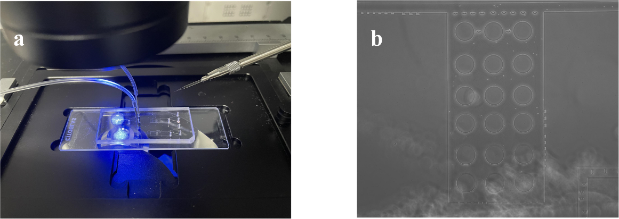
Fig. S1. The PDMS microfluidic chips in experiment. a The microfluidic chip mounted on a reverted fluorescence microscope. b Internal partial magnified image of the microchannel.

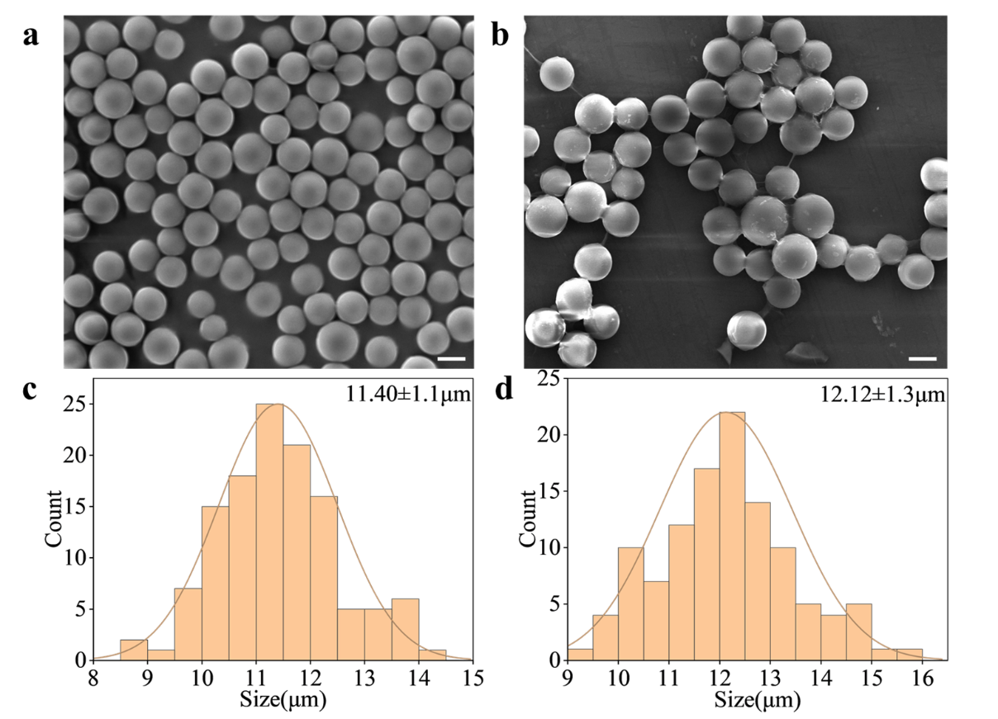
Fig. S2. Information of PS microspheres. a SEM images of uncoated PS microspheres. b SEM images of coated PS microspheres with rosin acid. c, d Particle size distribution of microspheres with and without coating, respectively. Scale bar, 5 $μm$.

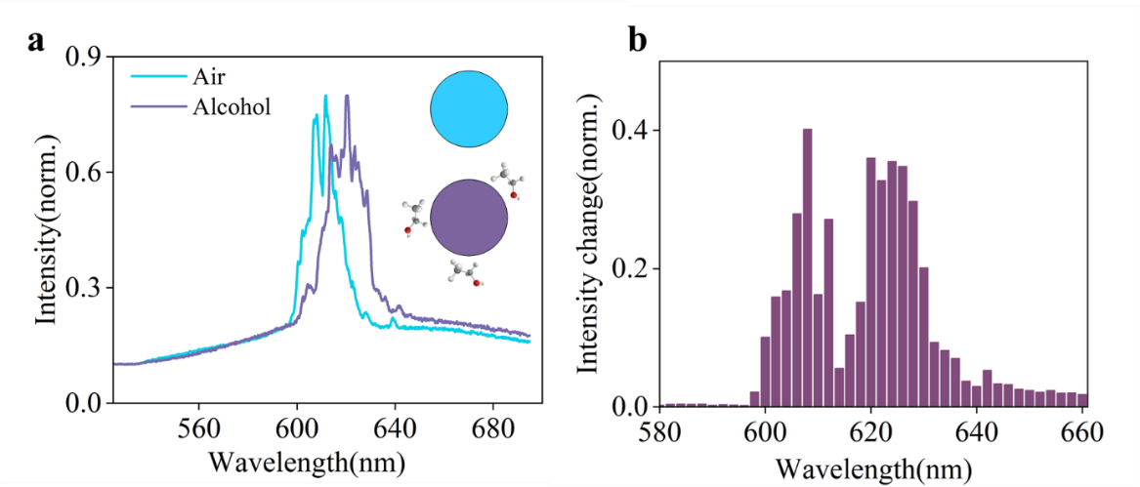
Fig. S3. The sensing ability of WGM lasing based on microsphere. a Comparison of lasing spectra of same microsphere with air and pure alcohol condition. b The spectral intensity difference between alcohol and air in the range of 580-660nm.

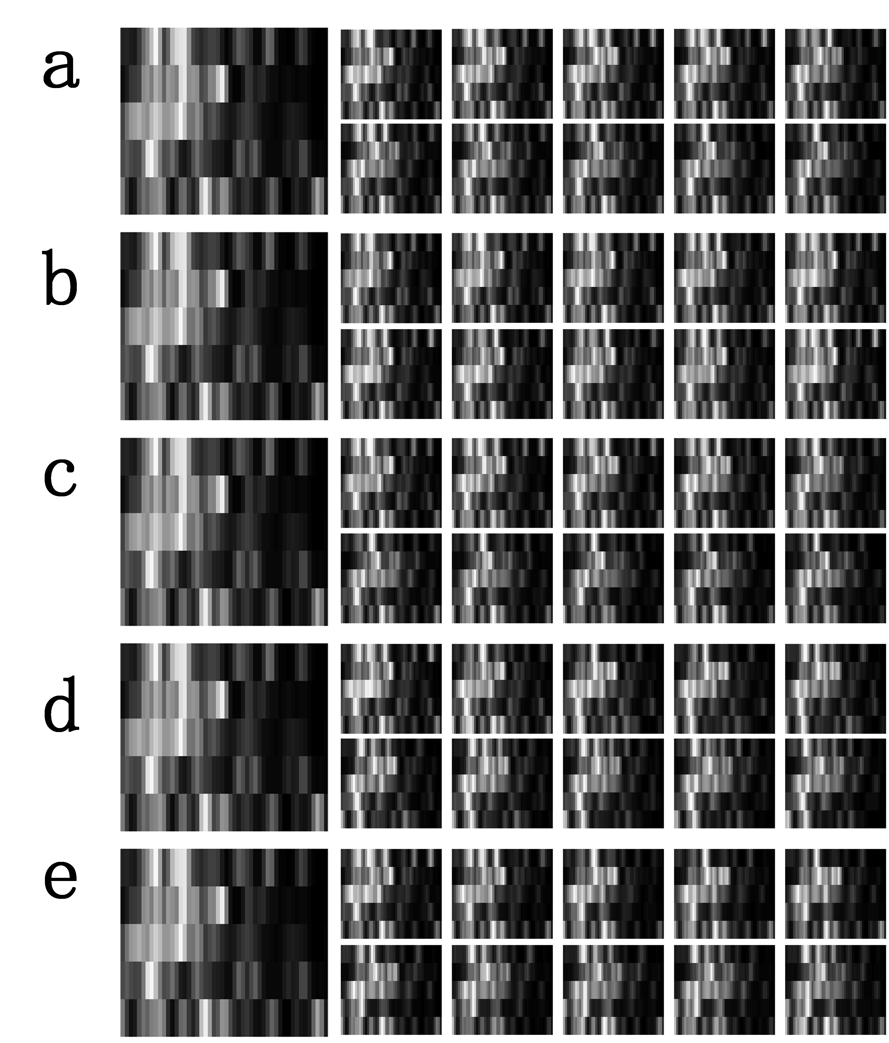
Fig. S4. GV-QR codes with change of concentration of a single vapor. The large image on the left corresponds to the initial concentration (DCE: 10%, ISO:10%, TOL:10%, TBP:10%, and BTL:10%). a In the case where the concentration of the other 4 vapors remained constant, the concentration of DEC was 12, 14, 16, 18, 20, 22, 24, 26, 28, and 30respectively. b, c, d, e Same as in case a, but the changing gases are ISO, TOL, TBP, and BTL.

Fig. S5. GV-QR codes with change of concentration of 2 vapors. The change of concentrations of the 5 vapors (DCE, ISO, TOL, TBP, and BTL) corresponding to each GV-QR codes are as follows:
a1 10% 10% 10% 10% 10%
a2 10% 12% 10% 10% 10%
a3 10% 14% 10% 10% 10%
a4 10% 16% 10% 10% 10%
a5 10% 18% 10% 10% 10%
a6 10% 20% 10% 10% 10%
a7 10% 22% 10% 10% 10%
a8 10% 24% 10% 10% 10%
a9 10% 26% 10% 10% 10%
a10 10% 28% 10% 10% 10%
a11 10% 30% 10% 10% 10%
a12 12% 10% 10% 10% 10%
a13 12% 12% 10% 10% 10%
a14 12% 14% 10% 10% 10%
a15 12% 16% 10% 10% 10%
a16 12% 18% 10% 10% 10%
a17 12% 20% 10% 10% 10%
a18 12% 22% 10% 10% 10%
a19 12% 24% 10% 10% 10%
a20 12% 26% 10% 10% 10%
a21 12% 28% 10% 10% 10%
a22 12% 30% 10% 10% 10%
a23 14% 10% 10% 10% 10%
a24 14% 12% 10% 10% 10%
a25 14% 14% 10% 10% 10%
a26 14% 16% 10% 10% 10%
a27 14% 18% 10% 10% 10%
a28 14% 20% 10% 10% 10%
a29 14% 22% 10% 10% 10%
a30 14% 24% 10% 10% 10%
a31 14% 26% 10% 10% 10%
a32 14% 28% 10% 10% 10%
a33 14% 30% 10% 10% 10%
a34 16% 10% 10% 10% 10%
a35 16% 12% 10% 10% 10%
a36 16% 14% 10% 10% 10%
a37 16% 16% 10% 10% 10%
a38 16% 18% 10% 10% 10%
a39 16% 20% 10% 10% 10%
a40 16% 22% 10% 10% 10%
a41 16% 24% 10% 10% 10%
a42 16% 26% 10% 10% 10%
a43 16% 28% 10% 10% 10%
a44 16% 30% 10% 10% 10%
a45 18% 10% 10% 10% 10%
a46 18% 12% 10% 10% 10%
a47 18% 14% 10% 10% 10%
a48 18% 16% 10% 10% 10%
a49 18% 18% 10% 10% 10%
a50 18% 20% 10% 10% 10%
a51 18% 22% 10% 10% 10%
a52 18% 24% 10% 10% 10%
a53 18% 26% 10% 10% 10%
a54 18% 28% 10% 10% 10%
a55 18% 30% 10% 10% 10%
a56 20% 10% 10% 10% 10%
a57 20% 12% 10% 10% 10%
a58 20% 14% 10% 10% 10%
a59 20% 16% 10% 10% 10%
a60 20% 18% 10% 10% 10%
a61 20% 20% 10% 10% 10%
a62 20% 22% 10% 10% 10%
a63 20% 24% 10% 10% 10%
a64 20% 26% 10% 10% 10%
a65 20% 28% 10% 10% 10%
a66 20% 30% 10% 10% 10%
a67 22% 10% 10% 10% 10%
a68 22% 12% 10% 10% 10%
a69 22% 14% 10% 10% 10%
a70 22% 16% 10% 10% 10%
a71 22% 18% 10% 10% 10%
a72 22% 20% 10% 10% 10%
a73 22% 22% 10% 10% 10%
a74 22% 24% 10% 10% 10%
a75 22% 26% 10% 10% 10%
a76 22% 28% 10% 10% 10%
a77 22% 30% 10% 10% 10%
a78 24% 10% 10% 10% 10%
a79 24% 12% 10% 10% 10%
a80 24% 14% 10% 10% 10%
a81 24% 16% 10% 10% 10%
a82 24% 18% 10% 10% 10%
a83 24% 20% 10% 10% 10%
a84 24% 22% 10% 10% 10%
a85 24% 24% 10% 10% 10%
a86 24% 26% 10% 10% 10%
a87 24% 28% 10% 10% 10%
a88 24% 30% 10% 10% 10%
a89 26% 10% 10% 10% 10%
a90 26% 12% 10% 10% 10%
a91 26% 14% 10% 10% 10%
a92 26% 16% 10% 10% 10%
a93 26% 18% 10% 10% 10%
a94 26% 20% 10% 10% 10%
a95 26% 22% 10% 10% 10%
a96 26% 24% 10% 10% 10%
a97 26% 26% 10% 10% 10%
a98 26% 28% 10% 10% 10%
a99 26% 30% 10% 10% 10%
a100 28% 10% 10% 10% 10%
a101 28% 12% 10% 10% 10%
a102 28% 14% 10% 10% 10%
a103 28% 16% 10% 10% 10%
a104 28% 18% 10% 10% 10%
a105 28% 20% 10% 10% 10%
a106 28% 22% 10% 10% 10%
a107 28% 24% 10% 10% 10%
a108 28% 26% 10% 10% 10%
a109 28% 28% 10% 10% 10%
a110 28% 30% 10% 10% 10%
a111 30% 10% 10% 10% 10%
a112 30% 12% 10% 10% 10%
a113 30% 14% 10% 10% 10%
a114 30% 16% 10% 10% 10%
a115 30% 18% 10% 10% 10%
a116 30% 20% 10% 10% 10%
a117 30% 22% 10% 10% 10%
a118 30% 24% 10% 10% 10%
a119 30% 26% 10% 10% 10%
a120 30% 28% 10% 10% 10%
a121 30% 30% 10% 10% 10%

Fig. S6. Tests for detection and identification of 10 sets of mixed gases. The concentration of the input mixed vapors (DCE, ISO, TOL, TBP, and BTL, respectively) is displayed on the right-hand side of each QR code, while the concentration of the output is displayed below. The table contains the errors for the 10 sets of tests.

Table 1 Detailed testing results of 10 sets of mixed vapors
Test Num. | Input | Output | Error
T1 | 14.50% 10.60% 10.00% 10.00% 10.00% | 14.35% 10.74% 9.98% 9.93% 9.89% | 0.15% -0.14% 0.02% 0.07% 0.11%
T2 | 11.60% 11.20% 10.00% 10.00% 10.00% | 11.77% 11.14% 9.70% 10.07% 9.88% | -0.17% 0.06% 0.30% -0.07% 0.12%
T3 | 12.80% 13.60% 10.00% 10.00% 10.00% | 13.05% 13.69% 9.68% 10.08% 10.04% | -0.25% -0.09% 0.32% -0.08% -0.04%
T4 | 12.60% 11.60% 10.00% 10.00% 10.00% | 12.55% 11.67% 9.70% 10.02% 9.96% | 0.05% -0.07% 0.30% -0.02% 0.04%
T5 | 12.30% 13.10% 10.00% 10.00% 10.00% | 12.14% 12.81% 10.24% 10.09% 9.99% | 0.16% 0.29% -0.24% -0.09% 0.01%
T6 | 15.20% 10.00% 10.00% 10.00% 10.00% | 14.78% 9.70% 10.29% 10.04% 9.89% | 0.42% 0.30% -0.29% -0.04% 0.11%
T7 | 12.40% 10.00% 10.00% 10.00% 10.00% | 12.07% 9.67% 10.43% 10.03% 9.93% | 0.33% 0.33% -0.43% -0.03% 0.07%
T8 | 13.60% 10.00% 10.00% 10.00% 10.00% | 13.75% 10.45% 9.74% 9.93% 9.87% | -0.15% -0.45% 0.26% 0.07% 0.13%
T9 | 17.00% 10.00% 10.00% 10.00% 10.00% | 17.14% 9.86% 9.72% 10.10% 9.92% | -0.14% 0.14% 0.28% -0.10% 0.08%
T10 | 20.00% 10.00% 10.00% 10.00% 10.00% | 20.24% 10.05% 9.57% 9.97% 9.93% | -0.24% -0.05% 0.43% 0.03% 0.07%

The artificial neural network
The artificial neural network consists of three layers, the input layer, hidden layer and output layer. A vector of data $X^{1}$ generated by the GV-QR code is entered into the input layer and dealt with a weight matrix $W^{1}$.

$$U^{1}=W^{1}*X^{1}$$
Then an activation function $σ_{1}$ is used to generate $X^{2}$.
$$X^{2}=σ_{1}(U^{1})$$
Finally, with weight matrix $W^{2}$ and activation function $σ_{2}$, we can get the gas composition vector Y form the output layer.
$$U^{3}={ W}^{2}*X^{2}$$
$$Y=σ_{2}(U^{3})$$

Other supporting information attachments（separate file）
A1 and A2 The videos titled "A1_One vapor change" and "A2_Two vapors change" show the GV-QR codes undergoing changes in response to the presence of one or two different vapors, respectively.
A3 and A4 Excel files containing two matrices named “A3_Matrix_m” and “A4_Matrix_n”, respectively, which include the results of neural network learning.
Fig. S4_55figures in detail 55 separate images corresponding to Fig. S4
Fig. S5_121figures in detail 121 separate images corresponding to Fig. S5

