Supplemental Table 1. Abbreviation
Abbreviation | Full name
METTL3 | methyltransferase 3
METTL14 | methyltransferase 14
WTAP | Wilms Tumor 1 associated protein
ALKBH5 | alkB homolog 5
FTO | fat mass and obesity associated
RBP | RNA-Binding Protein
YTHDF | YTH domain family
IGF2BPs | insulin-like growth factor 2 mRNA binding proteins
TUG1 | taurine upregulated gene 1
DMEM | dulbecco’s modified eagle’s medium
FBS | Fetal bovine serum
LncRNA | long non-coding RNA
PBS | phosphate buffer solution
RT-qPCR | Real Time Quantitative polymerase chain reaction
ATCC | American type culture collection
RIP | RNA immunoprecipitation
Act D | actinomycin D
PGC-1α | peroxisome proliferators-activatedreceptor γcoactivator 1 alpha
ROS | reactive oxygen species
Nrf1 | Nuclear Respiratory Factor 1
Nrf2 | Nuclear Respiratory Factor 2
TFAM | Mitochondrial transcription factor A
KW | Kidney Weight
ALB | Albumin
CRE | Creatinine
BUN | Blood Urea Nitrogen
TEM | Transmission electron microscope
rAAV | recombinant Adeno-Associated virus
MTF3212/R3319 | mitochondrial forward primer from nucleotide 3212 and reverse primer from nucleotide 3319
MT-ND1 | mitochondrial encoded NADH dehydrogenase 1
RPLP0 | acidic ribosomal phosphoprotein

Supplemental Table 2. Primer sequences
Gene | Forward (5'->3') | Reverse (5'->3')
β-actin（Human） | CATGTACGTTGCTATCCAGGC | CTCCTTAATGTCACGCACGAT
METTL3（Human） | AGATGGGGTAGAAAGCCTCCT | TGGTCAGCATAGGTTACAAGAGT
METTL14（Human） | AGTGCCGACAGCATTGGTG | GGAGCAGAGGTATCATAGGAAGC
FTO（Human） | ACTTGGCTCCCTTATCTGACC | TGTGCAGTGTGAGAAAGGCTT
YTHDF1（Human） | ATACCTCACCACCTACGGACA | GTGCTGATAGATGTTGTTCCCC
YTHDF2（Human） | AGCCCCACTTCCTACCAGATG | TGAGAACTGTTATTTCCCCATGC
IGF2BP2（Human） | AGTGGAATTGCATGGGAAAATCA | CAACGGCGGTTTCTGTGTC
lncRNA TUG1(Human) | TAGCAGTTCCCCAATCCTTG | CACAAATTCCCATCATTCC
PGC-1α(Human) | TCTGAGTCTGTATGGAGTGACAT | CCAAGTCGTTCACATCTAGTTCA
Nrf1(Human) | AAACGGCCTCATGTATTTGAGT | TAACGTGGCTCGAAGTTTCCG
Nrf2(Human) | TTCCCGGTCACATCGAGAG | TCCTGTTGCATACCGTCTAAATC
TFAM(Human) | ATGGCGTTTCTCCGAAGCAT | TCCGCCTATAAGCATCTTGA
MTF3212/R3319(Human) | CACCCAAGAACAGGGTTTGT | TGGCCATGGGTATGTTGTTAA
MT-ND1(Human) | ATGGCCAACCTCCTACTCCT | CTACAACGTTGGGGCCTTT
RPLP0(Human) | CAGCAAGTGGGAAGGTGTAATCC | CCCATTCTATCATCAACGGGTACAA
β-actin(Mouse) | GGCTGTATTCCCCTCCATCG | CCAGTTGGTAACAATGCCATGT
METTL3(Mouse) | CTGGGCACTTGGATTTAAGGA | TGAGAGGTGGTGTAGCAACTT
IGF2BP2(Mouse) | GTCCTACTCAAGTCCGGCTAC | CATATTCAGCCAACAGCCCAT
lncRNA TUG1(Mouse) | CTCTGGAGGTGGACGTTTTGT | GTGAGTCGTGTCTCTCTTTTCTC
PGC-1α(Mouse) | TATGGAGTGACATAGAGTGCT | CCACTTCAATCCACCCAGAAAG
Nrf1(Mouse) | AGCACGGAGTGACCCAAAC | TGTACGTGGCTACATGGACCT
Nrf2(Mouse) | CTTTAGTCAGCGACAGAAGGAC | AGGCATCTTGTTTGGGAATGTG
TFAM(Mouse) | ATTCCGAAGTGTTTTTCCAGCA | TCTGAAAGTTTTGCATCTGGGT
MT-CytB(Mouse) | GTGAACGATTGCTAGGGCC | CGATTCTTCGCTTTCCACTTCAT
MT-ND1(Mouse) | CTCTTATCCACGCTTCCGTTACG | GATGGTGGTACTCCCGCTGTA
MT-H19(Mouse) | GTACCCACCTGTCGTCC | GTCCACGAGACCAATGACTG

Supplemental Table 3. RNase Mazf PCR Primers sequence
Gene | Primer sequence | Annealing Tempreture(℃) | Product Length(bp)
lncRNA TUG1-2047 | F:5’GATTAGATGTTAGCCAGTTATGC3’  R:5’AAGTCTTTTGAGGTACATCCG3’ | 60 | 179
lncRNA TUG1-2391 | F:5’CTGGAACCCGAAAGAGCTTG3’  R:5’CTGGTGGTAGTGCTTGCTCA3’ | 60 | 130
lncRNA TUG1-4944 | F:5’GCAGGAAGGATTCAGTTTAT3’  R:5’TTCATTCGAGTAGCTCAGGAT3’ | 60 | 135
lncRNA TUG1-5628 | F:5’GATTACCAAAGAAAGTAGGGC3’  R:5’AGTCTATGCTACATCTGGGAGT3’ | 60 | 77

Supplemental Table 4. RIP Primer sequence
 | Primer sequence
lncRNA TUG1 Primer 1 | F:5’TAGCAGTTCCCCAATCCTTG3’  R:5’CACAAATTCCCATCATTCC3’
lncRNA TUG1Primer 2 | F:5’CTGACCCTCTCCGCCATTTA3’  R:5’TCGATTTAGGGGCCTGACTC3’
lncRNA TUG1 Primer 3 | F:5’TGGTGACACCTAAGGGGACT3’  R:5’TGAACTGTGCTGAGTGGAGG3’

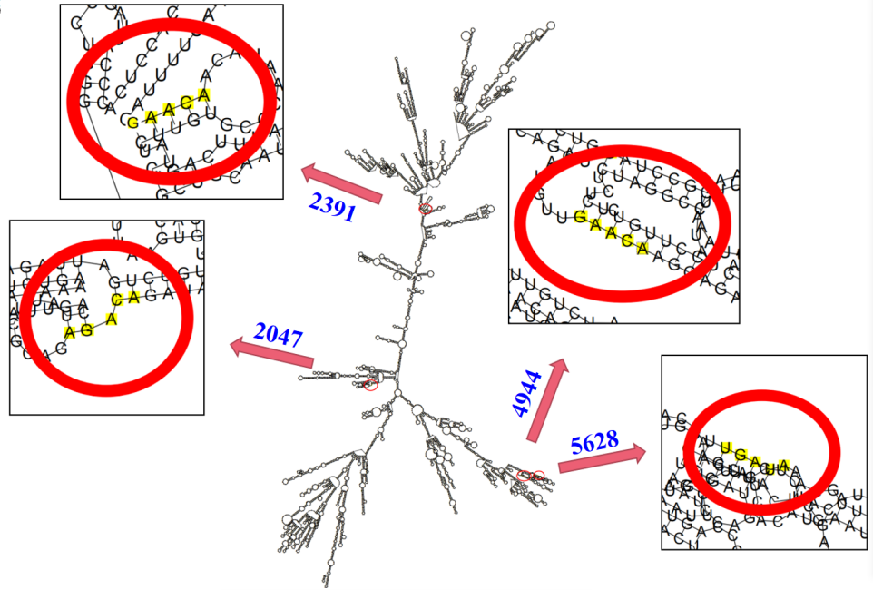
Supplemental Fig1. RNA clustering analysis of single-alkali and alkaline-based m⁶A modification. (B)Secondary structure of TUG1( using RNAfold webserver predict http://rna.tbi.univie.ac.AT/).

