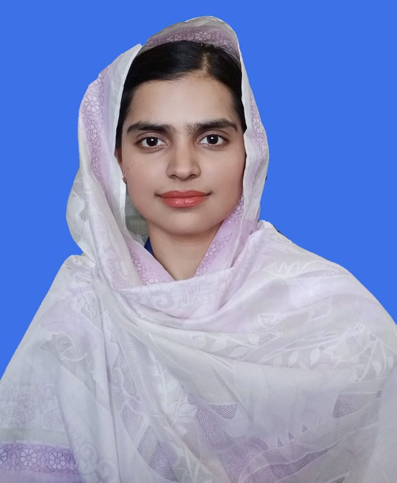

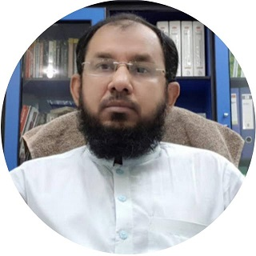

Engr. Rabail Memon received the Bachelor of Engineering degree in Electrical Engineering from Mehran University of Engineering and Technology Jamshoro in 2016. She received the Master of Engineering degree in Electrical Power Engineering from Mehran University of Engineering and Technology Jamshoro in 2018. She is doing a PhD in Electrical Engineering at Mehran University of Engineering and Technology Jamshoro. She is currently working as Lecturer in the department of Electrical Engineering MUET Jamshoro. Her areas of interest are renewable energy, Modeling and Simulation of Power Electronic Converters, and DC-DC Converter.She can be contacted at email: rabail.memon@faculty.muet.edu.pk

Prof. Dr. Mukhtiar Ahmed Mahar received the Bachelor of Engineering degree in Electrical Engineering from Mehran University of Engineering and Technology Jamshoro. He received the Master of Engineering degree in Electrical Power Engineering from Mehran University of Engineering and Technology Jamshoro. He received the Doctorate in Power Electronics & control from Mehran University of Engineering and Technology Jamshoro. He is currently working as Professor in the department of Electrical Engineering MUET Jamshoro. His areas of interest are Modeling and Simulation of Power Electronic Converters, Neural Network Control Power Electronic Converters, Flexible AC Transmission System (FACTS), Power Quality and Control of Electrical Machines. He has published his research work in many international journals and international conferences. He can be contacted at email: mukhtiar.mahar@faculty.muet.edu.pk

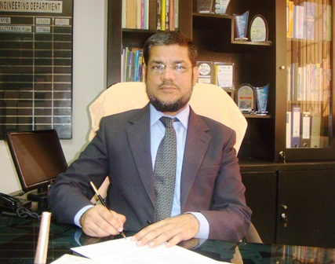

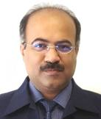

Prof. Dr. Abdul Sattar Larik received the Bachelor of Engineering degree in Electrical Engineering from Mehran University of Engineering and Technology Jamshoro. He received the Master of Engineering degree in Electrical Power Engineering from Mehran University of Engineering and Technology Jamshoro. He received the Doctorate in Electrical Engineering from Mehran University of Engineering and Technology Jamshoro. He is currently working as Professor in the department of Electrical Engineering and Dean Faculty of Sciences Technology & Humanities MUET Jamshoro. His areas of interests are power Semiconductor Devices, Sliding Mode Control, DC-DC Converter Topologies Control, Modeling and Simulation, Soft-switching Techniques, FACTS, Switch Mode Power Supplies (SMPS), Power Quality, converter control, modeling, and simulation. He Published 17 international paper,25 national and 15 conference papers. He can be contacted at email: sattar.larik@faculty.muet.edu.pk

Prof. Dr. Syed Asif Ali Shah received the Bachelor of Engineering degree in Electrical Engineering from Mehran University of Engineering and Technology Jamshoro in 1993. He received the Master of Engineering degree in Communication System and Networks from Mehran University of Engineering and Technology Jamshoro in 2004. He received the Doctorate in Stochastic Modeling from TUWIEN, Austria in 2010. He is currently working as Professor in the department of Electrical Engineering MUET Jamshoro. His areas of interest are Sustainable and Alternative Energy, Smart and Micro Grids, Distributed Generation, Electrical Power Transmission and Distribution and Performance Modeling of Networks. He has published his research work in many international journals and international conferences. He can be contacted at email: asif.shah@faculty.muet.edu.pk

