Table 1. Summary of models estimating the relationship between sex (model 1 and 2) and body mass (models 3 and 4) with tick loads in yellow-necked mice (Apodemus flavicollis). The Intercept corresponds to tick loads in female mice in August 2018. Sex M indicates the change in tick abundance for male hosts relative to females, Mass signifies the change in tick abundance per one gram increase in host body mass, Month June and Month July represent changes in tick abundance compared to August, and Year 2019 and Year 2020 denote changes in tick abundance relative to year 2018.
 | Model 1 (all) |  |  |  | Model 2 (paired) |  |  |  | Model 3 (only males) |  |  |  |  | Model 4 (only females)
Predictors | β | SE | z | p | β | SE | z | p | β | SE | z | p | β |  | SE | z | p
(Intercept) | 3.00 | 0.08 | 36.01 | <0.001 | 3.10 | 0.10 | 29.83 | <0.001 | 2.58 | 0.14 | 18.96 | <0.001 | 2.53 |  | 0.16 | 15.38 | <0.001
Sex M | 0.22 | 0.04 | 4.95 | <0.001 | 0.08 | 0.05 | 1.48 | 0.138
Mass |  |  |  |  |  |  |  |  | 0.02 | 0.00 | 6.30 | <0.001 | 0.02 |  | 0.00 | 3.76 | <0.001
Month July | 0.38 | 0.04 | 9.25 | <0.001 | 0.38 | 0.07 | 5.56 | <0.001 | 0.40 | 0.06 | 7.00 | <0.001 | 0.48 |  | 0.06 | 7.96 | <0.001
Month June | 0.64 | 0.06 | 11.07 | <0.001 | 0.54 | 0.09 | 6.02 | <0.001 | 0.70 | 0.08 | 8.90 | <0.001 | 0.68 |  | 0.08 | 8.33 | <0.001
Year 2019 | -1.20 | 0.06 | -19.22 | <0.001 | -1.24 | 0.09 | -13.61 | <0.001 | -1.26 | 0.08 | -15.45 | <0.001 | -1.24 |  | 0.09 | -13.52 | <0.001
Year 2020 | -1.14 | 0.07 | -16.88 | <0.001 | -1.18 | 0.10 | -12.30 | <0.001 | -1.18 | 0.09 | -13.85 | <0.001 | -1.12 |  | 0.10 | -11.58 | <0.001
Observations | 1224 |  |  |  | 481 |  |  |  | 663 |  |  |  |  | 561

Table 2. Summary of models estimating the association between sex (model 1 and 2) and body mass (models 3 and 4) with flea loads in yellow-necked mice (Apodemus flavicollis). See Table 1 for details.
 | Model 1 (all) |  |  |  | Model 2 (paired) |  |  |  | Model 3 (only males) |  |  |  | Model 4 (only females)
Predictors | β | SE | z | p | β | SE | z | p | β | SE | z | p | β | SE | Z | P
(Intercept) | 0.39 | 0.15 | 2.63 | 0.008 | 0.63 | 0.23 | 2.76 | 0.006 | -0.11 | 0.25 | -0.46 | 0.643 | -0.61 | 0.36 | -1.70 | 0.088
Sex M | 0.08 | 0.09 | 0.97 | 0.332 | -0.15 | 0.13 | -1.10 | 0.272
Mass |  |  |  |  |  |  |  |  | 0.02 | 0.01 | 3.23 | 0.001 | 0.04 | 0.01 | 3.64 | <0.001
Month July | 0.37 | 0.09 | 4.13 | <0.001 | 0.34 | 0.15 | 2.35 | 0.019 | 0.43 | 0.12 | 3.65 | <0.001 | 0.40 | 0.14 | 2.92 | 0.004
Month June | 0.28 | 0.13 | 2.20 | 0.028 | 0.25 | 0.21 | 1.16 | 0.245 | 0.27 | 0.17 | 1.63 | 0.102 | 0.36 | 0.19 | 1.87 | 0.062
Year 2019 | -0.42 | 0.14 | -3.10 | 0.002 | -0.64 | 0.22 | -2.94 | 0.003 | -0.41 | 0.16 | -2.56 | 0.010 | -0.50 | 0.23 | -2.24 | 0.025
Year 2020 | -0.16 | 0.14 | -1.19 | 0.235 | -0.34 | 0.21 | -1.61 | 0.107 | -0.26 | 0.15 | -1.68 | 0.093 | -0.09 | 0.22 | -0.40 | 0.692
Observations | 1183 |  |  |  | 469 |  |  |  | 636 |  |  |  | 547

 | Model 1 (all) |  |  |  | Model 2 (paired) |  |  |  | Model 3 (only males) |  |  |  | Model 4 (only females)
Juveniles included | β | SE | z | p | β | SE | z | p | β | SE | z | p | β | SE | z | p
Juveniles included | 0.21 | 0.04 | 5.03 | <0.001 | 0.07 | 0.05 | 1.28 | 0.201 | 0.02 | 0 | 7.74 | <0.001 | 0.02 | 0 | 4.44 | <0.001
Juveniles included | N=1389 |  |  |  | N=520 |  |  |  | N=709 |  |  |  | N=620
Juveniles < 14 g | β | SE | z | p | β | SE | z | p | β | SE | z | p | β | SE | z | p
Juveniles < 14 g | 0.22 | 0.04 | 4.95 | <0.001 | 0.07 | 0.05 | 1.38 | 0.169 | 0.02 | 0 | 6.61 | <0.001 | 0.02 | 0 | 3.75 | <0.001
Juveniles < 14 g | N=1224 |  |  |  | N=488 |  |  |  | N=677 |  |  |  | N=566
Juveniles < 15 g | β | SE | z | p | β | SE | z | p | β | SE | z | p | β | SE | z | p
Juveniles < 15 g | 0.22 | 0.04 | 4.95 | <0.001 | 0.08 | 0.05 | 1.47 | 0.142 | 0.02 | 0 | 6.3 | <0.001 | 0.02 | 0 | 3.76 | <0.001
Juveniles < 15 g | N=1224 |  |  |  | N=476 |  |  |  | N=663 |  |  |  | N=561
Juveniles < 16 g | β | SE | z | p | β | SE | z | p | β | SE | z | p | β | SE | z | p
Juveniles < 16 g | 0.21 | 0.04 | 4.85 | <0.001 | 0.08 | 0.06 | 1.43 | 0.152 | 0.02 | 0 | 6.28 | <0.001 | 0.02 | 0 | 3.68 | <0.001
Juveniles < 16 g | N=1198 |  |  |  | N=466 |  |  |  | N=656 |  |  |  | N=542
Juveniles < 17 g | β | SE | z | p
Juveniles < 17 g | 0.21 | 0.05 | 4.7 | <0.001 | 0.07 | 0.06 | 1.31 | 0.189 | 0.02 | 0 | 6.5 | <0.001 | 0.02 | 0.01 | 3.69 | <0.001
Juveniles < 17 g | N=1155 |  |  |  | N=452 |  |  |  | N=644 |  |  |  | N=511
Juveniles < 18 g | β | SE | z | p | β | SE | z | p | β | SE | z | p | β | SE | z | p
Juveniles < 18 g | 0.2 | 0.05 | 4.46 | <0.001 | 0.07 | 0.06 | 1.28 | 0.201 | 0.02 | 0 | 6.62 | <0.001 | 0.02 | 0.01 | 3.51 | <0.001
Juveniles < 18 g | N=1117 |  |  |  | N=442 |  |  |  | N=631 |  |  |  | N=486
Juveniles < 19 g | β | SE | z | p | β | SE | z | p | β | SE | z | p | β | SE | z | p
Juveniles < 19 g | 0.19 | 0.05 | 4.1 | <0.001 | 0.07 | 0.06 | 1.23 | 0.219 | 0.02 | 0 | 6.65 | <0.001 | 0.02 | 0.01 | 2.86 | 0.004
Juveniles < 19 g | N=1070 |  |  |  | N=424 |  |  |  | N=611 |  |  |  | N=459
Juveniles < 20 g | β | SE | z | p | β | SE | z | p | β | SE | z | p | β | SE | z | p
Juveniles < 20 g | 0.19 | 0.05 | 3.91 | <0.001 | 0.07 | 0.06 | 1.22 | 0.221 | 0.02 | 0 | 6.29 | <0.001 | 0.02 | 0.01 | 2.47 | 0.014
Juveniles < 20 g | N=1013 |  |  |  | N=397 |  |  |  | N=592 |  |  |  | N=421

Table 3. Summary of models estimating the association between sex (model 1 and 2) and body mass (models 3 and 4) with tick loads of yellow-necked mouse Apodemus flavicollis including juveniles or excluding them at different body mass thresholds.

Table 4. Summary of models estimating the association between sex (model 1 and 2) and body mass (models 3 and 4) with flea loads of yellow-necked mouse Apodemus flavicollis including juveniles or excluding them at different body mass thresholds.
 | Model 1 (all) |  |  |  | Model 2 (paired) |  |  |  | Model 3 (only males) |  |  |  | Model 4 (only females)
Juveniles included | β | SE | z | p | β | SE | z | p | β | SE | z | p | β | SE | z | p
Juveniles included | 0.14 | 0.08 | 1.75 | 0.08 | -0.11 | 0.13 | -0.83 | 0.406 | 0.21 | 0.05 | 3.92 | <0.001 | 0.04 | 0.01 | 4.45 | <0.001
Juveniles included | N=1346 |  |  |  | N=513 |  |  |  | N=679 |  |  |  | N=602
Juveniles < 14 g | β | SE | z | p | β | SE | z | p | β | SE | z | p | β | SE | z | p
Juveniles < 14 g | 0.08 | 0.08 | 0.92 | 0.356 | -0.15 | 0.13 | -1.12 | 0.261 | 0.17 | 0.05 | 3.24 | 0.001 | 0.04 | 0.01 | 3.53 | <0.001
Juveniles < 14 g | N=1199 |  |  |  | N=474 |  |  |  | N=648 |  |  |  | N=551
Juveniles < 15 g | β | SE | z | p | β | SE | z | p | β | SE | z | p | β | SE | z | p
Juveniles < 15 g | 0.08 | 0.09 | 0.97 | 0.332 | -0.17 | 0.13 | -1.31 | 0.19 | 0.17 | 0.05 | 3.23 | 0.001 | 0.04 | 0.01 | 3.64 | <0.001
Juveniles < 15 g | N=1183 |  |  |  | N=462 |  |  |  | N=636 |  |  |  | N=547
Juveniles < 16 g | β | SE | z | p | β | SE | z | p | β | SE | z | p | β | SE | z | p
Juveniles < 16 g | 0.07 | 0.09 | 0.83 | 0.407 | -0.19 | 0.13 | -1.46 | 0.143 | 0.18 | 0.05 | 3.38 | 0.001 | 0.04 | 0.01 | 3.46 | 0.001
Juveniles < 16 g | N=1157 |  |  |  | N=454 |  |  |  | N=629 |  |  |  | N=528
Juveniles < 17 g | β | SE | z | p | β | SE | z | p | β | SE | z | p | β | SE | z | p
Juveniles < 17 g | 0.04 | 0.09 | 0.5 | 0.617 | -0.19 | 0.13 | -1.45 | 0.148 | 0.18 | 0.05 | 3.3 | 0.001 | 0.03 | 0.01 | 2.81 | 0.005
Juveniles < 17 g | N=1117 |  |  |  | N=441 |  |  |  | N=617 |  |  |  | N=500
Juveniles < 18 g | β | SE | z | p | β | SE | z | p | β | SE | z | p | β | SE | z | p
Juveniles < 18 g | 0.01 | 0.09 | 0.13 | 0.897 | -0.22 | 0.13 | -1.66 | 0.096 | 0.2 | 0.06 | 3.49 | <0.001 | 0.03 | 0.01 | 2.26 | 0.024
Juveniles < 18 g | N=1080 |  |  |  | N=431 |  |  |  | N=605 |  |  |  | N=475
Juveniles < 19 g | β | SE | z | p | β | SE | z | p | β | SE | z | p | β | SE | z | p
Juveniles < 19 g | 0.03 | 0.09 | 0.32 | 0.751 | -0.21 | 0.14 | -1.54 | 0.123 | 0.19 | 0.06 | 3.33 | 0.001 | 0.03 | 0.01 | 2.48 | 0.013
Juveniles < 19 g | N=1034 |  |  |  | N=405 |  |  |  | N=584 |  |  |  | N=450
Juveniles < 20 g | β | SE | z | p | β | SE | z | p | β | SE | z | p | β | SE | z | p
Juveniles < 20 g | 0.02 | 0.09 | 0.18 | 0.858 | -0.17 | 0.14 | -1.21 | 0.227 | 0.16 | 0.06 | 2.78 | 0.005 | 0.02 | 0.01 | 1.84 | 0.066
Juveniles < 20 g | N=981 |  |  |  | N=383 |  |  |  | N=564 |  |  |  | N=417

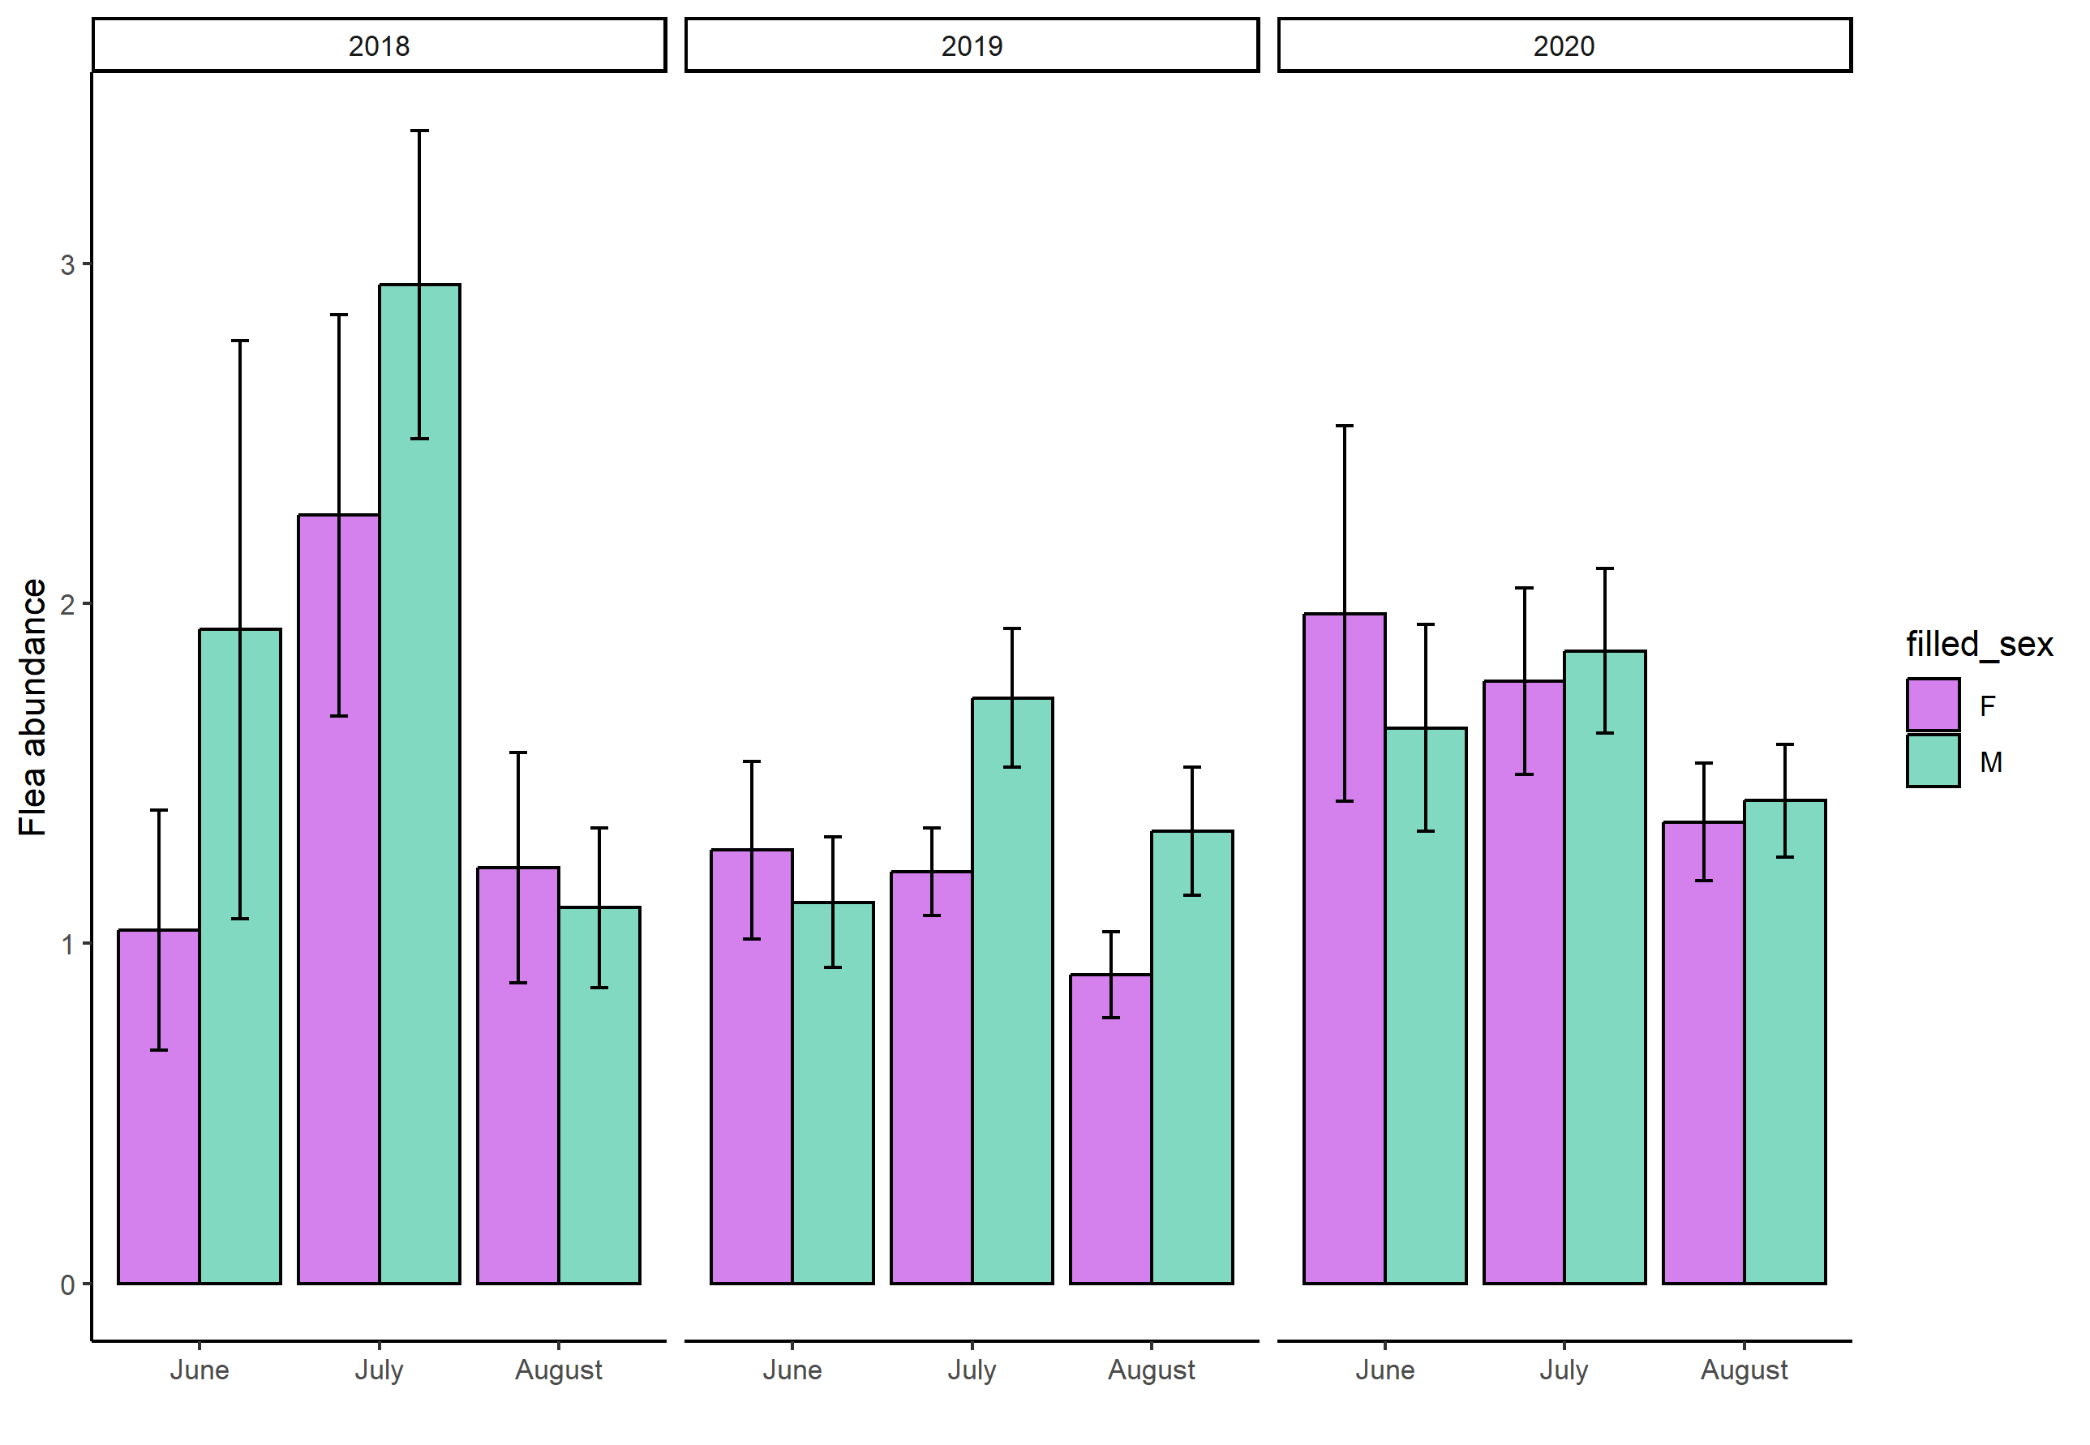
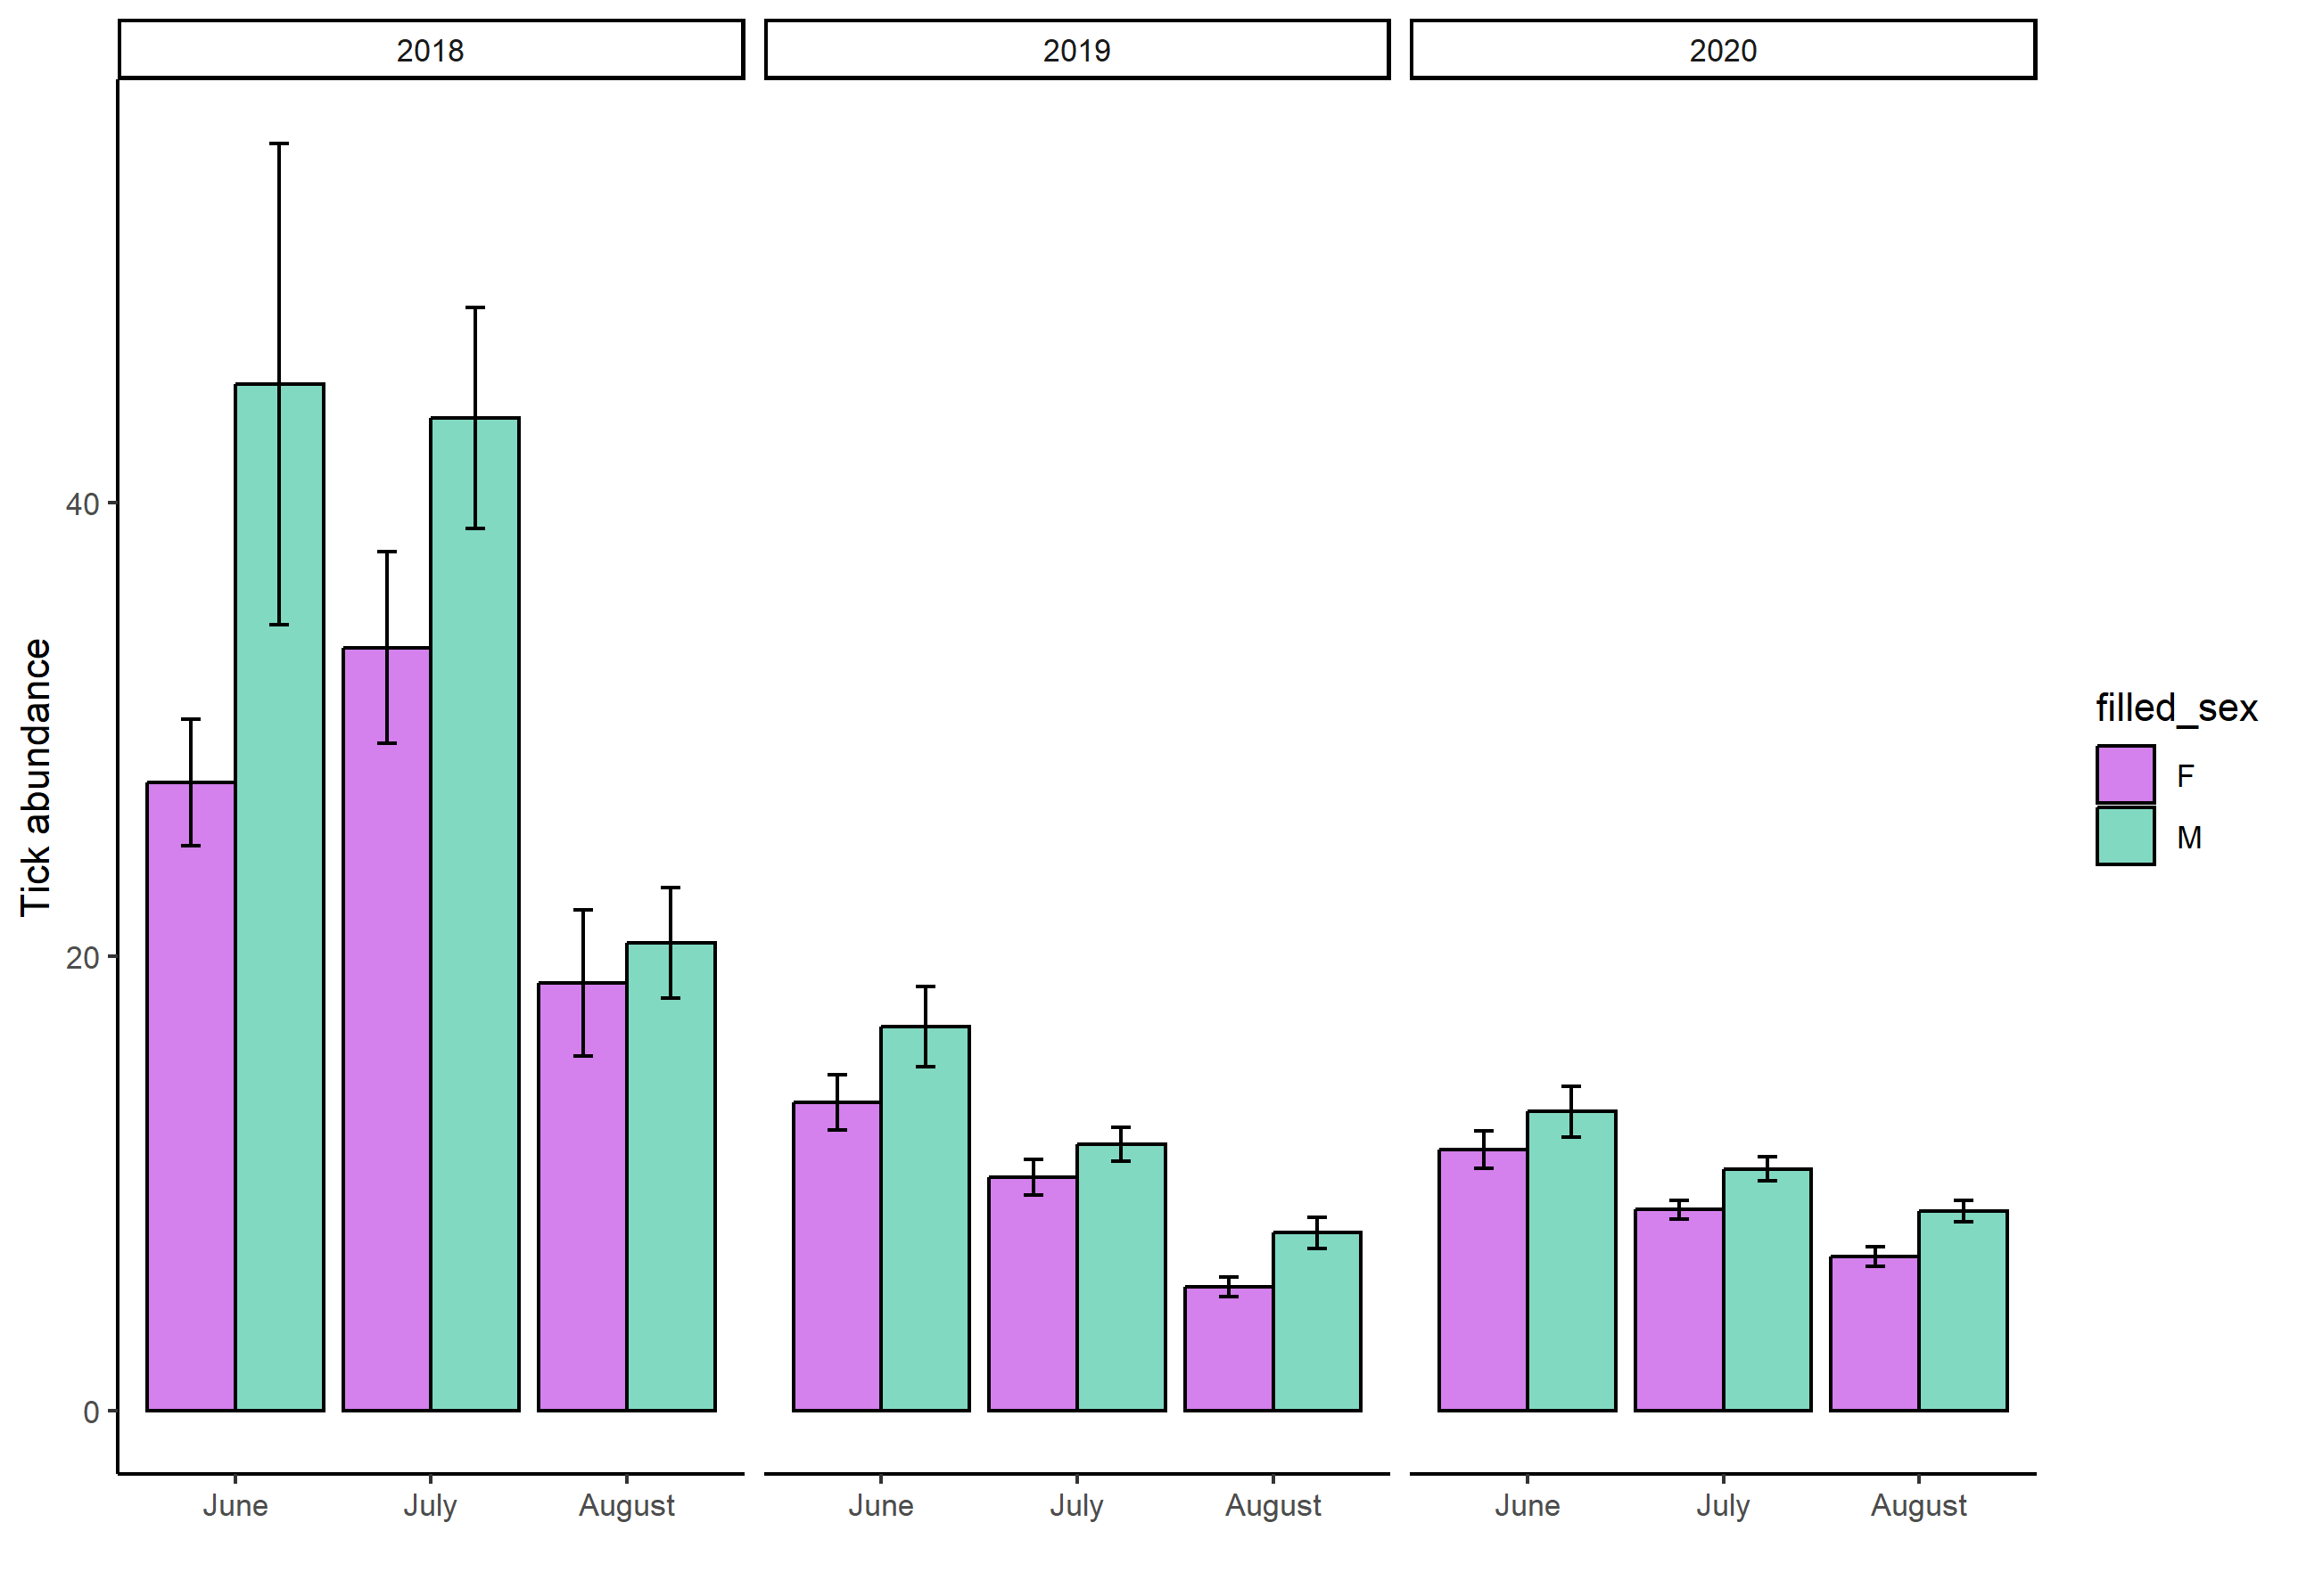
Figure 2. Yearly and monthly average (+- SE) abundance of fleas on female ( violet) and male (green) yellow-necked mouse Apodemus flavicollis.
Figure 1. Yearly and monthly average (+- SE) abundance of tick Ixodes ricinus on female ( violet) and male (green) yellow-necked mouse Apodemus flavicollis.

