Extended Data

Extended Data Fig. 1. Study design and data sources.
Extended Data Fig. 2. Spearman's rank correlation between the P-CaSE and M-CaSE scores.
Extended Data Fig. 3. Susceptibility of organs to primary cancer or metastases is associated with the organ-specific cell composition.
Extended Data Fig. 4. Susceptibility of organs to metastases is associated with high percentage of overexpressed immune genes.
Extended Data Fig. 5. Susceptibility of organs to metastases is associated with high percentage of overexpressed specific immune gene sets.

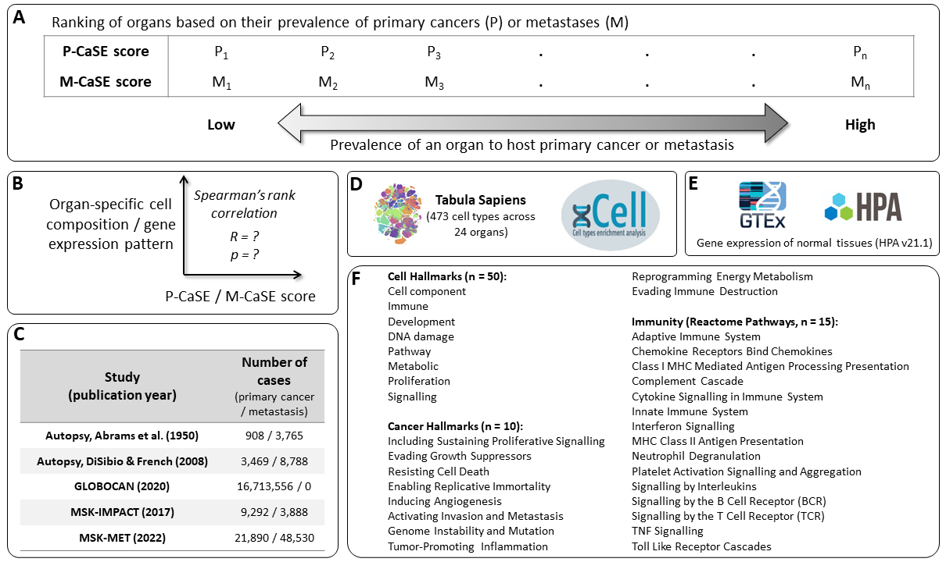
Extended Data Fig. 1. Study design and data sources. A – Organs are ranked based on their CaSE scores. B – Correlation is determined between the intrinsic features of healthy organs (organ-specific cell composition and gene expression pattern) and the CaSE scores. C – Cancer data sources used to determine CaSE scores with the number of primary cancer and metastasis samples. D – Data sources used to determine the organ-specific cell composition; Tabula Sapiens: empirical data; xCell: inferred from the gene expression data. E – Gene expression data; GTEx: collection of post-mortem samples; HPA: collection of samples from living donors. F – Specific gene sets used to group gene expression data.

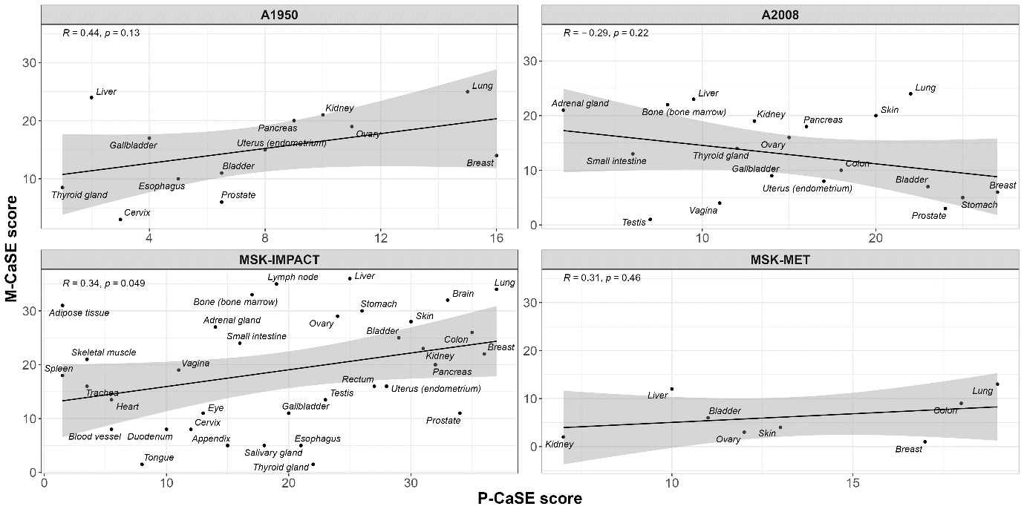
Extended Data Fig. 2. Spearman's rank correlation between the P-CaSE and M-CaSE scores. Scatterplots showing lack of correlation between the P-CaSE (X-axis) and M-CaSE (Y-axis) scores for four different sources of the cancer data. Dots represent individual organs. Cancer datasets (A1950, A2008, MSK-IMPACT, MSK-MET) are described in Materials and methods section on data acquisition.
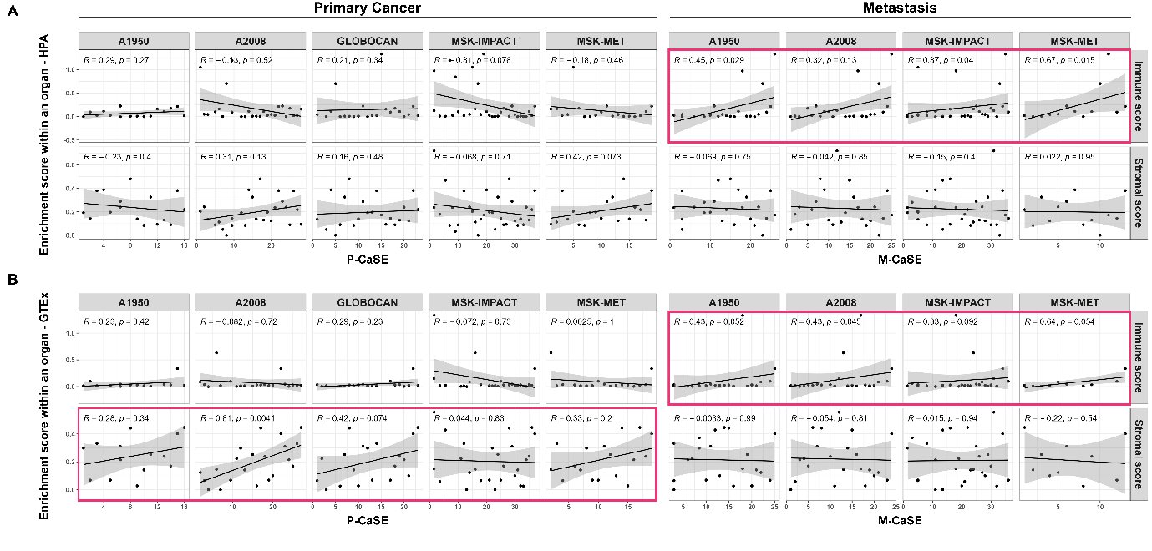
Extended Data Fig. 3. Susceptibility of organs to primary cancer or metastases is associated with the organ-specific cell composition. Scatterplots showing correlations between the CaSE scores (X-axis) and the immune and stromal enrichment scores (Y-axis; A – HPA data; B – GTEx data). Arbitrary criteria for a positive or a negative correlation trend were: 1) the same direction in at least three out of five cancer data sets for the P-CaSE scores and in at least three out of four cancer datasets for M-CaSE scores; 2) Spearman’s rho (R) higher than 0.2 for positive correlation or lower than -0.2 for negative correlation. Red rectangle: positive correlation trend; blue rectangle: negative correlation trend. Dots represent individual organs. Cancer datasets (A1950, A2008, GLOBOCAN, MSK-IMPACT, MSK-MET) are described in Materials and methods section on data acquisition.

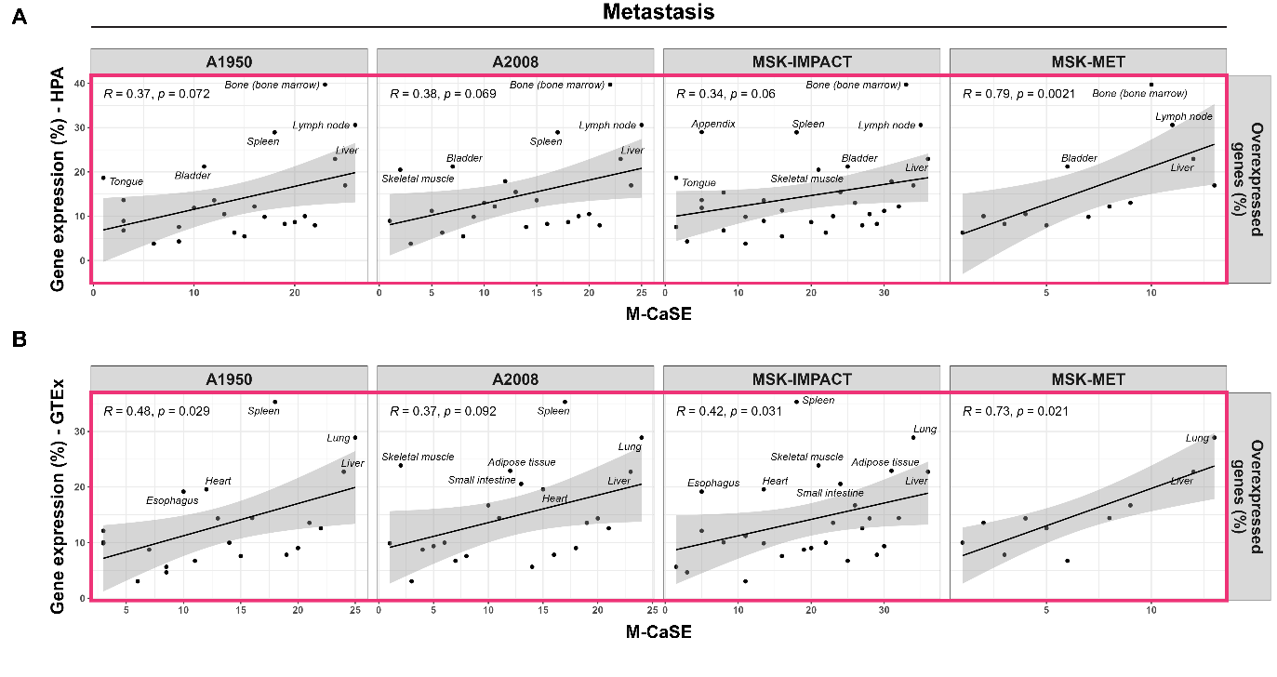
Extended Data Fig. 4. Susceptibility of organs to metastases is associated with high percentage of overexpressed immune genes. Scatterplots showing correlations between the CaSE scores (X-axis) and the portion of average organ-specific immunity-related overexpressed gene pattern (Y-axis; A – HPA data; B – GTEx data). Arbitrary criteria for a positive or a negative correlation trend were: 1) the same direction in at least three out of five cancer data sets for the P-CaSE scores and in at least three out of four cancer datasets for M-CaSE scores; 2) Spearman’s rho (R) higher than 0.2 for positive correlation or lower than -0.2 for negative correlation. Red rectangle: positive correlation trend; blue rectangle: negative correlation trend. Dots represent individual organs. Cancer datasets (A1950, A2008, MSK-IMPACT, MSK-MET) are described in Materials and methods section on data acquisition.

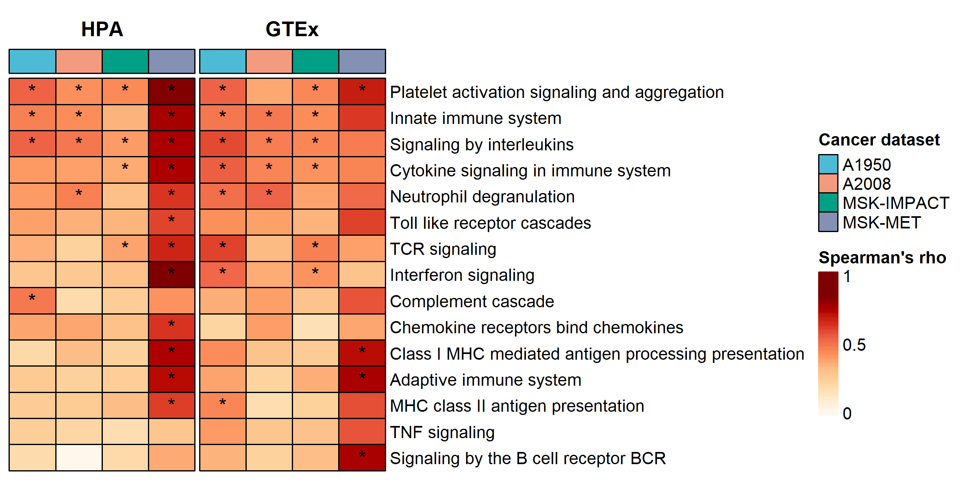
Extended Data Fig. 5. Susceptibility of organs to metastases is associated with high percentage of overexpressed specific immune gene sets. Heatmap showing correlations between the subsets of overexpressed genes from each individual immunity-related gene set and CaSE scores. Arbitrary criteria for robust correlation were: 1) the same direction and 2) significant correlation (p < 0.05), in at least three out of four cancer datasets for M-CaSE scores. Asterisks depict significant correlation. Cancer datasets (A1950, A2008, MSK-IMPACT, MSK-MET) are described in Materials and methods section on data acquisition.

