Mendelian Randomization Rules Out Causation Between Periodontitis and Hand Grip Strength

Ling Yu et al.

Supplementary Material
Table S1 SNPs used as instruments and their association with the exposure and the outcome
Table S2 Leave-one-out analyses
Table S3 Assessing directional pleiotropy through MR-Egger intercept and MR-PRESSO test.

Figure S1. Leave-one-out plot of the causal relationships between hand grip strength and periodontitis phenotypes.
Figure S2. Scatter plot of the causal relationships between hand grip strength and PD using different MR methods.
Figure S3. Forrest plot of the causal relationships between hand grip strength and periodontitis phenotypes.
Figure S4. Funnel plot of the causal relationships between hand grip strength and periodontitis phenotypes.

Table S1 SNPs used as instruments and their association with the exposure and the outcome
SNP | CHR | BP.hg38 | EA | OA | EAF | Exposure |  |  | R² | F | Outcome
 |  |  |  |  |  | BETA | SE | P-value | R² | F | BETA | SE | P-value
Periodontitis |  |  |  |  |  |  |  |  |  |  | Hand grip strength
rs12568187 | 1 | 91193691 | T | C | 0.565 | 0.020 | 0.004 | 2.99E-06 | 0.61801 | 21.828 | -0.013 | 0.011 | 0.235
rs396511 | 1 | 55958103 | A | C | 0.094 | 0.033 | 0.007 | 6.86E-06 | 0.12592 | 20.232 | 0.002 | 0.019 | 0.922
rs486650 | 1 | 234819885 | T | C | 0.463 | -0.019 | 0.004 | 8.02E-06 | 0.62907 | 19.936 | 0.000 | 0.011 | 0.975
rs2361750 | 2 | 1479396 | T | C | 0.424 | 0.020 | 0.004 | 4.78E-06 | 0.61236 | 20.921 | -0.010 | 0.013 | 0.425
rs62177307 | 2 | 161213318 | T | G | 0.901 | 0.035 | 0.007 | 7.54E-07 | 0.13480 | 24.473 | 0.007 | 0.018 | 0.678
rs2310078 | 4 | 29729208 | A | G | 0.500 | -0.019 | 0.004 | 5.01E-06 | 0.63422 | 20.830 | -0.012 | 0.011 | 0.276
rs145618551 | 5 | 139710804 | A | G | 0.013 | 0.095 | 0.020 | 1.87E-06 | 0.00685 | 22.724 | -0.041 | 0.066 | 0.535
rs34600528 | 5 | 76489014 | T | C | 0.781 | 0.023 | 0.005 | 7.84E-06 | 0.35837 | 19.972 | 0.009 | 0.013 | 0.498
rs67216148 | 6 | 45847740 | C | G | 0.180 | -0.026 | 0.006 | 2.01E-06 | 0.28827 | 22.582 | 0.010 | 0.014 | 0.484
rs9267673 | 6 | 31883679 | T | C | 0.090 | 0.033 | 0.007 | 7.19E-06 | 0.11803 | 20.142 | -0.012 | 0.018 | 0.504
rs11770716 | 7 | 41046432 | A | C | 0.024 | 0.062 | 0.014 | 6.70E-06 | 0.01863 | 20.277 | 0.031 | 0.035 | 0.365
rs7788600 | 7 | 155819301 | A | G | 0.153 | -0.026 | 0.006 | 9.83E-06 | 0.23612 | 19.545 | 0.010 | 0.015 | 0.495
rs11137087 | 8 | 6906040 | A | G | 0.367 | 0.020 | 0.004 | 6.90E-06 | 0.56801 | 20.223 | 0.010 | 0.011 | 0.367
rs28788605 | 8 | 95116434 | T | C | 0.114 | 0.031 | 0.007 | 2.55E-06 | 0.16287 | 22.128 | 0.019 | 0.021 | 0.352
rs2978889 | 8 | 6697316 | A | G | 0.491 | -0.020 | 0.004 | 1.99E-06 | 0.63393 | 22.601 | -0.001 | 0.011 | 0.898
rs1130072 | 9 | 14615935 | T | C | 0.488 | -0.021 | 0.004 | 6.93E-07 | 0.63362 | 24.631 | -0.003 | 0.011 | 0.806
rs7028167 | 9 | 86743347 | A | C | 0.783 | -0.025 | 0.005 | 1.51E-06 | 0.35518 | 23.126 | -0.010 | 0.013 | 0.447
rs73343691 | 10 | 112144641 | A | C | 0.831 | -0.026 | 0.006 | 6.18E-06 | 0.26646 | 20.430 | -0.014 | 0.015 | 0.346
rs10500684 | 11 | 7241818 | A | T | 0.815 | -0.028 | 0.005 | 4.55E-07 | 0.29649 | 25.442 | -0.020 | 0.013 | 0.144
rs61897920 | 11 | 126617737 | T | C | 0.012 | 0.090 | 0.020 | 5.28E-06 | 0.00644 | 20.730 | -0.021 | 0.052 | 0.687
rs653810 | 11 | 69448294 | A | G | 0.415 | -0.019 | 0.004 | 7.46E-06 | 0.60711 | 20.070 | 0.014 | 0.011 | 0.196
rs11168228 | 12 | 48150951 | A | G | 0.691 | 0.021 | 0.005 | 4.52E-06 | 0.50113 | 21.031 | 0.004 | 0.012 | 0.751
rs113990426 | 12 | 69185558 | A | G | 0.036 | -0.051 | 0.011 | 6.62E-06 | 0.03293 | 20.304 | -0.047 | 0.028 | 0.100
rs376615077 | 12 | 28353810 | A | G | 0.690 | -0.029 | 0.006 | 1.99E-07 | 0.40784 | 27.050 | -0.017 | 0.014 | 0.211
rs922161 | 12 | 84163323 | A | C | 0.353 | -0.023 | 0.004 | 1.15E-07 | 0.55411 | 28.101 | -0.012 | 0.011 | 0.297
rs11842443 | 13 | 57773725 | A | T | 0.971 | -0.058 | 0.013 | 4.41E-06 | 0.02393 | 21.077 | -0.041 | 0.031 | 0.179
rs145982086 | 13 | 31276044 | A | G | 0.989 | -0.116 | 0.025 | 3.16E-06 | 0.00452 | 21.716 | 0.057 | 0.056 | 0.309
rs2350998 | 15 | 89902609 | A | C | 0.029 | 0.059 | 0.013 | 2.41E-06 | 0.02434 | 22.231 | 0.014 | 0.036 | 0.700
rs4583176 | 15 | 61453111 | A | G | 0.244 | 0.023 | 0.005 | 3.67E-06 | 0.40180 | 21.428 | 0.006 | 0.013 | 0.653
rs1807019 | 18 | 48378106 | T | G | 0.796 | 0.024 | 0.005 | 4.83E-06 | 0.33255 | 20.903 | -0.025 | 0.013 | 0.058
rs12461706 | 19 | 52121235 | A | T | 0.602 | -0.026 | 0.004 | 1.19E-09 | 0.59474 | 36.979 | 0.000 | 0.011 | 0.971
rs113810758 | 20 | 20993705 | T | C | 0.024 | -0.064 | 0.014 | 3.34E-06 | 0.01841 | 21.613 | 0.043 | 0.036 | 0.235
rs6117933 | 20 | 7692365 | T | C | 0.181 | 0.027 | 0.006 | 1.27E-06 | 0.28939 | 23.464 | 0.019 | 0.014 | 0.165
rs77369438 | 20 | 39961825 | T | C | 0.142 | 0.028 | 0.006 | 4.67E-06 | 0.21634 | 20.967 | 0.014 | 0.015 | 0.360
AgP |  |  |  |  |  |  |  |  |  |  | Hand grip strength
rs17340482 | 1 | 27236578 | G | C | 0.900 | 0.445 | 0.091 | 9.99E-07 | 0.02297 | 23.930 | -0.032 | 0.017 | 0.060
rs1380780 | 3 | 163139348 | T | A | 0.720 | 0.270 | 0.059 | 4.27E-06 | 0.07964 | 21.140 | -0.015 | 0.012 | 0.188
rs6887423 | 5 | 36696501 | T | C | 0.420 | 0.255 | 0.053 | 1.42E-06 | 0.10703 | 23.253 | -0.003 | 0.011 | 0.788
rs1002204 | 7 | 87141497 | C | A | 0.470 | 0.239 | 0.054 | 7.92E-06 | 0.10802 | 19.957 | -0.017 | 0.011 | 0.104
rs4731202 | 7 | 79721630 | T | G | 0.660 | 0.247 | 0.055 | 8.54E-06 | 0.09388 | 19.813 | 0.003 | 0.011 | 0.802
rs2978951 | 8 | 6823295 | A | G | 0.410 | 0.270 | 0.054 | 4.49E-07 | 0.10490 | 25.471 | -0.009 | 0.011 | 0.426
rs747804 | 9 | 35944775 | G | A | 0.640 | 0.262 | 0.055 | 1.65E-06 | 0.09764 | 22.965 | -0.007 | 0.011 | 0.537
rs2144815 | 14 | 95800526 | T | C | 0.170 | 0.329 | 0.069 | 1.53E-06 | 0.04779 | 23.110 | 0.000 | 0.014 | 0.980
rs11633566 | 15 | 49394406 | G | A | 0.750 | 0.270 | 0.060 | 7.99E-06 | 0.07194 | 19.940 | 0.009 | 0.013 | 0.474
rs744280 | 15 | 25960629 | C | T | 0.730 | 0.270 | 0.060 | 7.97E-06 | 0.07563 | 19.945 | -0.003 | 0.012 | 0.803
rs4284742 | 19 | 52131733 | G | A | 0.760 | 0.285 | 0.062 | 4.66E-06 | 0.06796 | 20.972 | -0.002 | 0.013 | 0.866
rs6137428 | 20 | 2227689 | C | T | 0.900 | 0.419 | 0.091 | 3.92E-06 | 0.02302 | 21.304 | 0.021 | 0.018 | 0.227
CP |  |  |  |  |  |  |  |  |  |  | Hand grip strength
rs77930255 | 1 | 163913563 | T | C | 0.017 | 0.477 | 0.104 | 4.22E-06 | 0.00071 | 21.172 | 0.012 | 0.036 | 0.740
rs115399664 | 3 | 122458770 | T | C | 0.009 | 0.673 | 0.146 | 4.26E-06 | 0.00027 | 21.145 | 0.044 | 0.039 | 0.266
rs16827323 | 3 | 117325738 | T | C | 0.111 | 0.191 | 0.042 | 4.01E-06 | 0.01068 | 21.249 | 0.000 | 0.014 | 0.978
rs189543805 | 3 | 25133877 | T | C | 0.005 | 0.921 | 0.204 | 6.18E-06 | 0.00011 | 20.427 | 0.002 | 0.043 | 0.964
rs9874843 | 3 | 147453795 | G | A | 0.555 | -0.118 | 0.026 | 7.37E-06 | 0.04232 | 20.147 | 0.004 | 0.011 | 0.676
rs7690117 | 4 | 188604115 | C | G | 0.301 | 0.134 | 0.028 | 2.51E-06 | 0.03328 | 22.229 | 0.005 | 0.012 | 0.690
rs78626083 | 5 | 104985928 | G | A | 0.033 | 0.347 | 0.075 | 3.51E-06 | 0.00189 | 21.533 | -0.020 | 0.025 | 0.421
rs72894911 | 6 | 80481546 | C | A | 0.059 | 0.259 | 0.056 | 3.93E-06 | 0.00446 | 21.265 | 0.005 | 0.025 | 0.836
rs75175128 | 6 | 145696377 | G | A | 0.025 | 0.393 | 0.086 | 4.75E-06 | 0.00128 | 20.910 | 0.017 | 0.036 | 0.632
rs9348526 | 6 | 22586911 | A | G | 0.010 | 0.625 | 0.139 | 6.94E-06 | 0.00031 | 20.205 | 0.010 | 0.041 | 0.806
rs112573355 | 7 | 31826100 | C | G | 0.003 | 1.228 | 0.258 | 1.86E-06 | 0.00006 | 22.736 | 0.002 | 0.051 | 0.967
rs9648195 | 7 | 15012390 | A | C | 0.231 | 0.145 | 0.031 | 3.37E-06 | 0.02558 | 21.599 | 0.005 | 0.012 | 0.652
rs1946942 | 8 | 96102796 | T | C | 0.185 | 0.159 | 0.034 | 2.59E-06 | 0.01999 | 22.129 | -0.014 | 0.015 | 0.337
rs7836944 | 8 | 135436202 | A | G | 0.466 | 0.124 | 0.026 | 1.87E-06 | 0.04280 | 22.717 | 0.003 | 0.011 | 0.804
rs111735019 | 9 | 1381499 | T | A | 0.048 | 0.285 | 0.063 | 5.43E-06 | 0.00325 | 20.690 | 0.011 | 0.025 | 0.663
rs62567180 | 9 | 72096659 | A | C | 0.281 | 0.134 | 0.029 | 3.77E-06 | 0.03130 | 21.351 | 0.004 | 0.013 | 0.750
rs56222175 | 10 | 4251861 | T | A | 0.037 | 0.337 | 0.072 | 2.61E-06 | 0.00221 | 22.065 | 0.001 | 0.026 | 0.964
rs1959540 | 14 | 49082429 | T | C | 0.478 | 0.118 | 0.026 | 5.94E-06 | 0.04292 | 20.544 | 0.009 | 0.011 | 0.389
rs34982606 | 14 | 37841895 | A | G | 0.247 | -0.137 | 0.030 | 6.11E-06 | 0.02765 | 20.519 | -0.014 | 0.012 | 0.239
rs61427077 | 14 | 32604769 | G | C | 0.274 | -0.137 | 0.030 | 3.55E-06 | 0.03019 | 21.453 | -0.003 | 0.013 | 0.840
rs28583704 | 15 | 63100634 | C | T | 0.062 | 0.246 | 0.055 | 6.63E-06 | 0.00476 | 20.324 | 0.031 | 0.017 | 0.070
rs73404204 | 15 | 49250265 | G | A | 0.025 | 0.396 | 0.086 | 4.22E-06 | 0.00127 | 21.175 | 0.037 | 0.028 | 0.190
rs9932005 | 16 | 68822019 | T | C | 0.236 | -0.162 | 0.031 | 1.51E-07 | 0.02621 | 27.622 | -0.002 | 0.012 | 0.848
rs62065226 | 17 | 38349741 | G | C | 0.070 | 0.229 | 0.052 | 9.99E-06 | 0.00562 | 19.527 | 0.043 | 0.024 | 0.071
rs12458077 | 18 | 46892908 | T | C | 0.133 | 0.175 | 0.039 | 5.67E-06 | 0.01343 | 20.648 | 0.083 | 0.020 | 0.000
Hand grip strength |  |  |  |  |  |  |  |  |  |  | Periodontitis
rs12137233 | 1 | 227823146 | A | C | 0.190 | 0.065 | 0.013 | 7.46E-07 | 0.04605 | 24.548 | -0.005 | 0.005 | 0.333
rs4418584 | 1 | 236299823 | C | T | 0.550 | -0.063 | 0.014 | 3.42E-06 | 0.07241 | 21.709 | 0.000 | 0.005 | 0.981
rs7536094 | 1 | 159511457 | A | C | 0.184 | -0.075 | 0.016 | 2.87E-06 | 0.03689 | 21.875 | -0.007 | 0.006 | 0.207
rs13403900 | 2 | 143199871 | T | A | 0.096 | 0.104 | 0.020 | 3.04E-07 | 0.01701 | 26.354 | -0.014 | 0.007 | 0.052
rs3771501 | 2 | 70717653 | G | A | 0.526 | -0.070 | 0.011 | 5.04E-11 | 0.09290 | 43.237 | 0.000 | 0.004 | 0.943
rs4077155 | 2 | 1846806 | T | C | 0.327 | 0.055 | 0.011 | 8.32E-07 | 0.07824 | 24.373 | -0.001 | 0.005 | 0.749
rs6713703 | 2 | 238573942 | A | G | 0.698 | 0.055 | 0.012 | 3.83E-06 | 0.07053 | 21.332 | -0.001 | 0.005 | 0.888
rs7592340 | 2 | 128831806 | C | T | 0.794 | 0.064 | 0.013 | 1.71E-06 | 0.04815 | 22.740 | 0.003 | 0.005 | 0.565
rs114133398 | 3 | 193733924 | A | G | 0.091 | -0.087 | 0.019 | 4.04E-06 | 0.01723 | 21.189 | 0.004 | 0.007 | 0.619
rs150276717 | 3 | 8085258 | A | G | 0.020 | 0.172 | 0.037 | 4.22E-06 | 0.00208 | 21.165 | -0.016 | 0.016 | 0.311
rs115783351 | 4 | 108708540 | A | G | 0.024 | 0.163 | 0.033 | 9.80E-07 | 0.00279 | 24.019 | -0.001 | 0.014 | 0.932
rs13107325 | 4 | 103188709 | T | C | 0.073 | 0.096 | 0.020 | 8.54E-07 | 0.01370 | 24.190 | -0.004 | 0.008 | 0.658
rs146993563 | 4 | 1500327 | C | T | 0.896 | -0.096 | 0.018 | 1.35E-07 | 0.02042 | 27.897 | 0.004 | 0.008 | 0.615
rs191252760 | 4 | 61454905 | G | A | 0.023 | 0.186 | 0.034 | 3.17E-08 | 0.00268 | 30.561 | 0.014 | 0.014 | 0.313
rs12153280 | 5 | 35199262 | A | C | 0.087 | 0.085 | 0.018 | 3.61E-06 | 0.01705 | 21.372 | 0.004 | 0.008 | 0.578
rs35146088 | 5 | 91116709 | T | G | 0.036 | 0.139 | 0.028 | 4.68E-07 | 0.00500 | 25.475 | -0.010 | 0.010 | 0.285
rs185320691 | 6 | 32490292 | C | G | 0.105 | 0.146 | 0.022 | 1.48E-11 | 0.01711 | 45.563 | -0.009 | 0.008 | 0.243
rs35021449 | 6 | 32530583 | T | C | 0.097 | 0.125 | 0.022 | 1.33E-08 | 0.01578 | 32.438 | -0.008 | 0.009 | 0.353
rs6910879 | 6 | 32560739 | G | A | 0.088 | 0.125 | 0.022 | 1.35E-08 | 0.01452 | 32.318 | -0.004 | 0.009 | 0.697
rs72821916 | 6 | 5749228 | G | A | 0.041 | 0.124 | 0.026 | 1.91E-06 | 0.00600 | 22.599 | 0.000 | 0.011 | 0.974
rs74643782 | 6 | 73779838 | T | A | 0.017 | 0.181 | 0.039 | 3.78E-06 | 0.00170 | 21.391 | -0.020 | 0.016 | 0.224
rs76257146 | 6 | 126946392 | C | A | 0.021 | 0.174 | 0.036 | 1.06E-06 | 0.00227 | 23.779 | 0.003 | 0.016 | 0.870
rs7760841 | 6 | 32574868 | T | C | 0.164 | 0.123 | 0.015 | 3.34E-16 | 0.03581 | 66.245 | 0.004 | 0.006 | 0.558
rs10952289 | 7 | 150524681 | C | T | 0.346 | -0.055 | 0.011 | 6.90E-07 | 0.08047 | 24.641 | -0.006 | 0.004 | 0.203
rs12531053 | 7 | 15156415 | C | A | 0.418 | 0.051 | 0.011 | 1.77E-06 | 0.09065 | 22.877 | 0.007 | 0.004 | 0.082
rs59314951 | 7 | 98232380 | A | T | 0.081 | 0.113 | 0.023 | 1.12E-06 | 0.01270 | 23.718 | 0.008 | 0.008 | 0.300
rs6961756 | 7 | 147188563 | C | G | 0.631 | -0.053 | 0.011 | 3.17E-06 | 0.08067 | 21.860 | 0.007 | 0.004 | 0.111
rs113300414 | 9 | 71441154 | A | G | 0.026 | 0.165 | 0.033 | 3.87E-07 | 0.00307 | 25.775 | 0.000 | 0.013 | 0.996
rs4977302 | 9 | 19469624 | A | G | 0.035 | 0.129 | 0.028 | 3.50E-06 | 0.00478 | 21.445 | 0.001 | 0.011 | 0.911
rs7034200 | 9 | 4289050 | A | C | 0.484 | -0.049 | 0.011 | 3.42E-06 | 0.09305 | 21.369 | 0.003 | 0.004 | 0.472
rs117392952 | 10 | 91830356 | C | T | 0.011 | 0.289 | 0.056 | 2.15E-07 | 0.00076 | 26.861 | 0.013 | 0.021 | 0.555
rs34347509 | 10 | 69670521 | G | A | 0.022 | 0.164 | 0.036 | 4.20E-06 | 0.00241 | 21.129 | -0.025 | 0.017 | 0.152
rs72777762 | 10 | 12086214 | G | C | 0.128 | 0.073 | 0.016 | 2.18E-06 | 0.02848 | 22.364 | -0.013 | 0.006 | 0.036
rs2000924 | 11 | 74398125 | T | C | 0.258 | -0.061 | 0.012 | 5.27E-07 | 0.06197 | 25.247 | -0.008 | 0.005 | 0.105
rs7948251 | 11 | 122329056 | C | T | 0.674 | -0.054 | 0.011 | 1.49E-06 | 0.07749 | 23.160 | 0.002 | 0.004 | 0.720
rs1818759 | 12 | 53054893 | C | A | 0.045 | 0.123 | 0.025 | 1.09E-06 | 0.00668 | 23.785 | 0.005 | 0.010 | 0.610
rs7306606 | 12 | 24005101 | T | C | 0.531 | -0.052 | 0.011 | 1.20E-06 | 0.09280 | 23.605 | 0.000 | 0.004 | 0.936
rs4646571 | 15 | 58343137 | C | T | 0.402 | 0.057 | 0.011 | 1.27E-07 | 0.08872 | 27.981 | -0.007 | 0.004 | 0.085
rs141779071 | 16 | 24608345 | A | G | 0.039 | 0.144 | 0.026 | 5.06E-08 | 0.00557 | 29.752 | 0.010 | 0.011 | 0.397
rs4784329 | 16 | 53910261 | C | A | 0.427 | 0.049 | 0.011 | 4.57E-06 | 0.09118 | 21.108 | -0.002 | 0.004 | 0.572
rs72777366 | 16 | 13808306 | T | C | 0.166 | -0.077 | 0.015 | 2.04E-07 | 0.03696 | 27.068 | 0.006 | 0.006 | 0.260
rs9937642 | 16 | 85253605 | C | T | 0.255 | 0.056 | 0.012 | 3.66E-06 | 0.06193 | 21.267 | -0.010 | 0.005 | 0.043
rs1989803 | 17 | 43185492 | G | C | 0.360 | 0.060 | 0.011 | 7.04E-08 | 0.08271 | 29.258 | 0.002 | 0.004 | 0.647
rs56252779 | 17 | 9243954 | G | A | 0.031 | -0.152 | 0.033 | 3.19E-06 | 0.00367 | 21.730 | 0.000 | 0.013 | 0.972
rs552086 | 18 | 46806432 | C | G | 0.664 | -0.063 | 0.011 | 1.82E-08 | 0.07944 | 31.806 | -0.005 | 0.004 | 0.298
rs7505321 | 18 | 75247829 | C | T | 0.829 | -0.080 | 0.016 | 5.66E-07 | 0.03497 | 25.125 | -0.005 | 0.006 | 0.340
rs143384 | 20 | 34025756 | G | A | 0.411 | -0.053 | 0.011 | 1.04E-06 | 0.08854 | 23.721 | 0.006 | 0.004 | 0.167
Hand grip strength |  |  |  |  |  |  |  |  |  |  | CP
rs12137233 | 1 | 227823146 | A | C | 0.190 | 0.065 | 0.013 | 7.46E-07 | 0.04605 | 24.548 | -0.047 | 0.032 | 0.139
rs7536094 | 1 | 159511457 | A | C | 0.184 | -0.075 | 0.016 | 2.87E-06 | 0.03689 | 21.875 | 0.002 | 0.030 | 0.938
rs13403900 | 2 | 143199871 | T | A | 0.096 | 0.104 | 0.020 | 3.04E-07 | 0.01701 | 26.354 | 0.012 | 0.051 | 0.818
rs3771501 | 2 | 70717653 | G | A | 0.526 | -0.070 | 0.011 | 5.04E-11 | 0.09290 | 43.237 | 0.034 | 0.026 | 0.203
rs4077155 | 2 | 1846806 | T | C | 0.327 | 0.055 | 0.011 | 8.32E-07 | 0.07824 | 24.373 | 0.034 | 0.028 | 0.225
rs6713703 | 2 | 238573942 | A | G | 0.698 | 0.055 | 0.012 | 3.83E-06 | 0.07053 | 21.332 | -0.018 | 0.029 | 0.529
rs7592340 | 2 | 128831806 | C | T | 0.794 | 0.064 | 0.013 | 1.71E-06 | 0.04815 | 22.740 | -0.011 | 0.031 | 0.731
rs114133398 | 3 | 193733924 | A | G | 0.091 | -0.087 | 0.019 | 4.04E-06 | 0.01723 | 21.189 | -0.042 | 0.046 | 0.362
rs150276717 | 3 | 8085258 | A | G | 0.020 | 0.172 | 0.037 | 4.22E-06 | 0.00208 | 21.165 | -0.040 | 0.161 | 0.804
rs115783351 | 4 | 108708540 | A | G | 0.024 | 0.163 | 0.033 | 9.80E-07 | 0.00279 | 24.019 | -0.034 | 0.070 | 0.624
rs13107325 | 4 | 103188709 | T | C | 0.073 | 0.096 | 0.020 | 8.54E-07 | 0.01370 | 24.190 | 0.040 | 0.107 | 0.709
rs146993563 | 4 | 1500327 | C | T | 0.896 | -0.096 | 0.018 | 1.35E-07 | 0.02042 | 27.897 | 0.017 | 0.039 | 0.662
rs191252760 | 4 | 61454905 | G | A | 0.023 | 0.186 | 0.034 | 3.17E-08 | 0.00268 | 30.561 | -0.077 | 0.132 | 0.561
rs12153280 | 5 | 35199262 | A | C | 0.087 | 0.085 | 0.018 | 3.61E-06 | 0.01705 | 21.372 | -0.054 | 0.045 | 0.221
rs35146088 | 5 | 91116709 | T | G | 0.036 | 0.139 | 0.028 | 4.68E-07 | 0.00500 | 25.475 | 0.014 | 0.102 | 0.890
rs6910879 | 6 | 32560739 | G | A | 0.088 | 0.125 | 0.022 | 1.35E-08 | 0.01452 | 32.318 | 0.088 | 0.184 | 0.632
rs72821916 | 6 | 5749228 | G | A | 0.041 | 0.124 | 0.026 | 1.91E-06 | 0.00600 | 22.599 | 0.111 | 0.069 | 0.109
rs74643782 | 6 | 73779838 | T | A | 0.017 | 0.181 | 0.039 | 3.78E-06 | 0.00170 | 21.391 | -0.239 | 0.106 | 0.025
rs76257146 | 6 | 126946392 | C | A | 0.021 | 0.174 | 0.036 | 1.06E-06 | 0.00227 | 23.779 | 0.002 | 0.060 | 0.970
rs7760841 | 6 | 32574868 | T | C | 0.164 | 0.123 | 0.015 | 3.34E-16 | 0.03581 | 66.245 | 0.050 | 0.036 | 0.173
rs10952289 | 7 | 150524681 | C | T | 0.346 | -0.055 | 0.011 | 6.90E-07 | 0.08047 | 24.641 | 0.015 | 0.027 | 0.581
rs12531053 | 7 | 15156415 | C | A | 0.418 | 0.051 | 0.011 | 1.77E-06 | 0.09065 | 22.877 | -0.030 | 0.026 | 0.252
rs6961756 | 7 | 147188563 | C | G | 0.631 | -0.053 | 0.011 | 3.17E-06 | 0.08067 | 21.860 | 0.025 | 0.029 | 0.387
rs113300414 | 9 | 71441154 | A | G | 0.026 | 0.165 | 0.033 | 3.87E-07 | 0.00307 | 25.775 | -0.016 | 0.148 | 0.913
rs4977302 | 9 | 19469624 | A | G | 0.035 | 0.129 | 0.028 | 3.50E-06 | 0.00478 | 21.445 | 0.004 | 0.089 | 0.962
rs7034200 | 9 | 4289050 | A | C | 0.484 | -0.049 | 0.011 | 3.42E-06 | 0.09305 | 21.369 | -0.005 | 0.026 | 0.845
rs34347509 | 10 | 69670521 | G | A | 0.022 | 0.164 | 0.036 | 4.20E-06 | 0.00241 | 21.129 | -0.001 | 0.138 | 0.997
rs72777762 | 10 | 12086214 | G | C | 0.128 | 0.073 | 0.016 | 2.18E-06 | 0.02848 | 22.364 | 0.027 | 0.040 | 0.511
rs2000924 | 11 | 74398125 | T | C | 0.258 | -0.061 | 0.012 | 5.27E-07 | 0.06197 | 25.247 | -0.022 | 0.033 | 0.494
rs7948251 | 11 | 1.22E+08 | C | T | 0.674 | -0.054 | 0.011 | 1.49E-06 | 0.07749 | 23.160 | -0.044 | 0.029 | 0.129
rs1818759 | 12 | 53054893 | C | A | 0.045 | 0.123 | 0.025 | 1.09E-06 | 0.00668 | 23.785 | -0.138 | 0.093 | 0.136
rs7306606 | 12 | 24005101 | T | C | 0.531 | -0.052 | 0.011 | 1.20E-06 | 0.09280 | 23.605 | -0.021 | 0.026 | 0.424
rs4646571 | 15 | 58343137 | C | T | 0.402 | 0.057 | 0.011 | 1.27E-07 | 0.08872 | 27.981 | 0.015 | 0.027 | 0.564
rs141779071 | 16 | 24608345 | A | G | 0.039 | 0.144 | 0.026 | 5.06E-08 | 0.00557 | 29.752 | -0.006 | 0.072 | 0.929
rs147505997 | 16 | 18768375 | C | T | 0.011 | 0.521 | 0.110 | 2.29E-06 | 0.00039 | 22.317 | 0.060 | 0.115 | 0.599
rs4784329 | 16 | 53910261 | C | A | 0.427 | 0.049 | 0.011 | 4.57E-06 | 0.09118 | 21.108 | -0.012 | 0.026 | 0.639
rs72777366 | 16 | 13808306 | T | C | 0.166 | -0.077 | 0.015 | 2.04E-07 | 0.03696 | 27.068 | 0.029 | 0.033 | 0.365
rs9937642 | 16 | 85253605 | C | T | 0.255 | 0.056 | 0.012 | 3.66E-06 | 0.06193 | 21.267 | -0.018 | 0.030 | 0.541
rs552086 | 18 | 46806432 | C | G | 0.664 | -0.063 | 0.011 | 1.82E-08 | 0.07944 | 31.806 | -0.059 | 0.027 | 0.029
rs7505321 | 18 | 75247829 | C | T | 0.829 | -0.080 | 0.016 | 5.66E-07 | 0.03497 | 25.125 | -0.051 | 0.039 | 0.194
rs143384 | 20 | 34025756 | G | A | 0.411 | -0.053 | 0.011 | 1.04E-06 | 0.08854 | 23.721 | 0.036 | 0.026 | 0.169
Abbreviations: SNP, single nucleoid polymorphism; CHR, chromosome; BP.hg38, base pair position on human genome assembly build 38; EA, effect allele. OA, other allele. EAF, effect allele frequency. SE, standard error. R², explained phenotypic variability; F, F statistic; BETA, effect estimate; SE, standard error; AgP ,aggressive periodontitis; CP , chronic periodontitis.

Table S2 Leave-one-out analyses
SNP | OR | 95% CI |  | P value
Periodontitis – hand grip strength
rs10500684 | 0.095 | -0.089 | 0.279 | 0.312
rs11137087 | 0.106 | -0.077 | 0.289 | 0.256
rs11168228 | 0.115 | -0.068 | 0.299 | 0.218
rs1130072 | 0.117 | -0.067 | 0.301 | 0.213
rs113810758 | 0.139 | -0.045 | 0.322 | 0.138
rs113990426 | 0.094 | -0.089 | 0.278 | 0.314
rs11770716 | 0.106 | -0.077 | 0.289 | 0.257
rs11842443 | 0.098 | -0.085 | 0.282 | 0.294
rs12461706 | 0.122 | -0.063 | 0.308 | 0.196
rs12568187 | 0.140 | -0.043 | 0.324 | 0.134
rs145618551 | 0.127 | -0.056 | 0.309 | 0.173
rs145982086 | 0.140 | -0.044 | 0.324 | 0.136
rs1807019 | 0.151 | -0.032 | 0.334 | 0.107
rs2310078 | 0.103 | -0.081 | 0.286 | 0.272
rs2350998 | 0.114 | -0.069 | 0.297 | 0.221
rs2361750 | 0.130 | -0.052 | 0.313 | 0.162
rs28788605 | 0.107 | -0.076 | 0.290 | 0.251
rs2978889 | 0.119 | -0.065 | 0.302 | 0.205
rs34600528 | 0.110 | -0.074 | 0.293 | 0.241
rs376615077 | 0.098 | -0.086 | 0.282 | 0.296
rs396511 | 0.119 | -0.065 | 0.302 | 0.204
rs4583176 | 0.113 | -0.070 | 0.296 | 0.226
rs486650 | 0.120 | -0.063 | 0.303 | 0.200
rs6117933 | 0.097 | -0.086 | 0.281 | 0.299
rs61897920 | 0.126 | -0.057 | 0.309 | 0.177
rs62177307 | 0.114 | -0.070 | 0.298 | 0.226
rs653810 | 0.141 | -0.043 | 0.324 | 0.133
rs67216148 | 0.133 | -0.051 | 0.316 | 0.157
rs7028167 | 0.108 | -0.076 | 0.292 | 0.249
rs73343691 | 0.106 | -0.077 | 0.289 | 0.257
rs77369438 | 0.105 | -0.078 | 0.289 | 0.260
rs7788600 | 0.131 | -0.053 | 0.314 | 0.162
rs922161 | 0.102 | -0.082 | 0.286 | 0.279
rs9267673 | 0.131 | -0.052 | 0.314 | 0.162
All | 0.117 | -0.064 | 0.298 | 0.205

SNP | OR | 95% CI |  | P value
AgP- hand grip strength
rs1002204 | -0.013 | -0.038 | 0.012 | 0.307
rs11633566 | -0.022 | -0.047 | 0.004 | 0.092
rs1380780 | -0.014 | -0.039 | 0.011 | 0.269
rs17340482 | -0.011 | -0.037 | 0.014 | 0.379
rs2144815 | -0.019 | -0.045 | 0.006 | 0.131
rs2978951 | -0.016 | -0.042 | 0.009 | 0.211
rs4284742 | -0.019 | -0.044 | 0.007 | 0.148
rs4731202 | -0.020 | -0.045 | 0.005 | 0.118
rs6137428 | -0.024 | -0.049 | 0.001 | 0.061
rs6887423 | -0.018 | -0.044 | 0.007 | 0.156
rs744280 | -0.018 | -0.043 | 0.007 | 0.155
rs747804 | -0.017 | -0.042 | 0.008 | 0.190
All | -0.018 | -0.042 | 0.006 | 0.151

SNP | OR | 95% CI |  | P value
CP- hand grip strength
rs111735019 | 0.035 | 0.004 | 0.066 | 0.029
rs112573355 | 0.040 | 0.007 | 0.072 | 0.016
rs115399664 | 0.033 | 0.001 | 0.064 | 0.042
rs12458077 | 0.028 | -0.002 | 0.057 | 0.066
rs16827323 | 0.036 | 0.005 | 0.067 | 0.023
rs189543805 | 0.038 | 0.006 | 0.070 | 0.018
rs1946942 | 0.038 | 0.008 | 0.068 | 0.013
rs1959540 | 0.034 | 0.003 | 0.065 | 0.033
rs28583704 | 0.030 | 0.000 | 0.061 | 0.049
rs34982606 | 0.033 | 0.002 | 0.064 | 0.037
rs56222175 | 0.036 | 0.005 | 0.067 | 0.023
rs61427077 | 0.035 | 0.004 | 0.066 | 0.026
rs62065226 | 0.032 | 0.002 | 0.061 | 0.037
rs62567180 | 0.035 | 0.004 | 0.066 | 0.028
rs72894911 | 0.035 | 0.004 | 0.066 | 0.026
rs73404204 | 0.032 | 0.001 | 0.063 | 0.042
rs75175128 | 0.035 | 0.003 | 0.066 | 0.029
rs7690117 | 0.035 | 0.004 | 0.066 | 0.028
rs77930255 | 0.035 | 0.004 | 0.066 | 0.027
rs7836944 | 0.035 | 0.004 | 0.066 | 0.026
rs78626083 | 0.039 | 0.009 | 0.069 | 0.012
rs9348526 | 0.036 | 0.004 | 0.067 | 0.026
rs9648195 | 0.035 | 0.004 | 0.066 | 0.029
rs9874843 | 0.037 | 0.006 | 0.068 | 0.019
rs9932005 | 0.036 | 0.004 | 0.067 | 0.025
All | 0.035 | 0.005 | 0.065 | 0.023

SNP | OR | 95% CI |  | P value
hand grip strength - Periodontitis
rs10952289 | -0.016 | -0.038 | 0.006 | 0.163
rs113300414 | -0.014 | -0.036 | 0.009 | 0.230
rs114133398 | -0.013 | -0.036 | 0.009 | 0.256
rs115783351 | -0.014 | -0.036 | 0.009 | 0.234
rs117392952 | -0.015 | -0.037 | 0.008 | 0.192
rs12137233 | -0.012 | -0.035 | 0.010 | 0.282
rs12153280 | -0.015 | -0.037 | 0.008 | 0.201
rs12531053 | -0.017 | -0.039 | 0.006 | 0.148
rs13107325 | -0.013 | -0.036 | 0.009 | 0.253
rs13403900 | -0.010 | -0.033 | 0.012 | 0.373
rs141779071 | -0.015 | -0.038 | 0.007 | 0.182
rs143384 | -0.012 | -0.034 | 0.011 | 0.308
rs146993563 | -0.013 | -0.036 | 0.010 | 0.257
rs150276717 | -0.012 | -0.035 | 0.010 | 0.279
rs1818759 | -0.015 | -0.037 | 0.008 | 0.202
rs185320691 | -0.011 | -0.034 | 0.011 | 0.325
rs191252760 | -0.016 | -0.038 | 0.007 | 0.172
rs1989803 | -0.015 | -0.037 | 0.008 | 0.200
rs2000924 | -0.017 | -0.039 | 0.006 | 0.148
rs34347509 | -0.012 | -0.034 | 0.010 | 0.293
rs35021449 | -0.012 | -0.035 | 0.010 | 0.290
rs35146088 | -0.012 | -0.034 | 0.011 | 0.298
rs3771501 | -0.014 | -0.037 | 0.009 | 0.220
rs4077155 | -0.013 | -0.036 | 0.009 | 0.247
rs4418584 | -0.014 | -0.036 | 0.009 | 0.228
rs4646571 | -0.011 | -0.033 | 0.011 | 0.338
rs4784329 | -0.013 | -0.035 | 0.010 | 0.259
rs4977302 | -0.014 | -0.037 | 0.009 | 0.224
rs552086 | -0.016 | -0.038 | 0.007 | 0.167
rs56252779 | -0.014 | -0.036 | 0.009 | 0.228
rs59314951 | -0.016 | -0.038 | 0.007 | 0.164
rs6713703 | -0.014 | -0.036 | 0.009 | 0.237
rs6910879 | -0.013 | -0.036 | 0.009 | 0.253
rs6961756 | -0.011 | -0.034 | 0.011 | 0.321
rs7034200 | -0.013 | -0.035 | 0.010 | 0.267
rs72777366 | -0.012 | -0.034 | 0.011 | 0.298
rs72777762 | -0.011 | -0.033 | 0.012 | 0.349
rs72821916 | -0.014 | -0.036 | 0.009 | 0.229
rs7306606 | -0.014 | -0.036 | 0.009 | 0.234
rs74643782 | -0.012 | -0.034 | 0.010 | 0.291
rs7505321 | -0.016 | -0.038 | 0.007 | 0.169
rs7536094 | -0.016 | -0.039 | 0.006 | 0.158
rs7592340 | -0.015 | -0.037 | 0.008 | 0.197
rs76257146 | -0.014 | -0.037 | 0.008 | 0.222
rs7760841 | -0.016 | -0.039 | 0.007 | 0.170
rs7948251 | -0.013 | -0.036 | 0.009 | 0.249
rs9937642 | -0.011 | -0.033 | 0.012 | 0.344
All | -0.014 | -0.036 | 0.009 | 0.230

SNP | OR | 95% CI |  | P value
hand grip strength - CP
rs10952289 | 0.004 | -0.146 | 0.154 | 0.957
rs113300414 | -0.002 | -0.150 | 0.147 | 0.981
rs114133398 | -0.012 | -0.162 | 0.137 | 0.870
rs115783351 | 0.004 | -0.146 | 0.155 | 0.956
rs12137233 | 0.015 | -0.135 | 0.165 | 0.843
rs12153280 | 0.011 | -0.138 | 0.161 | 0.885
rs12531053 | 0.010 | -0.139 | 0.160 | 0.892
rs13107325 | -0.004 | -0.153 | 0.144 | 0.954
rs13403900 | -0.005 | -0.155 | 0.144 | 0.945
rs141779071 | -0.001 | -0.151 | 0.148 | 0.984
rs143384 | 0.014 | -0.136 | 0.163 | 0.859
rs146993563 | 0.004 | -0.147 | 0.154 | 0.960
rs147505997 | -0.018 | -0.176 | 0.139 | 0.821
rs150276717 | -0.001 | -0.149 | 0.147 | 0.990
rs1818759 | 0.009 | -0.140 | 0.158 | 0.907
rs191252760 | 0.002 | -0.147 | 0.151 | 0.977
rs2000924 | -0.010 | -0.159 | 0.140 | 0.896
rs34347509 | -0.002 | -0.151 | 0.146 | 0.974
rs35146088 | -0.004 | -0.152 | 0.145 | 0.962
rs3771501 | 0.017 | -0.134 | 0.168 | 0.822
rs4077155 | -0.017 | -0.166 | 0.133 | 0.829
rs4646571 | -0.010 | -0.160 | 0.140 | 0.899
rs4784329 | 0.003 | -0.147 | 0.152 | 0.973
rs4977302 | -0.003 | -0.152 | 0.146 | 0.970
rs552086 | -0.033 | -0.183 | 0.118 | 0.671
rs6713703 | 0.005 | -0.145 | 0.154 | 0.953
rs6910879 | -0.004 | -0.152 | 0.144 | 0.954
rs6961756 | 0.007 | -0.143 | 0.156 | 0.929
rs7034200 | -0.005 | -0.154 | 0.145 | 0.951
rs72777366 | 0.010 | -0.140 | 0.160 | 0.896
rs72777762 | -0.009 | -0.159 | 0.140 | 0.902
rs72821916 | -0.019 | -0.168 | 0.130 | 0.802
rs7306606 | -0.012 | -0.161 | 0.138 | 0.878
rs74643782 | 0.020 | -0.129 | 0.169 | 0.796
rs7505321 | -0.018 | -0.168 | 0.132 | 0.812
rs7536094 | -0.001 | -0.152 | 0.149 | 0.986
rs7592340 | 0.002 | -0.148 | 0.151 | 0.983
rs76257146 | -0.003 | -0.155 | 0.148 | 0.966
rs7760841 | -0.031 | -0.184 | 0.122 | 0.695
rs7948251 | -0.019 | -0.169 | 0.130 | 0.802
rs9937642 | 0.004 | -0.145 | 0.153 | 0.957
All | -0.002 | -0.150 | 0.145 | 0.974
Abbreviations: SNP, single nucleotide polymorphism; OR, odds ratio; CI, confidence interval; AgP ,aggressive periodontitis; CP , chronic periodontitis.
Table S3. Assessing directional pleiotropy through MR-Egger intercept and MR-PRESSO test.
Exposure | Outcome | MR-Egger intercept |  |  |  | MR-PRESSO global test
Exposure | Outcome | Intercept | SE | Pval |  | RSS_{obs} | P-value
PD | Hand grip strength | -1.23e-05 | 0.007 | 0.999 |  | 32.17 | 0.12
AgP | Hand grip strength | -5.53e-03 | 0.020 | 0.788 |  | 10.86 | 0.65
CP | Hand grip strength | 3.70e-3 | 0.006 | 0.542 |  | 27.06 | 0.42
Hand grip strength | PD | -4.20e-4 | 0.002 | 0.855 |  | 47.85 | 0.48
Hand grip strength | CP | -3.93e-3 | 0.013 | 0.764 |  | 40.27 | 0.60
Abbreviations: AgP, aggressive periodontitis; CP, chronic periodontitis.

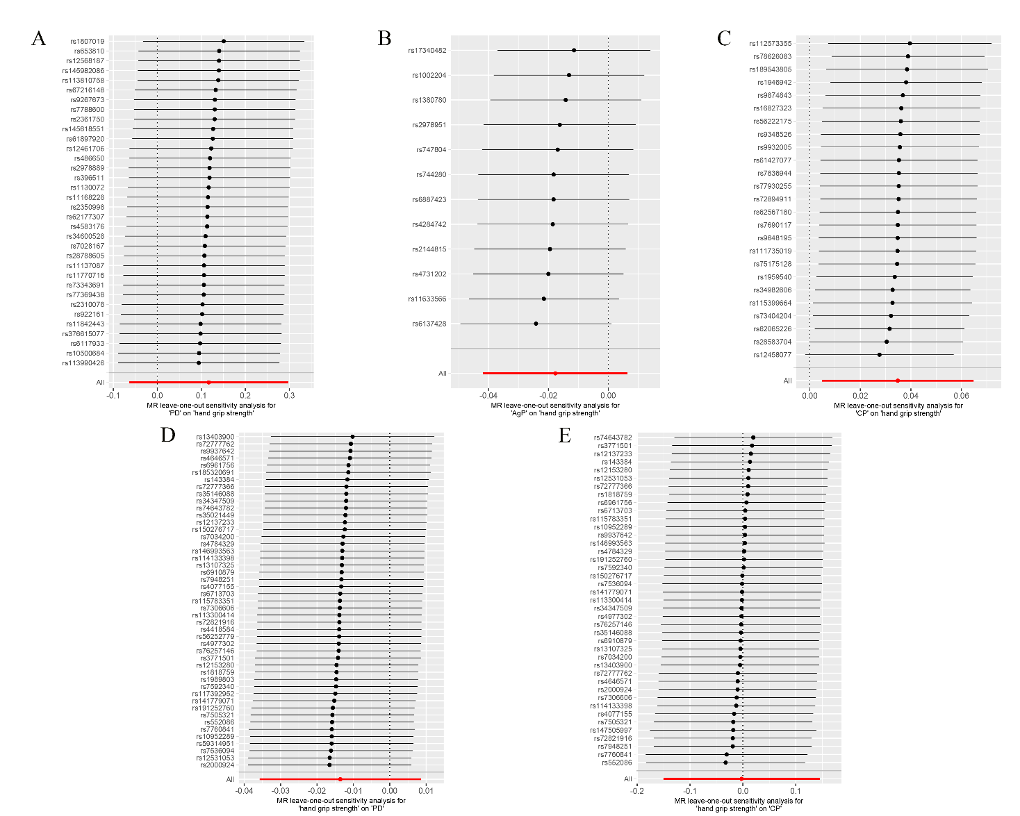
Figure S1. Leave-one-out plot of the causal relationships between hand grip strength and periodontitis phenotypes. (A) MR estimates for PD on hand grip strength. (B) MR estimates for AgP on hand grip strength. (C) MR estimates for CP on hand grip strength. (D) MR estimates for hand grip strength on PD. (E) MR estimates for hand grip strength on CP. The leave-one-out plot visualized how the causal estimates (point with horizontal line) between hand grip strength and periodontitis phenotypes were influenced by the removal of single variant.

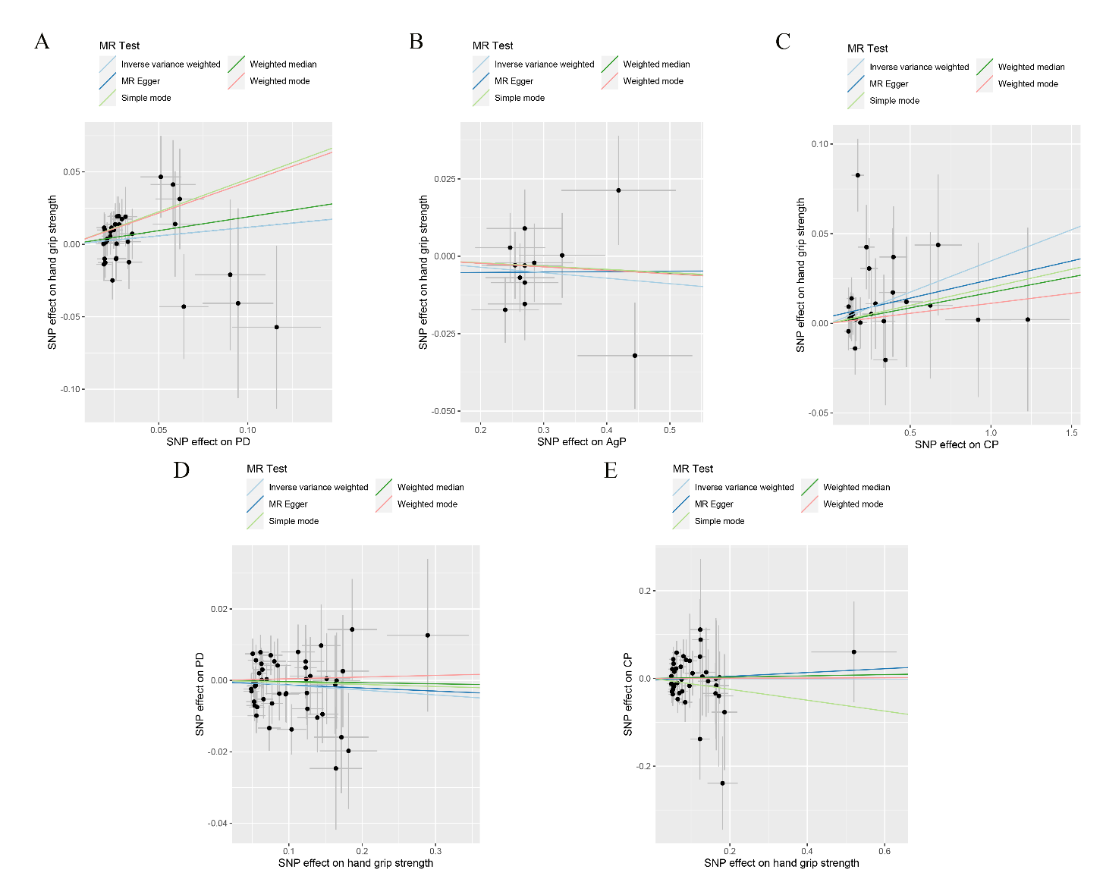
Figure S2. Scatter plot of the causal relationships between hand grip strength and PD using different MR methods. (A) Causal estimates for PD on hand grip strength. (B) Causal estimates for AgP on hand grip strength. (C) Causal estimates for CP on hand grip strength. (D) Causal estimates for hand grip strength on PD. (E) Causal estimates for hand grip strength on CP. The slope of each line corresponding to the causal estimates for each method.
Individual SNP-effect on the outcome (point and vertical line) against its effect on the exposure (point and horizontal line) was delineated in the background.

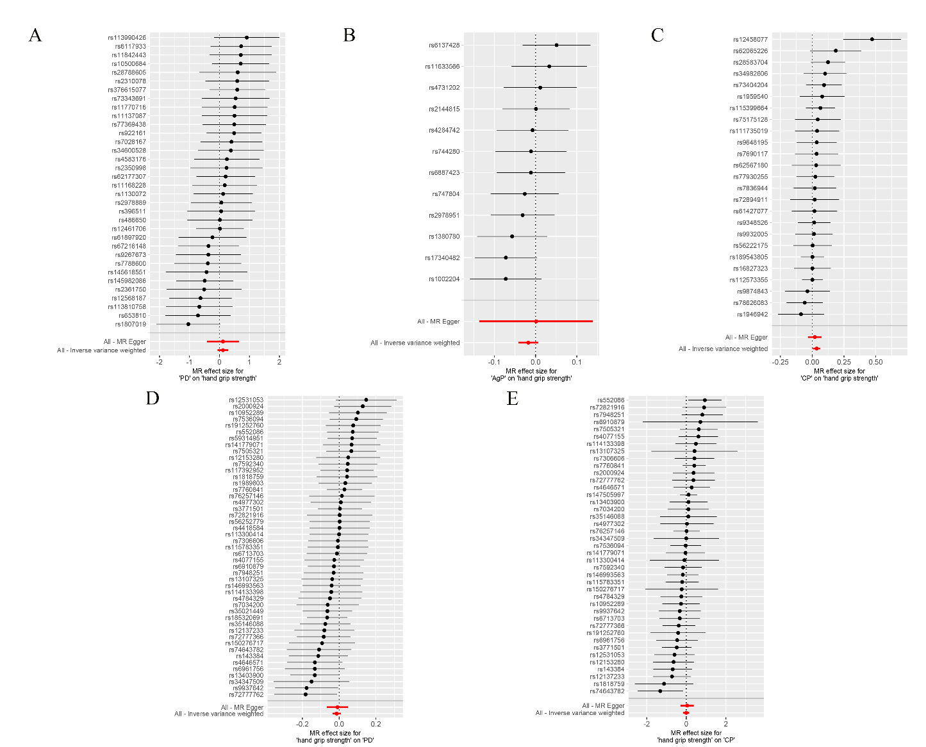
Figure S3. Forrest plot of the causal relationships between hand grip strength and periodontitis phenotypes. (A) MR estimates for PD on hand grip strength. (B) MR estimates for AgP on hand grip strength. (C) MR estimates for CP on hand grip strength. (d) MR estimates for hand grip strength on PD. (E) MR estimates for hand grip strength on PD.

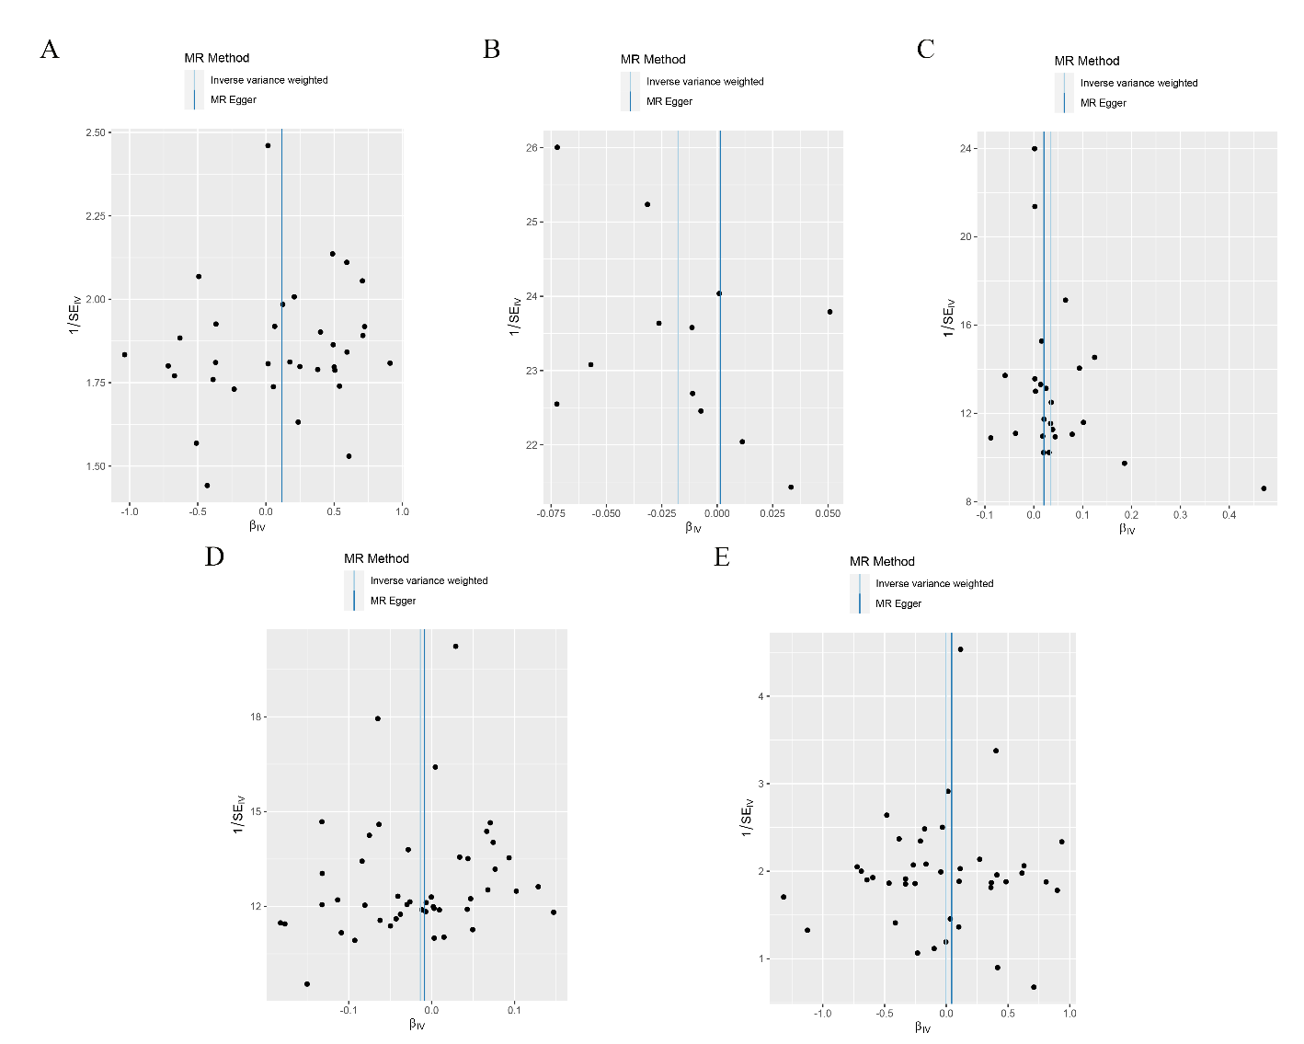Figure S4. Funnel plot of the causal relationships between hand grip strength and periodontitis phenotypes. (A) MR estimates for PD on hand grip strength. (B) MR estimates for AgP on hand grip strength. (C) MR estimates for CP on hand grip strength. (d) MR estimates for hand grip strength on PD. (E) MR estimates for hand grip strength on PD. The funnel plot illustrated the overall symmetry of causal estimates across all instrumental variables.

