Extended data
Extended Data Figure 1.
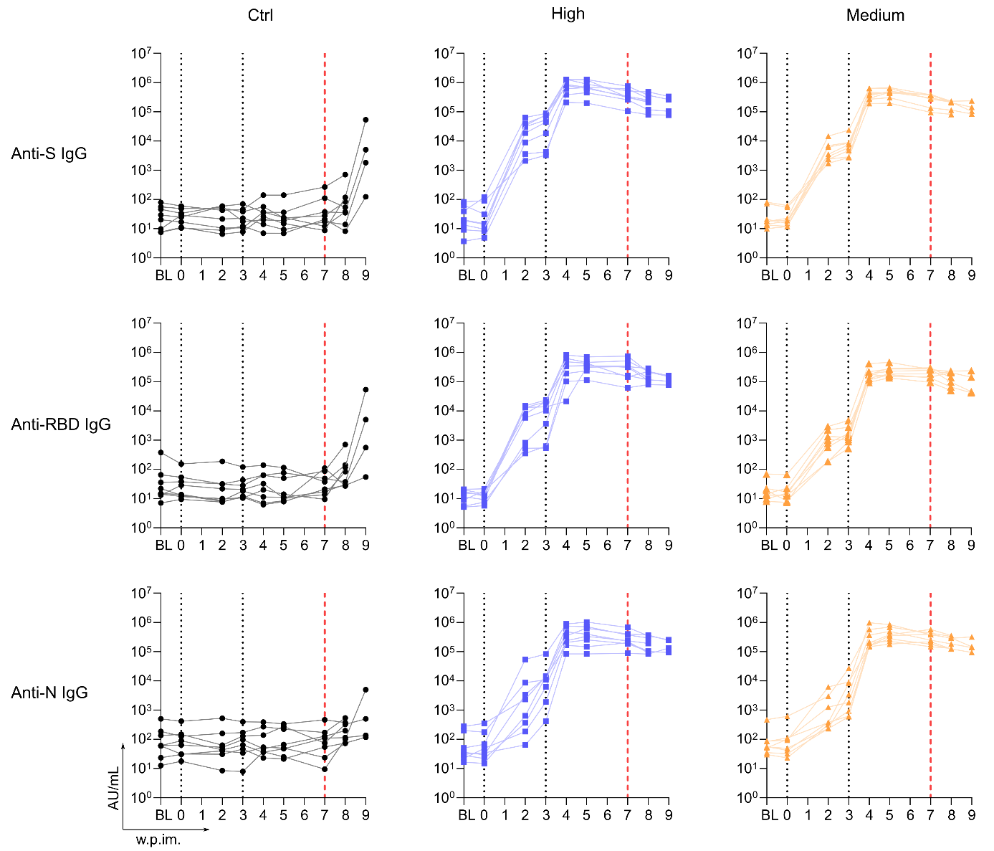
Figure S1. Antibody responses in cynomolgus macaques. Individual titers (AU/mL) of IgG binding to SARS-CoV-2 S (upper), RBD (center) and N (lower) proteins measured in sera samples. BL: baseline approximatively 3 weeks before first immunization. Black dotted vertical lines represent vaccinations. Red dotted vertical lines represent SARS-CoV-2 exposure.
Extended Data Figure 2.
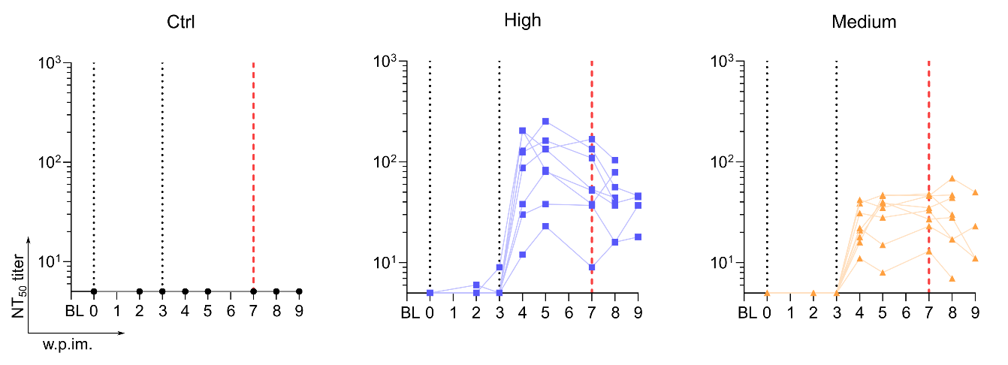
Figure S2. Neutralizing antibody responses in cynomolgus macaques. Individual titers of neutralizing antibody to SARS-CoV-2 (NT₅₀: 50 % neutralizing titer) in sera samples. BL: baseline approximatively 3 weeks before first immunization. Black vertical dotted lines represent vaccinations. Red vertical dotted lines represent SARS-CoV-2 exposure. Graph starts at the limit of quantification at 5.
Extended data Figure 3.
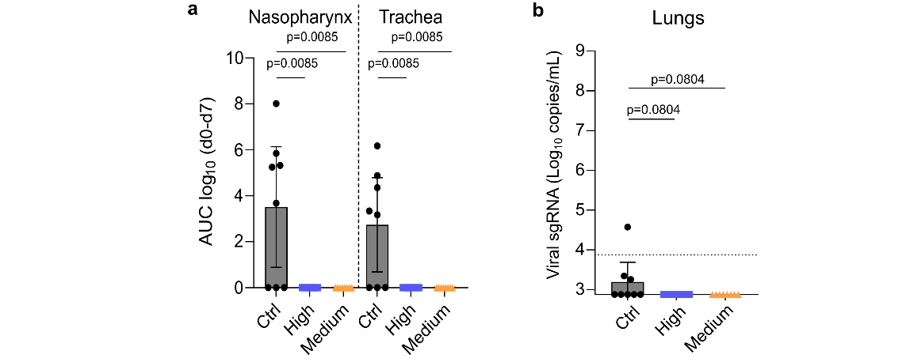
Figure S3. Subgenomic viral quantification (sgRNA) in fluids from respiratory tract following SARS-CoV-2 exposure. a, Area under the curve (AUC) of subgenomic viral RNA (sgRNA) quantification from day 0 to day 7 in nasopharyngeal (left) and tracheal (right) fluids collected with swabs. Bars represent the geometric mean with 95 % CI (non-parametric Kruskal-Wallis and Dunn’s multiple comparisons tests; n=8 per group). b, Individual sgRNA quantification in fluids from bronchoalveolar lavages (BAL) performed at day 3 post SARS-CoV-2 exposure. Bars represent the geometric mean with 95 % CI (non-parametric Kruskal-Wallis and Dunn’s multiple comparisons tests; n=8 per group). Dotted horizontal line represents the LLOQ at 3.87 log₁₀ copies/mL. Graph starts at the LLOD at 2.87 log₁₀ copies/mL. Values below the LLOD were plotted at 2.87 log₁₀ copies/mL.
Extended data Figure 4.
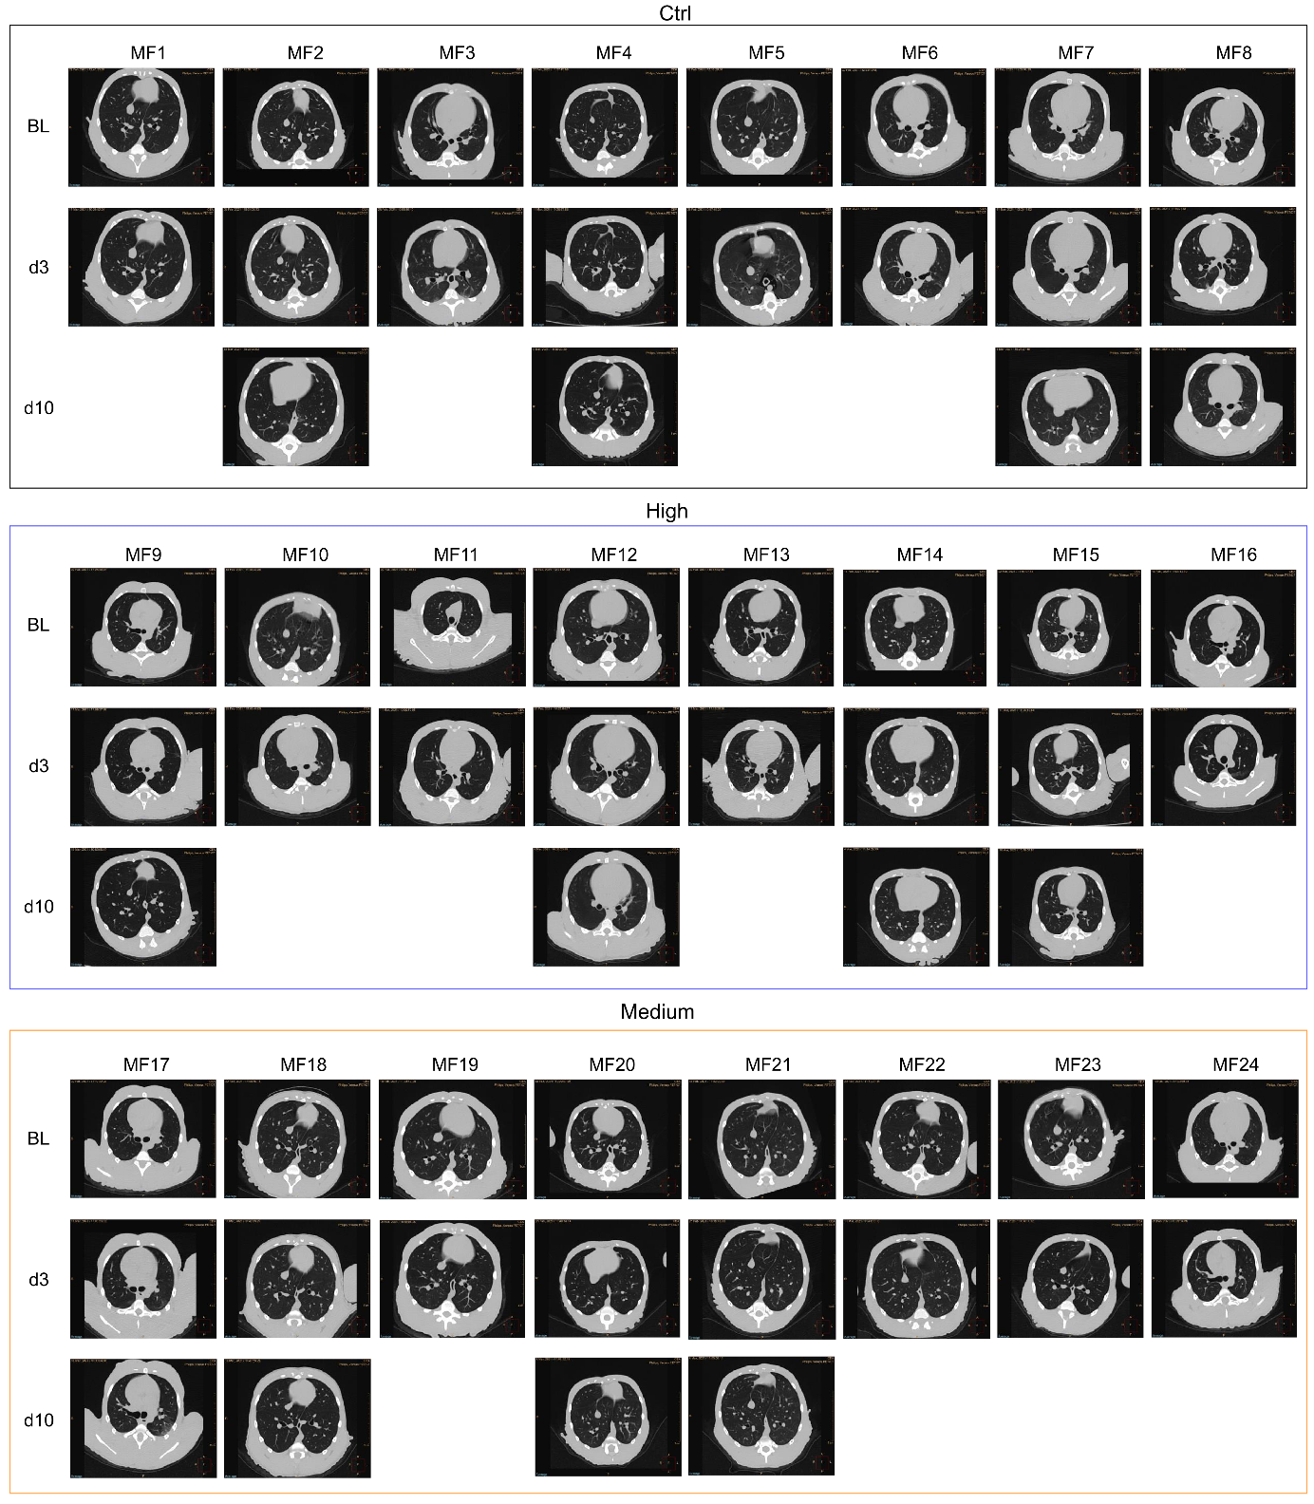
Figure S4. Illustrative images of CT acquisition following SARS-CoV-2 exposure. Representative transversal slices of chest CT scans performed at baseline (week 5 post first immunization), day 3 and day 10 post SARS-CoV-2 exposure showing typical lung lesions.

Extended data Figure 5.
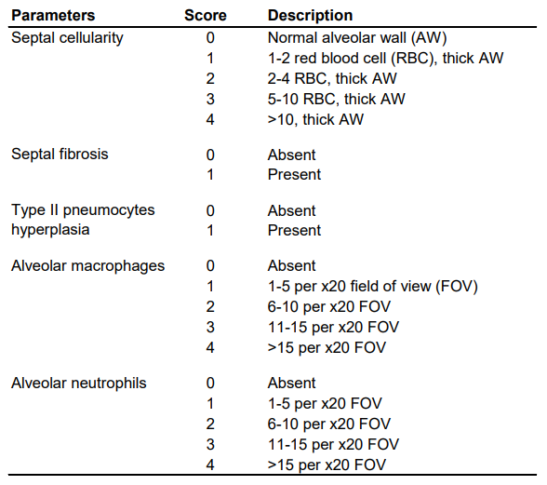
Figure S5. Histopathological score. Histopathology scoring system used for SARS-CoV-2 induced pulmonary lesions.

