Supplement for:
Preparation and characterization of poly(butylene succinate-co-adipate)/poly(lactic acid) blends with enhanced compatibility mechanical properties, and heat resistance
(Figure S1，Table S1)

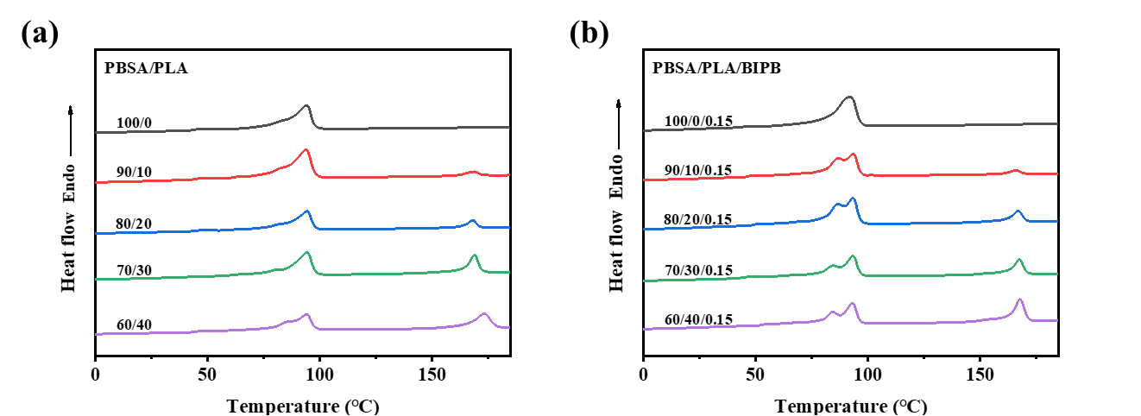
Fig. S1 DSC curves of neat PBSA, neat PLA, and PBSA/PLA/BIPB blends in the first heating run.

Table S1 HDT of neat PLA.
Sample | HDT (℃)
neat PLA (before isothermal treatment) | 60.1 ± 1.2
neat PLA (after isothermal treatment) | 71.3 ± 1.1

