Supporting Information
Photo switchable 4D printing remotely controlled responsive and mechanically robust shape memory polymer nanocomposites

Shiwei Feng¹, Xuelin Peng^{1,2}, Honggeng Li³, Jingjing Cui¹, Ruiqi Feng^{1,2}, Yongding Sun¹, Yunlong Guo¹, Zhe Lu¹, Weizi Gao¹, Fukang Liu¹, Chen Liang¹, Guang Hu¹, Qi Ge^{3,}*, Biao Zhang^{1,}*

¹Frontiers Science Center for Flexible Electronics (FSCFE), Xi’an Institute of Flexible Electronics, Northwestern Polytechnical University, Xi'an 710072, P. R. China
²Queen Mary University of London Engineering School, Northwestern Polytechnical University, Xi'an 710072, P. R. China
³Department of Mechanical and Energy Engineering, Southern University of Science and Technology, Shenzhen 518055, China
*E-mail: geq@sustech.edu.cn; iambzhang@nwpu.edu.cn

Supplementary Movie:

Supplementary Movie S1
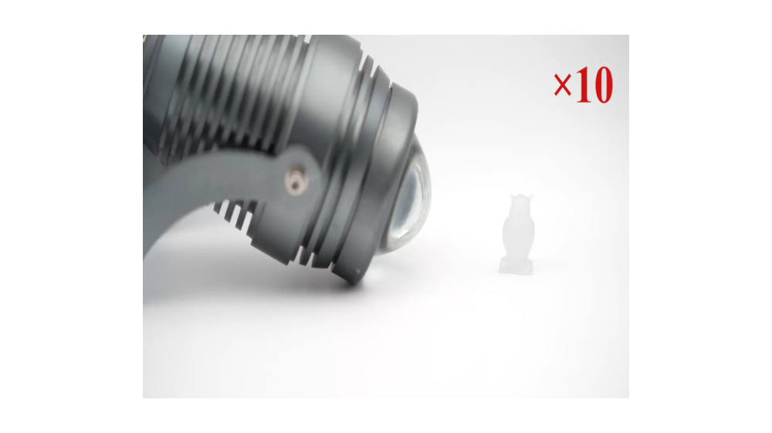
Title: Photo switchable and photothermal demonstration of the printed owl structure.
we print an owl by using our self-built DLP printer (405 nm). It can be seen that the printed structure appears colorless, of which the color changes to dark blue after the structures are irradiated with a 395 nm UV lamp. The color of the structure can return to colorless when the structures are irradiated with visible light. From the Supplementary Movie S1, we can clearly see that the printed owl turns from colorless to dark blue after the 395 nm UV light.

Supplementary Movie S2
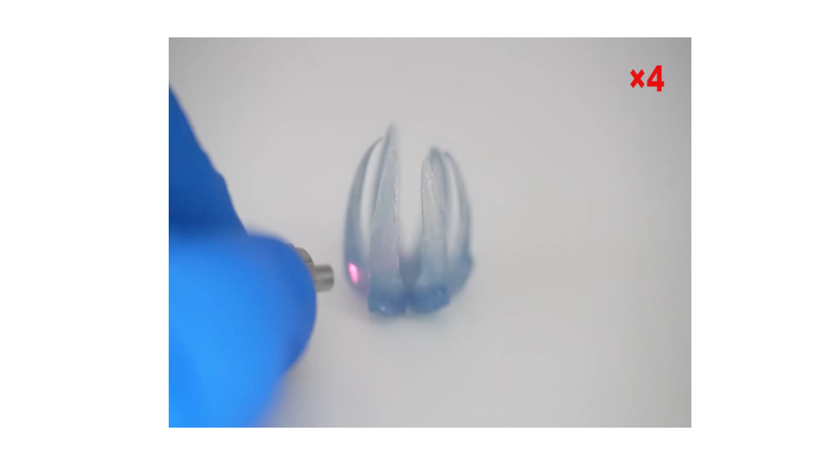
Title: Photo switchable and deformation demonstration of the printed flower structure.
we print a flower using our self-built DLP printer (405 nm). It can be seen that the printed structures appear the color changes to dark blue after irradiated with a 395 nm UV lamp. when the structure is under colored state, it exhibits photothermal effect. The flower with blooming petals (shape Ⅰ) were programmed to a temporary shape Ⅱ at 80 ℃, and then cooled down to room temperature to maintain the temporary shape. The shape Ⅱ is what the closed flower looks like at the beginning of the Supplementary Movie S3. When irradiated, shape Ⅱ can restore its original shape Ⅰ due to irradiated with an 808 nm NIR light source. Shape Ⅱ is what the flower looks like at the beginning of the Supplementary Movie S2. It can be seen that the flower structure can also recover its shape in 28 s when the structure is irradiated with an 808 nm NIR light source.

Supplementary Movie S3
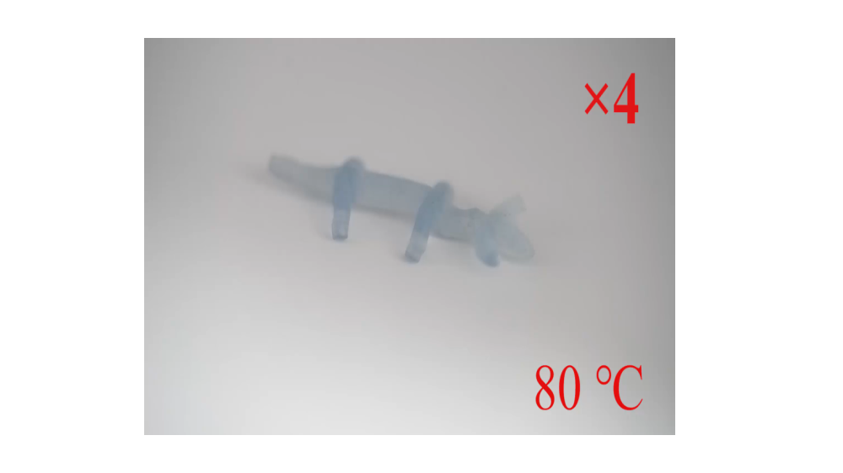
Title: The photo switchable shape memory behaviors of the designed and printed puppy structure.
we print a "puppy" using 3D modeling software. Due to the shape memory effect, the structure can be programmed to a 2D temporary shape, of which the color changes to blue upon UV irradiation (Programming temperature is 80 °C). The state is what the puppy looks like at the beginning of the Supplementary Movie S3. From the Supplementary Movie S3, we can clearly observe that when the infrared point light source irradiates part of the structure of the puppy, which is heated above the programmed temperature, thus gradually returning to its original shape. As the infrared light source moves, the puppy gradually returns to its original shape completely. It can be seen that the puppy can also recover its shape in 104 s when the structure is irradiated with an 808 nm NIR light source.

Supplementary Movie S4
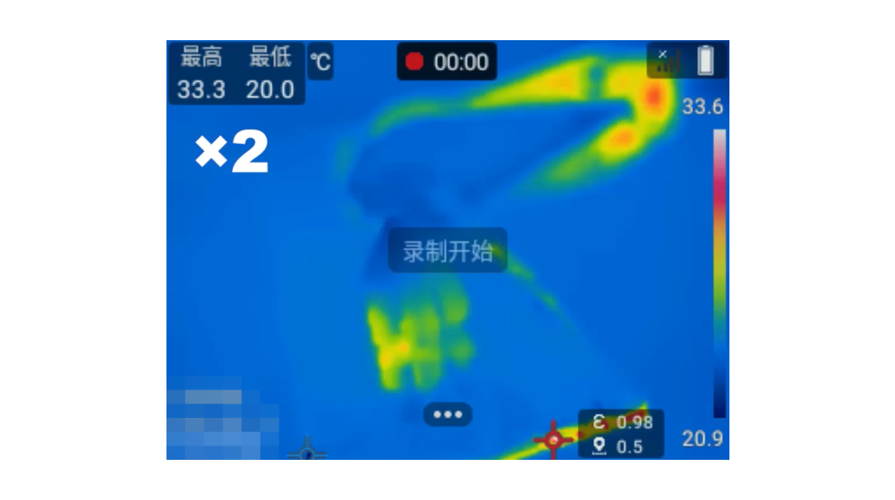
Title: The corresponding thermal infrared images during the shape memory process of the accurate remotely controlled deformation recovery using 808 nm NIR.
A NIR laser equipped with a laser collimator is used to irradiate the colored programmed flowers one meter away. The NIR-irradiated petals can return to their original state, while the rest of the petals maintain their programmed shape, indicating the precise regulation of the deformation according to the remote NIR control. Through thermal infrared video, the temperature of the flower increases from 26.3 °C to 94.2 °C in less than 100 s, demonstrating the efficient photothermal effect regardless of the distance (Supplementary Movie S4).

