Supporting Information

MATERIALS AND METHODS
General Information. Protein purification supplies were purchased from GE Healthcare (Piscataway, New Jersey, USA). Crystallization reagents were purchased from Hampton Research (Aliso Viejo, California, USA).
Cloning of Mpro gene to MBP self-cleavable fusion. The 3CL M^{pro} (Nsp5 M^{pro}) from SARS CoV-2 was cloned in a similar manner to SARS-CoV M^{pro} (PMID: 17189639) with the exception that upstream protein used was MBP instead of original GST. The gene for 3CL M^{pro} SARS-CoV-2 was optimized for E. coli expression synthesized and cloned directly into pET15b vector (Bio Basic) and named M^{pro}-pET15b. The M^{pro} gene was amplified from M^{pro}-pET15b using the following primers: 5’-gggttggaagttttgagcgctgttctgcagtctggtttccgt and 5’-gtgatggtgatgatgcggaccctggaaggtaacaccagagcactga followed by treatment with T4 polymerase in presence of dGTP. The vector for inserting M^{pro}: MBP-TEV-His₇ fragment from pMHTDelta238 (PMID: 17543538) was cloned to vector pMCSG81 and named pMCSG81-Delta238. For the purpose of cloning of M^{pro}, pMCSG81-Delta238 was amplified with the following primers: 5’-catcatcaccatcaccattgagatccggctgctand and 5’-caaaacttccaacccggcaccgtcgccgttaat. The PCR product was purified and T4 treated in presence of dCTP. Resulting T4 treated fragments were mixed and transformed into BL21-Gold(DE3) cells and selected against ampicillin. Plasmid from a single colony was purified and sequenced. The plasmid name was designated as pCSGID-Mpro. In this expression system at the N-terminus, the construct is flanked by the maltose binding protein followed by the 3CL M^{pro} autocleavage site SAVLQ↓SGFRK (arrow indicates the cleavage site) corresponding to the cleavage between NSP4 and NSP5 in the viral polyprotein. At the C-terminus, the construct codes for the human rhinovirus 3C PreScission protease cleavage site (SGVTFQ↓GP) connected to a His₆ tag. The authentic N-terminus is generated by 3CL M^{pro} autoprocessing during expression, whereas the authentic C-terminus is generated by the treatment with PreScission protease, similar to the published methodology¹.

Protein expression and purification. Expression of 3CL M^{pro} using Luria-Bertani, supplemented with 1 g/L glucose, was performed in E. coli (BL21-DE3) cells using carbenicillin antibiotic (150 mg/L of culture). The cells were grown to an OD₆₀₀ of 0.8 at 37 °C before induction with the addition of 0.2 mM isopropyl-D-thiogalactoside (IPTG). The temperature was then dropped to 18 °C and 3CL M^{pro} was overexpressed for 18 hours. The harvested cells were resuspended in the lysis buffer containing 20mM TRIS pH=8, 40 mM imidazole, 150 mM NaCl and 1mM TCEP. After cells were lysed by sonication the insoluble fraction was removed by centrifugation at 30,000g for 30 min, the supernatant was then loaded onto a HisTrap FF column. 3CL Mpro was eluted using a linear gradient of buffer containing 20mM TRIS pH=8, 500 mM imidazole, 150 mM NaCl and 1mM TCEP. The fractions containing the protease were then pooled, and PreScission protease containing a His₆ tag (Sigma-Aldrich, St. Louis, MO) was added at a 500:1 molar ratio. The mixture was then dialyzed against a solution containing 20mM TRIS pH=8, 150 mM NaCl, and 1mM TCEP for 18 hours at 4 °C to remove the C-terminal His₆ tag, resulting in a 3CL M^{pro} with authentic N- and C-termini. The PreScission-treated 3CL M^{pro} solution was applied to a HisTrap FF column to remove the PreScission protease, the C-terminal tag, and 3CL M^{pro} with uncleaved His tag. The authentic 3CL M^{pro} was collected in the flow-through and concentrated to 4 mg/mL.
Crystallization. The concentrated protein solution was first sent to the High-Throughput Crystallization Screening Center at the Hauptman-Woodward Medical Research Institute (Buffalo, NY), where 1536 crystallization conditions were screened using 96-well sitting drop plates. Thin plate-like crystal “flowers” appeared in several conditions within a week and were set up manually in the lab to reproduce the crystal growth. The best-looking crystals grew in 0.1M BIS-TRIS pH=6.5, 25% PEG3350. Several crystal “flower” aggregates were collected from this condition, and were used to make microseeds using Hampton Research seed beads. For X-ray crystallography, crystals were grown in 10 μL drops made by mixing the protein sample (4 mg/mL), reservoir solution (0.1M BIS-TRIS pH=6.5, 20% PEG3350) at a 1:1 ratio and 0.2 μL of miscroseeds (1:100 dilution) in a sitting drop setup. The resulting crystal drop pH was measured using a microelectrode to be 7.0. Single plate-like crystals grew in several days (Figure S1a). To collect a room-temperature diffraction dataset, a crystal of 3CL M^{pro} was mounted using the MiTeGen (Ithaca, NY) room-temperature capillary setup (Figure S1b,c).
X-ray data collection and structure refinement. Room temperature X-ray crystallographic data for ligand-free 3CL M^{pro} were collected on a Rigaku HighFlux HomeLab instrument equipped with a MicroMax-007 HF X-ray generator and Osmic VariMax optics. The diffraction images were obtained using an Eiger 4M hybrid photon counting detector. Diffraction data were integrated using the CrysAlis Pro software suite (Rigaku Inc., The Woodlands, TX). Diffraction data were then reduced and scaled using the Aimless² program from the CCP4 suite³, molecular replacement using PDB code 6M03 was then performed with Molrep³ from the CCP4 program suite. Refinement of the protein structure was conducted using Phenix.refine from the Phenix⁴ suite of programs and the COOT⁵ molecular graphics program. The geometry of the final structure was then carefully checked with Molprobity⁶; the data collection and refinement statics are shown below in Table S1.
MD Simulation. Classical molecular dynamics (MD) simulation was prepared, conducted, and analyzed on an apo 3CL M^{pro} dimer adapted from deposited structure PDB code 6Y84 using GROMACS 2020⁷. The system was described using the CHARMM36m force field⁸. The dimer was solvated in a rhombic dodecahedron with 10 Å from the nearest cell edge using the TIP3P⁹ water model and 8 Na ions. Periodic boundary conditions were applied, and the system was minimized in less than 1000 steps using the steepest descent algorithm. The system was equilibrated to 300 K and 1 bar using the V-rescale thermostat¹⁰ and Berendsen barostat¹¹. A 1 µs production MD was performed using the leap-frog integration with Nose-Hoover^{12,13} and Parinello-Rahman couplings¹⁴. Hydrogen bonds were constrained using the SHAKE algorithm¹⁵. Atomic coordinates were saved every 10 ps. RMSF was calculated for protein backbone atoms after RMSD convergence.

Table S1. Data reduction and refinement statistics for the room temperature structure of the 3CL Mpro from SARS-CoV2.

 | 3CL M^{pro}, PDB ID 6WQF
Data collection: | X-ray
Diffractometer | Rigaku HighFlux Eiger 4M
Space group | I2
Wavelength (Å) | 1.54
Cell dimensions:
a, b, c (Å) | 45.07, 54.06, 113.61
α, β, γ (°) | 90, 100.51, 90
Resolution (Å) | 27.92-2.30 (2.38-2.30)*
No. reflections unique | 11514 (858)
R_{merge} | 0.110 (0.621)
R_{pim} | 0.065 (0.421)
CC_{1/2} | 0.993 (0.666)
I / σI | 8.1 (1.9)
Completeness (%) | 95.4 (72.999.2)
Redundancy | 3.7 (2.7)
Refinement: | X-ray
Resolution | 27.92 – 2.30
Data rejection criteria | no observation & |F|=0
R_{work} / R_{free} | 0.180 / 0.230
Ramachandran statistics
Favored (%) | 95.72
Allowed (%) | 4.28
Outliers (%) | 0
R.M.S. deviations
Bond lengths (Å) | 0.002
Bond angles (°) | 0.444
All atom clashscore | 0.85

* Values in parentheses are for highest-resolution shell. Data were collected from 1 crystal for each structure.

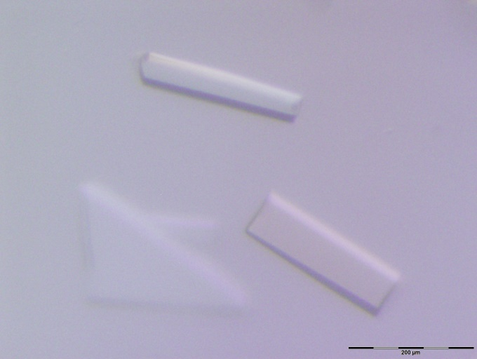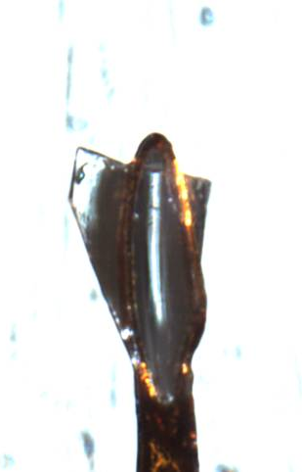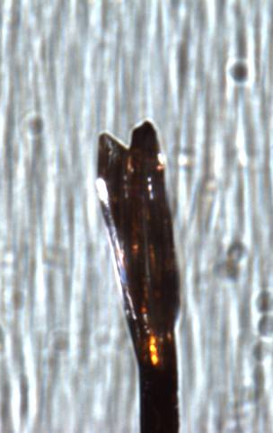
A B C
Figure S1. (A) Crystals of 3CL Mpro grown using the microseeding technique; (B, C) Crystal mounted on a loop used for the room-temperature X-ray data collection.

Figure S2. Superposition of the room temperature ligand-free structure of 3CL M^{pro} (green carbon atoms) in complex with inhibitor N3 (deep purple, PDB ID 6LU7) from SARS-CoV-2. The C-terminal tail flips 180 ° upon the inhibitor binding (shown by the curved red arrow).

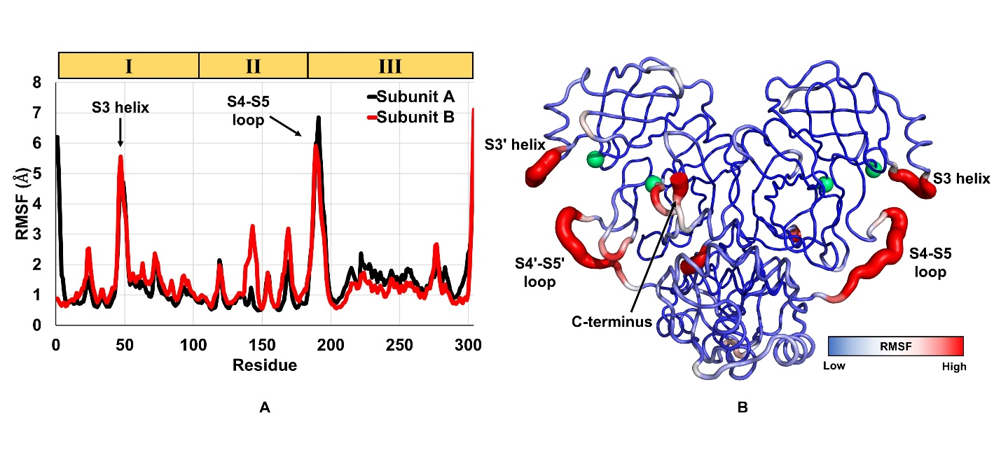
Figure S3. Root Mean Square Fluctuation (RMSF) analysis from a 1 µs MD simulation of an apo 3CL M^{pro} dimer. (A) Protein backbone RMSF by residue for Subunits A and B. (B) Cartoon-putty representation of 3CL M^{pro} colored by protein backbone RMSF with Cα of His41/41ʹ and Cys145/145ʹ shown as green spheres.

References

1. Zhang, L.; Lin, D.; Sun, X.; Curth, U.; Drosten, C.; Sauerhering, L.; Becker, S.; Rox, K.; Hilgenfeld, R., Crystal structure of SARS-CoV-2 main protease provides a basis for design of improved α-ketoamide inhibitors. Science 2020, eabb3405.
2. Evans, P. R.; Murshudov, G. N., How good are my data and what is the resolution? Acta Crystallographica Section D 2013, 69 (7), 1204-1214.
3. Winn, M. D.; Ballard, C. C.; Cowtan, K. D.; Dodson, E. J.; Emsley, P.; Evans, P. R.; Keegan, R. M.; Krissinel, E. B.; Leslie, A. G. W.; McCoy, A.; McNicholas, S. J.; Murshudov, G. N.; Pannu, N. S.; Potterton, E. A.; Powell, H. R.; Read, R. J.; Vagin, A.; Wilson, K. S., Overview of the CCP4 suite and current developments. Acta Crystallogr D 2011, 67, 235-242.
4. Adams, P. D.; Afonine, P. V.; Bunkoczi, G.; Chen, V. B.; Davis, I. W.; Echols, N.; Headd, J. J.; Hung, L. W.; Kapral, G. J.; Grosse-Kunstleve, R. W.; McCoy, A. J.; Moriarty, N. W.; Oeffner, R.; Read, R. J.; Richardson, D. C.; Richardson, J. S.; Terwilliger, T. C.; Zwart, P. H., PHENIX: a comprehensive Python-based system for macromolecular structure solution. Acta Crystallogr D Biol Crystallogr 2010, 66 (Pt 2), 213-21.
5. Emsley, P.; Lohkamp, B.; Scott, W. G.; Cowtan, K., Features and development of Coot. Acta Crystallogr D Biol Crystallogr 2010, 66 (Pt 4), 486-501.
6. Chen, V. B.; Arendall, W. B.; Headd, J. J.; Keedy, D. A.; Immormino, R. M.; Kapral, G. J.; Murray, L. W.; Richardson, J. S.; Richardson, D. C., MolProbity: all-atom structure validation for macromolecular crystallography. Acta Crystallogr D 2010, 66, 12-21.
7. Abraham, M. J.; Murtola, T.; Schulz, R.; Páll, S.; Smith, J. C.; Hess, B.; Lindahl, E. Gromacs: High Performance Molecular Simulations through Multi-Level Parallelism from Laptops to Supercomputers. SoftwareX 2015, 1–2, 19–25.
8. Huang, J.; Rauscher, S.; Nawrocki, G.; Ran, T.; Feig, M.; De Groot, B. L.; Grubmüller, H.; MacKerell, A. D. CHARMM36m: An Improved Force Field for Folded and Intrinsically Disordered Proteins. Nat. Methods 2016, 14 (1), 71–73.
9. Jorgensen, W. L.; Chandrasekhar, J.; Madura, J. D.; Impey, R. W.; Klein, M. L. Comparison of Simple Potential Functions for Simulating Liquid Water. J. Chem. Phys. 1983, 79 (2), 926–935.
10. Bussi, G.; Donadio, D.; Parrinello, M. Canonical Sampling through Velocity Rescaling. J. Chem. Phys. 2007, 126 (1), 014101.
11. Berendsen, H. J. C.; Postma, J. P. M.; Van Gunsteren, W. F.; Dinola, A.; Haak, J. R. Molecular Dynamics with Coupling to an External Bath. J. Chem. Phys. 1984, 81 (8), 3684–3690.
12. Nosé, S. A Molecular Dynamics Method for Simulations in the Canonical Ensemble. Mol. Phys. 1984, 52 (2), 255–268.
13. Hoover, W. G. Canonical Dynamics: Equilibrium Phase-Space Distributions. Phys. Rev. A 1985, 31 (3), 1695–1697.
14. Parrinello, M.; Rahman, A. Polymorphic Transitions in Single Crystals: A New Molecular Dynamics Method. J. Appl. Phys. 1981, 52 (12), 7182–7190.
15. Ryckaert, J.-P.; Ciccotti, G.; Berendsen, H. J. C. Numerical Integration of the Cartesian Equations of Motion of a System with Constraints: Molecular Dynamics of n-Alkanes. J. Comput. Phys. 1977, 23, 321-341.

