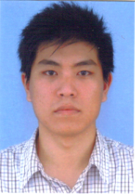
Hui Li received his BS. MS. and Ph. D from Harbin Institute of Technology (HIT), China in 2000, 2002 and 2006 respectively. He was with a postdoc. and an associate professor from 2005 to 2009 in HIT (Shenzhen), with an associate professor from 2009 to 2014 in Zhejiang University, and with a full professor from 2014 to 2020 in Hainan University. He was with a general manager assistant during 2011 in Shaanxi Electronic Information Group, China, and with a visitor scholar during 2013 in National Institute of Standard and Technology, USA. He is now a full professor and vice dean at the Wuxi University. He is an/a author/coauthor of 6 books, inventor of 20 patents and has published more 180 papers in the fields of wireless communication, communication networks, signal processing, etc. He is the High-level Talent of 3rd level in “515 Project” from 2017 and a Top-notch Personnel from 2018 and Leading Talent form 2019 at Hainan province. He received Best Paper Award in the international conferences of CSPS2018 and CISCE2019. His researching areas include: 5G+/6G wireless networks, space communication, maritime communications, IoT, etc.
E-mail: hitlihui1112@163.com


Xinyuan Yu received the BS and MS. degrees from Nanjing University of Information Science and Technology in 2016 and 2023 respectively. His researching areas include: 5G mobile communication, power control, and Optimization of cognitive network resources.


Yongjie Xu received the BS and MS. degrees from Nanjing University of Information Science and Technology in 2016 and 2023 respectively. His researching areas include: 5G mobile communication, and Edge Computing.

