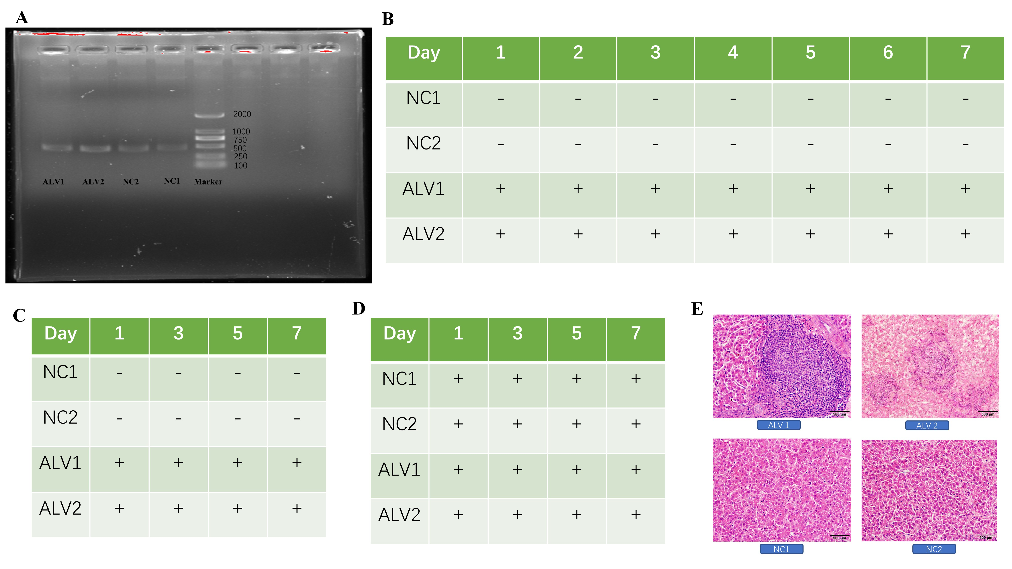
S1: A: Gel electrophoresis showed that four chickens were infected with ALV-J. B: Cloacal detoxification, sample NC is not detoxified, sample ALV is keeping detoxified. C: Viremia status, sample NC without viremia, sample ALV with viremia. D: Antibody profile, both with ALV-J specific antibodies. E: HE staining of liver tissue.

