Supplementary Information

Chiroptical detection and mutation analysis of cancer-associated extracellular vesicles in microfluidic devices with oriented chiral nanoparticles

Yoon-Tae Kang^{1,‡}, Ji-Young Kim^{1,‡}, Emine Sumeyra Turali-Emre¹, Hee-Jeong Jang¹, Minjeong Cha¹, Abha Kumari¹, Colin Palacios-Rolston¹, Chitra Subramanian¹, Emma Purcell¹, Sarah Owen¹, Chung-Man Lim¹, Rishindra Reddy³, Shruthi Jolly⁴, Nithya Ramnath⁵, Sunitha Nagrath^{1,2,*}, Nicholas A. Kotov^{1,*}

¹Department of Chemical Engineering and Biointerfaces Institute, University of Michigan, 2800 Plymouth Road, NCRC B10-A184, Ann Arbor, MI 48109, USA
Nicholas A. Kotov, Biointerfaces Institute,
Department of Chemical Engineering,
Department of Biomedical Engineering,
University of Michigan, Ann Arbor, MI
48109, USA
Nicholas A. Kotov, Biointerfaces Institute,
Department of Chemical Engineering,
Department of Biomedical Engineering,
University of Michigan, Ann Arbor, MI
48109, USA
²Roger Cancer Center, University of Michigan, 1500 E Medical Center Dr. Ann Arbor, 48109
³Michigan Medicine Thoracic Surgery Clinic, Taubman Center, 1500E Medical Center Dr. SPC 5344, Ann Arbor, MI, 48109 USA
⁴Radiation of Oncology, University of Hospital, University of Michigan, 1500 E Medical Center Dr. Ann Arbor, MI, 48109, USA
⁵Department of Internal Medicine, University of Michigan, Ann Arbor, MI, 48109 USA
*Correspondence: Dr. Nicholas A. Kotov (kotov@umich.edu) and Dr. Sunitha Nagrath (snagrath@umich.edu)
* Co-corresponding authors
‡ Two authors contributed equally to this work

Contents

S1. The size distribution and ζ-potential of the chiral AuNP probe 4
S2. UV-vis spectra of chiral Au NP 5
S3. Electron Tomography of L-Au NP 6
S4. Three-dimensional model structures of AuNP enantiomer 7
S5. Evaluation criteria for the present devices and definitions 8
S6. Fabrication and surface modification of CDEXO chip 9
S7. The chiral NP – exosome complex models for electromagnetic computation 10
S8. Calculated minimum inaccessible radius of the 3D model of chiral NPs 11
S9. EM analysis of Au NPs and sEVs 13
S10. Isolation and profiling of sEVs from using various methods 15
S11. Osipov-Pickup-Dunmur (OPD) chirality indices calculation 17
S12. CD profile of lung cancer patients 18
S13. Patients information 22

Figures & Table
Fig. S1. Size distribution and ζ-potential of the chiral ANPs 4
Fig. S2. UV-Vis spectra of chiral ANPs 5
Fig. S3. Three-dimensional morphology of Chiral AuNPs 6
Fig. S4. Three-dimensional enantiomer structure models of ANPs 7
Fig. S5. CDEXO microfluidic device 9
Fig. S6. The electromagnetic simulation on the L-NP with exosome-mimic dielectric particle 10
Fig. S7. Calculated minimum inaccessible radius of the chiral NPs for different pocket sizes: 11
Fig. S8. Chiro-plasmonic effect of chiral gold nanoparticles for sensing small-extracellular vesicles on CDEXO chip 12
Fig. S9. Elemental mapping analysis of surface modified chiral NPs 13
Fig. S10. EM analysis of sEVs 14
Fig. S11. Western blot analysis of sEV from three different cancer/normal lung cells carrying different EGFR mutations 15
Fig. S12. CDEXO chip-based sEV isolation validation 15
Fig. S13. CD signals of two different lung cancer cell line derived sEVs on CDEXO 16
Fig. S14. sEV recovery performance comparison between CDEXO chip and ultracentrifugation 16
Fig. S15. OPD calculation and comparison of EGFR mutant and wild type proteins 17
Fig. S16. Comparison of CD signal between healthy and lung cancer patients 18
Fig. S17. Average circular dichroism spectra change between clinical groups 18
Fig. S18. Comparison of CD signal between EGFR mutation subgroups in lung cancer patients 19
Fig. S19. Size profile analysis of EVs recovered from CDEXO chip using clinical samples 20
Fig. S20. CDEXO profiling of clinical samples using two different sEV capturing molecules, annexin V and anti-epidermal growth factor receptor (EGFR) 21
Table S1. Clinical information of the patient samples 22

S1. The size distribution and ζ-potential of the chiral Au NPs
The average diameter and ζ-potential determined by dynamic light scattering is 113.7 nm and 11.4 mV, respectively.
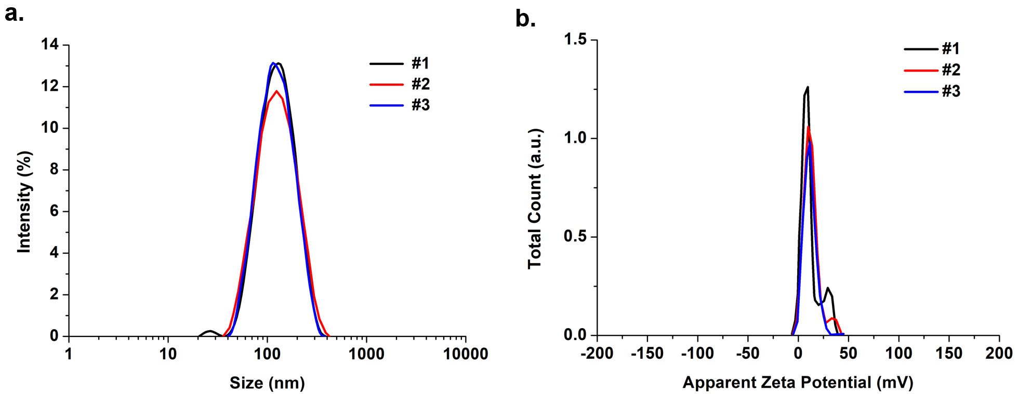
Figure S1. Size distribution and ζ-potential of the chiral NPs: (a) Size distribution by dynamic light scattering (DLS) and (b) ζ-potential of the chiral NPs.

S2. UV-vis spectra of chiral Au NPs
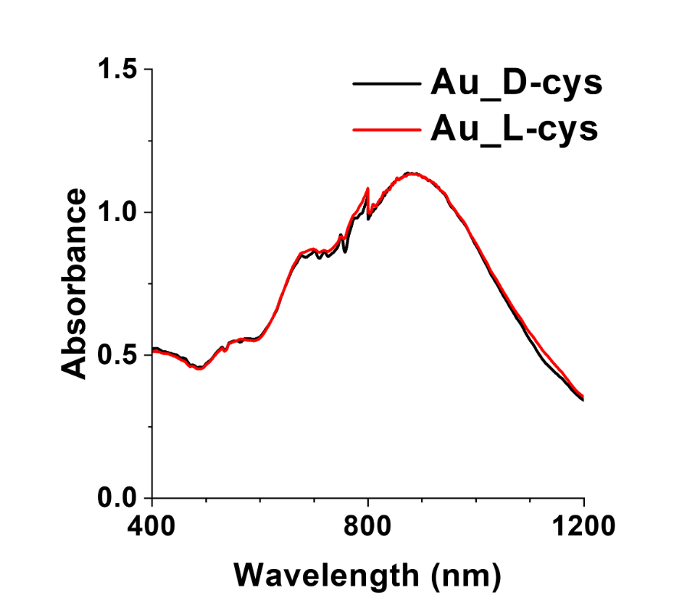
Figure S2. UV-vis spectra of chiral Au NPs

S3. Electron Tomography of L-Cys NPs
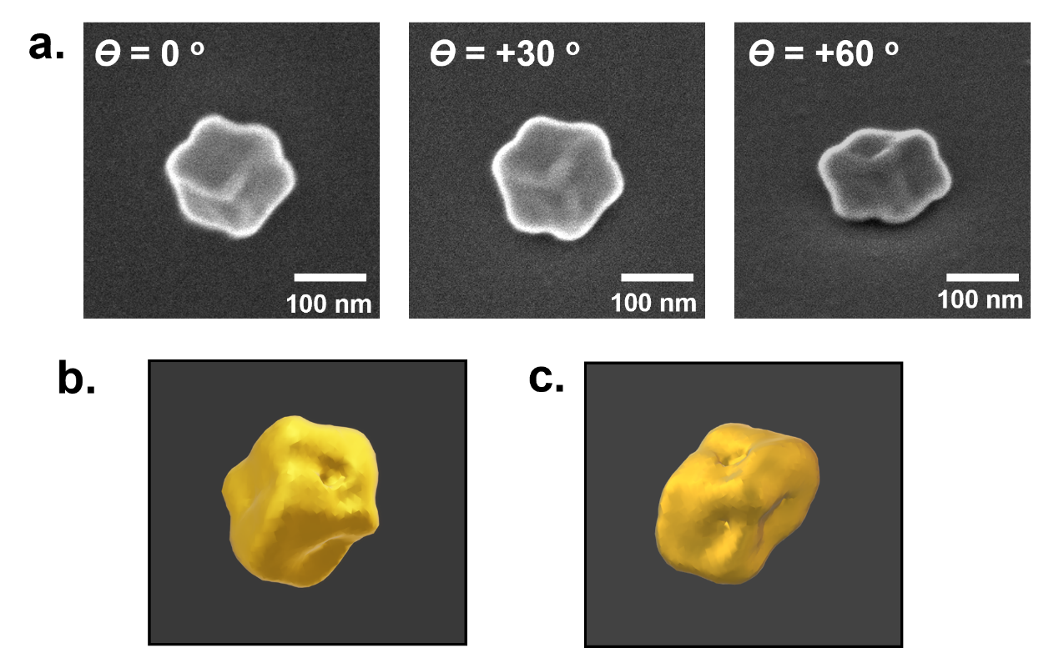
Figure S3. Three-dimensional morphology of chiral Au NPs: (a) Tilted series of SEM images for fully grown L-Cys NPs. (b,c,) Top (b) and side (c) view of reconstructed 3D electron tomography of the L-Cys NPs.

Please clarify the notations and composition
L-Cys?

S4. Three-dimensional model structures of Au NP enantiomers
The three-dimensional structure of Au NP enantiomers were constructed based on the morphology of the NPs observed by electron microscopies. The tilted SEM image series (Fig. S3a) showed that the NPs are the disc-like NPs with roughly estimated thickness of 100 nm. The two enantiomer model structures were constructed by importing distorted cuboid structures with propeller-like edges (edge length =150 nm). The structures are mirrored to each other on yz plane as shown in Fig. S4a and b. The 3D developed models have been imported into the electromagnetic simulation. (Fig. 2e,f) As expected, NPs fixed on the substrate showed considerable red shift and broadening in spectral range of the chiroptical bands compared to the chiral Au NPs colloid sample. Such change in chiroptical activities is often observed in deposition of anisotropic NPs due to its limited angle to the incidence as well as environmental dielectric change in solid states.

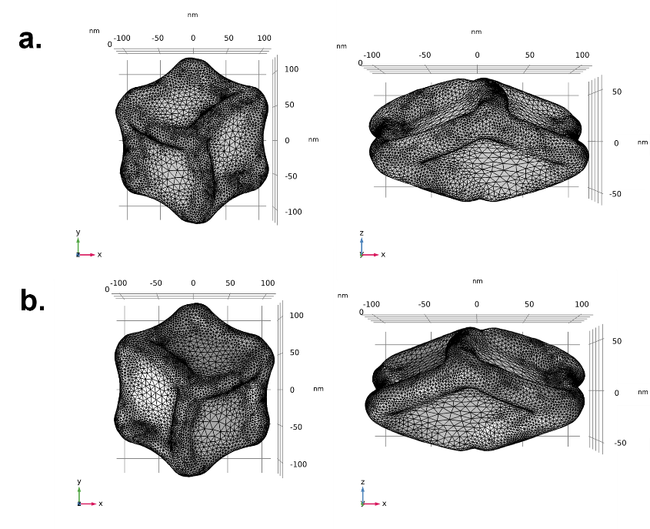
Figure S4. Three-dimensional enantiomer structure models of Au NPs: Top (left) and side (right) view of the enantiomers NP models which represents L-Cys (a) and D-Cys (b) AuNPs, respectively.

S5. Evaluation Criteria for the Present Devices and Definitions
Capture efficiency is the fraction of the isolated sEVs by CDEXO chip compared to initial amount of spiked sEVs. In this research, we evaluated the amount of isolated sEVs by subtraction of effluent’s amount to initial amount. Among whole concentration, we only evaluated the amount of exosome/sEV-sized vesicles, ranging 30-150nm, and it is calculated as follow.
$$Capture Efficiency \left(\%\right)=\left[1-\frac{\left(Concentration of Exosome-sized Vesicles in Capture Effluent\right)}{\left(Concentration of Exosome-sized Vesicles in Initial Sample\right)}\right]*100$$

The recovery rate is the fraction of release resultant to the sum of the capture effluent and release resultant. If we do not know the initial concentration of sample but want to know the isolation tendency of the present device, a simpler version of capture/release efficiency is ‘recovery rate’ derived only from capture effluent and release resultant concentrations. It is calculated as follow.
$$Recovery Rate \left(\%\right)=\left[\frac{\left(concentration of exosome-sized vesicles in release resultant\right)}{\left(concentration of exosome-sized vesicles in capture effluent+release resultant\right)}\right]*100\%$$

In order to evaluate whether the present device captures purified sEVs from the heterogeneous samples, we calculated the purity of the sample, the fraction of the concentration in exosome sized vesicles compared to whole concentration. Whole concentration values came directly from NTA result, and the concentrations of exosome sized vesicles were re-calculated from the NTA raw data.
$$Purity \left(\%\right)=\left[\frac{\left(concentration of exosome-sized vesicles in sample\right)}{\left(concentration of whole vesicles in sample\right)}\right]*100\%$$
S6. Fabrication and surface modification of CDEXO chip
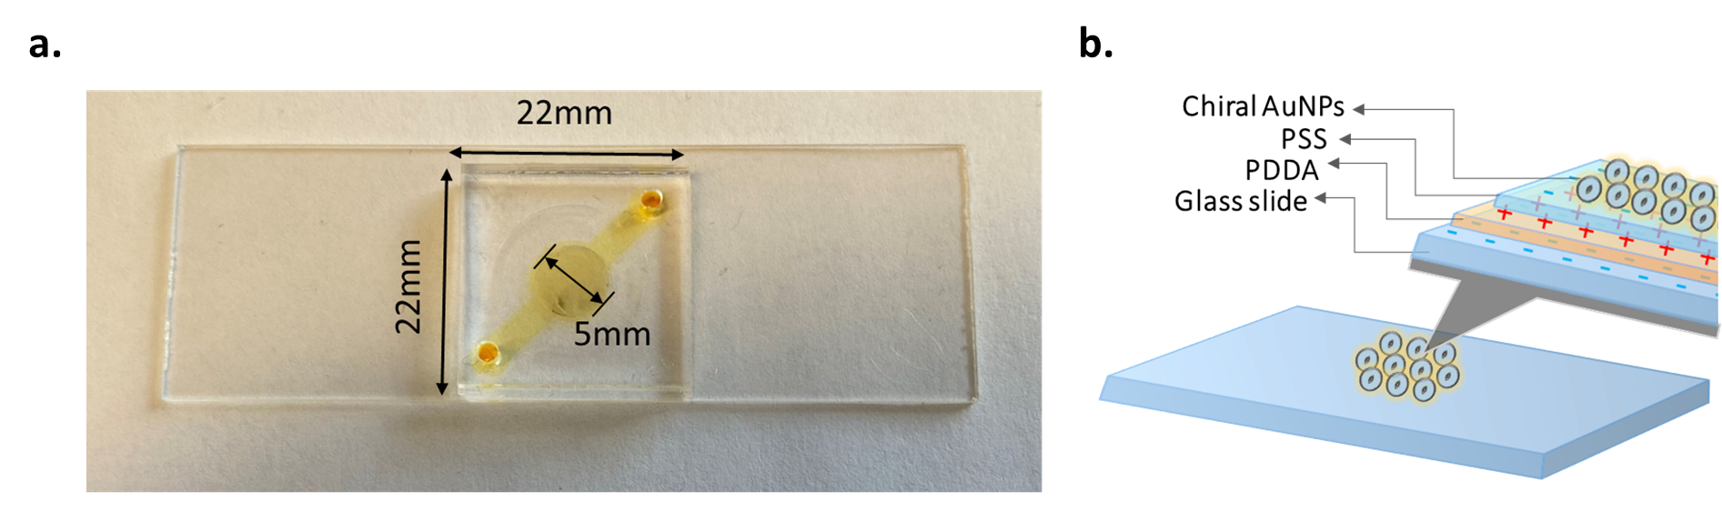

Figure S5. CDEXO microfluidic device: (a) the fabricated CDEXO device with dimensions; (b) information of each layer on CDEXO device.

S7. The chiral NP – sEV complex models for electromagnetic computation
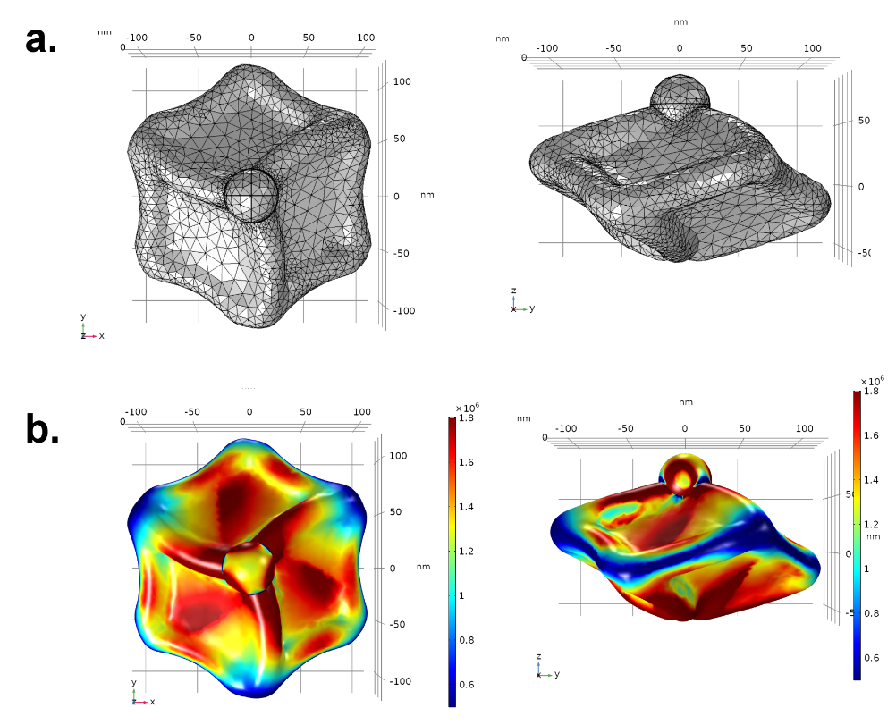
Figure S6. The electromagnetic simulation on the L-NP with exosome-mimic dielectric particle: Top (left) and side (right) view of (a) 3D model structure of AuNP-exosome complex and (b) averaged extinction surface map under CPL at wavelength of 550 nm.

S8. Calculated minimum inaccessible radius of the 3D model of chiral NPs

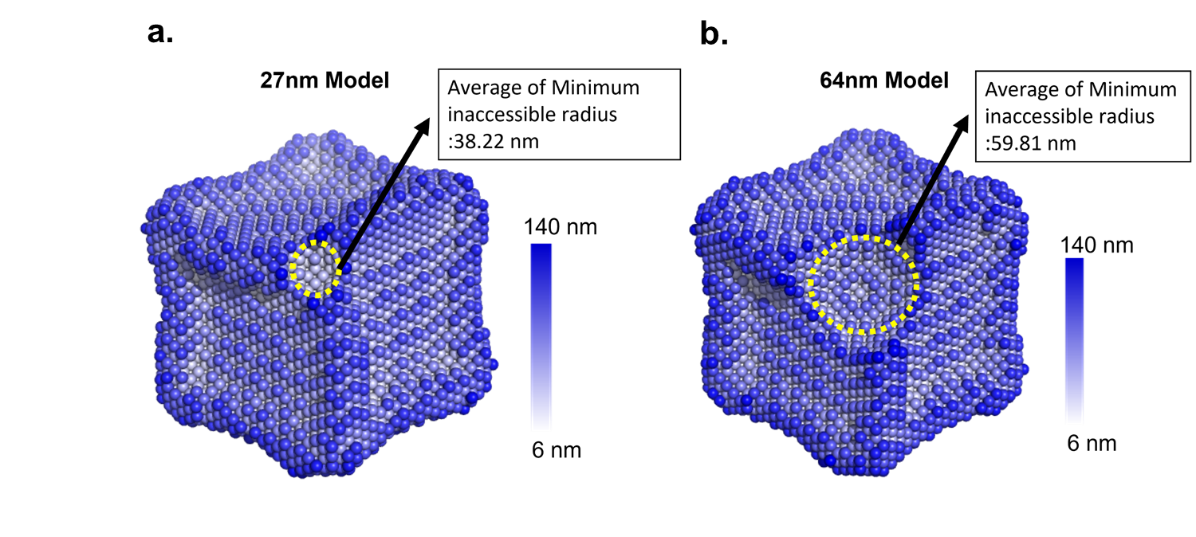
Figure S7. Calculated minimum inaccessible radius of the chiral NPs for different pocket sizes: (a) 27nm and (b) 64nm measured in Fig.4B

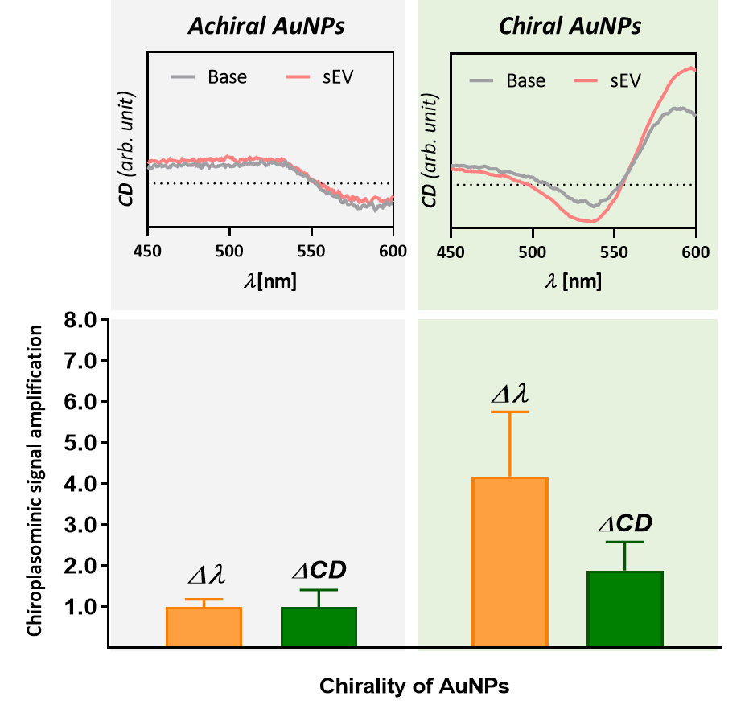
Figure S8. Chiro-plasmonic effect of chiral gold nanoparticles for sensing small-extracellular vesicles (H3255) on CDEXO chip

S9. EM analysis of Au NPs and sEVs
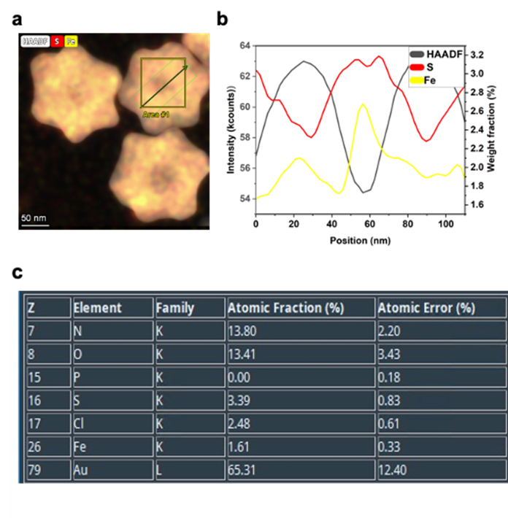
Figure S9. Elemental mapping analysis of surface modified chiral NPs (a) Elemental mapping of Au NPs after MUA treatment for iron (Fe) and sulfur (S) along with high-angle annular dark field (HAADF) image. (b) The linear profile along the green box in (a) to analyze weight fraction of S and Fe and HAADF image intensity. (c) The relative atomic percentage of all the elements detected within the boxed Area #1 in (a).

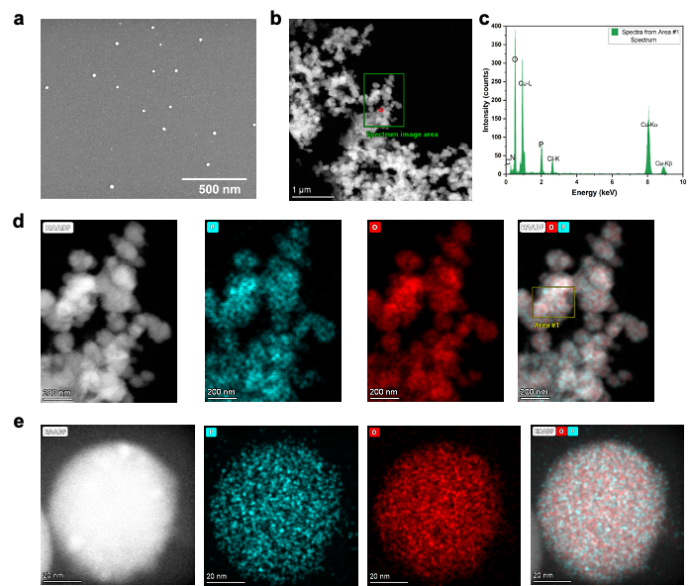
Figure S10. EM analysis of sEVs. (a) SEM image. (b) STEM-HAADF low magnification image of sEVs. (c) EDS analysis of the selected area in the selected area in green box in (b). (d) HAADF image of the selected area in green box in (b) and their elemental mapping for phosphorus (P), oxygen (O); overlapped image shows distribution of the two elements. (e) HAADF of a single sEV and its elemental mapping for P and O, overlay images of all three shows element distribution.

S10. Isolation and profiling of sEVs from using various methods

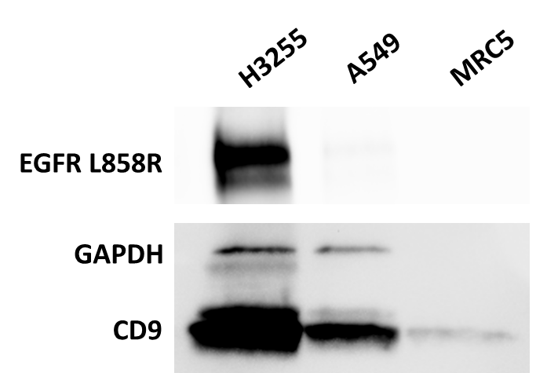
Figure S11. Western blot analysis of sEV from three different cancer/normal lung cells carrying different EGFR mutations
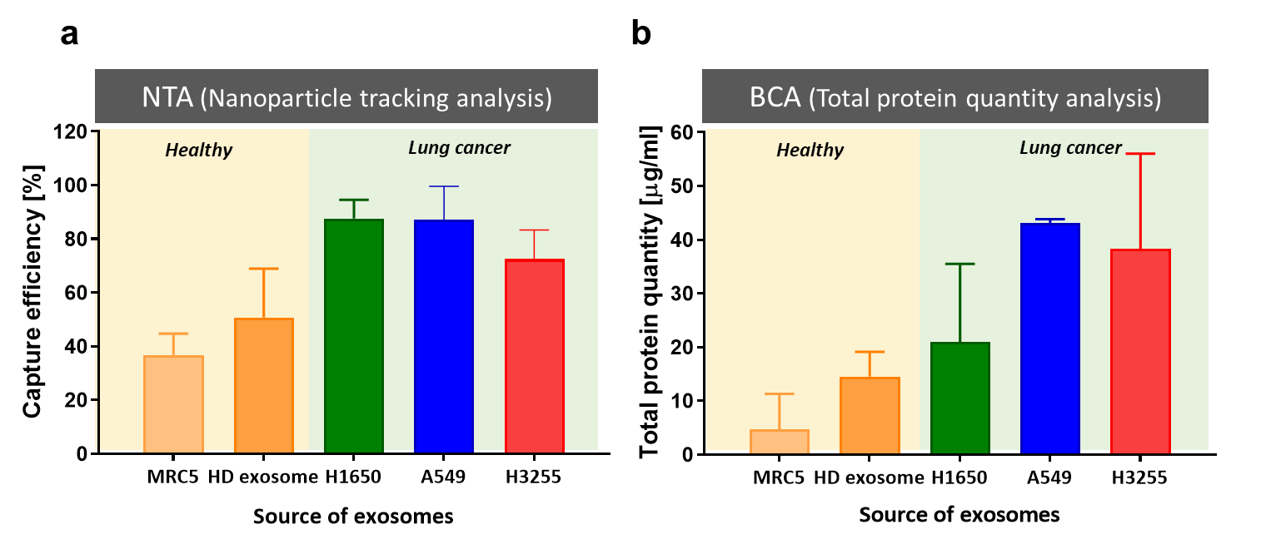
Figure S12. CDEXO chip-based sEV isolation validation using (a) NTA and (b) BCA-total protein quantity analysis
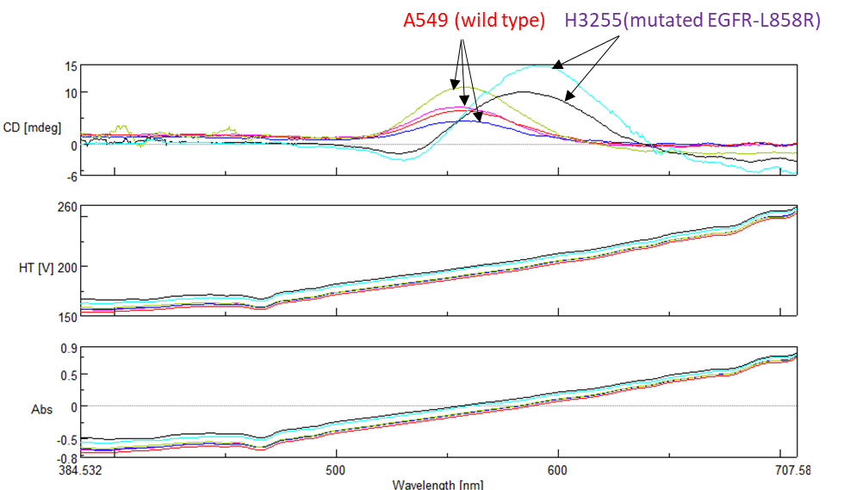
Figure S13. CD signals of two different lung cancer cell line derived sEVs on CDEXO device

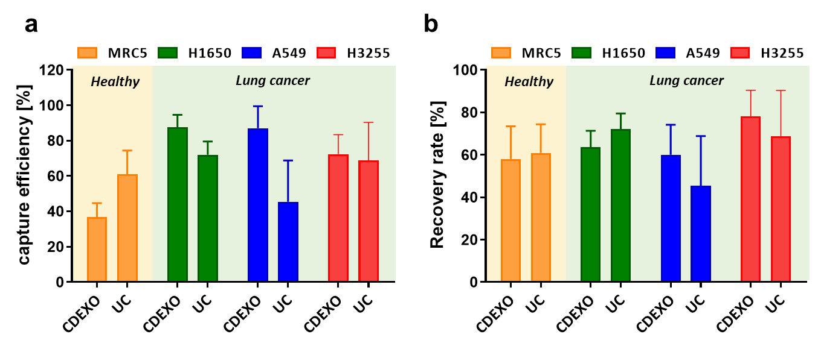
Figure S14. sEV recovery performance comparison between CDEXO chip and ultracentrifugation

S11. Osipov-Pickup-Dunmer (OPD) chirality indices calculation
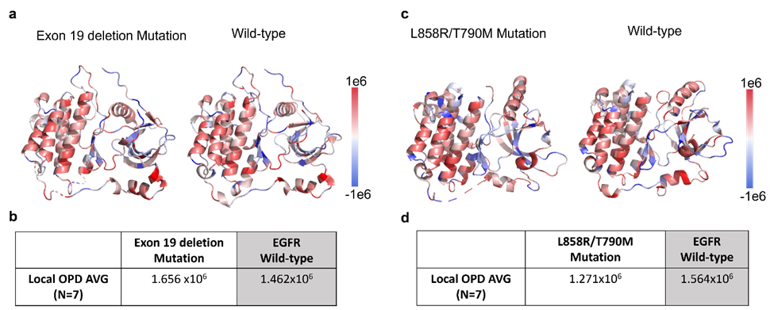
Figure S15. OPD calculation and comparison of EGFR mutant and wild type proteins: (a-b) EGFR wild type and Exon 19 deletion mutant protein. (c-d) EGFR wild type and L858R/T790M mutant protein. Each wild type is selected based on the ligands of the mutant protein crystalized with

S12. CD profile of lung cancer patients
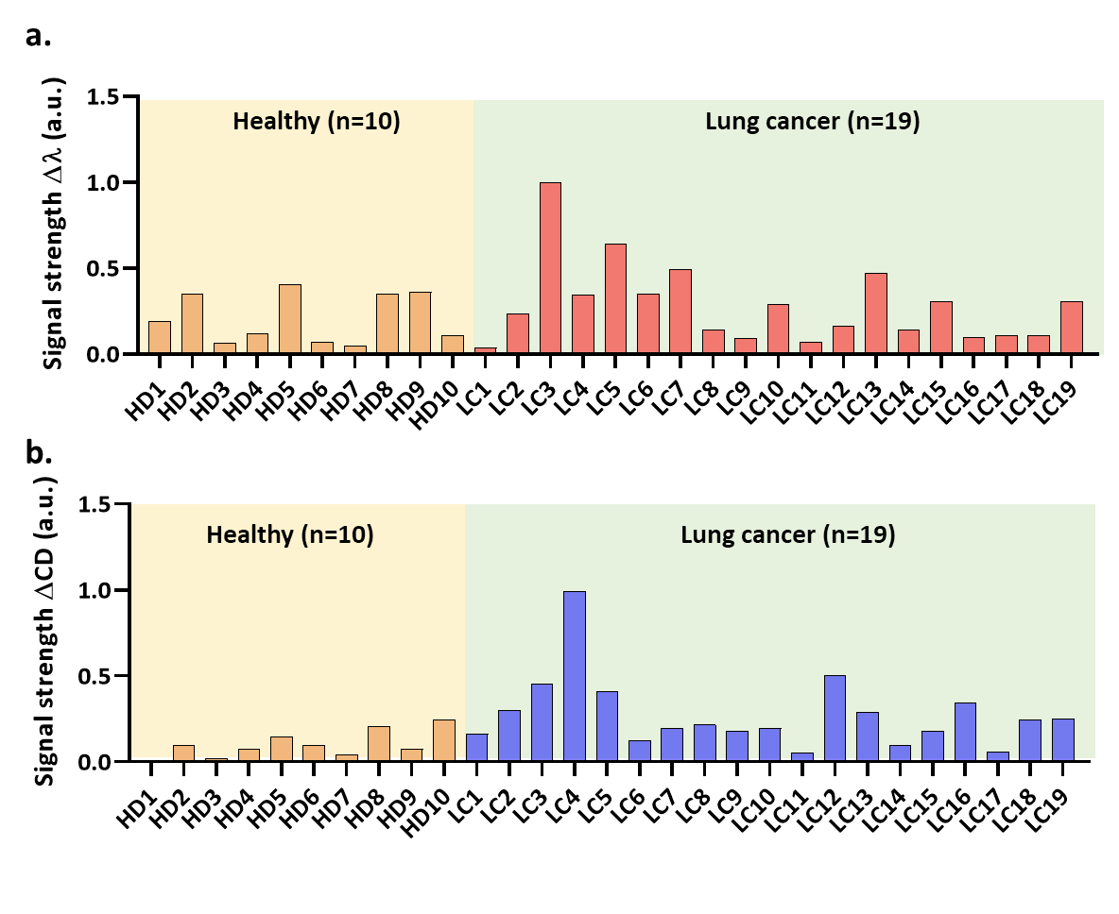
Figure S16. Comparison of CD signal between healthy and lung cancer patients: (a) amount of CD-peak shift for each sample; (b) percentage of change in CD peak magnitude after sEV isolation comparing to baseline CD-peak for each sample
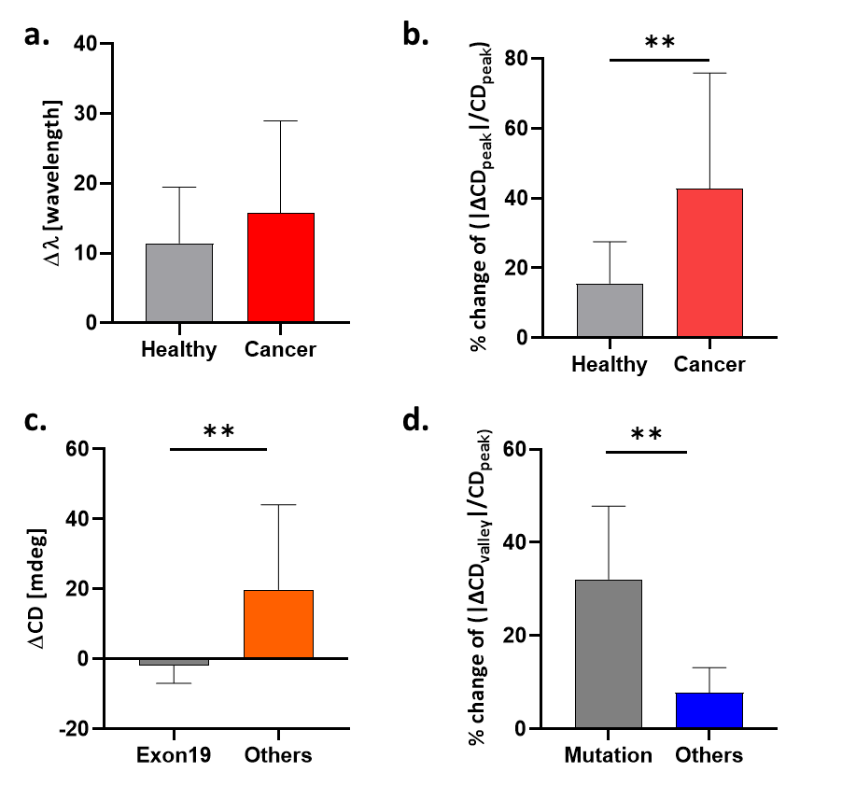
Figure S17. Average circular dichroism spectra change between clinical groups
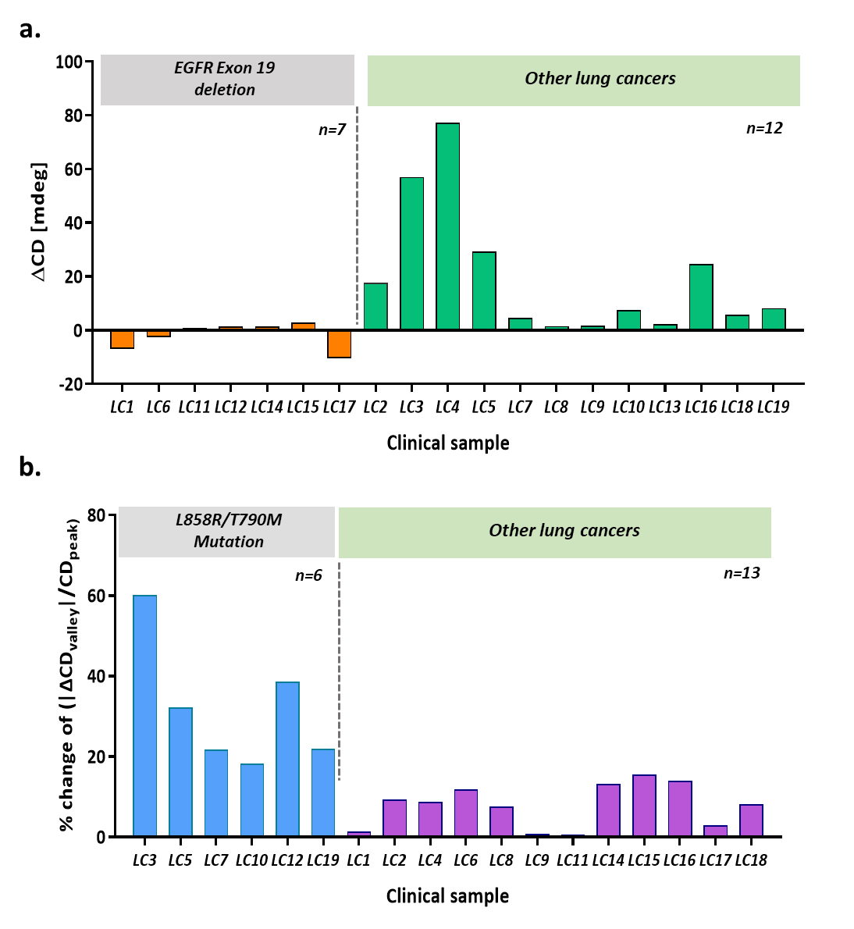
Figure S18. Comparison of CD signal between EGFR mutation subgroups in lung cancer patients: (a) EGFR exon 19 deletion patients and others. (b) EGFR point mutation (L858R/T790M) patients and others.

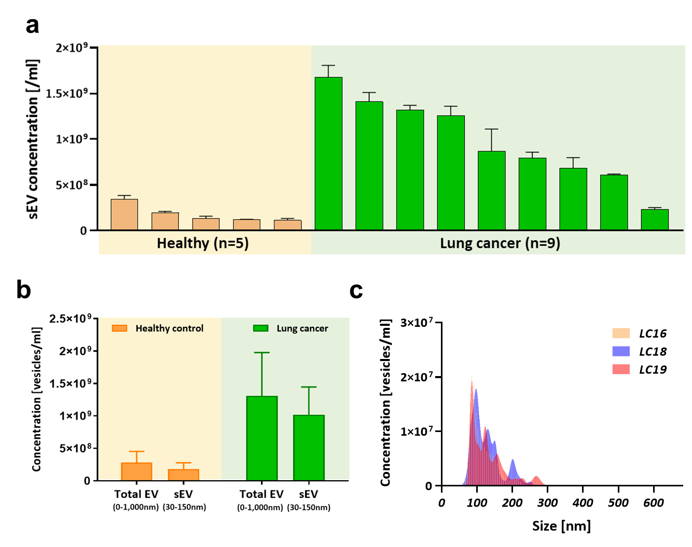
Figure S19. Size profile analysis of EVs recovered from CDEXO chip using clinical samples: (a) sEV concentration recovered from CDEXO chip. (b) total EV and sEV concentrations from healthy controls and lung cancer patient samples. (c) nanoparticle tracking analysis of total EVs from three lung cancer patient samples.

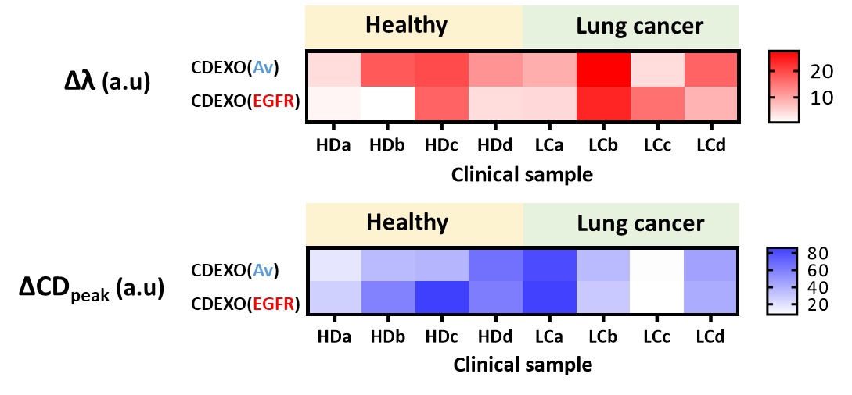
Figure S20. CDEXO profiling of clinical samples using two different sEV capturing molecules, annexin V and anti-epidermal growth factor receptor (EGFR)

S13. Patients information
Table S1. Clinical information of the patient samples
Cancer  Type | Sample ID | Sample description
Cancer  Type | Sample ID | Sex | Age | Stage | Adenocarcinoma subtype | Mutation | Treatment | Tumor origin
Lung cancer patient | LC1 | Male | 83 | III | Squamous cell | EGFR Exon 19 deletion | Carboplatin, Paclitaxel, radiation | Right lower lobe
Lung cancer patient | LC2 | Female | 65 | III | Squamous cell | None | Carboplatin, Paclitaxel, radiation | Left lower lobe
Lung cancer patient | LC3 | Female | 82 | IV | EGFR | L858/T790M | Osimertinib | Left upper lobe
Lung cancer patient | LC4 | Male | 74 | III | Squamous cell | None | Carboplatin, Paclitaxel, radiation | Left lower lobe
Lung cancer patient | LC5 | Female | 58 | IV | EGFR | EGFR mutation | Carboplatin/pemetrexed | Left upper lobe
Lung cancer patient | LC6 | Female | 61 | IV | EGFR | EGFR Exon 19 deletion | Tarceva | Left upper lobe
Lung cancer patient | LC7 | Female | 78 | IV | EGFR | EGFR mutant AC with T790M | Osimertinib | Right lower lobe
Lung cancer patient | LC8 | Female | 55 | IV | ROS1 | ROS1 Mutation | Crizotinib | Neck
Lung cancer patient | LC9 | Male | 58 | IV | ALK | None | Alectinib | Right lower lobe
Lung cancer patient | LC10 | Female | 61 | IV | EGFR | EGFR mutant AC with T790M | Osimertinib | Left upper lobe
Lung cancer patient | LC11 | Male | 62 | IV | EGFR | EGFR Exon 19 deletion | Afatinib | Right upper love
Lung cancer patient | LC12 | Male | 72 | IV | EGFR | EGFR Exon 19 deletion, T790M | Tagrisso | Left upper lobe
Lung cancer patient | LC13 | Female | 63 | IV | ROS-1 | ROS-1 | Carboplatin/pemetrexed | Left upper lobe
Lung cancer patient | LC14 | Male | 70 | N/A | EGFR | EGFR Exon 19 deletion | Tagrisso | Left upper lobe
Lung cancer patient | LC15 | Female | 49 | IV | EGFR | Exon 19 deletion | Afatinib, cetuximab | Left upper lobe
Lung cancer patient | LC16 | Female | 45 | IV | EGFR | EGFR mutation | Tagrisso | Left lower lobe
Lung cancer patient | LC17 | Male | 66 | IA | EGFR | Exon 19 deletion | Tagrisso | Left lower lobe
Lung cancer patient | LC18 | Female | 40 | IV | ROS1 | ROS1 rearrangement | Crizotinib | Lymph node
Lung cancer patient | LC19 | Female | 58 | IV | EGFR | L858/T790M | Pemetrexed | Left upper lobe

