Supplemental material for Measuring Long-Term Exposure to Wildfire PM_{2.5} in California: Time-Varying Inequities in Environmental Burden

Supplementary Methods 1: Domains of CalEnviroScreen 4.0. Please see the CalEnviroScreen 4.0 Report for additional details (1).
Indicator | Description | Source
Pollution Burden: Exposure
Air Quality: Ozone (ppm) | Mean of summer months (May-October) of the daily maximum 8-hour ozone concentration (ppm), averaged over three years (2017 to 2019). | Air Monitoring Network—CARB
Air Quality: PM_{2.5} (μg/m³) | Annual mean concentration of PM_{2.5} (weighted average of measured monitor concentrations and satellite observations, μg/m³), over three years (2015 to 2017). | Air Monitoring Network and Satellite Remote Sensing Data—CARB
Diesel Particulate Matter (tons/year) | Spatial distribution of gridded diesel PM emissions from on-road and non-road sources 2016 (tons/year). | EMFAC model 2017, the 2016 CEPAMv1.05 Inventory for criteria pollutants, and the CEIDARS 2012 database—CARB
Drinking Water Contaminants | Drinking water contaminant index for selected contaminants (2011 to 2019) | Water Boundary Tool – Tracking California  Sections and Townships - Public Land Survey System (layer hosted by Department of Pesticide Regulation)  High-Resolution Populated Areas Map of California (Pace et al., 2013)  SDWIS – California State Water Resources Control Board  EDT Library and Water Quality Analyses Data and Download Page – California State Water Resources Control Board  GAMA Program’s Groundwater Information System – California State Water Resources Control Board  GAMA Aquifer Risk Map Depth Filter Dataset — California State Water Resources Control Board
Children's Lead Risk from Housing (%) | Potential risk for lead exposure in children living in low-income communities with older housing.  Percentage of households within a census tract with likelihood of lead-based paint (LBP) hazards from the age of housing (2017 California parcel data and 5-year estimates 2015-2019) combined with the percentage of households that are both low-income (household income less than 80% of the county median family income) and have children under 6 years old (5-year estimates 2013-2017). | California Residential Parcel Data – Digital Map Products  ACS  Comprehensive Housing Affordability Strategy — HUD
Pesticide Use (lbs/mi²) | Total pounds of 132 selected active pesticide ingredients (filtered for hazard and volatility) used in production-agriculture per square mile, averaged over three years (2017 to 2019). | Pesticide Use Reporting — California Department of Pesticide Regulation
Toxic Releases from Facilities | Toxicity-weighted concentrations of modeled chemical releases to air from facility emissions and off-site incineration (averaged over 2017 to 2019 and including releases from Mexican facilities averaged over 2014 to 2016). | Toxics Release Inventory — EPA  Mexico Registry of Emissions and Transfer of Contaminants  Risk Screening Environmental Indicators — EPA
Traffic Impacts (vehicle-km/hr) | Sum of traffic volumes adjusted by road segment length (vehicle- kilometers per hour) divided by total road length (kilometers) within 150 meters of the census tract (traffic volumes estimates for 2017). | TomTom Find/Route/Display  TrafficMetrix® Traffic Count Database  University of California, Riverside College of Engineering – Center for Environmental Research and Technology in collaboration with Bernie Beckerman, PhD, independent contractor  US Customs and Border Protection, Border Crossing Entry Data; SANDAG
Pollution Burden: Environmental Effects
Cleanup Sites | Sum of weighted sites within each census tract. (Data downloaded July 2021) | EnviroStor Cleanup Sites Database — DTSC  Region 9 NPL Sites (Superfund Sites) Polygons (2021 Draft Data) – EPA, Region 9
Groundwater Threats | Sum of weighted scores for sites within each census tract. (Data downloaded July 2021) | GeoTracker Database – SWRCB  CIWQS – SWRCB
Hazardous Waste Generators and Facilities | Sum of weighted permitted hazardous waste facilities, hazardous waste generators, and chrome plating facilities within each census tract.  (Permitted hazardous waste facilities were downloaded July 2021, Hazardous waste data are from 2018-2020, and chrome plating facilities are based on a survey from 2018.) | EnviroStor Hazardous Waste Facilities Database and Hazardous Waste Tracking System – DTSC  Chrome Plating Airborne Toxics Control Measure – CARB
Impaired Water Bodies | Summed number of pollutants across all water bodies designated as impaired within the area (2018). | 2018 303(d) List of Impaired Water Bodies — SWRCB
Solid Waste Sites and Facilities | Sum of weighted solid waste sites and facilities (as of July 2021). | SWIS and CIA Disposal Sites Program – CalRecycle  Hazardous Waste Tracking System – DTSC
Population Characteristics: Sensitive Population
Asthma | Spatially modeled, age-adjusted rate of ED visits for asthma per 10,000 (averaged over 2015-2017). | Emergency Department and Patient Discharge Datasets from the State of California – OSHPD  Tracking California
Cardiovascular Disease | Spatially modeled, age-adjusted rate of emergency department (ED) visits for AMI per 10,000 (averaged over 2015-2017). | Emergency Department and Patient Discharge Datasets from the State of California – OSHPD  Tracking California
Low Birth Weight Infants (%) | Percent low birth weight, (averaged over 2009-2015). | CDPH  Tracking California
Population Characteristics: Socioeconomic Factor Indicators
Educational Attainment (%) | Percentage of the population over age 25 with less than a high school education (5-year estimate, 2015-2019). | ACS
Housing-Burdened Low-Income Households (%) | Housing-Burdened Low-Income Households. Percent of households in a census tract that are both low income (making less than 80% of the HUD Area Median Family Income) and severely burdened by housing costs (paying greater than 50% of their income to housing costs). (5-year estimates, 2013-2017). | Comprehensive Housing Affordability Strategy – HUD
Linguistic Isolation (%) | Percentage of limited English-speaking households, (2015-2019). | ACS
Poverty (%) | Percent of the population living below two times the federal poverty level (5-year estimate, 2015-2019). | ACS
Unemployment (%) | Percentage of the population over the age of 16 that is unemployed and eligible for the labor force. Excludes retirees, students, homemakers, institutionalized persons except prisoners, those not looking for work, and military personnel on active duty (5-year estimate, 2015-2019). | ACS
ACS, American Community Survey; CARB, California Air Resources Board; CalRecycle, California Department of Resources, Recycling and Recovery; CDPH, California Department of Public Health; CEHTP, California Environmental Health Tracking Program; CEIDARS, California Emissions Inventory Development and Reporting System; CIA, Closed, Illegal, and Abandoned; CIWQS, California Integrated Water Quality System Project; DTSC, Department of Toxic Substances Control; EMission FACtors (EMFAC); EPA, Environmental Protection Agency; GAMA, Groundwater Ambient Monitoring and Assessment; HUD, Housing and Urban Development; OSHPD, Office of Statewide Health Planning and Development; PM, particulate matter; SANDAG, San Diego Association of Governments; SWIS, Solid Waste Information System; SWRCB, State Water Resources Control Board; SDWIS, Safe Drinking Water System; SANDAG ,San Diego Association of Governments

Supplementary Figure 1: Five measures of census tract-level wildfire PM_{2.5} exposure by year from 2006–2020. (A) Number of weeks with average wildfire PM_{2.5} > 5 μg/m³; (B) Number of days with non-zero wildfire PM_{2.5} concentrations; (C) Mean daily wildfire PM_{2.5} exposure during the peak week; (D) Number of smoke wavesª; (E) Mean annual wildfire PM_{2.5} concentration.
ª We defined smoke waves as the number of instances of $≥$2 consecutive days with $≥$25μg/m³ wildfire PM_{2.5}, which was close to the study area and period 90th percentile of wildfire PM_{2.5} concentration on days with any wildfire PM_{2.5}, similar to prior work (2).

- Wildfire PM_{2.5} > 5 μg/m³
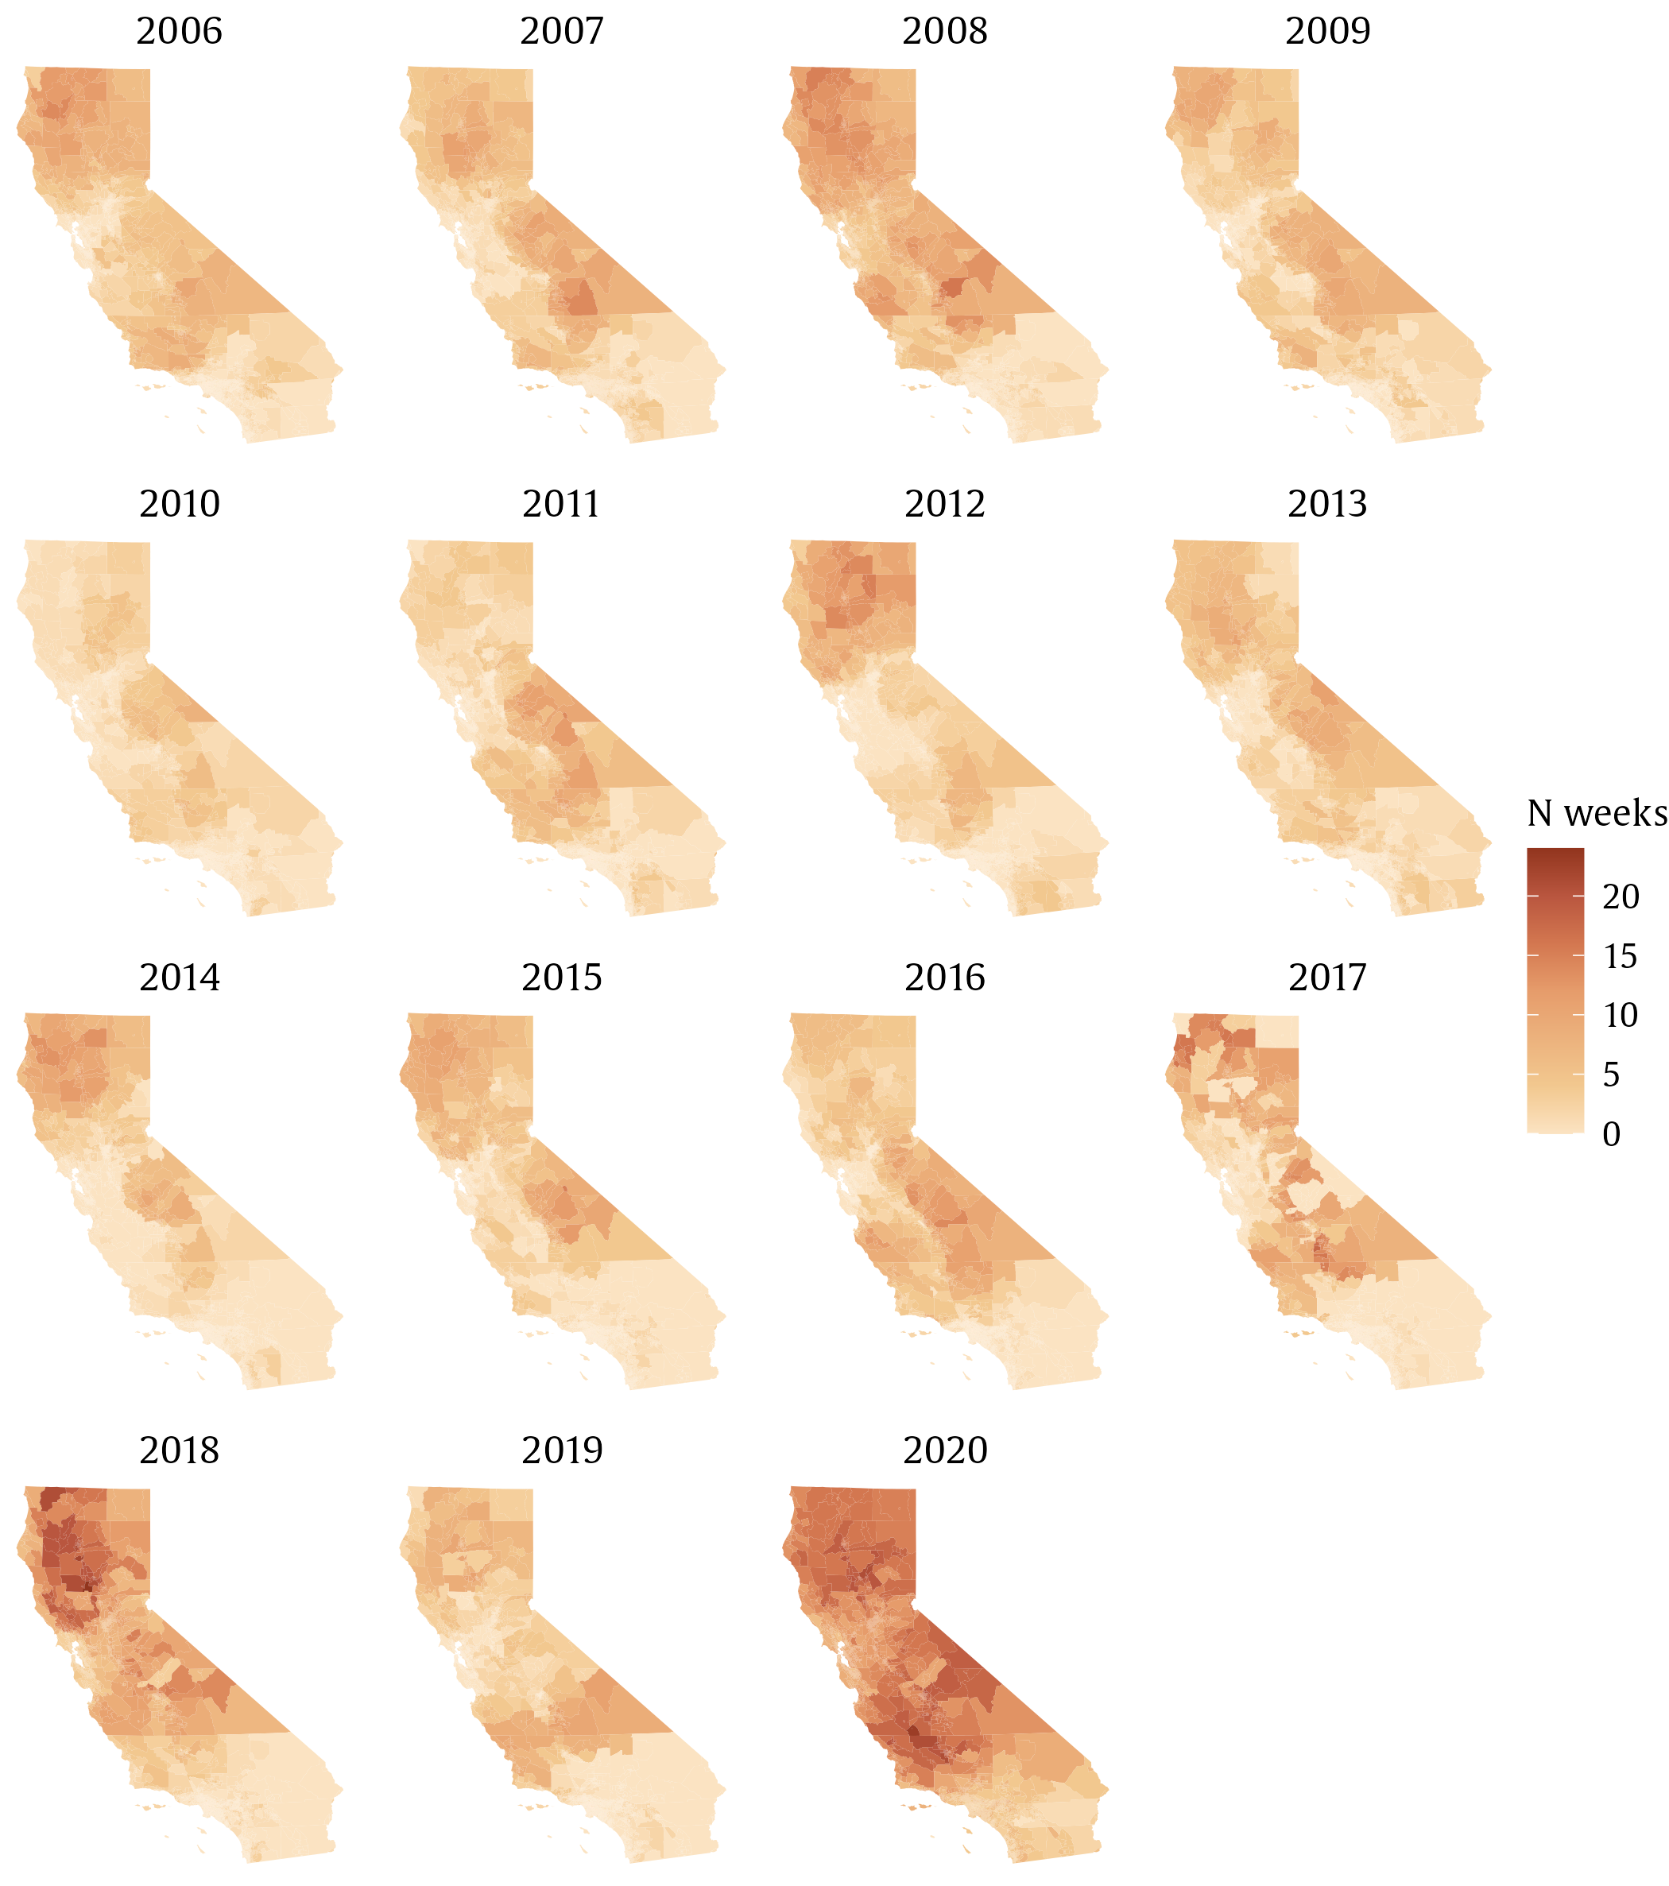

- Number of days with wildfire PM_{2.5} > 0

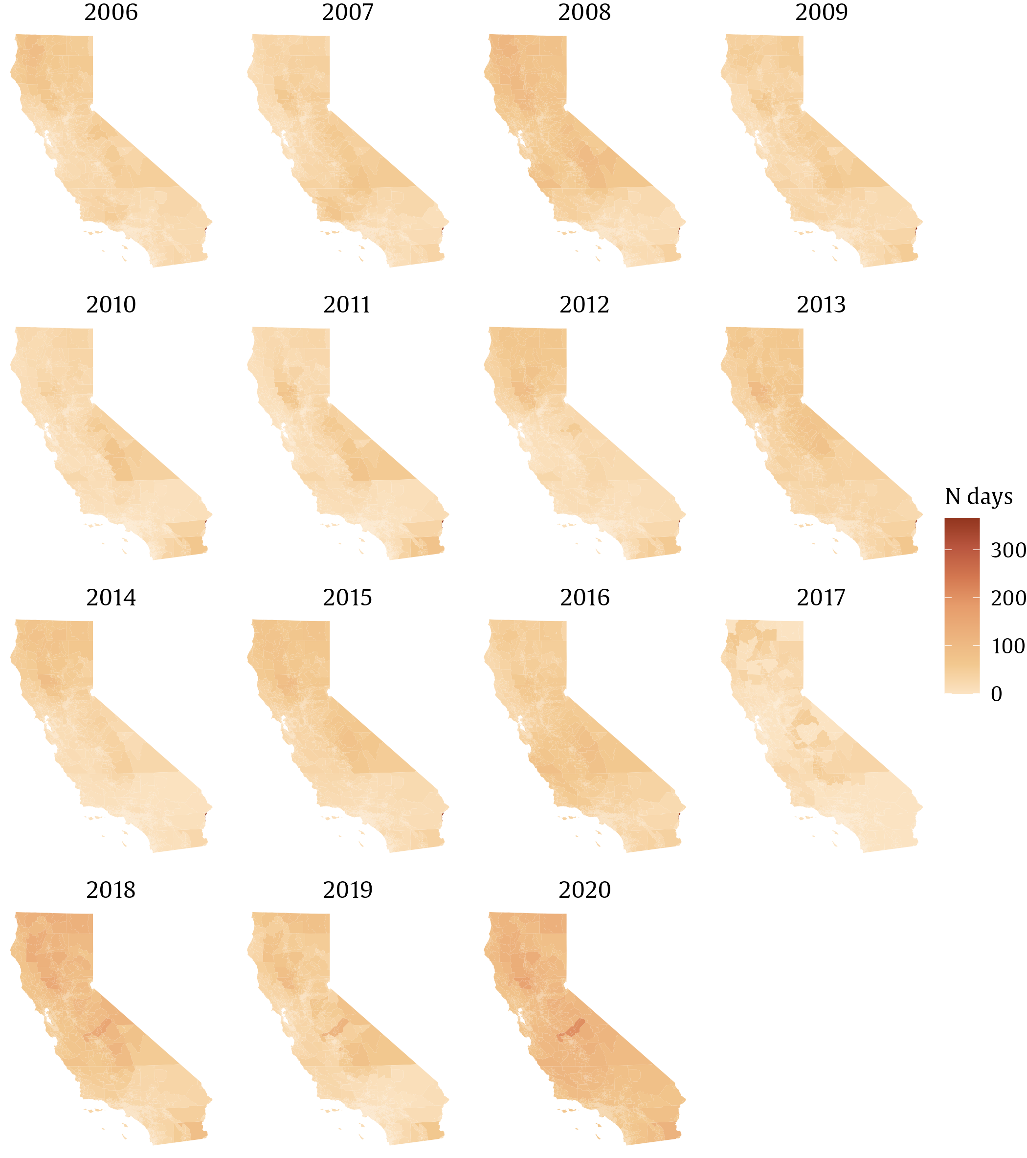

- Mean wildfire PM_{2.5} concentration during the peak week annually

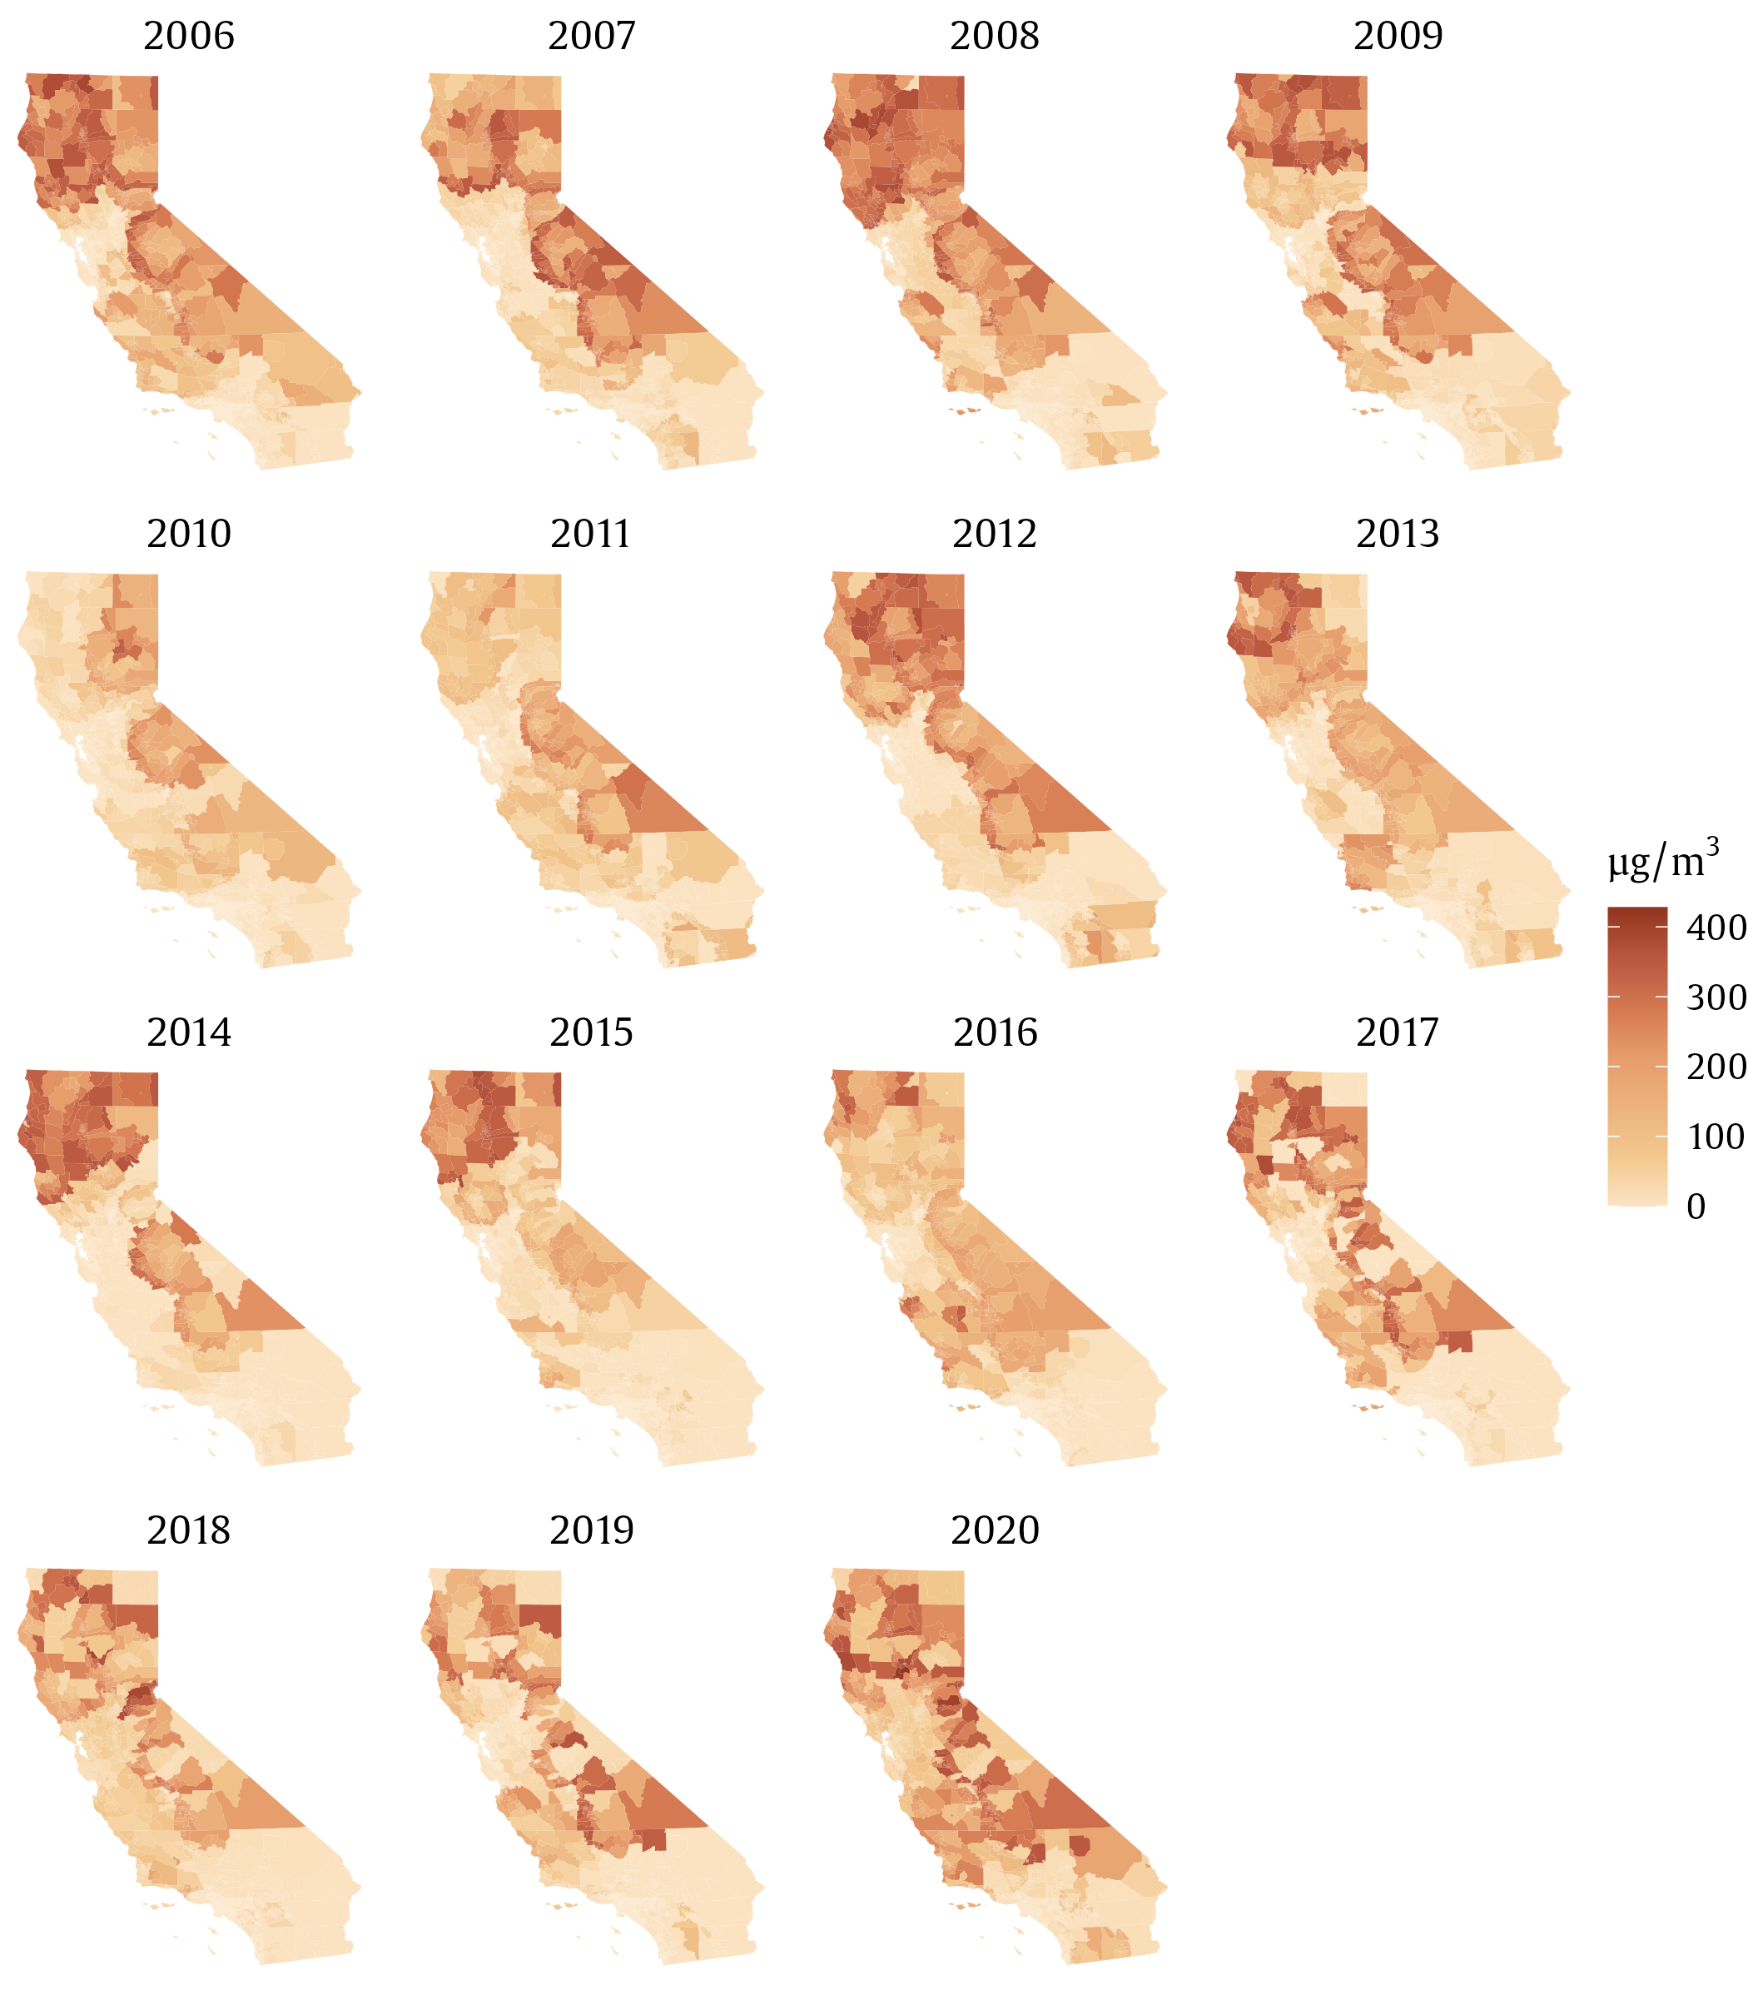

- Smoke waves

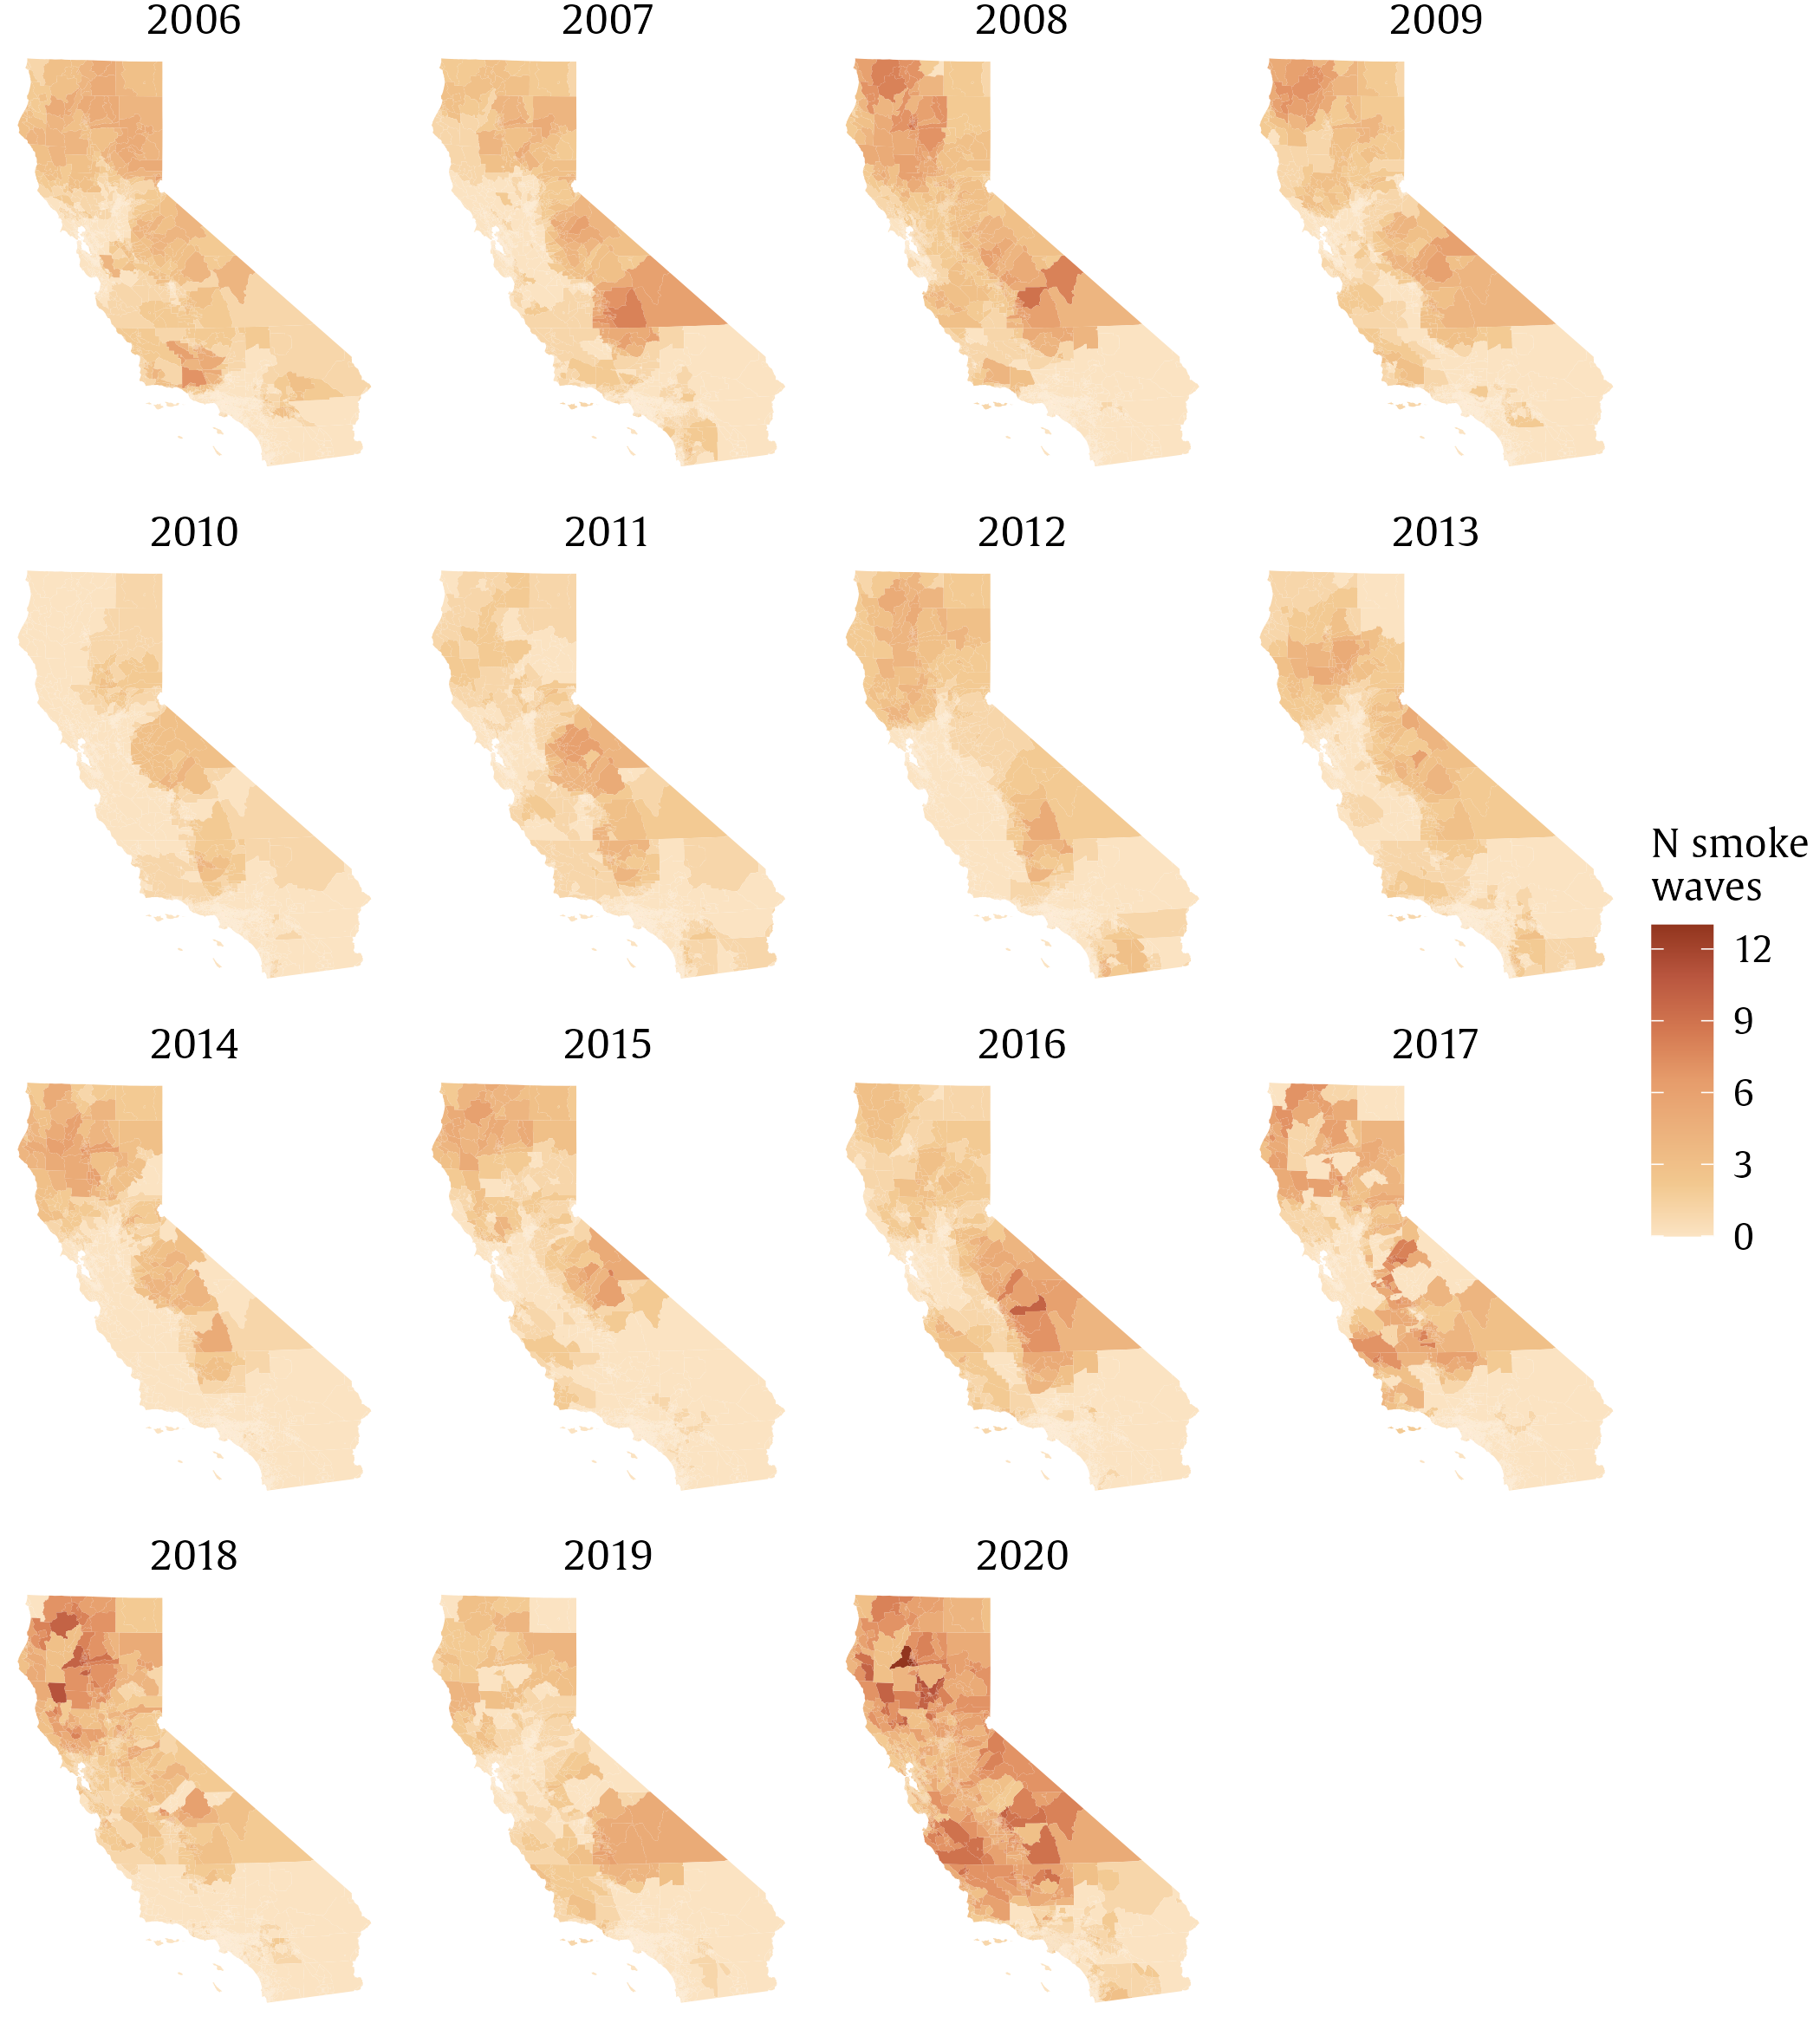

- Annual mean wildfire PM_{2.5} concentration
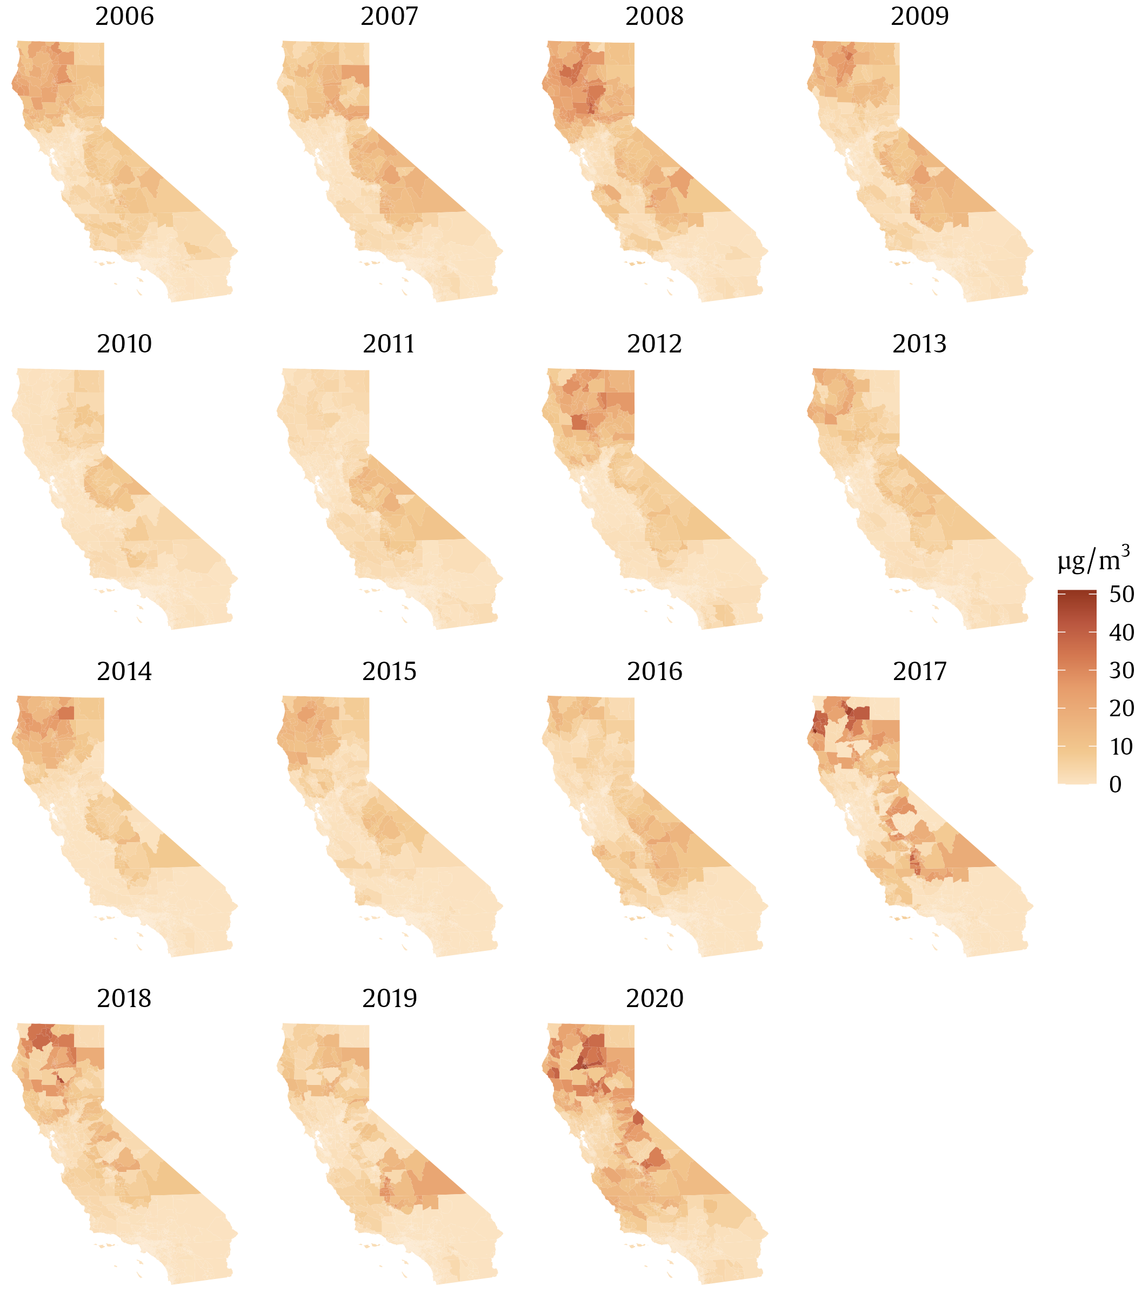

Supplemental Figure 2: Seasonality of wildfire PM_{2.5} exposures from 2006–2020. (A) Number of census tract-weeks with average wildfire PM_{2.5} > 5 μg/m³ each month; (B) Number of census tract-days with non-zero wildfire PM_{2.5} concentrations each month; (C) Population-weighted^{b} mean daily wildfire PM_{2.5} exposure during the peak week each month; (D) Number of census tracts experiencing a smoke wavesª each month; (E) Population-weighted^{b} mean monthly wildfire PM_{2.5} concentration.
ª We defined smoke waves as the number of instances of $≥$2 consecutive days with $≥$25μg/m³ wildfire PM_{2.5}, which was close to the study area and period 90th percentile of wildfire PM_{2.5} concentration on days with any wildfire PM_{2.5}, similar to prior work (2).
^{b} We derived population-weighted values from 2010 Decennial US census, with mean census tract wildfire PM_{2.5} contributing to the mean value proportionally by population count within the census tract boundary.
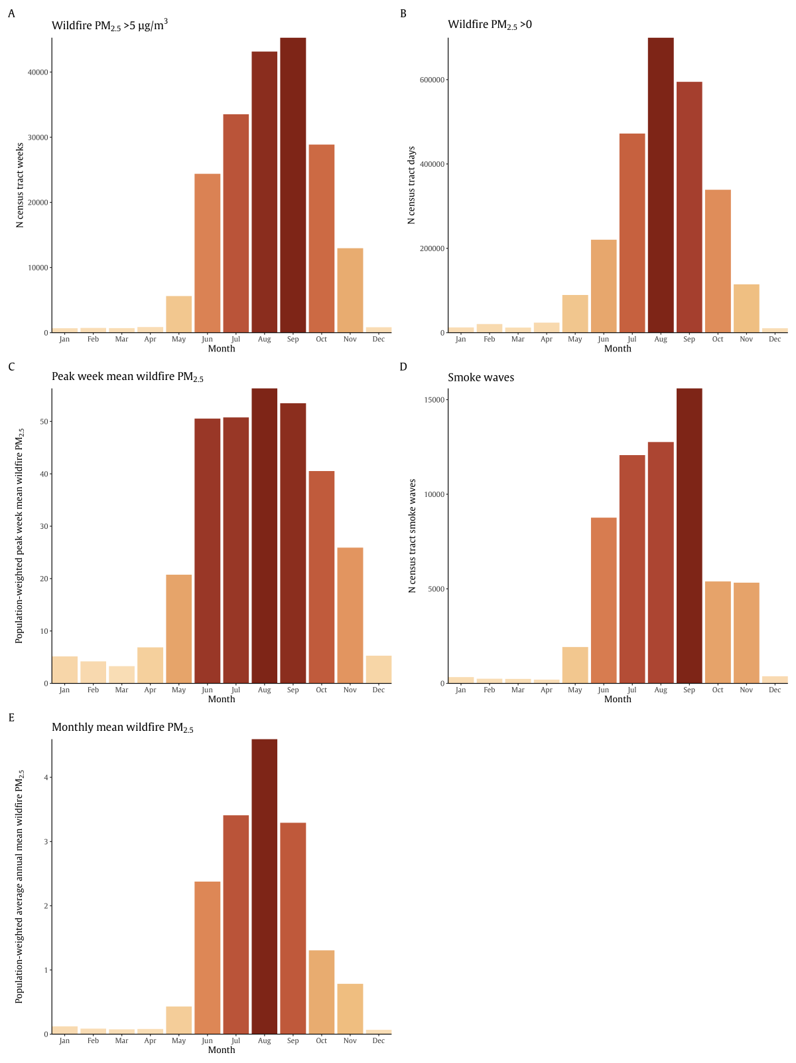

Supplementary Figure 3: Spearman correlations between 5 metrics of wildfire PM_{2.5} exposure (A) Summarized across the study period (2006–2020) and (B) Summarized annually
(A) Correlation overall
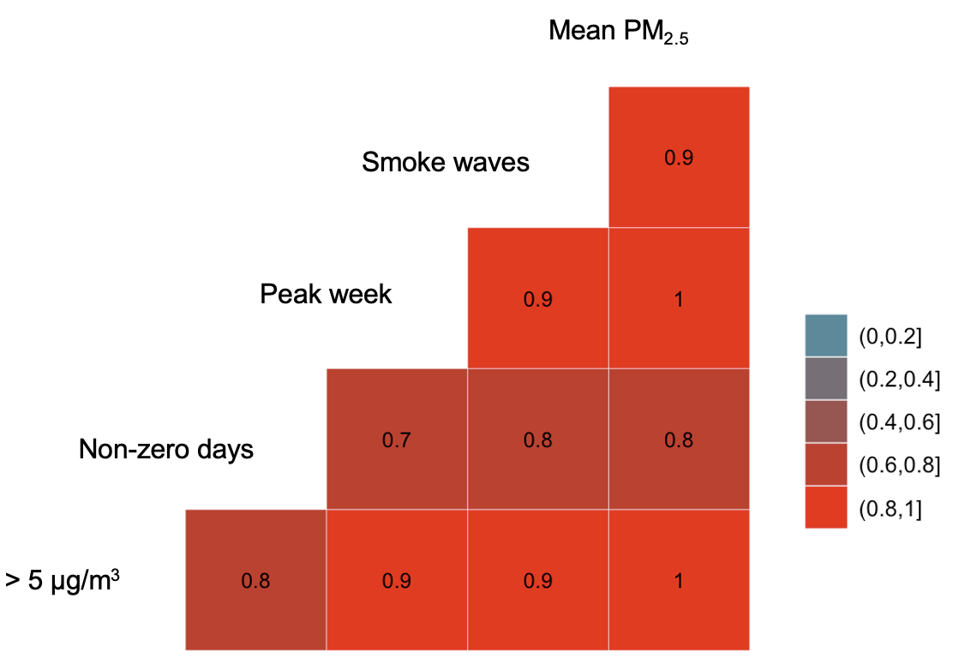
(B) Correlation by year
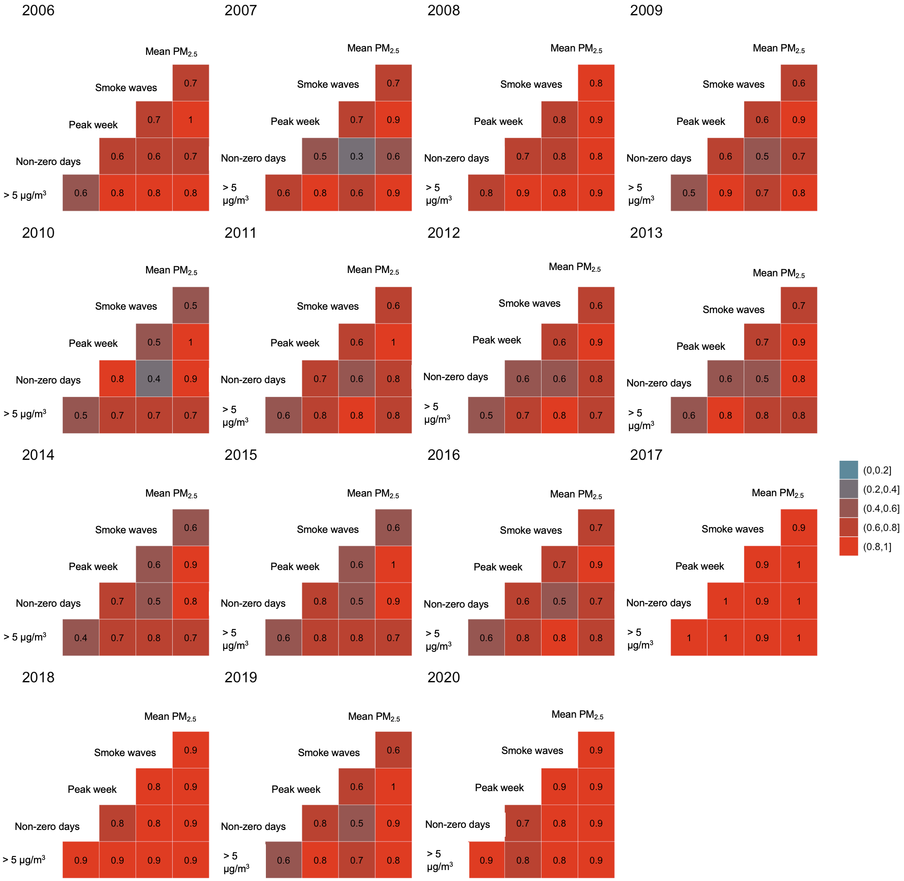
Supplementary Figure 4: Distribution of sociodemographic variables at the census tract level in California. (A) CalEnviroScreen 3.0 and 4.0 score percentilesª; (B) Racial/ethnic composition^{b}
ª CalEnviroScreen score data available from the California Office of Environmental Health Hazard Assessment: https://oehha.ca.gov/calenviroscreen
^{b} Racial/ethnic composition available from www.NHGIS.org from the 2010 Decennial US census.
CES, CalEnviroScreen; NH, Non-Hispanic; NH 2+, Non-Hispanic two or more races

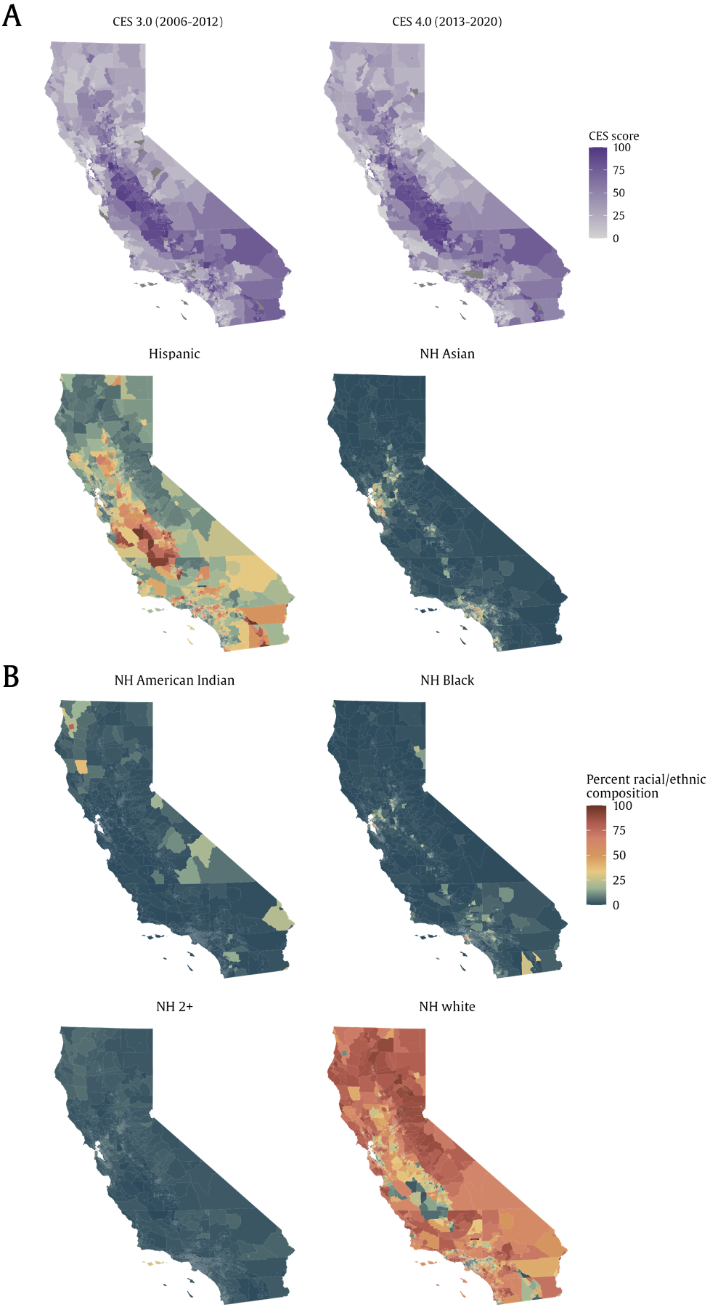
Supplementary Figure 5: The exposure distribution for the five wildfire PM_{2.5} measures by CES quartile from 2006 to 2020.
Columns are percentiles of exposure and rows are the five wildfire exposure measures as follows:
1 = Number of weeks with average wildfire PM_{2.5} >5 μg/m³
2 = Number of days with non-zero wildfire PM_{2.5} concentrations
3 = Average of mean daily wildfire PM_{2.5} concentration during the peak week
4 = Number of smoke wavesª
5 = Average of mean annual wildfire PM_{2.5} concentration
ª Smoke waves are defined as the number of instances of $≥$2 consecutive days with $≥$25μg/m³ wildfire PM_{2.5}, which was close to the study area and period 90th percentile of wildfire PM_{2.5} concentration on days with any wildfire PM_{2.5}, similar to prior work (2).

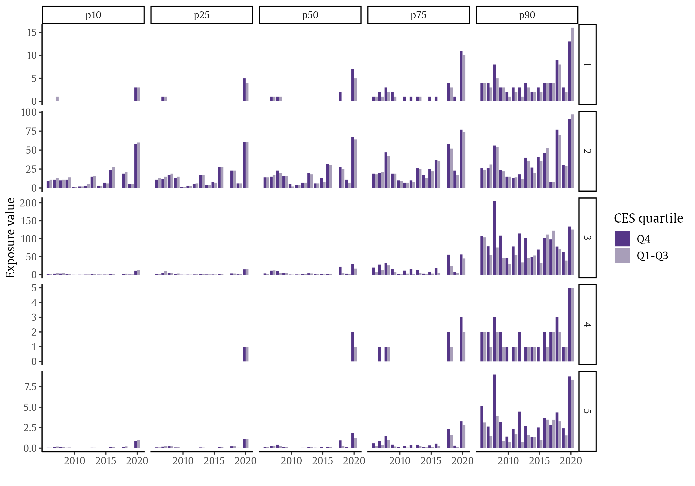

Supplementary Figure 6: Bivariate spatial distribution of mean wildfire PM_{2.5} concentration and CES quartileª from 2006–2020. Brighter shades of purple indicate a higher quartile of CES score and brighter shades of orange indicate a higher quartile of annual average wildfire PM_{2.5} concentration. The deep brown color in the upper lefthand corner of the legend identifies census tracts in the highest quartile of CES score and wildfire PM_{2.5} concentration.
ª CalEnviroScreen (CES) score data available from the California Office of Environmental Health Hazard Assessment: https://oehha.ca.gov/calenviroscreen was used to compute CES quartiles where quartile 4 indicates a disadvantaged community.

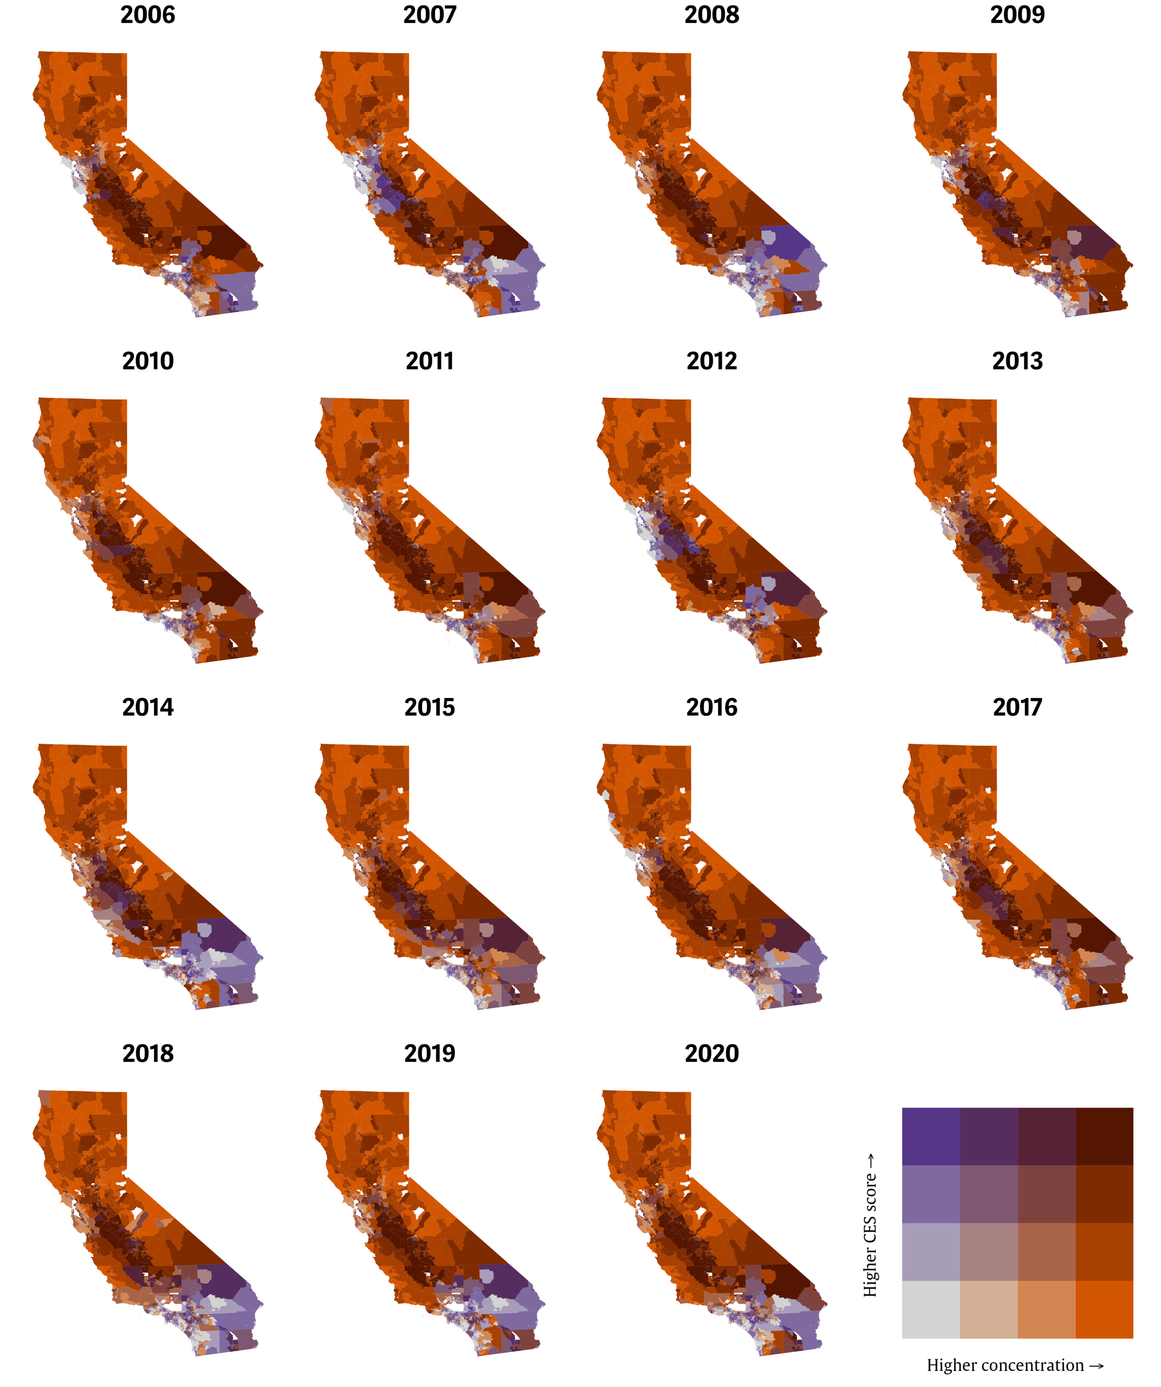

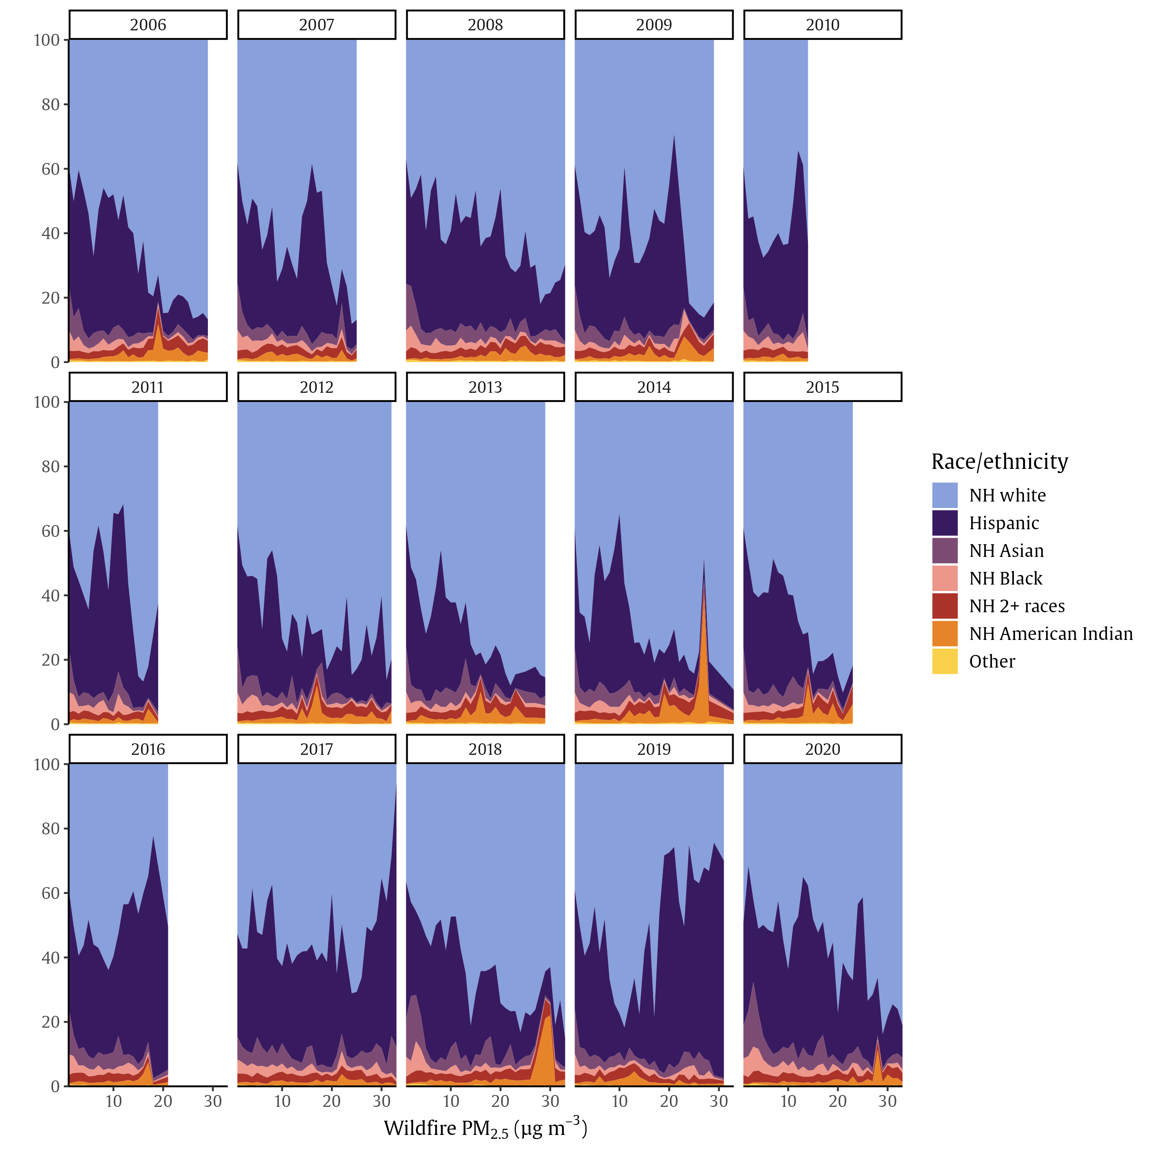
Supplementary Figure 7: Average census tract racial/ethnic composition by annual average wildfire PM_{2.5} concentration in California. The x-axis breaks are consistent across years with results restricted to the 99.9th percentile of annual average exposure. This results in white space, for example, for 2007 and 2010 when the 99.9th percentile was less than 30 μg/m³.
Census tract racial/ethnic composition (%)

Supplementary Figure 8: Average census tract racial/ethnic composition by five measures of census tract-level wildfire PM_{2.5} exposure in California. (A) Number of weeks with average wildfire PM_{2.5} > 5 μg/m³; (B) Number of days with non-zero wildfire PM_{2.5} concentrations; (C) Average of mean daily wildfire PM_{2.5} exposure during the peak week; (D) Number of smoke wavesª; (E) Average of mean annual wildfire PM_{2.5} concentration.
The first column shows the overall California racial/ethnic composition using 2010 census data. The second column shows racial/ethnic composition by wildfire PM_{2.5} exposure from 2006-2020. Columns 3-5 show he racial/ethnic composition by average wildfire PM_{2.5} exposure for the years 2018, 2019, and 2020.
ª Smoke waves are defined as the number of instances of $≥$2 consecutive days with $≥$25μg/m³ wildfire PM_{2.5}, which was close to the study area and period 90th percentile of wildfire PM_{2.5} concentration on days with any wildfire PM_{2.5}, similar to prior work (2).

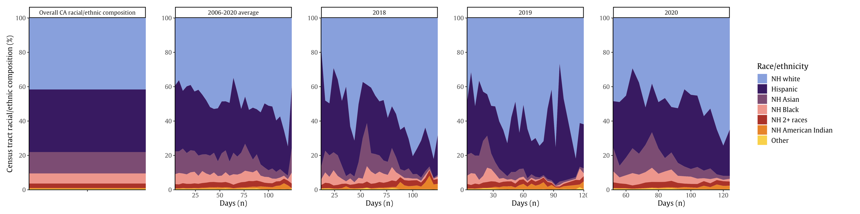
(A) Number of weeks with average wildfire PM_{2.5} > 5 μg/m³

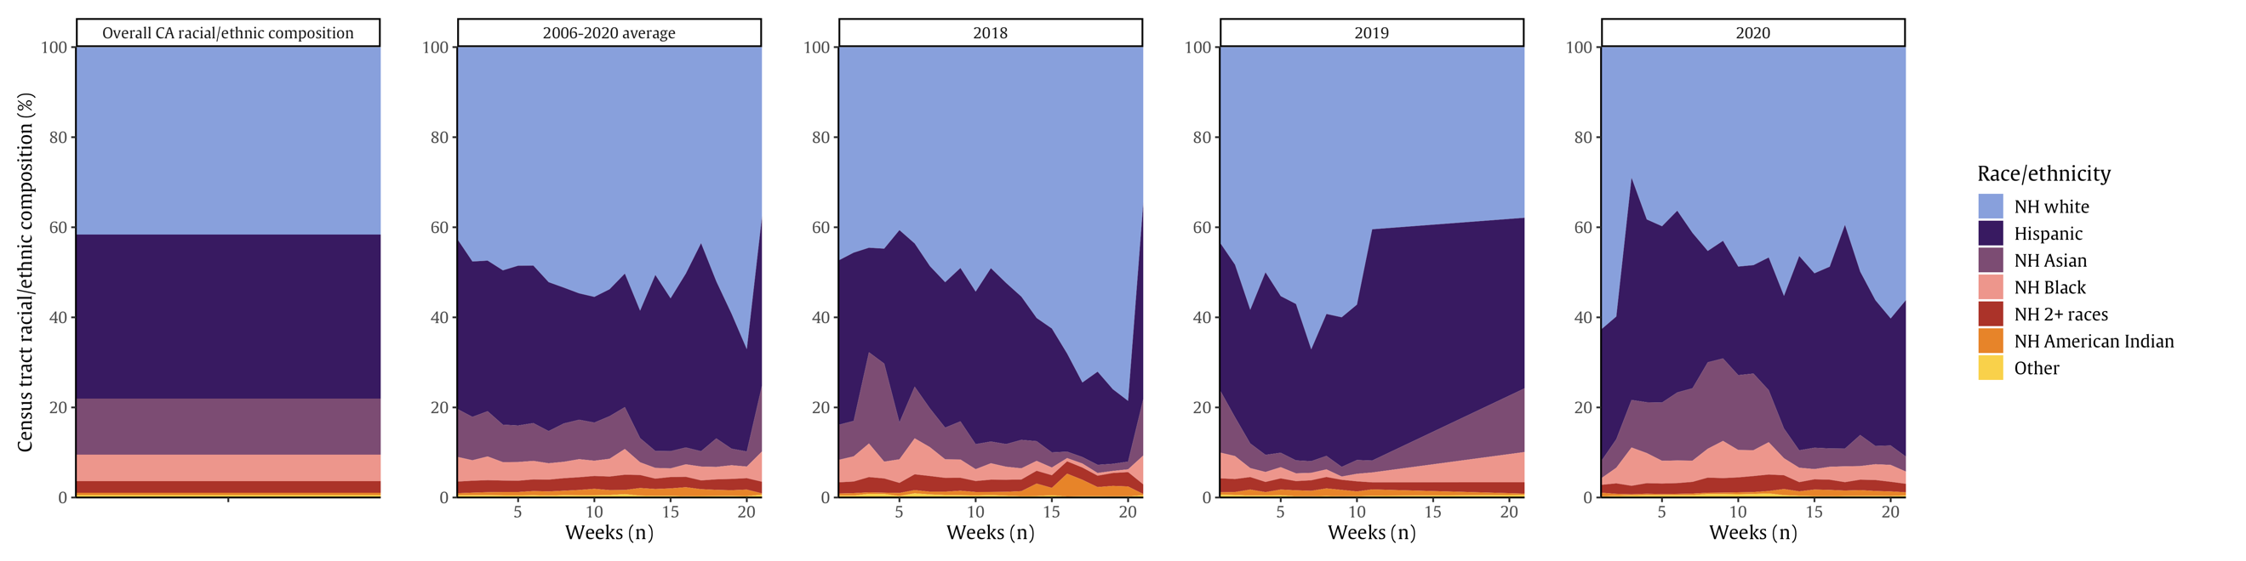
(B) Number of days with non-zero wildfire PM_{2.5} concentrations

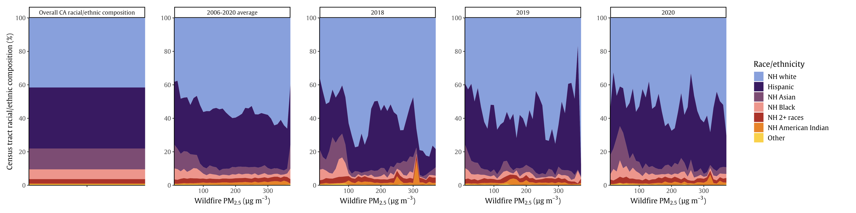
(C) Average of mean daily wildfire PM_{2.5} exposure during the peak week

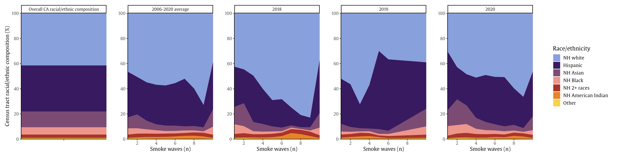
(D) Number of smoke wavesª

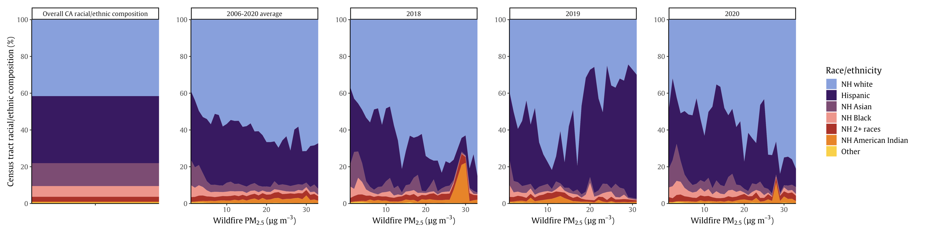
(E) Average of mean annual wildfire PM_{2.5} concentration

Supplementary Figure 9: Mean difference in long-term wildfire PM_{2.5} concentration by census tract racial/ethnic composition, averaged across 2006–2020 (panel 1) and during each year (other panels). (A) Number of weeks with average wildfire PM_{2.5} > 5 μg/m³; (B) Number of days with non-zero wildfire PM_{2.5} concentrations; (C) Average of mean daily wildfire PM_{2.5} concentration during the peak week; (D) Number of smoke wavesª; (E) Average of mean annual wildfire PM_{2.5} concentration. Points represent the average marginal estimate of difference in long-term wildfire PM_{2.5} exposure between census tracts with a 1-SD increase in the population making up each racial/ethnic category^{b} with lines (95% CI). The black horizontal dotted line at zero represents no difference in long-term wildfire PM_{2.5} exposure between tracts with a 1-SD increase in the population making up each racial/ethnic category.^{b}
ª Smoke waves are defined as the number of instances of $≥$2 consecutive days with $≥$25μg/m³ wildfire PM_{2.5}, which was close to the study area and period 90th percentile of wildfire PM_{2.5} concentration on days with any wildfire PM_{2.5}, similar to prior work (2).
^{b} For each racial/ethnic group, a 1-SD increase is as follows: Hispanic, 26.3%; non-Hispanic Asian, 14.7%; non-Hispanic American Indian or Alaska Native, 1.4%; non-Hispanic Black, 9.3%; non-Hispanic two or more races, 1.4%; non-Hispanic white, 26.9%.

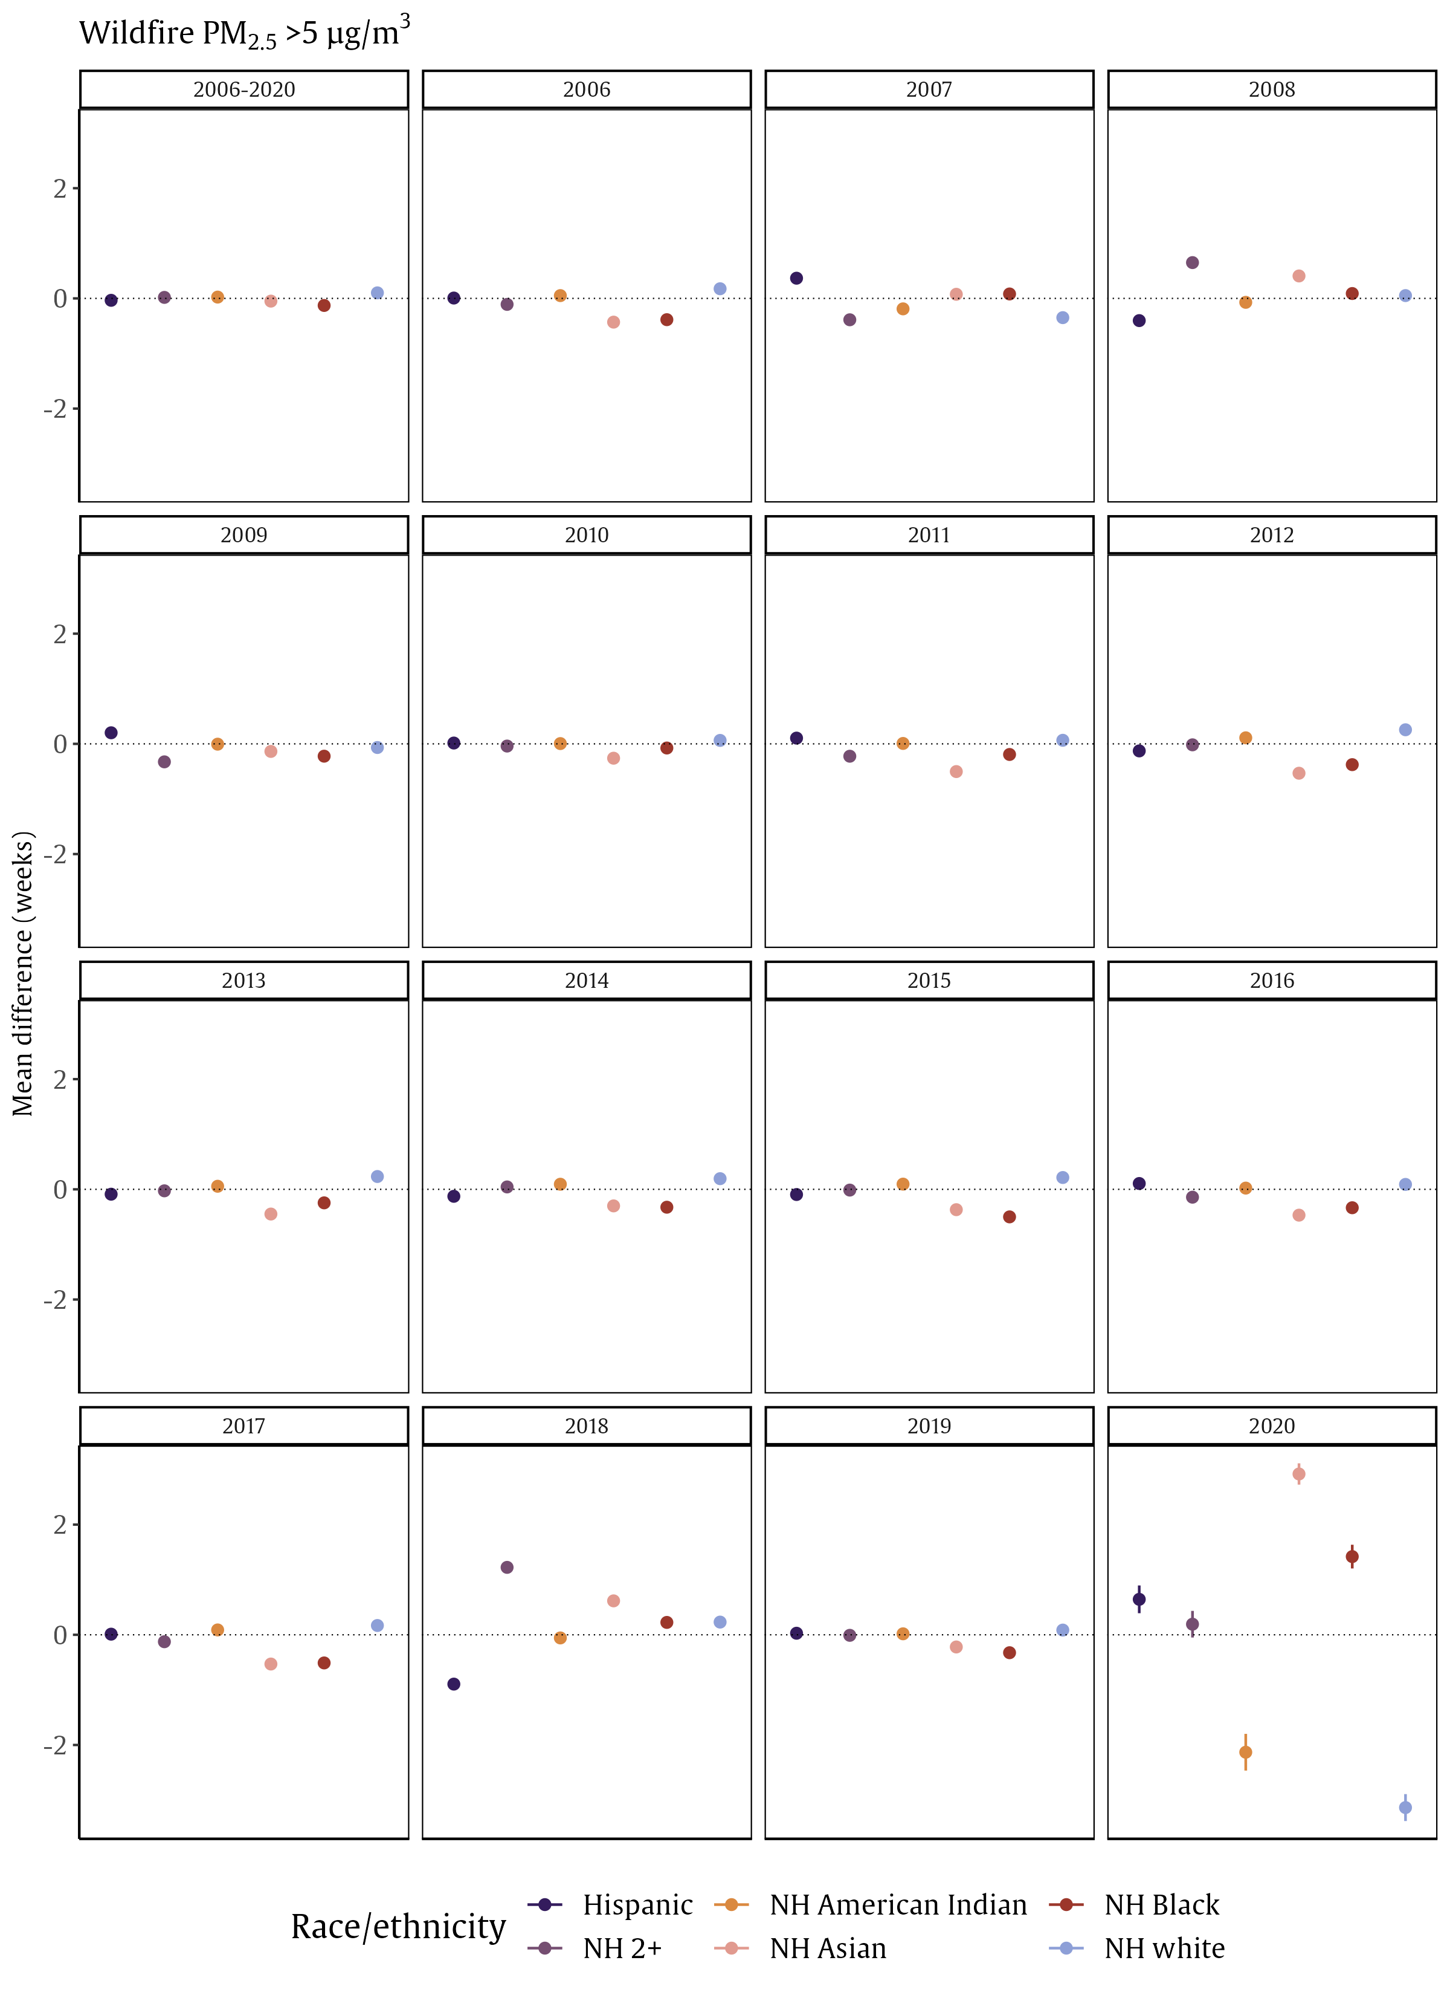
(B)
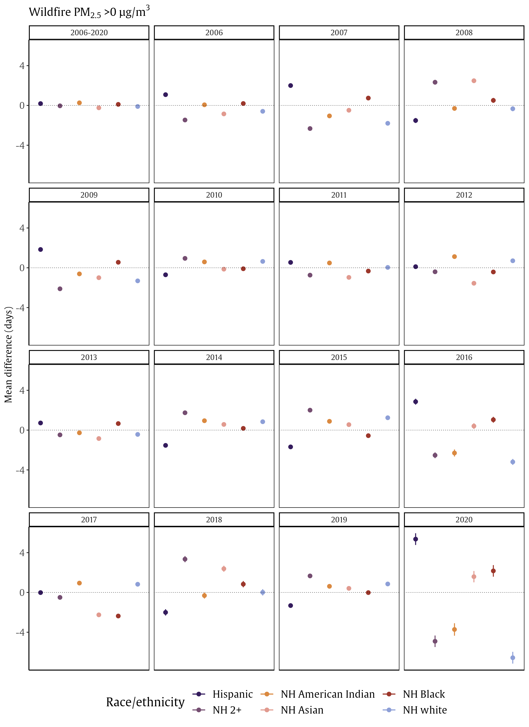
(C)
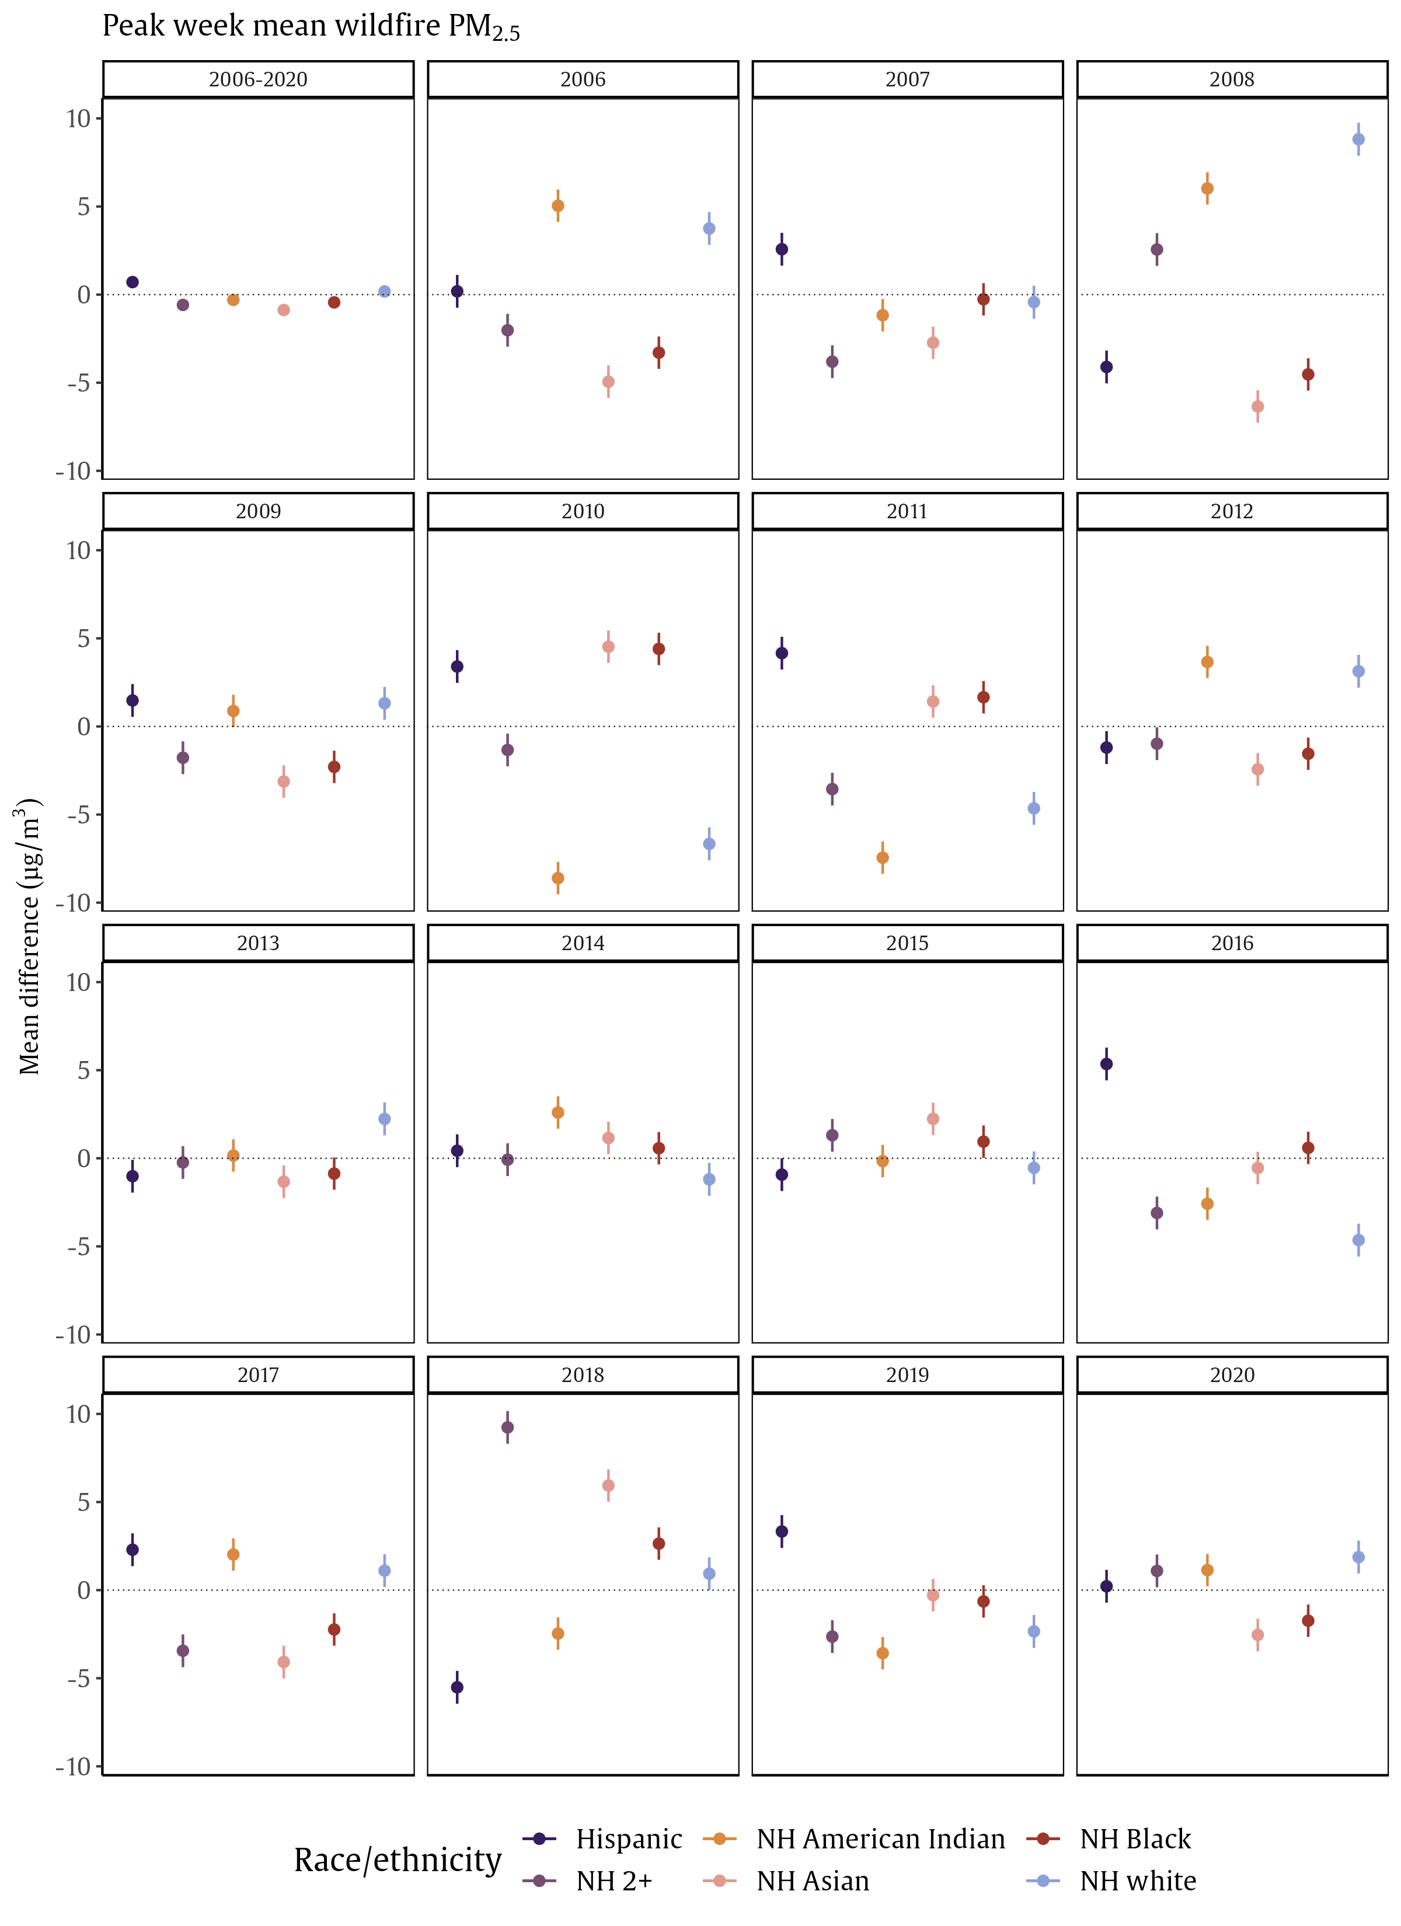
(D)
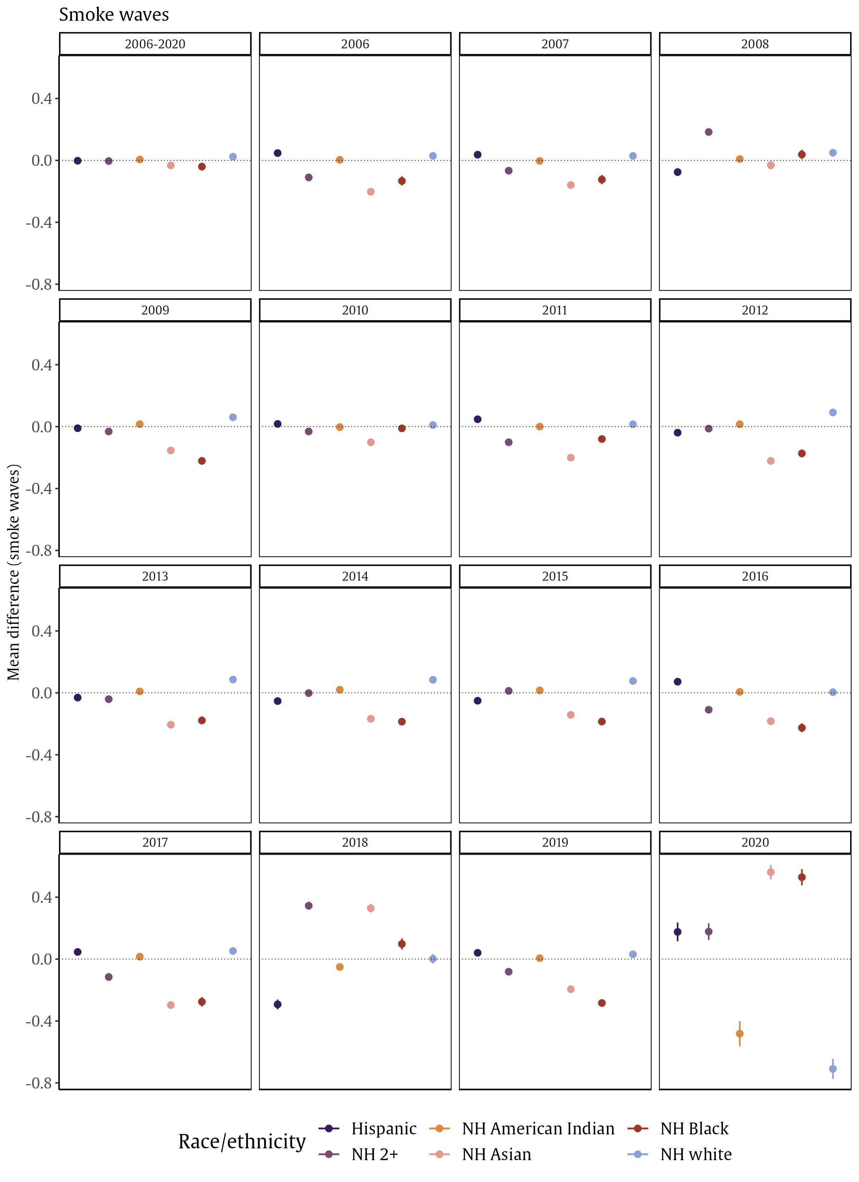
(E)
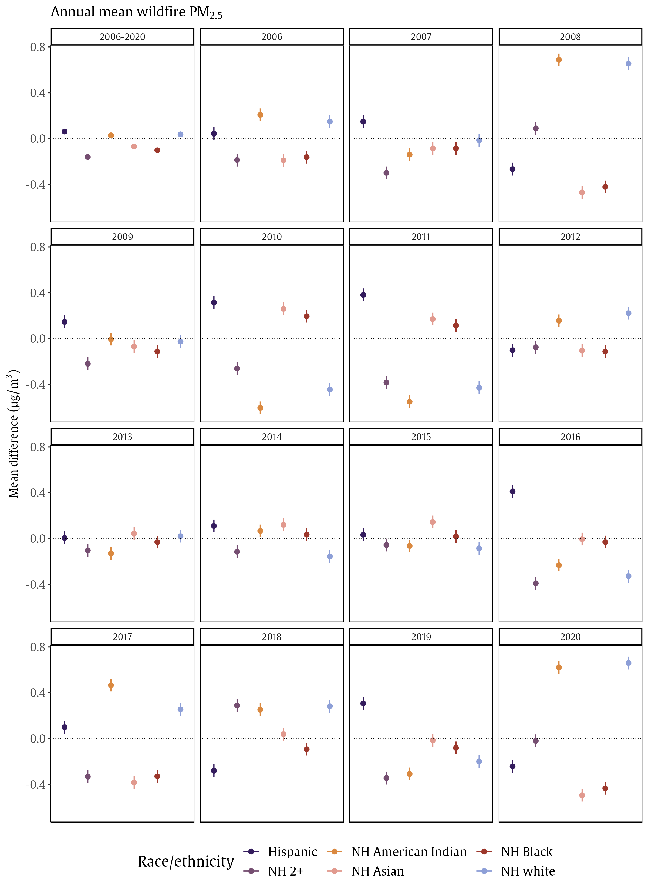

Supplementary Figure 10: Spatial distribution of residuals from the model estimating the association between CES score quartile 4 (disadvantaged communities) versus quartiles 1-3 and annual mean wildfire PM_{2.5} concentration in California from 2006–2020. Models were controlled for census tract level population density in 2010 (natural spline with 8 degrees of freedom) and census tract centroid latitude/longitude (natural spline with 20 degrees of freedom).
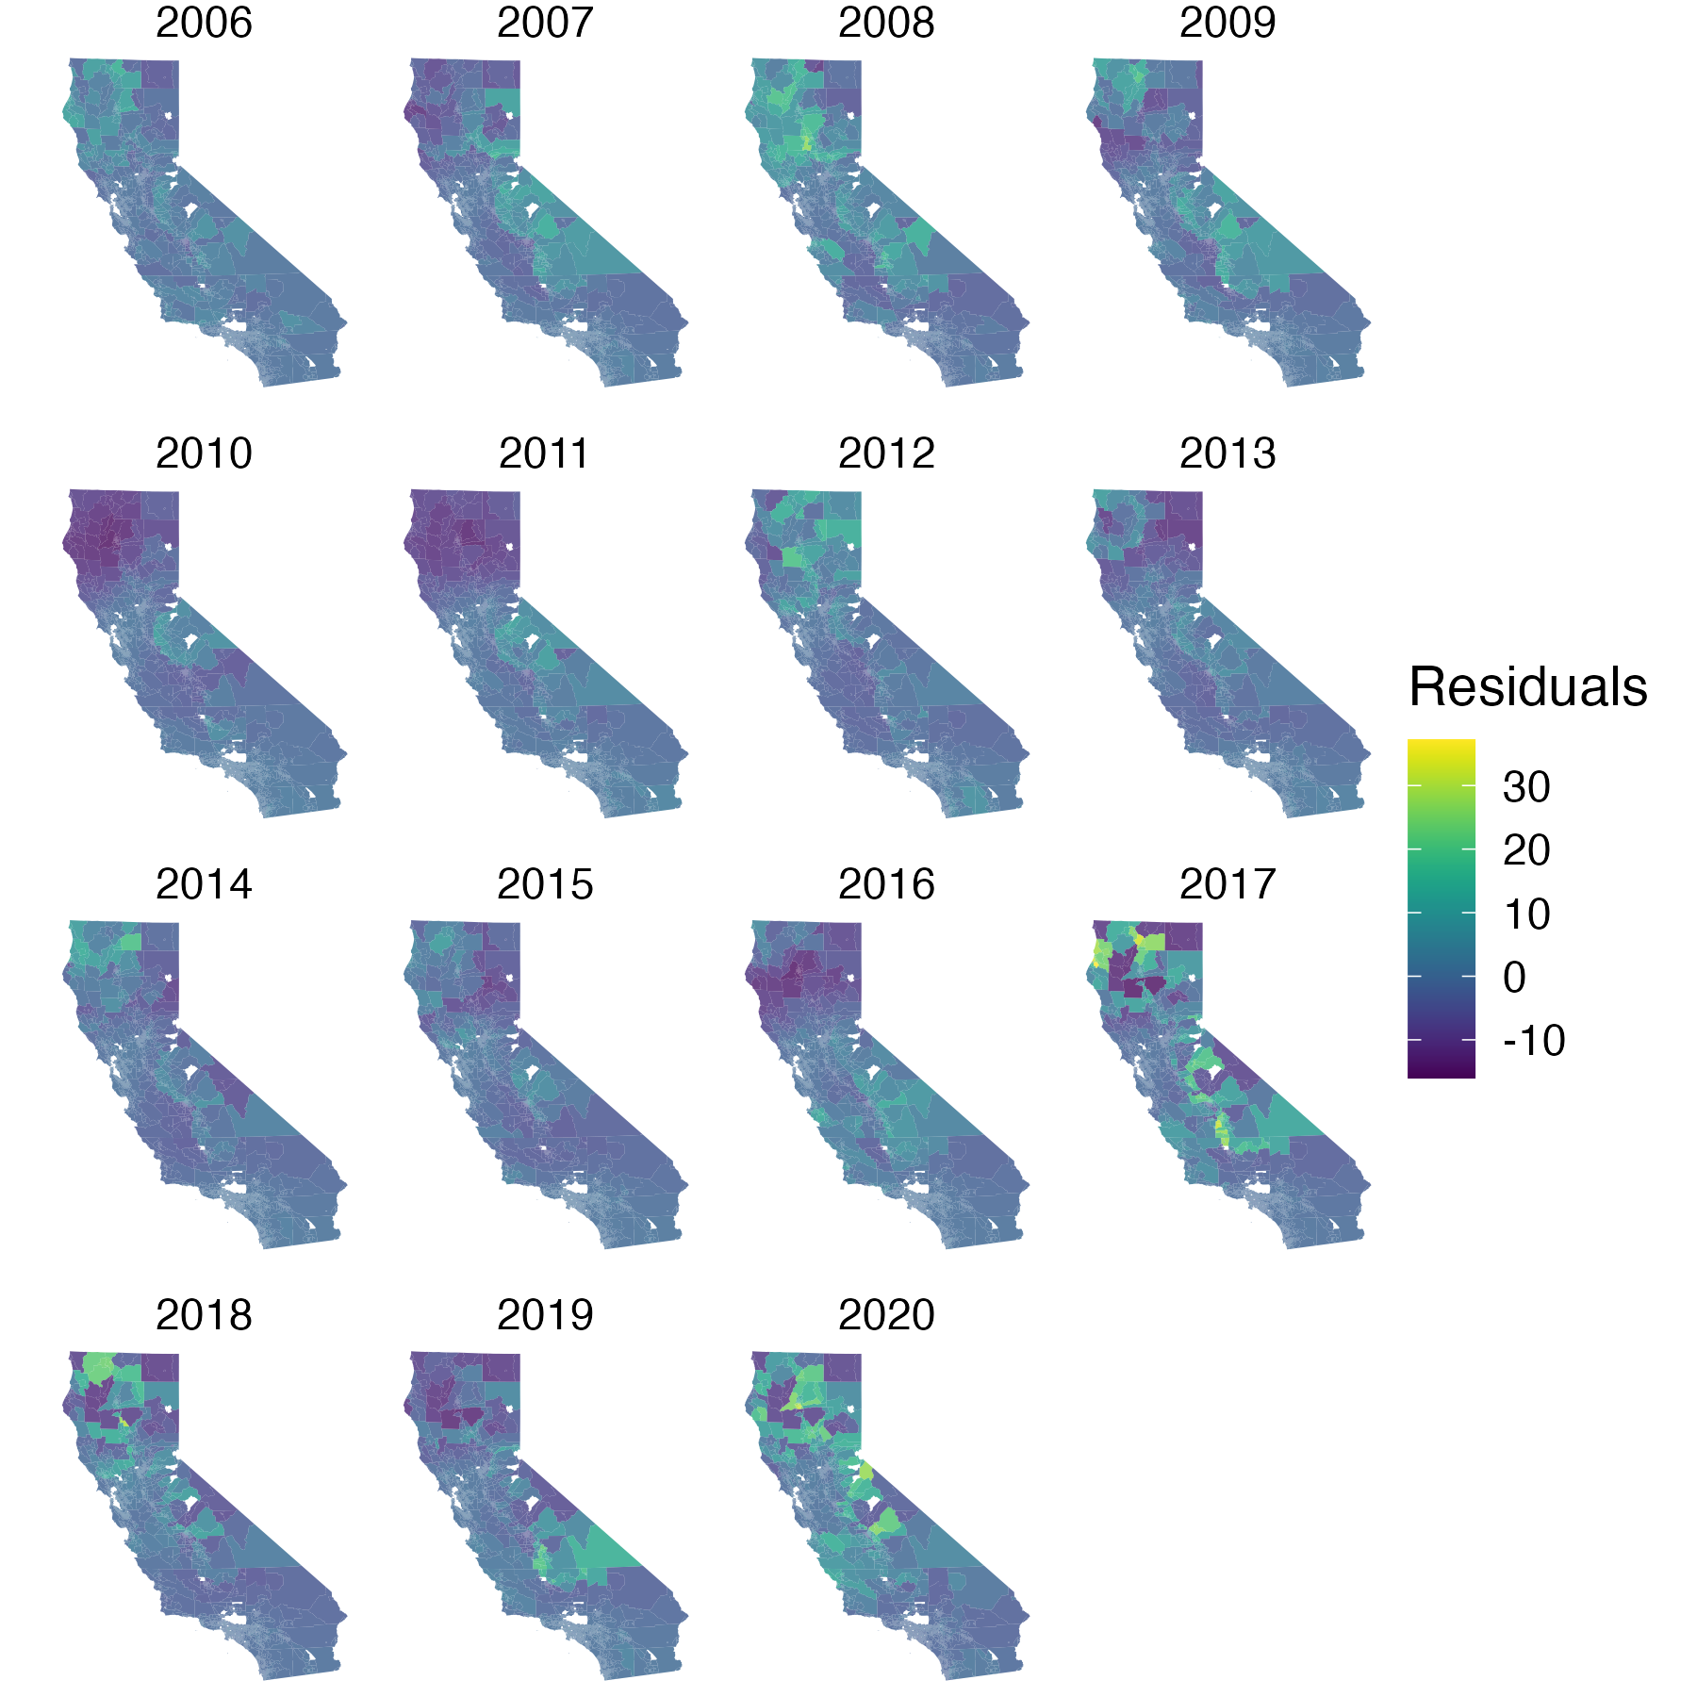

Supplementary Table 1: Risk ratios for each racial/ethnic group for wildfire PM_{2.5} exposure by year, 2006–2020. (A) Continuous annual mean wildfire PM_{2.5} concentration; (B) Annual mean wildfire PM_{2.5} concentration >25 μg/m³. A risk ratio greater than 1 (dark red/orange) indicates that racial/ethnic group j was over-represented among the exposed population, compared to their statewide representation, during year y and a risk ratio less than 1 (light brown) indicates that racial/ethnic group j was under-represented among the exposed population, compared to their statewide representation, during year y. A dash in a cell indicates no census tracts had >25 μg/m³ wildfire PM_{2.5} exposure in that year.
(A) Risk ratio for continuous wildfire PM_{2.5} exposure by racial/ethnic group
Year | Hispanic | NH Asian | NH American Indianª | NH Black | NH 2+ races | NH white
2006 | 0.91 | 0.38 | 3.08 | 0.44 | 0.96 | 1.35
2007 | 0.95 | 0.44 | 2.48 | 0.51 | 0.92 | 1.29
2008 | 0.86 | 0.49 | 2.84 | 0.48 | 1.03 | 1.35
2009 | 0.95 | 0.39 | 2.88 | 0.41 | 0.93 | 1.31
2010 | 1.02 | 0.36 | 2.29 | 0.62 | 0.90 | 1.24
2011 | 1.11 | 0.35 | 2.18 | 0.51 | 0.81 | 1.18
2012 | 0.78 | 0.34 | 3.42 | 0.40 | 1.02 | 1.48
2013 | 0.82 | 0.42 | 2.95 | 0.45 | 1.01 | 1.42
2014 | 0.87 | 0.38 | 3.94 | 0.43 | 0.99 | 1.38
2015 | 0.79 | 0.42 | 3.58 | 0.39 | 1.05 | 1.45
2016 | 1.10 | 0.44 | 2.36 | 0.52 | 0.87 | 1.15
2017 | 0.97 | 0.35 | 3.08 | 0.37 | 0.91 | 1.31
2018 | 0.82 | 0.72 | 2.44 | 0.67 | 1.10 | 1.29
2019 | 1.05 | 0.38 | 2.41 | 0.37 | 0.87 | 1.24
2020 | 0.92 | 0.68 | 2.08 | 0.68 | 1.01 | 1.21
(B) Risk ratio for wildfire PM_{2.5} concentration >25 μg/m³ by racial/ethnic group
Year | Hispanic | NH Asian | NH American Indianª | NH Black | NH 2+ races | NH white
2006 | 0.16 | 0.06 | 5.20 | 0.12 | 1.26 | 2.15
2007 | - | - | - | - | - | -
2008 | 0.48 | 0.19 | 4.13 | 0.17 | 1.14 | 1.80
2009 | 0.22 | 0.10 | 5.90 | 0.22 | 1.45 | 2.05
2010 | - | - | - | - | - | -
2011 | - | - | - | - | - | -
2012 | 0.48 | 0.09 | 5.31 | 0.11 | 1.14 | 1.86
2013 | 0.21 | 0.23 | 3.79 | 0.20 | 1.25 | 2.06
2014 | 0.19 | 0.07 | 37.0 | 0.14 | 1.53 | 1.76
2015 | - | - | - | - | - | -
2016 | - | - | - | - | - | -
2017 | 1.08 | 0.38 | 3.23 | 0.40 | 0.82 | 1.15
2018 | 0.34 | 0.15 | 10.3 | 0.16 | 1.31 | 1.88
2019 | 1.60 | 0.38 | 1.17 | 0.26 | 0.55 | 0.76
2020 | 0.41 | 0.16 | 5.61 | 0.17 | 1.11 | 1.85
ª Non-Hispanic American Indian or Alaska Native
NH, non-Hispanic

Supplementary Table 2: Mean difference in long-term wildfire PM_{2.5} concentration in CES score quartile 4 vs. quartiles 1-3 averaged across 2006–2020 and during each year. These results correspond to Figure 4 in the main manuscript. (A) Number of weeks with average wildfire PM_{2.5} > 5 μg/m³; (B) Number of days with non-zero wildfire PM_{2.5} concentrations; (C) Average of mean daily wildfire PM_{2.5} exposure during the peak week; (D) Number of smoke wavesª; (E) Average of mean annual wildfire PM_{2.5} concentration.
ª Smoke waves are defined as the number of instances of $≥$2 consecutive days with $≥$25μg/m³ wildfire PM_{2.5}, which was close to the study area and period 90th percentile of wildfire PM_{2.5} concentration on days with any wildfire PM_{2.5}, similar to prior work (2).
CES score, CalEnviroScreen score

Supplementary Table 2A: Number of weeks with average wildfire PM_{2.5} > 5 μg/m³
Effect estimate | Mean difference (95% CI)
Averaged across 2006–2020 | -0.38 (-0.42, -0.35)
By year
2006 | -0.24 (-0.31, -0.18)
2007 | 0.43 (0.30, 0.56)
2008 | -0.73 (-0.86, -0.59)
2009 | -0.15 (-0.23, -0.07)
2010 | -0.08 (-0.12, -0.04)
2011 | -0.13 (-0.18, -0.07)
2012 | -0.51 (-0.55, -0.46)
2013 | -0.40 (-0.45, -0.34)
2014 | -0.16 (-0.20, -0.11)
2015 | -0.31 (-0.36, -0.26)
2016 | -0.24 (-0.31, -0.18)
2017 | 0.06 (-0.01, 0.12)
2018 | -1.55 (-1.69, -1.41)
2019 | -0.21 (-0.27, -0.15)
2020 | 1.70 (1.10, 2.30)
Supplementary Table 2B: Number of days with non-zero wildfire PM_{2.5} concentrations
Effect estimate | Mean difference (95% CI)
Averaged across 2006–2020 | -0.01 (-0.15, 0.13)
By year
2006 | 1.57 (1.20, 1.94)
2007 | 3.83 (3.40, 4.25)
2008 | -2.06 (-2.62, -1.49)
2009 | 2.28 (1.87, 2.69)
2010 | -1.21 (-1.37, -1.06)
2011 | 0.76 (0.59, 0.93)
2012 | -0.59 (-0.80, -0.38)
2013 | 0.78 (0.29, 1.27)
2014 | -1.81 (-2.04, -1.58)
2015 | -3.33 (-3.66, -2.99)
2016 | 3.85 (3.13, 4.57)
2017 | 0.27 (0.18, 0.37)
2018 | -3.20 (-3.91, -2.49)
2019 | -1.97 (-2.27, -1.68)
2020 | 6.01 (4.59, 7.43)
Supplementary Table 2C: Average peak-week mean daily wildfire PM_{2.5} exposure
Effect estimate | Mean difference (95% CI)
Averaged across 2006–2020 | -2.80 (-3.43, -2.17)
By year
2006 | -2.60 (-4.73, -0.47)
2007 | 1.77 (-0.36, 3.90)
2008 | -10.62 (-12.75, -8.49)
2009 | -5.49 (-7.62, -3.36)
2010 | 1.80 (-0.33, 3.94)
2011 | -1.45 (-3.58, 0.68)
2012 | -10.08 (-12.21, -7.95)
2013 | -5.83 (-7.97, -3.70)
2014 | 1.89 (-0.24, 4.02)
2015 | -6.25 (-8.38, -4.12)
2016 | 1.41 (-0.72, 3.54)
2017 | 4.78 (2.65, 6.91)
2018 | -11.13 (-13.26, -8.99)
2019 | 0.96 (-1.17, 3.10)
2020 | -1.18 (-3.31, 0.95)
Supplementary Table 2D: Number of smoke wavesª
Effect estimate | Mean difference (95% CI)
Averaged across 2006–2020 | -0.09 (-0.11, -0.08)
By year
2006 | -0.20 (-0.32, -0.09)
2007 | -0.02 (-0.14, 0.10)
2008 | -0.76 (-0.88, -0.64)
2009 | -0.13 (-0.24, -0.01)
2010 | 0.29 (0.17, 0.40)
2011 | 0.27 (0.15, 0.39)
2012 | -0.61 (-0.72, -0.49)
2013 | -0.25 (-0.37, -0.13)
2014 | 0.04 (-0.08, 0.16)
2015 | -0.32 (-0.44, -0.20)
2016 | 0.21 (0.09, 0.33)
2017 | 0.15 (0.04, 0.27)
2018 | -0.70 (-0.82, -0.59)
2019 | 0.16 (0.05, 0.28)
2020 | -0.39 (-0.51, -0.27)
Supplementary Table 2E: Average of mean annual wildfire PM_{2.5} concentration
Effect estimate | Mean difference (95% CI)
Averaged across 2006–2020 | -0.16 (-0.20, -0.12)
By year
2006 | -0.24 (-0.37, -0.12)
2007 | -0.05 (-0.18, 0.07)
2008 | -0.80 (-0.92, -0.67)
2009 | -0.16 (-0.29, -0.04)
2010 | 0.25 (0.12, 0.37)
2011 | 0.24 (0.11, 0.36)
2012 | -0.64 (-0.77, -0.52)
2013 | -0.24 (-0.36, -0.11)
2014 | 0.06 (-0.07, 0.18)
2015 | -0.31 (-0.43, -0.18)
2016 | 0.22 (0.10, 0.35)
2017 | 0.17 (0.04, 0.29)
2018 | -0.69 (-0.82, -0.57)
2019 | 0.18 (0.05, 0.30)
2020 | -0.38 (-0.50, -0.25)

REFERENCES
1. L. August et al. (2021) CalEnvironScreen 4.0.
2. J. C. Liu et al., Who among the elderly is most vulnerable to exposure to and health risks of fine particulate matter from wildfire smoke? Am J Epidemiol 186, 730-735 (2017).

