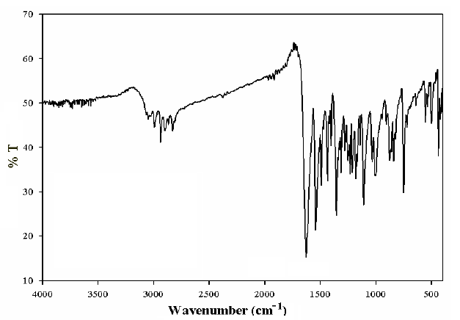Figure.S1. Shows the FT-IR spectrum of the ligand.

Figure.S2. Shows the FT-IR spectrum of the complexes (1 and 2).

Figure.S3. Shows the FT-IR spectrum of the complex (3).

Figure.S4. Shows the FT-IR spectrum of the complex (4).
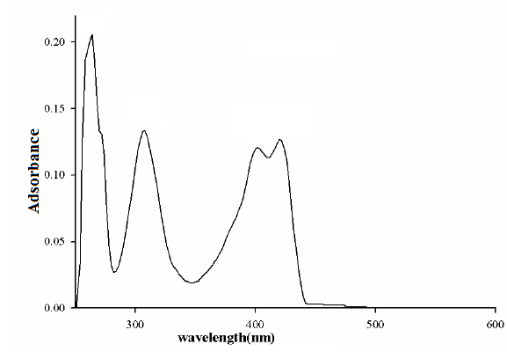
Figure S5. Shows the UV-Vis spectrum of the ligand with a concentration of
10⁻⁵mol/L in the acetonitrile solvent.

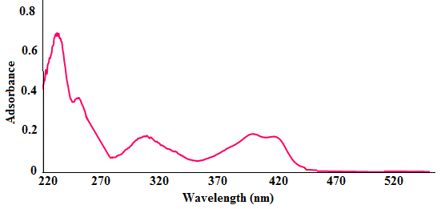
Figure S6. Shows the UV-Vis spectrum of the complexes (1 and 2) with a concentration of
10⁻⁵mol/L in the acetonitrile solvent.
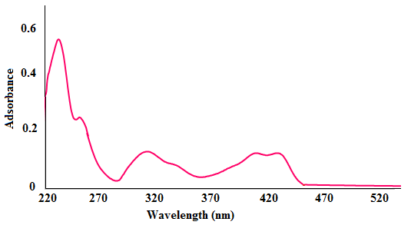
Figure S7. Shows the UV-Vis spectrum of the complexes (3) with a concentration of
10⁻⁵mol/L in the acetonitrile solvent.

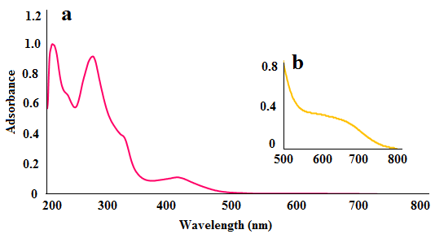
Figure S8. Shows the UV-Vis spectrum of the complex (4) with a concentration of 10⁻⁵mol/L; (a) and 10⁻³ mol/L; (b) in the acetonitrile solvent.

