SUPPLEMENTARY INFORMATION FOR
Capturing the colloidal microplastics with plant-based nanocellulose networks

Ilona Leppänen¹, Timo Lappalainen¹, Tia Lohtander², Christopher Jonkergouw³, Suvi Arola^{1*} and Tekla Tammelin^{1*}
This file includes:
Supplementary Figures 1 -12
Supplementary Tables 1 - 4

Supplementary Figures

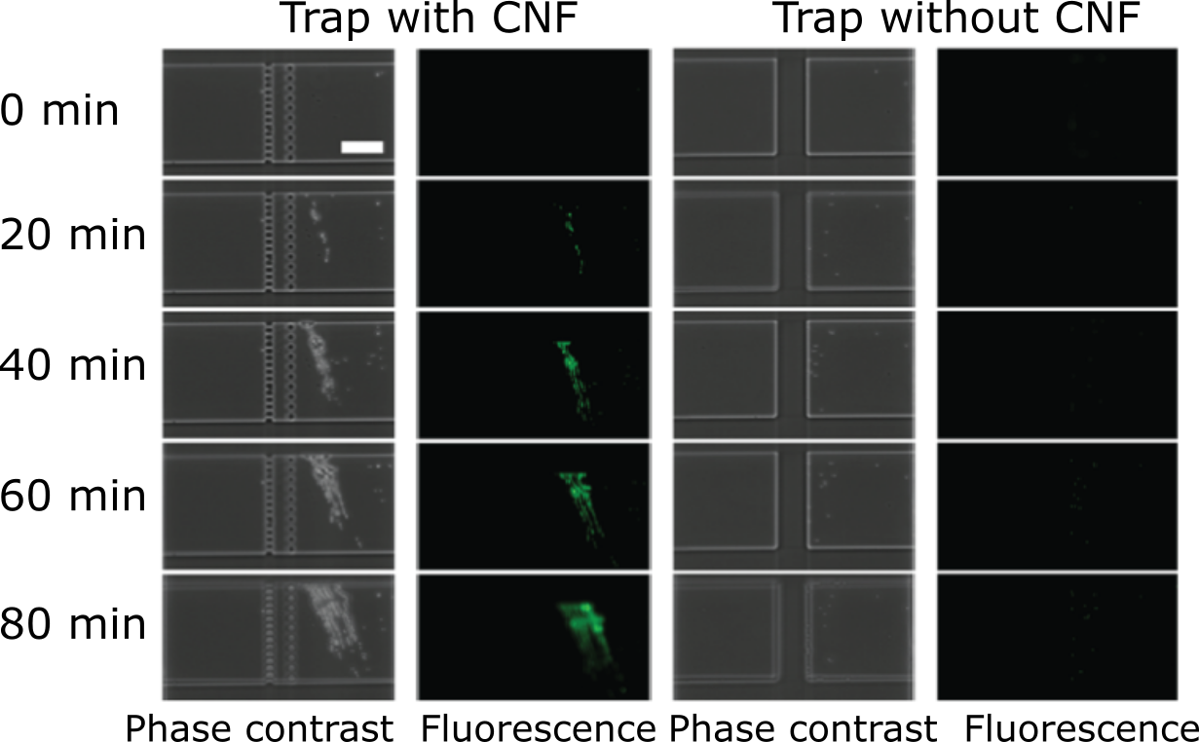

Supplementary Figure 1. Fluorescent and phase contrast microscopy images of microfluidic traps with native CNF hydrogel (two panels on the left) and without CNF hydrogel (two panels on the right) showing the fluorescence accumulation in the CNF hydrogel network due to cationic µPp entrapment over time. We took the images during the experiments at given time points, and they are shown as red dots in the manuscript Figure 1c, where the fluorescence accumulation is shown graphically.
Supplementary Figure 2. Fluorescence accumulation of anionic polystyrene particles over time by CNF hydrogel network. (a) Data showing accumulation of negatively charged nPp and (b) data showing accumulation of negatively charged µPp. Green curves show control trap without CNF hydrogel. The orange and blue curves show parallel experiments with CNF hydrogel in the traps.

Supplementary Figure 3. Profile analysis of microplastic particles captured by native CNF hydrogel network. (a) Cross-sectional analysis of the CNF hydrogel network during a washing cycle shows the intensity and location of the entangled particles. (b) Cross-section profile analysis of the CNF hydrogel network reveals clear differences between charge (positive and negative) and particle size (nPp and µPp) on the penetration into, and binding affinity towards the CNF hydrogel network. Positively charged particles, both micro and nano-sized display an increased signal, indicating an increased affinity towards the CNF hydrogel, whereas the nPp can penetrate further into the hydrogel network than the µPp. Scalebar in a) is 20 µm.

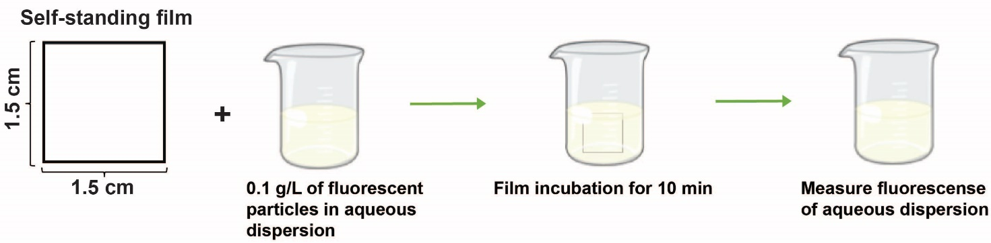
Supplementary Figure 4. The experimental setup for quantitative assessment of the self-standing films’ ability to capture plastic particles from aqueous dispersion.

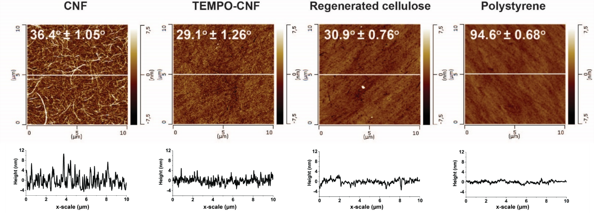
Supplementary Figure 5. Atomic force microscopy (AFM) height images of native cellulose nanofibrils (CNF), TEMPO-oxidized cellulose nanofibrils (TEMPO-CNF), regenerated cellulose (RC), and polystyrene (PS). The white line in the image corresponds to the height profile plot shown under each image. Static water contact angles for each ultrathin film are shown in the AFM images

Supplementary Figure 6. Change in frequency (a,c) and dissipation (b,d) as a function of time as detected by Quartz Crystal Microbalance with Dissipation monitoring (QCM-D). Change in frequency for stabile (a) and purified (c) nPp. Change in dissipation for stabile (b) and purified (d) nPp. (f₀ = 5 MHz, n = 5). Arrows in indicate the rinsing with phosphate buffer (10 mM, pH 6.8) was started. The black vertical lines in the beginning of the measurement indicate the time when PS particle injection was started (2min).

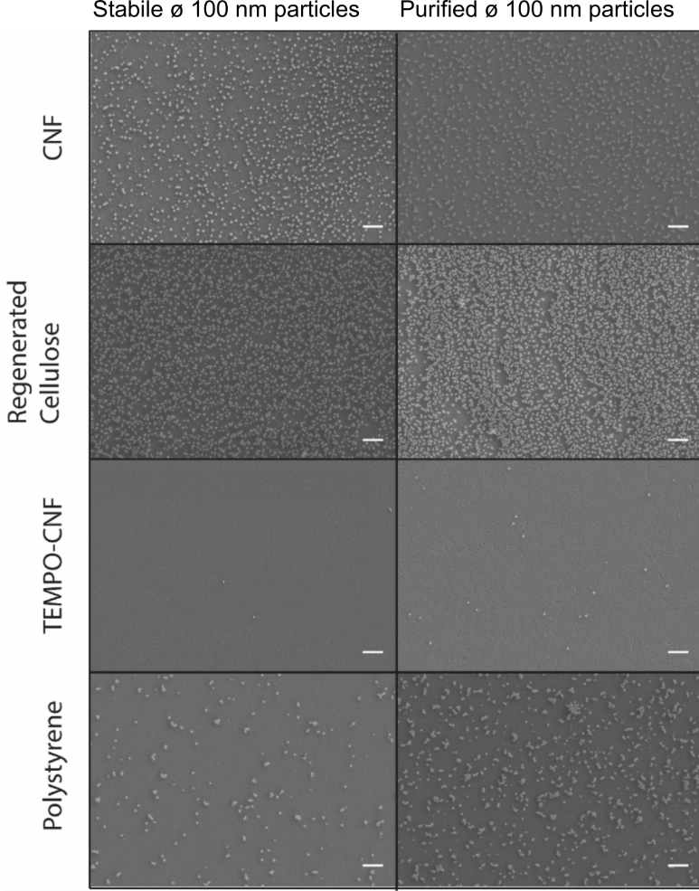
Supplementary Figure 7. Scanning electron microscopy (SEM) images of the QCM-D sensor surfaces after the adsorption experiments. The scale bar is 1 µm.
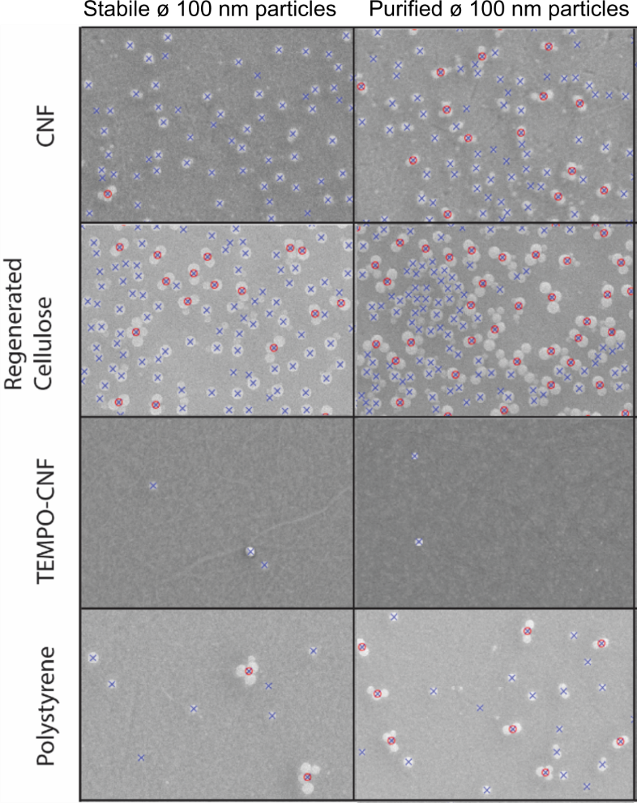
Supplementary Figure 8. Scanning electron microscopy (SEM) images (cropped from Supplementary Figure 5) of QCM-D adsorption experiments with identified and calculated nPp objects. Blue cross indicates a single identified nanoplastic particle, and red circle corresponds to an identified cluster with a minimum of three objects.

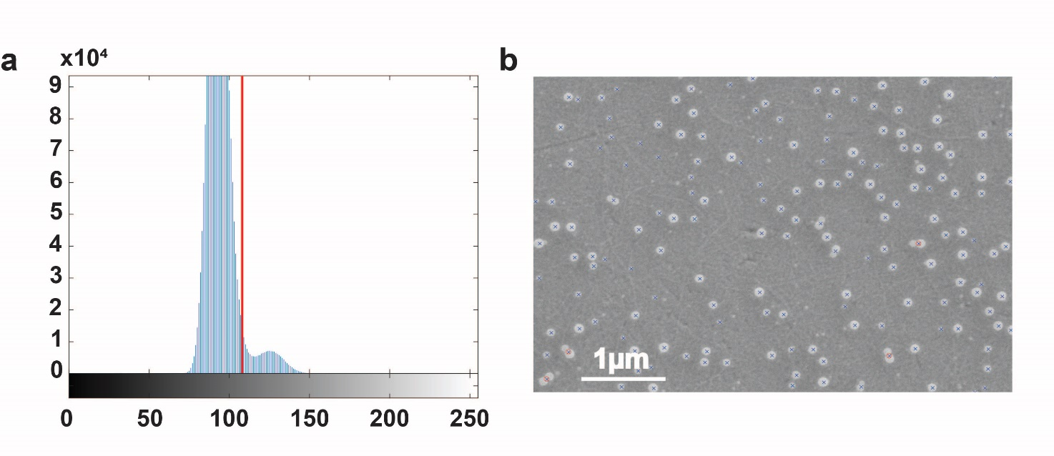
Supplementary Figure 9. a) Bimodal histogram of scanning electron microscopy (SEM) image, the threshold used for image segmentation (red vertical line), b) Particles identified from the image (stabile nPp on native CNF surface).

Supplementary Figure 10. Changes in dissipation (ΔD) versus changes in frequency (Δf) for the different nPp systems. (f₀ = 5 MHz, n = 5, t = 1h)

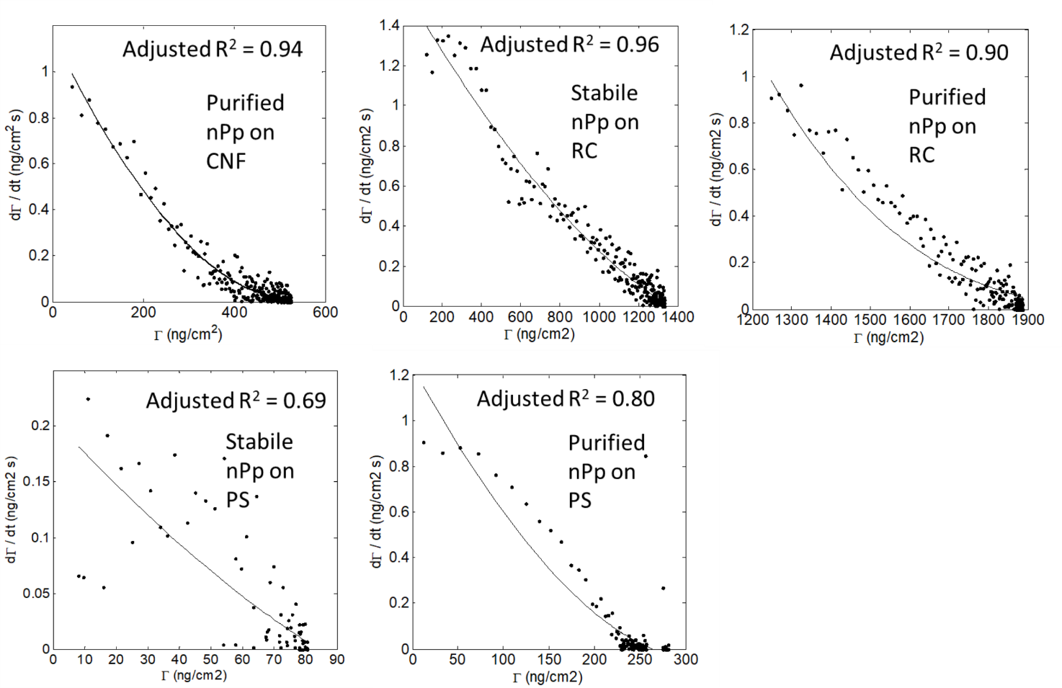
Supplementary Figure 11. Fittings of QCM-D adsorption data of purified and stabile nPp on CNF, RC and PS surfaces by the RSA model. Stabile nPp on CNF presented in the manuscript Fig. 3b.

Supplementary Figure 12. Calibration curves for fluorescently labelled nPp and µPp. Top graphs nPp, on the left negatively charged and on the right positively charged particles. Bottom graphs µPp, on the left negatively charged and on the right positively charged particles.

Supplementary Tables
Supplementary Table 1. ζ-potential values of the polystyrene particles.
Polystyrene (PS) particle | ø | ζ-potential (mV)ª
L9902 | 100 nm | -53.1
L9904 | 100 nm | 16.6
L4655 | 1.0 µm | -47.3
L9654 | 1.0 µm | 27.1
LB1 | 100 nm | -52.2
LB1 purified^{b} | 100 nm | -44.5
^{a)} Measurement conditions: 0.1 gL⁻¹ particle solution in phosphate buffer (10 mM, pH 7)
^{b)} Purified with the protocol provided by the supplier: dialysis against Milli-Q water with 1000 kDa MWCO dialysis membrane (Biotech CE Membrane Dialysis Trial Kit)

Supplementary Table 2. The number of cationic (+) and anionic (-) 100nm and 1.0 µm PS particles entrapped by self-standing films.
Film | PS particles | # of PS particles/mm²
CNF | ø 1.0 um  | 2.51×10⁵ ± 2.93×10⁴
CNF | ø 1.0 um  | 0.836×10⁵ ± 1.33×10⁴
CNF | ø 100 nm | 1.04×10⁸ ± 5.93×10⁷
CNF | ø 100 nm | 0.529×10⁸ ± 1.61×10⁷
TEMPO-CNF | ø 1.0 um | 3.27×10⁵ ± 2.93×10⁴
TEMPO-CNF | ø 1.0 um | 1.03×10⁵ ± 2.77×10⁴
TEMPO-CNF | ø 100 nm | 1.67×10⁸ ± 2.48×10⁷
TEMPO-CNF | ø 100 nm | 2.45×10⁸ ± 3.60×10⁷
Polystyrene | ø 1.0 um | 1.14×10⁵ ± 0.993×10⁴
Polystyrene | ø 1.0 um | 0.589×10⁵ ± 1.90×10⁴
Polystyrene | ø 100 nm | 1.34×10⁸ ± 2.50×10⁷
Polystyrene | ø 100 nm | 0.446×10⁸ ± 1.37×10⁷
Regenerated Cellulose | ø 1.0 um | 1.69×10⁵ ± 6.82×10⁴
Regenerated Cellulose | ø 1.0 um | 0.877×10⁵ ± 1.80×10⁴
Regenerated Cellulose | ø 100 nm | 1.14×10⁸ ± 1.43×10⁷
Regenerated Cellulose | ø 100 nm | 1.44×10⁸ ± 1.71×10⁷

Supplementary Table 3. The area of self-standing films needed to recover all cationic (+) and anionic (-) 100nm and 1.0 µm PS particles from the 0.1 gL⁻¹ solutions.
Film | PS particles | Area (cm²) needed to clear all particles^{a)}
CNF | ø 1.0 um | 30
CNF | ø 1.0 um | 85
CNF | ø 100 nm | 70
CNF | ø 100 nm | 140
TEMPO-CNF | ø 1.0 um | 20
TEMPO-CNF | ø 1.0 um | 70
TEMPO-CNF | ø 100 nm | 45
TEMPO-CNF | ø 100 nm | 30
Polystyrene | ø 1.0 um | 65
Polystyrene | ø 1.0 um | 125
Polystyrene | ø 100 nm | 55
Polystyrene | ø 100 nm | 165
Regenerated Cellulose | ø 1.0 um | 45
Regenerated Cellulose | ø 1.0 um | 85
Regenerated Cellulose | ø 100 nm | 65
Regenerated Cellulose | ø 100 nm | 50
^{a)} Amount of nPp and µPp in solution are calculated based on the solution fluorescence before film immersion and the standard curves for the particles. The amount of nPp in a 0.1 gL⁻¹solution is ~730G and µPp ~725M.
The maximum amount of particles that can be accommodated on different planar surfaces depends on the film's thickness and how the particles can penetrate inside the film. The self-standing films used in this study are very different in structure; they are made of different materials, two are colloidal (CNF, TEMPO-CNF), and two are polymeric (RC, PS). CNF and TEMPO-CNF have a large surface area compared to RC and PS, and they form porous films allowing particles to /enter inside the film structure/penetrate the film structure. The cellulose materials (CNF, TEMPO-CNF, and RC) swell significantly in water, affecting their thickness and thus volume. Both experiments and computer simulations have shown that the maximum volume fraction of randomly packed equal-sized hard spheres is 64% (Bernal close-packing limit).¹ However, because the volumes of the self-standing films are different, time-dependent, and challenging to determine, it is impossible to make comparisons concerning the theoretical maximum number of particles per unit area of the film. Thus, the performance of the different films was assessed by comparing the area of each film needed to capture all particles present in the solution (Supplementary Table 3).

Supplementary Table 4. The number of stabile (S) and purified (P) 100 nm PS particles adsorbed on various substrates compared to the theoretical maximum number that can adsorb on the surface.
Films | PS particles | # of PS particles/mm^{2 a)}
CNF | ø 100 nm  | 9.96×10⁶ ± 1.60×10⁶
CNF | ø 100 nm  | 7.97×10⁶ ± 1.30×10⁶
TEMPO-CNF | ø 100 nm | 9.89×10⁴ ± 2.64×10⁴
TEMPO-CNF | ø 100 nm | 9.32×10⁴ ± 1.83×10⁴
PS | ø 100 nm | 5.35×10⁶ ± 2.08×10⁶
PS | ø 100 nm | 1.53×10⁶ ± 0.164×10⁶
RC | ø 100 nm | 35.9×10⁶ ± 1.38×10⁶
RC | ø 100 nm | 25.3×10⁶ ± 1.79×10⁶
^{a)} # of PS particles/mm² is the number of particles per unit area (dN/dt) after the adsorption process gained by applying the image analysis.

References
1. Baranau, V. & Tallarek, U. Random-close packing limits for monodisperse and polydisperse hard spheres. Soft Matter (2014) doi:10.1039/c3sm52959b.

