Supplementary Tables
Supplementary Table S1. Sensory activation and frequency information relating to ART.

Sensor | Activation | Frequency of readings | End
Flow | On button press | 25 times per second | Max 6 s after initial draw
Temperature | On button press | Single reading | –
Humidity | On button press | Single reading | –
Pressure | On button press | Single reading | –
Accelerometer | On button press | Twice per second | When no flow is detected

Supplementary Table S2. E-liquid formulations.
E-liquid | Nicotine (mg/ml) | Flavour 1 (%) | Flavour 2 (%) | Flavour 3 (%) | PG (%) | VG (%) | Nicotine (%) | Water (%)
Phase 1  Wild Berries | 18 | 20 | 0.96 | 0.64 | 32.36 | 34.22 | 1.78 | 10
Dark Cherry | 12 | 15.94 | 10.63 | – | 27.44 | 34.71 | 1.29 | 10
Dark Cherry | 0 | 15.94 | 10.63 | – | 27.44 | 36 | 0 | 10
Phase 2  Dark Cherry | 18 | 15.94 | 10.63 | – | 27.44 | 34.218 | 1.782 | 10
Dark Cherry | 12 | 15.94 | 10.63 | – | 27.44 | 34.692 | 1.308 | 10
Dark Cherry | 6 | 15.94 | 10.63 | – | 27.44 | 35.34 | 0.66 | 10
Dark Cherry | 0 | 15.94 | 10.63 | – | 27.44 | 36 | 0 | 10
Mint | 18 | 4.50 | 2.36 | 0.18 | 46.96 | 34.218 | 1.782 | 10
Mint | 0 | 4.50 | 2.36 | 0.18 | 46.96 | 36 | 0 | 10
Blended Tobacco | 18 | 22.28 | N/A | N/A | 31.722 | 34.218 | 1.782 | 10
Blended Tobacco | 6  Abbreviations: PG, propylene glycol; VG, vegetable glycerine. | 22.28 | N/A | N/A | 31.722 | 36 | 0 | 10

Supplementary Table S3. Data collection points in Phases 1 and 2.
Stage | Phase 1 | Phase 2
Pre-vaping | -
Pre-vaping | - | –50 min
Pre-vaping | - | –40 min
Pre-vaping | - | –30 min
Pre-vaping | - | –20 min
Pre-vaping | –10 min | –10 min
Pre-vaping | –2–5 min | –
Vaping – start | 0 min | 0 min
Vaping | 4–5 min | 5 min
Vaping | 8 min | 8 min
Vaping – end | 10 min | 10 min
Post-vaping | 12 min | –
Post-vaping | 15 min | –
Post-vaping | - | 20 min
Post-vaping | 30 min | 30 min
Post-vaping | 60 min | –
Supplementary Table S4. Device mass loss in Phase 1.
Participant ID | Pre weight (mg) | Post weight (mg) | DML (mg)
ART – 12 mg/mL  nic 30 | 13.0608 | 12.9765 | 0.0843
28 | 12.9899 | 12.8973 | 0.0926
32 | 13.0504 | 13.0012 | 0.0492
31 | 13.0527 | 12.6835 | 0.3692
29 | 13.1469 | 13.0535 | 0.0934
27 | 13.0205 | 12.6835 | 0.3370
26 | 13.0916 | 13.0501 | 0.0415
24 | 12.9841 | 12.8918 | 0.0923
17 | 13.0844 | 13.0463 | 0.0381
33 | 13.0151 | 12.9376 | 0.0775
34 | 13.0276 | 12.8666 | 0.1610
35 | 13.0702 | 12.8882 | 0.1820
36 | 13.0740 | 13.0023 | 0.0717
ART – 0 mg/mL  32 | 13.1313 | 13.0454 | 0.0859
29 | 13.0147 | 12.8592 | 0.1555
27 | 12.9803 | 12.9113 | 0.069
17 | 13.0200 | 13.0173 | 0.0027

Supplementary Table S5. Device mass loss in Phase 2.

Participant ID Pre weight (mg) Post weight (mg) DML (mg)
18 mg/mL nic
- 13.0404 12.9927 0.0477
- 13.0962 12.8959 0.2003
24 13.1161 12.9952 0.1209
- 13.0468 12.9941 0.0527
- 13.0941 13.0168 0.0773
- 13.0326 12.9287 0.1039
- 13.1234 12.9513 0.1721
- 13.0267 12.8089 0.2178
- 13.0395 12.9848 0.0547
- 13.1313 13.0540 0.0773
- 13.1479 12.9953 0.1526
- 13.1435 12.993 0.1505
- 13.1819 13.1035 0.0784
- 13.1083 13.0042 0.1041
- 13.1292 12.901 0.2282
- 13.0658 12.9442 0.1216
12 mg/mL nic
22 13.1142 13.0228 0.0914
6 mg/mL nic
23 13.0170 12.9090 0.1080
0 mg/mL nic
- 13.1228 13.0521 0.0707
- 13.114 12.9527 0.1613
- 13.1536 12.9889 0.1647
- 13.0177 12.8937 0.1240
- 13.1524 12.9441 0.2083
- 13.0574 12.9591 0.0983
- 13.2149 12.9993 0.2156
- 13.1494 13.0153 0.1341
- 13.0165 12.8208 0.1957
- 13.1222 12.8647 0.2575
- 13.0852 13.0169 0.0683
- 13.0989 12.9934 0.1055
- 13.1368 12.9598 0.1770
35* 13.1156 12.8734 0.2422
- 13.0140 12.9122 0.1018
- 13.1234 12.9266 0.1968
- 13.0580 12.9809 0.0771
39* 13.0799 12.8801 0.1998
40 13.1234 12.9266 0.1968
*Due to noise on first recording, participants 35 and 39 repeated the session and the second data only are reported here

Supplementary Figures
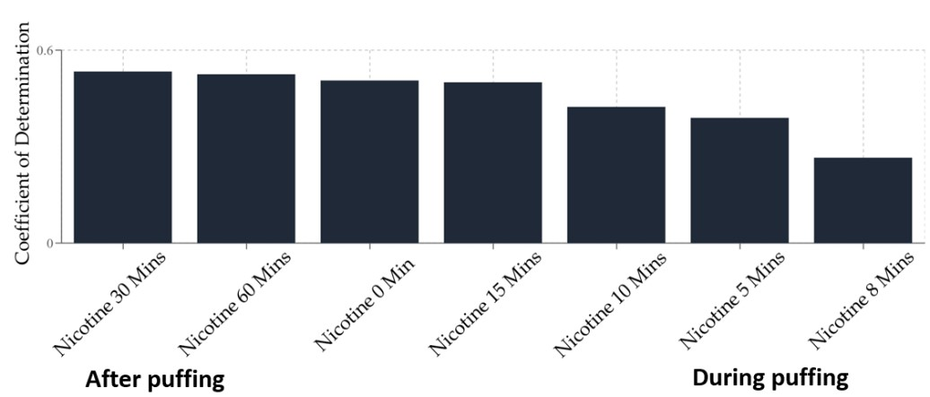
Supplementary Figure S1. Accuracy of the preliminary model based on historic nicotine PK data to predict nicotine plasma levels at different experimental time points.
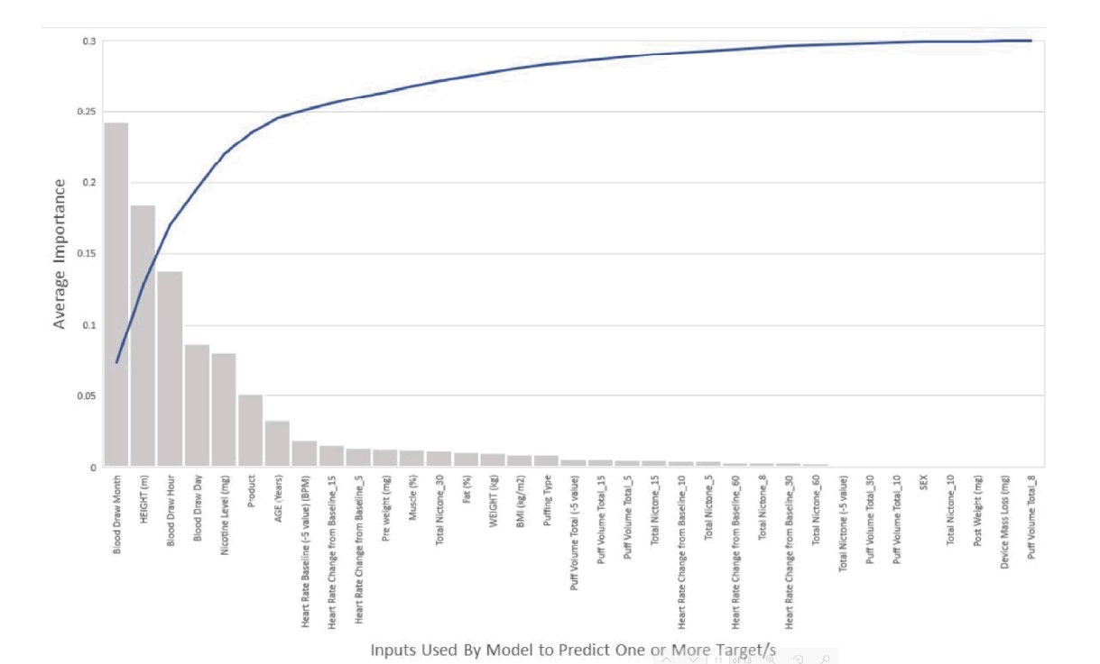
Supplementary Figure S2. Inputs used by the preliminary model to predict one or more targets.

NICOTINE GROUP (Subject ID) NON-NICOTINE GROUP (Subject ID)
Time from First Puff (min) | P17 | P18 | P22 | P23 | P24 | P26 | P27 | P28 | P29 | P31 | P32 | P33 | P34 | P35 | P36 | P37 | P38 | P39 | P40 |  | P17 | P18 | P22 | P23 | P24 | P26 | P27 | P28 | P29 | P31 | P32 | P33 | P34 | P35 | P36 | P37 | P38 | P39 | P40
1 | 3% | 3% | 1% | 2% | 3% | 2% | -4% | 7% | 5% | 2% | 0% | -5% | 14% | 14% | 4% | 4% |  | 9% | 9% |  | 4% | 4% | 2% | 27% | 1% | 2% | 1% | 4% | 9% |  | -5% | -2% | -1% | -3% | -1% | 3% | -2% | 5% | 2%
2 | 3% | -1% | 4% | 2% | 11% | -2% | -1% | 3% | 8% | 5% | 0% | -4% | 8% | 15% | -4% | 13% |  | 24% | 21% |  | -2% | 0% | 2% | -4% | 0% | -7% | -2% | 0% | 0% |  | -1% | -1% | -1% | 3% | -3% | 5% | -5% | 2% | -2%
3 | 18% | 4% | 6% | 4% | 18% | -1% | -6% | 6% | 9% | 12% | -1% | -7% | 13% | 7% | -4% | 19% |  | 26% | 9% |  | -3% | 1% | -1% | -6% | 2% | 0% | -5% | 4% | -4% |  | -3% | -2% | 0% | -4% | -2% | 3% | 1% | 4% | 6%
4 | 11% | 10% | 10% | 7% | 17% | 2% | -3% | 6% | 9% | 12% | 2% | -1% | 18% | 25% | 4% | 22% |  | 22% | 13% |  | 1% | -2% | 2% | -4% | 4% | -3% | -2% | 2% | 0% |  | -4% | -2% | -4% | 1% | 0% | -7% | -8% | 5% | 5%
5 | 12% | 7% | 8% | 11% | 17% | 1% | 0% | 7% | 5% | 9% | 2% | -1% | 21% | 24% | 1% | 28% |  | 24% | 16% |  | -2% | -3% | 1% | -4% | 5% | -4% | -5% | -4% | -3% |  | -3% | 3% | -5% | 3% | -4% | 0% | -6% | 4% | 6%
6 | 15% | 10% | 14% | 9% | 18% | -1% | -1% | 13% | 8% | 13% | 4% | 0% | 24% | 30% | 5% | 32% |  | 26% | 20% |  | 2% | -2% | -1% | -1% | -1% | -2% | -1% | 5% | 4% |  | -3% | 2% | -7% | 0% | 1% | 2% | -1% | 3% | 8%
7 | 14% | 10% | 19% | 10% | 23% | 2% | -1% | 2% | 5% | 11% | -3% | -3% | 21% | 24% | 4% | 36% |  | 31% | 23% |  | -2% | -2% | -2% | 10% | 2% | -6% | -4% | 1% | -3% |  | -5% | 3% | -6% | -3% | 3% | -3% | -8% | 8% | 2%
8 | 13% | 10% | 22% | 11% | 17% | 5% | 0% | 17% | 9% | 14% | -3% | -4% | 19% | 28% | 3% | 32% |  | 29% | 19% |  | 7% | -2% | 1% | -5% | 1% | -10% | -4% | -1% | -6% |  | 0% | -6% | -3% | 2% | -2% | 3% | 0% | 8% | 10%
9 | 13% | 12% | 20% | 12% | 17% | 3% | 4% | 21% | 7% | 8% | -6% | -6% | 24% | 27% | 9% | 46% |  | 29% | 23% |  | 0% | -4% | 1% | -4% | -1% | 0% | -4% | 2% | -1% |  | -5% | -2% | -6% | -1% | -5% | -2% | -4% | 4% | 10%
10 | 14% | 11% | 17% | 15% | 22% | 3% | 1% | 18% | 8% | 13% | -4% | -4% | 23% | 22% | 9% | 44% |  | 29% | 24% |  | -2% | -5% | 2% | 0% | 6% | 1% | -3% | 0% | -4% |  | -3% | 3% | 0% | 0% | -3% | 1% | -3% | 10% | 10%
11 | 10% | 13% | 19% | 13% | 16% | 1% | 0% | 14% | 2% | 11% | -5% | 3% | 34% | 18% | 5% | 39% |  | 22% | 17% |  | 2% | 3% | 5% | 0% | 2% | -4% | -2% | 2% | -4% |  | -1% | 2% | 0% | -3% | 0% | 10% | -1% | 3% | 5%
12 | 12% | 11% | 18% | 6% | 19% | 1% | -2% | 7% | -1% | 12% | 7% | -4% | 13% | 18% | 7% | 35% |  | 23% | 23% |  | 2% | 0% | 5% | -8% | -6% | 2% | -5% | -7% | -2% |  | -8% | -12% | 0% | 1% | -1% | 0% | -5% | 1% | -5%
13 | 11% | 13% | 19% | 5% | 21% | 10% | -1% | 6% | 6% | 0% | 1% | 0% | 14% | 19% | 11% | 36% |  | 21% | 24% |  | 1% | -1% | 6% | -9% | 0% | 1% | -3% | 5% | -2% |  | -10% | -13% | 0% | 3% | -1% | 5% | -1% | -5% | -7%
14 | 14% | 6% | 16% | 6% | 20% | 0% | 1% | 2% | 2% | 13% | -1% | 5% | 14% | 19% | 4% | 37% |  | 20% | 24% |  | -1% | 1% | 4% | -9% | -5% | 9% | -2% | -7% | -7% |  | -6% | -9% | 0% | 0% | -9% | 3% | -8% | -2% | -3%
15 | 10% | 14% | 17% | 10% | 14% | 1% | 0% | 3% | -3% | 12% | -6% | 4% | 16% | 21% | 5% | 44% |  | 23% | 29% |  | -3% | -1% | 6% | -7% | -5% | -7% | 10% | -4% | -3% |  | -3% | -9% | -5% | 0% | -10% | 3% | -13% | -5% | -1%
16 | 10% | 11% | 17% | 4% | 19% | 1% | -3% | 3% | 5% | 16% | -2% | 10% | 13% | 19% | 4% | 32% |  | 17% | 17% |  | -4% | 3% | 5% | -9% | -5% | -3% | -1% | -2% | -6% |  | -7% | -4% | -6% | 1% | -7% | 5% | -9% | -2% | -11%
17 | 16% | 10% | 14% | 4% | 17% | -6% | -4% | 4% | 1% | -2% | 3% | 2% | 17% | 17% | 5% | 53% |  | 11% | 20% |  | -3% | 8% | 2% | -9% | -3% | -1% | -2% | -6% | -3% |  | -7% | -5% | 0% | 2% | -5% | -1% | 2% | -3% | -8%
18 | 9% | 15% | 14% | 11% | 16% | -4% | -1% | 3% | 0% | 4% | -1% | 4% | 14% | 14% | 8% | 23% |  | 15% | 21% |  | -2% | -1% | 0% | -4% | 2% | 0% | 4% | -3% | -7% |  | -10% | -5% | -5% | -6% | -2% | -3% | 1% | -4% | -11%
19 | 8% | 6% | 17% | 2% | 15% | 1% | -6% | 0% | 2% | -1% | 1% | 0% | 12% | 13% | 8% | 49% |  | 12% | 12% |  | 0% | 0% | 7% | -4% | -4% | 11% | 2% | -2% | -5% |  | -6% | -7% | -6% | -5% | -8% | -12% | -6% | -3% | -10%
20 | 10% | 9% | 10% | 1% | 15% | 4% | -6% | 1% | 3% | -3% | 4% | 1% | 15% | 15% | 8% | 57% |  | 8% | 12% |  | -6% | 1% | 1% | -5% | -9% | 12% | 0% | -1% | -2% |  | -10% | 0% | -7% | 1% | -2% | 10% | -10% | -5% | -5%
21 | 9% | 14% | 12% | 5% | 16% | 7% | -9% | 5% | -1% | -2% | 1% | 4% | 7% | 18% | 6% | 31% |  | 9% | 14% |  | -5% | 8% | -2% | 0% | -3% | 4% | -3% | 2% | -2% |  | -1% | -3% | -8% | -1% | -8% | 0% | -10% | -3% | -16%
22 | 11% | 12% | 10% | 2% | 12% | 8% | -8% | 1% | 1% | 5% | -1% | -8% | 10% | 12% | 9% | 20% |  | 12% | 13% |  | -3% | -3% | 2% | -9% | -3% | 4% | -6% | -7% | -7% |  | -13% | -9% | -2% | -6% | -6% | -3% | -12% | -4% | -13%
23 | 10% | 12% | 13% | 0% | 6% | 2% | -7% | -2% | 5% | 11% | 0% | -9% | 11% | 12% | 8% | 31% |  | 7% | 18% |  | -2% | 1% | 3% | -8% | -4% | 6% | -5% | -4% | -3% |  | -9% | -9% | -9% | -3% | -8% | -2% | -3% | -4% | -11%
24 | 11% | 8% | 14% | 7% | 7% | -8% | -8% | 2% | 5% | 6% | 0% | -9% | 21% | 13% | 6% | 19% |  | 6% | 11% |  | -4% | -1% | -1% | -8% | -4% | 0% | -6% | -4% | -5% |  | 1% | -5% | -7% | -7% | -6% | 8% | 6% | -2% | -14%
25 | 8% | 8% | 11% | 2% | 3% | -5% | -8% | 4% | 4% | 6% | -4% | -10% | 10% | 10% | 4% | 31% |  | 11% | 16% |  | 1% | 2% | 0% | -6% | -4% | 9% | -5% | -2% | 3% |  | -14% | -9% | -3% | 3% | -10% | 2% | -10% | -4% | -6%
26 | 9% | 6% | 10% | 1% | 2% | -4% | -9% | 1% | -2% | 4% | -3% | -7% | 5% | 13% | 7% | 33% |  | 8% | 19% |  | 1% | 0% | 1% | 2% | -6% | -2% | -16% | 4% | -5% |  | -9% | -2% | -9% | 1% | -6% | -7% | -11% | -3% | -11%
27 | 11% | 12% | 9% | 4% | 5% | -4% | -6% | 3% | -1% | 3% | -4% | -6% | 7% | 13% | 1% | 0% |  | 7% | 16% |  | -4% | 1% | 1% | -2% | -9% | 3% | -7% | -5% | -5% |  | -8% | -3% | -7% | 1% | -6% | -3% | -8% | -5% | -7%
28 | 10% | 9% | 11% | 8% | 6% | -1% | -9% | -7% |  | 1% | -10% | -2% | 8% | 13% | 1% | 14% |  | 4% | 14% |  | -4% | 0% | 0% |  | -10% | 4% | -15% | -7% | -9% |  | -11% | -4% | -10% | -8% | -9% | 2% | 1% | -4% | -7%
29 | 4% | 9% | 8% | 2% | 6% | 7% | -7% | 11% |  | 6% | -8% | -8% | 5% | 11% | 3% | 35% |  | 12% | 11% |  | -1% | 0% | 3% | -15% | -7% | -8% | -16% | -9% | -7% |  | -9% | 4% | -3% | 0% | -10% | -6% | -1% | -2% | -12%
30 | 6% | 8% |  | 12% | 10% | 1% | -4% | 2% |  | -7% | -3% | 4% | 3% | 14% | 7% | 15% |  | 14% | 9% |  | -1% | -1% | -2% | -10% | -2% | 0% | -16% | -7% | -5% |  | -6% | -6% | 0% | -3% | -6% | -7% | -10% | -2% | -7%
Supplementary Figure S3. Percentage HR change relative to baseline value per participant (P17 to P40). Shading goes from Green, indicates a strong increase in HR relative to baseline, through Amber, slight decrease in HR relative to baseline to Red, a strong increase in HR relative to baseline. The left-hand and right-hand tables represent nicotine and non-nicotine groups, respectively.

-5.00
-4.00
-3.00
-2.00
-1.00
0.00
1.00
2.00
3.00
4.00
5.00
0
5
10
15
20
25
30
35
Delta BR (rpm)
Time from first puff (min)
Mean Delta BR (rpm) from Time Zero Baseline
Nicotine Group Average
Non-Nicotine Group Average
Supplementary Figure S4. Mean absolute change in breathing rate in the nicotine and non-nicotine groups (control) relative to baseline.

-10
%
%
-5
0
%
5
%
10
%
15
%
%
20
25
%
30
%
%
35
%
40
0
5
10
15
20
25
30
Delta GSR (%)
Time from first puff (min)
Mean Delta GSR (%): Individual Nicotine
-
Non
-
Nicotine
Supplementary Figure S5. Mean percentage change in GSR.

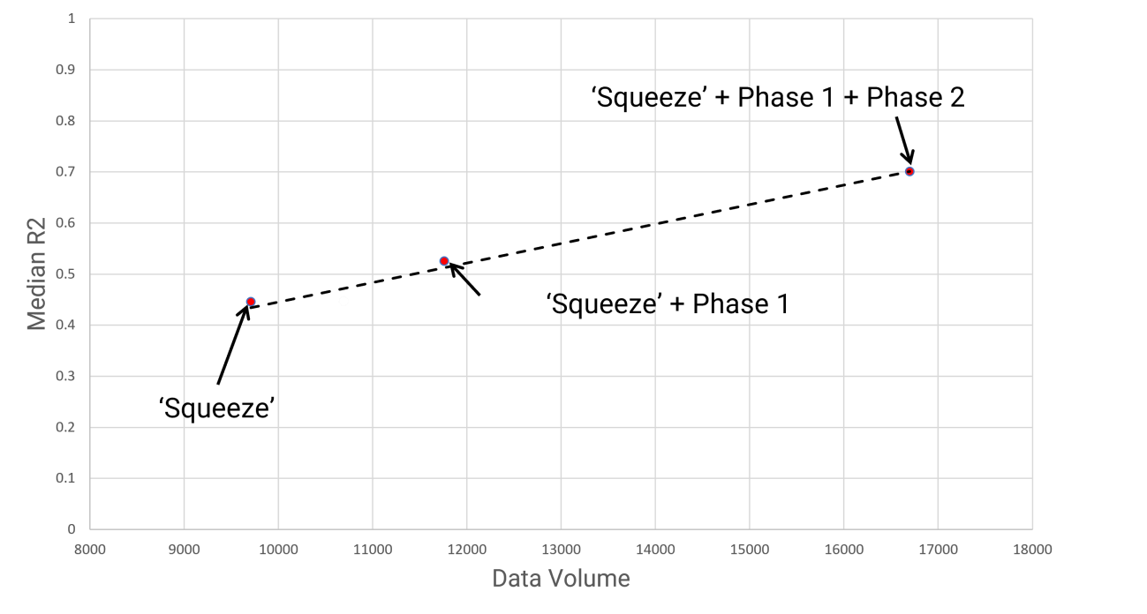
Supplementary Figure S6. Median R2 change as data ingestion into model increases.

Supplementary Questionnaire SQ1 Before Testing:
Have you exercised [Free Text Box]
Have you consumed any Caffeine today [Free Text Box]
How you has your day been [Free Text Box] After Testing:
Have you exercised [Free Text Box]
Have you consumed any Caffeine today [Free Text Box]
How you has your day been [Free Text Box]
Age: [Free Text Box]
Biological Sex: [Free Text Box]
Height: [Free Text Box]
Weight: [Free Text Box]
Average daily Nicotine Intake: [Free Text Box]
[All questions above will require a tick box option for ‘do not want to share this data’ to ensure participants aren’t pressured to fill in their data]

