Appendix 1. Data sources and selection of integrated utilities

Our data source for average electricity prices in Dallas and Houston is the US Bureau of Labor Statistics (BLS). Data collection for electricity prices (https://www.bls.gov/cpi/factsheets/household-energy.htm; https://www.bls.gov/regions/midwest/data/averageenergyprices_selectedareas_table.htm).
To select integrated utilities suitable for SC construction, we start with the EIA’s Form 861 databases from 1990 to 2020. As SC are counterfactuals (Abadie, 2021), we do not consider utilities in states that had implemented any form of retail competition in the period of retail competition in Texas (i.e., 2001-2020). The utility-specific average electricity rates are equal to total residential revenues divided by total residential sales.
Subject to data availability and other considerations, our selection excludes the following utilities:
- Utilities within ERCOT directly affected by restructuring: TXU, Houston Lighting and Power Company, Texas-New Mexico Power Company, and AEP-Texas.
- Non-Texas utilities in states with retail competition (https://www.electricchoice.com/map-deregulated-energy-markets/).
- All utilities serving California because community choice aggregation projects and the state’s numerous unique energy policies render the inclusion of California utilities as candidates for the control group questionable.
- Utilities with inexplicable data gaps in the EIA datasets: Southwestern Electric Power Company (in service areas outside of Texas), Iowa Public Service Company, Iowa Electric Lighting and Power, and Iowa-Illinois Gas and Electric.
- Utilities that merged during 2001-2020 and their regulated rate data were no longer collected by the EIA (e.g., Georgia Power and Savannah Electric).
- Gulf States Utilities in Texas and Louisiana and Louisiana Power and Light Company in Louisiana due to discontinuities in the regulated rate data following their consolidation into Entergy Corp.
- Small utilities with annual residential revenues less than $40 million (e.g., rural electric cooperatives).
- Federal power agencies (e.g., the Salt River Project in Arizona and Bonneville Power Administration in Oregon).
- Utilities in Alaska and Hawaii because of their geographic isolation.
Note that three of the four interstate utilities serving Texas were retained as control group candidates, since these utilities serve outside the ERCOT power region and have not been exposed to retail competition.

Appendix 2. Placebo tests
We perform two placebo tests to evaluate whether our SC results reported in the main text are entirely driven by random chance. The first test uses the iterative application of SC in the three cases to every other integrated utility not subject to market reform (Abadie et al., 2010). If the resulting price gap estimates resemble those for Houston and Dallas, they suggest that deregulation does not have a discernible effect on Texas’s retail prices.
Figures A1-A3 display the first set of placebo test results for the three cases. The black lines represent the price gaps between Dallas’s and Houston’s actual and synthetic prices. The gray lines are the placebo price gaps. These figures show that the positive price gaps for the two Texas cities reported in the main text are not due to random chance.
The second placebo test entails backdating the treatment year in the data (Abadie, Diamond, and Hainmueller 2015, Abadie and Vives-i-Bastida 2021). As the last pre-treatment year for our baseline cases is 2001, our backdated treatment year is 1996, five years before the actual market reform. Figures A4-A6 report the backdated and baseline estimates. The out-of-sample fit in 1997-2001 is very good for the placebo estimates portrayed by the dotted lines. Further, the placebo results since 2001 lend support to the SC estimates reported in the main text for deregulation’s discernible effect on Dallas’s and Houston’s retail prices.

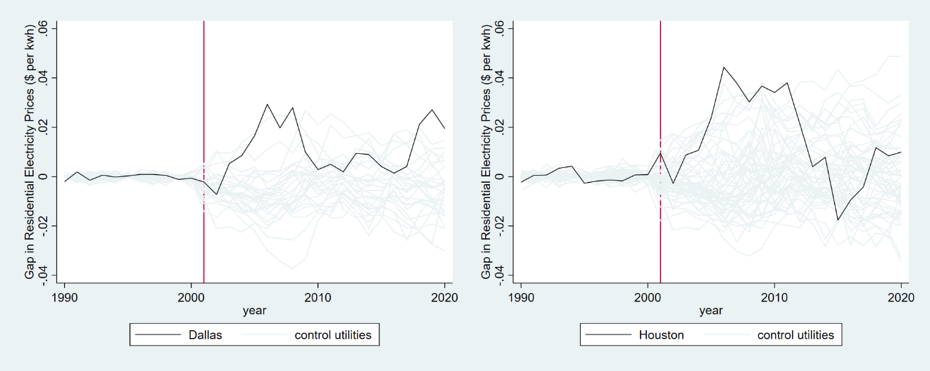
Figure A1. Case 1’s residential electricity price gaps in Dallas (Houston) and placebo gaps in 27 (52) control utilities (remove utilities with pre-reform MSPE two times higher than Dalla’s (Houston’s)).
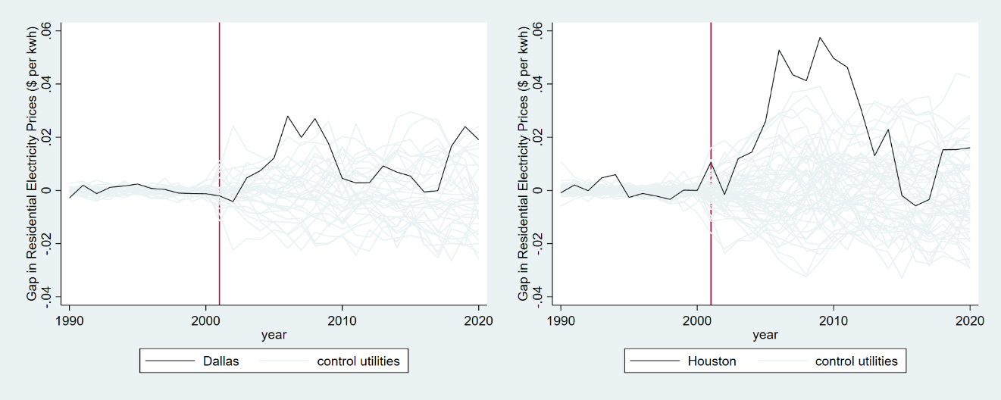
Figure A2. Case 2A’s residential electricity price gaps in Dallas (Houston) and placebo gaps in 33 (56) control utilities (remove utilities with pre-reform MSPE two times higher than Dalla’s (Houston’s)).

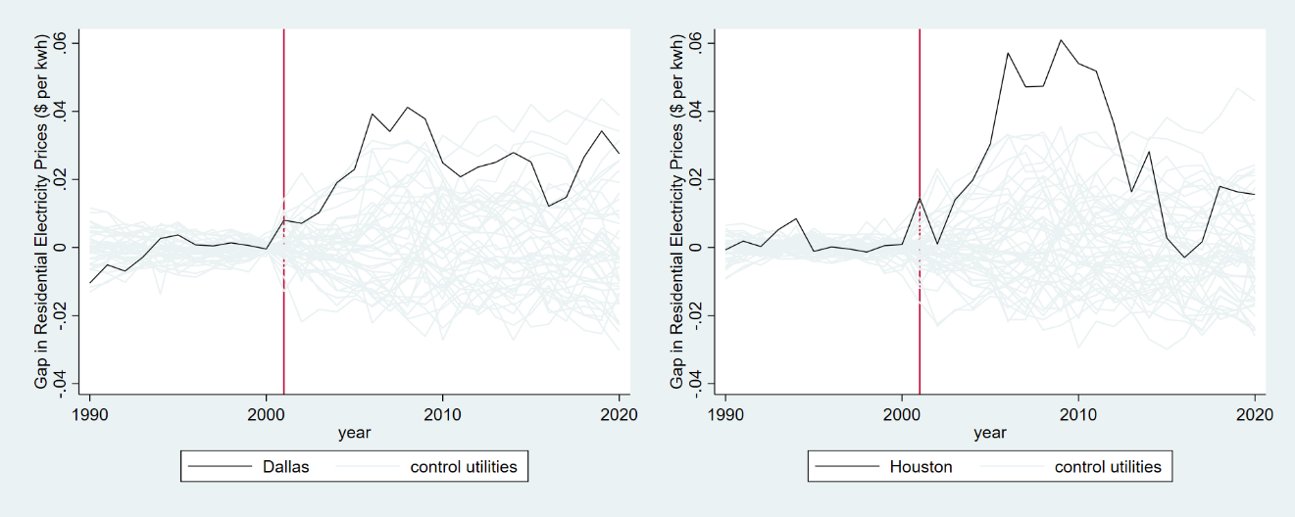
Figure A3. Case 2B’s residential electricity price gaps in Dallas (Houston) and placebo gaps in 42 (49) control utilities (remove utilities with pre-reform MSPE two times higher than Dalla’s (Houston’s)).
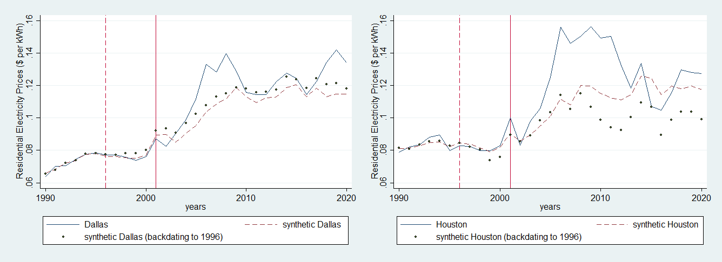
Figure A4. Case 1’s residential electricity price comparison; baseline synthetic control estimates (dash) and treatment backdated to 1996 (dot).

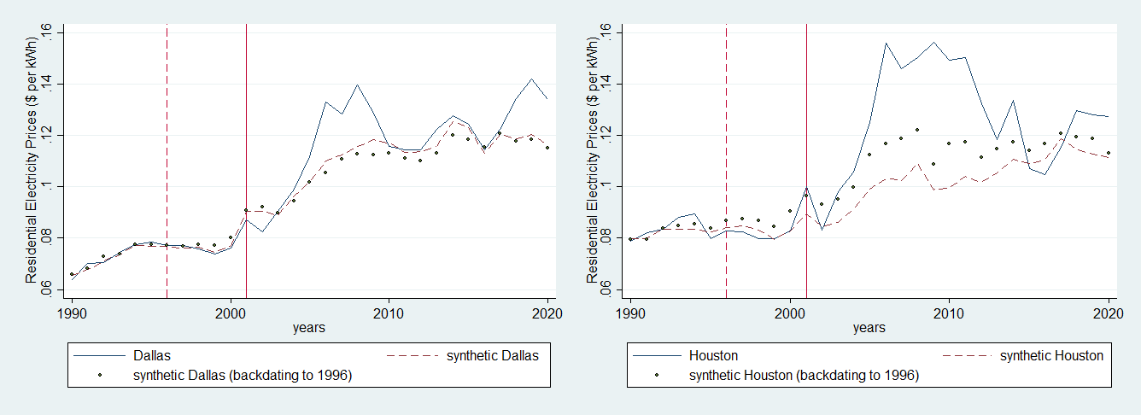
Figure A5. Case 2A’s residential electricity price comparison; baseline synthetic control estimates (dash) and treatment backdated to 1996 (dot).

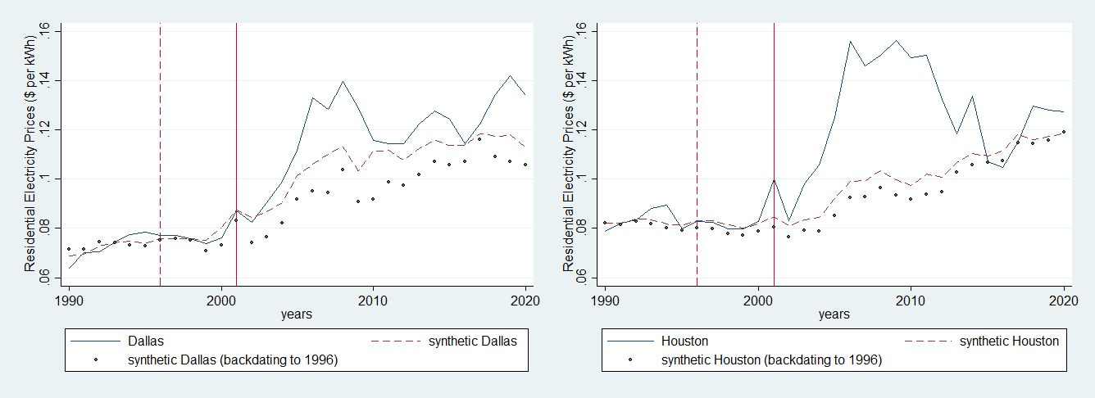
Figure A6. Case 2B’s residential electricity price comparison; baseline synthetic control estimates (dash) and treatment backdated to 1996 (dot).

