Appendix
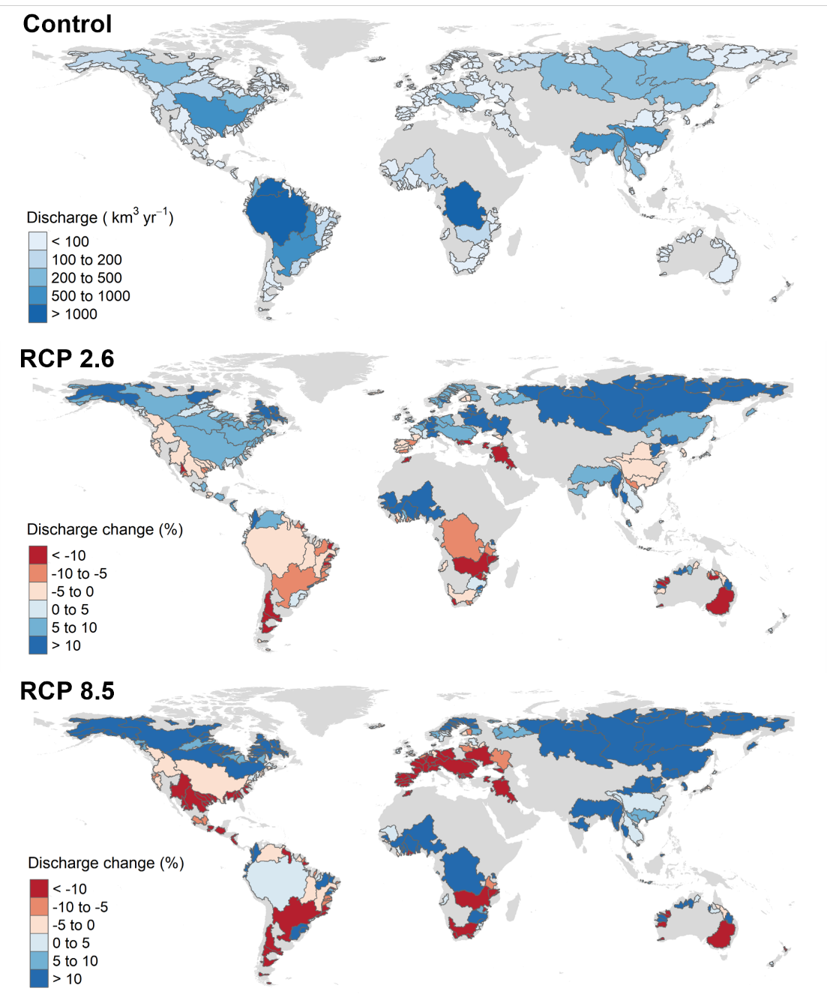
Appendix 1: Yearly discharge for the control period (km³.yr⁻¹) and future discharge anomalies (%) for RCP 2.6 and RCP 8.5.

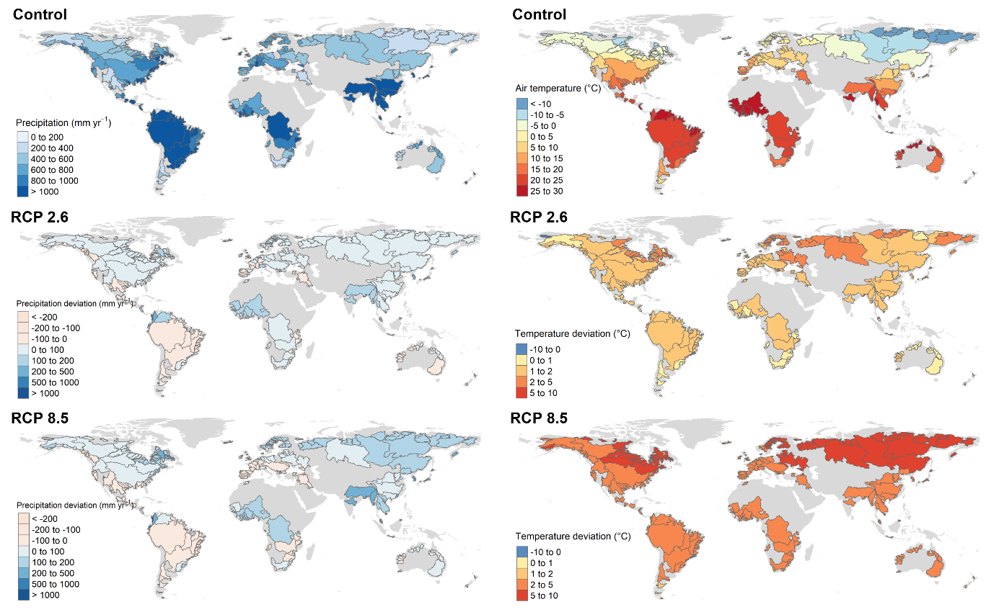
Appendix 2: Yearly precipitation amounts (mm) and average air temperature (°C) for the control period and resulting anomalies for the RCPs 2.6 and 8.5. Datasets come from the WorldClim databases.

