Supplementary Information for
Charge-induced ultralow friction

Mengzhou Liao^{1,2*}, Antonio Cammarata^{1*}, Tomas Polcar^{1,3}

¹ Department of Control Engineering, Faculty of Electrical Engineering, Czech Technical University in Prague, Technicka 2, 16627 Prague 6, Czech Republic
² College of Materials Science and Engineering, Sichuan University, Chengdu, 610065, China
³ National Centre for Advanced Tribology (nCATS), Department of Mechanical Engineering, University of Southampton, Highfield, SO17 1BJ, Southampton, United Kingdom

* Corresponding author. E-mail: mengzlia@fel.cvut.cz; cammaant@fel.cvut.cz

Supplementary Note 1: characterization of surfaces in the experiment
As shown in Fig. S1a-c, we choose good crystalline shape graphite flakes without obvious surface step edges. The thickness of graphite flakes ranges from hundreds of nanometers to a few microns, and the mean roughness (Sa) of their surface is around 169 pm. Fig. S1d and e show that The topography of charged and uncharged regions are identical, with local Sa of 91.97 and 88.19 pm, respectively. Fig. S1f shows that the charged sapphire surface is also atomic flat with a Sa of 258.3 pm. The strip structures in Fig. S1f are the atomic high steps due to the surface reconstruction.
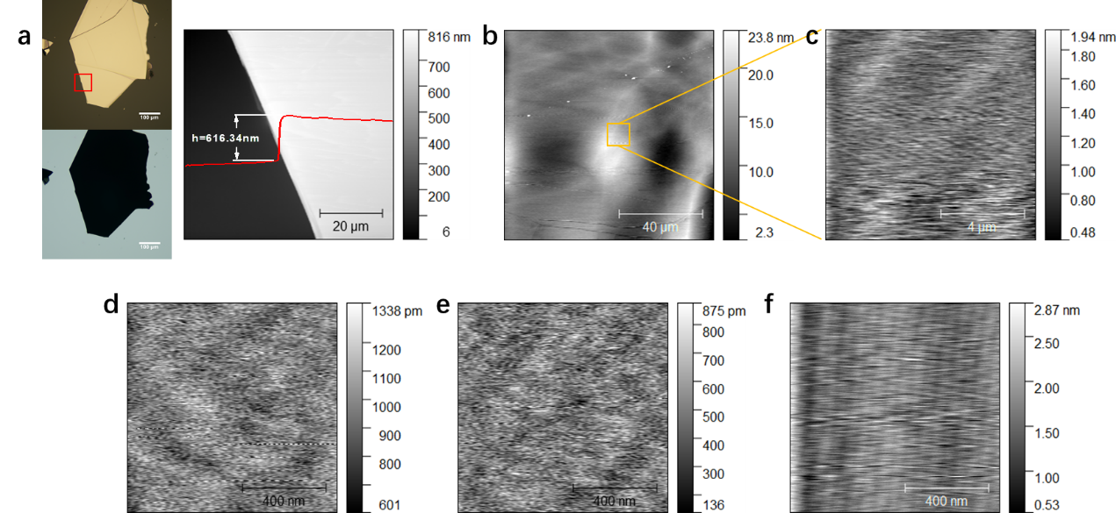
Figure S1 ▏Characterizations of surfaces in the experiment. a Reflection and transmission microscope images, and an AFM topography image of a typical exfoliated graphite flake on the PDMS. b-c AFM topography images of the exfoliated graphite surface. d An AFM topography image of an uncharged 300 nm SiO₂/Si substrate surface. e An AFM topography image of a charged 300 nm SiO₂/Si substrate surface. f An AFM topography image of a charged sapphire substrate surface.

Supplementary Note 2: repeated load tests
As shown in Fig. S2, we repeated the load-friction test between graphite-coated Si₃N₄ balls and uncharged 300 nm SiO₂/Si substrates multiple times. Their results are similar: graphite flakes wear out below 100 mN normal loads, they transfer to substrates after the wear-out, and their COFs are in the order of 10⁻².

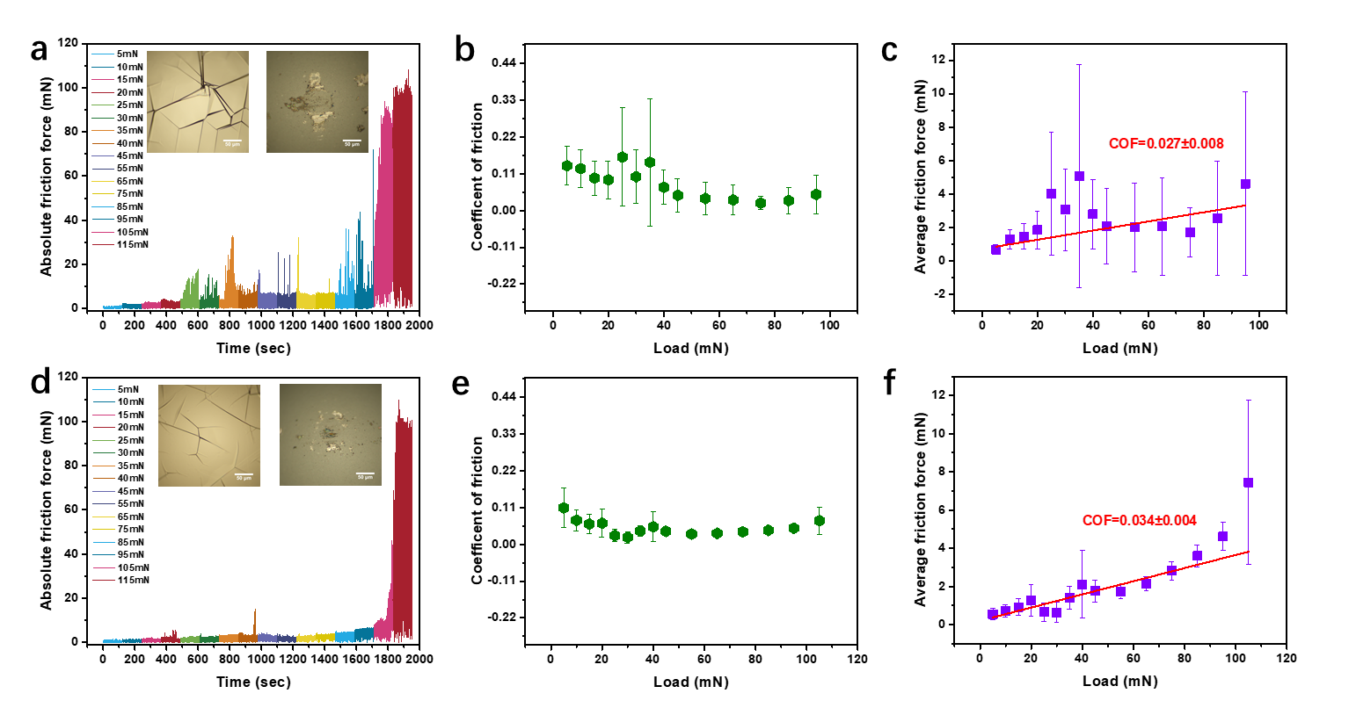
Figure S2 ▏Repeated load-friction measurements between graphite-coated Si₃N₄ balls and uncharged 300 nm SiO₂/Si substrates. a-c A friction performance between a graphite-coated ball and an uncharged 300 nm SiO₂/Si substrate with increasing loads: a The absolute friction force as a function of time with increasing normal loads, inserts are microscope images of the graphite coated ball before (left) and after (right) the measurement; b The coefficient of friction and c the average friction force as functions of normal loads, the red line is the linear fitting. d-e Another friction performance between a graphite-coated ball and an uncharged 300 nm SiO₂/Si substrate with increasing loads: d The absolute friction force as a function of time with increasing normal loads, inserts are microscope images of the graphite coated ball before (left) and after (right) the measurement; e The coefficient of friction and f the average friction force as functions of normal loads, the red line is the linear fitting. The error bar represents the standard deviation (SD).

Fig. S3 shows repeated experiments with different graphite-coated balls and charged SiO₂/Si substrates. Both can reach the 465mN normal load, and their COFs range from 10⁻³ to 10⁻⁴.

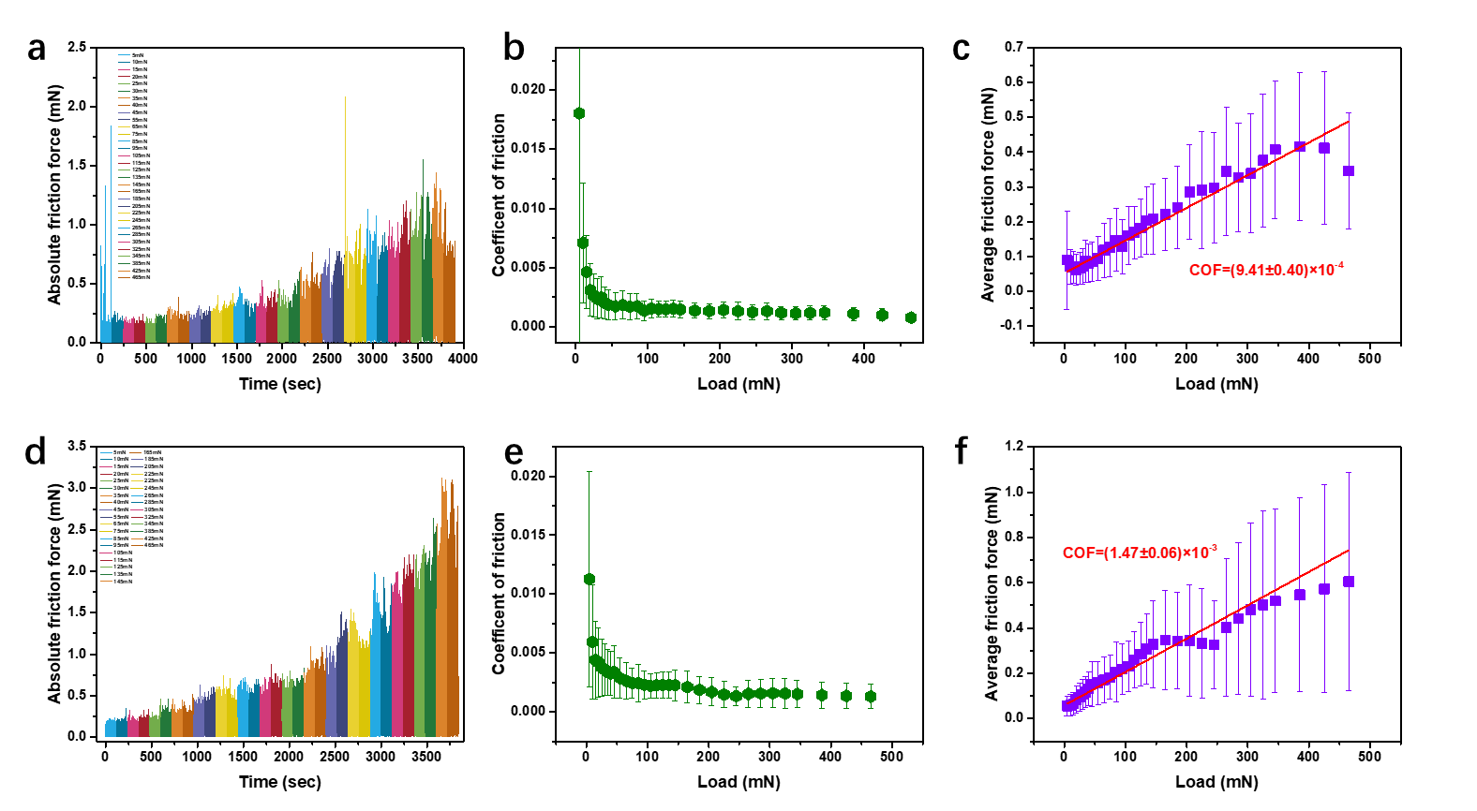
Figure S3 ▏Repeated load-friction measurements between graphite-coated Si₃N₄ balls and charged 300 nm SiO₂/Si substrates. a-c A friction performance between a graphite-coated ball and a charged 300 nm SiO₂/Si substrate with increasing loads: a The absolute friction force as a function of time with increasing normal loads; b The coefficient of friction and c the average friction force as functions of normal loads, the red line is the linear fitting. d-e Another friction performance between a graphite-coated ball and a charged 300 nm SiO₂/Si substrate with increasing loads: d The absolute friction force as a function of time with increasing normal loads; e The coefficient of friction and f the average friction force as functions of normal loads, the red line is the linear fitting. The error bar represents the SD.

Supplementary Note 3: results of a durability test stopped at 60 m sliding distance
In Fig. S4, we stopped a durability test around 60 m sliding distance. Microscope images of the graphite-coated ball before and after the test and the surface of the substrate after the test in Fig. S4b and c show that the 60 m sliding did not generate any wear to either the graphite or the charged 300 nm SiO₂/Si substrate surfaces. However, after we processed the image of the 300 nm SiO₂/Si substrate surface in the same way as Fig. 1d, we can see the brighter sliding trace, which means the sliding probably changed the charge distribution and most likely enhanced the charge accumulation at the sliding trace.

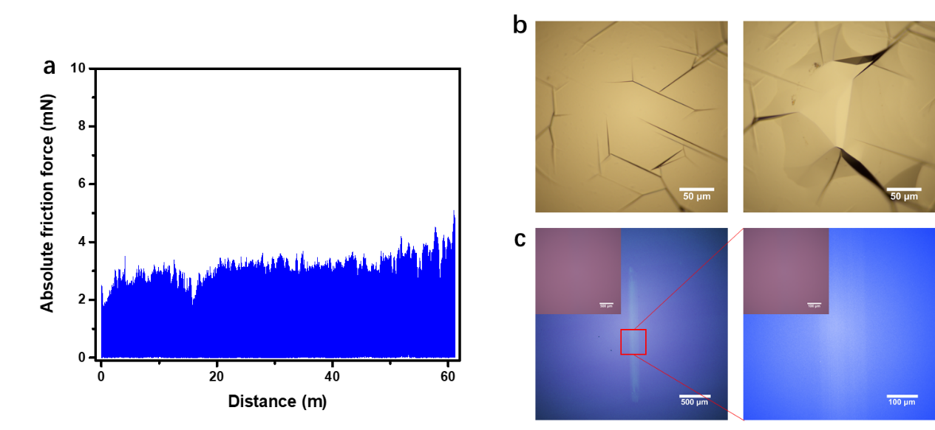
Figure S4 ▏Results of a durability test stopped at 60 m sliding distance. a The absolute friction force as a function of the sliding distance between a graphite-coated ball and a charged 300 nm SiO₂/Si substrate under 50 mN normal load, 0.2 Hz frequency and 1 mm amplitude of the reciprocating drive stage. b Microscope images of graphite coated ball before (left) and after (right) the measurement. c Microscope images of substrate's surface after the measurement, the scale bar of the insets is 500 μm.

Supplementary Note 4: details of the DFT simulation
Our starting point is the bulk α-SiO₂ (α-quartz, space group P3₁21, no. 152) structure with the (001) crystallographic axis oriented along the z Cartesian direction¹. We consider a 3x3x3 supercell of the primitive unit cell in the standard setting and select 7 Si layers, where each Si atom coordinates 4 oxygen atoms; we then truncate the periodicity of the structure by adding a vacuum slab parallel to the a,b plane with a thickness equal to 55 Å. Concerning the graphite, our reference is the bulk P6₃/mmc phase (space group number 194) with the (0001) crystallographic axis oriented along the z Cartesian direction^{2,3}. We consider a 4x4x2 supercell of the primitive unit cell in the standard setting and select 3 subsequent graphene sheets; we then add the 3 sheets to the SiO₂ surface model in such a way that the initial separation between the two structures is about 3.3 Å (Fig. S5a and Fig. 5d). This model represents the SiO₂/graphite interface with the non-treated SiO₂ surface; we name it SiO-gr. In our settings, the a lattice vector is parallel to the Cartesian x-axis, b lies in the Cartesian x,y plane, forming an angle of 120° with the a vector, while the c crystallographic axis is parallel to the Cartesian z-axis. The SiOH-gr-full model geometry is built starting from the SiO-gr system by adding an hydrogen atom in the vicinity of each of the oxygen crystallographic sites at the interface (Fig. S5b and Fig. 5e); similarly, we build the SiOH-gr-part model where some of the oxygen atoms at the interfaces are bonded with one hydrogen atom (Fig. S5c and Fig. 5f).

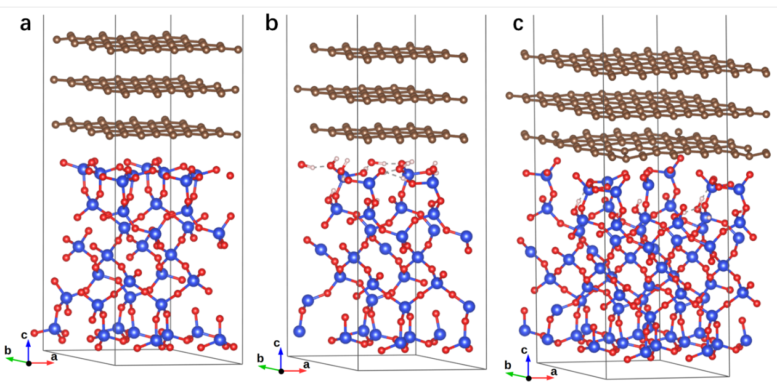
Figure S5 ▏Unit cell of the (a) SiO-gr, (b) SiOH-gr-full and (c) SiOH-gr-part model systems. Blue, red, brown and white spheres represent the position of the silicon, oxygen, carbon and hydrogen atoms, respectively; the thin solid lines mark the limits of the unit cell, where the vacuum slab is not shown for convenience of visualization.

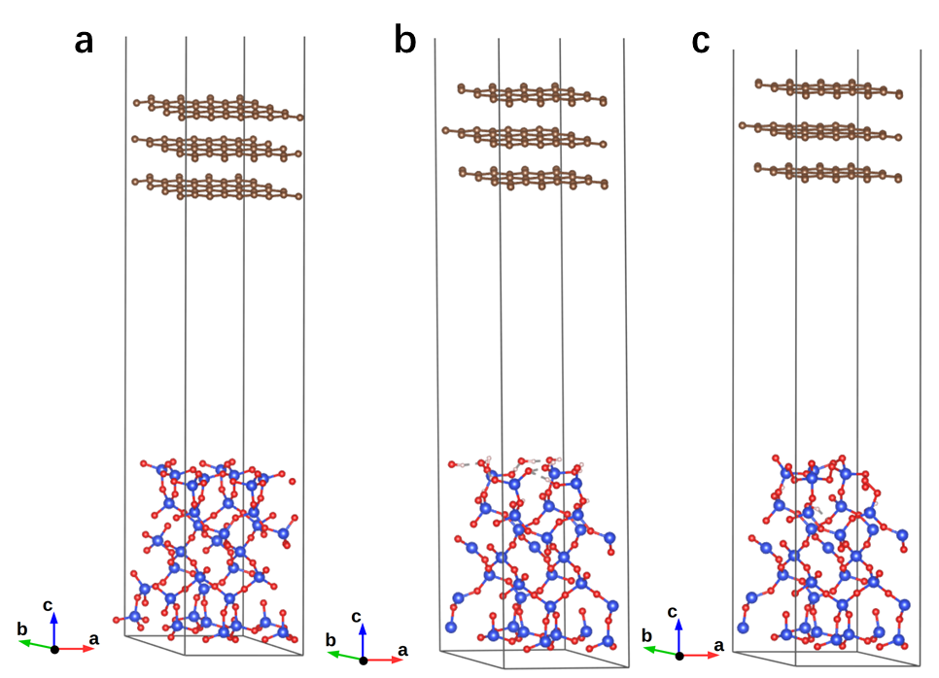
Figure S6 ▏Unit cell of the (a) SiO-gr^{sep}, (b) SiOH-gr-full^{sep} and (c) SiOH-gr-part^{sep} model systems. Atomic types and unit cells are represented as in Figure S5.

The models SiO-gr^{sep}, SiOH-gr-full^{sep} and SiOH-gr-part^{sep} are obtained from the corresponding SiO-gr, SiO-gr-full and SiO-gr-part models by imposing a distance of about 25 Å between the SiO₂ surface and the graphene layer facing it (Fig. S6).

Supplementary Note 5: The water contact angle measurements of the PDMS and sapphire
Contact angle measurements were performed on our homemade contact angle meter. We controlled the droplet volume to 15 μL and fitted the droplet profile with the elliptic curve to calculate the contact angle. In Fig. S7a, we measured the water contact angle of the PDMS surface, which is 101.0°. The sapphire surface shows 63.7° and 95.3° water contact angles for uncharged and charged surfaces, respectively.

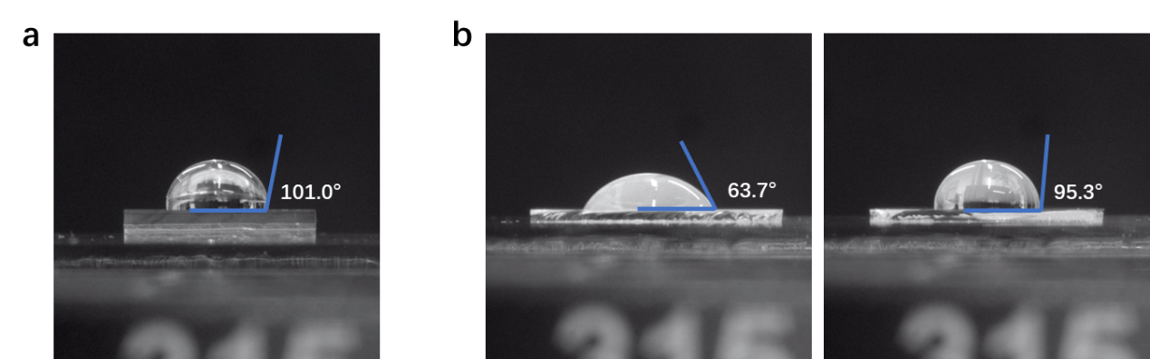
Figure S7 ▏The water contact angle measurements of the PDMS and the sapphire. a Water contact angle result of a PDMS surface. b Water contact angle results of uncharged and charged sapphire substrate surfaces.

Supplementary Note 6: the processed microscope images of the charge decay measurements
In Fig. S8, we show the processed imaged of the charge decay measurements. All images are captured and enhanced by the same process.
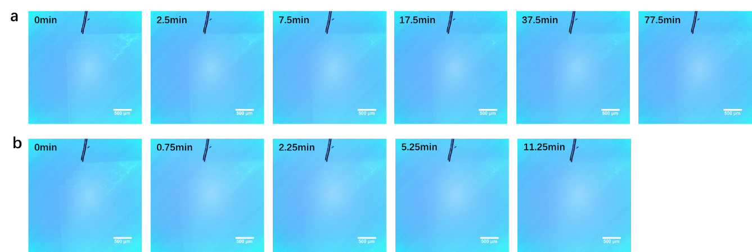
Figure S8 ▏The processed microscope images of the charge decay measurements. a 90 ℃. b 150 ℃.

Supplementary Note 7: the friction performance after the charge decay.
We did the friction test between a graphite-coated Si₃N₄ ball and a 300 nm SiO₂/Si substrate which is first charged and then annealed in the air under 150 ℃ for 30 min. Such a long annealing time is enough to wipe out surface charge. In Fig. S9, the results show that after the surface charge disappears, the friction performance between the graphite-coated Si₃N₄ ball and the 300 nm SiO₂/Si substrate is the same as in the uncharged case. Clear wear generation on the graphite and material transfer to the substrate is observed. The COF is in the order of 10⁻³.
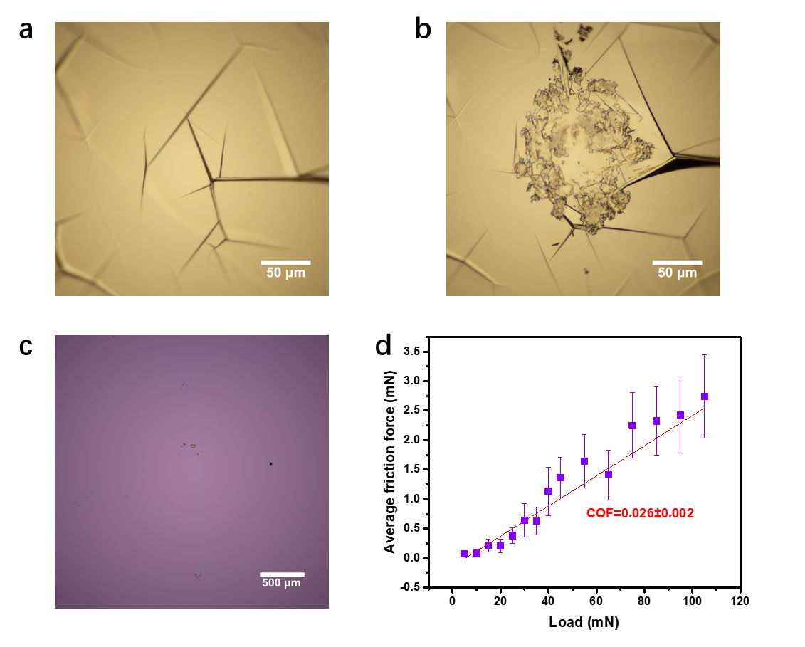
Figure S9 ▏Load-friction measurements between a graphite-coated Si₃N₄ ball and a 300 nm SiO₂/Si substrate which is first charged and then annealed in air under 150 ℃ for 30 min. a-b Microscope images of graphite coated ball before (a) and after (b) the measurement. c Microscope images of substrate's surface after the measurement. d The average friction force as a function of normal loads; the red line is the linear fitting, and the error bar represents the SD.
Reference

1 Swamy, V., Saxena, S. K., Sundman, B. & Zhang, J. A thermodynamic assessment of silica phase diagram. Journal of Geophysical Research: Solid Earth 99, 11787-11794, doi:https://doi.org/10.1029/93JB02968 (1994).
2 Delhaes, P. Graphite and Precursors (1st ed.). CRC Press, doi:https://doi.org/10.1201/9781482296921 (2001).
3 Pierson, H. O. Handbook of Carbon, Graphite, Diamonds and Fullerenes: Processing, Properties and Applications. (Elsevier Science, 2012).

