Supplementary Material

Supplementary Table 1 List of all the genomes used on the TE analysis and their respective Genebank ID and Stats.
Species | Bioproject | Assembly Level | Assembly Stats Total Sequence Length | Contig N50 | Scaffold N50 | Scaffold # | GC content | QV | BUSCO C | BUSCO D | BUSCO F | BUSCO M | BUSCO SC | BUSCO TC | BUSCO V
Emydura subglobosa | PRJNA512130 | Scaffold | 1,986,702,056 | 350,989 | 44,759,016 | 22,003,978 | 43.03% | 50.38 | 98.20% | 1.60% | 0.60% | 1.20% | 96.60% | 3,354 | 5.0.0
Podocnemis expansa | PRJNA512135 | Scaffold | 2,447,092,617 | 134,824 | 37,101,370 | 47,912,441 | 43.60% | 51.76 | 94.80% | 1.00% | 2.80% | 2.40% | 93.80% | 3,354 | 4.0.6
Carettochelys insculpta | PRJNA512133 | Scaffold | 2,356,570,494 | 116,202 | 45,881,824 | 73,276,037 | 45.32% | 54.54 | 92.70% | 6.40% | 3.60% | 4.00% | 86.00% | 3,354 | 4.0.6
Pelodiscus sinensis | PRJNA221645 | Scaffold | 2,202,466,388 | 21,993 | 3,350,749 | 19,904 | 44.41% | 34.07 | 96.50% | 1.06% | 1.51% | 1.99% | 95.44% | 7,480 | 4.0.2
Chelydra serpentina | PRJNA574487 | Scaffold | 2,401,360,239 | 80,593 | 21,135,443 | 113,431 | 44% | 48.82 | 95.00% | 1.00% | 3.60% | 1.40% | 94.00% | 3,354 | 4.0.6
Chelonia Mydas | PRJNA675851 | Chromosome | 2,134,358,617 | 39,415,510 | 134,428,053 | 92 | 44.01% | 47.70 | 99.01% | 1.12% | 0.31% | 0.68% | 97.89% | 7,480 | 4.1.4
Dermochelys coriacea | PRJNA655518 | Chromosome | 2,164,762,090 | 7,029,801 | 137,568,771 | 40 | 43.35% | 38.90 | 98.21% | 1.03% | 0.52% | 1.27% | 97.18% | 7,480 | 4.1.4
Platysternon megacephalum | PRJNA479402 | Scaffold | 1,928,419,311 | 205,283 | 7,406,563 | 159,903 | 44.55% | 38.41 | 98.00% | 1.00% | 0.80% | 1.20% | 97.00% | 3,354 | 5.0.0
Terrapene carolina triunguis | PRJNA415469 | Scaffold | 2,571,267,249 | 76,614 | 24,249,581 | 131,541,780 | 44.27% | 47.63 | 91.30% | 9.80% | 4.40% | 4.30% | 81.5% | 3,354 | 4.0.6
Chrysemys picta belii | PRJNA210179 | Chromosome | 2,481,351,664 | 21,318 | 6,605,846 | 78,631 | 44.19% | 49.65 | 98.20% | 0.78% | 1.02% | 0.79% | 97.42% | 7,480 | 4.1.4
Trachemys scripta elegans | PRJNA634151 | Chromosome | 2,126,182,493 | 204,575 | 140,411,086 | 138 | 43.81% | 50.43 | 97.57% | 0.86% | 0.63% | 1.80% | 96.71% | 7,480 | 4.0.2
Chelonoidis abingdonii | PRJNA611832 | Scaffold | 2,300,739,315 | 73,186 | 1,277,207 | 10,618 | 43.71% | 26.04 | 97.47% | 0.99% | 1.08% | 1.44% | 96.48% | 7,480 | 4.0.2
Continuation table Supplementary Table 1
Gopherus evgoodei | PRJNA559383 | Chromosome | 2,298,547,364 | 13,026,736 | 147,425,149 | 382 | 44.14% | 38.31 | 98.94% | 1.43% | 0.16% | 0.90% | 97.51% | 7,480 | 4.0.2
Mauremys reevesii | PRJNA699301 | Chromosome | 2,035,064,793 | 34,524,243 | 139,244,951 | 62 | 44.55% | 33.55 | 99.16% | 1.59% | 0.16% | 0.68% | 97.57% | 7,480 | 4.0.2
Cuora mccordi | PRJNA491715 | Scaffold | 2,390,374,423 | 74,338 | 32,628,679 | 129,476,169 | 44.70% | 50.94 | 91.60% | 2.10% | 4.40% | 4.00% | 89.50% | 3,354 | 4.0.6

Supplementary table 2. Proportion of PLE lower than 5 K-values for all representatives of testudines lineage
Species | Total PLE | PLE K-value<5 | [%]*
Platysternon megacephalum | 98,437 | 17,123 | 17.39%
Pelodiscus sinensis | 194,440 | 30,003 | 15.43%
Podocnemis expansa | 258,507 | 25,003 | 9.67%
Carettochelys insculpta | 312,531 | 42,634 | 13.64%
Emydura subglobosa | 49,357 | 5,269 | 10.68%
Mauremys reevesii | 94,041 | 24,117 | 25.65%
Gopherus evgoodei | 125,045 | 33,071 | 26.45%
Chelonoidis abingdonii | 108,624 | 26,160 | 24.08%
Terrapene carolina triunguis | 110,600 | 14,841 | 13.42%
Cuora mccordi | 125,192 | 35,390 | 28.27%
Chrysemys picta bellii | 121,701 | 17,707 | 14.55%
Trachemys scripta elegans | 119,010 | 33,145 | 27.85%
Chelonia mydas | 231,717 | 66,113 | 28.53%
Dermochelys coriacea | 324,013 | 140,928 | 43.49%
* Percentage of PLE with K-value < 5

Average without C. mydas and D. coriacea
Average Total PLE | Average PLE K-value<5 | Average [%]*
143,124 | 25,372 | 18.92%

Supplementary table 3. General proportions of PLEs compare with the most abundant superfamiles of TEs

 | Kimura | Total STR | % | LINEs | % | SINEs | % | PLEs | % | Neptune-1_DC | %
D. Coriacea | Low | 268,003 | 10.25% | 224,081 | 17.40% | 836 | 0.17% | 140,713 | 43.43% | 24,509 | 70.70%
D. Coriacea | Med | 667,214 | 25.51% | 395,975 | 30.75% | 33,882 | 6.81% | 131,897 | 40.71% | 8,691 | 25.07%
D. Coriacea | High | 1,680,017 | 64.24% | 667,650 | 51.85% | 463,146 | 93.03% | 51,403 | 15.86% | 1,467 | 4.23%
D. Coriacea | Total | 2,615,234 | 100% | 1,287,706 | 100.00% | 497,864 | 100% | 324,013 | 100.00% | 34,667 | 100%

 | Kimura | Total STR | % | LINEs | % | SINEs | % | PLEs | %
C. mydas | Low | 187,468 | 7.48% | 136,717 | 13.09% | 702 | 0.12% | 65,931 | 28.45%
C. mydas | Med | 626,819 | 25.01% | 344,040 | 32.93% | 34,741 | 6.11% | 121,332 | 52.36%
C. mydas | High | 1,692,128 | 67.51% | 563,949 | 53.98% | 532,902 | 93.76% | 44,454 | 19.18%
C. mydas | Total | 2,506,415 | 100% | 1,044,706 | 100% | 568,345 | 100% | 231,717 | 100%
Low= [0-5[ ; Medium = [5-15[ ; High = [15-50]

Supplementary table 4. Species names and abbreviation used for phylogenetic tree.
Abbreviation | Species
AAe | Aedes aegypti
AMi | Alligator mississippiensis
Bf | Branchiostoma floridae
Bm | Bombyx mori
CI | Ciona intestinalis
CMy | Chelonia mydas
CPB | Chrysemys picta bellii
Cr | Caenorhabditis remanei
Crp | Crocodylus porosus
DC | Dermochelys coriacea
DEl | Drosophila elegans
Dv | Drosophila virilis
Dw | Drosophila willistoni
Ebur | Eptatretus burgeri
EuTe | Eulimnadia texana
FR | Takifugu rubripes
LMi | Locusta migratoria
Obim | Octopus bimaculoides
OL | Oryzias latipes
PMon | Penaeus monodon
Pp | Pristionchus pacificus
Ppac | Pristionchus pacificus
Ptep | Parasteatoda tepidariorum
Sm | Schistosoma japonicum
Smed | Schmidtea mediterranea
SP | Sphenodon punctatus
Tama | Thalassophryne amazonica
Tcas | Tribolium castaneum
Xt | Xenopus tropicalis

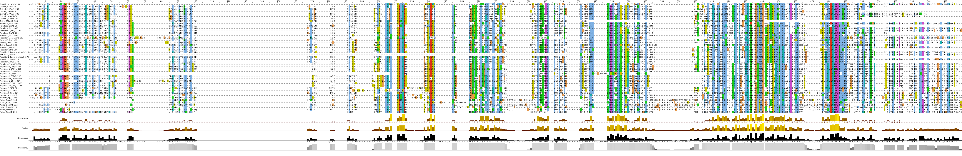
Supplementary Figure 1. Sequence alignment of PLE elements for several species as listed in methods. Alignments were visualised in Jalview using the Clustal2 colouring scheme.

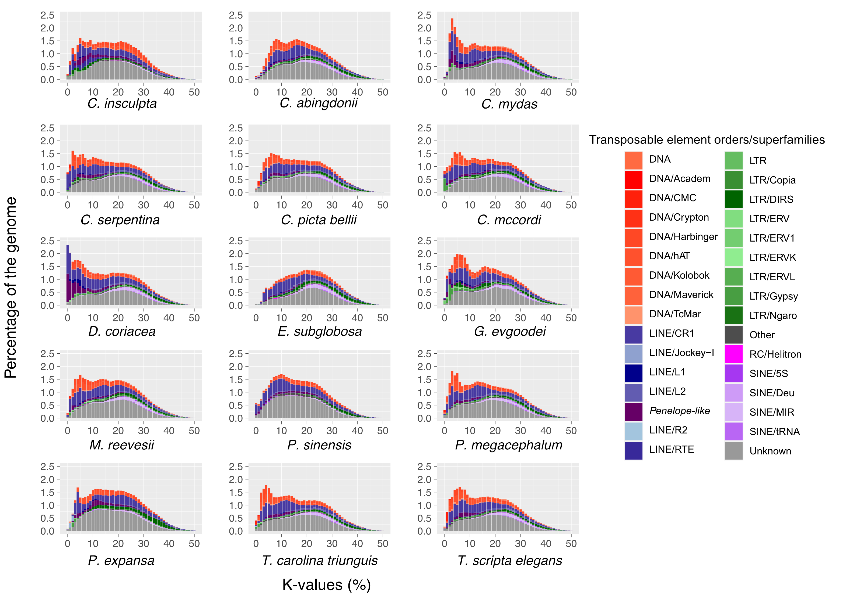
Supplementary Figure 2. Repeat elements divergence profiles according to RepeatMasker standart across the Testudines clade.

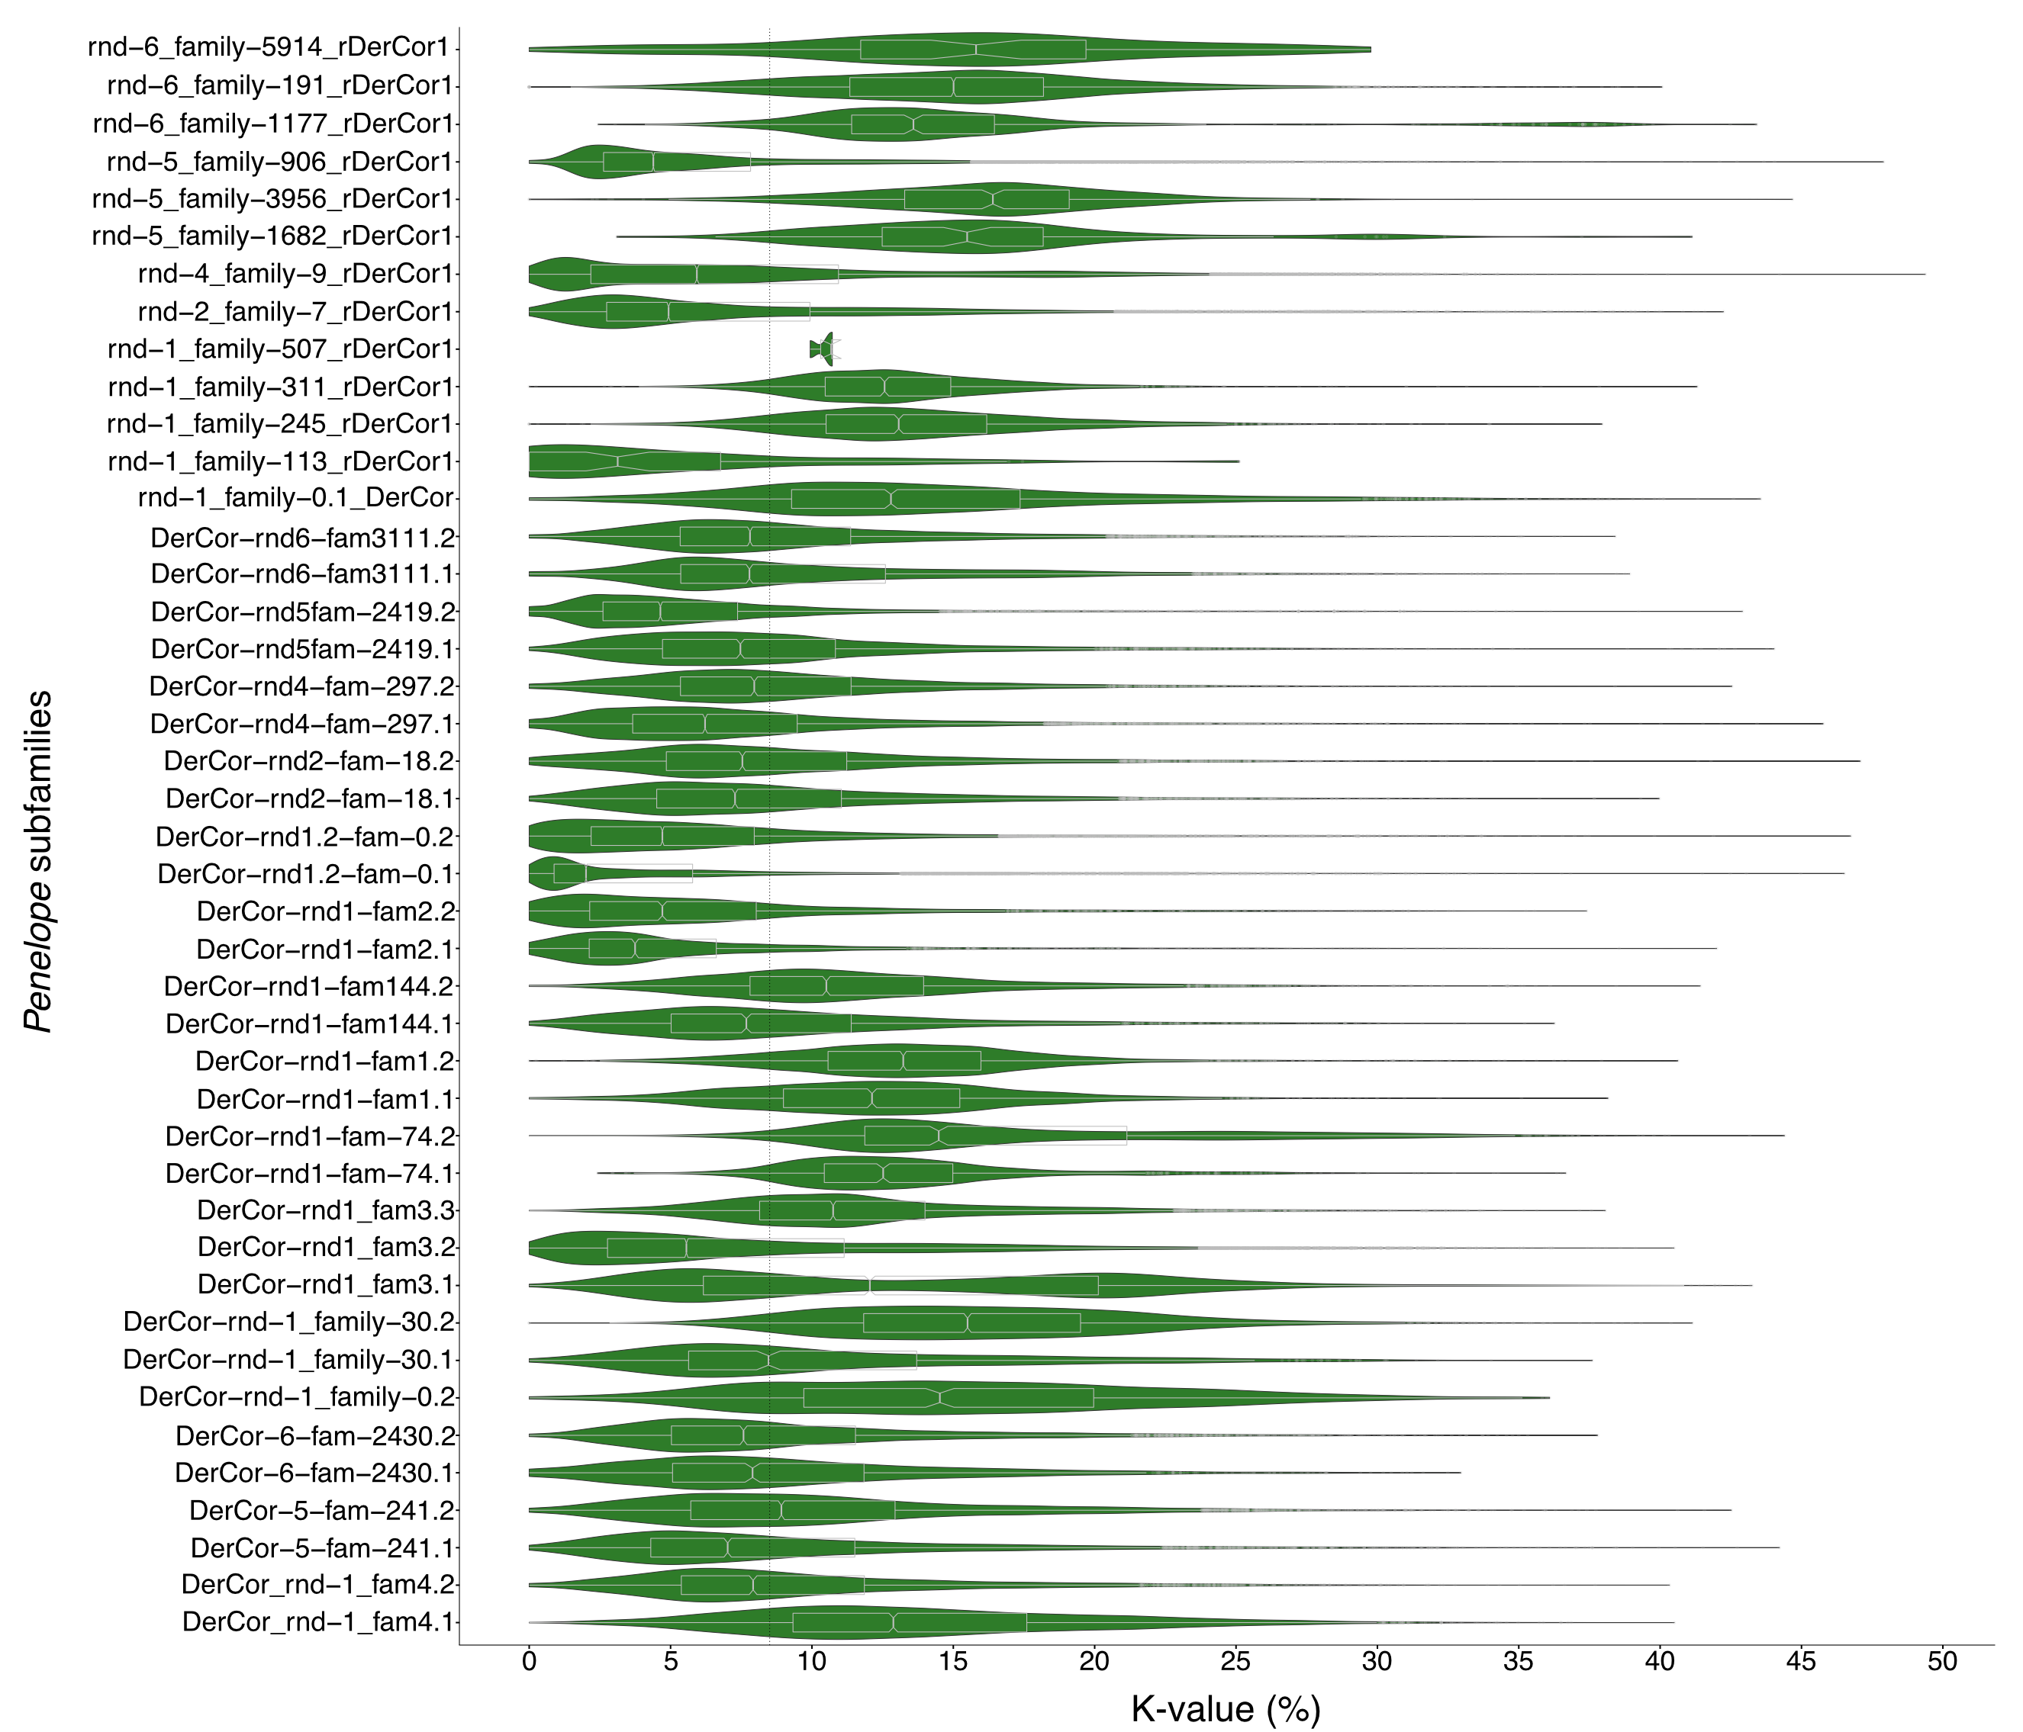

Supplementary Figure 3. Kimura 2-parameter distance to consensus (K-value) distribution for each PLE insertion in D. coriacea. Frequency distributions are shown in violin plots (green), and quartile distributions are shown in boxplots (grey). The average K-value for all the PLEs is shown as a vertical dotted black line.

