Contents

Supplementary Table
1 Comparison of various pressure-sensitive adhesives and bioadhesives

Supplementary Figures
1 Fabrication of the PSB
2 Synthetic scheme of the PSB
3 ¹H NMR spectrum of the PSB
4 FTIR spectra of the PSB
5 Various backing materials for the PSB
6 Rapid and reversible adhesion of the PSB on wet surfaces
7 Adhesion performance of the PSB in varying testing conditions
8 Burst pressure of the PSB
9 Characterization of strain sensor

Supplementary Video
1 Demonstration of PSB detachment characteristics

Supplementary Table 1 | Comparison of various pressure-sensitive adhesives and bioadhesives.
Material/Product | Adhesion speed (s) | Adhesion reversibility |  | Adhesion repositioning | Interfacial Toughness (J m⁻²) | Reference
VHB (3M) | < 1 | Yes |  | Yes | 480 (dry)  20 (wet) | N/A
Transpore (3M) | < 1 | Yes |  | Yes | 690 (dry)  30 (wet) | N/A
Micropore (3M) | < 1 | Yes |  | Yes | 250 (dry)  30 (wet) | N/A
Photocurable PGSA | > 5 | No |  | No | N/R | Ref. ¹
Photocurable tropoelastin | 30 ~ 180 | No |  | No | N/R | Ref. ²
Nanoparticle solution | ~ 30 | Yes  (1 cycle) |  | No | ~6 | Ref. ³
Entangled silicone fluids | ~900 | No |  | No | 46 (dry)  115 (wet) | Ref. ⁴
PVA-BA | < 120 | Yes |  | No | ~ 30 (wet) | Ref. ⁵
Tough hydrogel adhesive | > 180 | No |  | No | ~1,000 (wet) | Ref. ⁶
Dry double-sided tape | < 5 | No |  | No | > 710 (wet) | Ref. ⁷
TachoSil | 30 ~ 60 | No |  | No | N/R | N/A
Veriset | 180 | No |  | No | N/R | N/A
PSB | ~ 1 | Yes  (> 1,000 cycles) |  | Yes | 730 (dry)  380 (wet) | This work
N/A: Not applicable
N/R: Not reported
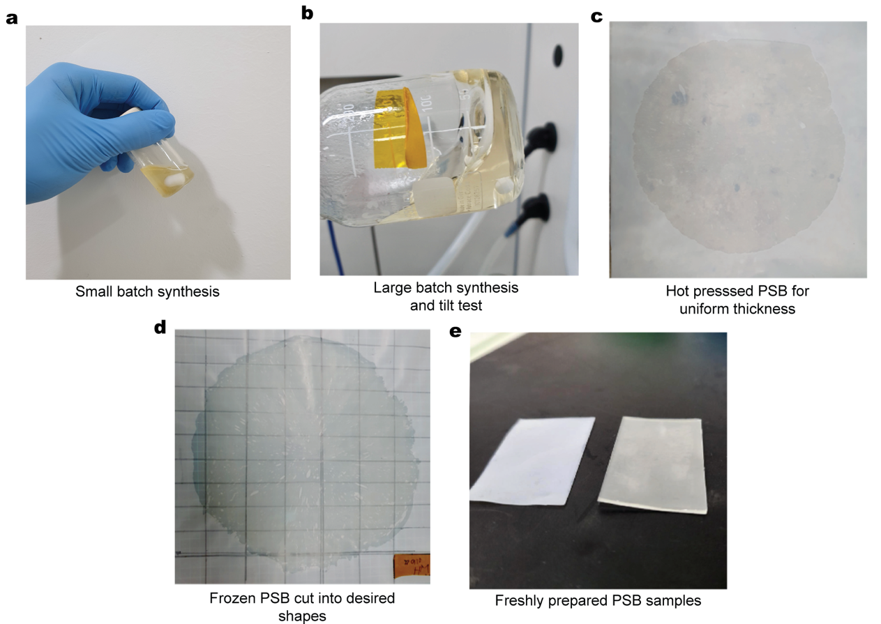

Supplementary Fig. 1 | Fabrication of the PSB. a,b, Image of the small (a) and large (b, ~30g) batch synthetized PSB and tilt test to evaluate reaction progression c,d, Images of the hot pressed PSB (c) and PSB prepared for cutting (d) PSB. e, Images of the PSB cut into pieces before use.
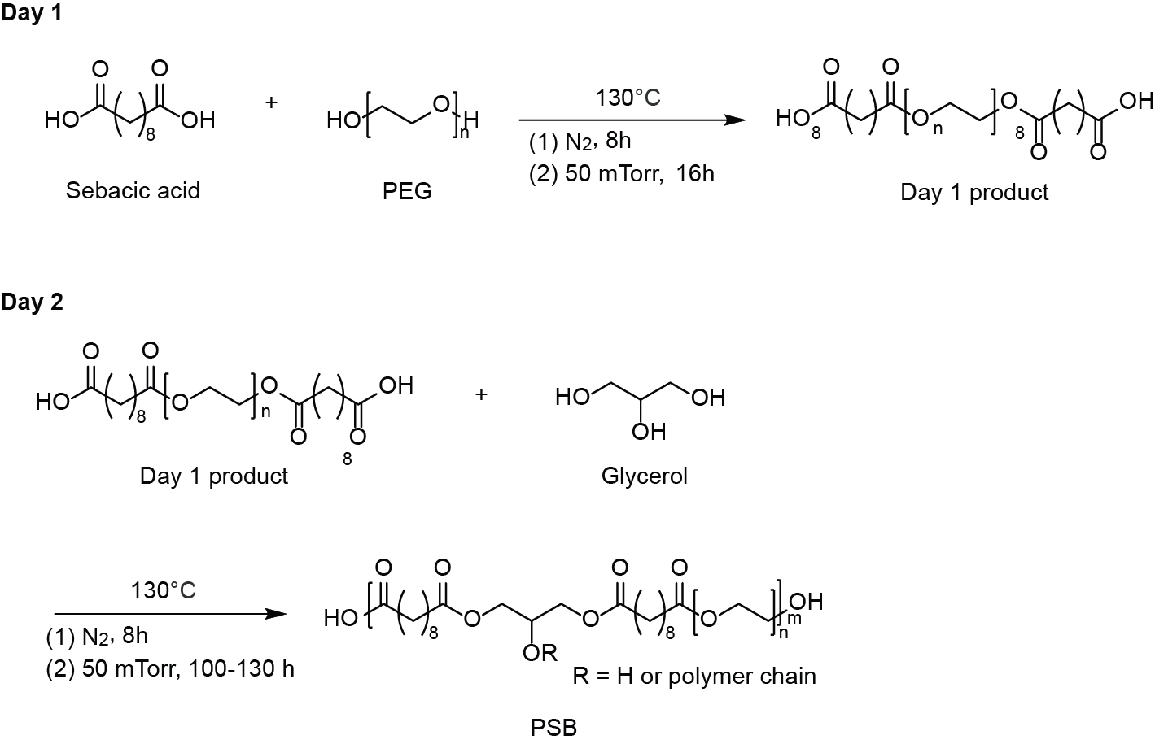

Supplementary Fig. 2 | Synthetic scheme of the PSB. In Day 1 synthesis, sebacic acid and PEG condense into a linear polymer chain to synthesize the Day 1 product. In Day 2 synthesis, glycerol is added to the Day 1 product to create a crosslinked PGS-co-PEG network (PSB) at varying crosslinking degrees by tuning the reaction time (75 h to 90 h).

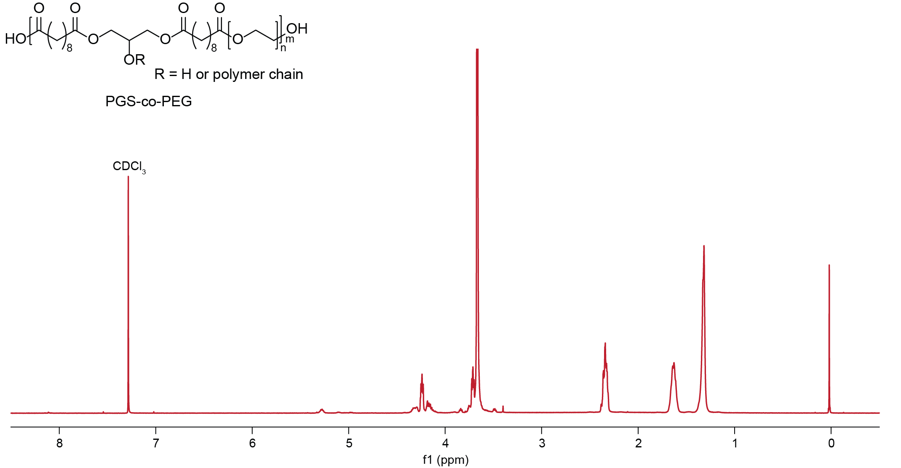

Supplementary Fig. 3 | ¹H NMR spectrum of the PSB. CDCl₃ (7.28 ppm peak) is used as a solvent for the PSB. 4.05-4.35 ppm multiplet peaks are attributable to glycerol. Methylene peak at 3.64 ppm is observed due to ethylene group in PEG. Peaks at 2.35, 1.62, 1.30 ppm are attributable to methylene groups of sebacic acid. ¹H NMR (400 MHz, CDCl₃): δ 4.05-4.35 (m, 6H), δ 3.64 (s, 49H), δ 2.35 (s, 9H), δ 1.62 (s, 9H), δ 1.30 (s, 18H).
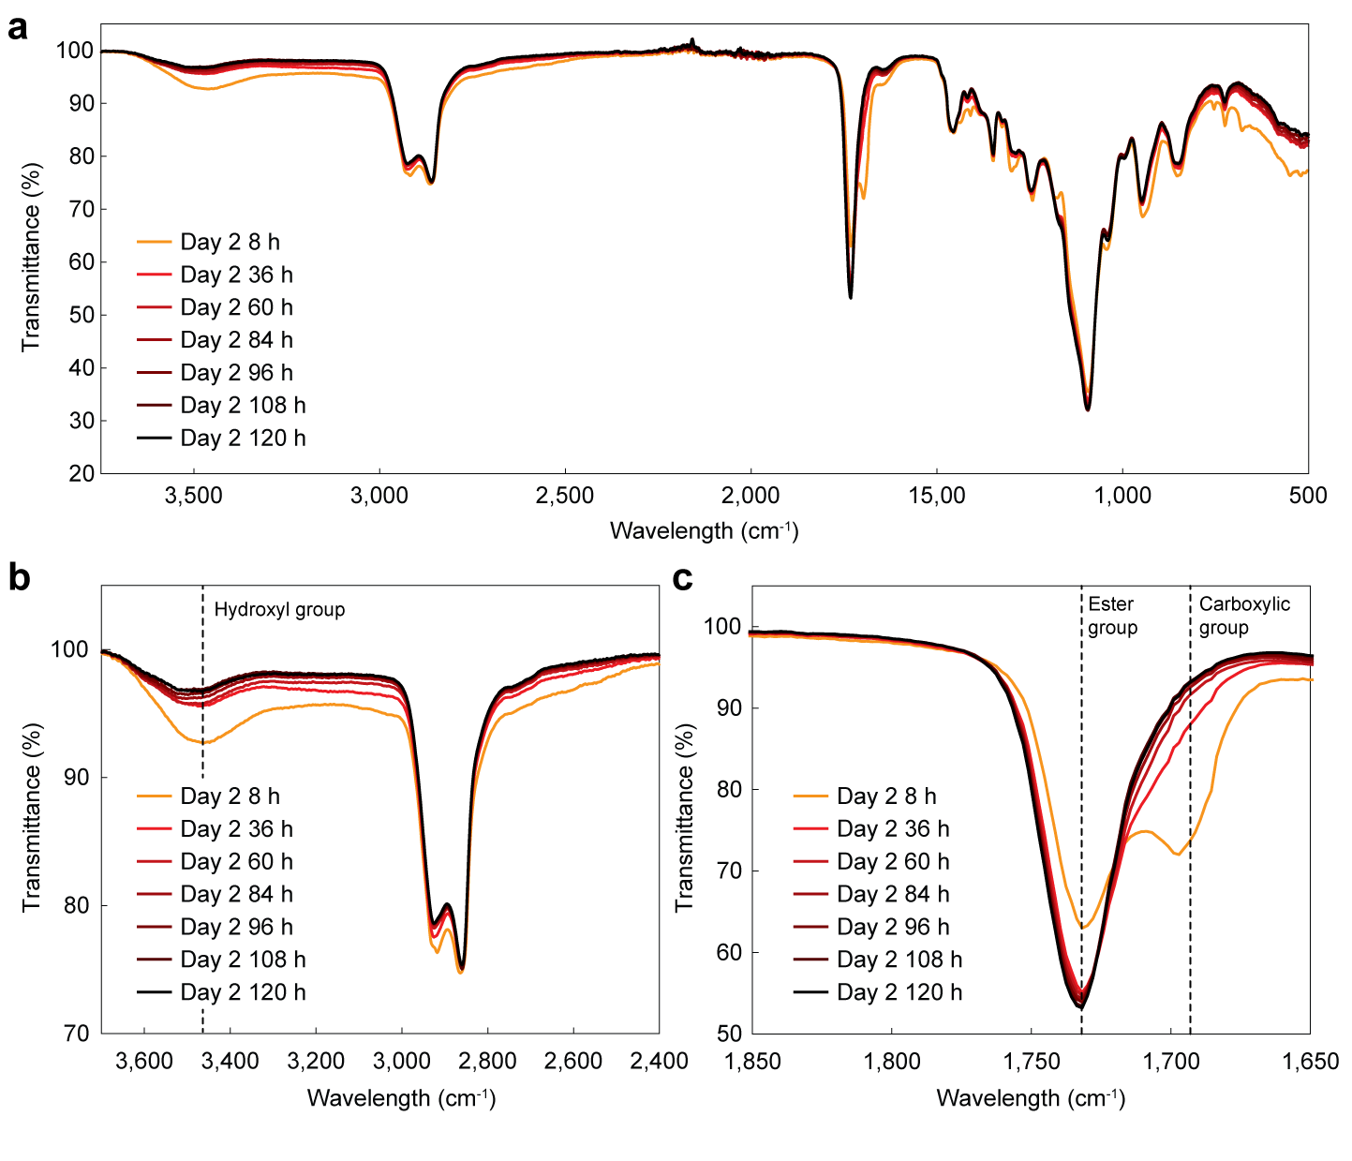

Supplementary Fig. 4 | FTIR spectra of the PSB. a, FTIR spectrum of the PSB synthesized with varying reaction time (8 h to 120 h). b,c, Selected parts of FTIR spectrum of the PSB for the wavelength range between 2,400 cm⁻¹ to 3,600 cm⁻¹ (b) and 1,650 cm⁻¹ to 1,850 cm⁻¹ (c). Peaks at 1,730 cm⁻¹ correspond to ester groups in the PSB (higher for higher crosslinking degree). Peaks at 1,690 cm⁻¹ correspond to carboxylic groups in the PSB (lower for higher crosslinking degree). Peaks at 3,460 cm⁻¹ correspond to hydroxyl groups in the PSB (higher for higher crosslinking degree).
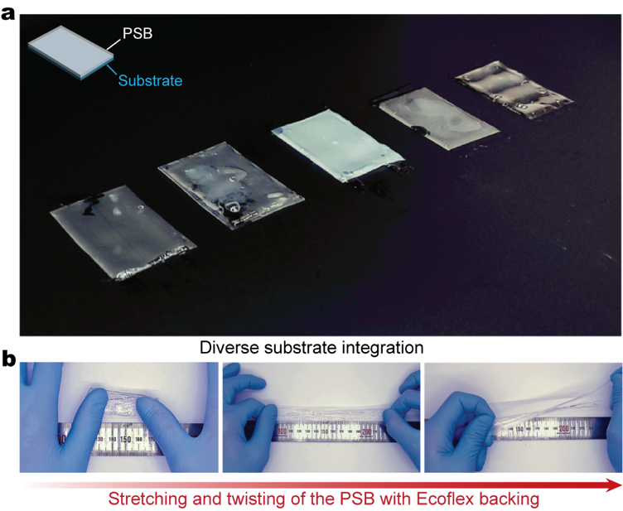

Supplementary Fig. 5 | Various backing materials for the PSB. a, Image of the PSB prepared based on various backing materials. From left to right: Styrene ethylene butylene styrene (SEBS), polyurethane (PU), polytetrafluoroethylene (PTFE), polycarbonate (PC), and stainless steel. b, Images of the PSB with Ecoflex backing before stretching (left), during stretching (middle), and being twisted (right).

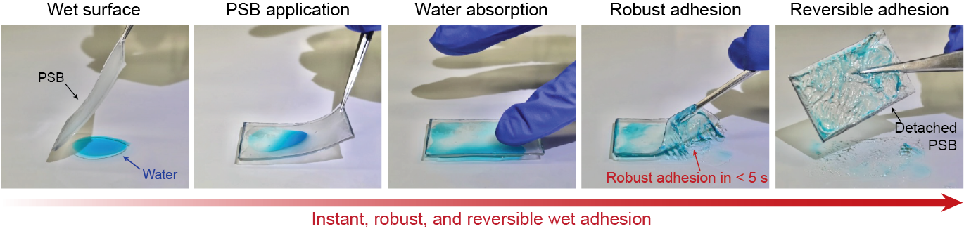

Supplementary Fig. 6 | Rapid and reversible adhesion of the PSB on wet surfaces. Snapshots of the rapid and reversible adhesion process of the PSB on a wet surface. Water is colored with a blue food dye for visualization.
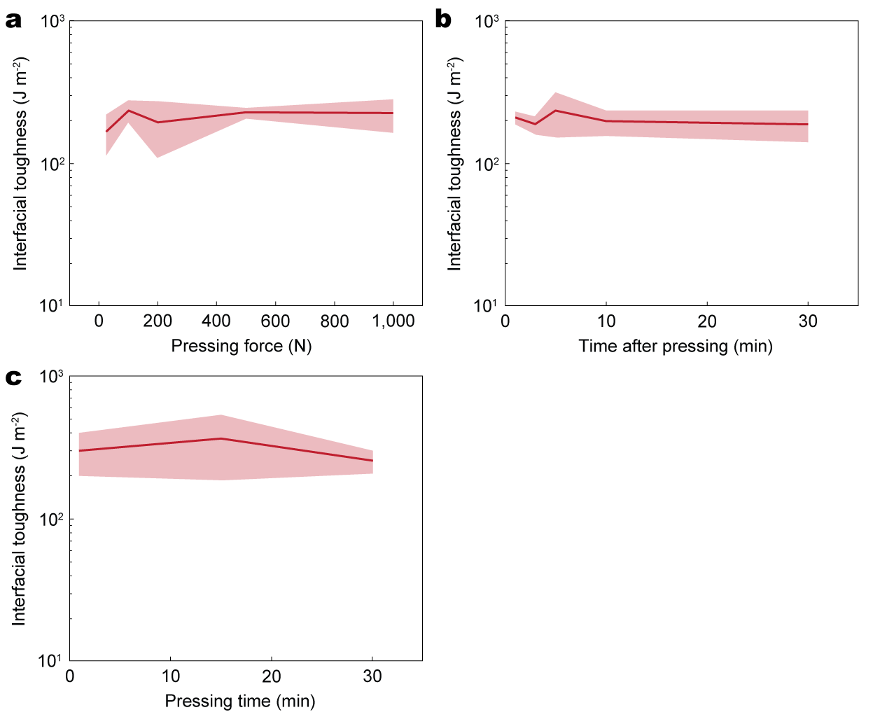

Supplementary Fig. 7 | Adhesion performance of the PSB in varying testing conditions. a, Interfacial toughness of the PSB adhered to wet porcine skin vs. pressing force during application. b, Interfacial toughness of the PSB adhered to wet porcine skin vs. time after pressure application. c, Interfacial toughness of the PSB adhered to wet porcine skin vs. pressing time during application. Values represent the mean and the standard deviation (n = 4).

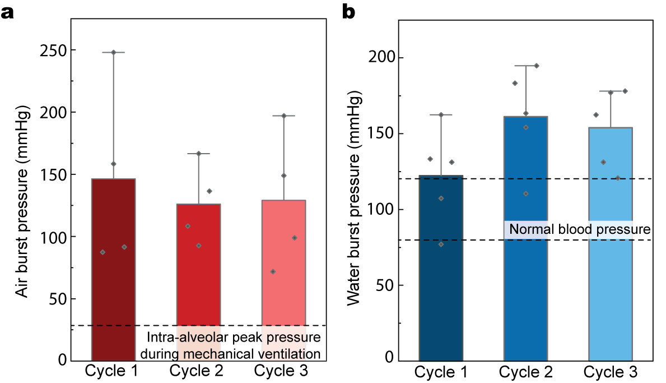

Supplementary Fig. 8 | Burst pressure of the PSB. a, Air burst pressure of the PSB adhered on wet porcine skin after 5 cycles of re-applications. Intra-alveolar peak pressure during mechanical ventilation (30 mmHg) is marked as a dotted line. b, Water burst pressure of the PSB adhered to wet porcine skin after 3 cycles of re-applications. Normal physiological blood pressure range (80-120 mmHg) is marked as dotted lines. Values represent the mean and the standard deviation (n = 4-5).

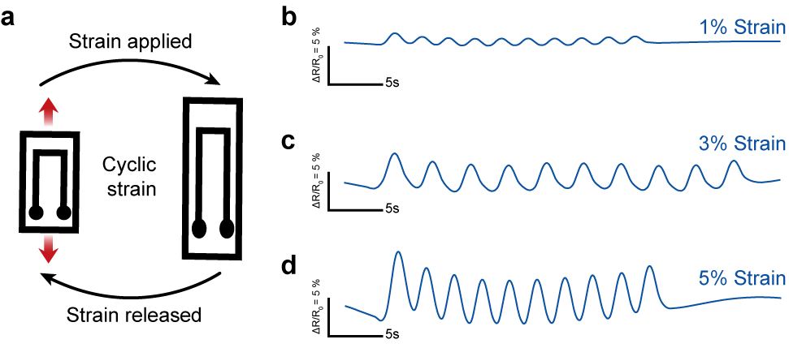

Supplementary Fig. 9 | Characterization of strain sensor. a, Schematic illustration of a strain sensor under cyclic deformation. b-d, Simultaneous impedance measurements as a function of time (1V at 1kHz) of the strain sensor with cyclic tensile strain amplitude of 1 % (b), 3 % (c), and 5 % (d).

Supplementary Video 1 | Demonstration of PSB detachment characteristics. Comparison of the adhesion and detachment process of PSB and a commercial PSA (VHB) on dry and wet surfaces.

Supplementary References

1 Lang, N. et al. A blood-resistant surgical glue for minimally invasive repair of vessels and heart defects. Sci. Transl. Med. 6, 218ra216 (2014).
2 Annabi, N. et al. Engineering a highly elastic human protein–based sealant for surgical applications. Sci. Transl. Med. 9, eaai7466 (2017).
3 Rose, S. et al. Nanoparticle solutions as adhesives for gels and biological tissues. Nature 505, 382-385 (2014)._
4 Liu, Y. et al. Gelation of highly entangled hydrophobic macromolecular fluid for ultrastrong underwater in situ fast tissue adhesion. Sci. Adv. 8, eabm9744 (2022).
5 Chen, M. et al. Fast, strong, and reversible adhesives with dynamic covalent bonds for potential use in wound dressing. Proc. Natl. Acad. Sci. U.S.A. 119, e2203074119 (2022).
6 Li, J. et al. Tough adhesives for diverse wet surfaces. Science 357, 378-381 (2017).
7 Yuk, H. et al. Dry double-sided tape for adhesion of wet tissues and devices. Nature 575, 169-174 (2019).

