Supplementary Materials for
Title: Endophyte mediated restoration of citrus microbiome and modulation of host defense genes against Candidatus Liberibacter asiaticus
Yongmei Li, Pengfei He, Ayesha Ahmed, Yinglong Liu, Waqar Ahmed, Yixin Wu, Yueqiu He, Pengbo He*, Shahzad Munir*
State Key Laboratory for Conservation and Utilization of Bio-Resources in Yunnan, Yunnan Agricultural University, Kunming, China

* Corresponding author:

Pengbo He

Email: pengbohe@163.com

Shahzad Munir

shahzad_munir@ynau.edu.cn
State Key Laboratory for Conservation and Utilization of Bio-resources in Yunnan, Yunnan Agricultural University, Kunming 650201, Yunnan, China

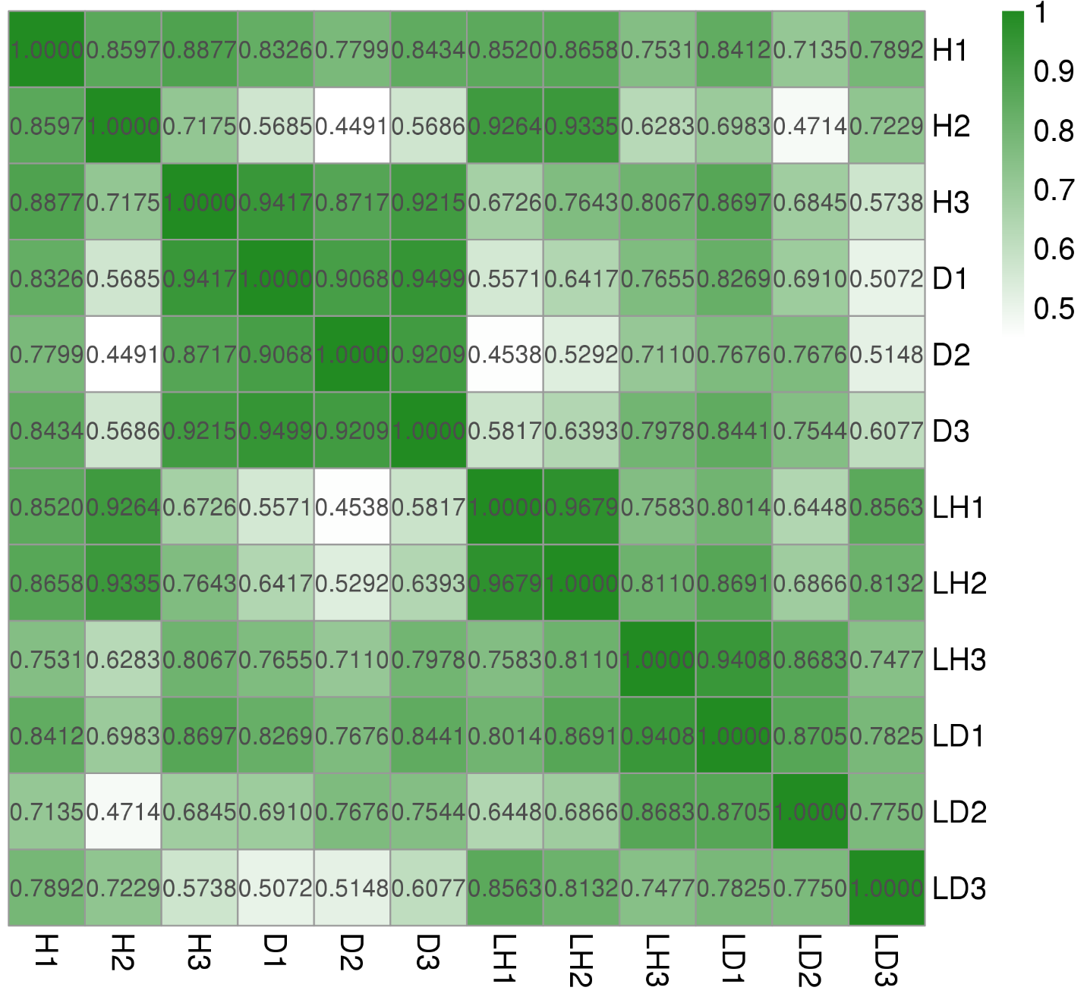
Figure S1. Pearson correlation analysis confirmed that in parallel experiments the correlation coefficient reached to 1.

Figure S2. Analysis of the differential expression of GO-enriched genes in endophyte L1-21 treated citrus plants. (A) Healthy and diseased citrus plants treated with Bacillus subtilis L1-21. (B) Venn diagram depicted similar genes in healthy and diseased citrus. (C) HLB affected citrus trees treated with endophyte. (D) Comparison of gene expression among endophyte treatment in healthy citrus plants. Significant GO terms are mentioned on Y-axis and number of upregulated and downregulated genes are depicted on X-axis.

Figure S3. Validation of genes by qPCR. Citrus diseased and healthy trees (LD and LH) treated with endophyte L1-21.
Table S1. List of primers used in the study
Gene IDs | Gene name |  | 5'--3' | Tm | Product
09806 | Ubiquitin-conjugating enzyme 28 | F | TCCACCCTAACATCAACAGCA | 58.7 | 137
09806 | Ubiquitin-conjugating enzyme 28 | R | AAGTGGGTCATCTGGGTTCG | 59.5 | 137
31847 | Actin-11 | F | GGTGTCAGCCATACAGTTCCT | 56.4 | 200
31847 | Actin-11 | R | TCATAGTCAAGAGCGATGTAAGC | 57 | 200
Ciclev10014586m.g | Cellulose synthase-like B4 | F | CTTTCTTGGCTGTGCGTCTC | 58.3 | 247
Ciclev10014586m.g | Cellulose synthase-like B4 | R | TGGCAGGAAAGTGGAGTTGG | 60.7 | 247
Ciclev10014991m.g | Hydroperoxide lyase 1 | F | TGAAAAGCACAAGAGCACGG | 59.7 | 205
Ciclev10014991m.g | Hydroperoxide lyase 1 | R | AGCACTAACCCTCAAGCCTC | 56.1 | 205
Ciclev10016883m.g | Chaperone DnaJ-domain superfamily protein | F | GCAGCCATCTTATTACAGCGTTC | 61.4 | 297
Ciclev10016883m.g | Chaperone DnaJ-domain superfamily protein | R | TTCCTCGCCTCAGCCATTAG | 60.4 | 297
Ciclev10022129m.g | Kunitz family trypsin and protease inhibitor protein | F | ACCTCTCCTTGATGTCCACG | 56.9 | 448
Ciclev10022129m.g | Kunitz family trypsin and protease inhibitor protein | R | AGACTCGCAAACGGATGGAC | 59.8 | 448
Ciclev10030743m.g | HSP90.5 | F | TAAAAGAGTCGGGATACGGTG | 57.2 | 114
Ciclev10030743m.g | HSP90.5 | R | ACAATCAAGTCCATCAGGCGA | 60.3 | 114
Ciclev10000117m.g | Cellulose synthase 6 | F | TAATGGATGAGGCAAGACAGC | 57.8 | 115
Ciclev10000117m.g | Cellulose synthase 6 | R | TGAAAGAAGAACCCGAGAACTAC | 57.6 | 115
Ciclev10011017m.g | Heat shock protein 70 | F | TGGTTGATGGCTCCTCTTATGG | 61.6 | 288
Ciclev10011017m.g | Heat shock protein 70 | R | TTGCCTTGATGGGGGATGAC | 62.6 | 288
Ciclev10012434m.g | Acclimation of photosynthesis to environment | F | GTTACTTAGGCTTATCCAATCACC | 56.8 | 150
Ciclev10012434m.g | Acclimation of photosynthesis to environment | R | AGGTAGTAGCCGAGGAAGGTTG | 59.7 | 150
Ciclev10024849m.g | Disease resistance protein | F | TCTGCGGTCGTAAGGGTGTA | 59 | 359
Ciclev10024849m.g | Disease resistance protein | R | GTTGAGACTGCGGAAACCACT | 59.1 | 359
Ciclev10029528m.g | Pathogenesis-related 4 | F | TCTGCCCAAAGTGCTTCTAATG | 59.9 | 295
Ciclev10029528m.g | Pathogenesis-related 4 | R | TGAACACTCCTTCGTCCAAATC | 59.2 | 295

Table S2. Data processing and quality reads for citrus microbiome analysis
Sample Name | Raw Reads | Clean Reads | Raw Tags | Clean Tags | Chimera | Effective Tags | Effective Ratio (%)
p0d-1 | 132656 | 132397 | 95690 | 94866 | 9643 | 85223 | 64.24
p0d-2 | 133741 | 133458 | 103374 | 102432 | 9717 | 92715 | 69.32
p0d-3 | 124144 | 123916 | 107245 | 106036 | 14254 | 91782 | 73.93
p1y1-1 | 124130 | 123693 | 98424 | 97647 | 3169 | 94478 | 76.11
p1y1-2 | 134305 | 133871 | 111306 | 110324 | 5997 | 104327 | 77.68
p1y1-3 | 128359 | 128009 | 108894 | 107880 | 5169 | 102711 | 80.02
p30d-1 | 133756 | 133566 | 116102 | 115051 | 5443 | 109608 | 81.95
p30d-2 | 121999 | 121803 | 102908 | 102076 | 6248 | 95828 | 78.55
p30d-3 | 127136 | 126955 | 107609 | 106726 | 5082 | 101644 | 79.95
p3d-1 | 125577 | 125383 | 113805 | 112877 | 6648 | 106229 | 84.59
p3d-2 | 134054 | 133876 | 119312 | 118323 | 6187 | 112136 | 83.65
p3d-3 | 121397 | 121242 | 109762 | 108793 | 7455 | 101338 | 83.48

Table S3. Genome alignment for unique mapped reads (gene transcripts)
Sample | Total Reads | Unmapped Reads | Unique Mapped Reads | Multiple Mapped reads | Mapping Ratio
H1 | 38103296 | 6252834 (16.41%) | 31545416 (82.79%) | 305046 (0.80%) | 83.59%
H2 | 49019746 | 7730246 (15.77%) | 40899322 (83.43%) | 390178 (0.80%) | 84.23%
H3 | 42882598 | 7021737 (16.37%) | 35531989 (82.86%) | 328872 (0.77%) | 83.63%
D1 | 39914292 | 6472641 (16.22%) | 33148857 (83.05%) | 292794 (0.73%) | 83.78%
D2 | 57378088 | 9314668 (16.23%) | 47578206 (82.92%) | 485214 (0.85%) | 83.77%
D3 | 44026696 | 6951039 (15.79%) | 36711295 (83.38%) | 364362 (0.83%) | 84.21%
LH1 | 41290702 | 6718742 (16.27%) | 34206340 (82.84%) | 365620 (0.89%) | 83.73%
LH2 | 50423504 | 8250361 (16.36%) | 41700115 (82.70%) | 473028 (0.94%) | 83.64%
LH3 | 52255074 | 8717833 (16.68%) | 43057243 (82.40%) | 479998 (0.92%) | 83.32%
LD1 | 41070900 | 6686650 (16.28%) | 34040450 (82.88%) | 343800 (0.84%) | 83.72%
LD2 | 39743714 | 6742021 (16.96%) | 32620409 (82.08%) | 381284 (0.96%) | 83.04%
LD3 | 53188416 | 8716450 (16.39%) | 43957896 (82.65%) | 514070 (0.97%) | 83.61%

Table S4. Differentially expressed genes (>1 log2 fold change) related to resistance to pathogen in diseased citrus trees treated with the endophyte Bacillus subtilis L1-21.
S. No | Description | Symbol | Gene ID | log2(FC)
 |  |  |  | Diseased | Healthy
1 | Pathogenesis-related 4 | PR4 | Ciclev10029328m.g | 10.73 | 9.59
2 | Pathogenesis-related 4 | PR4 | Ciclev10029327m.g | 10.42 | 9.34
3 | Chitin elicitor receptor kinase 1 | LYSM RLK1 | Ciclev10017678m.g | 4.14 | 2.24
4 | Respiratory burst oxidase homologue D | RBOHD | Ciclev10027774m.g | 4.02 | 2.64
5 | Pathogenesis-related 4 | PR4 | Ciclev10029536m.g | 2.12 | 0.00
6 | Disease resistance protein (CC-NBS-LRR class) family | -- | Ciclev10030667m.g | 1.78 | 1.58
7 | MYB domain protein 116 | MYB116 | Ciclev10021157m.g | 1.69 | 0.00
8 | NB-ARC domain-containing disease resistance protein | RPS2 | Ciclev10000338m.g | 1.44 | 1.05
9 | Chaperone protein htpG family protein | HSP90.5 | Ciclev10030743m.g | 1.40 | 1.77
10 | Disease resistance protein (CC-NBS-LRR class) family | RPS5 | Ciclev10024849m.g | 1.30 | 1.13
11 | Disease resistance protein (CC-NBS-LRR class) family | RPS5 | Ciclev10024854m.g | 1.15 | 0.00
12 | Calcium-dependent protein kinase (CDPK) family protein | -- | Ciclev10019463m.g | 1.11 | 0.00
13 | Mitogen-activated protein kinase 1 | MPK1 | Ciclev10001531m.g | 1.03 | 1.10
14 | CRINKLY4 related 3 | CCR3 | Ciclev10030732m.g | 1.82 | 0.00
15 | Heat shock protein 70 (HSP 70) family protein | -- | Ciclev10011017m.g | 1.71 | 1.29
16 | Chaperone protein htpG family protein | HSP90.5 | Ciclev10030743m.g | 1.40 | 1.77
17 | Heat shock protein 70 (Hsp 70) family protein | BIP1 | Ciclev10000531m.g | 2.41 | 1.75
18 | CLPC homologue 1 | HSP93-V | Ciclev10033976m.g | 1.02 | 1.27
19 | CLPC homologue 1 | HSP93-V | Ciclev10030863m.g | 1.00 | 1.20
20 | Heat shock protein 70 | HSP70 | Ciclev10027981m.g | -1.19 | 0.00
21 | 17.6 kDa class II heat shock protein | HSP17.6II | Ciclev10009756m.g | -2.93 | 0.00
22 | Phloem protein 2-A12 | PP2-A12 | Ciclev10021489m.g | 1.08 | 0.00

Table S5. Differentially expressed genes (>1 log2 fold change) related to expression of secondary metabolites in diseased citrus trees treated with the endophyte Bacillus subtilis L1-21.
S. No | Description | Symbol | Gene ID | log2(FC)
 |  |  |  | Diseased | Healthy
1 | Homogentisate phytyltransferase 1 | VTE2 | Ciclev10008872m.g | 3.01 | 0.00
2 | Lipoxygenase 2 | LOX2 | Ciclev10014199m.g | 2.68 | 2.05
3 | Peroxidase superfamily protein | -- | Ciclev10021010m.g | 2.67 | 1.18
4 | Cysteine synthase 26 | CS26 | Ciclev10031768m.g | 2.45 | 2.96
5 | Branched-chain amino acid transaminase 2 | BCAT-2 | Ciclev10001429m.g | 2.19 | 2.72
6 | Pyridoxal-5\'-phosphate-dependent enzyme family protein | -- | Ciclev10015207m.g | 1.86 | 0.00
7 | S-adenosyl-L-methionine-dependent methyltransferases superfamily protein | CCoAOMT1 | Ciclev10026344m.g | 1.77 | 0.00
8 | Aldehyde dehydrogenase 3F1 | ALDH3F1 | Ciclev10025492m.g | 1.77 | 1.30
9 | S-adenosyl-L-methionine-dependent methyltransferases superfamily protein | CCoAOMT1 | Ciclev10012561m.g | 1.76 | 0.00
10 | Geranylgeranyl pyrophosphate synthase 1 | GGPS1 | Ciclev10012067m.g | 1.72 | 1.24
11 | Galactose mutarotase-like superfamily protein | -- | Ciclev10012004m.g | 1.69 | 0.00
12 | Magnesium-protoporphyrin IX methyltransferase | CHLM | Ciclev10032123m.g | 1.67 | 1.74
13 | GroES-like zinc-binding dehydrogenase family protein | PAR2 | Ciclev10020620m.g | 1.58 | 1.43
14 | Homogentisate phytyltransferase 1 | VTE2 | Ciclev10032730m.g | 1.55 | 0.00
15 | Isopentenyl diphosphate isomerase 1 | IPP1 | Ciclev10012312m.g | 1.55 | 1.10
16 | Hydroxymethylglutaryl-CoA synthase | MVA1 | Ciclev10020042m.g | 1.48 | 1.61
17 | Aldehyde dehydrogenase 2C4 | REF1 | Ciclev10010514m.g | 1.46 | 1.66
18 | Alpha amylase family protein | EMB2729 | Ciclev10007401m.g | 1.45 | 1.60
19 | Tryptophan synthase beta type 2 | TSBtype2 | Ciclev10011534m.g | 1.30 | 1.39
20 | Protochlorophyllide oxidoreductase A | PORA | Ciclev10008520m.g | 1.25 | 0.00
21 | Pyridoxal phosphate (PLP)-dependent transferases superfamily protein | AGD2 | Ciclev10028382m.g | 1.15 | 1.15
22 | Arginosuccinate synthase family | -- | Ciclev10019860m.g | 1.14 | 1.57
23 | Phosphoglucose isomerase 1 | PGI1 | Ciclev10000603m.g | 1.02 | 0.00
24 | Squalene synthase 1 | SQS1 | Ciclev10028537m.g | 1.01 | 0.00
25 | Beta glucosidase 46 | BGLU46 | Ciclev10014887m.g | -1.29 | -1.95
26 | Beta glucosidase 11 | BGLU11 | Ciclev10019719m.g | -2.98 | -2.50

Table S6. Protein folding, chaperones, heat shock proteins.
S. No | Description | Symbol | Gene ID | log2(FC)
 |  |  |  | Diseased | Healthy
1 | Chaperone DnaJ-domain superfamily protein | -- | Ciclev10002683m.g | 1.48 | 2.51
2 | Chaperone DnaJ-domain superfamily protein | -- | Ciclev10016883m.g | 2.70 | 4.14
3 | Chaperone DnaJ-domain superfamily protein | -- | Ciclev10009810m.g | 1.44 | 1.57
4 | Chaperone protein htpG family protein | HSP90.5 | Ciclev10030743m.g | 1.41 | 1.77
5 | Co-chaperone GrpE family protein | -- | Ciclev10008685m.g | 1.04 | 1.40
6 | Ubiquitin-conjugating enzyme/RWD-like protein | -- | Ciclev10021040m.g | 2.50 | 1.20
7 | Plant U-Box 15 | PUB15 | Ciclev10003715m.g | 2.17 | 0.00
8 | Transducin/WD40 repeat-like superfamily protein | -- | Ciclev10007255m.g | 1.87 | 1.71
9 | Senescence-associated E3 ubiquitin ligase 1 | SAUL1 | Ciclev10030698m.g | 1.79 | 0.00
10 | Ubiquitin carboxyl-terminal hydrolase family protein | -- | Ciclev10003568m.g | 1.60 | 1.78
11 | U-box domain-containing protein kinase family protein | -- | Ciclev10018795m.g | 1.56 | 1.55
12 | plant U-box 29 | PUB29 | Ciclev10001380m.g | 1.32 | 1.04
13 | Rad23 UV excision repair protein family | RAD23C | Ciclev10011886m.g | 1.19 | 1.22
14 | ubiquitin 4 | UBQ4 | Ciclev10012291m.g | 1.14 | 0.00
15 | F-box/RNI-like superfamily protein | SKP2A | Ciclev10001527m.g | -1.24 | -1.07

Table S7. Up and down-expression of genes related to photosynthesis, starch accumulation and carbohydrate metabolism (padj<0.05).
S.No | Description | Symbol |  | Gene ID | log2(FC)
 |  |  |  |  | Diseased | Healthy
 | Photosynthesis
1 | Ferredoxin 3 |  | FD3 | Ciclev10029499m.g | 1.07 | 1.28
2 | Acclimation of photosynthesis to environment |  | APE1 | Ciclev10012434m.g | -1.45 | -1.15
3 | Photosystem II reaction center PSB28 protein |  | PSB28 | Ciclev10022322m.g | -1.57 | -1.14
 | Starch accumulation
1 | beta glucosidase 46 |  | BGLU46 | Ciclev10014887m.g | -1.29 | -1.95
2 | beta glucosidase 11 |  | BGLU11 | Ciclev10019719m.g | -2.98 | -2.50
 | Carbohydrate metabolism
1 | Aldehyde dehydrogenase 3F1 |  | ALDH3F1 | Ciclev10025492m.g | 1.77 | 1.30
2 | Galactose mutarotase-like superfamily protein |  | -- | Ciclev10012004m.g | 1.69 | 0.00
3 | GroES-like zinc-binding dehydrogenase family protein |  | PAR2 | Ciclev10020620m.g | 1.58 | 1.43
4 | Hydroxymethylglutaryl-CoA synthase / HMG-CoA synthase / 3-hydroxy-3-methylglutaryl coenzyme A synthase |  | MVA1 | Ciclev10020042m.g | 1.48 | 0.00
5 | Alpha amylase family protein |  | EMB2729 | Ciclev10007401m.g | 1.45 | 1.60
6 | Arginosuccinate synthase family |  | -- | Ciclev10019860m.g | 1.14 | 1.57
7 | Phosphoglucose isomerase 1 |  | PGI1 | Ciclev10000603m.g | 1.02 | 0.00

Table S8. Genes related to cell wall, oxidative stress, and plant defense.
S.No | Description |  | Symbol |  | Gene ID |  |  | log2(FC)
 |  |  |  |  |  |  | Diseased |  |  | Healthy
 | Cell Wall
1 | Cellulose synthase like E1 | CSLE1 |  | Ciclev10007586m.g |  | -1.16 |  |  | 0.00
2 | Cellulose synthase like G3 | CSLG3 |  | Ciclev10023570m.g |  | -2.00 |  |  | -1.78
3 | Cellulose synthase-like B4 | CSLB04 |  | Ciclev10014586m.g |  | -3.11 |  |  | -3.08
 | Oxidative Stress
1 | Glutathione S-transferase family protein | -- |  | Ciclev10008944m.g |  | 1.64 |  |  | 1.65
2 | Glutathione S-transferase tau 7 | GSTU7 |  | Ciclev10032702m.g |  | 1.47 |  |  | 1.16
3 | Glutathione S-transferase PHI 10 | GSTF10 |  | Ciclev10033001m.g |  | 1.46 |  |  | 0.00
4 | Glutathione S-transferase TAU 8 | GSTU8 |  | Ciclev10005808m.g |  | 1.33 |  |  | 0.00
5 | Glutathione S-transferase TAU 8 | GSTU8 |  | Ciclev10005812m.g |  | 1.13 |  |  | 0.00
 | Plant defense
1 | Respiratory burst oxidase homologue D | RBOHD |  | Ciclev10027774m.g |  | 4.03 |  |  | 2.63
2 | Leucine-rich repeat protein kinase family protein | SOBIR1 |  | Ciclev10019897m.g |  | 2.30 |  |  | 2.20
3 | WRKY DNA-binding protein 33 | WRKY33 |  | Ciclev10000654m.g |  | 1.65 |  |  | 1.40
4 | WRKY DNA-binding protein 40 | WRKY40 |  | Ciclev10009250m.g |  | 2.75 |  |  | 1.74

Table S9. Gene expression of important transcription factors (padj<0.05).
S. No | Description | Symbol | Gene ID | log2(FC)
 |  |  |  | Diseased | Healthy
1 | WRKY DNA-binding protein 55 | WRKY55 | Ciclev10033384m.g | 3.10 | 3.89
2 | myb domain protein 15 | MYB15 | Ciclev10005629m.g | 2.89 | 2.75
3 | WRKY DNA-binding protein 40 | WRKY40 | Ciclev10009250m.g | 2.75 | 1.74
4 | WRKY DNA-binding protein 28 | WRKY28 | Ciclev10018230m.g | 2.75 | 2.95
5 | WRKY DNA-binding protein 50 | WRKY50 | Ciclev10009761m.g | 2.35 | 1.69
6 | IAA-leucine resistant (ILR)-like gene 6 | ILL6 | Ciclev10000964m.g | 2.10 | 0.00
7 | MYB domain protein 116 | MYB116 | Ciclev10021157m.g | 1.69 | 0.00
8 | WRKY DNA-binding protein 33 | WRKY33 | Ciclev10000654m.g | 1.65 | 1.40
9 | MYB domain protein 1 | MYB1 | Ciclev10031463m.g | 1.64 | 1.91
10 | Heat shock transcription factor A4A | HSF A4A | Ciclev10015413m.g | 1.60 | 1.48
11 | Ethylene insensitive 3 family protein | EIN3 | Ciclev10000608m.g | 1.46 | 1.18
12 | Heat shock transcription factor A8 | HSFA8 | Ciclev10015541m.g | 1.34 | 1.29
13 | WRKY DNA-binding protein 11 | WRKY11 | Ciclev10008836m.g | 1.33 | 1.06
14 | Ethylene insensitive 3 family protein | EIN3 | Ciclev10014617m.g | 1.28 | 0.00
15 | Thioredoxin family protein | UNE5 | Ciclev10020618m.g | 1.26 | 0.00
16 | Embryo defective 1703 | emb1703 | Ciclev10023383m.g | 1.26 | 1.50
17 | Auxin response factor 8 | ATARF8 | Ciclev10014200m.g | 1.08 | 1.32
18 | Oxysterol-binding family protein | UNE18 | Ciclev10011693m.g | 1.04 | 1.11
19 | NAC (No Apical Meristem) domain transcriptional regulator superfamily protein | ATAF1 | Ciclev10001976m.g | -1.14 | 0.00
20 | Ethylene responsive element binding factor 4 | RAP2.5 | Ciclev10009484m.g | -1.73 | -1.50
21 | Auxin response factor 16 | ARF16 | Ciclev10030860m.g | -1.93 | -2.48
22 | Plant-specific transcription factor YABBY family protein | YAB1 | Ciclev10022170m.g | -2.34 | -2.78
23 | Basic helix-loop-helix (bHLH) DNA-binding superfamily protein | UNE10 | Ciclev10020323m.g | -2.64 | -2.28

