Table S1 Bioclimatic variables
Code | Bioclimatic Variables | Units
Bio_01 | Annual mean temperature | °C
Bio_02 | Mean diurnal range (mean of monthly max. and min. temp.) | °C
Bio_03 | Isothermality ((Bio2/Bio7) ×100)
Bio_04 | Temperature seasonality (standard deviation ×100)
Bio_05 | Maximum temperature of warmest month | °C
Bio_06 | Minimum temperature of coldest month | °C
Bio_07 | Temperature annual range (Bio5–Bio6) | °C
Bio_08 | Mean temperature of wettest quarter | °C
Bio_09 | Mean temperature of driest quarter | °C
Bio_10 | Mean temperature of warmest quarter | °C
Bio_11 | Mean temperature of coldest quarter | °C
Bio_12 | Annual rainfall | mm
Bio_13 | Rainfall of wettest period | mm
Bio_14 | Rainfall of driest period | mm
Bio_15 | Rainfall seasonality (Coefficient of Variation)
Bio_16 | Rainfall of wettest quarter | mm
Bio_17 | Rainfall of driest quarter | mm
Bio_18 | Rainfall of warmest quarter | mm
Bio_19 | Rainfall of coldest quarter | mm

Table S2: True Skill Statistic (TSS) value of all Replicates

Replicates | TSS value | Average TSS value
0 | 0.666223 | 0.579422
1 | 0.53559 | 0.579422
2 | 0.488303 | 0.579422
3 | 0.681123 | 0.579422
4 | 0.497803 | 0.579422
5 | 0.445416 | 0.579422
6 | 0.477074 | 0.579422
7 | 0.651265 | 0.579422
8 | 0.463945 | 0.579422
9 | 0.712181 | 0.579422
10 | 0.421158 | 0.579422
11 | 0.658665 | 0.579422
12 | 0.686123 | 0.579422
13 | 0.558019 | 0.579422
14 | 0.748439 | 0.579422

Table S3: Calculation of Important Value Index and Shannon-Weiner diversity Index for tree species available in the study area falling under Tropical dry deciduous forests (Group 5)
RANK | Species | Relative Frequency | Relative Density | Relative Dominance | IVI | Shannon-Weiner diversity Index
1 | Shorea robusta | 17.476 | 42.623 | 13.146 | 73.245 | 0.363
2 | Buchanania cochinchinensis | 12.621 | 14.988 | 2.570 | 30.180 | 0.284
3 | Madhuca latifolia | 6.796 | 5.152 | 12.197 | 24.145 | 0.153
4 | Casseriato mentosa | 9.709 | 7.026 | 2.152 | 18.886 | 0.187
5 | Diospyros melonoxylon | 7.767 | 3.747 | 5.718 | 17.232 | 0.123
6 | Terminalia alata | 5.825 | 3.981 | 5.571 | 15.377 | 0.128
7 | Butea monosperma | 5.825 | 5.621 | 3.813 | 15.259 | 0.162
8 | Albizia lebbeck | 0.971 | 0.937 | 11.068 | 12.976 | 0.044
9 | Litsea glutinosa | 4.854 | 2.810 | 2.987 | 10.651 | 0.100
10 | Boswellia serrata | 1.942 | 1.171 | 6.711 | 9.824 | 0.052
11 | Lagerstroemia parviflora | 2.913 | 1.405 | 5.366 | 9.684 | 0.060
12 | Wrightia tinctoria | 5.825 | 1.874 | 1.268 | 8.966 | 0.075
13 | Anogeissus latifolia | 3.883 | 2.108 | 2.929 | 8.920 | 0.081
14 | Pterocarpus marsupium | 1.942 | 1.405 | 5.209 | 8.556 | 0.060
15 | Sterculia urens | 3.883 | 1.171 | 2.638 | 7.692 | 0.052
16 | Dalbergia lanceolaria | 2.913 | 1.171 | 3.001 | 7.085 | 0.052
17 | Schleichera oleosa | 0.971 | 0.234 | 5.780 | 6.985 | 0.014
18 | Semecarpus anacardium | 0.971 | 1.639 | 3.635 | 6.245 | 0.067
19 | Soymida febrifuga | 1.942 | 0.703 | 1.882 | 4.526 | 0.035
20 | Haldinia cordifolia | 0.971 | 0.234 | 2.360 | 3.565 | 0.014
 | TOTAL | 100.000 | 100.000 | 100.000 | 300.000 | 2.107
 | Simpson's Index | 0.779
 | Pielou’s Evenness index | 0.703

Table S4: Calculation of Important Value Index and Shannon-Weiner diversity Index for tree species available in the study area falling under Tropical moist deciduous forests (Group 3)

RANK | Species | Relative Frequency | Relative Density | Relative Dominance | IVI | Shannon-Weiner diversity Index
1 | Shorea robusta | 10.843 | 29.054 | 8.777 | 48.675 | 0.356
2 | Madhuca latifolia | 9.639 | 8.784 | 6.256 | 24.678 | 0.199
3 | Buchanania cochinchinensis | 9.639 | 11.824 | 1.543 | 23.006 | 0.252
4 | Lagerstroemia parviflora | 6.024 | 7.095 | 5.570 | 18.689 | 0.188
5 | Pterocarpus marsupium | 6.024 | 3.378 | 7.637 | 17.039 | 0.164
6 | Wrightia tinctoria | 7.229 | 7.095 | 2.325 | 16.649 | 0.188
7 | Diospyros melonoxylon | 6.024 | 6.081 | 2.431 | 14.536 | 0.170
8 | Casseria tomentosa | 6.024 | 5.068 | 3.429 | 14.520 | 0.151
9 | Dalbergia sissoo | 4.819 | 3.041 | 5.949 | 13.809 | 0.106
10 | Schleichera oleosa | 3.614 | 1.689 | 8.162 | 13.465 | 0.069
11 | Anogeissus latifolia | 6.024 | 3.716 | 3.074 | 12.815 | 0.122
12 | Butea monosperma | 4.819 | 2.703 | 3.351 | 10.873 | 0.098
13 | Bombax ceiba | 2.410 | 1.351 | 3.868 | 7.629 | 0.058
14 | Boswellia serrata | 1.205 | 0.676 | 5.735 | 7.615 | 0.034
15 | Vitex peduncularis | 1.205 | 0.676 | 5.691 | 7.571 | 0.034
16 | Bridelia retusa | 2.410 | 1.689 | 3.410 | 7.509 | 0.069
17 | Semecarpus anacardium | 2.410 | 1.351 | 3.029 | 6.790 | 0.058
18 | Litsea glutinosa | 1.205 | 0.676 | 4.774 | 6.655 | 0.034
19 | Terminalia bellirica | 2.410 | 1.014 | 3.047 | 6.470 | 0.047
20 | Terminalia alata | 1.205 | 1.014 | 4.154 | 6.372 | 0.047
21 | Haldinia cordifolia | 2.410 | 0.676 | 2.053 | 5.138 | 0.034
22 | Sterculia urens | 1.205 | 0.676 | 3.091 | 4.971 | 0.034
23 | Mitragyna parvifolia | 1.205 | 0.676 | 2.644 | 4.524 | 0.034
 | TOTAL | 100.000 | 100.000 | 100.000 | 300.000 | 2.544
 | Simpson's Index | 0.879
 | Pielou’s Evenness index | 0.800

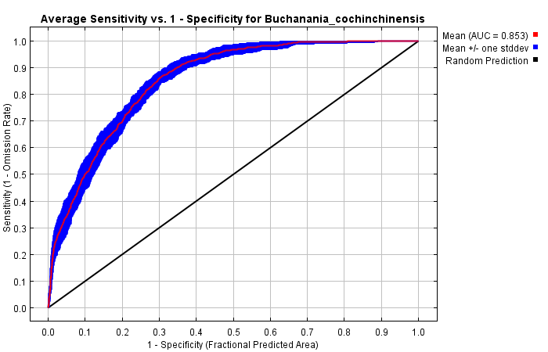
Fig. S1AUC (Area Under Curve) graph showing the model performance of B. cochinchinensis

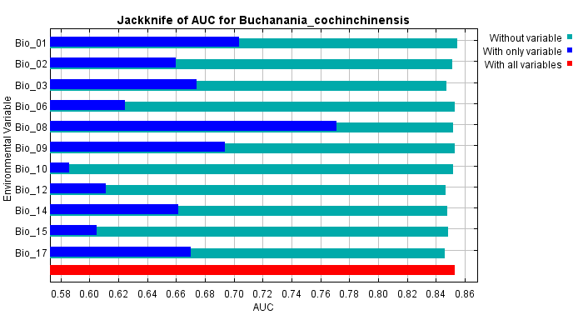
Fig. S2The Jackknife of test AUC for B. cochinchinensisshows Bioclimatic variable Bio_8 contributed most in limiting the distribution of B. cochinchinensis.The environmental variable with highest gain when used in isolation was Bio_08, which hence seems to have the greatest valuable information by itself.

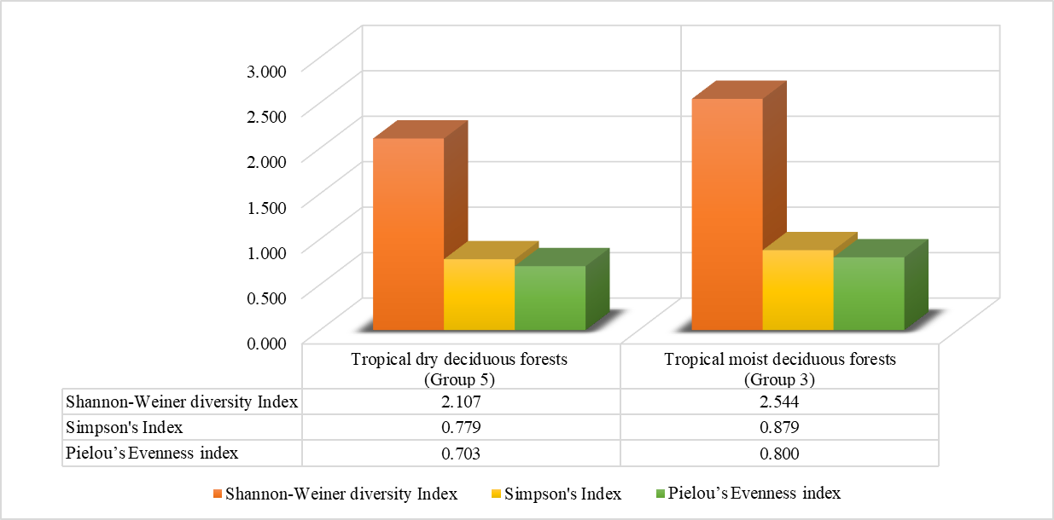
Fig. S3 Comparison of Shannon-Weiner diversity Index, Simpson’s Index and Pielou’s Evenness Index in the study area falling under Tropical dry deciduous forests (Group 5) and Tropical moist deciduous forests (Group 3)

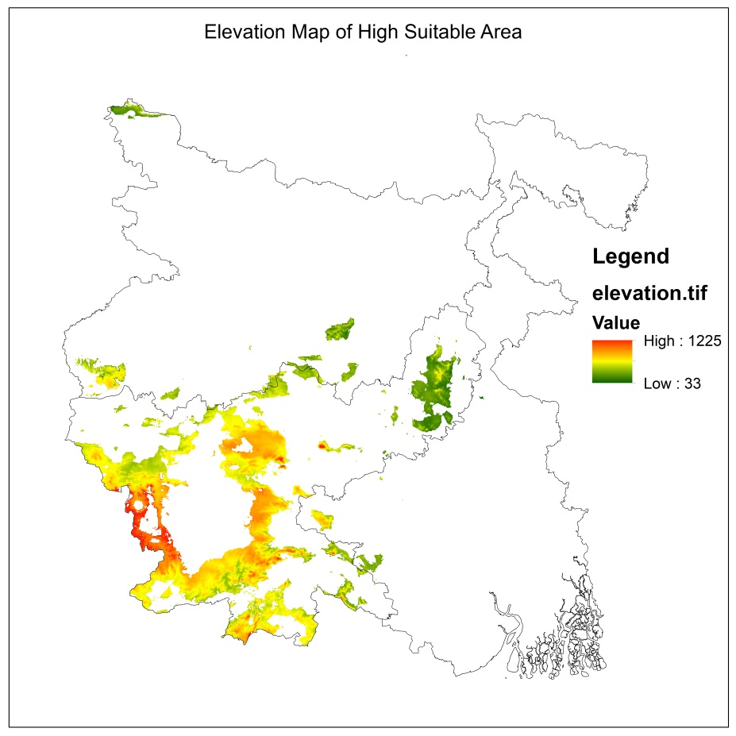
Fig. S4 Elevation map of high suitable zone

