Figure S1. Funnel plot to assess publication bias among studies evaluating handwashing in Kenya, Uganda and Tanzania.
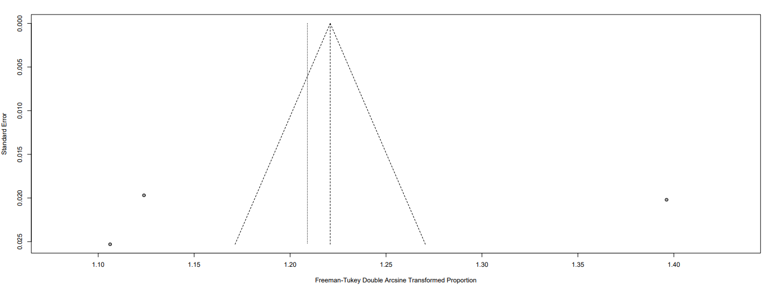
The triangle represents the estimates of the included studies that reported on levels of handwashing. The Freeman-Tukey double arcsine transformed is plotted on the horizontal axis, against the standard error of the transformed proportion. The vertical line in the funnel plot indicates the random effect summary estimate and the sloping two lines indicate the expected 95% confidence intervals for a given standard error.
Figure S2. Funnel plot to assess publication bias among studies evaluating vaccine acceptance in Kenya and Uganda.
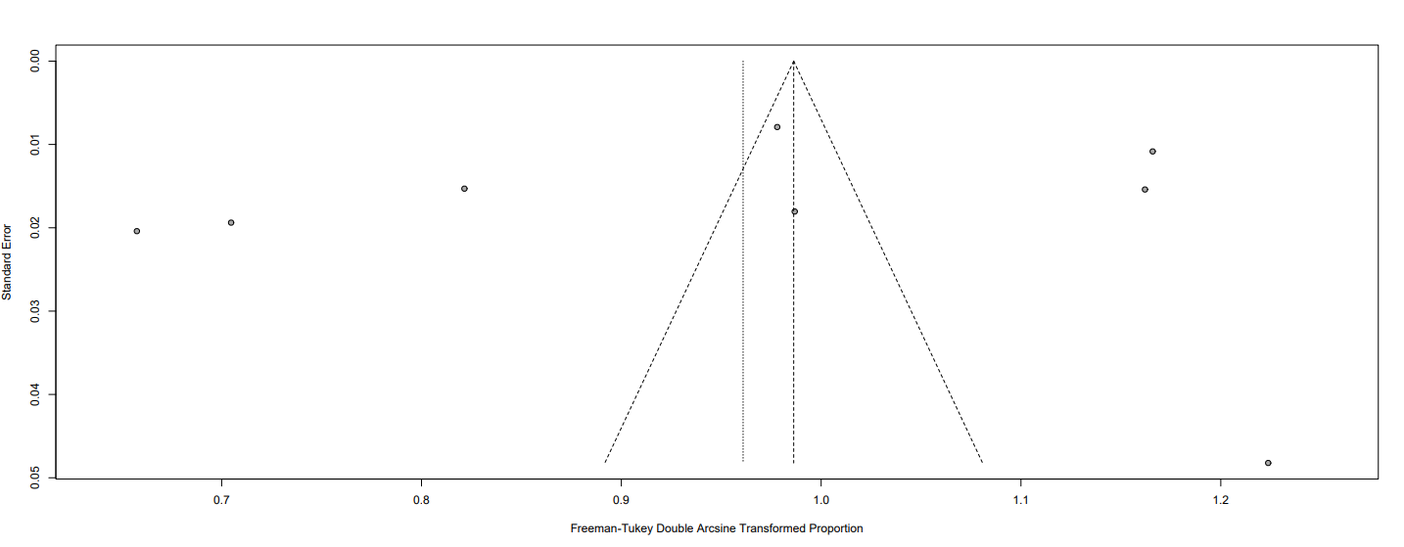
Figure S2. Funnel plot to assess publication bias among studies evaluating vaccine acceptance in Kenya and Uganda. The triangle represents the estimates of the included studies that reported on vaccine acceptance. The Freeman-Tukey double arcsine transformed is plotted on the horizontal axis, against the standard error of the transformed proportion. The vertical line in the funnel plot indicates the random effect summary estimate and the sloping two lines indicate the expected 95% confidence intervals for a given standard error.

Figure S3. Funnel plot to assess publication bias among studies evaluating vaccine hesitance in Kenya, Uganda and Tanzania.
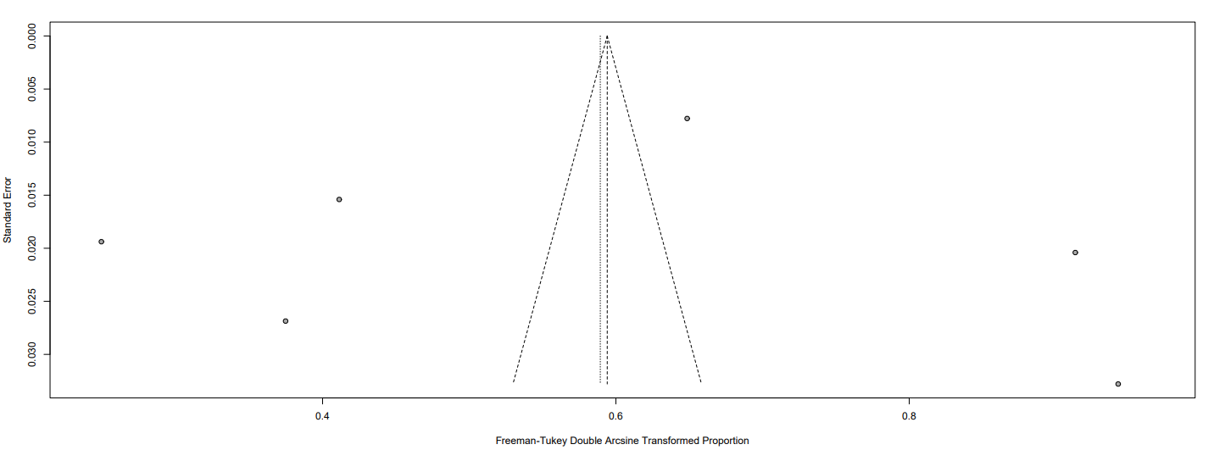
The triangle represents the estimates of the included studies that reported on vaccine hesitance. The Freeman-Tukey double arcsine transformed is plotted on the horizontal axis, against the standard error of the transformed proportion. The vertical line in the funnel plot indicates the random effect summary estimate and the sloping two lines indicate the expected 95% confidence intervals for a given standard error.

