Supplementary information
Individual and combinatorial effects of stiffness and electrical conductivity on host-immune responses to conductive hydrogels

Sanghun Lee^{1†}, Junggeon Park^{1†}, and Jae Young Lee¹*
¹School of Materials Science and Engineering, Gwangju Institute of Science and Technology, Gwangju, 61005, Republic of Korea

† These authors contributed equally.
*jaeyounglee@gist.ac.kr

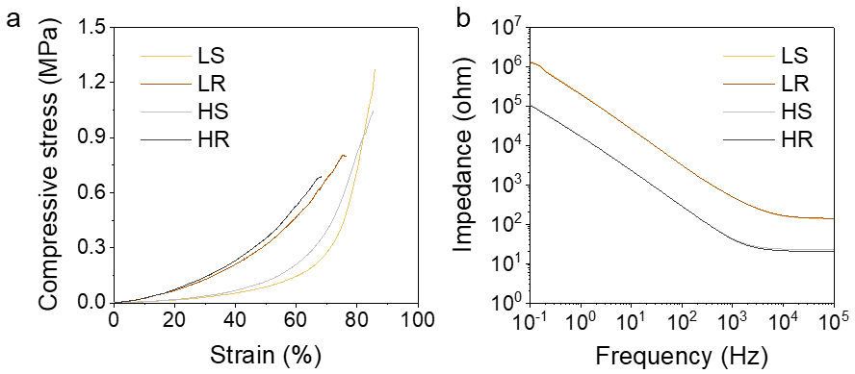
Supplementary Fig. 1: Compressive stress measurement and electrochemical impedance spectroscopy (EIS) of ECHs. a Universal testing machine (TO-100-IC, Testone, KR) was used for compressive test. The sample was placed between two loads of the machine, and compressive strength was measured at a compressive speed of 5 mm min⁻¹. b Flat disc typed ECHs were prepared for EIS measurement. Each sample was placed between two parallel gold-coated glasses. A computer-assisted electrochemical device (VersaSTAT3, Princeton Applied Research, Princeton, NJ, USA) was utilized to apply an alternative sinusoidal potential of 10 mV in frequency range of 1–10⁵ Hz.

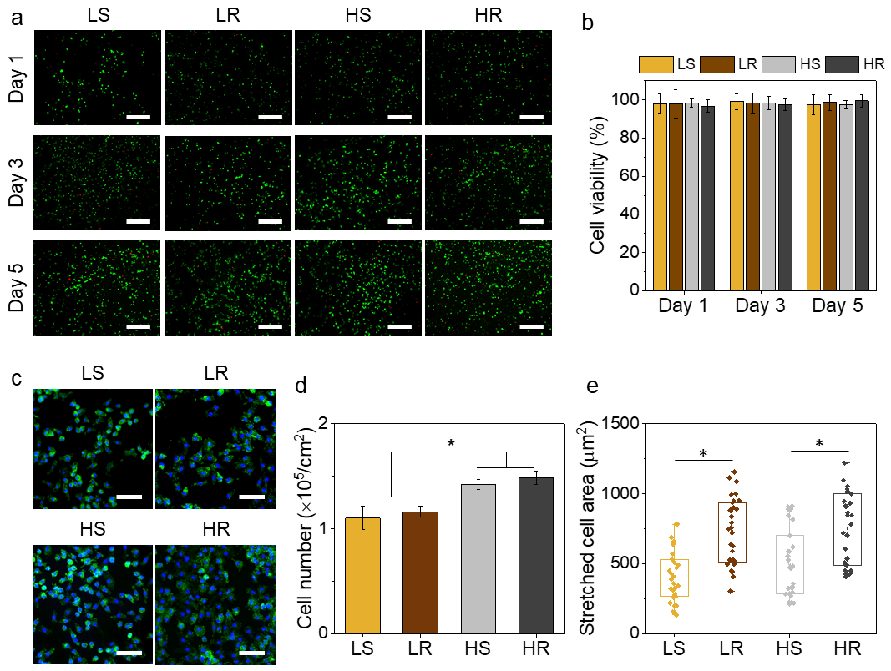
Supplementary Fig. 2: Cytotoxicity test and F-actin staining of in vitro cultured BMDMs on ECHs. BMDMs were seeded on each sample at a density of 10⁵ cells per 1 cm² and incubated in culture medium containing 25 ng/mL of M-CSF for 1, 3, or 5 d (without LPS/IFNγ induction). a Cell viability was assessed on 1, 3, and 5 d after seeding using LIVE/DEAD viability assay kit (Invitrogen, Waltham, USA) according to the manufacturer’s protocols. Green and red fluorescence cells represent live and dead cells, respectively. Scale bars: 200 μm. b Cell viability was presented as the percentage of live cells in the total cells. c Immunostaining of BMDMs cultured on ECHs. After 1 d of culture, samples were fixed in 3.7% paraformaldehyde at 25 °C for 20 min and thereafter incubated in a permeabilization solution (DPBS containing 0.1% v/v of Triton X-100) for 20 min, followed by incubation in Alexa Fluor 488-phalloidin solution (1:200 in DPBS containing 2% w/v of BSA). After cell nuclei staining with DAPI solution (1:1000 in DPBS) for 2 min. Fluorescence images were acquired using a fluorescence microscope. Green and blue fluorescence colors indicate F-actin and nuclei, respectively. Scale bars: 100 μm. d Number of attached cells was counted (p < 0.05). e Cell stretched area was quantified using ImageJ software (p < 0.05).

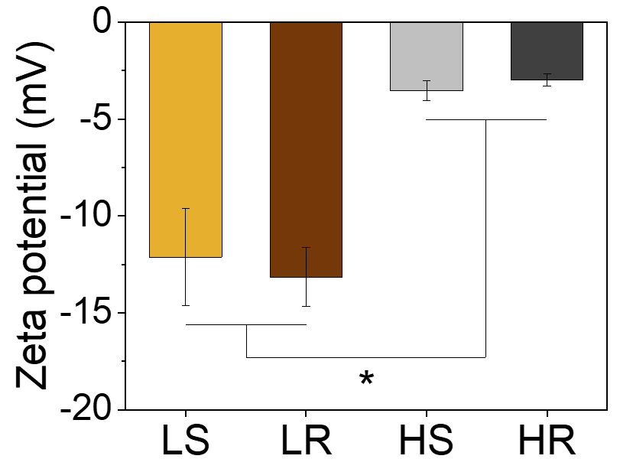
Supplementary Fig. 3: Zeta potential of each hydrogel (LS, LR, HS and HR). Surface zeta potential of each hydrogel was measured using an electrophoretic light scattering spectrophotometer (ELS-Z2, Otsuka Electronics Co., Japan) equipped with a laser diode light source (638 nm). *p < 0.05.

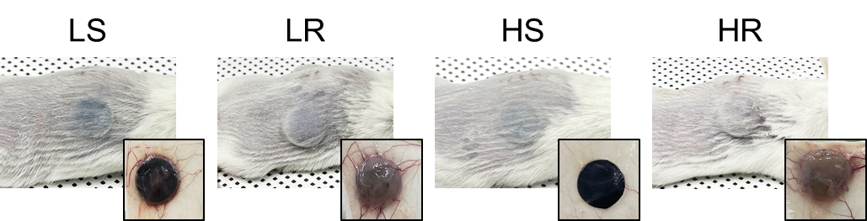

Supplementary Fig. 4: Photographs of implantation sites and implanted ECHs on day 15. Black boxes indicate individual ECHs in subcutaneous tissues.

