Supplementary Fig 1: The phylogenetic tree of the F-box genes (MGG 13435 MoMet30, MGG 08345 MoCdc4, MGG 09696 MoFwd1, MGG 00768 MoFbx15) of Magnaporthe oryzae with identified F-box genes of Puccinia triticina.

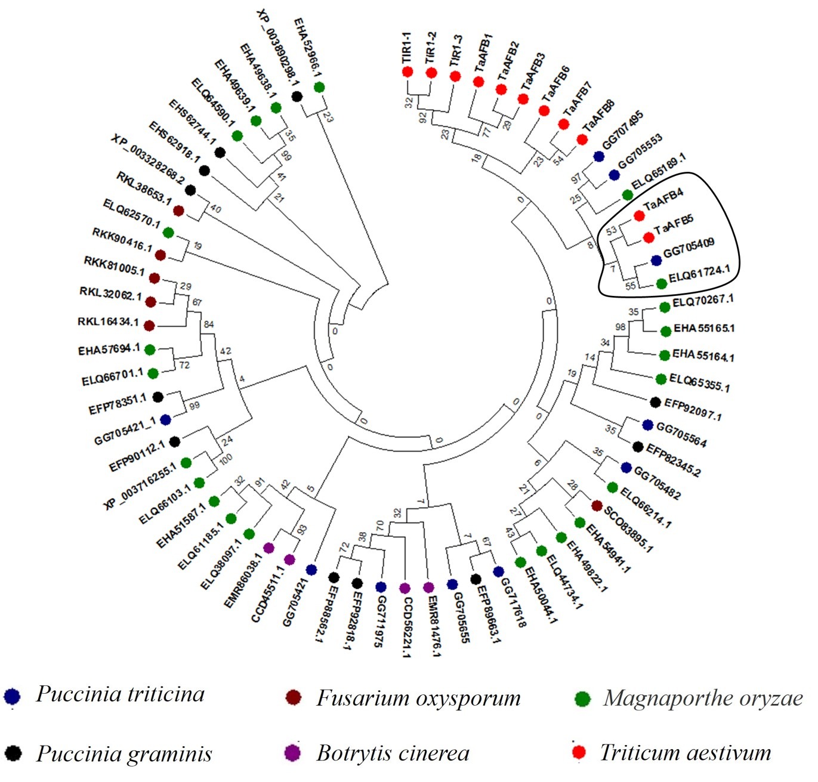
Supplementary Fig. 2: Phylogenetic analysis of F-box proteins identified in Puccinia triticina with other plant pathogenic fungal species such Fusarium oxysporum, Magnaporthe oryzae, Puccinia graminis, Botrytis cinerea and Auxin signaling F-box (TaAFB) proteins of Triticum aestivum.

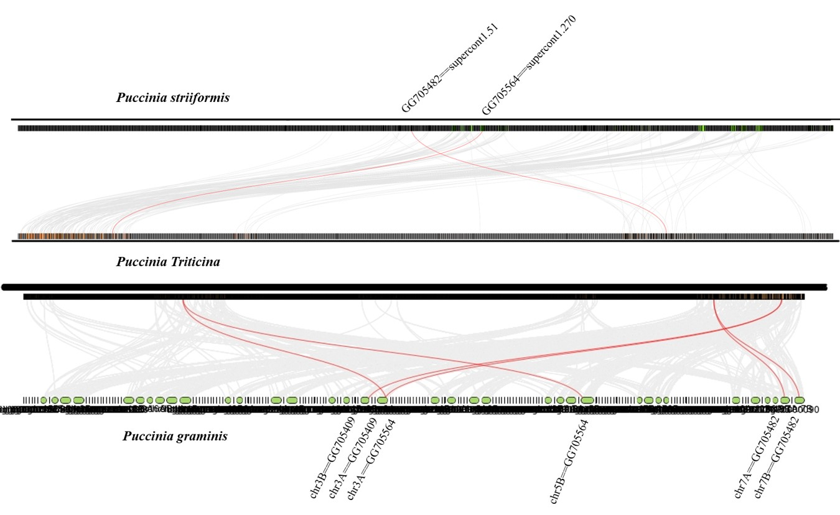
Supplementary Fig. 3: Synteny analysis between the F-box genes of Puccinia triticina with Puccinia striiformis and Puccinia graminis. The gray lines indicate the collinear blocks on the genome of mentioned species and red lines indicate the syntenic F-box gene pairs.
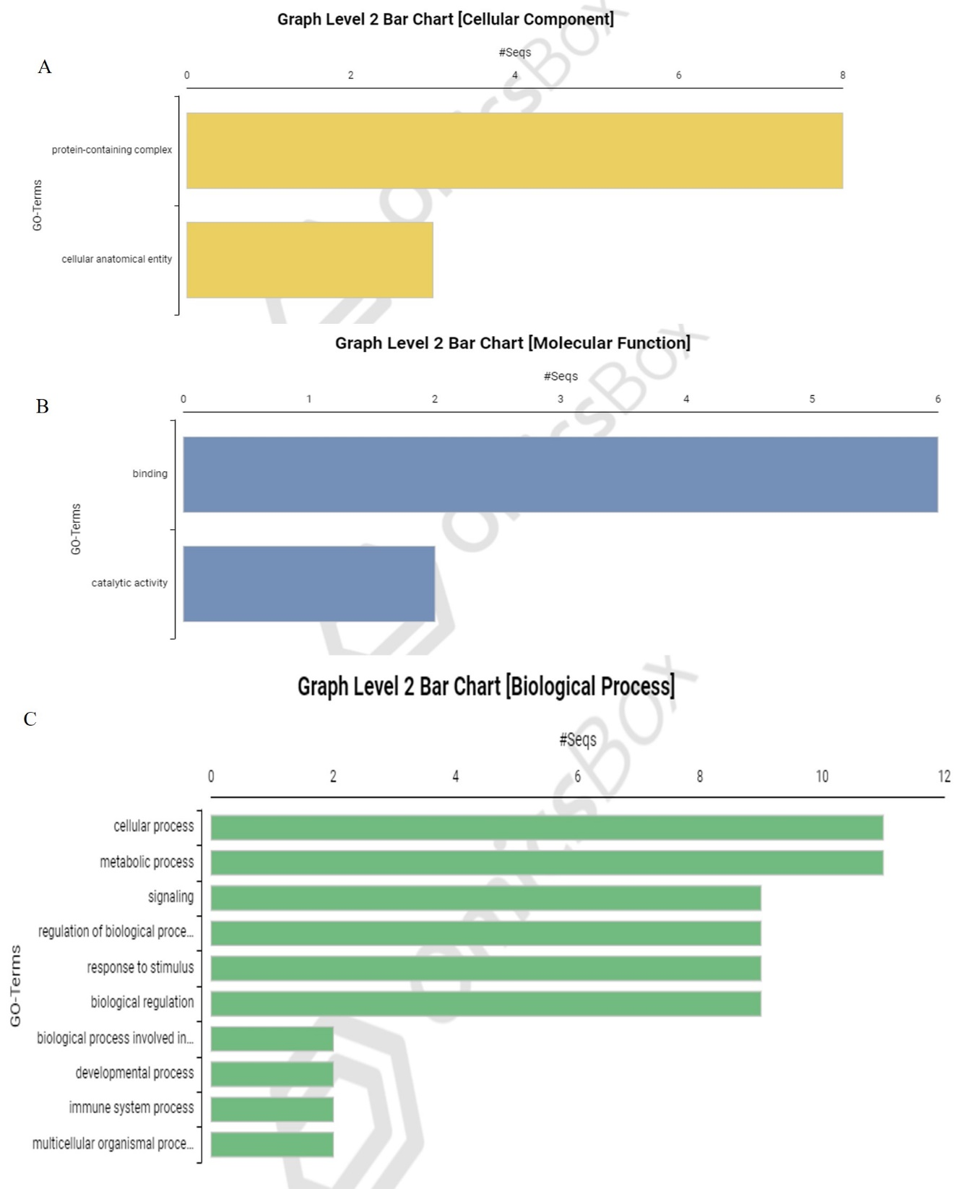
Supplementary Fig. 4: Gene ontology (GO) of F-box genes in Puccinia triticina using Blast2GO (Omicsbox). A: Cellular components, B: Molecular components, C: Cellular components
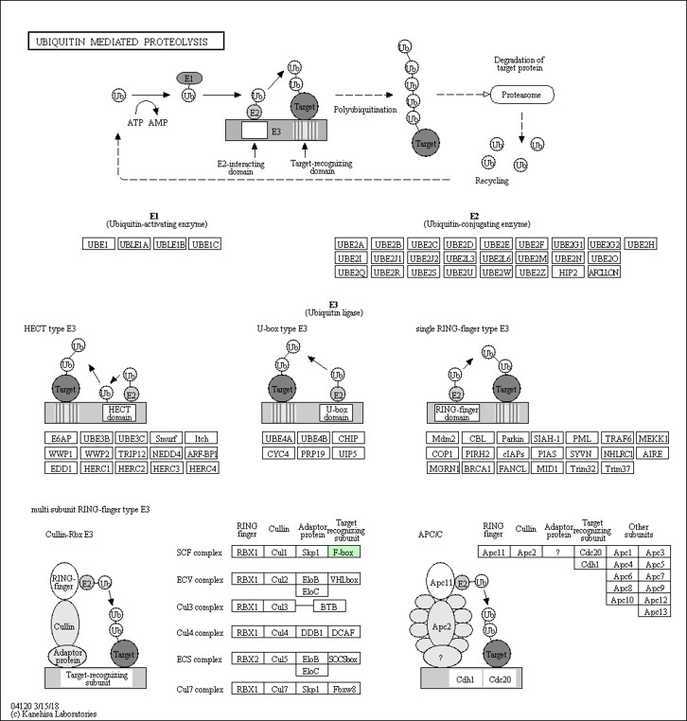
Supplementary Fig. 5 A: KEGG pathway reconstructed for F-box proteins in Puccinia triticina using BlastKOALA showing ubiquitin mediated proteolysis.

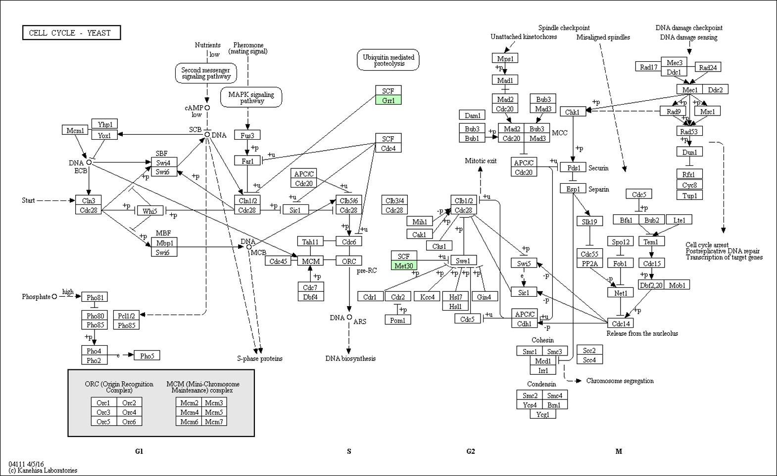
Supplementary Fig. 5 B: KEGG pathway reconstructed for F-box proteins in Puccinia triticina using BlastKOALA

